**1.13** You are climbing a staircase. It takes n steps to reach the top. Each time you can either climb 1 or 2 steps. In how many **distinct ways can you climb to the top**?

**AIM**:

To find the number of distinct ways to climb to the top of a staircase with n steps, where each move can be 1 step or 2 steps.

**ALGORITHM:**

1. Define a recursive function count(n) that returns the number of ways to reach step n.

2. If n <= 2, return n (base cases).

3. If result for n is already in memo, return it.

4. Otherwise, compute count(n-1) + count(n-2) and store it in memo.

5. Return count(n).

**PROGRAM:**

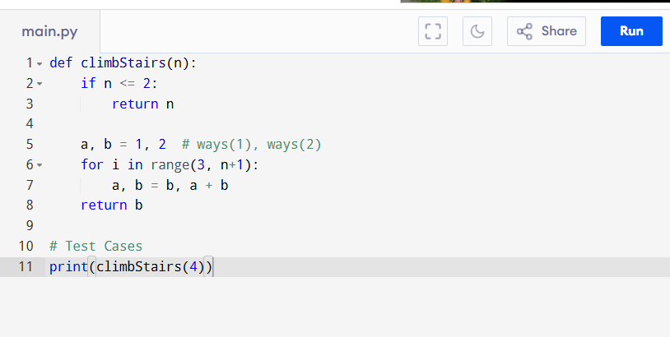

Input:

n = 4

Output:

**RESULT:**

Thus the program to find the number of distinct ways to climb to the top of a staircase is successfully executed, and the output is verified.

**PERFORMANCE ANALYSIS:**

• Time Complexity: O(n)

• Space Complexity: O(1)