**1.15** In a string S of lowercase letters, these letters form consecutive groups of the same character. For example, a string like s = "abbxxxxzyy" has the groups "a", "bb", "xxxx", "z", and "yy". A group is identified by an interval [start, end], where start and end denote the start and end indices (inclusive) of the group. In the above example, "xxxx" has the interval [3,6]. A group is considered large if it has 3 or more characters. Return the intervals of every large group sorted in increasing order by start index.

**AIM**:

To identify large groups (3 or more consecutive identical characters) in a string s and return their intervals [start, end].

**ALGORITHM:**

1.Initialize result = [].

2. Use two pointers:

• i = start index of a group.

• Traverse the string with j.

3. While traversing:

• If s[j] != s[i], it means the group ended at j-1.

• Check if group length (j-1 - i + 1) >= 3.

• If yes → append [i, j-1] to result.

• Update i = j (start new group).

4. After loop ends, check the last group as well.

5. Return result.

**PROGRAM:**

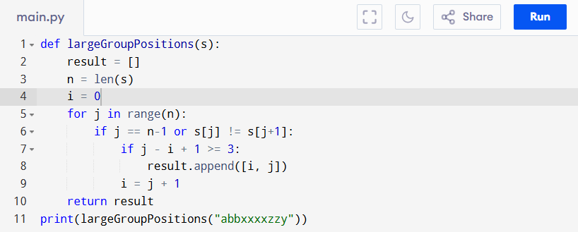

Input:

s = "abbxxxxzzy"

Output:

**RESULT:**

Thus the program to identify large groups in a string is successfully executed, and the output is verified.

**PERFORMANCE ANALYSIS:**

• Time Complexity: O(n) (one pass through string).

• Space Complexity: O(1) (excluding result storage).