**1.7** Write a program that takes an input list of n numbers and  **creates a new list containing only the unique elements from the original list**. What is the space complexity of the algorithm

**AIM**:

To create a program that takes an input list of n numbers and creates a new list containing only the unique elements from the original list.

**ALGORITHM:**

1.Initialize an empty set seen and an empty list unique_list.

2.Iterate through each element x in the input list.

3.If x is not in seen, add it to both seen and unique_list.

4.Return unique_list.

**PROGRAM:**

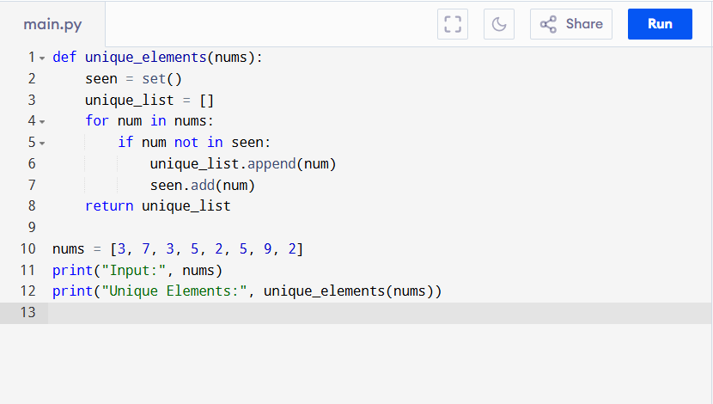

Input:

nums = [3, 7, 3, 5, 2, 5, 9, 2]

Output:

**RESULT:**

Thus the program to create a new list from the original list is successfully executed, and the output is verified.

**PERFORMANCE ANALYSIS:**

We use a set (seen) to store unique elements → O(n) in worst case.

We also use a list (unique_list) to return result → O(n).

* Total Space Complexity = O(n)
* Time Complexity = O(n) (since each membership check in a set is O(1) on average).