**2.5** Write code for Insertion Sort that manages arrays with duplicate elements during the sorting process. Ensure the algorithm's behavior when encountering duplicate values, including whether it preserves the relative order of duplicates and how it affects the overall sorting outcome.

**Examples:**

**1. Array with Duplicates**:

**Input**: [3, 1, 4, 1, 5, 9, 2, 6, 5, 3]

**Output**: [1, 1, 2, 3, 3, 4, 5, 5, 6, 9]

**AIM**

To implement **Insertion Sort** to sort an array **containing duplicate elements.**

**ALGORITHM**

· Start from the second element.

· Compare the current element with elements before it.

· Shift larger elements one position ahead to make space.

· Insert the current element at its correct position.

**PROGRAM**

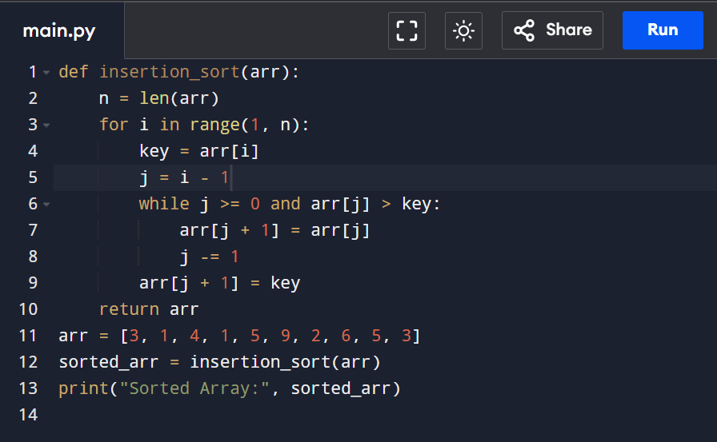

Input:

[3, 1, 4, 1, 5, 9, 2, 6, 5, 3]

Output:

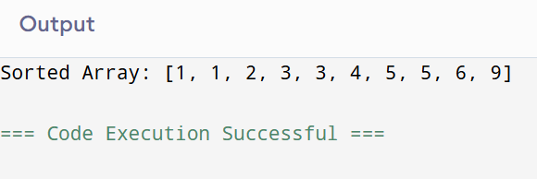

**RESULT:**

Thus the program to write code for Insertion Sort that manages arrays with duplicate elementsis successfully executed and the output is verified.

**PERFORMANCE ANALYSIS:**

* Time Complexity: O(n)
* Space Complexity: O(1)