**2.7 Finding Substrings in a List of Words**

**AIM**

To return all strings from a given list that are substrings of another string in the same list.

**ALGORITHM**

1. **Start**
2. Read the array of strings words.
3. Initialize an empty list result.
4. For each string w1 in words:
5. For each string w2 in words:
6. If w1 ≠ w2 **and** w1 is a substring of w2:
7. Append w1 to result.
8. Break inner loop.
9. Return result.
10. **End**

**PROGRAM**

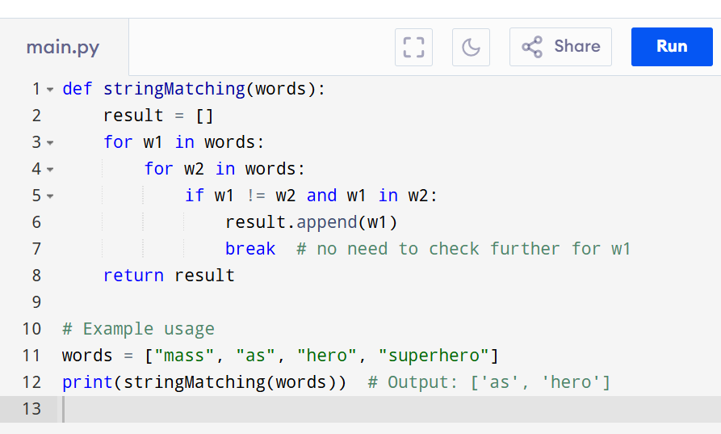

Input:

["mass", "as", "hero", "superhero"]

Output:

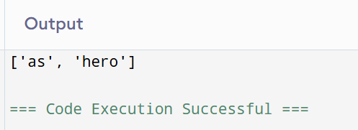

**RESULT:**

Thus the program is successfully executed and the output is verified.

**PERFORMANCE ANALYSIS:**

· **Time Complexity:** O(n² · k²)

· **Space Complexity:** O(n)