**4.5**. Assume you are solving the Traveling Salesperson Problem for 4 cities (A, B, C, D) with known distances between each pair of cities. Now, you need to add a fifth city (E) to the problem.

**AIM**  
To solve the Traveling Salesperson Problem (TSP) for 5 cities with given distances and find the shortest route and total distance.

**ALGORITHM**

1. Input the distance matrix for all cities (A, B, C, D, E).
2. Generate all possible permutations of city visits starting from the first city.
3. For each permutation, calculate the total travel distance.
4. Keep track of the minimum distance and corresponding route.
5. Output the shortest route and its total distance.

**PROGRAM:-**

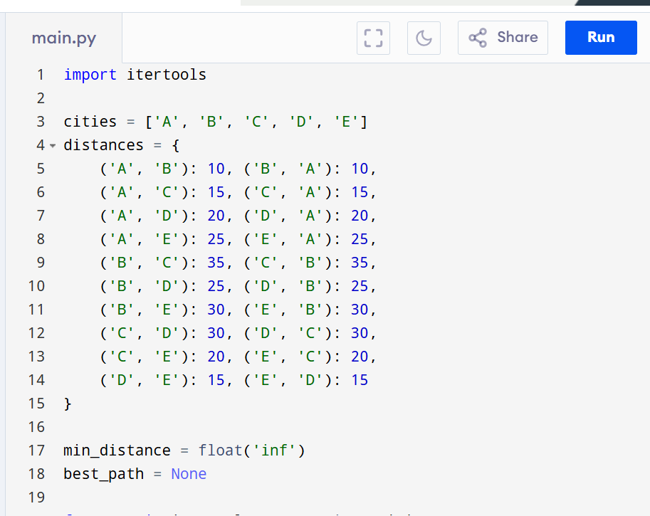

INPUT:-

Cities: A, B, C, D, E

Distances: Given above

OUTPUT:-

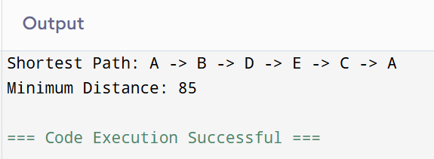

**RESULT:-**

The program successfully finds the shortest route and minimum travel distance for the given 5-city TSP.

**PERFORMANCE ANALYSIS:**

· **Time Complexity:** O(n!) for generating permutations.

· **Space Complexity:** O(1)