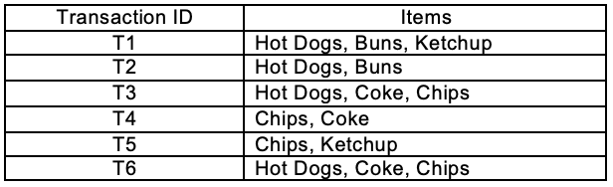

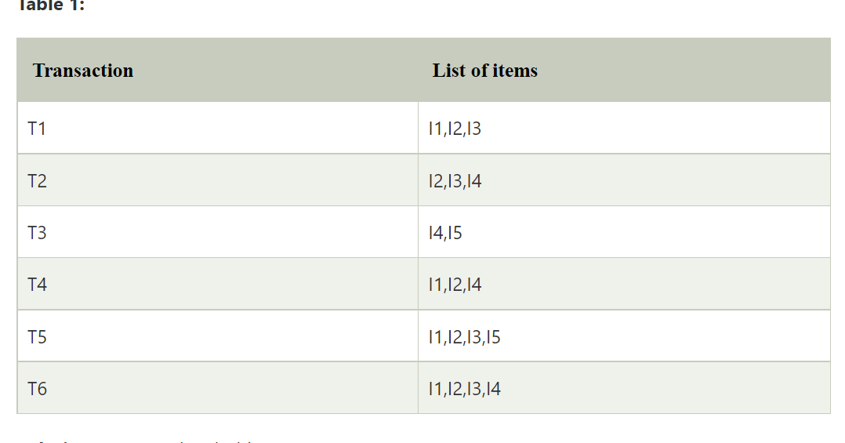

Perform the apriori algorthim

1. 1  Bread, Peanuts, Milk, Fruit, Jam
2. 2  Bread, Jam, Soda, Chips, Milk, Fruit
3. 3  Steak, Jam, Soda, Chips, Bread
4. 4  Jam, Soda, Peanuts, Milk, Fruit
5. 5  Jam, Soda, Chips, Milk, Bread
6. 6  Fruit, Soda, Chips, Milk
7. 7  Fruit, Soda, Peanuts, Milk
8. 8  Fruit, Peanuts, Cheese, Yogurt

Create the ARFF data set for the below data set:

