Junior Data Scientist – Trader Behavior Insights
Candidate: Vikas Kumar
Date: 06/11/2025

- Objective
The goal of this assignment is to analyze the relationship between trader behavior and Bitcoin market sentiment. Using historical trade data and the Fear & Greed Index (FGI), we aim to:
- Explore patterns in trade volume, profitability, and leverage.
- Understand how market sentiment affects trader performance.
- Identify insights that could help build smarter trading strategies.

2. Datasets
- Historical Trader Data (Hyperliquid)
  - Columns include: Account, Coin, Execution Price, Size Tokens, Size USD, Side, Timestamp IST, Start Position, Direction, Closed PnL, Transaction Hash, Order ID, Crossed, Fee, Trade ID
  - Shape: 211,224 rows × 16 columns
- Bitcoin Market Sentiment Dataset (Fear & Greed Index)
  - Columns: Date, Classification (Fear / Greed), Value
  - Shape: 2,644 rows × 4 columns

- Data Preparation
- Historical timestamps were converted from Timestamp IST to UTC and extracted as a date.
- Fear & Greed Index dates were parsed and aligned with historical trade dates.
- Both datasets were merged on the date to match each trade with the market sentiment on that day.
Files created:
- merged_trades_with_sentiment.csv (CSV of merged dataset)

4. Exploratory Data Analysis (EDA)
4.1 Trades per Day
- Observed variation in trade activity over time.
- Plots saved in outputs/trades_per_day.png.
Observation: Peaks in trading volume often align with periods of extreme market sentiment (Fear or Greed).
4.2 Average PnL vs Sentiment
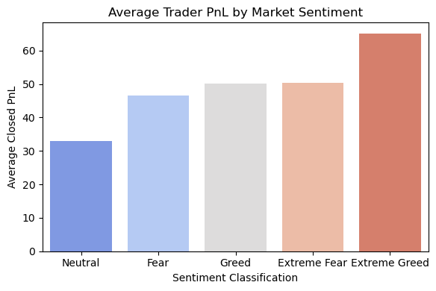
Observation: Traders tend to have higher average PnL during moderate sentiment periods. Extreme fear or greed sometimes correlates with more losses.
4.3 Top 10 Accounts by Total PnL
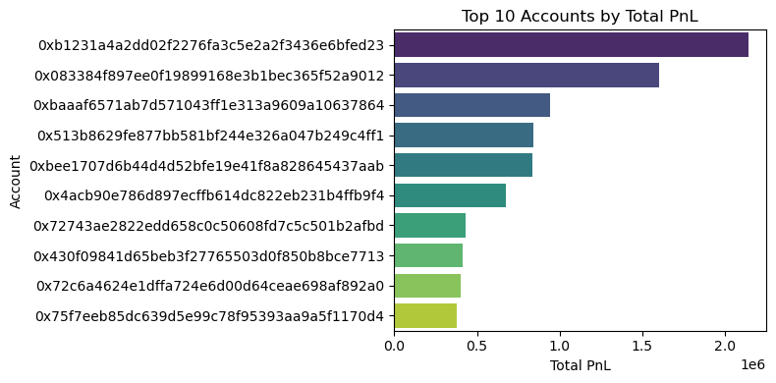
Observation: A small number of accounts generate the majority of profits.

5. Key Insights
- Market sentiment impacts trader performance, but individual strategies also play a significant role.
- Most profitable traders manage risk well, regardless of extreme fear/greed conditions.
- Trade volume spikes during high fear/greed periods, indicating emotional trading patterns.
- The merged dataset allows future modeling to predict profitable trades based on sentiment, trade size, and time.

6. Recommendations
- Use Fear & Greed Index as one factor in automated trading strategies, combined with trader behavior metrics.
- Focus on risk management during extreme sentiment periods.
- Explore predictive modeling to identify potentially profitable trades before execution.

7. Conclusion
This analysis provides insights into how market sentiment influences trader behavior. The merged dataset and charts serve as a foundation for deeper modeling and strategic decision-making in Web3 trading.
Files included in submission:
- notebook_1.ipynb – main analysis notebook
- csv_files/merged_trades_with_sentiment.csv – processed dataset
- outputs/ – charts
- ds_report.pdf – this report

