TERM 3 HOLIDAY ASSIGNMENT 2026
FORM THREE
GEOGRAPHY PAPER 2
Section | Questions | Maximum Score | Candidate's Score
A | 1 – 5 | 25
B | 6 | 25
B | 7 | 25
B | 8 | 25
TOTAL |  | 100
SECTION A
1. (a) What is mining? (2 marks)
________________________________________________________________________________
________________________________________________________________________________
(b) Name a mineral in Kenya mined through each of the following methods: (3 marks)
(i) Drilling
________________________________________________________________________________
(ii) Dredging
________________________________________________________________________________
(iii) Alluvial mining
________________________________________________________________________________
2. (a) What is a forest reserve? (2 marks)
________________________________________________________________________________
________________________________________________________________________________
(b) Name three forest reserves in Kenya. (3 marks)
________________________________________________________________________________
________________________________________________________________________________
3. (a) Give two types of aerial photograph. (2 marks)
________________________________________________________________________________
(b) State three limitations of using photographs to study geography. (3 marks)
________________________________________________________________________________
________________________________________________________________________________
4. State three disadvantages of using observation as a method of collecting data. (3 marks)
________________________________________________________________________________
________________________________________________________________________________
5. (a) Define sampling as a method of collecting statistical data. (2 marks)
________________________________________________________________________________
________________________________________________________________________________
(b) Identify the type of sampling described below. (3 marks)
(i) Selection of members of a population by drawing names or numbers from a container so that every member has an equal chance of selection.
________________________________________________________________________________
(ii) Selection of members by choosing every nth item after a regular starting point.
________________________________________________________________________________
(iii) Selection of a sample by dividing the population into groups with similar characteristics and selecting from the groups.
________________________________________________________________________________
SECTION B
(Answer all the questions in this section)
6. The table below shows the amount of selected minerals mined in East Africa in the year 2026.
MINERAL | TONNES ('000)
SODA ASH | 165
COPPER | 112
FLUORSPAR | 90
TITANIUM | 84
COAL | 149
TOTAL | 600
(a) (i) Calculate the difference between the highest and the lowest mineral amount. (2 marks)
________________________________________________________________________________
(b) (i) Using a radius of 4 cm, draw a pie chart to represent the data above. (9 marks)
________________________________________________________________________________
________________________________________________________________________________
________________________________________________________________________________
________________________________________________________________________________
________________________________________________________________________________
(ii) Give three disadvantages of using pie charts as a method of representing statistical data. (3 marks)
________________________________________________________________________________
________________________________________________________________________________
(c) Apart from pie charts, list three other methods that can be used to represent the data above. (3 marks)
________________________________________________________________________________
________________________________________________________________________________
(d) Explain four challenges facing mining in Kenya. (8 marks)
________________________________________________________________________________
________________________________________________________________________________
________________________________________________________________________________
________________________________________________________________________________
7. (a) Define forestry. (2 marks)
________________________________________________________________________________
________________________________________________________________________________
(b) State five characteristics of planted forests. (5 marks)
________________________________________________________________________________
________________________________________________________________________________
________________________________________________________________________________
(c) Name two examples of indigenous hardwood trees in Kenya. (2 marks)
________________________________________________________________________________
(d) State the differences in forestry between Kenya and Canada under the following headings.
(i) Tree species. (2 marks)
________________________________________________________________________________
(ii) Location of forest. (2 marks)
________________________________________________________________________________
(iii) Marketing of forest products. (2 marks)
________________________________________________________________________________
(e) The photograph below shows a forestry activity. Use it to answer the questions that follow.
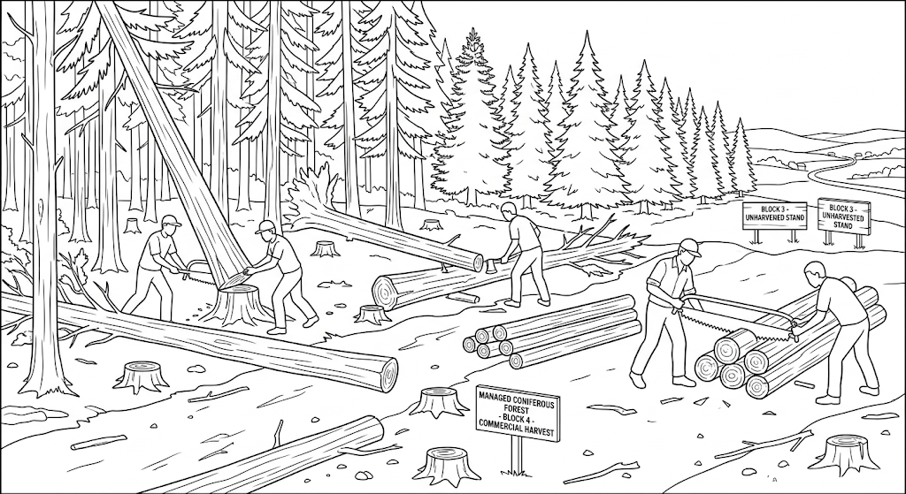
(i) Identify the type of photograph represented by the photograph. (1 mark)
________________________________________________________________________________
(ii) Give three reasons in support of your answer in (e)(i). (3 marks)
________________________________________________________________________________
________________________________________________________________________________
(iii) Identify the economic activity shown in the photograph. (1 mark)
________________________________________________________________________________
(iv) What time of the day is the photograph likely to have been taken? (1 mark)
________________________________________________________________________________
(f) What are some of the possible negative impacts of the activity captured in the photograph? (4 marks)
________________________________________________________________________________
________________________________________________________________________________
________________________________________________________________________________
8. The table below shows the number of softwood trees sampled from forest Y between 2025 and 2026.
TREE / YEAR | 2025 | 2026
EUCALYPTUS | 760 | 900
CYPRUS | 690 | 780
SPRUCE | 340 | 610
PINE | 940 | 1,180
TOTAL | 2,730 | 3,470
(a) Calculate the percentage increase in the total number of trees between the two years. (2 marks)
________________________________________________________________________________
________________________________________________________________________________
(b) (i) Draw a divided rectangle measuring 12 cm to represent the number of trees in the year 2025. (8 marks)
________________________________________________________________________________
________________________________________________________________________________
________________________________________________________________________________
________________________________________________________________________________
________________________________________________________________________________
________________________________________________________________________________
(ii) State three advantages of using divided rectangles to represent statistical data. (3 marks)
________________________________________________________________________________
________________________________________________________________________________
(c) (i) State three soil properties that favour growth of softwood trees. (3 marks)
________________________________________________________________________________
________________________________________________________________________________
(ii) State three economic importance of forests. (3 marks)
________________________________________________________________________________
________________________________________________________________________________
(d) Explain three measures taken to conserve forests in Kenya. (6 marks)
________________________________________________________________________________
________________________________________________________________________________
________________________________________________________________________________
END OF QUESTION PAPER

