CORE MATHEMATICS
GRADE 10 TERM 3 OPENER EXAM 2026
TIME: 2½ HOURS

Candidate's Name: …………………………………………………… | Admission No.: ……………………………………
 | Date: ……………………………………………
Candidate's Signature: ……………………………………

INSTRUCTIONS TO CANDIDATES
- Write your name, admission number, class and date in the spaces provided above.
- This paper consists of ten (10) questions.
- Answer ALL questions in the spaces provided in this booklet.
- All working MUST be shown clearly in the spaces provided below each question.
1.
(a) Classify each of the following numbers as rational (R) or irrational (I): (4 marks)
(i) √49

(ii) √11

(iii) 0.75

(iv) π

(b) Find the reciprocal of 2⅖, giving your answer as a fraction in its simplest form. (2 marks)

2.
(a) Simplify: (2³ × 2⁵) ÷ 2⁴ (2 marks)

(b) Simplify, leaving your answer in index form: (x⁴y²)³ ÷ x²y⁵ (2 marks)

(c) Solve for x: 3^(2x − 1) = 81 (2 marks)

3.
(a) Evaluate log₃ 81. (2 marks)

(b) Given that log 2 = 0.3010 and log 5 = 0.6990, evaluate log 20 without using a calculator or tables. Show your working. (3 marks)

(c) Solve for x: log₂ x = 5 (2 marks)

4. (6 marks)
(a) Expand and simplify: (x + 3)(x − 5) (2 marks)

(b) Factorise completely: x² − 5x − 24 (2 marks)

(c) Hence, or otherwise, solve the equation x² − 5x − 24 = 0 (2 marks)

5. The table below shows values of y = x² − 2x − 3 for −2 ≤ x ≤ 4.
x | -2 | -1 | 0 | 1 | 2 | 3 | 4
y | 5 |  | -3 |  | -3 |  | 5

(a) Complete the table above by finding the missing values of y. (3 marks)

(b) On the grid provided on the next page, draw the graph of y = x² − 2x − 3 for −2 ≤ x ≤ 4. Use a scale of 2 cm to represent 1 unit on the x-axis and 1 cm to represent 1 unit on the y-axis. (5 marks)

(c) Using your graph, estimate the roots of the equation x² − 2x − 3 = 0. (2 marks)

(d) State the minimum value of y and the corresponding value of x. (2 marks)

(e) By drawing a suitable straight line on the same grid, use your graph to solve the equation x² − 2x − 3 = 2. (3 marks)

Grid for Question 5 — plot y = x² − 2x − 3
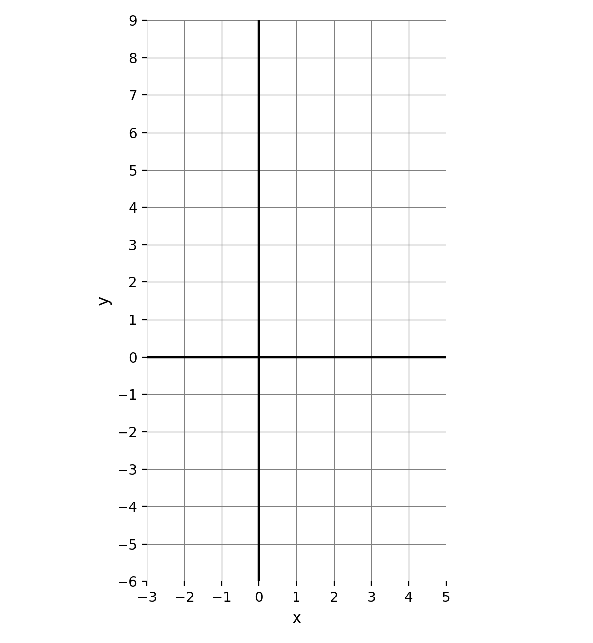

6.
(a) In the diagram below, triangle ABC is similar to triangle PQR, with AB corresponding to PQ. (6 marks)
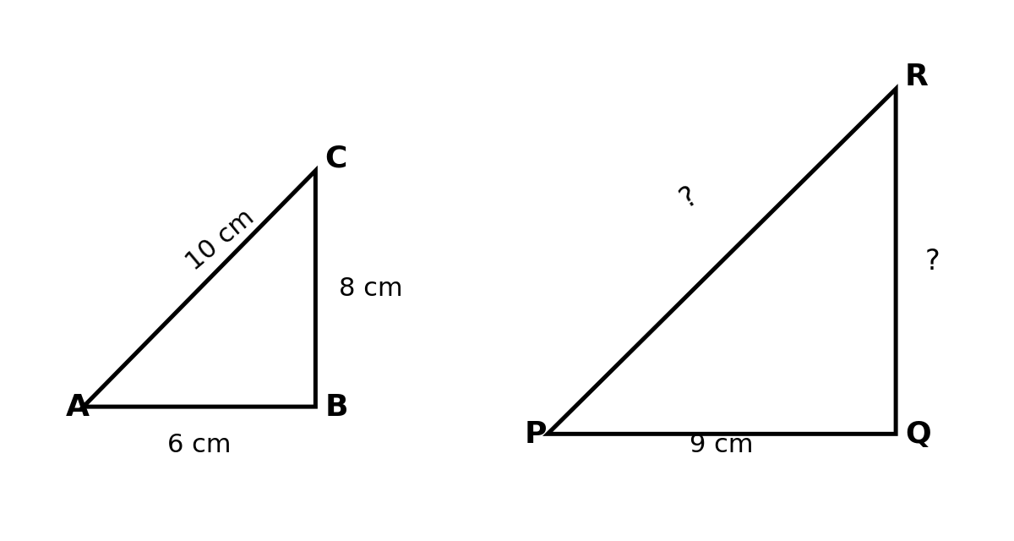
Given that AB = 6 cm, BC = 8 cm, AC = 10 cm and PQ = 9 cm, calculate:
(i) the scale factor of the enlargement from triangle ABC to triangle PQR

(ii) the length QR

(iii) the length PR

(b) A model of a lorry is made to a scale of 1 : 20. The length of the model is 12 cm. Find the actual length of the lorry, in metres. (2 marks)

(c) Two similar cylindrical water tanks have radii 3 cm and 9 cm respectively. If the volume of the smaller tank is 150 cm³, find the volume of the larger tank. (4 marks)

7.
(a) Define the term congruent figures. (2 marks)

(b) State any two conditions that can be used to prove that two triangles are congruent. (2 marks)

(c) On the Cartesian plane provided on the next page, triangle ABC has vertices A(1, 1), B(4, 1) and C(4, 3). (8 marks)
(i) Draw the image A′B′C′ of triangle ABC under a reflection in the y-axis (the line x = 0). State the coordinates of A′, B′ and C′.

(ii) Draw the image A″B″C″ of triangle ABC under a rotation of 90° clockwise about the origin. State the coordinates of A″, B″ and C″.

(d) Find the equation of the mirror line that maps the point (2, 5) onto the point (2, −5). (2 marks)

(e) A regular pentagon is rotated about its centre. State its order of rotational symmetry and the angle of rotation. (2 marks)

Cartesian plane for Question 7
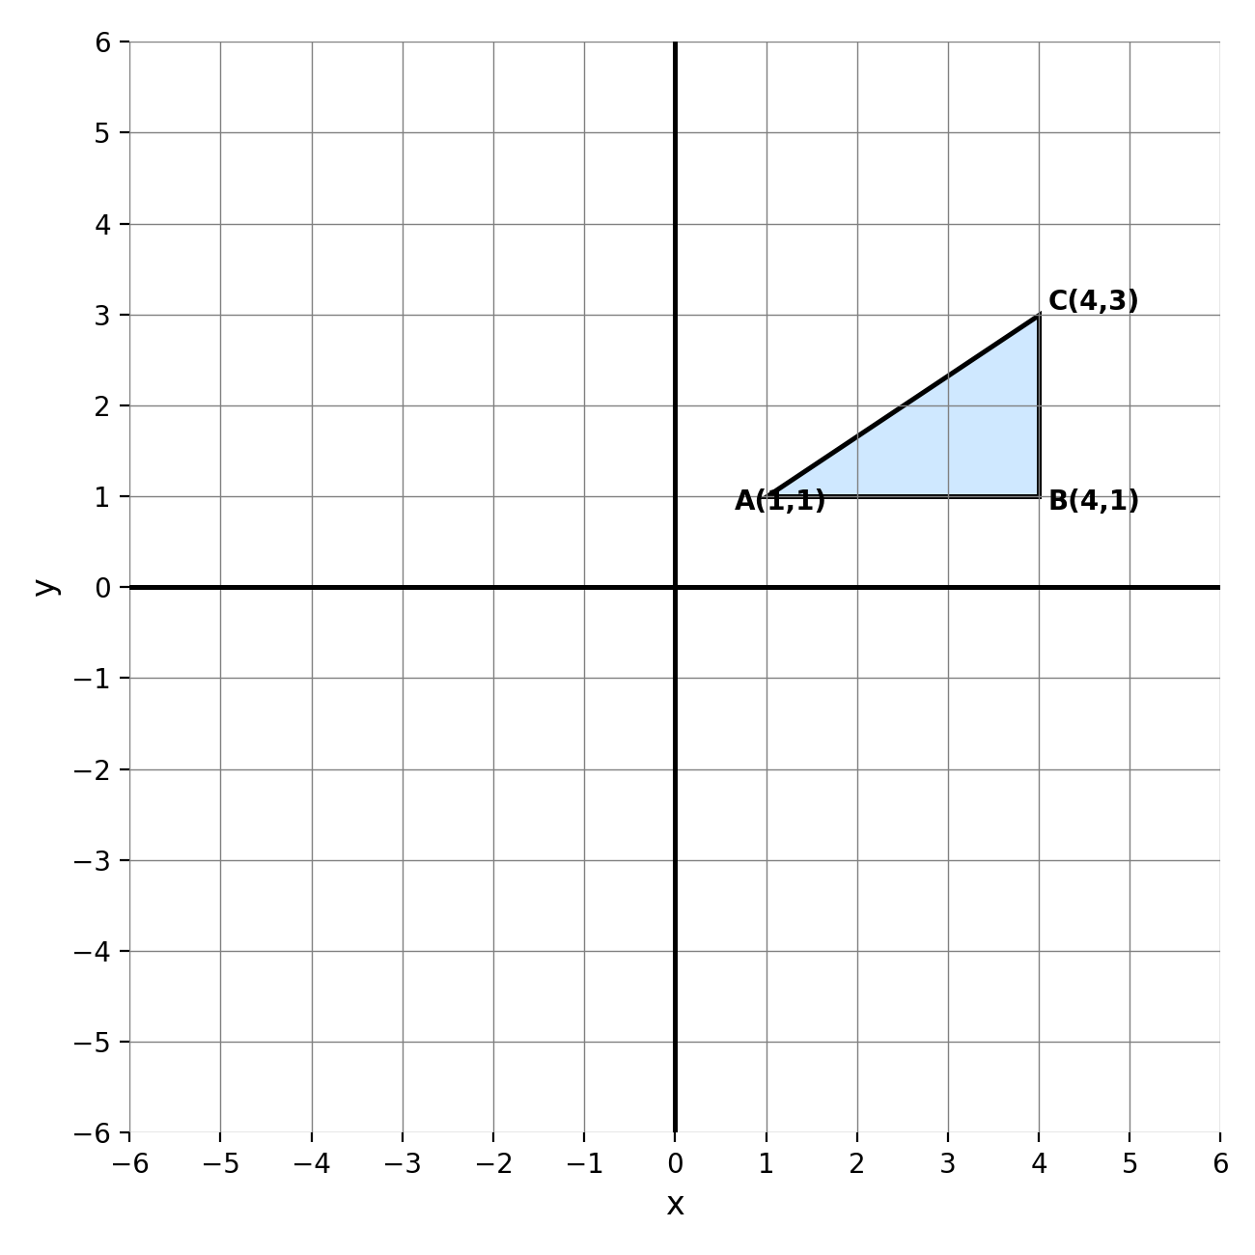

8.
(a) A ship sails from port P on a bearing of 065° for a distance of 40 km to point Q. At Q, it changes course and sails on a bearing of 155° for a distance of 30 km to point R. (10 marks)
(i) Using a scale of 1 cm to represent 5 km, make an accurate scale drawing showing the relative positions of P, Q and R. Use the space provided on the next page.
(ii) By measurement from your scale drawing, determine the distance PR, in kilometres.

(iii) By measurement from your scale drawing, determine the bearing of R from P.

(b) The diagram below shows the relative positions of three towns X, Y and Z. (2 marks)
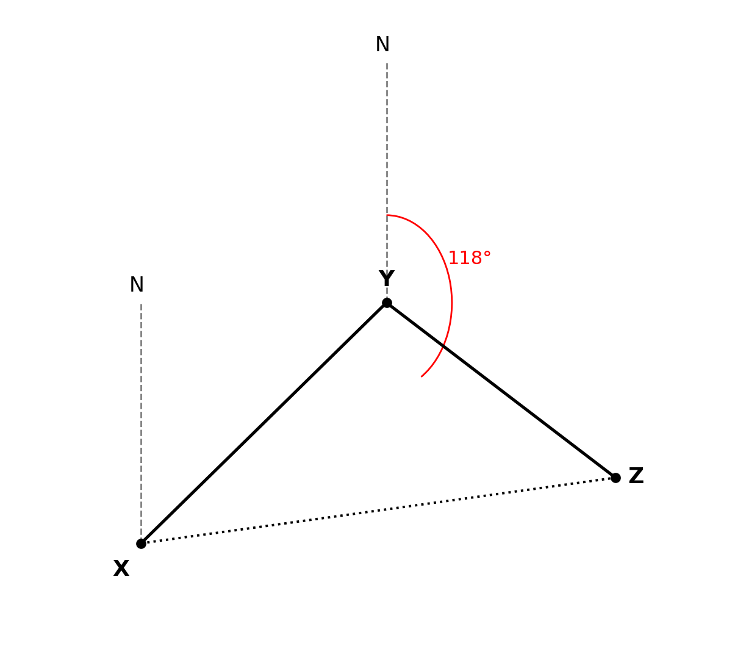
Using the diagram, state:
(i) the bearing of Z from Y

(ii) the bearing of Y from Z

Scale-drawing space for Question 8(a) — 1 cm represents 5 km. North line and point P are given.
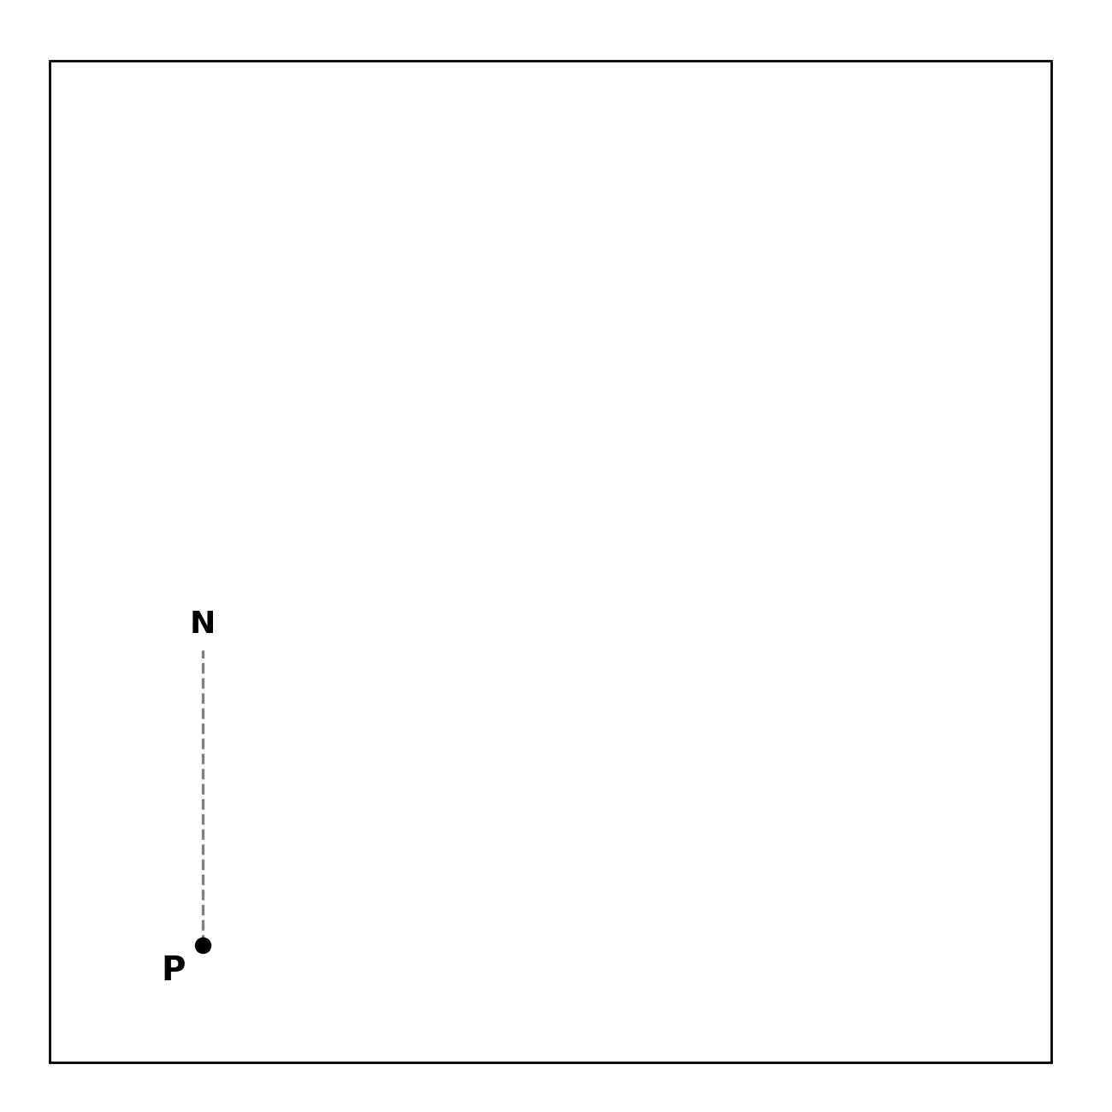

9.
(a) Using the right-angled triangle shown below, find: (3 marks)
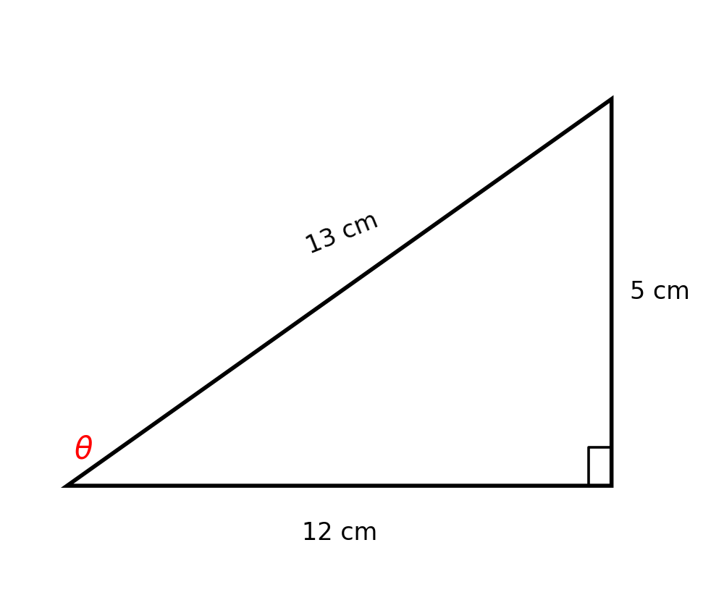
(i) sin θ

(ii) cos θ

(iii) tan θ

(b) Without using a calculator or mathematical tables, evaluate: sin 30° × cos 60° + tan 45° (4 marks)

(c) A ladder 6 m long leans against a vertical wall so that it makes an angle of 68° with the ground, as shown in the diagram below. Using sin 68° = 0.9272 and cos 68° = 0.3746, calculate, correct to 2 decimal places: (4 marks)
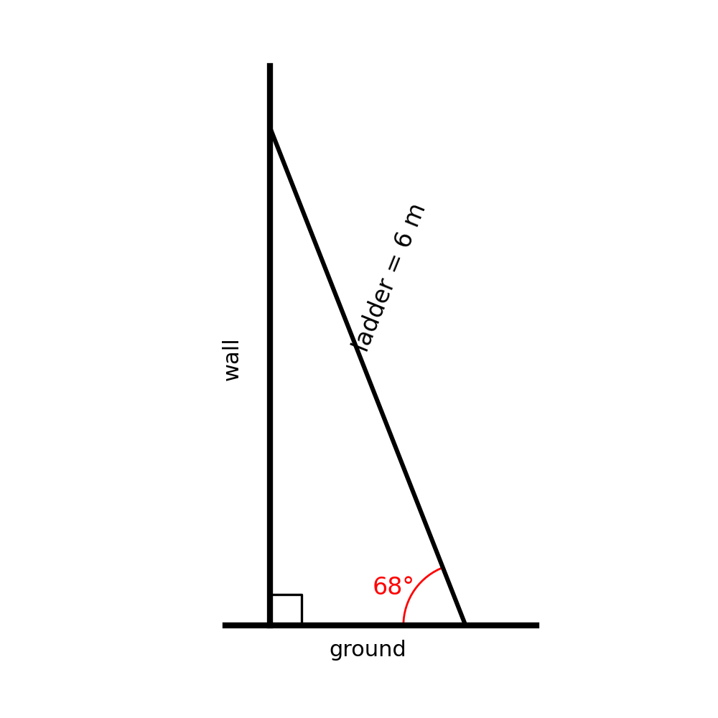
(i) the height the ladder reaches up the wall

(ii) the distance of the foot of the ladder from the wall

(d) Define the term angle of elevation. (2 marks)

(e) Find the value of θ, to the nearest degree, given that tan θ = 1.4281, for 0° ≤ θ ≤ 90°. (2 marks)

10. Using a ruler and a pair of compasses only, construct triangle ABC in which AB = 7 cm, BC = 6 cm and angle ABC = 60°. Measure and state the length of AC. (5 marks)

