KENYA CERTIFICATE OF BASIC EDUCATION

SENIOR SCHOOL ASSESSMENT

DECEMBER ASSIGNMENT 2026
GRADE 10 – CHEMISTRY
Time: 2 Hours
LEARNER’S DETAILS
Name: _____________________________________________________________. School: ____________________________________________.
Assessment Number: _______________________________________________. Date: ____________________________________________.
School Code: ______________________________________________________. Signature: _______________________________________.

INSTRUCTIONS TO CANDIDATES
- Write your name in the spaces provided above.
- Write the name of your school and your stream in the spaces provided.
- Write your admission number and the date of the assessment in the spaces provided.
- This paper consists of two sections: A and B.
- Answer all questions in section A and section B.
- Answer the questions in English.
- All answers MUST be written in the spaces provided in the paper.
- Do NOT remove any page from this question paper.

FOR OFFICIAL USE ONLY (EXAMINER’S USE)
SECTION | SECTION A | SECTION B | % SCORE | EE1 | EE2 | ME1 | ME2 | AE1 | AE2 | BE1 | BE2
SCORE RANGE | 30 MARKS | 50 MARKS |  | 90-100 | 75-89 | 58-74 | 41-57 | 31-40 | 21-30 | 11-20 | 1-10
POINTS |  |  |  | 8 POINTS | 7 POINTS | 6 POINTS | 5 POINTS | 4 POINTS | 3 POINTS | 2 POINTS | 1 POINT
LEARNER’S TOTAL SCORE

SECTION A (30 MARKS)

INSTRUCTIONS TO LEARNERS
- This paper consists of TWO SECTIONS: A and B.
- Answer ALL questions.
- Section A carries 30 marks while Section B carries 50 marks.
- All questions are structured; there are no multiple-choice questions.
- Show all working for calculations.
- Write chemical formulae and equations correctly and balance equations where necessary.
- Study the diagrams carefully before answering questions based on them.
- Use appropriate scientific terminology throughout your answers.
- Non-programmable calculators may be used where necessary.

SECTION A: 30 MARKS
Answer ALL questions in this section.
  - A mixture contains iron filings, sand and common salt.
a) Name the method that can be used to separate the iron filings from the mixture. (1 mark)
b) State the method used to separate sand from the salt solution after adding water to the remaining mixture. (1 mark)
c) Name the method that can be used to obtain solid sodium chloride from the salt solution. (1 mark)
  - A learner measured the volume of a liquid using a measuring cylinder as shown below.
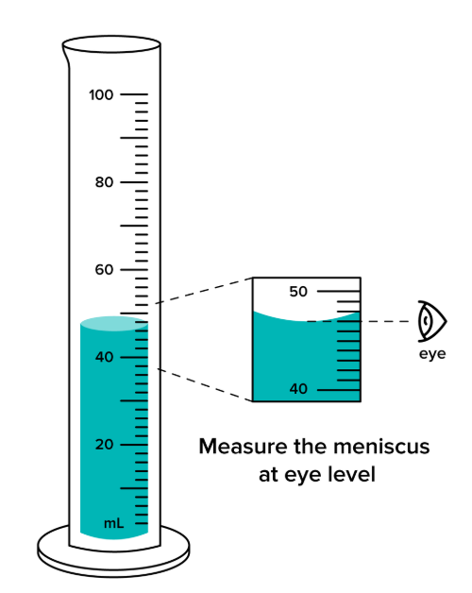
a) What should the learner do to obtain an accurate reading of the volume? (1 mark)
___________________________________________________________________________________________
b) At which part of the meniscus should the reading be taken for water? (1 mark)
______________________________________________________________
c) State the appropriate position of the learner's eye when taking the reading. (1 mark)
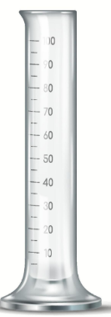
________________________________________________________________________________________
  - Study the apparatus represented below.

a) Identify the apparatus represented above. _________________________________ (1 mark)
b) State one use of the apparatus in the chemistry laboratory. (1 mark)
_______________________________________________________________________________________
c) Name one other apparatus that can be used to measure a fixed volume of a liquid accurately. (1 mark)
_____________________________________________________________________________________
  - An atom of element A has 13 protons, 13 electrons and 14 neutrons.
a) State the atomic number of element A. (1 mark)
___________________________________________________________________________
b) Calculate the mass number of element A. (1 mark)

c) Write the electronic arrangement of element A. (1 mark)
___________________________________________________________________________
  - Consider the following elements:
Element | Electronic arrangement
P | 2.1
Q | 2.8.2
R | 2.8.6
a) Which element belongs to Group 1? (1 mark)
___________________________________________________________________________
b) Which element belongs to Group 16? (1 mark)
___________________________________________________________________________
c) State the period occupied by element Q. (1 mark)
___________________________________________________________________________
  - Calcium has the electronic arrangement 2.8.8.2, while oxygen has the electronic arrangement 2.6.
a) State the number of electrons calcium loses when forming an ion. (1 mark)
___________________________________________________________________________
b) State the number of electrons oxygen gains when forming an ion. (1 mark)
___________________________________________________________________________
c) Write the formula of the compound formed between calcium and oxygen. (1 mark)
___________________________________________________________________________

  - A learner tested three solutions using litmus paper.
Solution | Effect on blue litmus | Effect on red litmus
A | Turns red | No change
B | No change | Turns blue
C | No change | No change
a) Identify solution A as acidic, alkaline or neutral. (1 mark)
___________________________________________________________________________
b) Identify solution B as acidic, alkaline or neutral. (1 mark)
___________________________________________________________________________
c) Identify solution C as acidic, alkaline or neutral. (1 mark)
___________________________________________________________________________
  - Study the observations obtained when two indicators were added to an unknown solution.
UNKNOWN SOLUTION

┌─────────────┐
│ │
│ SAMPLE │
│ │
└─────────────┘
↓
Indicator X
↓
RED

┌─────────────┐
│ │
│ SAMPLE │
│ │
└─────────────┘
↓
Indicator Y
↓
COLOURLESS
a) If indicator X is phenolphthalein, state whether the observation is possible. Give a reason. (1 mark)
___________________________________________________________________________
b) State the colour of phenolphthalein in an alkaline solution. (1 mark)
___________________________________________________________________________
c) Name one indicator that may give a red colour in a strongly acidic solution. (1 mark)
___________________________________________________________________________

  - Study the compounds below:
A
H H H
| | |
H – C – C – C – H
| | |
H H H

B

H H H H
| | | |
H – C – C – C – C – H
| | | |
H H H H

a) Name compound A. (1 mark)
___________________________________________________________________________
b) Name compound B. (1 mark)
___________________________________________________________________________
c) State the homologous series to which the two compounds belong. (1 mark)
___________________________________________________________________________
  - A learner burns a hydrocarbon in a plentiful supply of air.
a) Name the type of combustion expected when sufficient oxygen is available. (1 mark)
____________________________________________________________________________________
b) Name the two main products formed during complete combustion of a hydrocarbon. (1 mark)
____________________________________________________________________________________
c) State one environmental effect of carbon dioxide released during combustion. (1 mark)
___________________________________________________________________________________

SECTION B:50 MARKS
Answer ALL questions in this section.
  - A learner carried out an experiment in which magnesium ribbon was placed in dilute hydrochloric acid. Bubbles of gas were produced and the magnesium gradually disappeared.

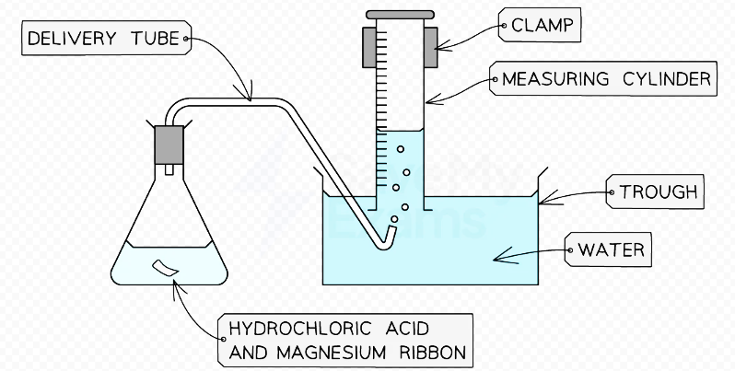

a) Name the gas produced. ____________________________________________ (1 mark)
b) Describe a chemical test for the gas identified in (a). (2 marks)
____________________________________________________________________________________________________________________________________________________________________________________________________
c) State two observations made during the reaction apart from the production of gas. (2 marks)
____________________________________________________________________________________________________________________________________________________________________________________________________
d) Write a balanced chemical equation for the reaction. (2 marks)
____________________________________________________________________________________________________________________________________________________________________________________________________
e) Name the salt formed in the reaction. (1 mark)
__________________________________________________________________
f) Explain why magnesium ribbon is cleaned before it is placed in the acid. (2 marks)
____________________________________________________________________________________________________________________________________________________________________________________________________

  - A farmer obtained a soil sample that was found to be excessively acidic. The farmer was advised to apply an appropriate substance to reduce the acidity.
a) What is meant by an acid? (1 mark)
____________________________________________________________________________________________________________________________________________________________________________________________________
b) Name one substance that can be used to reduce excessive acidity in agricultural soil. (1 mark)
_____________________________________________________________________________
c) Explain how the substance named in (b) helps to reduce soil acidity. (2 marks)
____________________________________________________________________________________________________________________________________________________________________________________________________
d) Hydrochloric acid reacts with calcium hydroxide. Write a balanced chemical equation for the reaction.
(2 marks)
____________________________________________________________________________________________________________________________________________________________________________________________________
e) Name the type of reaction represented by the equation in (d). (1 mark)
______________________________________________________________
f) Name the salt formed in the reaction. (1 mark)
____________________________________________________________
g) State two practical applications of neutralisation reactions. (2 marks)
____________________________________________________________________________________________________________________________________________________________________________________________________
  - A learner was instructed to prepare lead(II) iodide by mixing suitable solutions of lead(II) nitrate and potassium iodide.
The process is represented below.

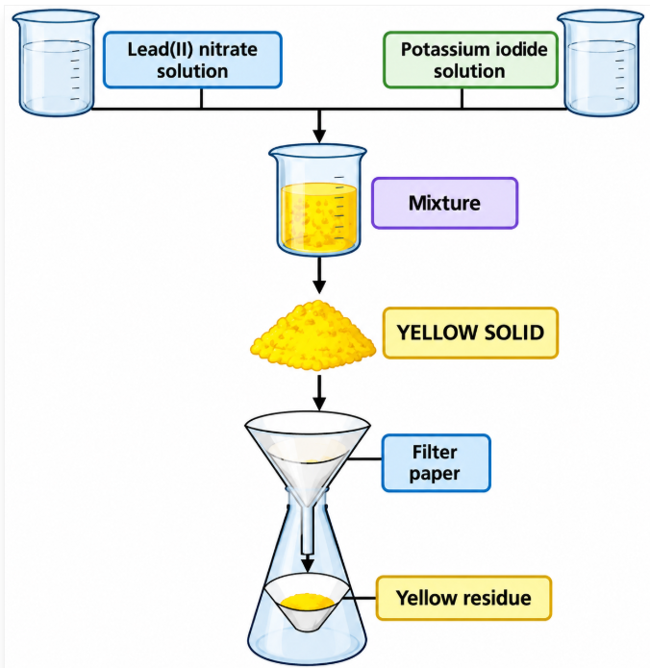

a) Name the yellow solid formed. ______________________________ (1 mark)
b) Name the method used to separate the solid from the mixture. _____________________________ (1 mark)
c) State the purpose of the filter paper. (1 mark)
____________________________________________________________________________________
d) Write a balanced chemical equation for the reaction using chemical formulae. (3 marks)
____________________________________________________________________________________________________________________________________________________________________________________________________e) Explain why the reaction is classified as a precipitation reaction. (2 marks)
____________________________________________________________________________________________________________________________________________________________________________________________________f) State one way of obtaining a cleaner sample of the solid product. (1 mark)
__________________________________________________________________________________________________
  - The following compounds are represented by their molecular formulae:
- A – C₂H₆
- B – C₃H₆
- C – C₄H₁₀
- D – C₅H₁₀

a) Identify the compounds that are alkanes. (2 marks) _______________________________________________________
b) Identify the compounds that could represent alkenes. (2 marks) _______________________________________________
c) State the general formula of alkanes. (1 mark) ____________________________________________________________________________________________________________________________________________________________________________________________________d) State the general formula of alkenes. (1 mark) ____________________________________________________________________________________________________________________________________________________________________________________________________e) Give the names of compounds A and C. (2 marks)
A: ________________________________________
C: ________________________________________
f) State one chemical test that can be used to distinguish an alkene from an alkane. (1 mark) ____________________________________________________________________________________________________________________________________________________________________________________________________g) State the expected observation when the test in (f) is carried out on an alkene. (1 mark) ____________________________________________________________________________________________________________________________________________________________________________________________________
  - A Grade 10 learner was investigating the reaction between an acid and a carbonate. The learner placed a small amount of calcium carbonate in a flask and added dilute hydrochloric acid.
The experimental arrangement is represented below.
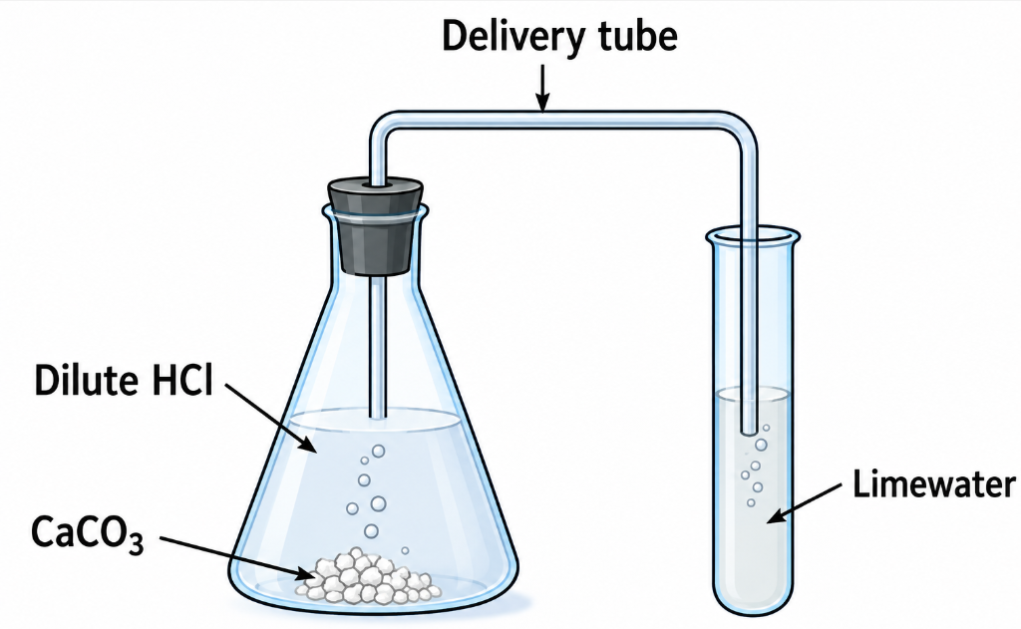
a) Name the gas produced in the flask. ___________________________________________(1 mark)

b) State the chemical test for the gas using limewater. (2 marks) ____________________________________________________________________________________________________________________________________________________________________________________________________c) State the observation expected in the limewater test. (1 mark) ____________________________________________________________________________________________________________________________________________________________________________________________________d) Write a balanced chemical equation for the reaction between calcium carbonate and hydrochloric acid. (3 marks) ____________________________________________________________________________________________________________________________________________________________________________________________________e) Name the salt formed in the reaction. (1 mark) ____________________________________________________
f) State two safety precautions the learner should observe during the experiment. (2 marks) ____________________________________________________________________________________________________________________________________________________________________________________________________

THIS IS THE LAST PRINTED PAGE

GRADE 10 CHEMISTRY

MARKING SCHEME

SECTION A

1:
a) Magnetic separation / use of a magnet.
(1 mark)
b) Filtration.
(1 mark)
c) Evaporation to dryness / crystallisation.
(1 mark)

2:
a) Place the measuring cylinder on a level surface before taking the reading.
(1 mark)
b) The bottom of the meniscus.
(1 mark)
c) The eye should be at the same level as the meniscus to avoid parallax error.
(1 mark)

3:
a) Measuring cylinder.
(1 mark)
b) Used to measure the volume of liquids.
(1 mark)
c) Pipette or burette.
(1 mark)

4:
Given:
- Protons = 13
- Electrons = 13
- Neutrons = 14
a) Atomic number = 13.
(1 mark)
b)
Mass number=protons + neutrons=13+14=27
Answer: 27
(1 mark)
c) Electronic arrangement = 2.8.3.
(1 mark)

5:
a) Element P.
(1 mark)
b) Element R.
(1 mark)
c) Element Q has three occupied electron shells.
Period 3.
(1 mark)

6:
a) Calcium loses 2 electrons.
(1 mark)
b) Oxygen gains 2 electrons.
(1 mark)
c) Formula of the compound:
CaO\boxed{CaO}
(1 mark)

7:
a) Solution A – Acidic.
(1 mark)
b) Solution B – Alkaline.
(1 mark)
c) Solution C – Neutral.
(1 mark)

8:
a) No. Phenolphthalein is colourless in an acidic solution and pink in an alkaline solution.
(1 mark)
b) Pink.
(1 mark)
c) Methyl orange.
(1 mark)

9:
a) Compound A – Propane. (1 mark)
b) Compound B – Butane. (1 mark)
c) Alkanes. (1 mark)

10:
a) Complete combustion. (1 mark)
b) Carbon dioxide and water.
(1 mark)
c) Any one:
- Carbon dioxide contributes to global warming.
- It contributes to the greenhouse effect.
- It contributes to climate change.
(1 mark)

SECTION B

11:

a) Gas produced
Hydrogen gas (H₂).
(1 mark)

b) Test for hydrogen
Collect the gas in a test tube and introduce a lighted splint.
A squeaky pop is heard if the gas is hydrogen.
(2 marks)

c) Two observations
Any two:
- Magnesium ribbon gradually disappears/dissolves.
- Effervescence/bubbles are produced.
- The reaction produces heat; the mixture becomes warm.
- The magnesium reacts vigorously with the acid.
(2 marks)

d) Balanced equation
Mg+2HCl→MgCl₂+H₂
(2 marks)

e) Salt formed
Magnesium chloride (MgCl₂). (1 mark)

f) Reason for cleaning magnesium
Magnesium ribbon is cleaned to remove the oxide coating on its surface so that the magnesium can react directly with the hydrochloric acid.
(2 marks)

12:

a) Meaning of an acid
An acid is a substance that produces hydrogen ions (H⁺) in aqueous solution.
(1 mark)

b) Substance used to reduce soil acidity
Any one:
- Calcium carbonate
- Calcium oxide
- Calcium hydroxide
- Agricultural lime
(1 mark)

c) How it reduces acidity
The alkaline substance reacts with and neutralises the acids in the soil, thereby increasing the soil pH towards neutrality.
(2 marks)

d) Balanced equation
2HCl+Ca(OH)₂→CaCl₂+2H₂O
(2 marks)

e) Type of reaction
Neutralisation reaction.
(1 mark)

f) Salt formed
Calcium chloride (CaCl₂).
(1 mark)

g) Applications of neutralisation
Any two:
- Treating acidic soils using lime.
- Treating indigestion/heartburn using antacids.
- Treating acidic industrial waste.
- Correcting the pH of water.
- Treating acidic conditions in lakes or other water bodies.
(2 marks)

13:

a) Yellow solid
Lead(II) iodide (PbI₂).
(1 mark)

b) Separation method
Filtration.
(1 mark)

c) Purpose of filter paper
It allows the liquid/filtrate to pass through while retaining the insoluble lead(II) iodide precipitate.
(1 mark)

d) Balanced chemical equation
Pb(NO₃)₂(aq)+2KI(aq)→PbI₂(s)+2KNO₃(aq)
(3 marks)

e) Why it is a precipitation reaction
It is a precipitation reaction because two soluble solutions react to form an insoluble solid, lead(II) iodide, which separates from the solution as a precipitate.
(2 marks)

f) Obtaining a cleaner sample
Wash the precipitate with distilled/deionised water before drying it.
(1 mark)

14:
Given:
- A – C₂H₆
- B – C₃H₆
- C – C₄H₁₀
- D – C₅H₁₀

a) Compounds that are alkanes
A and C.
(2 marks)

b) Compounds that could represent alkenes
B and D.
(2 marks)

c) General formula of alkanes
CnH2n+2
(1 mark)

d) General formula of alkenes
CnH2n
(1 mark)

e) Names of A and C
A = Ethane
C = Butane
(2 marks)

f) Chemical test for an alkene
Add bromine water to the substance and shake.
(1 mark)

g) Observation with an alkene
The orange/brown colour of bromine water is decolourised.
(1 mark)

15:

a) Gas produced
Carbon dioxide (CO₂).
(1 mark)

b) Chemical test
Pass the gas through limewater (calcium hydroxide solution).
(2 marks)

c) Observation
The limewater turns milky/cloudy.
(1 mark)

d) Balanced chemical equation
CaCO₃+2HCl→CaCl₂+H₂O+CO₂
(3 marks)

e) Salt formed
Calcium chloride (CaCl₂).
(1 mark)

f) Safety precautions
Any two:
- Wear safety goggles.
- Wear a laboratory coat.
- Handle dilute hydrochloric acid carefully.
- Avoid contact of the acid with the skin and eyes.
- Do not inhale gases directly.
- Handle glassware carefully.
- Carry out the experiment in a well-ventilated laboratory.
(2 marks)

KENYA CERTIFICATE OF BASIC EDUCATION

SENIOR SCHOOL ASSESSMENT

TERM 3: PROJECT BASED ASSESSMENT 2026
GRADE 10 – CHEMISTRY
Time: 2 Hours
LEARNER’S DETAILS
Name: _____________________________________________________________. School: ____________________________________________.
Assessment Number: _______________________________________________. Date: ____________________________________________.
School Code: ______________________________________________________. Signature: _______________________________________.
Time: To be completed over an agreed project period
Mode: Individual or teacher-approved pair/group project

PROJECT TITLE

INVESTIGATION OF ACIDS AND BASES IN EVERYDAY MATERIALS USING A NATURAL INDICATOR

INTRODUCTION
Chemistry is applied in everyday activities such as food preparation, agriculture, cleaning, medicine, water treatment and environmental conservation.
In this project, the learner will investigate the acidic and basic properties of selected household substances using a natural indicator prepared from plant material. The learner will collect data, record observations, interpret results and present evidence of the investigation.
The project should demonstrate the learner's ability to:
- plan and carry out a simple chemical investigation;
- prepare and use a natural indicator;
- distinguish between acidic, neutral and basic substances;
- record observations systematically;
- analyse and interpret experimental results;
- apply chemistry to everyday life;
- demonstrate safe handling of materials;
- communicate findings using a written and/or digital portfolio.

LEARNER'S TASK
You are required to investigate the acidic or basic nature of at least five readily available household substances using a natural indicator.
Examples of substances may include:
- lemon juice;
- vinegar;
- soap solution;
- baking soda solution;
- ordinary water;
- fruit juice;
- salt solution;
- toothpaste solution.
Do not taste or deliberately ingest any substance used in the investigation.
You may use a natural indicator prepared from suitable plant material such as red/purple cabbage, hibiscus or another teacher-approved indicator source.

PROJECT REQUIREMENTS

TASK 1: PROJECT PLANNING – 3 MARKS
Before carrying out the investigation, prepare a brief project plan containing the following:

(a) State the problem to be investigated. (1 mark)

(b) State the aim of the investigation. (1 mark)

(c) State one hypothesis or prediction about the expected results. (1 mark)

TASK 2: PREPARATION OF THE NATURAL INDICATOR – 3 MARKS
Prepare a natural indicator using a suitable plant material.

(a) Identify the plant material selected for preparing the indicator. (1 mark)
______________________________________________________________________________________________

(b) Describe the procedure followed to obtain the indicator solution. (1 mark)
______________________________________________________________________________________________

(c) State one safety precaution observed during preparation and use of the indicator. (1 mark)
______________________________________________________________________________________________

TASK 3: EXPERIMENTAL INVESTIGATION – 5 MARKS
Select at least five household substances and test each substance using the natural indicator.
Prepare a results table similar to the one below.
Substance Tested | Colour Before Adding Indicator | Colour After Adding Indicator | Inference
Substance 1
Substance 2
Substance 3
Substance 4
Substance 5

(a) Correctly identify and record at least five substances tested. (1 mark)

(b) Record the colour changes observed for the different substances. (2 marks)

(c) Classify the substances as acidic, neutral or basic, based on the indicator results. (2 marks)

TASK 4: DATA ANALYSIS AND INTERPRETATION – 4 MARKS
Use your results to answer the following:

(a) Which substance was the most clearly acidic according to your indicator? Give a reason for your answer. (1 mark)

(b) Which substance was the most clearly basic according to your indicator? Give a reason. (1 mark)

(c) Identify one substance that could be considered approximately neutral and explain your answer. (1 mark)

(d) State one limitation of using a natural indicator compared with a standard laboratory pH indicator or pH meter.
(1 mark)

TASK 5: APPLICATION OF CHEMISTRY TO DAILY LIFE – 2 MARKS
Explain two ways in which knowledge of acids and bases is useful in everyday life.
Examples may include:
- agriculture and soil management;
- food preservation;
- cleaning;
- treatment of acidic soils;
- water treatment;
- household safety;
- manufacture of products. (2 marks)

TASK 6: DIGITAL PORTFOLIO / EVIDENCE OF WORK – 2 MARKS
The learner must maintain digital evidence of the project throughout the investigation.
The digital portfolio may contain:
- photographs showing preparation of materials;
- photographs showing the investigation being carried out;
- photographs of the natural indicator;
- photographs of the tested substances;
- photographs of the results table;
- photographs/video of the completed project;
- a typed or handwritten copy of the project report;
- relevant diagrams, observations or data;
- evidence of communication with the teacher where applicable, such as an email or approved digital submission.

Evidence requirement
The learner should save the digital portfolio safely on a phone, computer, flash disk, cloud storage or another teacher-approved platform.
If the project involves a sizeable model, display, chart or other physical product, the learner should:
- bring the model/product to school on the official opening date or date specified by the school for assessment, OR
- if the model/product is too large or cannot safely be transported, take clear photographs and/or video from different angles showing the completed work and submit the evidence as directed by the teacher.
The learner should retain the original evidence until the project has been assessed. (2 marks)

PROJECT REPORT FORMAT
The final project report should be arranged in the following order:

1. Cover Page
Include:
- Name of learner
- Admission number
- School
- Grade
- Subject
- Project title
- Teacher
- Date

2. Introduction
Briefly explain acids, bases and indicators.

3. Problem Statement
State the problem being investigated.

4. Aim
State the purpose of the investigation.

5. Hypothesis
Give the learner's prediction.

6. Materials
List the materials used.

7. Procedure
Describe the investigation step by step.

8. Safety Precautions
List the precautions observed.

9. Results
Present observations in a table.

10. Data Analysis
Explain what the observations show.

11. Conclusion
State whether the findings support the hypothesis.

12. Application
Explain how knowledge of acids and bases is useful in daily life.

13. Evidence Portfolio
Attach or provide photographs, video evidence, diagrams and other evidence of the work.

14. References
List any books, approved learning resources or other sources consulted.

MARKING SCHEME – 20 MARKS
Task | Assessment Area | Marks
1 | Project planning | 3
2 | Preparation of natural indicator | 3
3 | Experimental investigation and observations | 5
4 | Data analysis and interpretation | 4
5 | Application of chemistry to daily life | 2
6 | Digital portfolio/evidence of work | 2
TOTAL |  | 20

DETAILED ASSESSMENT RUBRIC
Competency/Aspect | EE | ME | AE | Marks
Planning | Clear problem, aim and logical hypothesis | Mostly clear planning | Limited planning | 3
Practical skills | Correct preparation and safe handling | Minor errors | Requires considerable guidance | 3
Investigation | Accurate testing, observations and classification | Generally accurate | Incomplete investigation | 5
Analysis | Correct interpretation supported by evidence | Reasonable interpretation | Limited interpretation | 4
Application | Relevant real-life applications | Some relevant applications | Limited application | 2
Portfolio | Clear, authentic and well-organised evidence | Adequate evidence | Incomplete evidence | 2
TOTAL |  |  |  | 20

TEACHER'S ASSESSMENT CHECKLIST
Learner's Name: ______________________________
Grade: __________
Admission No.: ______________________________
No. | Assessment Indicator | Marks Awarded
1 | States a clear investigation problem | /1
2 | States a suitable aim | /1
3 | Gives a reasonable hypothesis/prediction | /1
4 | Identifies suitable indicator material | /1
5 | Correctly describes preparation of indicator | /1
6 | Observes safety precautions | /1
7 | Tests at least five substances | /1
8 | Records colour changes accurately | /2
9 | Correctly classifies substances | /2
10 | Identifies acidic substance with justification | /1
11 | Identifies basic substance with justification | /1
12 | Identifies/explains neutral substance | /1
13 | States a limitation of natural indicators | /1
14 | Gives two relevant applications | /2
15 | Provides adequate digital/physical evidence | /2
TOTAL |  | /20

IMPORTANT INSTRUCTIONS TO LEARNERS
- This is a practical project and not a multiple-choice examination.
- The project must represent your own work.
- You may consult your Chemistry notes, approved learning resources and the teacher for guidance.
- Do not copy another learner's results.
- Record actual observations obtained during your investigation.
- Do not taste or ingest any chemical or household substance.
- Use teacher-approved materials and follow laboratory safety procedures.
- Keep photographs or video evidence as the work progresses rather than only photographing the final product.
- Maintain a digital portfolio/evidence folder containing your work.
- Where the completed project includes a sizeable physical model, display or product, bring it to school on the official opening/assessment date as directed by the school.
- If the product is too large to transport, submit clear photographs and/or video evidence showing the completed work.
- The teacher may ask the learner to demonstrate or explain the project orally to verify ownership of the work.
- Submit the completed written report together with the required evidence.
- Ensure all electronic files are clearly labelled with the learner's name, grade and project title.

GRADE 10 CHEMISTRY

END-OF-YEAR PROJECT

SCHOOL-BASED PRACTICAL ASSESSMENT

MARKING SCHEME
Project: Investigation of Acids and Bases in Everyday Materials Using a Natural Indicator
Total Marks: 20
Note to teacher: Since this is a practical/project assessment, learners' actual observations may differ slightly depending on the substances, concentrations and natural indicator used. Award marks for scientifically reasonable observations and conclusions, not for forcing identical colours/results.

TASK 1: PROJECT PLANNING — 3 MARKS

(a) Problem statement — 1 mark
Expected answer:
Household substances have different chemical properties, and some are acidic, some basic and others approximately neutral. The investigation seeks to determine the nature of selected household substances using a natural indicator.
Award:
- Clear and relevant problem statement — 1 mark

(b) Aim — 1 mark
Expected answer:
To investigate and classify selected household substances as acidic, neutral or basic using a natural plant indicator.
Award:
- Appropriate aim related to the investigation — 1 mark

(c) Hypothesis/prediction — 1 mark
Expected answer:
If different household substances are tested using a natural indicator, they will produce different colour changes because they have different acidic or basic properties.
Accept: Any scientifically reasonable prediction.
Award:
- Logical and testable hypothesis — 1 mark

Task 1 Total: 3 marks

TASK 2: PREPARATION OF THE NATURAL INDICATOR — 3 MARKS

(a) Identify the plant material — 1 mark
Accept any suitable teacher-approved plant indicator, for example:
- Red/purple cabbage
- Hibiscus petals
- Other suitable plant material containing natural pigments
Award:
- Correctly identifies suitable plant material — 1 mark

(b) Procedure for preparing the indicator — 1 mark
Sample answer:
- Collect suitable plant material.
- Cut or crush the material into small pieces.
- Place it in a container.
- Add hot water and allow it to stand/steep.
- Filter the mixture to obtain the coloured indicator solution.
- Allow it to cool before use.
Award 1 mark for:
- A reasonably correct procedure showing extraction of the indicator pigment.

(c) Safety precaution — 1 mark
Any one:
- Do not taste the substances.
- Wash hands after the experiment.
- Handle hot water carefully.
- Wear protective clothing/gloves where appropriate.
- Do not mix unknown household chemicals.
- Keep chemicals away from the eyes and mouth.
- Work in a well-ventilated area.
- Clean the working area after the experiment.
Task 2 Total: 3 marks

TASK 3: EXPERIMENTAL INVESTIGATION — 5 MARKS
A possible set of results is shown below.
Substance Tested | Colour Before Indicator | Colour After Indicator* | Inference
Lemon juice | Colourless/pale | Acidic-indicator colour | Acidic
Vinegar | Colourless/pale | Acidic-indicator colour | Acidic
Baking soda solution | Colourless | Basic-indicator colour | Basic
Soap solution | Colourless/cloudy | Basic-indicator colour | Basic
Water | Colourless | Little/no significant change | Approximately neutral
*The exact colour depends on the natural indicator used.

(a) Identify at least five substances — 1 mark
- Five suitable substances correctly identified — 1 mark

(b) Record colour changes — 2 marks
Award:
- Correct observations for three or more substances — 1 mark
- Correct observations for the remaining substances/consistent complete table — 1 mark
Important: Accept different colours where the learner has used a different valid natural indicator and the observation is scientifically plausible.

(c) Classification — 2 marks
Award:
- Correctly classifies acidic substances — 1 mark
- Correctly classifies basic/neutral substances — 1 mark

Task 3 Total: 5 marks

TASK 4: DATA ANALYSIS AND INTERPRETATION — 4 MARKS

(a) Most clearly acidic substance — 1 mark
Sample answer:
Lemon juice was clearly acidic because it produced the colour associated with an acidic medium when the natural indicator was added.
Accept: Vinegar or another correctly tested acidic substance if supported by the learner's results.
Award: 1 mark

(b) Most clearly basic substance — 1 mark
Sample answer:
Baking soda solution was basic because it produced the colour associated with a basic medium when tested with the natural indicator.
Accept: Soap solution or another correctly tested basic substance if supported by results.
Award: 1 mark

(c) Approximately neutral substance — 1 mark
Sample answer:
Water was approximately neutral because it produced little or no significant colour change with the natural indicator.
Accept: Another substance if the learner's experimental results reasonably support the conclusion.
Award: 1 mark

(d) Limitation of a natural indicator — 1 mark
Any one:
- It may only give an approximate indication of acidity or alkalinity.
- Its colour changes may be less distinct than those of laboratory indicators.
- The colour may be affected by the concentration of the substance.
- Different plant materials produce different colours.
- It cannot usually give an exact pH value.
- Colour interpretation can be subjective.
Award: 1 mark

Task 4 Total: 4 marks

TASK 5: APPLICATION OF CHEMISTRY TO DAILY LIFE — 2 MARKS

Expected answers
Any two well-explained applications:
- Agriculture: Acids and bases are important in managing soil pH for suitable crop growth.
- Cleaning: Basic substances are found in some cleaning products and can help remove grease.
- Food: Acids such as those in citrus fruits and vinegar are used in food preparation and preservation.
- Water treatment: Knowledge of pH helps in monitoring and treating water.
- Household safety: Understanding acidic and basic substances helps people handle cleaning materials safely.
- Manufacturing: Acids and bases are used in the production of many industrial and household products.
Marking:
- First relevant application with explanation — 1 mark
- Second relevant application with explanation — 1 mark

Task 5 Total: 2 marks

TASK 6: DIGITAL PORTFOLIO / EVIDENCE — 2 MARKS

Expected evidence
The learner should provide evidence such as:
- photograph of materials;
- photograph of preparation of the natural indicator;
- photograph/video of the investigation;
- photograph of tested substances;
- photograph of results;
- completed project report;
- diagrams;
- digital records;
- teacher-approved email/digital submission evidence where applicable.

Marking
2 marks:
- Clear, authentic and well-organised evidence showing the stages of the project.
1 mark:
- Some evidence provided but incomplete or poorly organised.
0 marks:
- No meaningful evidence of the project provided.

Special requirement for sizeable models/products
Where a learner produces a sizeable physical model, display or other project product:
- The learner should bring the model/product to school on the official opening/assessment date as directed by the school.
- Where transportation is impractical, the learner should provide clear photographs and/or video showing the completed model/product from different angles.
- The teacher may require the learner to explain or demonstrate the work to authenticate it.

Task 6 Total: 2 marks

SUMMARY MARKING SCHEME
Task | Component | Marks
1 | Problem, aim and hypothesis | 3
2 | Natural indicator preparation and safety | 3
3 | Investigation, observations and classification | 5
4 | Analysis and interpretation | 4
5 | Everyday applications | 2
6 | Digital portfolio/evidence | 2
TOTAL |  | 20

CONSOLIDATED TEACHER'S MARK SHEET
No. | Assessment Indicator | Marks
1 | States a clear investigation problem | /1
2 | States a suitable aim | /1
3 | Gives a logical hypothesis/prediction | /1
4 | Identifies suitable natural indicator material | /1
5 | Describes preparation of indicator | /1
6 | States a relevant safety precaution | /1
7 | Identifies at least five substances | /1
8 | Records colour observations | /2
9 | Correctly classifies substances | /2
10 | Identifies an acidic substance and gives reason | /1
11 | Identifies a basic substance and gives reason | /1
12 | Identifies/explains an approximately neutral substance | /1
13 | States one limitation of natural indicators | /1
14 | Gives first relevant application | /1
15 | Gives second relevant application | /1
16 | Provides adequate digital/physical evidence | /2
 | TOTAL | /20

EXPECTED CONCLUSION
Model answer:
The investigation showed that different household substances have different chemical properties. Lemon juice and vinegar were found to be acidic, while substances such as baking soda solution and soap solution were basic. Water was approximately neutral. The natural indicator was therefore useful for distinguishing between acidic, neutral and basic substances, although it does not normally provide an exact pH value. The investigation also demonstrated the importance of acids and bases in everyday life.
Marking: Award the conclusion mark(s) under the relevant project criteria where the learner's conclusion is consistent with their actual recorded results.

TEACHER'S NOTE
Because this is a school-based practical assessment, the teacher should assess the learner's process, practical skills, observations, interpretation, application and evidence, rather than awarding marks solely on whether the learner's final colour observations exactly match the model table above.

