PHYSICS GRADE 10
OPENER EXAM TERM 3 2026
TIME: 2 HOURS

NAME…………………………ADM NO……………………….

DATE…………………………...SIGN……………………………

INSTRUCTIONS TO CANDIDATES:
1. Write your name, admission number, and class in the spaces provided below.
2. Answer ALL the questions in the spaces provided.
3. Mathematical tables and silent electronic calculators may be used.
4. All working MUST be clearly shown where applicable.

1. State the SI units of the following base quantities:
(a) Thermodynamic Temperature ...................................................... (1 mark)
(b) Luminous Intensity ....................................................................... (1 mark)
(c) Electric Current ............................................................................. (1 mark)

2. The diagram below shows a section of a vernier caliper being used to measure the diameter of a metal ball.
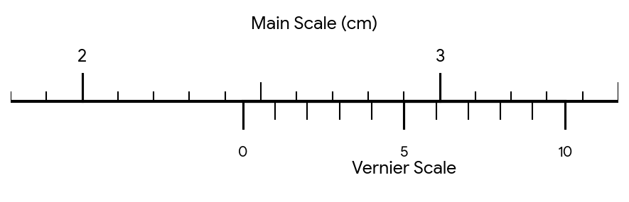
. Determine the reading shown on the instrument. (3 marks)

3. A solid metal cylinder has a radius of 7 cm and a height of 10 cm. If its mass is 12.32 kg, calculate the density of the metal in kg/m³. (Take π = 22/7) (5 marks)

4. Identify the branch of physics that deals with the study of:
(a) The behaviour of light and its properties. ..................................... (1 mark)
(b) The relationship between heat and other forms of energy. ............ (1 mark)
(c) Motion of bodies under the influence of forces. ........................... (1 mark)

5. Define the term 'force' and state its SI unit. (2 marks)

6. Explain why water wets glass but mercury does not, in terms of cohesive and adhesive forces. (3 marks)

7. A spring stretches by 4.0 cm when a mass of 200 g is suspended from it. Calculate the spring constant in N/m. (4 marks)

8. A rectangular solid block of mass 120 kg has dimensions 5 m by 3 m by 2 m as shown in the diagram below.
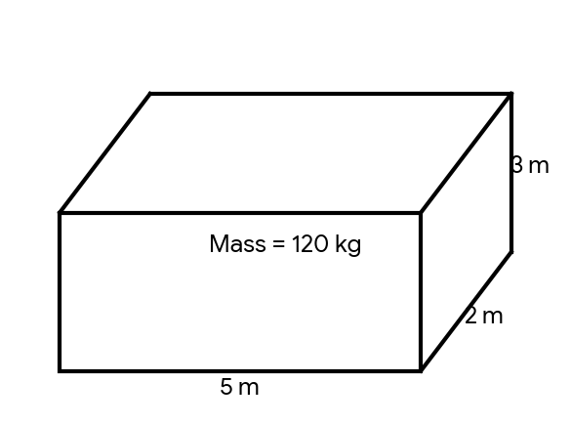
. (a) Calculate the maximum pressure the block can exert on a horizontal surface. (4 marks)

. (b) Determine the minimum pressure the block can exert on the same surface. (2 marks)

9. A diver is 15 m below the surface of a fresh water lake. Calculate the total pressure experienced by the diver. (Atmospheric pressure = 101,325 Pa, density of water = 1000 kg/m³) (5 marks)

10. (a) State two reasons why mercury is preferred over water as a barometric liquid. (2 marks)

. (b) The barometric height of a town is 68 cmHg. Calculate the atmospheric pressure in Pascals. (Density of mercury = 13,600 kg/m³) (3 marks)

11. In an experiment to observe Brownian motion, smoke particles are enclosed in a smoke cell and illuminated with a strong beam of light. They are observed using a microscope.
. (a) State what is observed through the microscope. (2 marks)

. (b) Explain the cause of the observation made in (a) above. (3 marks)

. (c) State the effect of increasing the temperature of the smoke cell on the observation. (1 marks)

12. The diagram below shows a bimetallic strip made of brass and iron at room temperature.
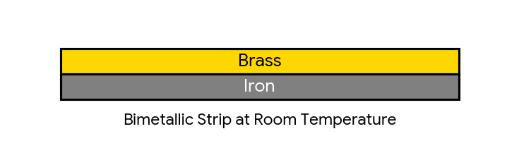
. (a) In the space below, sketch the appearance of the bimetallic strip when it is heated significantly. (Brass expands more than iron). (3 marks)

. (b) State one application of a bimetallic strip. (1 marks)

13. Explain how a vacuum flask minimizes heat loss by:
(i) Conduction (2 marks)

(ii) Convection (2 marks)

(iii) Radiation (2 marks)

14. Water exhibits anomalous expansion.
. (a) Explain what is meant by 'anomalous expansion of water'. (2 marks)

. (b) Sketch a graph of volume against temperature for water between 0°C and 10°C. (4 marks)

. (c) Explain the biological significance of anomalous expansion of water to aquatic life during winter. (3 marks)

15. (a) State the two laws of reflection of light. (2 marks)

. (b) List three characteristics of an image formed by a plane mirror. (3 marks)

16. The diagram below represents a pinhole camera setup used to view an object.
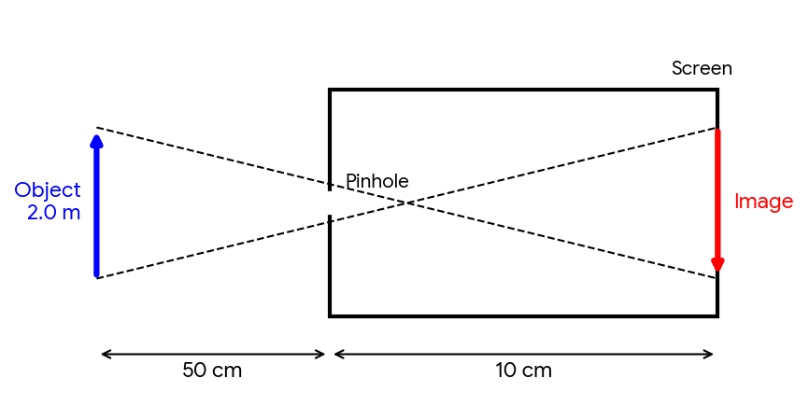
. (a) Based on the dimensions given in the diagram, calculate the magnification of the pinhole camera. (3 marks)

. (b) Calculate the height of the image formed on the screen. (3 marks)

. (c) State two changes that would occur to the image if the pinhole is made larger. (2 marks)

17. Two plane mirrors are inclined at an angle of 60° to each other. Calculate the number of images formed when an object is placed between them. (3 marks)

18. A girl stands 3 m in front of a plane mirror. If she moves 1 m away from the mirror:
. (a) What is the new distance between the girl and her image? (2 marks)

. (b) State the principle of operation of a simple periscope and give one practical use of it. (3 marks)

