TERM 3 HOLIDAY ASSIGNMENT 2026
FORM THREE
MATHEMATICS PAPER 1
Section / Question Numbers | Maximum Score | Candidate’s Score
SECTION I: 1 – 16 | 50 Marks
SECTION II: 17 – 24 (Any five) | 50 Marks
TOTAL | 100 Marks

SECTION I (50 MARKS)
1. Without using mathematical tables or a calculator, evaluate: (3 marks)
[-6(-4 + 7) − 24 ÷ (−6) + 5] ÷ [2(−3) + (−14)(−1)]
________________________________________________________________________________
________________________________________________________________________________
2. Find the value of x which satisfies the equation 3²ˣ⁺¹ = 81ˣ⁻¹. (3 marks)
________________________________________________________________________________
________________________________________________________________________________
3. Given that cos(2x + 10°) = sin(3x − 20°), find tan x correct to 4 significant figures, where 0° < x < 90°. (3 marks)
________________________________________________________________________________
________________________________________________________________________________
________________________________________________________________________________
4. State the integral values of x which satisfy the simultaneous inequalities 2x − 3 < 5 + x < 11 + 2x. (3 marks)
________________________________________________________________________________
________________________________________________________________________________
5. Simplify the following quadratic expression completely: 3x² − 7x − 6 − (x² − 5x + 2). (2 marks)
________________________________________________________________________________
________________________________________________________________________________
6. In the circle below, chords PQ and RS intersect at X. Given that RX = 6 cm, XS = 4 cm and PQ = 15 cm, calculate PX. (3 marks)
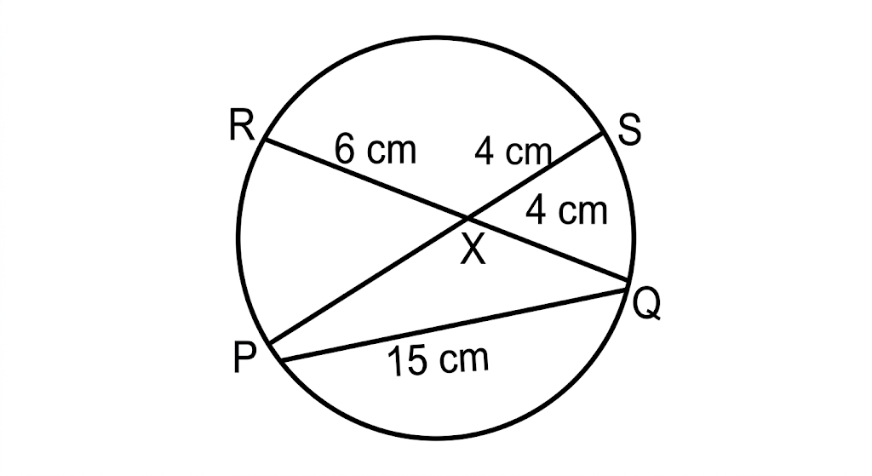
________________________________________________________________________________
________________________________________________________________________________
________________________________________________________________________________
7. The size of an interior angle of a regular polygon is (2x + 15)° while its exterior angle is (x − 15)°. Find the number of sides of the polygon. (3 marks)
________________________________________________________________________________
________________________________________________________________________________
________________________________________________________________________________
8. A Kenyan bank buys and sells foreign currencies at the exchange rates shown below. (4 marks)
Currency | Buying (Ksh) | Selling (Ksh)
1 Euro | 147.56 | 148.00
1 US dollar | 94.22 | 94.50
A tourist arrived in Kenya with 9,850 Euros. He converted all the Euros to Kenya shillings at the bank. He spent Ksh 1,250,000 while in Kenya and converted the remaining Kenya shillings into US dollars at the bank. Find the amount in dollars that he received, correct to 2 decimal places.
________________________________________________________________________________
________________________________________________________________________________
________________________________________________________________________________
________________________________________________________________________________
9. Kisumu and Eldoret are two towns 360 kilometres apart. A bus left Kisumu at 8.15 a.m. travelling towards Eldoret at 72 km/h. After 45 minutes, a saloon car left Kisumu travelling in the same direction at 90 km/h. How far from Eldoret did the saloon car catch up with the bus? (4 marks)
________________________________________________________________________________
________________________________________________________________________________
________________________________________________________________________________
________________________________________________________________________________
10. Eighteen men working at the rate of 8 hours a day can complete a piece of work in 15 days. How many more men, working at the rate of 6 hours a day, would complete the same work in 12 days? (3 marks)
________________________________________________________________________________
________________________________________________________________________________
________________________________________________________________________________
11. Three sirens wail at intervals of 24 minutes, 36 minutes and 45 minutes. If they wail together at 6.24 a.m. on Monday, at what time and on which day will they next wail together? (3 marks)
________________________________________________________________________________
________________________________________________________________________________
________________________________________________________________________________
12. Four similar shirts and three pairs of trousers cost a total of Ksh 5,300. Two similar shirts and one pair of trousers cost Ksh 2,500. Find the cost of three shirts and two pairs of trousers. (3 marks)
________________________________________________________________________________
________________________________________________________________________________
________________________________________________________________________________
13. Find the reciprocals of 625 and 0.078125. Hence evaluate 1/625 + 1/0.078125. (4 marks)
________________________________________________________________________________
________________________________________________________________________________
________________________________________________________________________________
14. Determine the equation of the line passing through (2, −1) and parallel to the line whose equation is 4x − 3y = 7. (3 marks)
________________________________________________________________________________
________________________________________________________________________________
________________________________________________________________________________
15. The figure below represents two sectors with common centre O and radii OA and OB respectively. Given that OB is twice OA, angle AOC = 75° and OA = 10 cm, calculate the area of the shaded region. (3 marks)
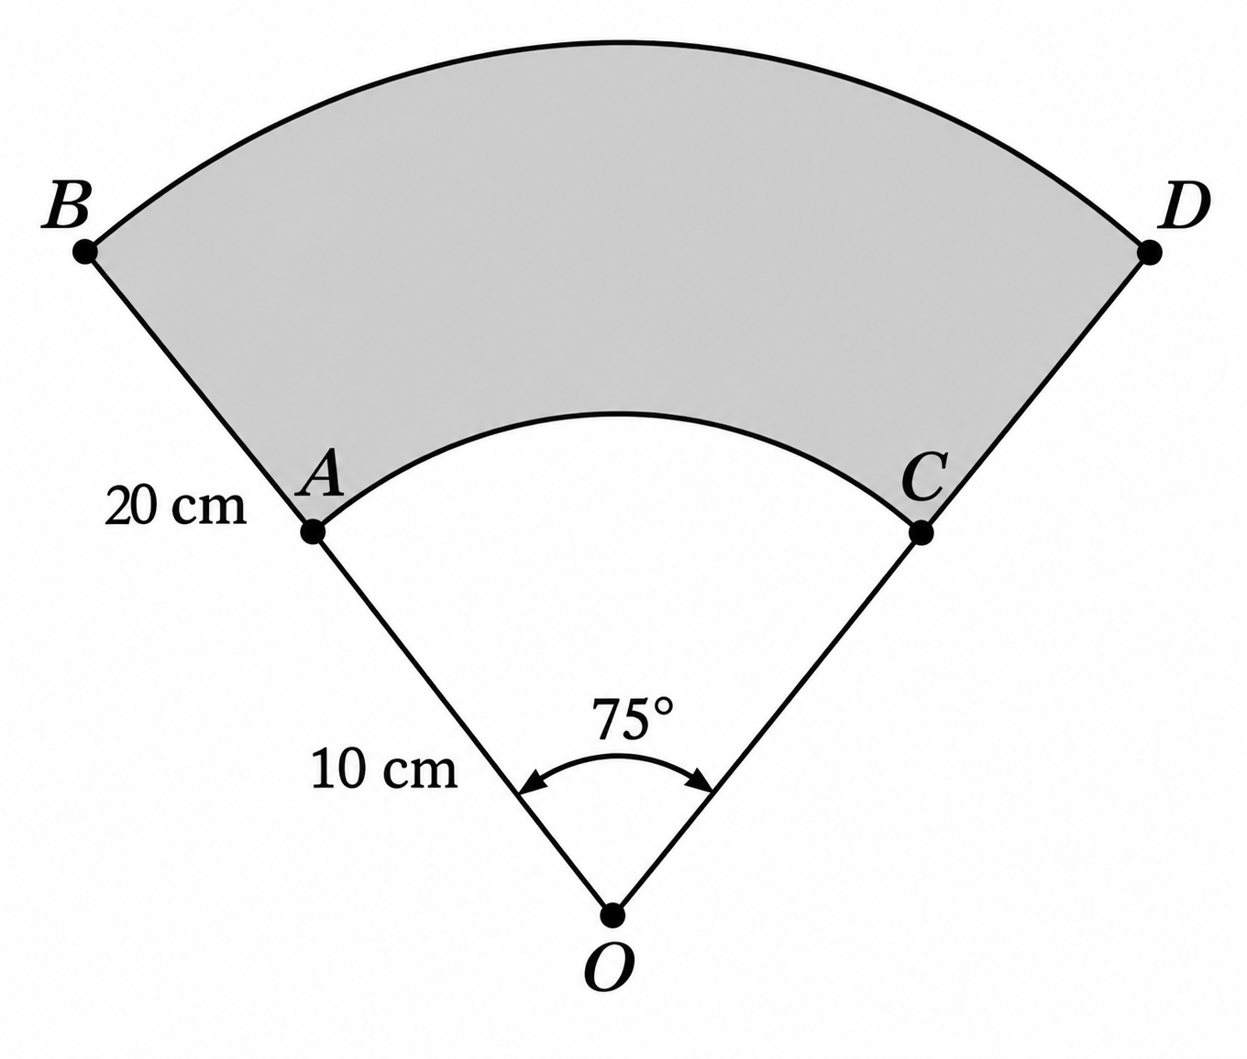
________________________________________________________________________________
________________________________________________________________________________
________________________________________________________________________________
16. The figure below shows a triangular prism. Sketch the net of the prism, showing all dimensions. (3 marks)

________________________________________________________________________________
________________________________________________________________________________
________________________________________________________________________________
________________________________________________________________________________
________________________________________________________________________________
________________________________________________________________________________
________________________________________________________________________________
________________________________________________________________________________

SECTION II (50 MARKS)
Answer ONLY five questions in this section.
17. The data below shows the marks scored by students in a Mathematics test. (10 marks)
Marks | 10–19 | 20–29 | 30–39 | 40–49 | 50–59 | 60–69 | 70–79
Frequency | 2 | 5 | 12 | 15 | 9 | 5 | 2
a) Determine the modal class. (1 marks)
________________________________________________________________________________
b) Calculate the mean mark. (5 marks)
________________________________________________________________________________
________________________________________________________________________________
________________________________________________________________________________
________________________________________________________________________________
c) Calculate the median mark. (4 marks)
________________________________________________________________________________
________________________________________________________________________________
________________________________________________________________________________
________________________________________________________________________________
18. The angle of elevation of the top of a vertical mast viewed by an observer 60 metres away is 18.5°. (10 marks)
a) Calculate, to 4 significant figures:
i) the height of the mast, given that the height of the observer is 1.6 m. (3 marks)
________________________________________________________________________________
________________________________________________________________________________
________________________________________________________________________________
ii) the length of a cable fixed at the feet of the observer to the top of the mast. (3 marks)
________________________________________________________________________________
________________________________________________________________________________
________________________________________________________________________________
b) Another observer, also 1.6 m tall and directly behind the first observer, finds the angle of elevation of the top of the mast to be 9.25°. Find the distance between the two observers. (4 marks)
________________________________________________________________________________
________________________________________________________________________________
________________________________________________________________________________
________________________________________________________________________________
19. Two tanks are similar in shape. The capacities of the tanks are 1,728,000 litres and 216,000 litres respectively. (10 marks)
a) Find the height of the smaller tank if the larger tank is 360 cm tall. (4 marks)
________________________________________________________________________________
________________________________________________________________________________
________________________________________________________________________________
b) Calculate the surface area of the larger tank if the smaller tank has a surface area of 900 m². (3 marks)
________________________________________________________________________________
________________________________________________________________________________
________________________________________________________________________________
c) Estimate the mass of the smaller tank if the mass of the larger one is 960 kg. (3 marks)
________________________________________________________________________________
________________________________________________________________________________
________________________________________________________________________________
20. A bus left Nairobi at 7.30 a.m. and travelled towards Kisumu at an average speed of 70 km/h. At 8.00 a.m., a car left Kisumu towards Nairobi at an average speed of 105 km/h. Given that the distance between Nairobi and Kisumu is 420 km, calculate: (10 marks)
a) the time the car arrived in Nairobi. (2 marks)
________________________________________________________________________________
________________________________________________________________________________
b) the time the two vehicles met. (3 marks)
________________________________________________________________________________
________________________________________________________________________________
________________________________________________________________________________
c) the distance from Nairobi to the meeting point. (2 marks)
________________________________________________________________________________
________________________________________________________________________________
d) the distance of the bus from Kisumu when the car arrived in Nairobi. (3 marks)
________________________________________________________________________________
________________________________________________________________________________
________________________________________________________________________________
21. A ship sails from A to D through B and C. B is 480 km on a bearing of N40°E from A. C is on a bearing of 320° from B and at a distance of 600 km. The bearings of D from A and C are N15°W and S70°W respectively. (10 marks)
a) Using the scale 1 cm to represent 100 km, show the relative positions of A, B, C and D. (4 marks)
________________________________________________________________________________
________________________________________________________________________________
________________________________________________________________________________
________________________________________________________________________________
________________________________________________________________________________
________________________________________________________________________________
________________________________________________________________________________
b) Find the distance of D from:
i) A. (1 marks)
________________________________________________________________________________
ii) C. (1 marks)
________________________________________________________________________________
c) Find the bearing of D from B. (1 marks)
________________________________________________________________________________
________________________________________________________________________________
d) If the ship was sailing at an average speed of 500 km/h, find how long the journey took. (3 marks)
________________________________________________________________________________
________________________________________________________________________________
________________________________________________________________________________
22. The figure below shows a frustum cut from a cone. (10 marks)
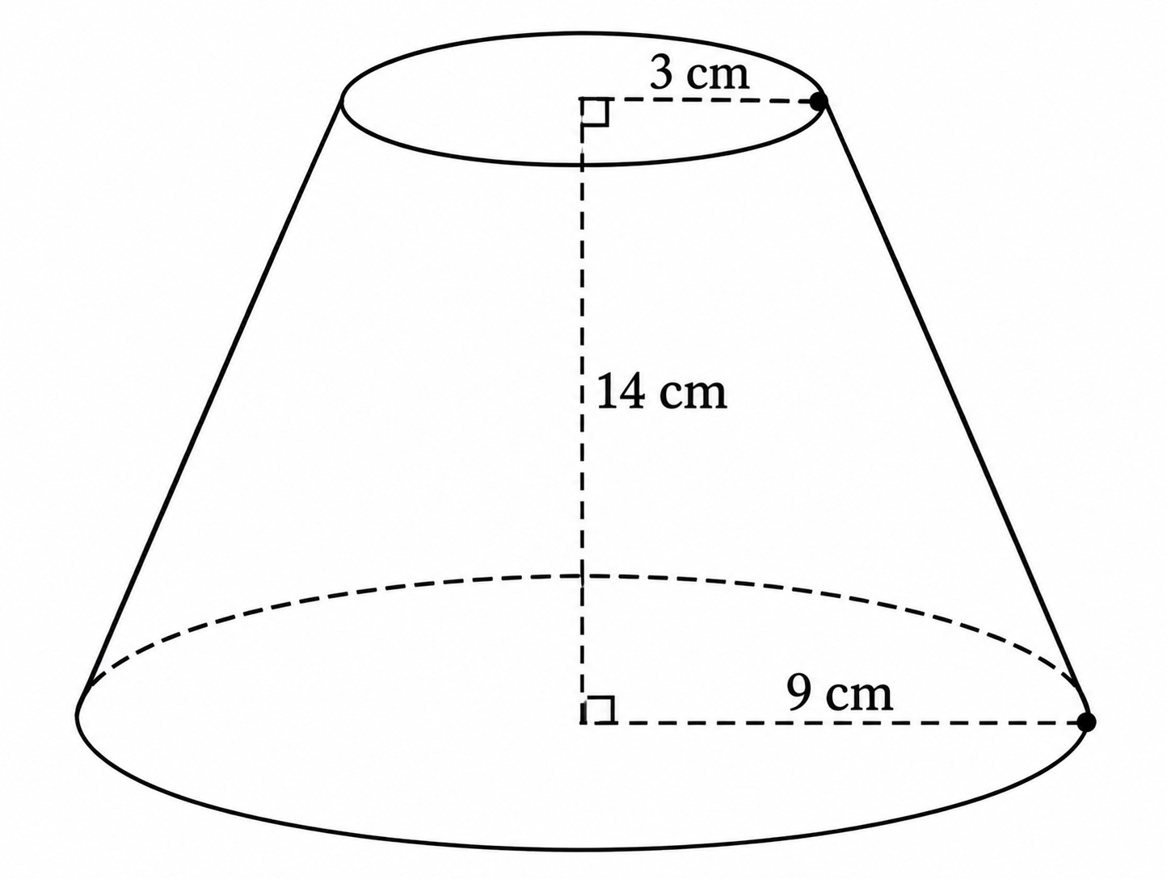
a) Calculate the original height from which the frustum was cut. (2 marks)
________________________________________________________________________________
________________________________________________________________________________
b) Calculate the surface area of the curved part of the frustum. (4 marks)
________________________________________________________________________________
________________________________________________________________________________
________________________________________________________________________________
c) Calculate the volume of the frustum. (4 marks)
________________________________________________________________________________
________________________________________________________________________________
________________________________________________________________________________
________________________________________________________________________________
23. On the graph paper provided, plot the point P(1,2), Q(1,5) and R(4,3), and join them to form triangle PQR. (10 marks)
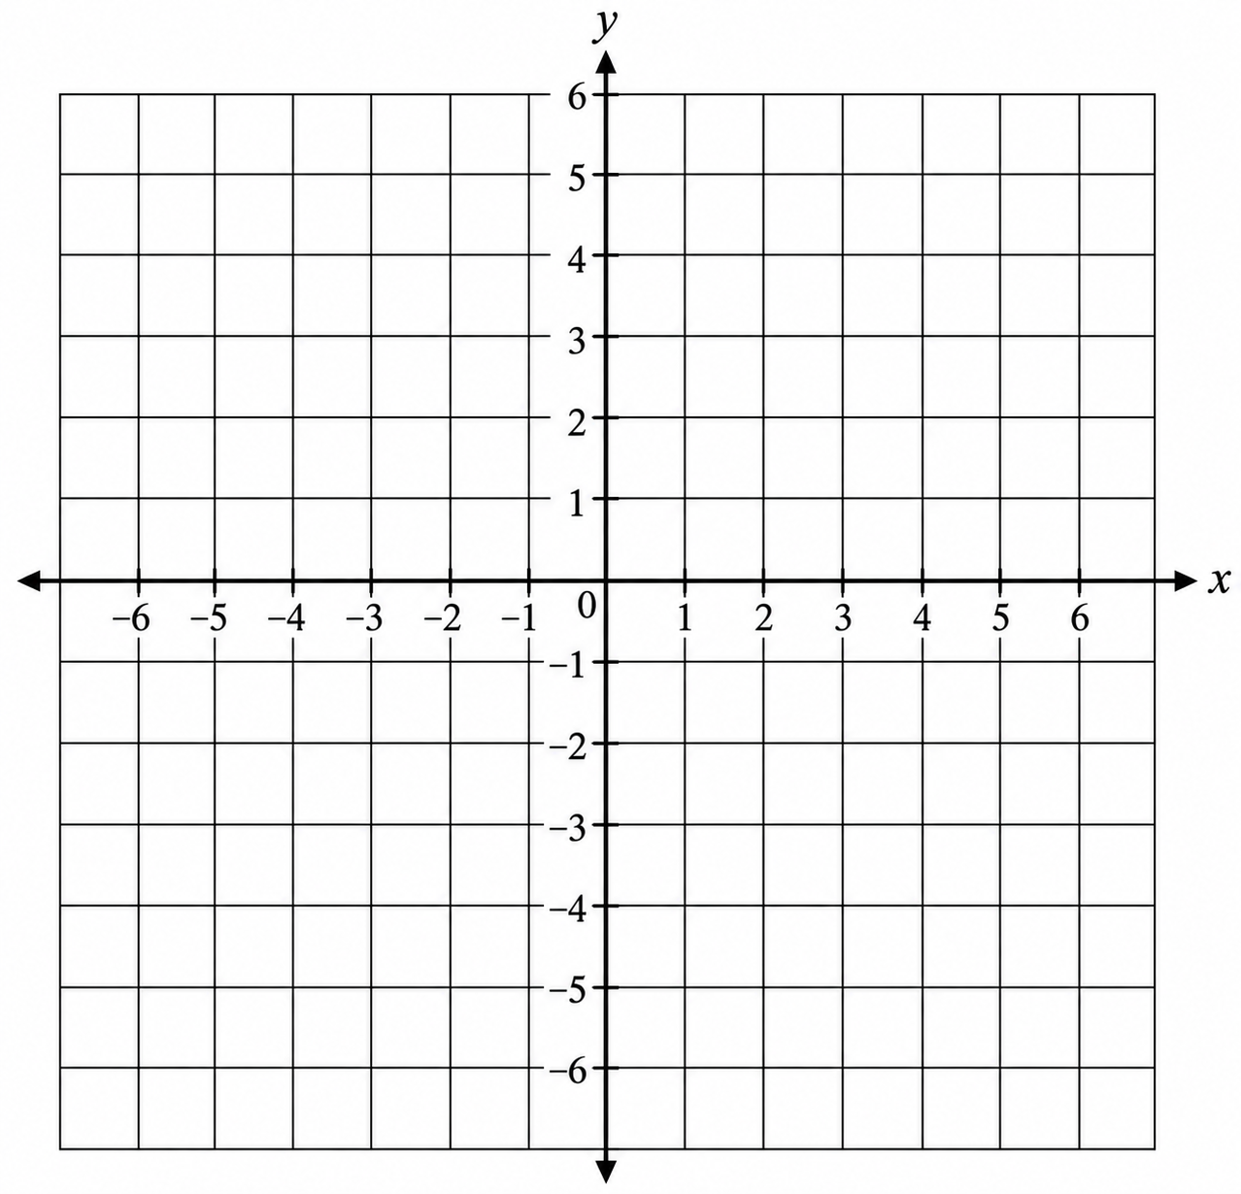
a) Plot P, Q and R and join them to form triangle PQR. (1 marks)
________________________________________________________________________________
________________________________________________________________________________
________________________________________________________________________________
________________________________________________________________________________
________________________________________________________________________________
b) Reflect triangle PQR in the line x = 0 and label the image P′Q′R′. (2 marks)
________________________________________________________________________________
________________________________________________________________________________
________________________________________________________________________________
________________________________________________________________________________
________________________________________________________________________________
c) Triangle P′Q′R′ is given a translation by vector (3, −2). State the coordinates and plot triangle P″Q″R″. (3 marks)
________________________________________________________________________________
________________________________________________________________________________
________________________________________________________________________________
________________________________________________________________________________
________________________________________________________________________________
d) Rotate triangle P″Q″R″ about the origin through −90°. State the coordinates of P‴Q‴R‴. (3 marks)
________________________________________________________________________________
________________________________________________________________________________
________________________________________________________________________________
________________________________________________________________________________
e) Identify two pairs of triangles that are direct congruences. (1 marks)
________________________________________________________________________________
________________________________________________________________________________
24. The figure below shows two circles of radii 12 cm and 9 cm with centres A and B respectively. The common chord PQ is 10 cm. (10 marks)
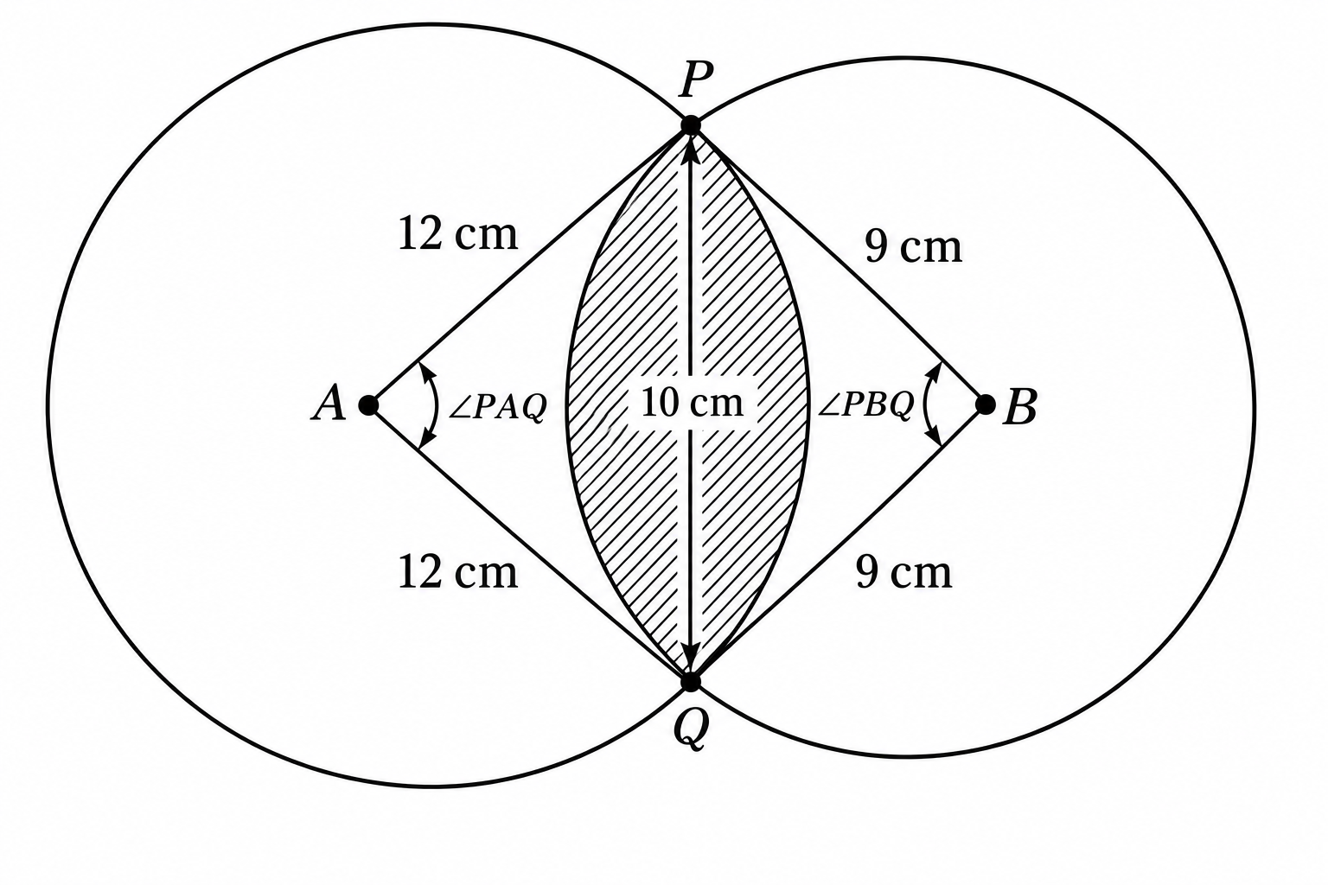
a) Calculate angle PAQ, correct to 2 decimal places. (2 marks)
________________________________________________________________________________
________________________________________________________________________________
b) Calculate angle PBQ, correct to 2 decimal places. (2 marks)
________________________________________________________________________________
________________________________________________________________________________
c) Calculate the area of the shaded part. (6 marks)
________________________________________________________________________________
________________________________________________________________________________
________________________________________________________________________________
________________________________________________________________________________
________________________________________________________________________________
________________________________________________________________________________

