TERM 3 HOLIDAY ASSIGNMENT 2026
FORM THREE
BUSINESS STUDIES PAPER 1
Section | Question Numbers | Maximum Score | Candidate's Score
Paper 1 | 1 – 25 | 100 Marks
TOTAL |  | 100 Marks

1. Outline four advantages of personal selling as a method of product promotion. (4 marks)
(i) (1 mark)
________________________________________________________________________________
(ii) (1 mark)
________________________________________________________________________________
(iii) (1 mark)
________________________________________________________________________________
(iv) (1 mark)
________________________________________________________________________________
2. Briefly define the following terms as used in transport. (4 marks)
(a) Mode of transport (1 mark)
________________________________________________________________________________
(b) Means of transport (1 mark)
________________________________________________________________________________
(c) Method of propulsion (1 mark)
________________________________________________________________________________
(d) Terminal (1 mark)
________________________________________________________________________________
3. Identify four sources from which business ideas can be generated. (4 marks)
(i) (1 mark)
________________________________________________________________________________
(ii) (1 mark)
________________________________________________________________________________
(iii) (1 mark)
________________________________________________________________________________
(iv) (1 mark)
________________________________________________________________________________
4. Outline four features of economic resources. (4 marks)
(i) (1 mark)
________________________________________________________________________________
(ii) (1 mark)
________________________________________________________________________________
(iii) (1 mark)
________________________________________________________________________________
(iv) (1 mark)
________________________________________________________________________________
5. State four types of business activities. (4 marks)
(i) (1 mark)
________________________________________________________________________________
(ii) (1 mark)
________________________________________________________________________________
(iii) (1 mark)
________________________________________________________________________________
(iv) (1 mark)
________________________________________________________________________________
6. Listed below are various forms of production. For each form of production, indicate using a tick (√) the correct classification in the appropriate column. (4 marks)
Form of production | Primary | Secondary | Tertiary
Fishing
Textile manufacturing
Banking
Road construction

7. Give four reasons why an entrepreneur needs to prepare a business plan. (4 marks)
(i) (1 mark)
________________________________________________________________________________
(ii) (1 mark)
________________________________________________________________________________
(iii) (1 mark)
________________________________________________________________________________
(iv) (1 mark)
________________________________________________________________________________
8. State four advantages of using the internet as a means of communication. (4 marks)
(i) (1 mark)
________________________________________________________________________________
(ii) (1 mark)
________________________________________________________________________________
(iii) (1 mark)
________________________________________________________________________________
(iv) (1 mark)
________________________________________________________________________________
9. Outline four ways in which individual consumers may protect themselves against exploitation by unscrupulous business persons. (4 marks)
(i) (1 mark)
________________________________________________________________________________
(ii) (1 mark)
________________________________________________________________________________
(iii) (1 mark)
________________________________________________________________________________
(iv) (1 mark)
________________________________________________________________________________
10. Using the balance sheet equation, calculate the missing figures represented by A, B, C and D in the table below. (4 marks)
Case | Capital (Ksh) | Liabilities (Ksh) | Assets (Ksh)
(i) | A | 3,280 | 24,500
(ii) | 35,750 | B | 128,600
(iii) | 160,000 | 294,500 | C
(iv) | D | 186,400 | 512,800

________________________________________________________________________________
________________________________________________________________________________
________________________________________________________________________________
________________________________________________________________________________
11. Outline four factors that are used to determine the size of a firm. (4 marks)
(i) (1 mark)
________________________________________________________________________________
(ii) (1 mark)
________________________________________________________________________________
(iii) (1 mark)
________________________________________________________________________________
(iv) (1 mark)
________________________________________________________________________________
12. Highlight four circumstances under which a producer would not need a lot of warehousing space or facilities. (4 marks)
(i) (1 mark)
________________________________________________________________________________
(ii) (1 mark)
________________________________________________________________________________
(iii) (1 mark)
________________________________________________________________________________
(iv) (1 mark)
________________________________________________________________________________
13. Outline four disadvantages of public limited companies. (4 marks)
(i) (1 mark)
________________________________________________________________________________
(ii) (1 mark)
________________________________________________________________________________
(iii) (1 mark)
________________________________________________________________________________
(iv) (1 mark)
________________________________________________________________________________
14. State four advantages of an open office layout. (4 marks)
(i) (1 mark)
________________________________________________________________________________
(ii) (1 mark)
________________________________________________________________________________
(iii) (1 mark)
________________________________________________________________________________
(iv) (1 mark)
________________________________________________________________________________
15. Highlight four characteristics of an asset. (4 marks)
(i) (1 mark)
________________________________________________________________________________
(ii) (1 mark)
________________________________________________________________________________
(iii) (1 mark)
________________________________________________________________________________
(iv) (1 mark)
________________________________________________________________________________
16. Outline four features of life assurance. (4 marks)
(i) (1 mark)
________________________________________________________________________________
(ii) (1 mark)
________________________________________________________________________________
(iii) (1 mark)
________________________________________________________________________________
(iv) (1 mark)
________________________________________________________________________________
17. Highlight four characteristics of an oligopolistic market structure. (4 marks)
(i) (1 mark)
________________________________________________________________________________
(ii) (1 mark)
________________________________________________________________________________
(iii) (1 mark)
________________________________________________________________________________
(iv) (1 mark)
________________________________________________________________________________
18. The following information relates to Kito business for the year ended 31-12-2026:
Capital as at 31-12-2026 = Ksh 96,000; Drawings for the year = Ksh 15,000; Net loss for the year = Ksh 8,000; Extra capital introduced during the year = Ksh 27,000.
Required: Determine the capital on 1-1-2026. (4 marks)
________________________________________________________________________________
________________________________________________________________________________
________________________________________________________________________________
________________________________________________________________________________
19. State four factors that may influence a firm's decision on what to produce. (4 marks)
(i) (1 mark)
________________________________________________________________________________
(ii) (1 mark)
________________________________________________________________________________
(iii) (1 mark)
________________________________________________________________________________
(iv) (1 mark)
________________________________________________________________________________
20. The following are some of the documents used in home trade: cash sale receipt, catalogue, invoice and statement of account. Match each document with the appropriate description provided in the table below. (4 marks)
Description | Document
(a) Shows details of goods offered
(b) Gives quantity, unit price and total amount to be paid
(c) Shows transactions since the date of the last statement
(d) Shows description of goods bought, prices and total amount paid

21. The figure below shows a shift in demand for a commodity from D₀D₀ to D₁D₁. State four possible causes that have led to this situation. (4 marks)
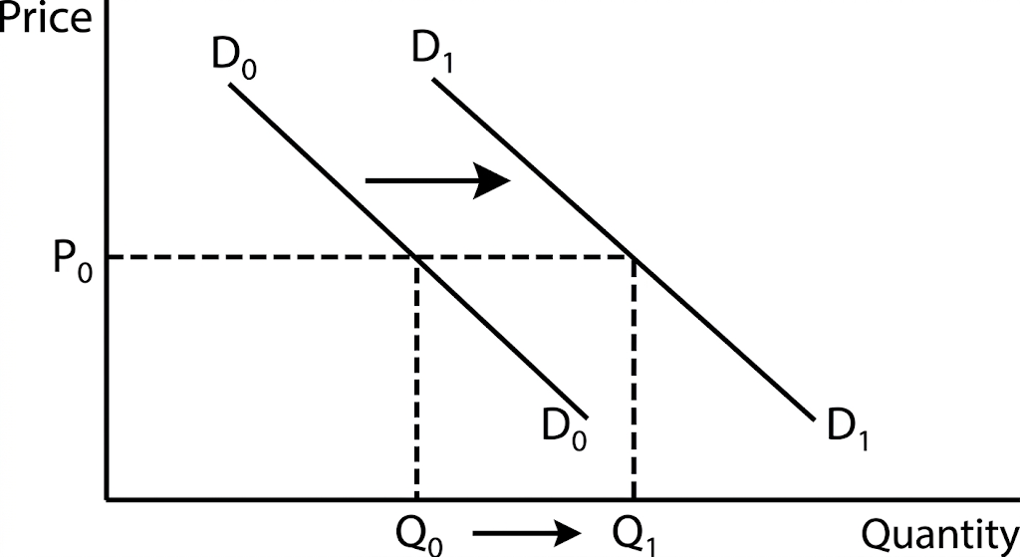
________________________________________________________________________________
________________________________________________________________________________
________________________________________________________________________________
________________________________________________________________________________
22. Outline four factors to consider when choosing a distributing channel. (4 marks)
(i) (1 mark)
________________________________________________________________________________
(ii) (1 mark)
________________________________________________________________________________
(iii) (1 mark)
________________________________________________________________________________
(iv) (1 mark)
________________________________________________________________________________
23. State four social responsibilities that a sugar manufacturing company should have towards the community. (4 marks)
(i) (1 mark)
________________________________________________________________________________
(ii) (1 mark)
________________________________________________________________________________
(iii) (1 mark)
________________________________________________________________________________
(iv) (1 mark)
________________________________________________________________________________
24. Give four reasons why one would prefer a letter to a telephone to send a message. (4 marks)
(i) (1 mark)
________________________________________________________________________________
(ii) (1 mark)
________________________________________________________________________________
(iii) (1 mark)
________________________________________________________________________________
(iv) (1 mark)
________________________________________________________________________________
25. Outline four unethical practices in product promotion. (4 marks)
(i) (1 mark)
________________________________________________________________________________
(ii) (1 mark)
________________________________________________________________________________
(iii) (1 mark)
________________________________________________________________________________
(iv) (1 mark)
________________________________________________________________________________

