KENYA CERTIFICATE OF BASIC EDUCATION

SENIOR SCHOOL ASSESSMENT

DECEMBER ASSIGNMENTS 2026
GRADE 10 – GEOGRAPHY
Time: 2 Hours
LEARNER’S DETAILS
Name: _____________________________________________________________. School: ____________________________________________.
Assessment Number: _______________________________________________. Date: ____________________________________________.
School Code: ______________________________________________________. Signature: _______________________________________.

INSTRUCTIONS TO CANDIDATES
- Write your name in the spaces provided above.
- Write the name of your school and your stream in the spaces provided.
- Write your admission number and the date of the assessment in the spaces provided.
- This paper consists of two sections: A and B.
- Answer all questions in section A and section B.
- Answer the questions in English.
- All answers MUST be written in the spaces provided in PAPER.
- Do NOT remove any page from this question paper.

FOR OFFICIAL USE ONLY (EXAMINER’S USE)
SECTION | SECTION A | SECTION B | % SCORE | EE1 | EE2 | ME1 | ME2 | AE1 | AE2 | BE1 | BE2
SCORE RANGE | 45 MARKS | 35 MARKS |  | 90-100 | 75-89 | 58-74 | 41-57 | 31-40 | 21-30 | 11-20 | 1-10
POINTS |  |  |  | 8 POINTS | 7 POINTS | 6 POINTS | 5 POINTS | 4 POINTS | 3 POINTS | 2 POINTS | 1 POINT
LEARNER’S TOTAL SCORE

SECTION A 30 MARKS Answer ALL questions in this section.
- (a) The table below shows agricultural crop production data (in metric tonnes) for a region in Kenya over a 4-year period: Study the data and answer the following sub-questions:
Year | Maize (Tonnes) | Tea (Tonnes) | Coffee (Tonnes) | Total
2021 | 120 | 80 | 40 | 240
2022 | 150 | 90 | 60 | 300
2023 | 180 | 110 | 70 | 360
2024 | 200 | 120 | 80 | 400
(i) Calculate the percentage contribution of Tea to the total agricultural output in the year 2023. Show your working. (2 marks)

(ii) Calculate the percentage increase in Maize production from 2021 to 2024. (2 marks)

(iii) State two advantages of using a comparative (grouped) bar graph to represent this data compared to a simple pie chart. (2 marks)
(i) _____________________________________________________________________________________
(ii) ____________________________________________________________________________________
- State three causes of movements of the Earth. (3 marks)
- _________________________________________________________________________________________
- _________________________________________________________________________________________
- _________________________________________________________________________________________

- State two characteristics of a destructive plate boundary. (2 marks)
- _________________________________________________________________________________________
- _________________________________________________________________________________________
- Outline three natural causes of earthquakes. (3 marks)
- _________________________________________________________________________________________
- _________________________________________________________________________________________
- _________________________________________________________________________________________
- State two effects of earthquakes on crustal rocks. (2 marks)
- _________________________________________________________________________________________
- _________________________________________________________________________________________
- a) State two factors that determine the degree of folding in rocks. (2 marks)
- _________________________________________________________________________________________
- _________________________________________________________________________________________

b) State three effects of faulting on drainage systems. (3 marks)
- _________________________________________________________________________________________
- _________________________________________________________________________________________
- _________________________________________________________________________________________
- The feature shown below is an extrusive volcanic landform. Study it and answer the questions that follow.
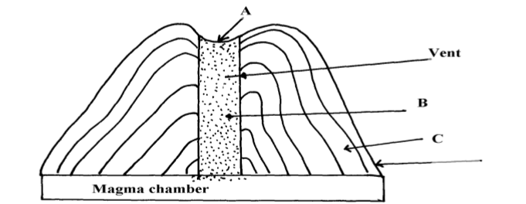
b) Name the parts labelled A, B and C (3 marks)
A: _______________________________
B: _______________________________
C: _______________________________
c) Using well-labelled diagrams, describe how each of the following features is formed:
i. An anticline (3 marks)

ii. An overthrust fold (3 marks)

SECTION A 50 MARKS Answer ALL questions in this section.
- a) What is meant by the Plate Tectonic Theory? (2 marks)
_____________________________________________________________________________________________________________________________________________________________________________________________________________________________________________________________________________________________
b) Name three types of plate boundaries. (3 marks)
- _________________________________________________________________________________________
- _________________________________________________________________________________________
- _________________________________________________________________________________________
c) Explain two pieces of evidence that support the Continental Drift Theory. (2 marks)
- _________________________________________________________________________________________
- _________________________________________________________________________________________
d) Explain three ways in which folding features can pose problems to people. (3 marks)
(i) _____________________________________________________________________________________
(ii) ____________________________________________________________________________________
(iii) ___________________________________________________________________________________

- (a) Define the term Geographic Information System (GIS). (2 marks)
______________________________________________________________________________________________________________________________________________________________________________________________
(b) Differentiate between Vector data and Raster data structures as used in GIS spatial analysis. (2 marks)
______________________________________________________________________________________________________________________________________________________________________________________________
(c) State three application areas of GIS in modern agricultural resource management in Kenya. (3 marks)
(i) _____________________________________________________________________________________
(ii) ____________________________________________________________________________________
(iii) ___________________________________________________________________________________
- (a) What is the fundamental difference between plutonic igneous rocks and volcanic igneous rocks based on cooling rate and texture? (2 marks)
_____________________________________________________________________________________________________________________________________________________________________________________________________________________________________________________________________________________________
(b) Complete the table below by providing the corresponding metamorphic equivalent for each original rock type: (3 marks)
Original Parent Rock | Metamorphic Equivalent
Limestone | (i)
Clay / Shale | (ii)
Granite | (iii)
- (a) Name two features formed by major crustal folding on a global scale. (2 marks)
(i) _____________________________________________________________________________________
(ii) ____________________________________________________________________________________

(b) Describe how an Overthrust Fold (Nappe) is formed under intense compression. (4 marks)
____________________________________________________________________________________________________________________________________________________________________________________________________________________________________________________________________________________________________________________________________________________________________________________________
- Study the topographic contour map representation provided below to answer sub-questions (a) through (e).
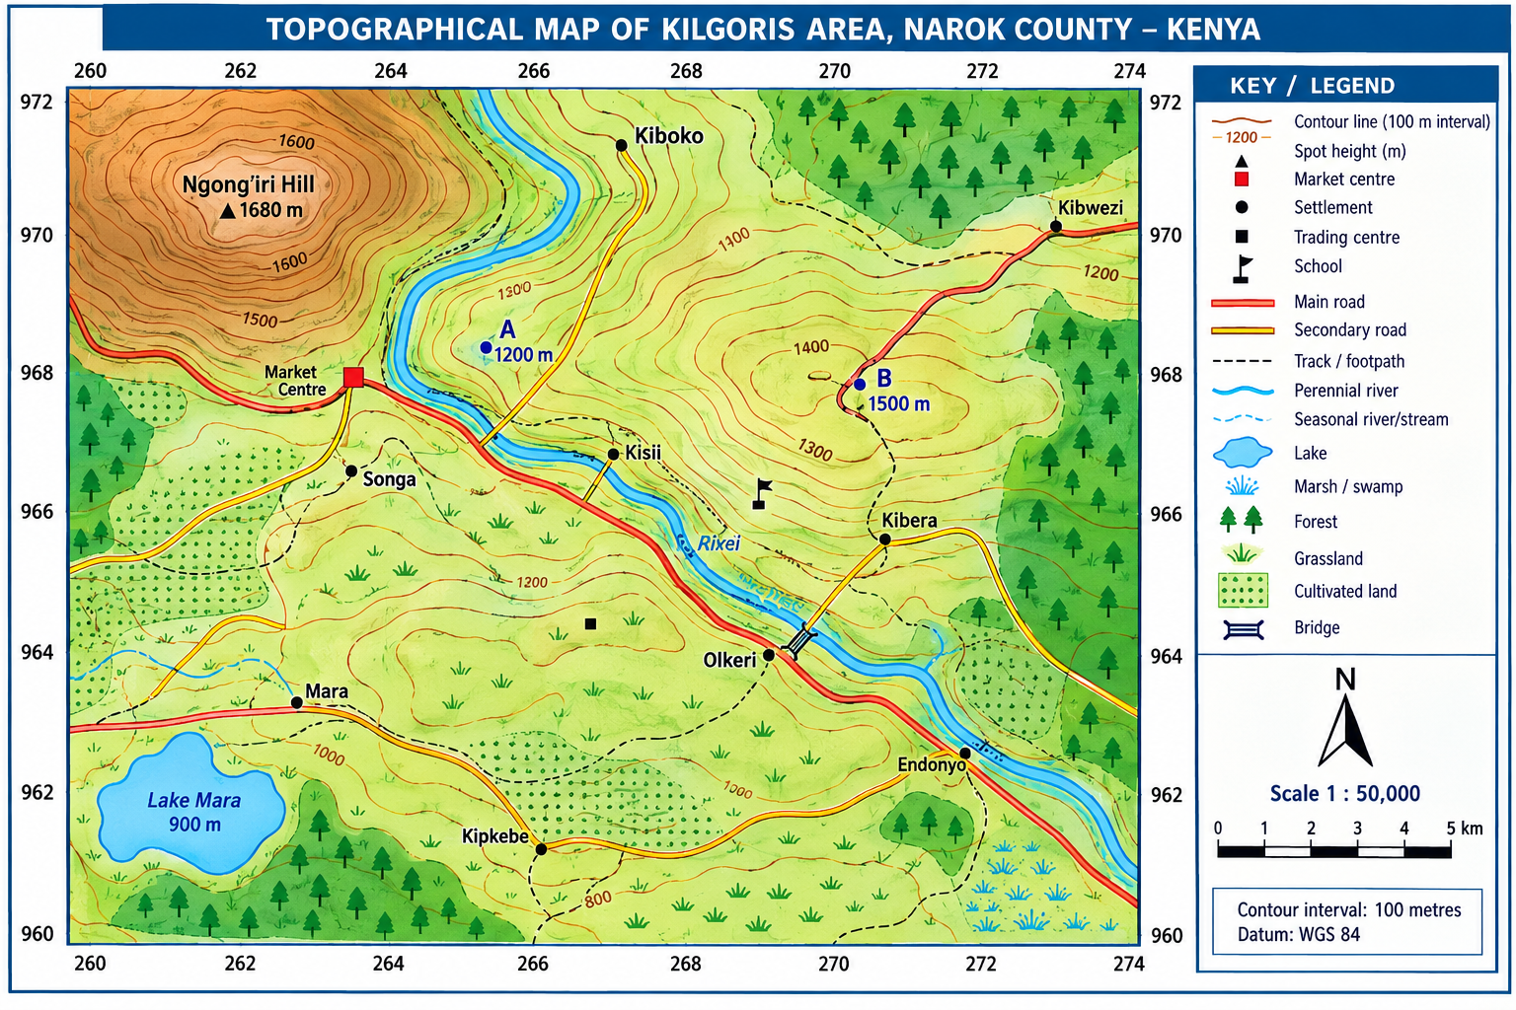
(a) (i) Convert a map scale of 1:50,000 into a statement scale in kilometers. (1 mark)

(ii) If the distance between two market centers measured along a straight line on a 1:50,000 map is 14.6 cm, calculate the actual ground distance in kilometers. (2 marks)

(b) (i) Calculate the gradient between point A (elevation 1200 m) and point B (elevation 1500 m) separated by a map distance corresponding to 6 km on the ground. Give your answer as a ratio. (3 marks)

(ii) Identify the terrain relief feature characterized by closely spaced contour lines along a river valley. (1 mark)
_________________________________________________________________________
(c) Below is statistical data representing energy generation by source in Kenya for a specific operational year:
- Geothermal: 45%
- Hydroelectric: 35%
- Wind & Solar: 15%
- Thermal (Fossil Fuels): 5%
(i) Calculate the proportional central angle in degrees (∘) for each energy sector required to construct a standard Pie Chart (Divided Circle). (4 marks)
- Geothermal: _________________________________________________________________________
- Hydroelectric: ______________________________________________________________________
- Wind & Solar: ______________________________________________________________________
- Thermal: ___________________________________________________________________________
(ii) State two mathematical rules that must be adhered to when drawing a divided rectangle (component bar chart). (2 marks)
(i) _____________________________________________________________________________________
(ii) ____________________________________________________________________________________
(d) Explain three factors influencing the distribution of human settlements as interpreted from topographic maps. (3 marks)
(i) _____________________________________________________________________________________
(ii) ____________________________________________________________________________________
(iii) ___________________________________________________________________________________
(e) State four primary steps followed when constructing a topographic cross-section (relief profile) between two grid references. (4 marks)
(i) _____________________________________________________________________________________
(ii) ____________________________________________________________________________________
(iii) ___________________________________________________________________________________
(iv) ___________________________________________________________________________________
- (a) (i) Distinguish between intrusive and extrusive volcanic landforms. (2 marks)
______________________________________________________________________________________________
_____________________________________________________________________________________________
_____________________________________________________________________________________________
(ii) State three characteristics of a basic (basaltic) lava flow. (3 marks)
(i) _____________________________________________________________________________________
(ii) ____________________________________________________________________________________
(iii) ___________________________________________________________________________________
(b) Describe the operational process of extracting soda ash (trona) from Lake Magadi using the dredging method. (4 marks)
____________________________________________________________________________________________________________________________________________________________________________________________________________________________________________________________________________________________________________________________________________________________________________________________
(c) Explain three environmental degradation problems associated with open-cast mining in Kenya. (3 marks)
(i) _____________________________________________________________________________________
(ii) ____________________________________________________________________________________
(iii) ___________________________________________________________________________________
- (a) (i) Define large-scale commercial plantation farming. (1 mark)
______________________________________________________________________________________________________________________________________________________________________________________________
(ii) State three physical conditions required for successful commercial tea cultivation in the Kenyan highlands. (3 marks)
(i) _____________________________________________________________________________________
(ii) ____________________________________________________________________________________
(iii) ___________________________________________________________________________________
(b) Explain two ways in which the Kenyan government supports small-scale sugarcane farmers to boost national agricultural yield. (2 marks)
(i) _____________________________________________________________________________________
(ii) ____________________________________________________________________________________
(iii) ___________________________________________________________________________________
(c) (i) Differentiate between raw-material-oriented industries and market-oriented industries. (2 marks)
_____________________________________________________________________________________________________________________________________________________________________________________________________________________________________________________________________________________________
(ii) Name two cottage industries practiced in Kenya. (2 marks)
(i) _____________________________________________________________________________________
(ii) ____________________________________________________________________________________
- (a) (i) Define Geothermal Energy. (1 mark)
______________________________________________________________________________________________________________________________________________________________________________________________
(ii) State three advantages of geothermal power over hydroelectric power in Kenya. (3 marks)
(i) _____________________________________________________________________________________
(ii) ____________________________________________________________________________________
(iii) ___________________________________________________________________________________
(b) Describe how electrical energy is produced from geothermal steam at the Olkaria Geothermal Station. (3 marks)
____________________________________________________________________________________________________________________________________________________________________________________________________________________________________________________________________________________________________________________________________________________________________________________________
(c) Explain three factors that have favored Japan as a global industrial giant despite lacking major natural mineral resources. (3 marks)
(i) _____________________________________________________________________________________
(ii) ____________________________________________________________________________________
(iii) ___________________________________________________________________________________
- Study the data in the table below and use it to answer the questions that follow.
Mineral | Production (000 tonnes)
Gold | 26
Fluorspar | 14
Soda ash | 32
Zinc | 28

a) Using a radius of 5 cm, draw a pie chart to represent the mineral production in Kenya shown in the table above. (7 marks)

b) State three advantages of using a pie chart to represent statistical data. (3 marks)
- _________________________________________________________________________________________
- _________________________________________________________________________________________
- _________________________________________________________________________________________
- A county has fertile volcanic soils, adequate rainfall, deposits of minerals, a river, geothermal resources and a growing population. The county government plans to develop agriculture, mining, energy generation and manufacturing industries.

a) Explain two ways in which physical factors favour agriculture in the county. (2 marks)
- _________________________________________________________________________________________
- _________________________________________________________________________________________

b) State two economic benefits of mining to the county. (2 marks)
- _________________________________________________________________________________________
- _________________________________________________________________________________________

c) State one environmental problem associated with mining. (1 mark)

________________________________________________________________________________________________________________________________________________________________________

d) Name two renewable sources of energy that could be developed in the county. (2 marks)
- _________________________________________________________________________________________
- _________________________________________________________________________________________

e) State one advantage of using renewable energy. (1 mark)
______________________________________________________________________________________________________________________________________________________________________________________________

f) Explain two factors that could influence the location of industries in the county. (2 marks)
- _________________________________________________________________________________________
- _________________________________________________________________________________________

THIS IS THE LAST PRINTED PAGE

GEOGRAPHY

MARKING SCHEME

SECTION A (30 MARKS)

1. (a)

(i) Percentage contribution of Tea in 2023
Tea production in 2023 = 110 tonnes
Total production in 2023 = 360 tonnes
$$\text{Percentage}=\frac{110}{360}×100$$
$$=\boxed{30.56\%}$$

(ii) Percentage increase in Maize production from 2021 to 2024
Production in 2021 = 120 tonnes
Production in 2024 = 200 tonnes
Increase:
$$200-120=80\text{ tonnes}$$
$$\text{Percentage increase}=\frac{80}{120}×100$$
$$=\boxed{66.67\%}$$

(iii) Advantages of a comparative (grouped) bar graph
- Allows direct side-by-side comparison of individual crop quantities across several years.
- Clearly shows absolute values and changes in production over time.
- Makes trends and differences between crops easy to identify.

2. Causes of movements of the Earth
- Convectional currents in the mantle.
- Isostatic readjustments/isostasy.
- Gravitational/tectonic forces.
- Movement of magma within the crust.

3. Characteristics of a destructive plate boundary
- Plates move towards each other, causing convergence or collision.
- The denser plate sinks beneath the lighter plate into the mantle through subduction.
- Deep ocean trenches are formed.
- Violent volcanic activity may occur.
- Strong earthquakes are common.

4. Natural causes of earthquakes
- Sudden release of strain along fault lines due to tectonic movements.
- Volcanic eruptions and rapid movement of magma beneath the crust.
- Gravitational collapse of underground caves or rock structures.

5. Effects of earthquakes on crustal rocks
- Cause severe fracturing, faulting and displacement of rock layers.
- Trigger landslides and rockfalls, especially in mountainous areas.

6. (a) Factors determining the degree of folding in rocks
- Intensity or amount of compressional forces applied.
- Temperature of the rocks.
- Elasticity/flexibility or ductility of the rocks.
- Duration of time over which the compressional forces act.

(b) Effects of faulting on drainage systems
- Faulting may offset or divert river courses along fault lines.
- Fault scarps crossing river courses may create waterfalls or rapids.
- Uplifted fault blocks may form new drainage divides.
- Faulting may lead to the formation of Rift Valley lakes in grabens.

7. (b) Volcanic Diagram Identification
A – Crater
B – Vent/Central pipe (magma conduit)
C – Alternating layers of volcanic ash and lava (stratovolcano structure)

(c) Formation descriptions
(i) Anticline
- Formed when crustal rock layers are subjected to horizontal compressional forces.
- The forces push the rock strata towards each other.
- The layers bend upwards into an arch or crest-like structure.
- The upward arch is called an anticline.
(ii) Overthrust Fold (Nappe)
- Formed when very intense horizontal compressional forces act on rock layers.
- An asymmetrical fold develops and becomes an overfold.
- Continued compression causes the upper limb to fracture along a thrust plane.
- The upper limb slides horizontally over the lower limb, forming an overthrust fold or nappe.

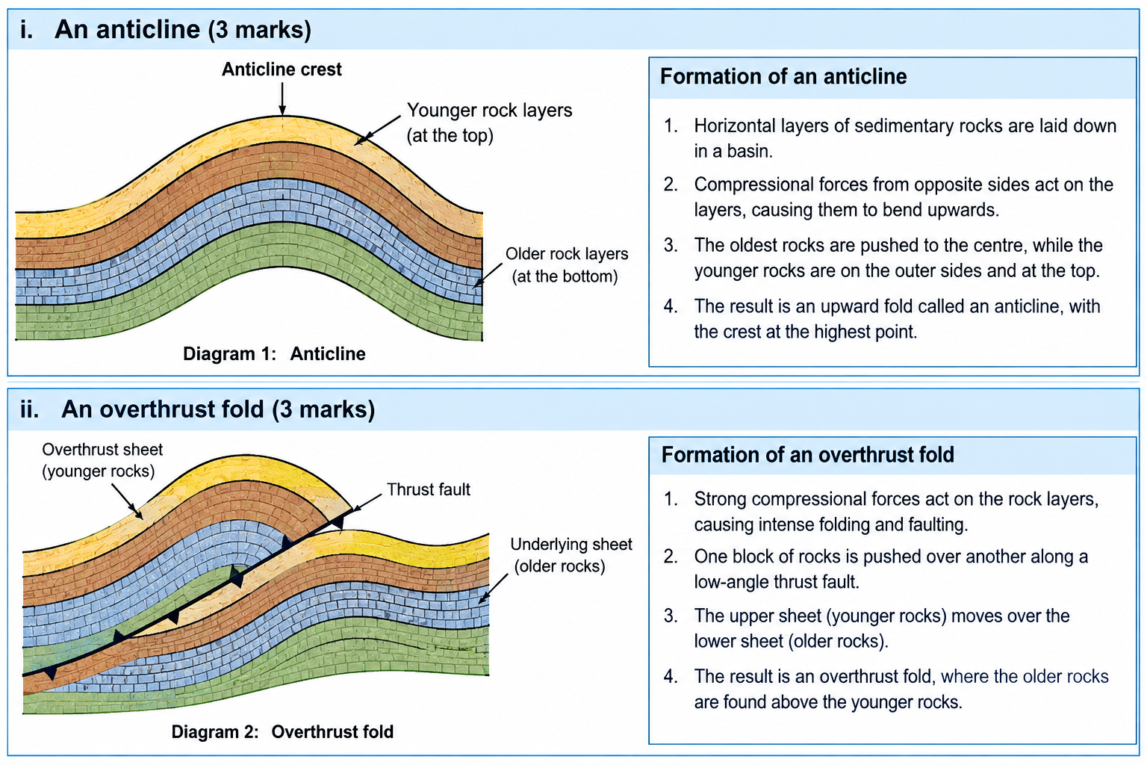

SECTION B (50 MARKS)

8. (a) Plate Tectonic Theory
The theory states that the Earth’s lithosphere, consisting of the crust and upper mantle, is divided into several rigid segments called tectonic plates which move slowly over the semi-molten asthenosphere.

(b) Types of plate boundaries
- Constructive/divergent boundary.
- Destructive/convergent boundary.
- Transform/conservative/neutral boundary.

(c) Evidence supporting Continental Drift Theory
Jigsaw fit of continents
- The coastlines of South America and Africa fit together remarkably well.
Fossil evidence
- Identical fossils, such as Glossopteris and Mesosaurus, have been found in rocks of the same age on continents that are now widely separated.

(d) Problems posed by folding features
- Fold mountains have steep terrain which creates barriers to transport and communication.
- Steep slopes encourage soil erosion and landslides.
- High mountain ranges may create rain-shadow areas with low rainfall and poor agricultural production.

9. (a) Geographic Information System (GIS)
A Geographic Information System (GIS) is a computer-based system used to capture, store, manipulate, analyse, manage and present geographical or spatial data.

(b) Vector and Raster Data Structures
Vector data
- Represents geographical features using discrete points, lines and polygons.
- Features are represented using specific coordinates.
Raster data
- Represents geographical features using a continuous grid of cells or pixels.
- Each cell contains a value representing a particular attribute.

(c) Applications of GIS in agricultural resource management
- Precision farming and soil fertility mapping.
- Crop yield estimation and crop health monitoring using satellite imagery.
- Land suitability classification.
- Water-resource management.
- Monitoring changes in agricultural land use.

10. (a) Plutonic and Volcanic Igneous Rocks
Plutonic igneous rocks
- Form when magma cools and solidifies deep beneath the Earth’s surface.
- Cool slowly.
- Have coarse-grained textures with large visible crystals.
Volcanic igneous rocks
- Form when lava erupts onto the Earth’s surface and cools.
- Cool rapidly.
- Have fine-grained, glassy or aphanitic textures with very small crystals.

(b) Metamorphic equivalents
Original Rock | Metamorphic Rock
(i) Limestone | Marble
(ii) Clay/Shale | Slate
(iii) Granite | Gneiss

11. (a) Features formed by global folding
- Fold mountain ranges such as the Himalayas, Andes, Alps and Rockies.
- Intermontane plateaus.
- Structural basins.

(b) Formation of an Overthrust Fold (Nappe)
- Horizontal compressional forces act on crustal rock layers.
- Continued pressure causes an asymmetrical fold to develop into an overfold.
- One limb is pushed over the other.
- Extreme compression exceeds the elasticity of the rocks, producing a rupture called a thrust plane.
- The upper limb breaks and is pushed/slides horizontally over the lower limb.
- This produces an overthrust fold or nappe.

12. (a)

(i) Convert map scale 1:50,000 to statement scale
$$1\text{ cm}=50,000\text{ cm}$$
$$50,000\text{ cm}=500\text{ m}=0.5\text{ km}$$
Therefore:
$$\boxed{1\text{ cm represents }0.5\text{ km}}$$

(ii) Actual ground distance
Map distance = 14.6 cm
$$14.6×0.5=7.3\text{ km}$$
$$\boxed{7.3\text{ km}}$$

(b) (i) Gradient calculation
Vertical Interval:
$$1500-1200=300\text{ m}$$
Horizontal Equivalent:
$$6\text{ km}=6000\text{ m}$$
Therefore:
$$\text{Gradient}=\frac{300}{6000}$$
$$=\frac{1}{20}$$
$$\boxed{1:20}$$

(ii) Relief feature
Any one:
- Steep slope
- Gorge
- V-shaped valley wall

(c) (i) Pie Chart Central Angles
Geothermal:
$$\frac{45}{100}×{360}^{∘}=\boxed{{162}^{∘}}$$
Hydroelectric:
$$\frac{35}{100}×{360}^{∘}=\boxed{{126}^{∘}}$$
Wind and Solar:
$$\frac{15}{100}×{360}^{∘}=\boxed{{54}^{∘}}$$
Thermal:
$$\frac{5}{100}×{360}^{∘}=\boxed{{18}^{∘}}$$

(ii) Rules for constructing a divided rectangle
- The total length/width of the rectangle should represent 100% or the grand total.
- The subdivisions should be drawn accurately according to the values represented.
- Components should be arranged in a consistent order, such as largest to smallest or chronological order.
- Each section should be clearly labelled.

(d) Factors influencing settlement distribution on maps
Relief/Topography
- Flat or gently sloping land encourages dense settlement.
- Steep slopes tend to have sparse settlement.
Drainage/Water supply
- Settlements tend to concentrate near rivers, lakes and springs because of the availability of water.
Transport infrastructure
- Linear settlements often develop along major roads and railway lines because of ease of accessibility.

(e) Steps in constructing a topographic cross-section
- Draw a straight line joining the two required points/grid references on the map.
- Place a strip of paper along the line.
- Mark every point where a contour intersects the line and record its elevation.
- Transfer the marked strip onto the horizontal axis of graph paper.
- Draw vertical lines at the marked positions using the selected vertical scale.
- Plot the corresponding heights.
- Join the plotted points smoothly to form the cross-section.

13. (a)

(i) Intrusive and Extrusive Landforms
Intrusive landforms
- Form when magma cools and solidifies beneath the Earth’s surface.
- Examples include sills, dykes and batholiths.
Extrusive landforms
- Form when lava erupts onto the Earth’s surface and solidifies.
- Examples include volcanoes and lava plateaus.

(ii) Characteristics of basic/basaltic lava
- Has low silica content.
- Has low viscosity and is highly fluid.
- Has a high melting temperature.
- Flows rapidly over long distances.
- Forms gently sloping volcanic landforms.

(b) Dredging process for Soda Ash at Lake Magadi
- A floating excavator or dredger cuts and digs the solid trona crust from the lake bed.
- The crushed trona is mixed with lake liquor to form a slurry.
- The slurry is pumped through pipes to the processing factory on the shore.
- It is washed, centrifuged and calcined to produce soda ash.
- The soda ash is then packaged.

(c) Environmental degradation caused by open-cast mining
- Destruction of natural vegetation and wildlife habitats.
- Land degradation through the creation of deep and unsafe open pits.
- Soil erosion.
- Dust pollution.
- Contamination of water bodies through silt and chemicals.

14. (a)

(i) Large-scale commercial plantation farming
This is the cultivation of a single cash crop on large tracts of land or estates using substantial capital, specialised machinery and organised labour, mainly for commercial purposes and export or processing.

(ii) Physical requirements for tea
- High and well-distributed annual rainfall of about 1,200–2,000 mm.
- Cool to warm temperatures of about 15°C–25°C.
- Deep, well-drained and acidic volcanic soils.
- Suitable soil pH of approximately 4.5–5.6.

(b) Government support for sugarcane farmers
- Provision of subsidised farm inputs such as fertilisers.
- Provision of high-yielding sugarcane varieties.
- Development of feeder roads and other infrastructure.
- Provision of agricultural extension services.
- Provision of credit and financial support through relevant agricultural institutions.

(c) (i) Raw-material-oriented and Market-oriented industries
Raw-material-oriented industries
- Locate near sources of raw materials.
- This reduces transportation costs, especially for bulky or perishable raw materials.
Market-oriented industries
- Locate near consumer centres.
- This is suitable where finished products are fragile, perishable or expensive to transport.

(ii) Examples of cottage industries in Kenya
- Wood carving.
- Basketry and weaving/kiondo making.
- Pottery.
- Blacksmithing/Jua Kali metal fabrication.

15. (a)

(i) Geothermal Energy
Geothermal energy is heat energy generated and stored beneath the Earth’s crust and obtained in the form of steam or hot water.

(ii) Advantages of geothermal energy over hydroelectric power
- Provides reliable electricity throughout the year and is less affected by drought or rainfall fluctuations.
- Requires a relatively smaller land area than large hydroelectric reservoirs.
- Has relatively low operating costs in the long term.
- Produces low greenhouse gas emissions.

(b) Electricity generation at Olkaria Geothermal Station
- Deep wells are drilled into hot underground aquifers.
- High-pressure steam is brought to the surface through the wells.
- The steam passes through separators to remove moisture.
- Dry, high-pressure steam is directed onto turbines.
- The turbines rotate generators, producing electricity.

(c) Factors favouring Japan as an industrial giant
- Availability of a highly skilled, disciplined and technologically advanced workforce.
- Availability of reliable sources of power.
- Well-developed transport and communication systems.
- Presence of deep-water natural harbours.
- Efficient sea transport for importing raw materials and exporting manufactured goods.
- Advanced technology and industrial infrastructure.

16. (a) Pie Chart Construction
Total production:
$$26+14+32+28=100\text{ (000 tonnes)}$$

Calculated angles
Gold:
$$\frac{26}{100}×{360}^{∘}=\boxed{{93.6}^{∘}}$$
Fluorspar:
$$\frac{14}{100}×{360}^{∘}=\boxed{{50.4}^{∘}}$$
Soda ash:
$$\frac{32}{100}×{360}^{∘}=\boxed{{115.2}^{∘}}$$
Zinc:
$$\frac{28}{100}×{360}^{∘}=\boxed{{100.8}^{∘}}$$

Marking points for the drawing
- Draw a circle of approximately 5 cm radius.
- Plot the calculated sector angles accurately using a protractor.
- Label all sectors clearly.
- Provide a complete key/legend.
- Give the pie chart an appropriate title.

(b) Advantages of a Pie Chart
- Gives an immediate visual summary of proportional relationships.
- Makes it easy to compare the relative sizes of components.
- Simple to interpret.
- Provides an attractive visual presentation of data.

17. (a) Physical factors favouring agriculture
- Fertile volcanic soils provide essential nutrients for high crop yields.
- Adequate and reliable rainfall supports crop growth.
- Suitable temperatures encourage crop development.

(b) Economic benefits of mining
- Creates employment opportunities.
- Raises the incomes and living standards of people.
- Generates government revenue through taxes and royalties.
- Provides funds for infrastructure development.

(c) Environmental problem of mining
- Destruction of ecosystems and natural vegetation.
- Soil erosion.
- Creation of open pits and degraded land.
- Pollution of land and water.

(d) Renewable energy sources
Any two:
- Geothermal energy
- Hydroelectric power
- Solar energy
- Wind energy
- Biomass energy

(e) Advantage of renewable energy
- It is environmentally friendly and produces relatively little pollution.
- It is continuously replenished by natural processes.

(f) Factors influencing industrial location
- Proximity to raw materials and minerals to minimise transportation costs.
- Availability of reliable power supply, such as geothermal or hydroelectric power.
- Availability of adequate water for cooling and industrial processing.
- Availability of labour.
- Good transport and communication networks.

KENYA CERTIFICATE OF BASIC EDUCATION

SENIOR SCHOOL ASSESSMENT

TERM 3 PROJECT BASED ASSESSMENT 2026
GRADE 10 – GEOGRAPHY
LEARNER’S DETAILS
Name: _____________________________________________________________. School: ____________________________________________.
Assessment Number: _______________________________________________. Date: ____________________________________________.
School Code: ______________________________________________________. Signature: _______________________________________.

INSTRUCTIONS TO CANDIDATES
- Write your name in the spaces provided above.
- Write the name of your school and your stream in the spaces provided.
- Write your admission number and the date of the assessment in the spaces provided.
- This paper consists of two sections: A and B.
- Answer all questions in section A and section B.
- Answer the questions in English.
- All answers MUST be written in the spaces provided in PAPER.
- Do NOT remove any page from this question paper.

FOR OFFICIAL USE ONLY (EXAMINER’S USE)
SECTION | SECTION A | SECTION B | % SCORE | EE1 | EE2 | ME1 | ME2 | AE1 | AE2 | BE1 | BE2
SCORE RANGE | 45 MARKS | 35 MARKS |  | 90-100 | 75-89 | 58-74 | 41-57 | 31-40 | 21-30 | 11-20 | 1-10
POINTS |  |  |  | 8 POINTS | 7 POINTS | 6 POINTS | 5 POINTS | 4 POINTS | 3 POINTS | 2 POINTS | 1 POINT
LEARNER’S TOTAL SCORE

PROJECT TASK
You are required to carry out a small geographical field study in your local area to investigate traffic flow and road-user behaviour.
Choose a safe observation point near your home, school, market centre or another accessible public place.
Safety: Do not stand on the road or enter dangerous areas. Carry out the observation from a safe place and, where necessary, with an adult's guidance.

Research Question
What is the nature of traffic flow and road-user behaviour in my local area?

PART A: PROJECT PLANNING – 3 MARKS

1. State the following:
(a) Title of your investigation. (1 mark)
______________________________________________________________________________________________________________________________________________________________________________________________
(b) State one objective of the investigation. (1 mark)
________________________________________________________________________________________________________________________________________________________________________________________________________________
(c) State the method you will use to collect your primary data. (1 mark)
________________________________________________________________________________________________________________________________________________________________________________________________________________

PART B: FIELD DATA COLLECTION – 5 MARKS
Conduct your observation for one hour.
Divide the one-hour period into six 10-minute intervals.
Record the number of road users/vehicles observed during each interval.
Use the following categories:
- Motorcycles
- Private cars
- Matatus/buses
- Trucks/lorries
- Bicycles

2. Complete the field observation table.
Time interval | Motorcycles | Cars | Matatus/Buses | Trucks/Lorries | Bicycles
0–10 minutes
10–20 minutes
20–30 minutes
30–40 minutes
40–50 minutes
50–60 minutes
TOTAL
Marks: 5
Award marks for:
- appropriate field observation – 1 mark
- correct recording – 2 marks
- completed intervals – 1 mark
- correct totals – 1 mark

PART C: DATA ANALYSIS – 4 MARKS

3. Use your totals in the table above.
(a) Identify the most common category of road user/vehicle observed. (1 mark)
________________________________________________________________________________________________________________________________________________________________________________________________________________
(b) Identify the least common category observed. (1 mark)
________________________________________________________________________________________________________________________________________________________________________________________________________________
(c) Calculate the percentage contribution of the most common category.
(2 marks)

PART D: GRAPHICAL PRESENTATION – 4 MARKS

4. Present your collected data using a bar graph.
Draw a bar graph showing the total number of each type of road user/vehicle observed.
Your graph must have:
- a suitable title;
- correctly labelled horizontal axis;
- correctly labelled vertical axis;
- an appropriate scale;
- accurately plotted bars.
4 marks

Suggested title:
TRAFFIC COMPOSITION OBSERVED IN __________________ AREA

PART E: INTERPRETATION AND CONCLUSION – 4 MARKS

5. Interpret your findings.
(a) Give two reasons why the most common type of vehicle/road user may have recorded the highest frequency.
2 marks
(i) _________________________________________________________
(ii) ________________________________________________________
(b) State one road-safety problem you observed or identified in the study area. 1 mark
________________________________________________________________________________________________________________________________________________________________________________________________________________
(c) Suggest one practical measure that could improve road safety in the area. 1 mark
________________________________________________________________________________________________________________________________________________________________________________________________________________

FINAL PROJECT REPORT
At the end of your project, write a short conclusion of 4–6 sentences answering:

What did your investigation reveal about traffic flow and road safety in your local area?
________________________________________________________________________________________________________________________________________________________________________________________________________________________________________________________________________________________________________________________________________________________________________________________________________________________________________________________________________________________________________________________________________________________________________________________________________________________________________________________________________________________________________________________________________________________________________________________________________________________________________________________________

MARKING SCHEME – 20 MARKS
Component | Marks
A. Project planning | 3
Title | 1
Objective | 1
Data collection method | 1
B. Field data collection | 5
Actual observation | 1
Appropriate recording | 2
Six time intervals completed | 1
Correct totals | 1
C. Data analysis | 4
Most common category | 1
Least common category | 1
Percentage calculation | 2
D. Bar graph | 4
Title | 1
Axes and labels | 1
Appropriate scale | 1
Accurate plotting | 1
E. Interpretation and conclusion | 4
Two reasons | 2
Road-safety problem | 1
Practical recommendation | 1
TOTAL | 20

MATERIALS REQUIRED
The learner should use:
- Exercise book/project file
- Pen and pencil
- Ruler
- Graph paper
- Calculator
- Stopwatch/watch/mobile phone timer
- Observation table
- Clipboard or notebook

EVIDENCE TO SUBMIT
The completed project should contain:
- Project title
- Research question
- Objective
- Method of data collection
- Original field observation table
- Calculations
- Bar graph
- Interpretation
- Conclusion
- Recommendation

Optional evidence
The learner may attach one photograph of the observation point, provided this can be done safely and without unnecessarily photographing identifiable people.

