KENYA JUNIOR SCHOOL EDUCATION ASSESSMENT
GRADE 7 MATHEMATICS
DECEMBER ASSIGNMENT

LEARNER’S DETAILS
Name: _________________________________________________________________________.
School: _______________________________________________________________________.
Assessment Number: _________________________. Date: ________________________.
School Code: ______________________. Signature: _______________________.

INSTRUCTIONS TO LEARNERS
- Write your name and class on the answer sheet provided.
- Answer ALL question

QUESTIONS

- Work out Hm 20 m 30 cm + 2 Hm 45 m 18 cm (2 mks)

- Munyao walked from home to the market a distance of 8 Hm 9 Dm 7 m to pivk up his bicycle. He then cycled to school a distance of 4 Hm 7 Dm 8 m. What distance in total did he cover from, home to school? (2 mks)

- Find the value of x. (2 mks)
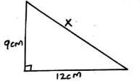

- Illustrate y < 2 on a number line. (2 mks)

- Simplify : 5(x + 5) + 4)2x + 5) = (2 mks)

- Kibe had d goats. Kayian has four times as many goats as Kibe. Write down an expression for the total number of goats owned by Kibe and Kayian. (2 mks)

- Work out : √2.25 (2 mks)

- Find the perimeter of the shape below. (2 mks)
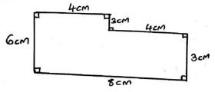

- Work out the circumference (2 mks)
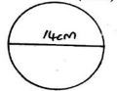

- How many square metres are there in 10 acres?

- What is the area of the figure below in hectares?
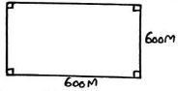

- Find the area of the parallelogram below. (2mks)
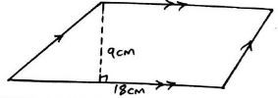

- Calculate the area of a circle whose diameter is 10 cm. (Take π = 3.14 cm)

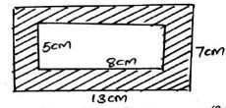

- Convert 8 m³ into cubic centimetres. (2 mks)

- Calculate the value of the figure below. (2 mks)
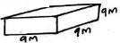

- The cross sectional area of a cube is 64 cm². If it's side is 8 cm. What is the volume of the cube? (2 mks)

- What is the time on the clock face? (2mks)
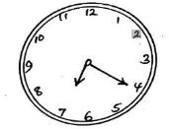

- Which of the following are odd numbers?

9, 57, 17, 124, 17, 46, 541, 6 (2 mks)

- In 2020 Maziwa Milk Processing Company produced 625, 483 196 packets of milk. In same year, the company sold 615295438 packets of milk. How many packets of milk
remained? (2 mks)

- 1729316 + 2070492 = (2 mks)

- 8483926 + 316 = (2 mks)

- Find the next number in the sequence 2, 3, 5, 7, 11, (2 mks)

- Find the area of the shaded region. (2 mks)

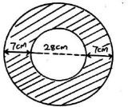

- Work out: 35 + 3 ½ (2 mks)

- Grade 7 learners of Timis Comprehensive School learnt and identified all prime numbers between 20 and 50. They later added them. What answer did they get? (2 mks)

- The number written on a chart is 543006704.0289. Use it to answer question 1 (a) to (e).

  - Write the number in words. (1mk)

  - What is the place value of 5?(1mk)

  - What is the number correct to 3 decimal places? (1mk)

  - Round off the number to 2 significant figures. (1mk)

  - What is the place value of 9?(1mk)

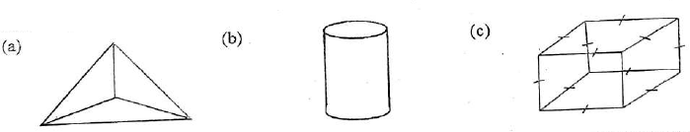
- Identify the 3D shapes.

- Work out:-

- 14¹/₃ - 6³/₄ =

- 9 ²/₉ + 6 ²/₃ =

- 19 - ⁷/₉

- A rectangular plot of land measures 12m long and 5¹/₄ m wide. What is the area of the plot? square (1 mk)

- Mr Lima, who is a dairy farmer, stored milk in three containers of 30 litres, 36 litres and 60 litres. The milk in each container was then repacked by his salesman into smaller containers. The amount of milk in each of the smaller containers was the same. What was the capacity of the largest container used to repack the milk? (2 mks)

- Dan had a string of 567.973m. What is the length of the string rounded off to the nearest tenth? (2 mks)

- Tom earns a monthly salary of Kshs. 12,000. He spends ¹/₃ on food, ³/₈ on rent and uses the rest on transport. How much money does he spend on transport? (2 mks)

- A circular wheel has a diameter of 42cm. What distance in metres does it cover when it makes 80 revolutions? (Take π = ²²/₇) (2 mks)

- A trader sold a microwave at Shs. 12,500 making a profit of shs. 3,450. What was the buying price of the microwave? (2 mks)

- What is the next number in the series below? (2 mks)
21, 23, 26, 31, 38,

- What is the size of angle SRQ in the triangle below? (2 mks)
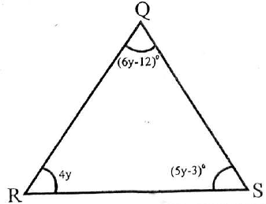

- What is the distance round the figure below? (2 mks)
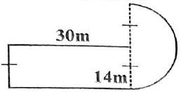

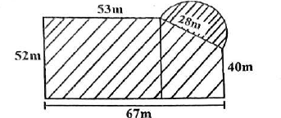
- Work out the area of the figure below.(2mks)

- What is the value of?
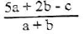

if a=3, b=2 and c=4?

- Tim slept at 8:45p.m. and woke up at 7:35a.m. How long did he sleep? (1 mark)

- A pickup weighs 1.5 tonnes when empty and 2300kg when carrying 20 bags of beans. What is the average weight of each bag in kilograms? (1 mark)

Evaluate :-

63 – 9 x 12+4+28 (2 mks)

- What is ¹/₆ of (24 - 6) x ¹/₄ ÷ 2? (2 mks)

- What is the perimeter of the following rectangle?
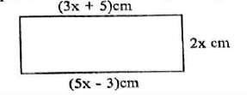

- Arrange the following fractions in descending order.

⁴/₅, ¹/₄, ⁷/₈, ²/₃

- Find the distance round the following figure in decametres. (2 mks)
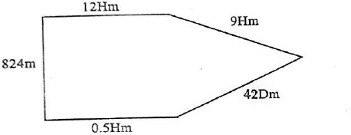

- The graph below shows Stanley's journey.

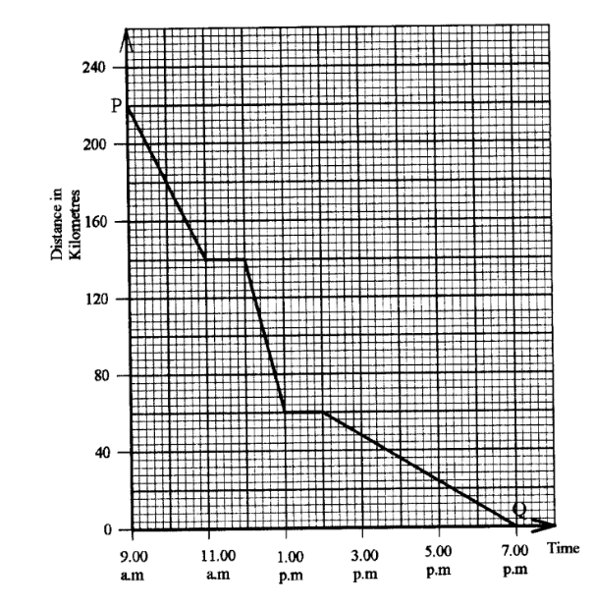

  - What distance did he travel a? (1 mark)

  - What was his average speed for the whole journey? (1 mark)

  - What distance had he covered at 3:00p.m.? (1 mark)

Answers

- 10 Hm 85 m 48 cm

- 13 Hm 7 Dm

- x = 15

- 13x + 40

- 5d

- 1.5

- 28 cm

- 44 cm

- 40468.6 m²

- 36 hectares

- 162 cm

- 51 cm²

- 8000 000 cm³

- 729 m²

- 512 m²

- 7 : 20

- 9, 57, 17, 541

- 10, 187, 758

- 10, 187 758

- 26 847 rem 274

- 13

- 770 cm²

- 10

- 251

- (a) five hundred and forty-three million, six thousand seven hundred and four point zero two eight nine

  - hundreds of millions

  - 543006704.209

  - 543,000,000

  - tens of thousands

- (a) triangular prism

  - cylinder

  - cube

- a) 7⁷/₁₂

- 15⁸/₉

- 18 ²/₉

- 63m²

- 6 litres

- 568.0m

- 3500

- 105.6m

- sh.9050

- 49

- 52⁰

- 132m

- 3708 m²

- 3

- 10hrs 50min

- 40 kg

- 64

- ³/₈m

- 50 cm

- ⁷/₈, ⁴/₅, ²/₃, ¹/₄

- 339.4Dm

- (a)

