TERM 3 HOLIDAY ASSIGNMENT 2026
FORM THREE
PHYSICS PAPER 1 (232/1)
Section / Questions | Maximum Score | Candidate's Score
A: 1–13 | 25
B: 14 | 12
B: 15 | 12
B: 16 | 13
B: 17 | 10
B: 18 | 8
TOTAL | 80

SECTION A (25 MARKS)
1. The figure below shows the reading on a burette after 55 drops of a liquid have been used. If the initial reading was at the zero mark, determine the volume of one drop. (2 marks)
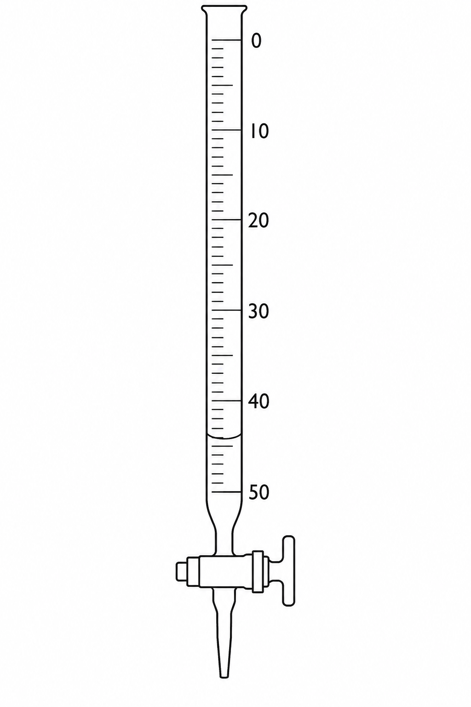
________________________________________________________________________________
________________________________________________________________________________
2. State one factor that affects the surface tension of a liquid. (1 marks)
________________________________________________________________________________
________________________________________________________________________________
3. Some water in a tin can was boiled for some time. The can was then sealed and cooled. After some time it collapsed. Explain this observation. (2 marks)
________________________________________________________________________________
________________________________________________________________________________
________________________________________________________________________________
4. A solid weighs 18.2 N on the surface of a moon where the gravitational field strength is 1.4 N/kg. Determine the mass of the solid. (2 marks)
________________________________________________________________________________
________________________________________________________________________________
5. A paper windmill with a horizontal axis is placed above a candle as shown in the figure below. When the candle is lit, the paper windmill begins to rotate. Explain this observation. (2 marks)
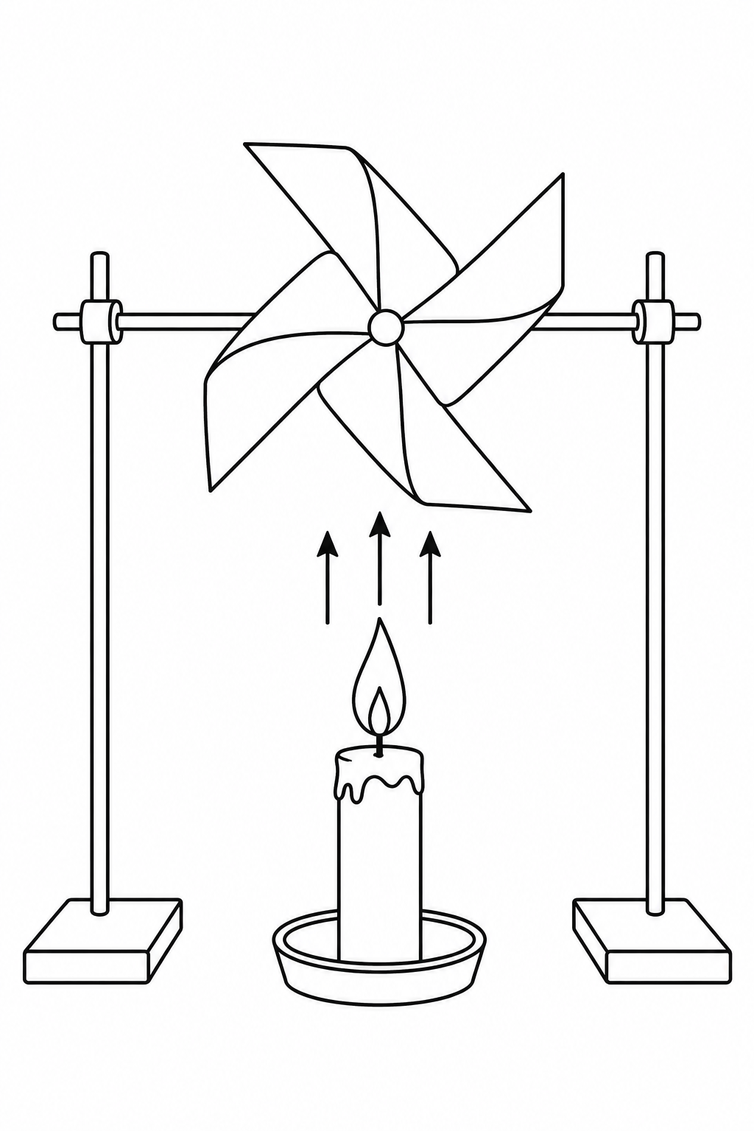
________________________________________________________________________________
________________________________________________________________________________
________________________________________________________________________________
6. When a liquid is heated in a glass flask, its level at first falls and then rises. Explain this observation. (2 marks)
________________________________________________________________________________
________________________________________________________________________________
________________________________________________________________________________
7. The figure below shows a uniform cardboard in the shape of a parallelogram. Locate its centre of gravity. (1 marks)
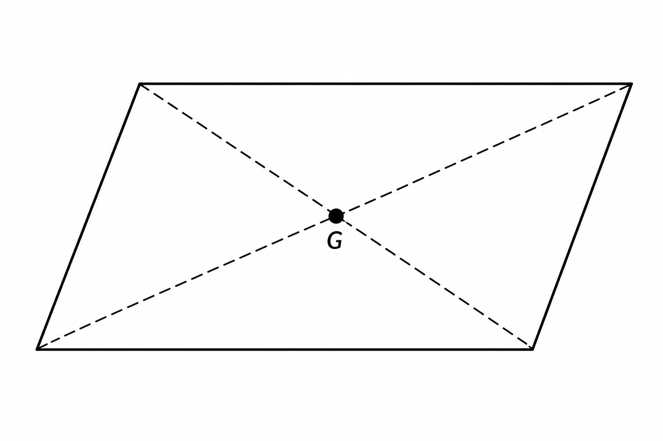
________________________________________________________________________________
________________________________________________________________________________
8. On the axes provided, sketch the density-temperature graph when water is heated from 0 °C to 10 °C. (1 marks)
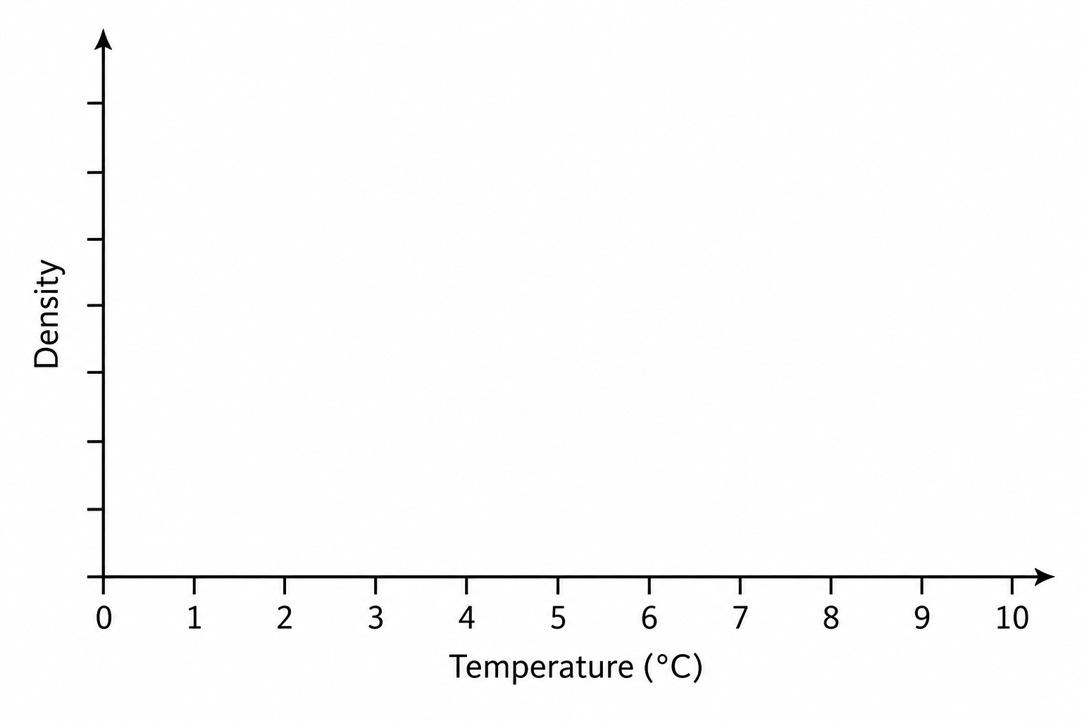
9. (a) An aeroplane is moving horizontally through still air at a uniform speed. It is observed that when the speed of the plane is increased, its height above the ground increases. State the reason for this observation. (1 marks)
________________________________________________________________________________
________________________________________________________________________________
(b)(i) Name one other force, other than weight and upthrust, acting on an object falling through a liquid. (1 marks)
________________________________________________________________________________
(b)(ii) State two ways in which friction can be minimized. (1 marks)
________________________________________________________________________________
________________________________________________________________________________
10. (i) The figure below shows water sprinkling from a pipe. Explain why the pipe rotates. (2 marks)
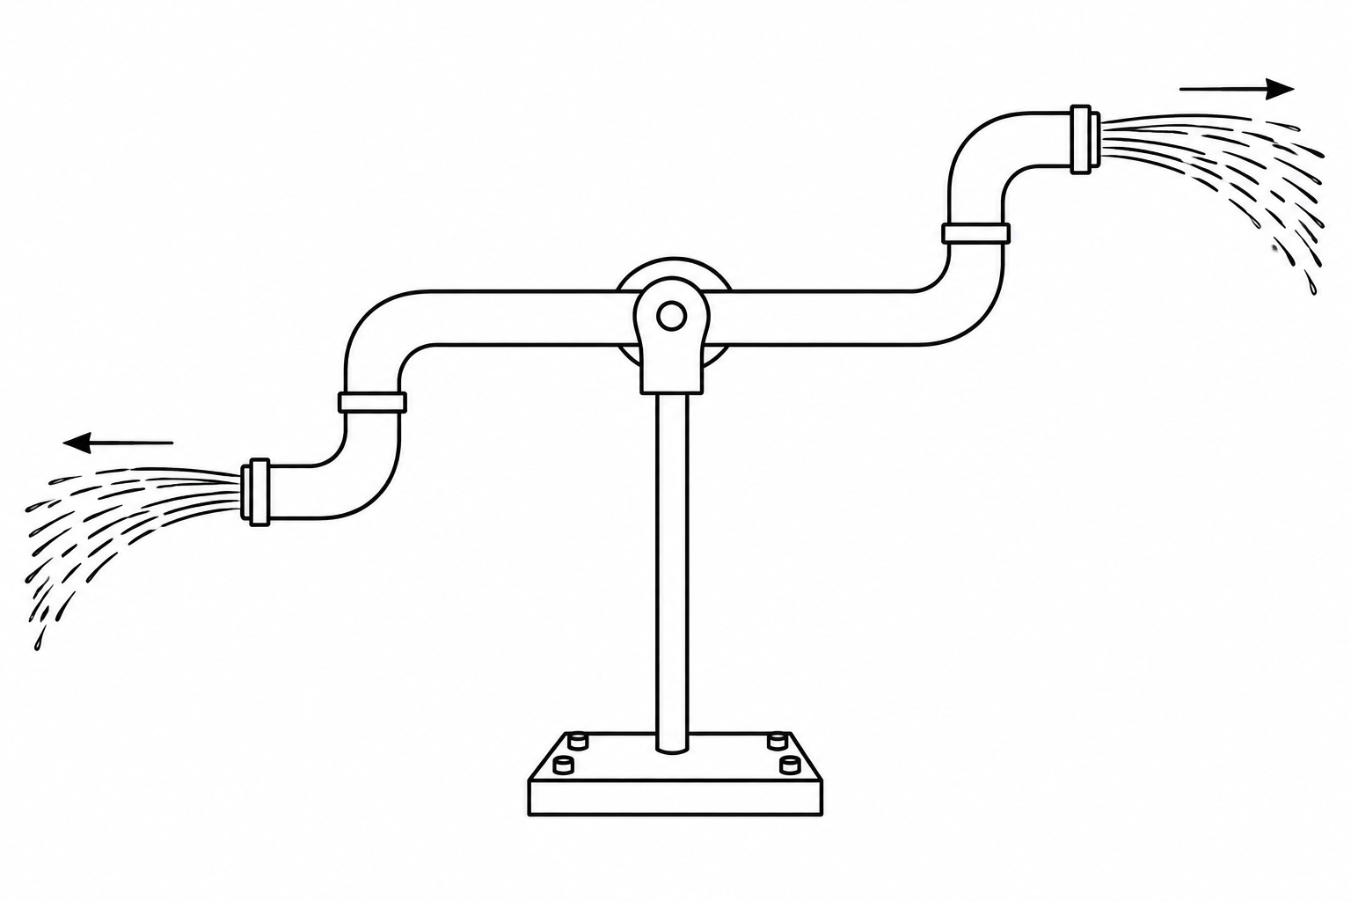
________________________________________________________________________________
________________________________________________________________________________
________________________________________________________________________________
10(ii). A fisherman jumping ashore from a boat may fall into the water even if the boat is very close to the shore. Explain. (2 marks)
________________________________________________________________________________
________________________________________________________________________________
________________________________________________________________________________
11. A drop of blue ink is introduced at the bottom of a beaker containing water. After some time, all the water in the beaker turns blue. Name the process that takes place. (1 marks)
________________________________________________________________________________
________________________________________________________________________________
12. An astronaut climbing a very high mountain is likely to experience nose bleeding. Explain why this may happen. (1 marks)
________________________________________________________________________________
________________________________________________________________________________
13. (a) State the SI unit of a spring constant. (1 marks)
________________________________________________________________________________
(b) Two identical springs, each of spring constant 4 N/cm, are used to support a load of 36 N as shown in the figure below. Determine the extension of each spring. (2 marks)
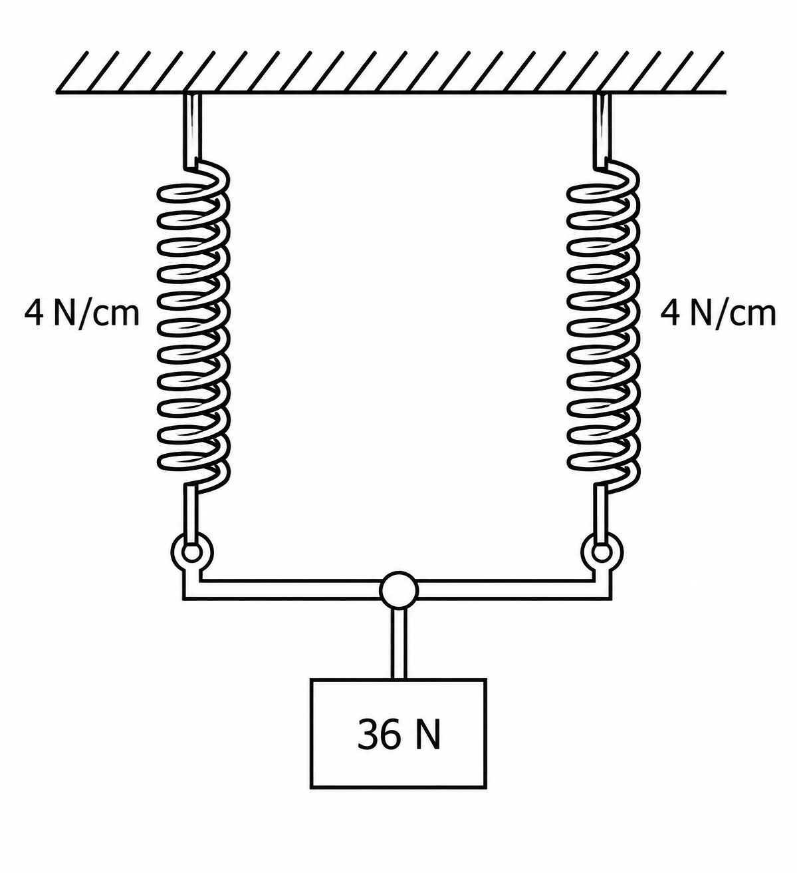
________________________________________________________________________________
________________________________________________________________________________
________________________________________________________________________________

SECTION B (55 MARKS)
Answer ALL the questions in this section.
14. (a) The figure below shows a velocity-time graph for the motion of a certain body. Describe the motion in the regions:
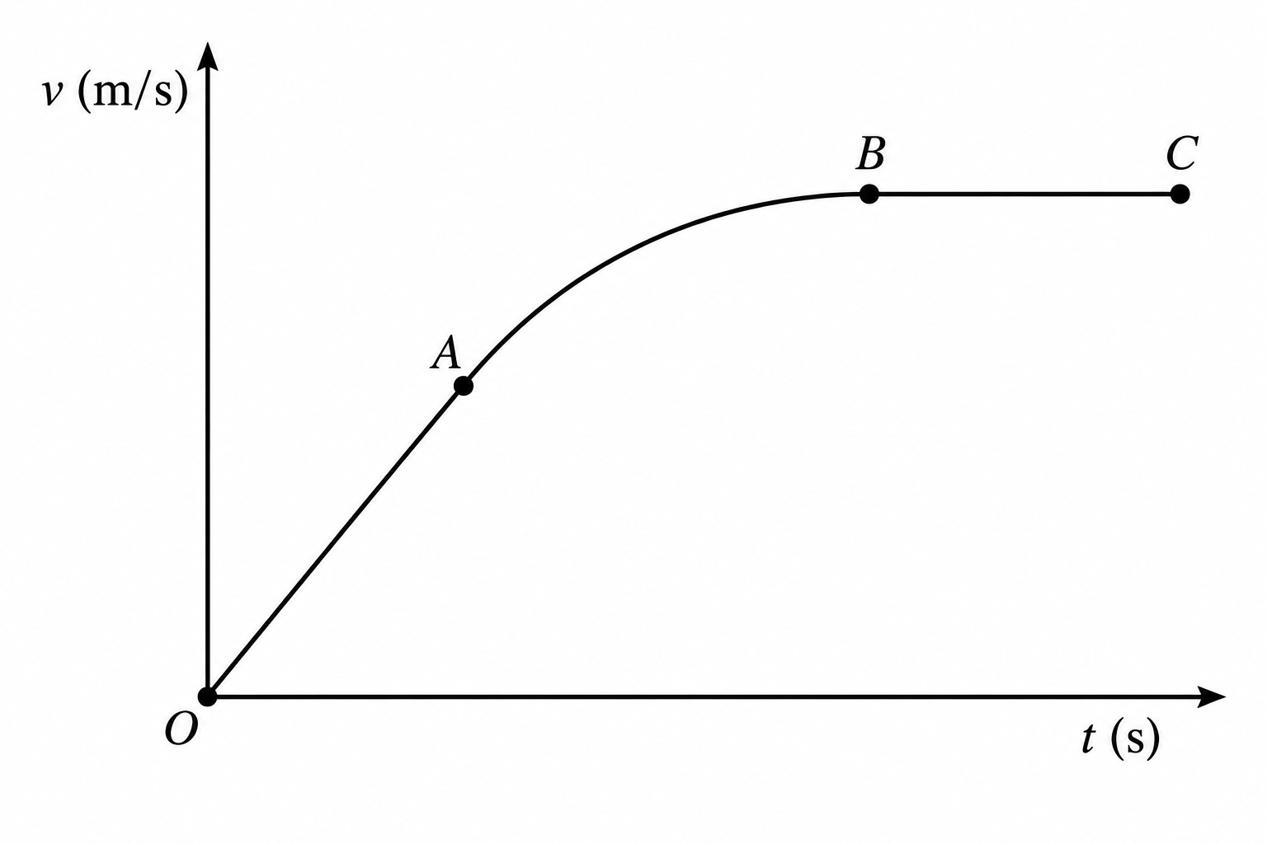
(i) OA. (1 marks)
________________________________________________________________________________
(ii) AB. (1 marks)
________________________________________________________________________________
(iii) BC. (1 marks)
________________________________________________________________________________
14(b). A car moving initially at 12 m/s decelerates uniformly at 3 m/s². Determine:
(i) its velocity after 1.5 s. (2 marks)
________________________________________________________________________________
________________________________________________________________________________
(ii) the distance travelled in 1.5 s. (2 marks)
________________________________________________________________________________
________________________________________________________________________________
(iii) the time taken by the car to stop. (2 marks)
________________________________________________________________________________
________________________________________________________________________________
(iv) Sketch the velocity-time graph for the motion of the car up to the time it stops. (1 marks)
________________________________________________________________________________
________________________________________________________________________________
________________________________________________________________________________
________________________________________________________________________________
________________________________________________________________________________
(v) From the graph, determine the distance covered by the car before it stopped. (2 marks)
________________________________________________________________________________
________________________________________________________________________________
________________________________________________________________________________
15. (a) On a certain planet, a simple pendulum of length 0.64 m oscillates with a frequency of 0.30 Hz. If the mass of the body suspended is 40 g, determine:
(i) the acceleration due to gravity on the planet. Take π = 3.142. (2 marks)
________________________________________________________________________________
________________________________________________________________________________
(ii) the weight of the body on the planet. (2 marks)
________________________________________________________________________________
________________________________________________________________________________
(b) The figure shows a smooth card placed over the open end of a container. A coin is placed on the card. When the card is pulled horizontally away suddenly, the coin drops into the container. Explain this observation. (2 marks)
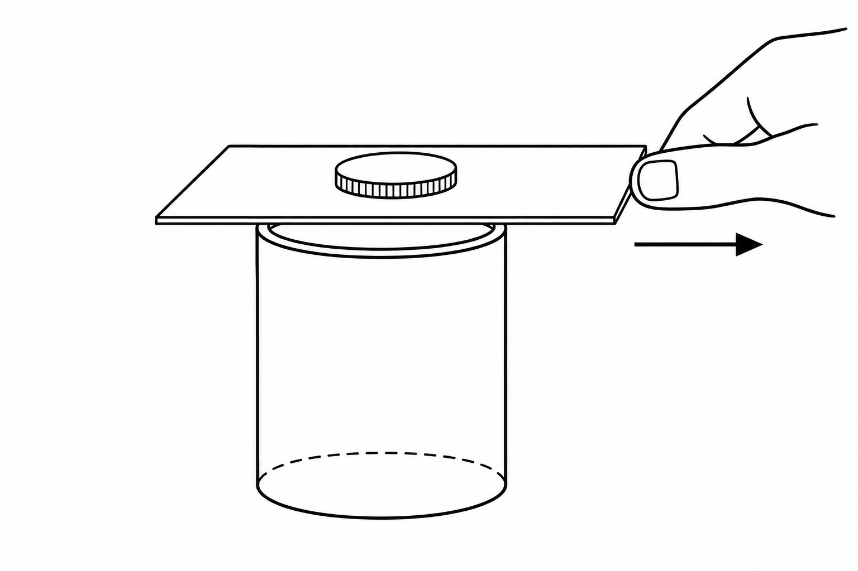
________________________________________________________________________________
________________________________________________________________________________
________________________________________________________________________________
15(c). A person of mass 75 kg is standing in a lift. What force does the person exert on the floor when the lift is:
(i) at rest? Take g = 10 N/kg. (1 marks)
________________________________________________________________________________
(ii) accelerating upwards at 3 m/s². (2 marks)
________________________________________________________________________________
________________________________________________________________________________
(iii) moving downwards with an acceleration of 2 m/s². (2 marks)
________________________________________________________________________________
________________________________________________________________________________
(iv) moving upwards with a constant velocity of 5 m/s. (1 marks)
________________________________________________________________________________
16. (a) A person pulls a box of weight 800 N up an inclined plane 7.5 m long using a force of 500 N parallel to the plane as shown in the figure below.
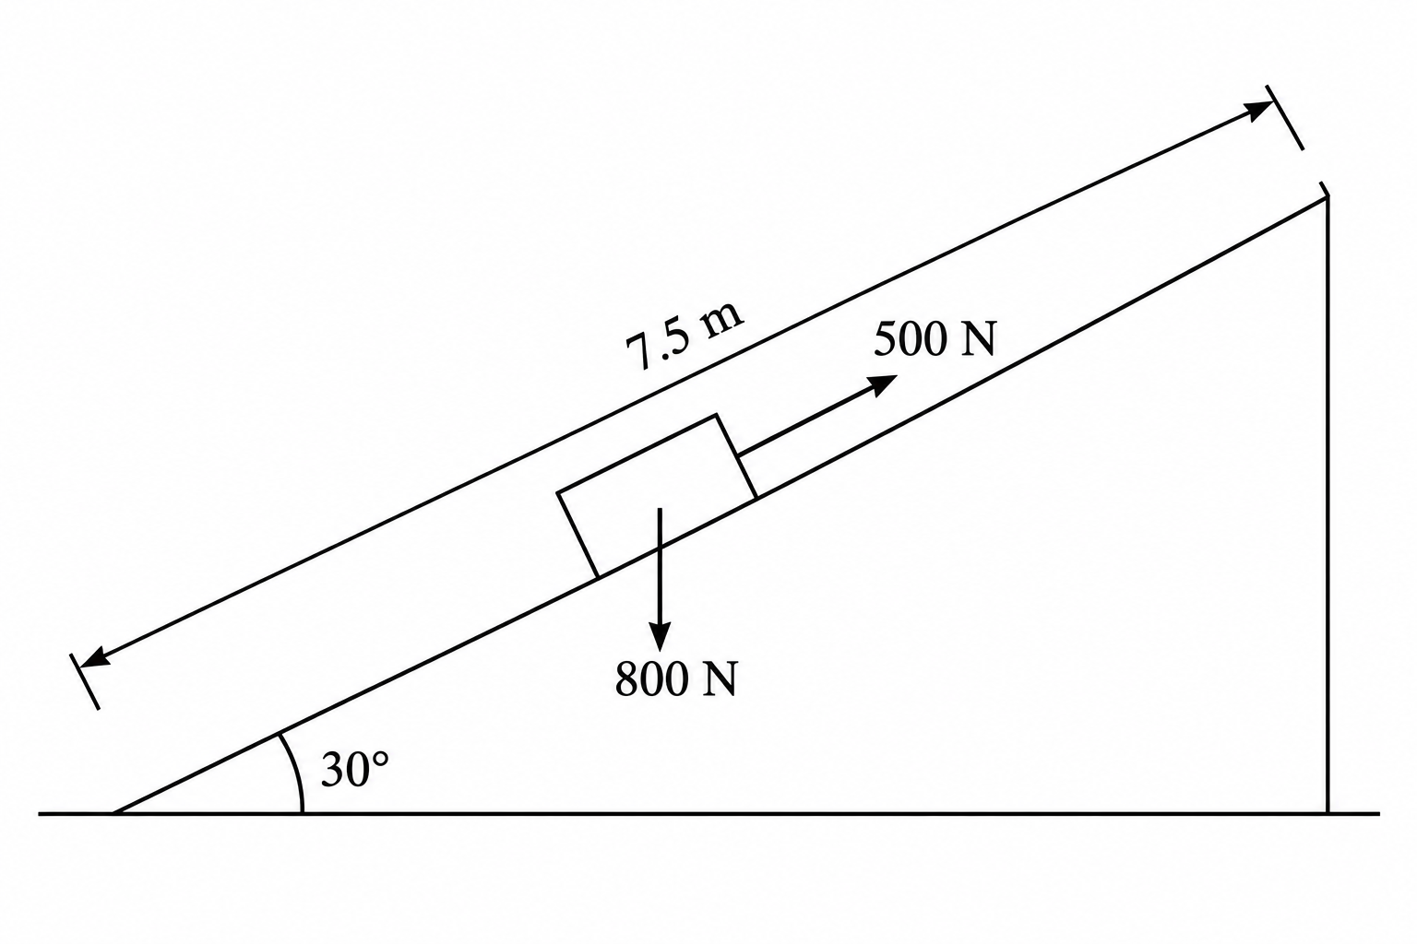
Calculate:
(i) the velocity ratio (VR). (1 marks)
________________________________________________________________________________
(ii) the vertical height h. (2 marks)
________________________________________________________________________________
________________________________________________________________________________
(iii) the work done by the effort. (2 marks)
________________________________________________________________________________
________________________________________________________________________________
(iv) the useful work done. (2 marks)
________________________________________________________________________________
________________________________________________________________________________
(v) the efficiency of the plane. (2 marks)
________________________________________________________________________________
________________________________________________________________________________
16(b). The figure shows a simple pendulum of length 60 cm. The pendulum bob has a mass of 100 g and oscillates between A and C through the rest position B.
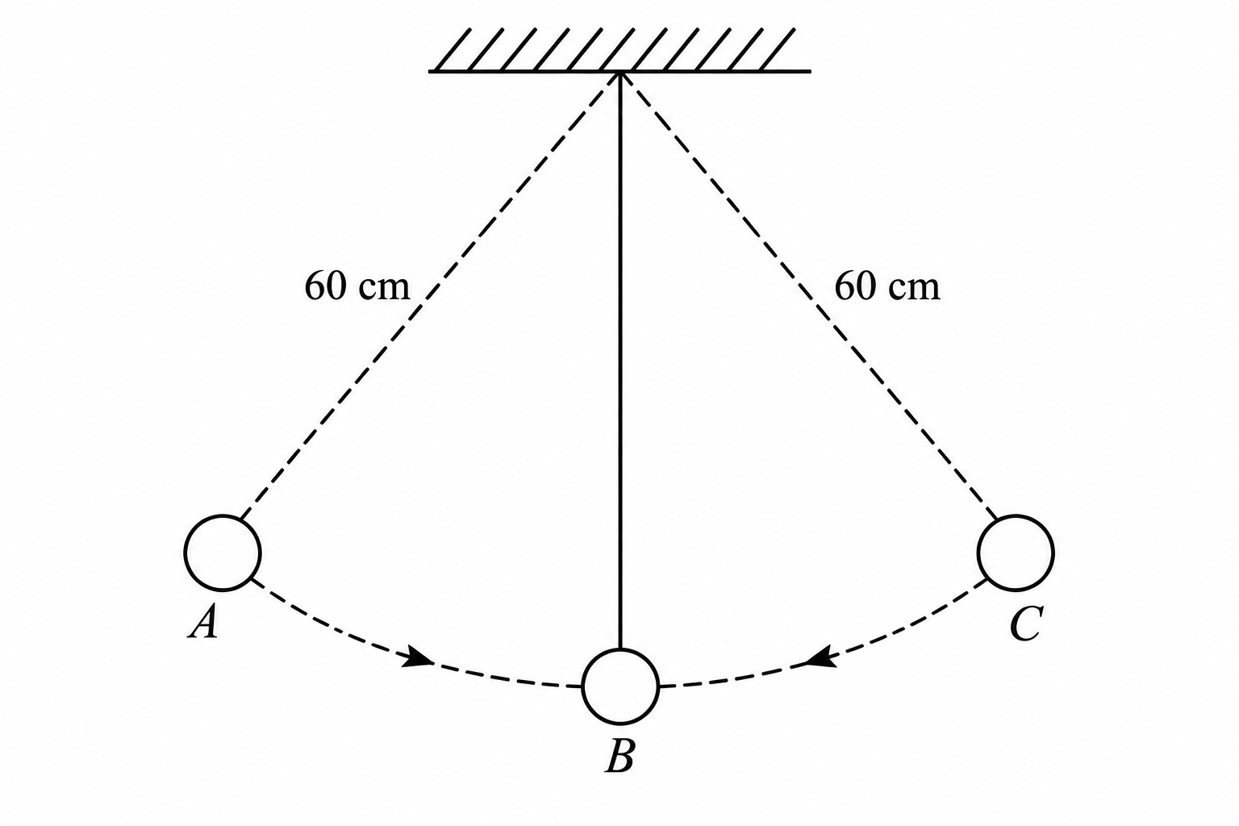
(i) Indicate with an arrow on path ABC the direction of greatest velocity as the bob moves from A to C. (1 marks)
________________________________________________________________________________
________________________________________________________________________________
(ii) State the form of energy possessed by the pendulum bob at A. (1 marks)
________________________________________________________________________________
(iii) Determine the velocity of the bob at B if the vertical height through which it falls from A to B is 0.15 m. Take g = 10 m/s². (2 marks)
________________________________________________________________________________
________________________________________________________________________________
________________________________________________________________________________
17. (a) A metal pail feels colder to touch than a plastic pail on a cold morning even though both have the same temperature. Explain this observation. (1 marks)
________________________________________________________________________________
________________________________________________________________________________
(b) The diagram below shows a vacuum flask.
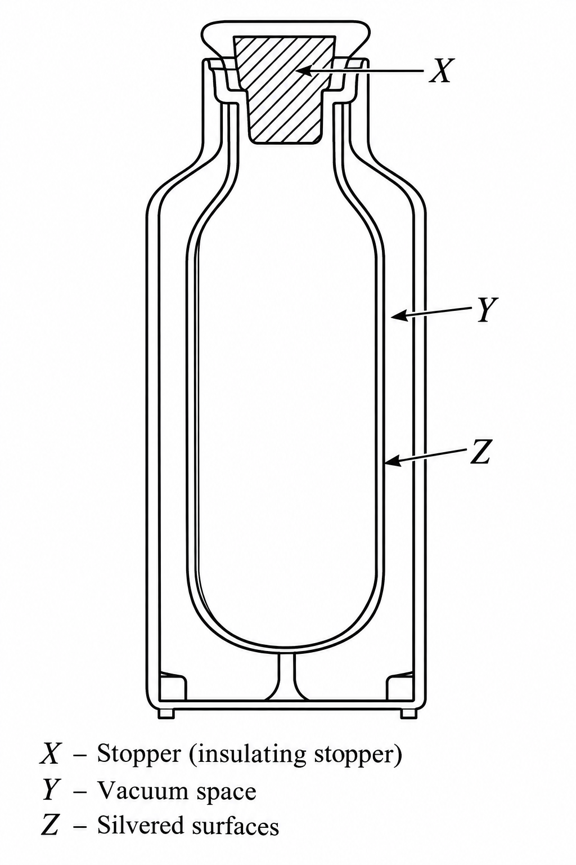
(i) Name the parts labelled X and Z. (2 marks)
________________________________________________________________________________
________________________________________________________________________________
(ii) Name the material the part labelled Y is made of. (1 marks)
________________________________________________________________________________
(iii) State how the thermos flask minimizes heat loss. (2 marks)
________________________________________________________________________________
________________________________________________________________________________
________________________________________________________________________________
(c) The figure below shows a clinical thermometer which is not graduated.
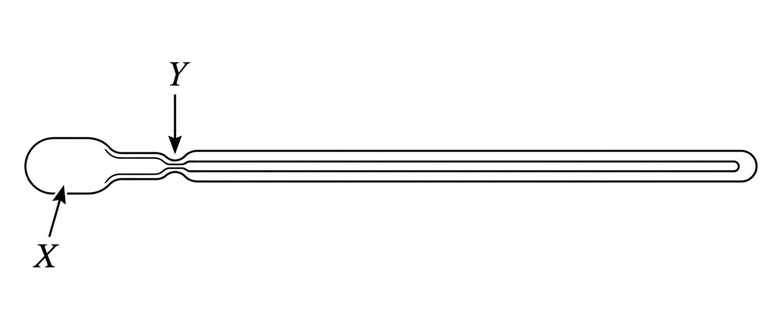
(i) Name the parts indicated by X and Y. (2 marks)
________________________________________________________________________________
________________________________________________________________________________
(ii) What is the function of the part labelled Y? (1 marks)
________________________________________________________________________________
(iii) State the appropriate scale range in degrees Celsius for a clinical thermometer. (1 marks)
________________________________________________________________________________
18. (a) In opening a door, the moment exerted about the hinges is 18 N m. If the pushing force is 30 N and perpendicular to the door, what is the distance of the force from the hinges? (2 marks)
________________________________________________________________________________
________________________________________________________________________________
(b) A uniform plank of wood is balanced 35 cm from one end when a lead of 0.10 kg is hung at one end as shown. Calculate the weight of the plank. Take g = 10 N/kg. (2 marks)
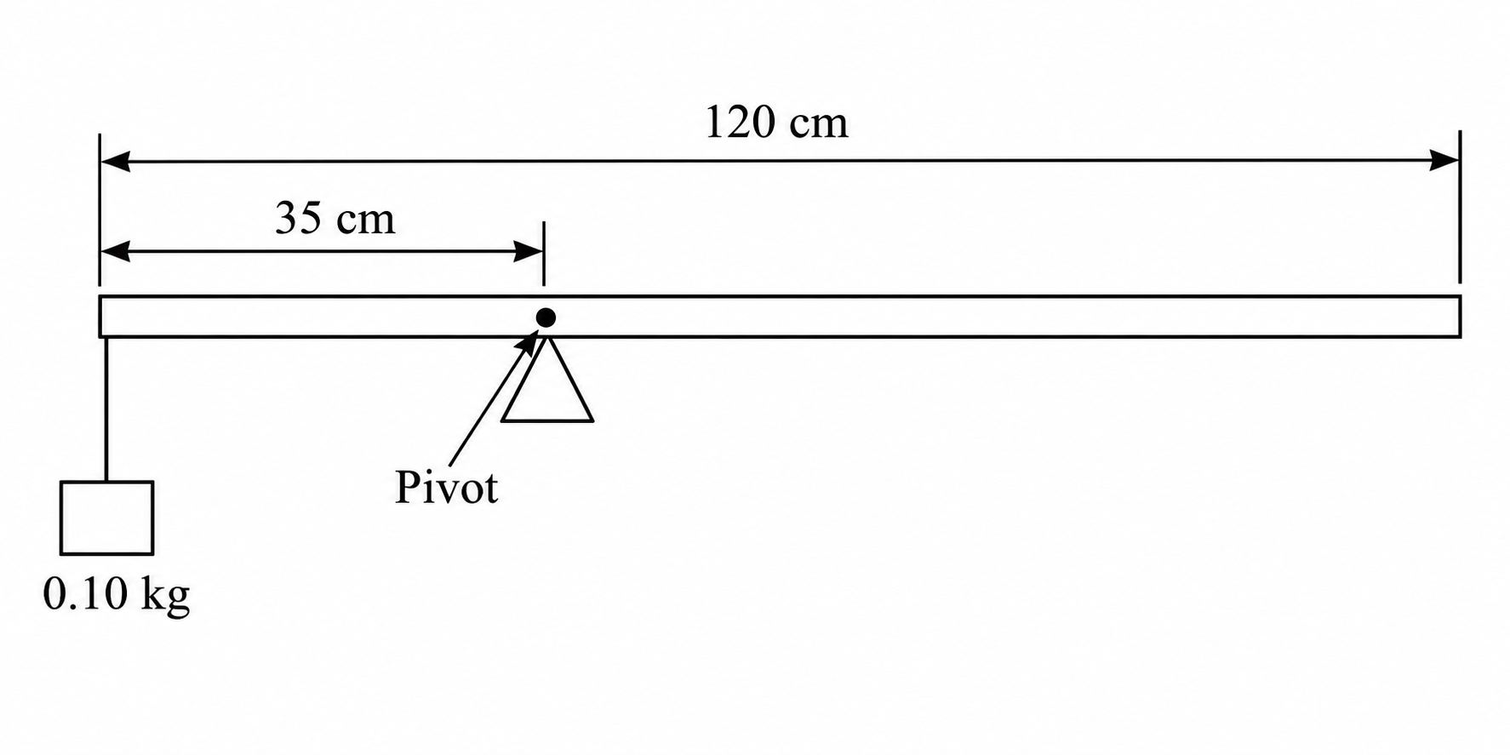
________________________________________________________________________________
________________________________________________________________________________
________________________________________________________________________________
(c) State two factors that affect the position of the centre of gravity. (2 marks)
________________________________________________________________________________
________________________________________________________________________________
(d) The figure shows an oil patch formed on a water surface laced with lycopodium powder. Given that the patch came from one drop of oil whose volume was 39.27 mm³, determine the size of one molecule of the oil. (2 marks)





