TERM 3 HOLIDAY ASSIGNMENT 2026
FORM THREE
BIOLOGY PAPER 3 (PRACTICAL)
Question | Maximum Score | Candidate's Score
1 | 13
2 | 12
3 | 15
TOTAL | 40

1. You are provided with a suspension labelled M which contains food substances. You are also provided with iodine solution, Benedict's solution, dilute hydrochloric acid, dilute sodium hydrogen carbonate, copper(II) sulphate and dilute sodium hydroxide. Carry out tests to determine the food substances in suspension M. (13 marks)
Food substrate being tested | Procedure | Observation | Conclusion
Starch
Reducing sugar
Protein
Lipid

Use the appropriate reagents and record the observations and conclusions in the table. Where heating is required, use the available apparatus safely.

2. Photographs Q1, R1 and S1 represent three different organisms. Study them and use them to answer the questions that follow. (12 marks)
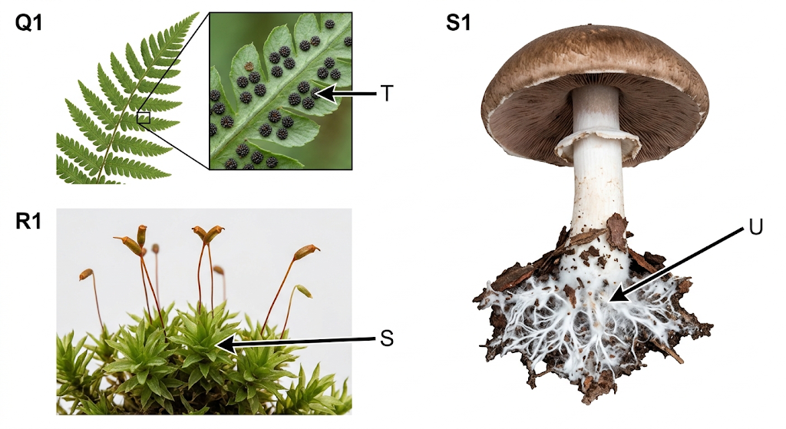
a) Identify the kingdom to which each of the organisms belongs. (2 marks)
________________________________________________________________________________
________________________________________________________________________________
Organism | Kingdom
Q1 and R1
S1

b) Name the divisions to which Q1 and R1 belong. (2 marks)
________________________________________________________________________________
________________________________________________________________________________
Organism | Division
Q1
R1

c) Name the structures labelled S, T and U. (3 marks)
________________________________________________________________________________
________________________________________________________________________________
________________________________________________________________________________
S: _________________________________________________
T: _________________________________________________
U: _________________________________________________
d) i) Name the structures responsible for reproduction of S1. (1 mark)
________________________________________________________________________________
ii) State one economic importance of organism S1. (1 mark)
________________________________________________________________________________
e) State the mode of nutrition for organism S1 and Q1. (2 marks)
________________________________________________________________________________
________________________________________________________________________________
S1: _________________________________________________
Q1: _________________________________________________
f) Name the dominant generation of specimen Q1 in wet weather. (1 mark)
________________________________________________________________________________

3. You are provided with a specimen labelled K. (15 marks)
a) i) Giving a reason, identify the part of the plant represented by specimen K. (2 marks)
________________________________________________________________________________
________________________________________________________________________________
ii) Cut the specimen into two halves transversely. Observe the arrangement of seeds inside the specimen. Suggest its type of placentation. (1 mark)
________________________________________________________________________________
b) i) Suggest the mode of dispersal for specimen K. (1 mark)
________________________________________________________________________________
ii) Give one reason for your answer in (b)(i). (1 mark)
________________________________________________________________________________
c) i) Specimen K in its raw state has an excretory substance in its skin. Name the excretory substance. (1 mark)
________________________________________________________________________________
ii) State one importance of the excretory substance named in (c)(i) to human beings. (1 mark)
________________________________________________________________________________
d) i) From the remaining parts of specimen K, cut thin strips measuring 1 cm wide and 5 cm long. Place two strips in tap water (solution X) and two in concentrated salt solution (solution Y). Allow the set-ups to stand for 30 minutes. Record the shape of the strips from each solution. (2 marks)
________________________________________________________________________________
________________________________________________________________________________
Solution X: _________________________________________________
Solution Y: _________________________________________________
ii) Using your fingers, feel the texture of the strips from the two solutions. (2 marks)
________________________________________________________________________________
________________________________________________________________________________
Solution X: _________________________________________________
Solution Y: _________________________________________________
e) Explain the observations made in (d)(i) and (d)(ii) for the strips in solution X. (4 marks)
________________________________________________________________________________
________________________________________________________________________________
________________________________________________________________________________
________________________________________________________________________________
________________________________________________________________________________
________________________________________________________________________________
________________________________________________________________________________
________________________________________________________________________________

