COMPETENCY BASED EDUCATION

JUNIOR SCHOOL EDUCATION ASSESSMENT

NOVEMBER-DECEMBER ASSIGNMENT 2026
GRADE 8 – SOCIAL STUDIES
Time: 2 Hours
LEARNER’S DETAILS
Name: ________________________________________________. School: ________________________________________.
Assessment Number: _________________________________. Date: __________________________________________.
School Code: _______________________________________. Signature: ______________________________________.

INSTRUCTIONS TO CANDIDATES
- Write your name in the spaces provided above.
- Write the name of your school and your stream in the spaces provided.
- Write your admission number and the date of the assessment in the spaces provided.
- This paper consists of two sections: A and B.
- Answer all questions in section A and section B.
- Answer the questions in English.
- All answers MUST be written in the spaces provided in the paper.
- Do NOT remove any page from this question paper.

FOR OFFICIAL USE ONLY (EXAMINER’S USE)
SECTION | SECTION A | SECTION B | % SCORE | EE1 | EE2 | ME1 | ME2 | AE1 | AE2 | BE1 | BE2
SCORE RANGE | 30 MARKS | 50 MARKS |  | 90-100 | 75-89 | 58-74 | 41-57 | 31-40 | 21-30 | 11-20 | 1-10
POINTS |  |  |  | 8 POINTS | 7 POINTS | 6 POINTS | 5 POINTS | 4 POINTS | 3 POINTS | 2 POINTS | 1 POINT
LEARNER’S TOTAL SCORE

SECTION A (30 MARKS)
Answer ALL questions in this section.
- Elsy, a grade 8 learner is interested in knowing the component of the Kenyan constitution. She searched from the internet and identified the components of the Kenya constitution. Mention any four components of Kenya constitution she identified. (4 marks)
- ____________________________________________________________________________________
- ____________________________________________________________________________________
- ____________________________________________________________________________________
- ____________________________________________________________________________________

- The chart below shows the arms of the government and their roles.
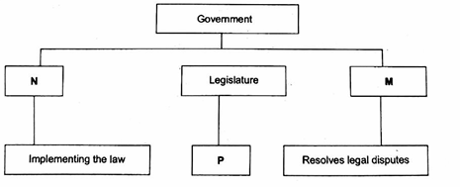
Fill in the information in parts marked M, N and P respectively. (3 mks)

M: __________________________________
N: ___________________________________
P: ___________________________________

- You have been elected as a school captain. Identify one way in which;

a. you can exhibit good leadership intended in chapter six of the constitution of Kenya. (1 mark)

________________________________________________________________________________________________________________________________________________________________________
b). you can apply constitutional principles of leadership and integrity in daily interactions with other learners. (1 mark)
________________________________________________________________________________________________________________________________________________________________________

- Abisa is a child right activist. Demonstrate any two ways in which Abisa can protect violation of children rights. (2 marks)
- ____________________________________________________________________________________
- ____________________________________________________________________________________
- A group of learners are discussing the inspiring values and principles from Wangari Mathai and Mahatma Ghadhi that made them to be selected Nobel Prize Winners. Highlight two of the values and guiding principles. (2 marks)
- ____________________________________________________________________________________
- ____________________________________________________________________________________
- Hellen outlined the changes that took place in humans as a result of evolution. Mention any two of the changes. (2 mks)
- ____________________________________________________________________________________
- ____________________________________________________________________________________
- Leila lives along the Coast of East Africa. Identify any two Swahili civilization that are practiced where Leila lives. (2 mks)
- ____________________________________________________________________________________
- ____________________________________________________________________________________
- Tenje described the organization of the trans-Saharan slave trade. Describe its organization as per Tenje's description. (2 mks)
- ____________________________________________________________________________________
- ____________________________________________________________________________________
- Abdullah and his friends are discussing the effects of Trans-Saharan slave trade. Mention any two effects of the Trans-Saharan slave trade they discussed. (2 mks)
- ____________________________________________________________________________________
- ____________________________________________________________________________________

- Ahmed, a Kenyan citizen, has always wanted to become a surgeon. He is offered a scholarship in a university in South Africa. Ahmed decides to move to South Africa to study.
  - What type of migration is illustrated about Ahmed? (1 mark)

_______________________________________________________

  - What has made Ahmed to migrate? (1 mark)
________________________________________________________________________________________________________________________________________________

  - Identify any two effects of migration that can be as a result of Ahmed's migration. (2 marks)

- ____________________________________________________________________________________
- ____________________________________________________________________________________
- a) What is the demographic trends as used in population growth in Kenya? (1 mark)

______________________________________________________________
b) Ponje researched on the demographic trends in Kenya. He then wrote a report. Mention two demographic trends he would include in his report. (2 marks)
- ____________________________________________________________________________________
- ____________________________________________________________________________________

- Maria, a grade 8 girl is always seen lonely and poses low self-esteem due to her poor performance in class. Identify three ways Maria can build a healthy self-esteem for promotion of social cohesion. (3 marks)
- ____________________________________________________________________________________
- ____________________________________________________________________________________
- ____________________________________________________________________________________
- ____________________________________________________________________________________
- Doris is feeling overwhelmed with school work and co-curricular activities. In which two ways can she manage her stress and prioritize her responsibilities? (2 mks)
- ____________________________________________________________________________________
- ____________________________________________________________________________________
- Tom and Boby are arguing over a seat in a bus. Tom claims he was sitting there first while Boby says that he left his bag on the seat to safe it.
- Explain two ways the learners can come to a resolution that is fair for both of them (2 marks)
- ____________________________________________________________________________________
- ____________________________________________________________________________________
- Identify two ways that they can communicate their needs and feelings without getting angry and upset. (2 mks)
- ____________________________________________________________________________________
- ____________________________________________________________________________________
- Ndere outlined the benefits of community service learning to her community. State two benefits she addressed. (2 mks)
- ____________________________________________________________________________________
- ____________________________________________________________________________________
- grade 8 learners of Chomboro Junior school identified factors that influence weather and climate. Mention three factors learners identified. (3 mks)
- ____________________________________________________________________________________
- ____________________________________________________________________________________
- ____________________________________________________________________________________

- The diagram below shows the map of Pombe school. The length of one square grid is equivalent to 10 metres.

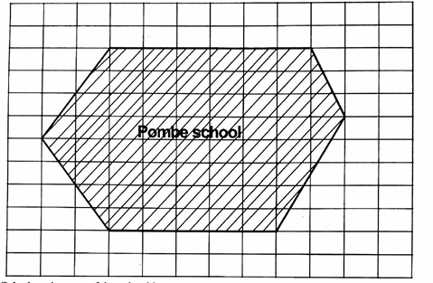

Calculate the areas of the school in square meters. (4 mks)

- Kizito visited one of the towns along the Coast of East Africa.

- The type of vegetation witnessed by Kizito was _________________(1 mark)

- Mention one characteristic of the vegetation in 18(a) above. (1 mark)

____________________________________________________________________________________________________________________________________________________________________________________

- Kendi wanted to visit historical sites and monuments in Africa. State two historical sites and monuments she is likely to visit. (2 marks)
- ____________________________________________________________________________________
- ____________________________________________________________________________________

SECTION C (80 MARKS)
Answer all questions in the spaces provided.
TASK 1: MAPWORK
Study the map of TOKA area and use it to answer the questions that follow
- A Social Studies teacher used the sketch map provided to facilitate a lesson on map reading and interpretation.
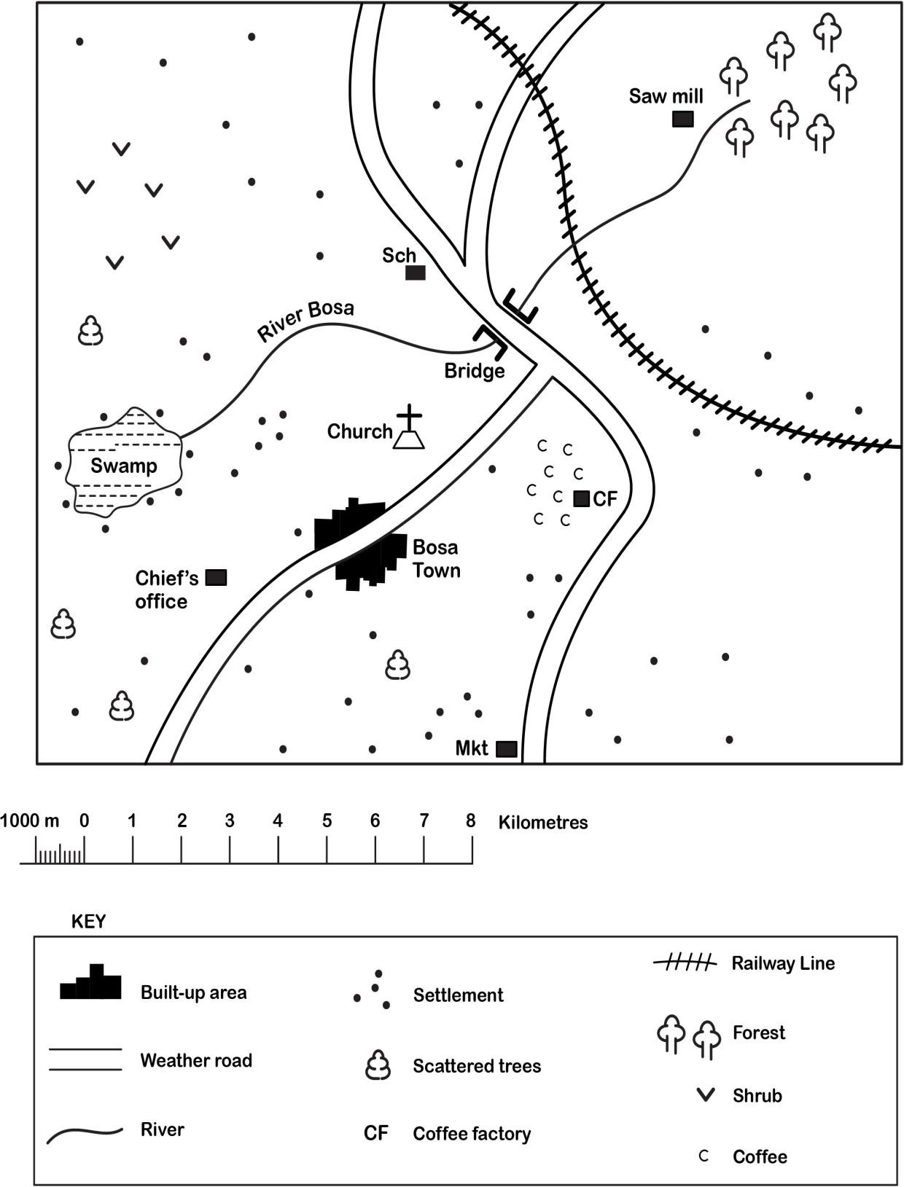


Mkt ☐ Market

a) The teacher asked the learners to state the direction one would take when walking from the sawmill to Bosa Town along the weather road.
Direction: ___________________________________________ (1 mark)
b) During the lesson, the teacher asked the learners to measure the distance along the weather road from the bridge to the market.
State the distance in kilometres. (2 marks)
Distance: ___________________________________________
c) The learners studied some economic activities carried out in the area.
Name four of these activities. (4 marks)
i. ________________________________________________________________________________________________________.
ii. ________________________________________________________________________________________________________.
iii. ________________________________________________________________________________________________________.
iv. ________________________________________________________________________________________________________.
d) The learners were asked to discuss the types of vegetation found in the area.
Identify three types of vegetation that they discussed. (3 marks)
i. _________________________________________________________________________________________________________.
ii. _________________________________________________________________________________________________________.
iii. ________________________________________________________________________________________________________.

TASK 2: GEOGRAPHY (25 Marks)
- During a geography project, Grade 8 learners from Umoja School carried out a field study on farming in their community.
a. State four methods they used to collect data in the field.
i. __________________________________________________________________________________________________.
ii. __________________________________________________________________________________________________.
iii.__________________________________________________________________________________________________.
iv. _________________________________________________________________________________________________.
b. Mention three methods they used to record the data collected.
- _________________________________________________________________________________________________
- _________________________________________________________________________________________________
- __________________________________________________________________________________________________________

c. State three challenges they faced when carrying out the field study.
- _________________________________________________________________________________________________
- _________________________________________________________________________________________________
- __________________________________________________________________________________________________________
d. Suggest three possible solutions to the challenges faced during the study.
- _________________________________________________________________________________________________
- _________________________________________________________________________________________________
- __________________________________________________________________________________________________________
e. Explain two importance of collecting accurate data during fieldwork.
- _________________________________________________________________________________________________
- _________________________________________________________________________________________________
- A Grade 8 learner recorded the following monthly temperatures from a nearby weather station.
Month | Jan | Feb | Mar | Apr | May | Jun | Jul | Aug | Sep | Oct | Nov | Dec
Temp °C | 29 |   24 | 33 | 27 | 27 | 29 | 29 | 28 | 33 | 28 | 30 | 29
a. Use the data to draw a simple bar graph showing the monthly temperatures.

b. Identify the month with the highest temperature.
__________________________________________________________________________________________
c. Identify the month with the lowest temperature.
__________________________________________________________________________________________
d. Suggest two factors that may influence temperature in this area.
- _________________________________________________________________________________________________
- _________________________________________________________________________________________________
e. Explain two importance of recording weather data.
- _________________________________________________________________________________________________
- _________________________________________________________________________________________________
- During a geography lesson, learners discussed factors influencing where people live in Africa.
a. State three factors that influence population distribution in Africa.
- _________________________________________________________________________________________________
- _________________________________________________________________________________________________
- _________________________________________________________________________________________________
b. List three components of the solar system.
- _________________________________________________________________________________________________
- _________________________________________________________________________________________________
- __________________________________________________________________________________________________________
- Caroline is learning about the geography of early African civilizations and is studying the role of rivers.
(a) Name two important rivers in Africa. (2 marks)
i. __________________________________________________________________________________________________________
ii. _________________________________________________________________________________________________________
(b) Explain how rivers contributed to the development of early African societies. (4 marks)
i. __________________________________________________________________________________________________________
ii. _________________________________________________________________________________________________________

- Sarah is exploring the geography of Africa and is studying climate patterns across different regions.
(a) Name two factors that influence climate in Africa. (2 marks)
i. __________________________________________________________________________________________________________
ii. _________________________________________________________________________________________________________
(b) Study the map below and use it to answer the following question.
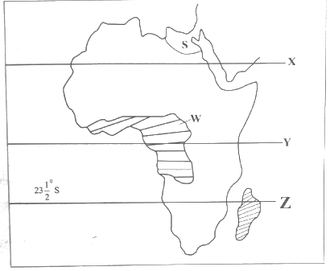
    - identify the climatic region marked W
_________________________________________________________________________________________________
    - What is the name of the following lines marked X and Y
X: _________________________________________________
Y: __________________________________________________
    - Name two countries crossed by the line marked Z
__________________________________________________________
__________________________________________________________
    - Identify country marked S
___________________________________________________________
(c) Explain the impact of climate on human settlement in Africa. (2 marks)
i. __________________________________________________________________________________________________________
ii. _________________________________________________________________________________________________________

(d) Using digital devices, Grade 8 learners searched for the effects of migration in Africa and came up with the following findings:
- Development of rural areas.
- Development of slums.
- Expansion of road network
- Separation of families.
Classify the above effects into positive and negative effects. (4 marks)
 | Positive |  | Negative
i |  | i
ii |  | ii

TASK 2: HISTORY AND GOVERNMENT (30 Marks)
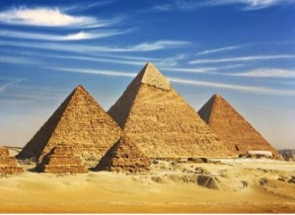
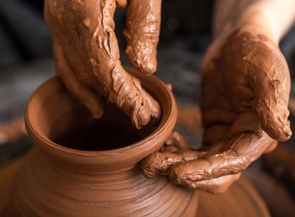
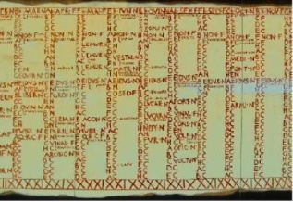
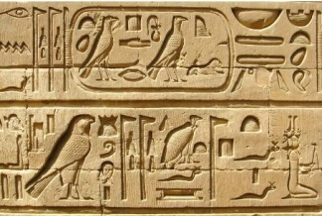
- During a history lesson, learners discussed ancient civilizations and early human life.
a. Name the following Ancient Egyptian invention.
A B C D
A: ______________________________________________________.
B: ______________________________________________________.
C: ______________________________________________________.
D: ______________________________________________________.
b. State three factors that led to the growth of the Great Zimbabwe Civilization.
- _________________________________________________________________________________________________
- _________________________________________________________________________________________________
- _________________________________________________________________________________________________
c. Mention four contributions of early civilization to the modern world.
- _________________________________________________________________________________________________
- _________________________________________________________________________________________________
- _________________________________________________________________________________________________
- _________________________________________________________________________________________________

d. State three characteristics of Homo sapiens.
- _________________________________________________________________________________________________
- _________________________________________________________________________________________________
- _________________________________________________________________________________________________
- During a discussion on African history, learners studied early kingdoms and communities.
a. Name two factors that led to the growth of the Kingdom of Kongo.
- _________________________________________________________________________________________________
- _________________________________________________________________________________________________
b. Identify two terms of the Berlin conference
- _________________________________________________________________________________________________
- _________________________________________________________________________________________________
c. Describe two aspects of the social organization of the Zulu community up to 1900.
- _________________________________________________________________________________________________
- _________________________________________________________________________________________________
d. Write the country in which the following monuments and historical sites are found
 | Historical site | Location
i. | Meroe
ii. | Timbuktu
iii. | Fort Jesus
iv. | Roben Island
- The learners explored early trade along the Indian Ocean coast.
a. State four factors that led to the development of the Trans-Saharan Trade in the 15th century.
- _________________________________________________________________________________________________
- _________________________________________________________________________________________________
- _________________________________________________________________________________________________
- _________________________________________________________________________________________________
b. State two social injustices committed against Africans during the Indian Ocean Slave Trade.
- _________________________________________________________________________________________________
- _________________________________________________________________________________________________
c. Explain two economic effects of the Trans-Saharan Slave trade on East Africa.
- _________________________________________________________________________________________________
- _________________________________________________________________________________________________
- During a lesson on early farming, learners studied how ancient Egyptians practiced irrigation.
a. Name four crops that were grown in the Rift Valley of East Africa, Egypt, and Nubia.
- _________________________________________________________________________________________________
- _________________________________________________________________________________________________
- _________________________________________________________________________________________________
- _________________________________________________________________________________________________
b. Name two animals that were domesticated in those regions.
- _________________________________________________________________________________________________
- _________________________________________________________________________________________________
c. Identify the irrigation methods used in ancient Egypt as described:
i. The farmer collects water using a bucket tied to one end of a long stick balanced like a see-saw.
________________________________________________________________________________
ii. When the River Nile flooded, water and silt were deposited on the land before farming began.
_________________________________________________________________________________
d. Match the following irrigation methods correctly:
Irrigation Method | Name
(i) Canals dug from the Nile River | 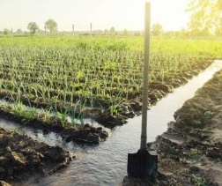
(ii) Basin formed to trap water after floods | 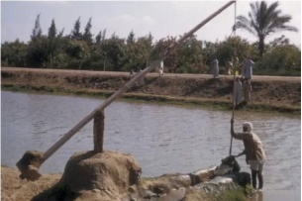
(iii) A bucket and pole device used to lift water | 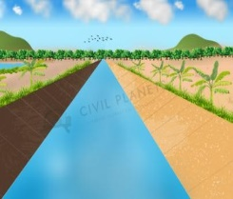

TASK 3: CITIZENSHIP (25 Marks)
- During a civic education session, learners reviewed the United Nations Human Rights Charter.
a. Human rights can be classified into social, economic, and political rights. Identify two social rights provided for in the Charter.
- _________________________________________________________________________________________________
- _________________________________________________________________________________________________
b. Explain three importances of human rights in society.
- _________________________________________________________________________________________________
- _________________________________________________________________________________________________
- _________________________________________________________________________________________________
c. State two ways of promoting equality and non-discrimination in the community.
- _________________________________________________________________________________________________
- _________________________________________________________________________________________________
- _________________________________________________________________________________________________
d. Mention three reasons why human rights should be protected.
- _________________________________________________________________________________________________
- _________________________________________________________________________________________________
- _________________________________________________________________________________________________
e. Suggest three ways in which learners can respect the rights of others at school.
- _________________________________________________________________________________________________
- _________________________________________________________________________________________________
- _________________________________________________________________________________________________
- During a peace awareness day, Grade 8 learners discussed ways of promoting peace and harmony.
a. State three personal characteristics that express a state of peace for mutual social well-being.
- _________________________________________________________________________________________________
- _________________________________________________________________________________________________
- _________________________________________________________________________________________________
b. Name three approaches that promote inner peace for harmonious living.
- _________________________________________________________________________________________________
- _________________________________________________________________________________________________
- _________________________________________________________________________________________________
c. State three causes of conflict in schools.
- _________________________________________________________________________________________________
- _________________________________________________________________________________________________
- _________________________________________________________________________________________________
d. Mention three peaceful methods of resolving conflicts.
- _________________________________________________________________________________________________
- _________________________________________________________________________________________________
- ________________________________________________________________________________________________
e. Explain two importance of peace in national development.
- _________________________________________________________________________________________________
- _________________________________________________________________________________________________
- During a lesson on economic development, learners discussed how trade evolved over time.
a. State two uses of money.
- _________________________________________________________________________________________________
- _________________________________________________________________________________________________
b. Explain two advantages of using money instead of barter trade.
- _________________________________________________________________________________________________
- _________________________________________________________________________________________________
c. Give two examples of Kenyan banknotes in circulation today.
- _________________________________________________________________________________________________
- _________________________________________________________________________________________________

d. Suggest two ways of promoting fair trade in Kenya.
- _________________________________________________________________________________________________
- _________________________________________________________________________________________________
e. State two reasons why saving money is important.
- _________________________________________________________________________________________________
- _________________________________________________________________________________________________

TASK 4: LIFE SKILLS EDUCATION (20 Marks)
- During a guidance lesson, Grade 8 learners discussed how to build positive self-esteem.
a. Define the term self-awareness.
__________________________________________________________________________________________________
__________________________________________________________________________________________________
__________________________________________________________________________________________________
b. Mention three characteristics of a person with positive self-esteem.
- _________________________________________________________________________________________________
- _________________________________________________________________________________________________
- _________________________________________________________________________________________________
c. State two ways of improving one’s self-image.
- _________________________________________________________________________________________________
- _________________________________________________________________________________________________
d. Give two reasons why it is important to know your strengths and weaknesses.
- _________________________________________________________________________________________________
- _________________________________________________________________________________________________
e. Explain one effect of low self-esteem on a learner’s performance.
__________________________________________________________________________________________________

- During class elections, candidates were asked to demonstrate good leadership skills.
a. Mention three good decision-making skills that a leader should have.
- _________________________________________________________________________________________________
- _________________________________________________________________________________________________
- _________________________________________________________________________________________________
b. State two qualities of an effective leader.
- _________________________________________________________________________________________________
- _________________________________________________________________________________________________
c. Explain two benefits of involving others in decision-making.
- _________________________________________________________________________________________________
- _________________________________________________________________________________________________
d. Suggest two consequences of poor decision-making in leadership.
- _________________________________________________________________________________________________
- _________________________________________________________________________________________________
e. Give one example of a student leadership role in school and its responsibility.
__________________________________________________________________________________________________
__________________________________________________________________________________________________
- The learners of Mwangaza Primary participated in a community clean-up exercise.
a. State three benefits of participating in community service.
- _________________________________________________________________________________________________
- _________________________________________________________________________________________________
- _________________________________________________________________________________________________
b. Mention three ways in which learners can conserve the environment at school.
- _________________________________________________________________________________________________
- _________________________________________________________________________________________________
- _________________________________________________________________________________________________
c. Give two examples of sustainable use of natural resources.
- _________________________________________________________________________________________________
- _________________________________________________________________________________________________
d. Explain two effects of environmental pollution.
- _________________________________________________________________________________________________
- _________________________________________________________________________________________________
e. Suggest two activities that promote environmental awareness among learners.
- _________________________________________________________________________________________________
- _________________________________________________________________________________________________

Answers

- 1. Preamble, Bill of rights
- Devolution structure of government
- citizenship and environment
- leadership
- integrity
- elections
- national security
- public finance
- amendments of the constitution constitution
- M - Judiciary N - Executive P - Make laws
- a) Have integrity, serve the people, honest, uphold values, promote social justice, promote and protect rights and freedoms, foster culture of good governance.
b). Lead by example, Act with honesty strive for excellence, uphold the rule of law, promote equality, respect rights and dignity.

- Raising awareness, educating yourself on human rights, encourage diversity and inclusivity Demonstrating respect for human rights.
- Equality and social justice, empowerment through action, violent resistance, courage in the face of opposition, environment, stewardship, global citizenship.
- 1. Human beings evolved to walk on two legs
  - Over time the human brain has grown larger
  - Developed ability to make and use tools
  - Developed language
  - Influenced human teeth
  - Evolved complex social structures
- 1. Introduction of Swahili dishes
  - Introduced new way of dressing
  - Emergence of Kiswahili language
  - Swahili architecture
  - Islamic religion
  - Use of transport systems such as shows and boats
  - Emergence of city states which serve as trade and cultural centres
- 1. Organized trade crossing the entirety of the desert.
  - Facilitated by the development of oasis settlements and spread of camel culture and Islam, Berbers and Arabs in North Africa began to travel in caravans all the way to West Africa.
- 1. Led to introduction of Islam
  - Reduced population
  - Incited conflicts
  - Disrupted local economies
  - Led to loss of cultural knowledge
  - Increased wealth
  - Led to enslavery

- a. Emigration

b. Education c.
- Increase in the supply of human labour
- Strain on limited resources
- Increase in pipulation
- Rapid population growth
- Congestion in urban centres
- Decreased population.

- a) The pattern or changes in the characteristics of a population over a specific period of time b)
- Growing population
- Rural-urban migration
- Families having fewer children
- Migration in search of employment, education.
- 1. Seeking support when needed.
  - Taking care of herself
  - Engaging in activities that build confidence
  - Surrounding herself with positive influence
  - Maintain positive attitude
 | 6. | Celebrating success
 | 7. | Being assertive
 | 8. | Being kind to yourself
13. | 1. | Balance work and play
 | 2. | Plan your day
 | 3. | Stick to your plan
 | 4. | Get enough sleep
 | 5. | Eat good food
 | 6. | Ask for help when you need it
 | 7. | Use positive energy of stress
 | 8. | Deal with problems as they come

- a) Negotiation, problem-solving, mediation, apologizing, forgiveness b)
  - Communicate with kindness
  - Listen to each other
  - Respect each other's opinion
  - Seeks clarification
- 1. Gives us opportunity to apply what we have learnt in the classroom to real life situations.
- Help develop skills such as problem solving.
- We gain better understanding
- Boosts self-esteem
- Benefiting from the project
- Encourages diversity
- 1. Relief
- Alitude
- Human activities
- Ocean currents
- Land ans Sea breezes
- Latitude

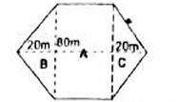

Area of A = L x W = 80m x 50 = 4000m

Area of B = ¹/₂ x b x h = ¹/₂ x 80 x 20 = 800m² Area of C= ¹/₂bh = ¹/₂ x 80 x 20 = 800m
Total area = A+B+C

= 4000 + 800 + 800 = 5600m²

- a. Mangrove

b. Mangrove trees grow to medium heights, have breathing roots, grow in salty water.

- Fort Jesus, Kilwa, Meroe, Great Zimbabwe, The Giza Pyramids, Timbuktu, Robben Island.

TASK 1: MAPWORK
1. Study the map of TOKA area and use it to answer the questions that follow:
a) Direction from Sawmill to Bosa Town along the weather road:
South-West (SW)
b) Distance along the weather road from the bridge to the market:
Approximately 6.5 km (Acceptable range: 6.2 km – 6.8 km)
c) Four economic activities carried out in the area:
i. Lumbering / Timber harvesting (evidenced by the Sawmill and Forest)
ii. Trading / Commerce (evidenced by the Market and Bosa Town built-up area)
iii. Crop Farming / Coffee growing (evidenced by the Coffee plantations and Coffee Factory - CF)
iv. Transportation (evidenced by the Railway line and Weather road)
d) Three types of vegetation found in the area:
i. Forest
ii. Swamp vegetation / Reeds
iii. Shrub (or Scattered trees)

TASK 2: GEOGRAPHY
2. Field study on farming:
a. Four methods used to collect data in the field:
i. Observation
ii. Interviewing local farmers
iii. Administering questionnaires
iv. Taking photographs / Audio recording
b. Three methods used to record data collected:
i. Writing notes in field notebooks
ii. Filling in tally sheets / Questionnaires
iii. Taking photographs / Audio-video recording
c. Three challenges faced during the field study:
i. Bad weather conditions (e.g., heavy rainfall or excessive heat)
ii. Language barrier or uncooperative respondents
iii. Long walking distances / Difficult terrain
d. Three possible solutions to the challenges faced:
i. Carrying appropriate rain gear/protective clothing and umbrellas
ii. Using local interpreters or polite language to encourage responses
iii. Choosing manageable, accessible routes or arranging transport
e. Two importances of collecting accurate data during fieldwork:
i. Ensures reliable and valid conclusions/findings for the research study.
ii. Helps in proper decision-making and planning for farming improvements.
3. Temperature Data and Weather Analysis:
a. Simple Bar Graph showing monthly temperatures:
(Use the grid below: Horizontal axis = Months [Jan–Dec], Vertical axis = Temperature in °C [Scale: 1 cm = 5 °C]).
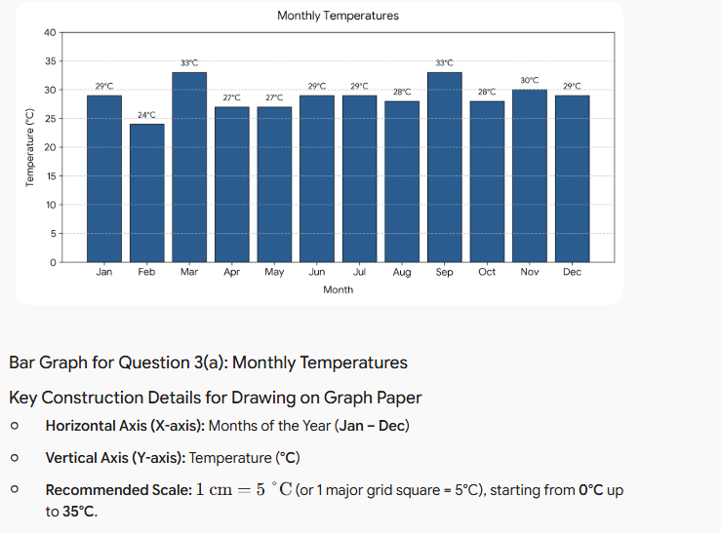

b. Month with the highest temperature: March and September (both 33 °C)
c. Month with the lowest temperature: February (24 °C)
d. Two factors that may influence temperature in this area:
i. Altitude / Elevation above sea level
ii. Distance from the sea / Latitude / Cloud cover
e. Two importances of recording weather data:
i. Helps farmers plan agricultural activities like planting and harvesting.
ii. Helps predict future weather trends and natural disasters for early warning.
4. Population and Solar System:
a. Three factors influencing population distribution in Africa:
i. Climate (rainfall and temperature availability)
ii. Soil fertility for agricultural production
iii. Availability of water resources (rivers and lakes)
b. Three components of the solar system:
i. The Sun
ii. Planets (and their moons)
iii. Asteroids / Comets / Meteoroids
5. Rivers in Early African Civilizations:
(a) Two important rivers in Africa:
i. River Nile
ii. River Niger (or River Congo / River Zambezi)
(b) How rivers contributed to the development of early African societies:
i. Water supply for irrigation agriculture, leading to food surplus and settlement growth.
ii. Transportation and trade routes, enabling commerce and cultural exchange between communities.
6. Climate in Africa:
(a) Two factors that influence climate in Africa:
i. Latitude (distance from the Equator)
ii. Altitude (height above sea level)
(b) Map Analysis:
i. Climatic region marked W: Equatorial Climate Region
ii. Lines marked X and Y:
- X: Tropic of Cancer
- Y: Equator
iii. Two countries crossed by line Z ( Tropic of Capricorn): Mozambique, Madagascar (or South Africa, Botswana, Namibia)
iv. Country marked S: Egypt
(c) Impact of climate on human settlement in Africa:
i. Areas with high, reliable rainfall support high population densities due to viable agriculture.
ii. Arid and semi-arid regions have sparse populations due to extreme heat and water scarcity.
(d) Classification of Migration Effects:
Positive | Negative
i. Development of rural areas | i. Development of slums
ii. Expansion of road network | ii. Separation of families

TASK 3: HISTORY AND GOVERNMENT
7. Ancient Civilizations and Early Human Life:
a. Ancient Egyptian Inventions / Achievements:
- A: Hieroglyphics (Ancient Egyptian writing system)
- B: Papyrus scroll / Calendar record / Egyptian script
- C: Pottery / Ceramic craftsmanship (Potter's wheel)
- D: Pyramids (Architecture and engineering)
b. Three factors leading to the growth of Great Zimbabwe:
i. Control over regional gold and ivory trade routes.
ii. Fertile soils and abundant rainfall supporting agriculture and cattle rearing.
iii. Able and strong leadership unifying the kingdom.
c. Four contributions of early civilizations to the modern world:
i. Development of writing systems and record-keeping.
ii. Inventions in architectural engineering and construction techniques.
iii. Introduction of irrigation systems and structured farming methods.
iv. Development of early legal codes, government structures, and mathematics/astronomy.
d. Three characteristics of Homo sapiens:
i. Large brain capacity (1200 cm³ – 1400 cm³).
ii. Fully upright bipedal posture and walk.
iii. Highly developed speech capability and tool-making ability.
8. Early Kingdoms and Communities:
a. Two factors leading to the growth of the Kingdom of Kongo:
i. Strategic position along trading networks (salt, iron, copper, textiles).
ii. Strong centralized administrative system under the Manikongo.
b. Two terms of the Berlin Conference (1884–1885):
i. Principle of Effective Occupation: A power had to physically occupy and establish administration over a territory to claim it.
ii. Declaration of freedom of navigation on major African rivers (e.g., Congo and Niger Rivers).
c. Two aspects of social organization of the Zulu up to 1900:
i. Organized into age-regiments (amabutho) serving both social and military duties.
ii. Believed in a supreme creator (Unkulunkulu) and practiced ancestral veneration.
d. Historical Sites and Locations:
Historical Site | Location (Country)
i. Meroe | Sudan
ii. Timbuktu | Mali
iii. Fort Jesus | Kenya
iv. Robben Island | South Africa
9. Early Trade along the Indian Ocean and Trans-Saharan Routes:
a. Four factors leading to the development of Trans-Saharan Trade:
i. Introduction of the camel as a reliable means of desert transport.
ii. Availability of valuable commodities (gold from West Africa, salt from the Sahara).
iii. Establishment of trade routes and water oases across the desert.
iv. Strong political stability provided by empires like Ghana and Mali.
b. Two social injustices committed against Africans during the Indian Ocean Slave Trade:
i. Violent raids and forcible separation of families.
ii. Dehumanizing living conditions and physical abuse during capture and transport.
c. Two economic effects of the Trans-Saharan / Slave Trade on East Africa:
i. Depopulation of productive labor, leading to a collapse in local agricultural output.
ii. Introduction of foreign manufactured goods that disrupted local artisan industries.
10. Early Farming and Irrigation:
a. Four crops grown in the Rift Valley, Egypt, and Nubia:
i. Wheat
ii. Barley
iii. Sorghum
iv. Flax (or Millet)
b. Two animals domesticated in those regions:
i. Cattle
ii. Donkeys (or Sheep / Goats)
c. Irrigation methods identified:
i. Shadoof (Bucket tied to a balanced stick)
ii. Basin / Inundation irrigation (Trapping floodwaters and silt)
d. Matching Irrigation Methods:
Irrigation Method | Name
(i) Canals dug from the Nile River | Canal Irrigation
(ii) Basin formed to trap water after floods | Basin Irrigation
(iii) A bucket and pole device used to lift water | Shadoof Irrigation

TASK 4: CITIZENSHIP
11. Human Rights and Equality:
a. Two social rights provided for in the UN Charter:
i. Right to education.
ii. Right to healthcare / standard of living.
b. Three importances of human rights in society:
i. Protects individuals from state abuse and oppression.
ii. Promotes human dignity, justice, and self-worth.
iii. Fosters social stability and peaceful co-existence.
c. Two ways of promoting equality and non-discrimination:
i. Enforcing fair laws that penalize bias and discrimination.
ii. Providing equal access to public services and opportunities regardless of background.
d. Three reasons why human rights should be protected:
i. To prevent conflict, oppression, and injustice.
ii. To guarantee freedom and personal growth for all citizens.
iii. To build a fair, democratic, and inclusive society.
e. Three ways learners can respect the rights of others at school:
i. Refraining from bullying, teasing, or discriminating against classmates.
ii. Listening respectfully to opinions expressed by peers.
iii. Respecting school property and personal belongings of others.
12. Promoting Peace and Harmony:
a. Three personal characteristics that express a state of peace:
i. Tolerance towards differing viewpoints.
ii. Self-control and emotional composure.
iii. Empathy and kindness toward others.
b. Three approaches that promote inner peace:
i. Mindfulness and meditation/prayer.
ii. Positive self-reflection and stress management.
iii. Forgiveness and letting go of grudges.
c. Three causes of conflict in schools:
i. Bullying and peer pressure.
ii. Miscommunication or rumors among students.
iii. Unfair distribution or sharing of learning resources.
d. Three peaceful methods of resolving conflicts:
i. Dialogue / Discussion
ii. Mediation by a neutral third party
iii. Negotiation and compromise
e. Two importances of peace in national development:
i. Attracts domestic and foreign investments that create economic growth.
ii. Ensures uninterrupted delivery of vital social services like education and healthcare.
13. Economic Development and Trade:
a. Two uses of money:
i. Medium of exchange for goods and services.
ii. Store of value and unit of account.
b. Two advantages of using money over barter trade:
i. Eliminates the double coincidence of wants problem.
ii. Money is easily divisible, portable, and standardizes value across products.
c. Two examples of Kenyan banknotes in circulation today:
i. Ksh 100 note
ii. Ksh 1,000 note (or Ksh 200 / Ksh 500)
d. Two ways of promoting fair trade in Kenya:
i. Regulating market prices to prevent exploitation of small producers.
ii. Standardizing weights, measures, and quality standards for goods sold.
e. Two reasons why saving money is important:
i. Provides financial security during emergencies or unexpected needs.
ii. Enables capital accumulation for future investments or long-term goals.

TASK 4: LIFE SKILLS EDUCATION
14. Self-Awareness and Self-Esteem:
a. Definition of self-awareness:
Self-awareness is the clear understanding of one's own character, feelings, motives, desires, strengths, and weaknesses.
b. Three characteristics of a person with positive self-esteem:
i. High self-confidence and self-belief.
ii. Ability to accept feedback and handle mistakes constructively.
iii. Assertiveness in communication without being aggressive.
c. Two ways of improving one’s self-image:
i. Focus on personal strengths and set achievable goals.
ii. Practice positive self-talk and avoid negative self-criticism.
d. Two reasons why it is important to know your strengths and weaknesses:
i. Helps in choosing appropriate career paths and personal goals.
ii. Enables working on weaknesses while leveraging strengths for personal improvement.
e. One effect of low self-esteem on a learner’s performance:
It leads to fear of failure, low participation in class activities, and poorer academic output.
15. Leadership Skills:
a. Three good decision-making skills that a leader should have:
i. Problem-solving and analytical thinking.
ii. Evaluating pros and cons before acting.
iii. Active listening and consulting relevant stakeholders.
b. Two qualities of an effective leader:
i. Integrity and honesty.
ii. Clear vision and good communication skills.
c. Two benefits of involving others in decision-making:
i. Promotes a sense of ownership and commitment to decisions made.
ii. Brings diverse perspectives, leading to better and more informed outcomes.
d. Two consequences of poor decision-making in leadership:
i. Loss of trust and respect from group members/subordinates.
ii. Organizational failure or wasted time and resources.
e. One example of a student leadership role in school and its responsibility:
- Role: School Captain / Class Prefect
- Responsibility: Maintaining order, representing student needs to teachers, and organizing student activities.
16. Community Service and Environment:
a. Three benefits of participating in community service:
i. Builds civic responsibility and social unity.
ii. Helps develop practical life skills like teamwork and leadership.
iii. Solves real community problems and improves local living conditions.
b. Three ways learners can conserve the environment at school:
i. Planting trees and caring for school gardens.
ii. Practicing proper waste disposal and recycling paper/plastics.
iii. Turning off lights and water taps when not in use.
c. Two examples of sustainable use of natural resources:
i. Rainwater harvesting for school/home use.
ii. Using renewable energy like solar power instead of fossil fuels.
d. Two effects of environmental pollution:
i. Spread of waterborne and respiratory diseases.
ii. Degradation of soil fertility and destruction of wildlife habitats.
e. Two activities that promote environmental awareness among learners:
i. Forming or joining Environmental / Wildlife Clubs.
ii. Participating in tree planting days and cleanup campaigns.

