COMPETENCY BASED EDUCATION

JUNIOR SCHOOL EDUCATION ASSESSMENT

NOVEMBER-DECEMBER ASSIGNMENT 2026
GRADE 8 – CREATIVE ARTS AND SPORTS
Time: 2 Hours
LEARNER’S DETAILS
Name: ________________________________________________. School: ________________________________________.
Assessment Number: _________________________________. Date: __________________________________________.
School Code: _______________________________________. Signature: ______________________________________.

INSTRUCTIONS TO CANDIDATES
- Write your name in the spaces provided above.
- Write the name of your school and your stream in the spaces provided.
- Write your admission number and the date of the assessment in the spaces provided.
- This paper consists of two sections: A and B.
- Answer all questions in section A and section B.
- Answer the questions in English.
- All answers MUST be written in the spaces provided in the paper.
- Do NOT remove any page from this question paper.

FOR OFFICIAL USE ONLY (EXAMINER’S USE)
SECTION | SECTION A | SECTION B | % SCORE | EE1 | EE2 | ME1 | ME2 | AE1 | AE2 | BE1 | BE2
SCORE RANGE | 30 MARKS | 50 MARKS |  | 90-100 | 75-89 | 58-74 | 41-57 | 31-40 | 21-30 | 11-20 | 1-10
POINTS |  |  |  | 8 POINTS | 7 POINTS | 6 POINTS | 5 POINTS | 4 POINTS | 3 POINTS | 2 POINTS | 1 POINT
LEARNER’S TOTAL SCORE

SECTION A (30 MARKS)
Answer ALL questions in this section.
- Grade 8 learners of Kadem Junior school are analysing 3-D artwork. Identify the three areas they should pay attention to when analysing the 3-D artwork. (3 mks)
- ___________________________________________________________________________________
- ___________________________________________________________________________________
- ___________________________________________________________________________________
- A group of learners are performing a folk dance. List down any two participants in the folk dance they are performing. (2 mks)
- ___________________________________________________________________________________
- ___________________________________________________________________________________
- Robert and his friends wanted to play indigenous tagging games played in Kenya. Mention two of such games. (2 mks)
- ___________________________________________________________________________________
- ___________________________________________________________________________________
- Njenga is preparing materials and tools for basketry. Identify any three materials for basketry Njenga is preparing. (3 mks)
- ___________________________________________________________________________________
- ___________________________________________________________________________________
- ___________________________________________________________________________________
- Your classmates performed folk dances from different Kenyan communities. Name the folk dances from the following communities. (4 mks)
a Agikuyu:__________________________________________

  - Luhya:_____________________________________________

  - Luo:________________________________________________

  - Akamba:____________________________________________

- The diagram below shows a type of serve in volleyball.
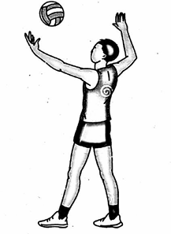

- The skill is known as (1 mk)

- Write down two other skills in volleyball apart from serving skills. (2 mks)
- ___________________________________________________________________________________
- ___________________________________________________________________________________

- Adam is writing a verse. Identify two language use he should apply as he write the verse. (2 mks)
- ___________________________________________________________________________________
- ___________________________________________________________________________________
- Nyogesa is playing a descant recorder. Mention two techniques of playing descant recorder he must use. (2 mks)
- ___________________________________________________________________________________
- ___________________________________________________________________________________
- Rosa was decorating a fabric using Baik technique. Identify two techniques she would apply. (2 mks)
- ___________________________________________________________________________________
- ___________________________________________________________________________________
- Grade 8 learners of Hill Junior school are playing netball game.
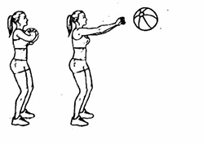

- Identify the type of pass they performed as shown in the diagram. (1 mk)
______________________________________________________

- Mention two footwork skills learners performed during the game. (2 mks)
- ___________________________________________________________________________________
- ___________________________________________________________________________________
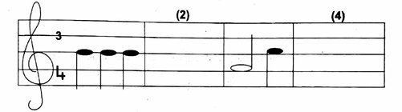
- Tinde performed 4-bar melodies in G-major and 3/4 time as shown below. Complete bar 2 and 4 respectively. (4 mks)

- A learner created a montage composition of athletes running. During the creativity he was to check out for some factors. Mention two of the factors he was to focus on. (2 marks)
- ___________________________________________________________________________________
- ___________________________________________________________________________________
- Alex and his friends are practising a middle distance race. State any two middle distance races they are likely to be practising. (2 marks)
- ___________________________________________________________________________________
- ___________________________________________________________________________________
- Tito was asked by the teacher to describe what 3/4 time is when performing rhythmic patterns in 3/4 time. If Tito gave the correct answer, write down his description. (2 marks)
___________________________________________________________________________________
___________________________________________________________________________________
- In the space provided below make a still life drawing of the displayed items (Bucket, Jug, Bucket) by your teacher. Take into account the elements and principles of Visual Arts. (5 marks).
- ___________________________________________________________________________________
- ___________________________________________________________________________________
- ___________________________________________________________________________________
- ___________________________________________________________________________________
- ___________________________________________________________________________________
- Kotoi listed down three elements of a verse. Write the three elements Kotoi listed. (3 mks)

- ___________________________________________________________________________________
- ___________________________________________________________________________________
- ___________________________________________________________________________________
- The following musical notes were drawn by Arnold during Creative Arts and Sports lesson. Write down the rests of each musical note he drew. (3 marks)
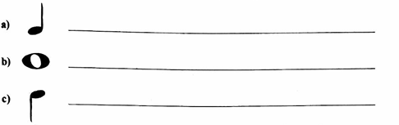

- Ndemo highlighted three social roles of Creative Arts and Sports in the society. List down the three roles he highlighted. (3 marks)
- ___________________________________________________________________________________
- ___________________________________________________________________________________
- ___________________________________________________________________________________

Answers

- 1. Organization of the work balance
- Proportion
- Dominance
- Topic
- Theme
- 1. Instrumentalists
  - Soloists
  - Response group (singers)
  - Dancers
- 1. Laser tag
  - Elephant stampede
  - Tag rugby
- 1. Raffia
  - Bamboo sticks
  - Banana fibre
  - Sisal fibre
  - Polyester yarn
  - Carbon fibre
  - Acrylic yarn

- a. Muthongoci, Mwomboko, Ndumo, Ngucu, Kabaata, Gichukia, Mugonji

- Isikuti dance

- Ramongi dance. Dodo dance, Mijangore

- Kilumi dance

- a. Overarm serve

b. Dig, Spiking, Villey skills

- 1. Imagery (simile, metaphor, personification)
  - Sound (alliteration, rhyme, repetition)
  - Diction
  - Line
  - Stanza
- 1. Fingering
  - Pinching
  - Slurring
  - Embouchure
  - Tonguing
  - Blowing
- 1. Diamond pleating
  - Crackled textures effects.

- a. Chest pass b.
- Landing
- Pivoting

- Correct insertion of three crochet beats in bar 2 and 4.

- 1. Subject matter
  - Posture
  - Centre of interest
  - Finishing
  - Presenting creativity

- 8oom, 1500m, 1000m, 1200m

- Three crotchet beats per bar

- -

- 1. Character
  - Theme
  - Setting
- 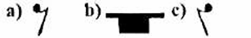

- 1. Social cohesion
  - Social identity
  - Culture preservation
  - health
  - Citizenship
  - Patriotism
  - Entertainment

