GEOGRAPHY
GRADE 10 TERM 3 OPENER EXAM 2026
TIME: 2 HOURS

Candidate's Name: …………………………………………………… | Admission No.: ……………………………………
Class / Stream: ………………………………………………… | Date: ……………………………………………

INSTRUCTIONS TO CANDIDATES
- Write your name, admission number, class and date in the spaces provided above.
- This paper consists of eight (8) questions.
- Answer ALL questions in the spaces provided in this booklet.

1.
(a) Define the term "Geography". (2 marks)

(b) Geography is divided into two main branches. Name and briefly explain each branch. (4 marks)

(c) State one way in which the study of Geography contributes to sustainable development. (2 marks)

2.
(a) Distinguish between weather and climate. (4 marks)

(b) The diagram below shows an instrument used to measure an element of weather. (6 marks)
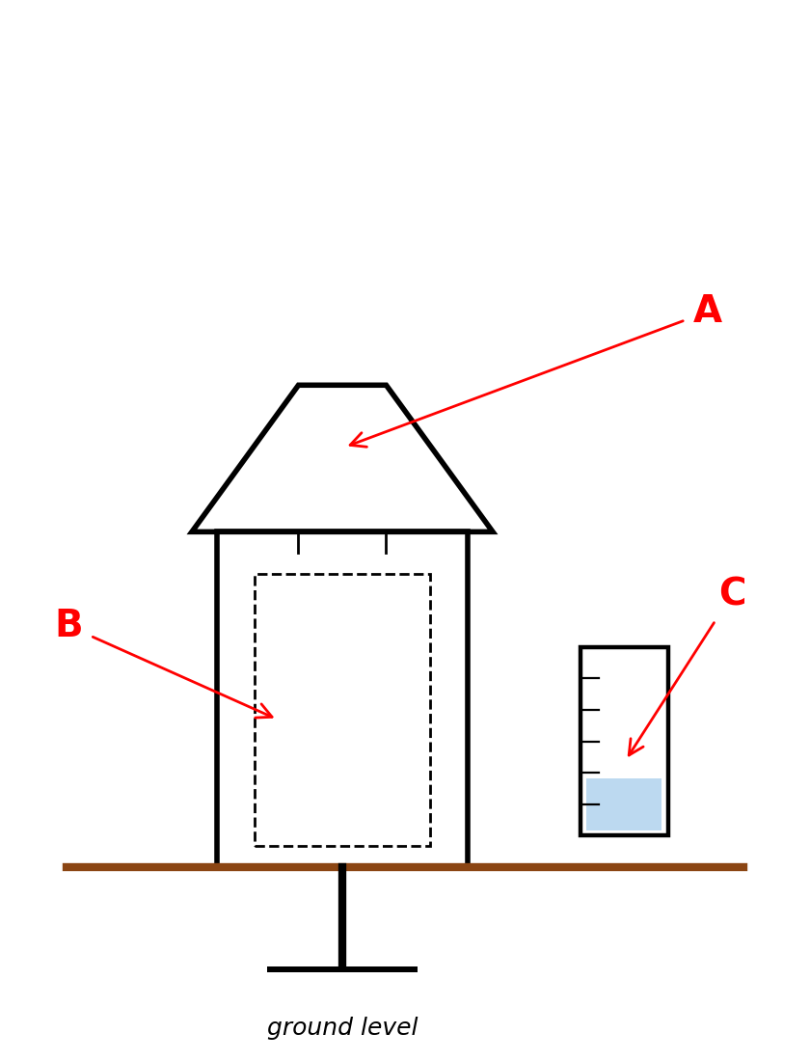
(i) Identify the instrument.

(ii) Name the parts labelled A, B and C.

(iii) State one precaution taken when siting this instrument.

(c) State two career opportunities related to the study of weather and climate. (2 marks)

(d) Give one reason why weather forecasting is important to farmers. (2 marks)

3.
(a) Define the term "contour line" as used in map reading. (2 marks)

(b) State two characteristics of contour lines. (4 marks)

(c) The diagram below is a simplified contour map extract showing a hill, with contour lines at an interval of 50 m and a line X–Y drawn across it. (8 marks)
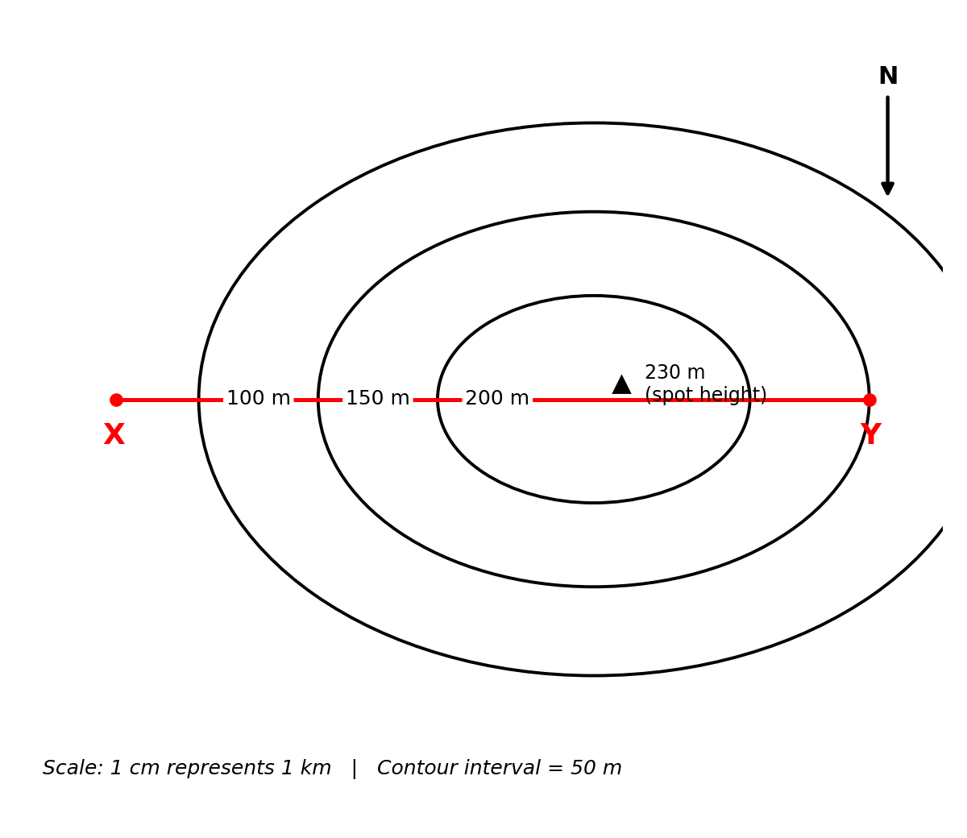
(i) Study Table 1 below, which shows the height above sea level at points measured along the line X–Y.

Distance from X (km) | 0 | 1 | 2 | 2.5 | 3 | 4 | 5
Height (m) | 100 | 150 | 200 | 230 | 200 | 150 | 100

On the grid provided on the next page, draw a well-labelled cross-section along the line X–Y using the data in Table 1. Use a vertical scale of 1 cm to represent 20 m.

(ii) State the general shape of the relief shown by the contour pattern, giving a reason for your answer.

(d) Give two uses of contour maps to a farmer.
(2 marks)

Grid for the cross-section along line X – Y (Question 3(c)(i))
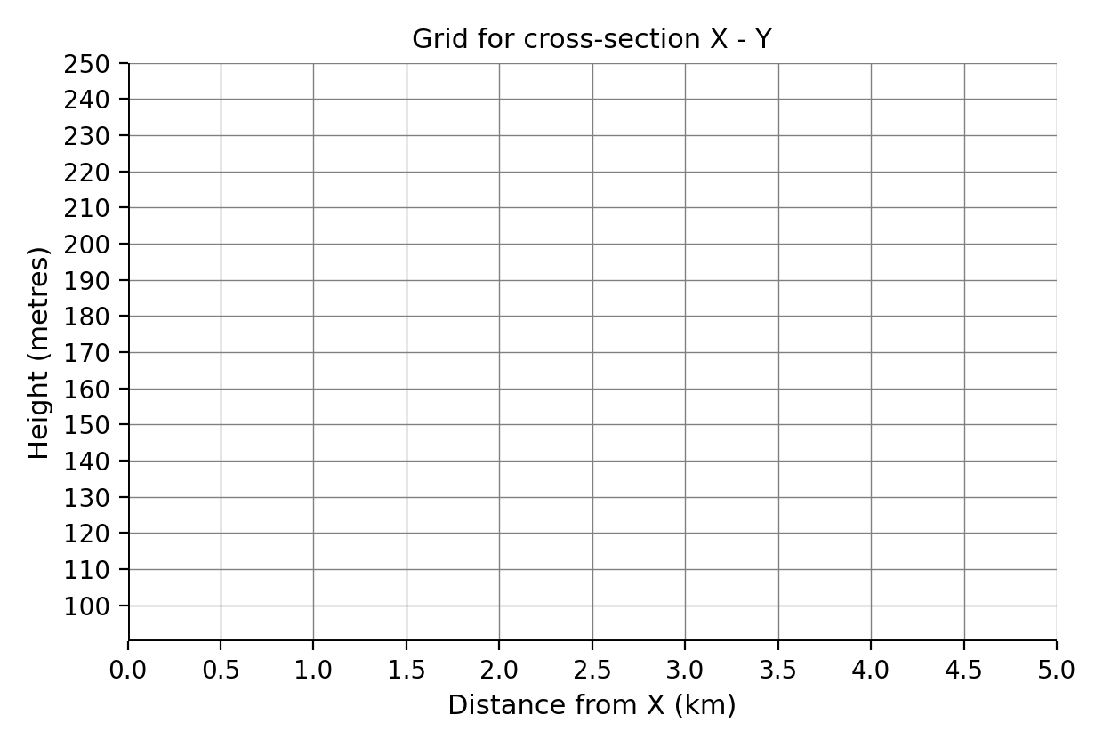

4.
(a) State two methods used to collect geographical data such as rainfall data. (2 marks)

(b) The table below shows the monthly rainfall (mm) received at a weather station for one year. (4 marks)

Month | Jan | Feb | Mar | Apr | May | Jun | Jul | Aug | Sep | Oct | Nov | Dec
Rainfall (mm) | 40 | 35 | 90 | 150 | 120 | 45 | 30 | 25 | 40 | 110 | 130 | 85

(i) Calculate the total annual rainfall received.

(ii) Calculate the mean monthly rainfall, correct to 1 decimal place.

(c) On the grid provided on the next page, draw a bar graph to represent the rainfall data given in (b) above.

(4 marks)
(d) State two limitations of using bar graphs to represent geographical data. (2 marks)

Grid for the bar graph (Question 4(c))
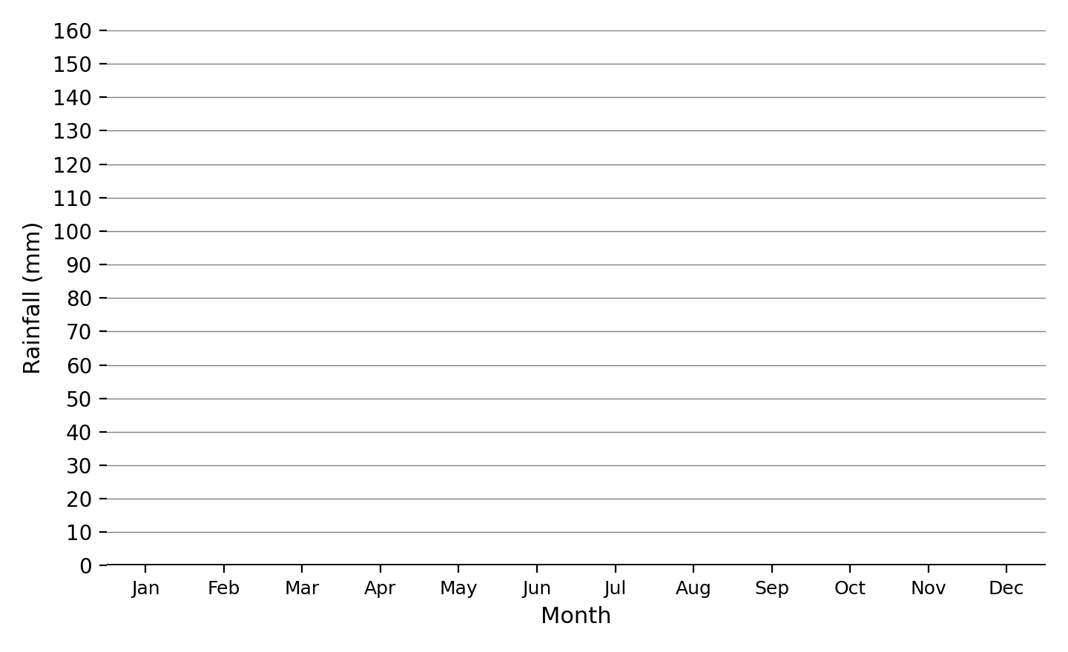

5.
(a) Define the following terms: (4 marks)
(i) Geographic Information System (GIS)

(ii) Global Positioning System (GPS)

(b) State two components of a GIS. (2 marks)

(c) State one daily application of GPS technology. (2 marks)

6.
(a) Classify rocks into three main types based on their mode of formation, giving one example of each. (6 marks)

(b) The diagram below shows the rock cycle. Study it and answer the questions that follow. (3 marks)
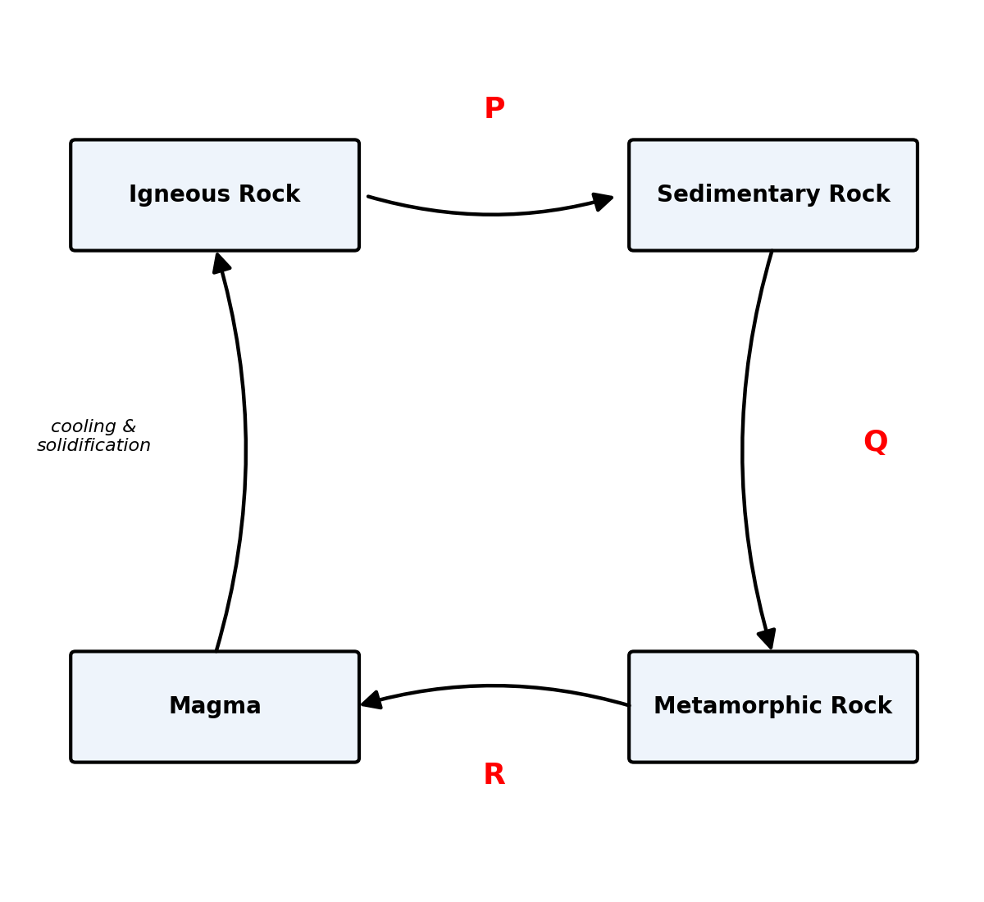
Name the processes labelled P, Q and R.

(c) State two characteristics of sedimentary rocks. (2 marks)

(d) State three economic significances of rocks in Kenya. (3 marks)

7.
(a) Define the term "volcanicity". (2 marks)

(b) State two causes of volcanicity. (4 marks)

(c) The diagram below shows a section of a volcano. Study it and answer the questions that follow. (6 marks)
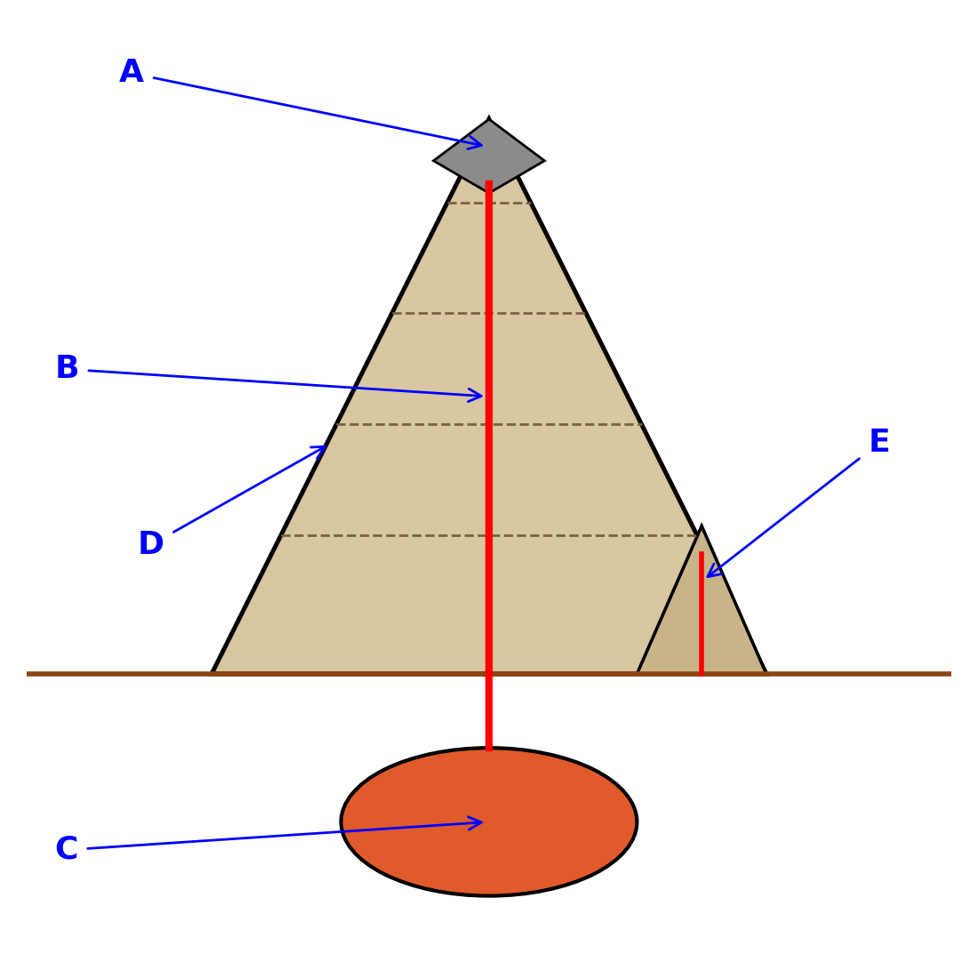
(i) Identify the parts labelled A, B, C, D and E.

A
B
C
D
E

(ii) Name the type of volcano illustrated.

(d) State two economic significances of volcanicity to Kenya. (2 marks)

(e) State one hazard associated with volcanic eruptions. (2 marks)

8.
(a) Define the following terms: (2 marks)
(i) Focus

(ii) Epicentre,

(b) The diagram below shows the occurrence of an earthquake. (3 marks)
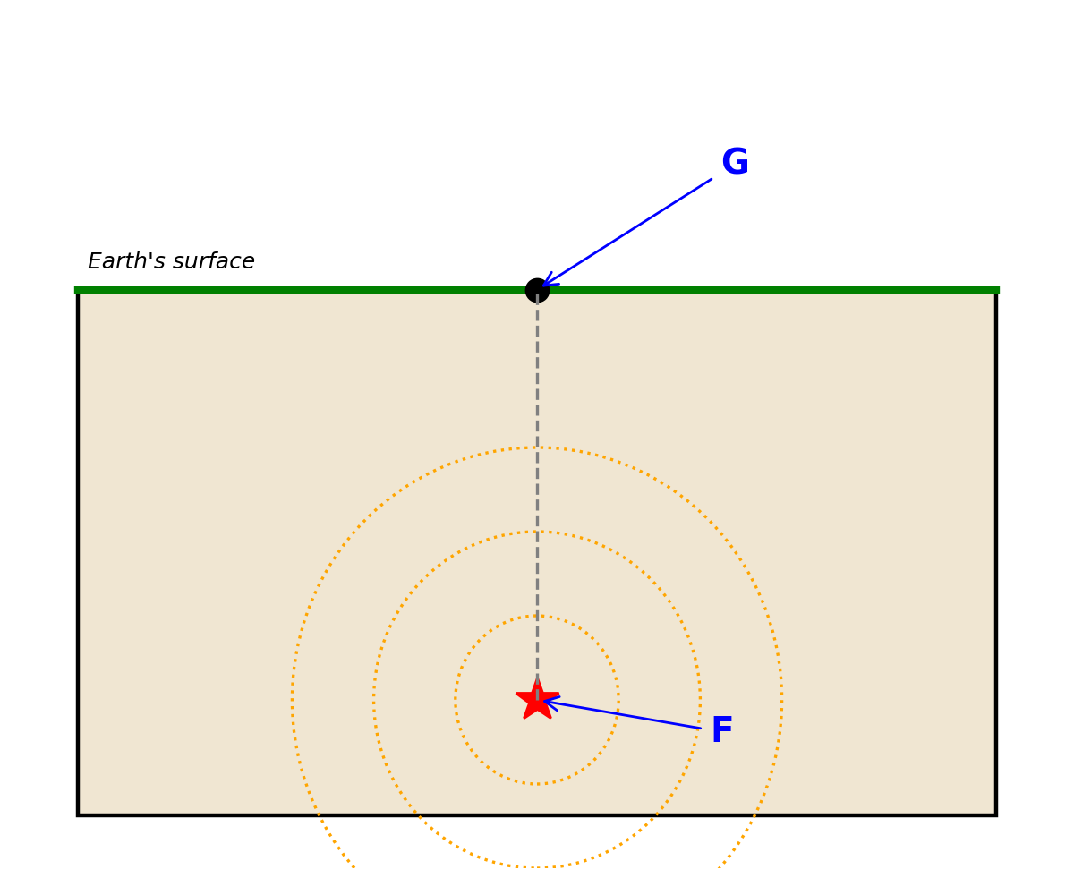
(i) Identify the parts labelled F and G.

(ii) Name the instrument used to measure/record earthquakes.

(c) State two causes of earthquakes. (2 marks)

(d) State three effects of earthquakes on human activities. (3 marks)

(e) State one measure that can be taken to reduce the impact of earthquakes in earthquake-prone areas. (2 marks)

6

