COMPETENCY BASED EDUCATION

JUNIOR SCHOOL EDUCATION ASSESSMENT

NOVEMBER-DECEMBER ASSIGNMENT 2026
GRADE 8 – MATHEMATICS
Time: 2 Hours
LEARNER’S DETAILS
Name: ________________________________________________. School: ________________________________________.
Assessment Number: _________________________________. Date: __________________________________________.
School Code: _______________________________________. Signature: ______________________________________.

INSTRUCTIONS TO CANDIDATES
- Write your name in the spaces provided above.
- Write the name of your school and your stream in the spaces provided.
- Write your admission number and the date of the assessment in the spaces provided.
- This paper consists of two sections: A and B.
- Answer all questions in section A and section B.
- Answer the questions in English.
- All answers MUST be written in the spaces provided in the paper.
- Do NOT remove any page from this question paper.

FOR OFFICIAL USE ONLY (EXAMINER’S USE)
SECTION | SECTION A | SECTION B | % SCORE | EE1 | EE2 | ME1 | ME2 | AE1 | AE2 | BE1 | BE2
SCORE RANGE | 30 MARKS | 50 MARKS |  | 90-100 | 75-89 | 58-74 | 41-57 | 31-40 | 21-30 | 11-20 | 1-10
POINTS |  |  |  | 8 POINTS | 7 POINTS | 6 POINTS | 5 POINTS | 4 POINTS | 3 POINTS | 2 POINTS | 1 POINT
LEARNER’S TOTAL SCORE

SECTION A (30 MARKS)
Answer ALL questions in this section.
- During an Integrated Science practical, grade 8 learners measure the mass of a specimen as 5.1956g.

  - Round off the number 5.1956 correct to 2 decimal places. (1 mk)

  - What is the place value of digit 6 in the number 5.1956? (1 mk)

- The temperature of some towns were recorded as below.
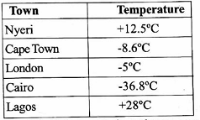

Identify the integers from the temperatures recorded. (2 mks)

- Grade 8 learners used their laptops to determine the value of (+4) (6). Use a number line to evaluate the value of (+4) - (6). (2 mks)

- a. Determine the value ²/₃ - ¹/₅ ÷ ¹/₂ (2 mks)

b. Msafari spent ¹/₈ of her salary on food, ¹/₂ on rent, ¹/₂ of the remainder on school fees and saved the rest. Determine the fraction of the salary that she saved. (3 mks)

- a. Determine the value of 1.96 + 144 ÷ 2 - 36. (2 mks)

- A leaner converted a certain mass from grams to tonnes. He got 0.007015t.

  - Determine the number of significant in the number 0.007015. (1 mk)

  - Express the number 0.007015 to 3 significant figures. (1 mk)

  - Express the number 0.007015 in standard form. (1 mk)

- Juma cut out a sector from a circular card board of radius 63cm.
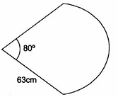

Determine the perimeter of the sector. (Use π=²²/₇) (2 mks)

- During a Creative Arts and Sports lesson, learners made a design as shown below.
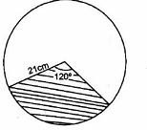

Calculate the area of the shaded part of the design. (Use π = ²²/₇)

- a. A brick measures 15cm long, 10cm wide and 8cm high. Determine the total surface area of the brick. (2 mks)
b. Mutwiri constructed a closed cylindrical water tank. The radius of the tank is 0.7m and the height is 2m. He painted the outside surface.
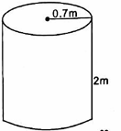

Determine the total surface area painted. (Use π=²²/₇)

- A carpenter constructed the design of a roof as shown.
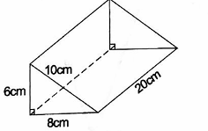

Determine the surface area of the design. (2 mks)

- a. A square seedbed measures 1.625 on each side. Use four figure Mathematical table to work out the area of the farm in square metres. (2 mks)

b. The area of a square design is 0.234m². Use the table of square root to determine the length of one side. (2 mks)

- A manufacturing company produced 8400 iron sheets in 5 days. Calculate the rate of production per day. (1 mk)

- Aisha and Juma shared their profit of sh 24000 in the ration of 5:7 respectively. How much money did Juma receive? (2 mks)

- Twelve people working at the same rate can complete some work in 16 days. How many more days will 8 people working at the same rate take to complete the same work? (2 mks)

- The price of a book increased from sh 400 to sh 500. Calculate the percentage increase. (2 mks)

- Auma deposited sh 300000 in a bank that offered a simple interest rate of 5% per annum. How much was in her account after 2 years? (2 mks)

- A laptop was valued at sh 100000 when it was bought. The value depreciated at the rate of 105 per year. Determine the value of the laptop after 2 years. (2 mks)

- A teacher wrote the expression
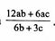

Factorize the expression. (2 mks)

- Given that c=4, d=5 and e= -3, evaluate. (2 mks)
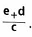

- Using elimination method, evaluate the value of x and y in the equation. (2 mks)
4x + y = 9
3x - y = 5

Answers

- a. 5.20

b. Ten thousandths

- -5°c, + 28°c

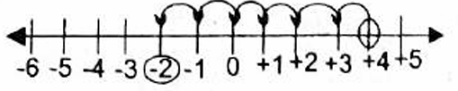

- a.

²/₃ - ¹/₅ ÷ ¹/₂

²/₃ - ¹/₅ × ²/₁
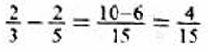

b.

Food = ¹/₈, Rent - ¹/₂

school fees - (¹/₂ × ³/₈) = ³/₁₆ Savings - ¹/₈ + ¹/₂ + ³/₁₆ = ¹³/₁₆ Salary saved = 1 - ¹³/₁₆
= ¹/₁₆ - ¹³/₁₆ = ³/₁₆

- a.

1.96 + 144 ÷ 2 - 36
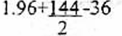

1.96 + 72 - 36

73.96 - 36 = 37.96

b.

r = 0.171717 (i)

10r = 1.71717 (ii)

100r = 17.1717 (iii)

(iii) - (i)

100r = 17.1717

r = 0.1717

⁹⁹r/₉₉ = ¹⁷/₉₉ r = ¹⁷/₉₉
- a. 4 significant figures

b. 702

c. 7.015 × 10⁻³

- θ/₃₆₀ 2πr + D

⁸⁰/₃₆₀ × 2 × ²²/₇ × 63 + 126 = 88 + 126 = 214cm

- θ/₃₆₀ π²

120/₃₆₀ × ²²/₇ × 21 × 21 = 22 × 21 = 462cm²

- a.

15 × 10 × 2 = 300

10 × 8 × 2 = 160

15 × 8 × 2 = ²⁴⁰/₇₀₀cm² b.
Top painted area = ²²/₇ × 0.7 × 0.7 = 1.54m² Painted curved SA = ²²/₇ × 1.4 × 2 = 8.8m² Bottom painted area = ²²/₇ × 0.7 × 0.7 = 1.54m² Total area = 1.54 + 8.8 + 1.54 = 11.88cm²
- Area of the triangles = ¹/₂ × 8 × 6 × 2 = 48cm² Area of the rectangles = 8 × 20 = 160cm² Area of the rectangles = 20 × 10 = 200cm² Area of the rectangle = 20 × 6 = 120cm²
Total S.A = 528cm²

- a. 1.625 × 1.625 = 2.640625m²

b. √0.234 = 0.4837m
- 5 days = 8400 1 day = ?
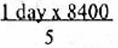

= 1680 sheets per day

- 24000 - 5:7

Aisha - ⁵/₁₂

Juma = ⁷/₁₂

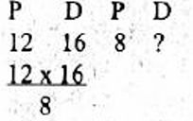
⁷/₁₂ × 24000 = sh 14000

= 24

More = 24 - 16 = 8 more days

- Increase = 500 - 400 = sh 100
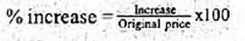

= ¹⁰⁰/₄₀₀ × 100% = 25%

- SI = PRT/100

= 300000 × ⁵/₁₀₀ × 2 = sh 30000

Total amount = 300000 + 30000

= sh 330000

- After 1 = 100000 - 100%

90%
= 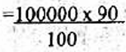

= 90000

After 2 years

90000 - 90%

80%
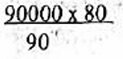

= sh 80000

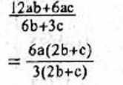

= ⁶ᵃ/₃ = 2a

- 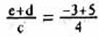

= ²/₄ = ¹/₂

- 3x4x+y = 9

4x3x-y = 5

12x+3y = 27
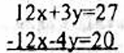

+ ⁷ʸ/₇ = ⁷/₇ y = 1

