KENYA JUNIOR SCHOOL EDUCATION ASSESSMENT
GRADE 7
DECEMBER ASSIGNMENT

LEARNER’S DETAILS
PRETECHNICAL STUDIES
Name: _____________________________________________________________________.
School: _____________________________________________________________________.
Assessment Number: ________________________. Date: _________________________.
School Code: ______________________. Signature: ______________________.

INSTRUCTIONS TO LEARNERS
- Write your name and class on the answer sheet provided.
- Answer ALL questions in Section A and Section B.
- Ensure your work is neat and clear, Answer in English.

SECTION A: (20 MARKS)
Answer ALL questions in this section on the separate answer sheet provided.

- During a visit to a metal workshop, learners observed that aluminium sheets could be bent into various shapes without breaking. Which physical property of metals does this demonstrate?
A. Ductility
B. Hardness
C. Magnetism
D. Malleability
- The school electrician used copper wires to connect bulbs in a classroom. Which property makes copper suitable for this work?
A. Dull appearance
B. Poor conductor of heat
C. Conductivity of electricity
D. Non-magnetic nature
- At the school gate, a watchman used a magnet to identify metal objects in students’ bags. This activity demonstrates:
A. Conductivity
B. Magnetism
C. Ductility
D. Malleability
- Iron, aluminium, and copper are examples of:
A. Non-metallic materials
B. Metallic materials
C. Synthetic materials
D. Plastic materials
- A class project required learners to make key holders using recycled metals. Which reason best explains why metallic materials are preferred?
A. They can dissolve easily in water.
B. They are weak and brittle.
C. They are strong and durable.
D. They absorb heat quickly.
- During a community clean-up, learners were advised to reuse old tins to make lamps instead of throwing them away. This practice encourages:
A. Resource wastage
B. Efficient use of resources
C. Pollution of the environment
D. Destruction of materials
- A farmer uses land, labour, and capital to grow maize. These are examples of:
A. Economic resources
B. Consumer goods
C. Free gifts of nature
D. Government property
- Learners at a business club designed posters advertising services like shoe repair and tailoring. These services are examples of:
A. Goods
B. Materials
C. Resources
D. Services

- During a lesson, the teacher drew a map showing where minerals, water, and forests are found in Kenya. This activity is called:
A. Resource allocation
B. Resource mapping
C. Resource extraction
D. Resource sharing
- In a car repair garage, the technician used a magnet to collect nails from the floor. The tool used demonstrates:
A. Plasticity
B. Magnetism
C. Elasticity
D. Conductivity
- A tailor uses a sewing machine daily without getting tired, while a computer works for long hours without rest. Which characteristic of computers does this describe?
A. Accuracy
B. Versatility
C. Diligence
D. Consistency
- A computer that performs a specific function such as monitoring patients in a hospital is classified by:
A. Purpose
B. Size
C. Speed
D. Memory
- A school’s ICT club was asked to identify computers by size. Which of the following is the correct order from smallest to largest?
A. Desktop, Mini, Micro, Super
B. Micro, Mini, Mainframe, Supercomputer
C. Mainframe, Super, Mini, Micro
D. Mini, Micro, Super, Mainframe
- Wanjiru uses a computer to type notes, calculate marks, and design posters. This shows that computers are:
A. Limited to one function
B. Slow and inaccurate
C. Versatile machines
D. Unable to store data
- A supermarket uses computers to record daily sales and store information. The main function being demonstrated is:
A. Processing and storage of data
B. Decoration of receipts
C. Displaying goods
D. Packing and labeling

- A school administrator uses emails to communicate official information to teachers. The main advantage of email communication is:
A. It is very slow and costly.
B. It allows instant communication.
C. It requires paper and ink.
D. It can only be used at night.
- During a science fair, learners from different counties interacted online through video calls. Which ICT tool were they using?
A. Mobile phone
B. Video conferencing
C. Radio
D. Fax machine
- A class group uses a WhatsApp platform to share school projects. This is an example of:
A. Social networking
B. Manual communication
C. Web browsing
D. Traditional communication
- A student found a pop-up link asking for personal details while online. This is an example of:
A. Antivirus
B. Phishing
C. Data encryption
D. Online collaboration
- Learners researched different Internet Service Providers (ISPs) in Kenya. Which one of the following is an ISP?
A. Telkom Kenya
B. Microsoft Word
C. Adobe Photoshop
D. Google Docs
- The use of the Internet in learning benefits learners because it:
A. Limits access to information
B. Promotes global communication and research
C. Reduces collaboration among students
D. Causes loss of data
- During a drawing lesson, the teacher asked learners to use different line types. Which line shows the visible edges of an object?
A. Hidden line
B. Centre line
C. Continuous thick line
D. Construction line

- A student used a compass to draw a circle in plane geometry. The method applied is known as:
A. Angular dimensioning
B. Radial dimensioning
C. Linear dimensioning
D. Chain dimensioning
- The school carpenter measured and marked a piece of wood before cutting it. This process demonstrates the importance of:
A. Dimensioning drawings
B. Estimating size
C. Polishing materials
D. Sketching decorations
- A student drew a diagram combining a square and a circle to form a lamp base. This represents:
A. Artistic drawing
B. Combined shapes in plane geometry
C. Freehand sketching
D. Abstract drawing
- In the school workshop, learners were asked to wear gloves, aprons, and safety boots. These items are examples of:
A. Safety gears
B. Decorations
C. Tools
D. Machines

- When cleaning computers in the lab, learners unplugged cables and used dry cloths. This practice prevents:
A. Overheating
B. Electrical shocks and damage
C. Virus infection
D. Software updates
- Which of the following is a physical threat to computers?
A. Phishing
B. Hacking
C. Dust and theft
D. Cyberbullying
- During an ICT lesson, learners discussed how to protect their devices from online attacks. One way to do this is by:
A. Ignoring antivirus software
B. Sharing passwords with friends
C. Installing updated antivirus programs
D. Accepting friend requests from strangers
- A technician was asked to explain the role of Pre-Technical Studies in school. Which statement is correct?
A. It prepares learners for manual labour only.
B. It helps learners gain technical, business, and computer skills.
C. It discourages creativity in design.
D. It focuses only on drawing and art.

SECTION B: (50 MARKS)
- Which component of Pre-Technical Studies enables learners in Grade 7 to use information and communication technology appropriately? (1 mark)
_______________________________________________________________________________
- Pendo used the following abbreviations when drawing to save time and space:
(i) DRG (ii) A/C (iii) CSK (iv) O/D
Write the abbreviations above in full. (4 marks)
Abbreviation | Full Meaning

(i) DRG

(ii) A/C

(iii) CSK

(iv) O/D
- State four principles of free-hand sketching. (4 marks)
a) .........................................................................................................................................................................
b) ........................................................................................................................................................................
c) .........................................................................................................................................................................
d) .........................................................................................................................................................................
- A group of learners collected the following items:
(i) Floor tile (ii) Nails (iii) Toothbrush (iv) Key
Group the items in terms of metals and non-metals. (2 marks)
Metals | Non-metals
(i) ................................... | (i) ...................................
(ii) .................................. | (ii) ..................................

- During a practical lesson, learners observed that copper could conduct electricity.
a) Name two other metals that conduct electricity. (2 marks)
i) ...............................................................................................................................................
ii) ...............................................................................................................................................
b) State two uses of copper in the home environment. (2 marks)
i) ................................................................................................................................................
ii) .................................................... ............................................................................................
- Jamii Junior School learners carried out a study on synthetic materials.
a) Name two synthetic materials. (2 marks)
i) ................................................................................................................................................
ii) ...............................................................................................................................................
b) Give two uses of synthetic materials. (2 marks)
i) ................................................................................................................................................
ii) ...............................................................................................................................................
- During a visit to a carpentry workshop, learners were taught about various tools and their uses.
Use an arrow to match each tool with its correct use. (4 marks)
Tool | Use
Tape measure | Twisting wires
Try square | Mark parallel lines
Marking gauge | Check squareness
Pliers | Measure lengths

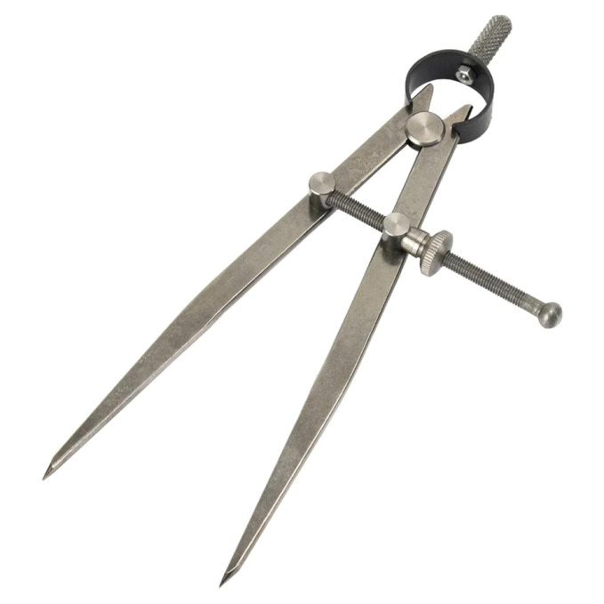
- A Pre-Technical Studies teacher came to class with the instrument shown below:

a) Name the instrument. (1 mark)
........................................................ ............................................................................................
b) State two uses of the instrument. (2 marks)
i) ................................................... .............................................................................................
ii) ................................................ ................................................................................................
c) Give one way of caring for the instrument. (1 mark)
............................................. .......................................................................................................
- During an educational trip, Grade 7 learners visited a textile production unit located near a large cotton farm.
State three benefits of the unit being located in that area. (3 marks)
a) ....................................... .........................................................................................................
b) .................................. ..............................................................................................................
c) .................................. ..............................................................................................................
- A community-based group is running a small poultry project as part of its entrepreneurship program.
Outline three factors it should consider when setting financial goals for the project to be successful and sustainable. (3 marks)
a) ............................... .................................................................................................................
b) .......................... ......................................................................................................................
c) ........................... .....................................................................................................................
- Grade 7 learners are learning how to start a business.
List three sources from which they may obtain business ideas. (3 marks)
a) .............................. ..................................................................................................................
b) .............................. ..................................................................................................................
c) ............................... .................................................................................................................
- The picture below shows a computer user environment.
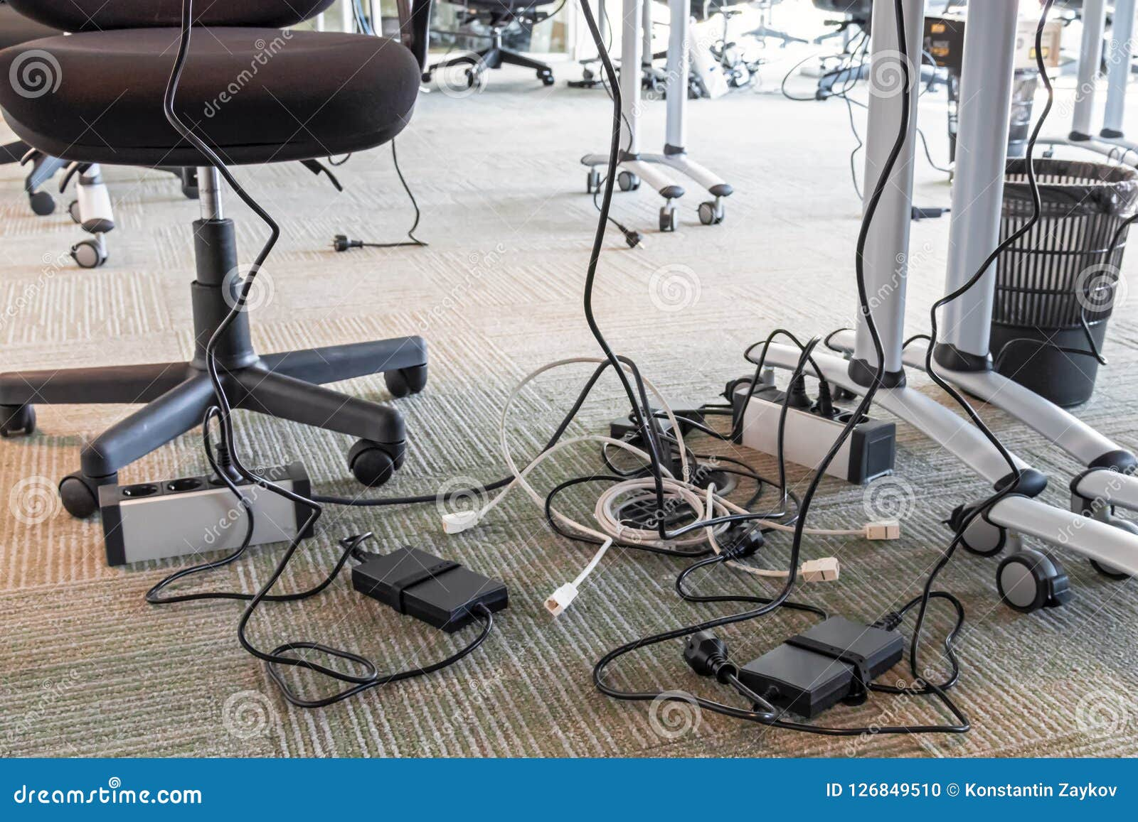
a) Identify one potential safety threat to users in the environment. (1 mark)
......................................... ...........................................................................................................
b) Explain one safety measure that should be put in place to prevent the threat in (a). (1 mark)
................................... .................................................................................................................

- A teacher displayed the following chart during a lesson on the classification of computers.
Hybrid computers
Q:
P:
Classification according to functionality

a) Name the types of computers labelled:
P: ........................................................................................... (1 mark)
Q: ........................................................................................... (1 mark)
b) State one characteristic of hybrid computers. (1 mark)
...................................................................................................................................................................................
- A class teacher uses a smartphone to communicate with parents through social media.
a) Name two ICT tools the class teacher uses to communicate. (2 marks)
i) ................................ ................................................................................................................
ii) ................................ ...............................................................................................................
b) Explain one benefit of using ICT tools for communication. (1 mark)
………………………………………………………………………………………………………………………………………………………………...................................................................................................................
- a) The following table shows a list of tasks and computer hardware devices.
Use arrows to match each task with the appropriate device. (4 marks)
Task | Computer Hardware Device
Typing a document | Microphone
Listening to music | Digital camera
Recording videos | Flash disk
Transferring files between computers | Keyboard
 | Speakers

b) State the mouse action used to:
(i) Open a file ...................... ............................................................................................................... (1 mark)
(ii) Display a shortcut menu ....... ....................................................................................................... (1 mark)
46. Define the following terms. (4 marks)
a) Pre-Technical Studies
__________________________________________________________________________________________________________________________________________________________________________________________
b) Safety
__________________________________________________________________________________________________________________________________________________________________________________________
47. State four roles of Pre-Technical Studies in day-to-day life. (4 marks)
i. _________________________________________________________
ii. _________________________________________________________
iii. ________________________________________________________
iv. _________________________________________________________
48. State three examples of artistic drawings. (3 marks)
i. _________________________________________________________
ii. _________________________________________________________
iii. ________________________________________________________
49. Differentiate between technical drawings and artistic drawings in terms of: (2 marks)
a) Dimensioning __________________________________________________________________________________________________________________________________________________________________________________
b) Precision
__________________________________________________________________________________________________________________________________________________________________________________________
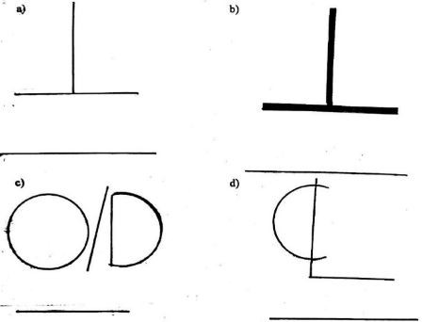
50. Study the symbols, abbreviations and lines provided below and identify each one. (4 marks)

51. Differentiate between the following. (4 marks)
a) Metallic materials and non-metallic materials
__________________________________________________________________________________________________________________________________________________________________________________________
b) Ferrous metals and non-ferrous metals
__________________________________________________________________________________________________________________________________________________________________________________________
52. An ammeter, a voltmeter and an ohmmeter are placed on a table. How would you differentiate the three instruments? (3 marks)
a) Ammeter – ________________________________________________
b) Voltmeter – _______________________________________________
c) Ohmmeter – _______________________________________________

53. State four fields or situations in which a tape measure is used. (4 marks)
i. ________________________________________________________________________________________
ii. _______________________________________________________________________________________
iii. _______________________________________________________________________________________
iv. _______________________________________________________________________________________
54. State two uses of an odd-leg caliper. (2 marks)
i. ________________________________________________________________________________________
ii. _______________________________________________________________________________________
55. State the four factors of production. (2 marks)
i. ________________________________________________________________________________________
ii. _______________________________________________________________________________________
iii. _______________________________________________________________________________________
iv. _______________________________________________________________________________________
56. State two importance of entrepreneurship to an individual. (2 marks)
i. ________________________________________________________________________________________
ii. _______________________________________________________________________________________
57. State four ways of generating business ideas. (4 marks)
i. ________________________________________________________________________________________
ii. _______________________________________________________________________________________
iii. _______________________________________________________________________________________
iv. _______________________________________________________________________________________
58. State two uses of money. (2 marks)
i. ________________________________________________________________________________________
ii. _______________________________________________________________________________________
59. Define the following terms. (3 marks)
a) Computer Science
__________________________________________________________________________________________________________________________________________________________________________________________
b) Online Safety
__________________________________________________________________________________________________________________________________________________________________________________________
c) Phishing
__________________________________________________________________________________________________________________________________________________________________________________________
60. I am the smallest, least powerful and cheapest type of computer. I am commonly used by individuals, and my processing unit is based on a microprocessor. Who am I? (1 mark) ________________________
16. State four characteristics of computers. (4 marks)
i. ________________________________________________________________________________________
ii. _______________________________________________________________________________________
iii. _______________________________________________________________________________________
iv. _______________________________________________________________________________________
61. Classify computers according to their purpose. (2 marks) i. _________________________________________________________
ii. _________________________________________________________
62. Grade 7 learners were discussing safety during a practical lesson. They identified several situations that could cause harm to a person. State six hazards to personal safety. (6 marks)
i. ________________________________________________________________________________________
ii. _______________________________________________________________________________________
iii. _______________________________________________________________________________________
iv. _______________________________________________________________________________________
v. _______________________________________________________________________________________
vi. ______________________________________________________________________________________
63. During a practical lesson, the teacher asked learners to categorise tools according to their uses. Categorise the following tools as measuring, cutting, boring, holding, marking, scooping or striking tools. (6 marks)
a) Rotary leather punch – _____________________________________
b) Screwdriver – _____________________________________________
c) Hand brace – ______________________________________________
d) Protractor – _______________________________________________
e) Pair of compasses – ________________________________________
f) Mallet – __________________________________________________

64. During a first aid lesson, learners identified several items found in a first aid box. State the purpose of each of the following items. (5 marks)
a) Triangular bandage – _______________________________________
b) Eye wash – _______________________________________________
c) Antiseptic solution – _______________________________________
d) Cold pack – _______________________________________________
e) First aid manual – _________________________________________
65. State three roles played by Pre-Technical Studies in our day-to-day life. (3 marks)
i. _________________________________________________________
ii. _________________________________________________________
iii. ________________________________________________________
66. State three examples of physical threats that may occur in a workplace. (3 marks)
i. _________________________________________________________
ii. _________________________________________________________
iii. ________________________________________________________
67. Explain how naked electrical wires can become a physical threat in a work environment. (2 marks)
__________________________________________________________________________________________________________________________________________________________________________________________
68. State three examples of non-metallic materials. (3 marks)
i. ________________________________________________________________________________________
ii. _______________________________________________________________________________________
iii. _______________________________________________________________________________________
69. State two examples of cleaning tools. (2 marks)
i. ________________________________________________________________________________________
ii. _______________________________________________________________________________________

70. State two examples of artistic drawings. (2 marks)
i. ________________________________________________________________________________________
ii. _______________________________________________________________________________________
71. Grade 7 learners were discussing the importance of Business Studies. State three important points they were likely to discuss. (3 marks)
i. _________________________________________________________
ii. _________________________________________________________
iii. ________________________________________________________
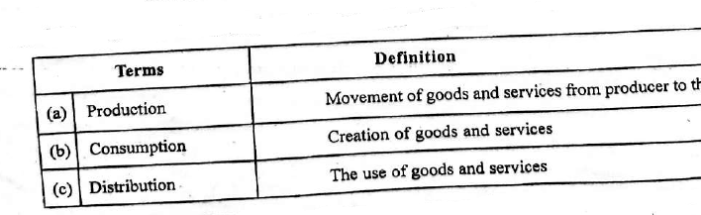
72. Study the terms and definitions provided in the table below. Match each term with its correct definition. (3 marks)

73. A resource person was invited to teach Grade 7 learners about the components of Business Studies. Identify the component described in each statement below. (5 marks)
a) The study of all activities involved in identifying a business opportunity and obtaining the necessary resources to start and run a business.
Answer: _________________________________________________
b) The ability to understand and use various financial skills.
Answer: _________________________________________________
c) The study of trade and aids to trade.
Answer: _________________________________________________
d) The systematic way of keeping correct business records arising from trading activities.
Answer: _________________________________________________
e) The study of how people try to satisfy their unlimited needs and wants using the limited resources available.
Answer: _________________________________________________

74. During a Business Studies seminar, learners examined different Kenyan currency notes and discussed the themes and features represented on them. State the theme associated with each of the following notes. (4 marks)
a) KSh 200 note – ____________________________________________
b) KSh 50 note – _____________________________________________
c) KSh 1,000 note – __________________________________________
d) KSh 500 note – ___________________________________________
75. Grade 7 learners were studying large-scale retail outlets. State three types of large-scale retailers. (3 marks)
i. _________________________________________________________
ii. _________________________________________________________
iii. ________________________________________________________
32. Define the term money. (2 marks)
__________________________________________________________________________________________________________________________________________________________________________________________
__________________________________________________________________________________________________________________________________________________________________________________________
76. The evolution of computers began with the development of early calculating devices. Describe three mechanical devices that were used during the early stages of computer development. (6 marks)
a) _________________________________________________________
b) _________________________________________________________
c) _________________________________________________________
77. A computer consists of different components. State three input devices used to enter data into a computer. (3 marks)
i. _________________________________________________________
ii. _________________________________________________________
iii. ________________________________________________________

78. Grade 7 learners were discussing the computer processing cycle during a Computer Studies lesson. State the four stages of the computer processing cycle. (4 marks)
i. _________________________________________________________
ii. _________________________________________________________
iii. ________________________________________________________
iv. _________________________________________________________
79. An abacus is an early counting device that was used to perform basic calculations. What does the term ABACUS stand for? (3 marks)
__________________________________________________________________________________________________________________________________________________________________________________________
80. State four devices that can be attached to the system unit of a computer. (4 marks)
i. ________________________________________________________________________________________
ii. _______________________________________________________________________________________
iii. _______________________________________________________________________________________
iv. _______________________________________________________________________________________
81. Computers can be classified according to different criteria. State three classifications of computers according to their purpose. (3 marks)
i. ________________________________________________________________________________________
ii. _______________________________________________________________________________________
iii. _______________________________________________________________________________________
MARKING SCHEME
Grade 7 Pre-Technical Studies December Assignment.

SECTION A: MULTIPLE CHOICE QUESTIONS (20 MARKS)
- D — Malleability (Property that allows metals to be hammered or bent into thin sheets without breaking)
- C — Conductivity of electricity (Copper has high electrical conductivity)
- B — Magnetism (Attraction of magnetic materials by a magnet)
- B — Metallic materials
- C — They are strong and durable
- B — Efficient use of resources (Reusing materials promotes resource conservation)
- A — Economic resources (Land, labor, capital, and entrepreneurship are economic resources/factors of production)
- D — Services (Intangible activities provided to satisfy human wants)
- B — Resource mapping (Identifying and representing the geographic location of resources)
- B — Magnetism
- C — Diligence (Ability of a computer to work continuously without fatigue or loss of accuracy)
- A — Purpose (Special-purpose vs. general-purpose computers)
- B — Micro, Mini, Mainframe, Supercomputer (Correct ascending order by size and capacity)
- C — Versatile machines (Ability to perform different tasks seamlessly)
- A — Processing and storage of data
- B — It allows instant communication
- B — Video conferencing
- A — Social networking
- B — Phishing (Deceptive attempt to obtain sensitive personal information online)
- A — Telkom Kenya (Internet Service Provider)
- B — Promotes global communication and research
- C — Continuous thick line (Used for visible outlines/edges in technical drawing)
- B — Radial dimensioning (Dimensioning circles and arcs using radius/diameter)
- A — Dimensioning drawings
- B — Combined shapes in plane geometry
- A — Safety gears (Personal Protective Equipment - PPE)
- B — Electrical shocks and damage
- C — Dust and theft (Physical hazards to computing equipment)
- C — Installing updated antivirus programs
- B — It helps learners gain technical, business, and computer skills

SECTION B: STRUCTURED QUESTIONS (50 MARKS)

31. Component of Pre-Technical Studies
- Computer Studies (or Information and Communication Technology / ICT)

32. Drawing Abbreviations
Abbreviation | Full Meaning
(i) DRG | Drawing
(ii) A/C | Across Corners / Air Conditioning
(iii) CSK | Countersunk
(iv) O/D | Outside Diameter

33. Four Principles of Free-Hand Sketching
a) Keep pencil points sharp and proper grip.
b) Maintain proportional balance in size and dimensions.
c) Draw straight lines with smooth, continuous arm movements rather than short, jerky strokes.
d) Use light guidelines initially before darkening final outlines.

34. Classification of Materials
Metals | Non-metals
(i) Nails | (i) Floor tile
(ii) Key | (ii) Toothbrush

35. Conductors and Uses of Copper
a) Two other metals that conduct electricity:
- i) Aluminium
- ii) Silver (or Iron, Gold)
b) Two uses of copper in the home environment:
- i) Electrical wiring in domestic circuits and appliances.
- ii) Plumbing pipes and water heating tubes.

36. Synthetic Materials
a) Two synthetic materials:
- i) Plastics (e.g., PVC, Polythene)
- ii) Nylon (or Polyester, Synthetic rubber)
b) Two uses of synthetic materials:
- i) Manufacturing household utensils, containers, and packaging.
- ii) Making synthetic clothing fibers, ropes, and electrical insulation.

37. Matching Carpentry Tools to Uses
- Tape measure -Measure lengths
- Try square - Check squareness
- Marking gauge - Mark parallel lines
- Pliers - Twisting wires

38. Technical Instrument Care & Use
a) Name of instrument: Pair of Compasses (or Divider)
b) Two uses:
- i) Drawing circles and arcs in geometric construction.
- ii) Stepping off distances and transferring linear measurements.
c) Way of caring: Keep the points protected and store in a protective case away from moisture.

39. Benefits of Locating Textile Production Near a Cotton Farm
a) Reduced transportation costs for raw cotton.
b) Direct access to fresh, high-quality raw materials without delays.
c) Lower production costs leading to higher profit margins.

40. Factors in Setting Financial Goals for Poultry Project
a) Cost of inputs: Feeds, vaccines, equipment, and housing expenses.
b) Expected revenue: Target market pricing and projected sales of eggs/meat.
c) Timeframe: Short-term vs. long-term financial returns and cash flow requirements.

41. Sources of Business Ideas
a) Identifying unmet consumer needs and problems in the community.
b) Observing market trends and analyzing existing businesses for gaps.
c) Exploring personal hobbies, skills, and talents.

42. Safety in Computer Environment
a) Potential safety threat: Overcrowded/tangled electrical cables on the floor (tripping hazard / risk of electrical short circuit).
b) Safety measure: Cable management using trunking/conduits and proper placement away from walkways.

43. Classification of Computers
a) Types of computers:
- P: Analog Computers
- Q: Digital Computers
b) Characteristic of Hybrid Computers: They combine features of both analog computers (measuring continuous physical quantities) and digital computers (processing discrete data using digits).

44. Communication Tools
a) Two ICT tools used:
- i) Smartphone (Hardware)
- ii) WhatsApp / Social Media Application (Software Platform)
b) One benefit: Enables real-time, low-cost broadcast of announcements to multiple recipients simultaneously.

45. Hardware Tasks & Mouse Actions
a) Matching Tasks:
- Typing a document - Keyboard
- Listening to music - Speakers
- Recording videos - Digital camera
- Transferring files between computers - Flash disk
b) Mouse Actions:
- (i) Open a file: Double-clicking (Left-click twice rapidly)
- (ii) Display a shortcut menu: Right-clicking

46. Definitions
a) Pre-Technical Studies: An integrated learning area providing foundational knowledge, practical skills, and values across Technical Drawing, Computer Studies, Business Studies, and Applied Sciences.
b) Safety: The condition of being protected from harm, injury, danger, or damage in a workplace or living environment.

47. Four Roles of Pre-Technical Studies
i. Equips learners with practical technical and problem-solving skills for everyday tasks.
ii. Promotes environmental conservation through resource reuse and efficient utilization.
iii. Builds foundation for career pathways in engineering, technology, and business.
iv. Fosters financial literacy and entrepreneurial mindset.

48. Examples of Artistic Drawings
i. Landscape paintings/sketches
ii. Portraiture (human drawings)
iii. Abstract art / Still life drawings

49. Technical vs. Artistic Drawings
a) Dimensioning: Technical drawings specify exact numerical dimensions, scales, and units; artistic drawings do not use exact dimensions.
b) Precision: Technical drawings require strict accuracy using drawing instruments and standard conventions; artistic drawings rely on personal expression, proportion, and visual interpretation.

50. Identification of Drawing Symbols/Lines
- Perpendicularity
- Square
- Outer diameter
- Center Line

51. Material Differences
a) Metallic vs. Non-metallic: Metallic materials possess luster, high electrical and thermal conductivity, and malleability (e.g., iron, copper); non-metallic materials lack metallic luster, are generally poor conductors, and are brittle or soft (e.g., wood, plastic, glass).
b) Ferrous vs. Non-ferrous: Ferrous metals contain iron as their main element and are magnetic (e.g., steel, cast iron); non-ferrous metals do not contain iron and are non-magnetic (e.g., aluminium, copper, brass).

52. Differentiating Measuring Instruments
a) Ammeter: Marked with symbol 'A'; measures electric current in Amperes (A).

b) Voltmeter: Marked with symbol 'V'; measures potential difference (voltage) in Volts (V).
c) Ohmmeter: Marked with symbol (Omega); measures electrical resistance in Ohms

53. Fields Where Tape Measures are Used
i. Construction and building sites
ii. Tailoring and garment making
iii. Carpentry and woodworking
iv. Surveying and landscaping

54. Uses of an Odd-Leg Caliper
i. Scribing lines parallel to an edge or shoulder.
ii. Locating the center of cylindrical/round workpieces.

55. Four Factors of Production
i. Land
ii. Labour
iii. Capital
iv. Entrepreneurship

56. Importance of Entrepreneurship to an Individual
i. Source of income and self-employment.
ii. Allows personal independence and creative problem solving.

57. Four Ways of Generating Business Ideas
i. Identifying gaps/unmet demands in local markets.
ii. Conducting surveys and consumer feedback research.
iii. Combining existing products or services in innovative ways.
iv. Converting personal hobbies, talents, and skills into business offerings.

58. Two Uses of Money
i. Medium of exchange (buying goods and services).
ii. Store of value (saving wealth for future use) / Measure of value.

59. Definitions
a) Computer Science: The study of computation, information processing, computer hardware/software design, and algorithmic processes.
b) Online Safety: Practices and precautions taken to protect personal data, privacy, and digital assets while navigating the internet.
c) Phishing: A fraudulent cyberattack mechanism where attackers impersonate trustworthy entities to trick users into revealing sensitive data like passwords or credit card numbers.

60. Computer Identification
- Microcomputer (or Personal Computer / PC)

16/61. Characteristics & Classification of Computers
- Characteristics of Computers:
i. Speed
ii. Accuracy
iii. Diligence
iv. Versatility (and Storage)
- Classification according to Purpose:
i. General-Purpose Computers
ii. Special-Purpose Computers

62. Six Hazards to Personal Safety
i. Slippery floors.
ii. Exposed or naked electrical wires.
iii. Poorly stored sharp tools.
iv. Inadequate ventilation or toxic chemical fumes.
v. Dark or unlit work areas.
vi. Lifting heavy loads using improper posture.

63. Categorization of Tools
a) Rotary leather punch – Boring tool (or Punching tool)
b) Screwdriver – Holding / Driving tool
c) Hand brace – Boring tool
d) Protractor – Measuring / Marking tool
e) Pair of compasses – Marking / Drawing tool
f) Mallet – Striking tool

64. First Aid Items and Uses
a) Triangular bandage: Used as a sling to support injured arms/shoulders or secure dressings in place.
b) Eye wash: Used to flush out dirt, dust, or harmful chemicals from the eyes.
c) Antiseptic solution: Used to clean wounds and prevent bacterial infections.
d) Cold pack: Reduces swelling and relieves pain from sprains, strains, or bruises.
e) First aid manual: Provides step-by-step instructions on administering emergency care correctly.

65. Three Roles of Pre-Technical Studies
i. Imparts hands-on technical and vocational skills.
ii. Enhances digital literacy and technological competence.
iii. Promotes safety awareness in domestic and industrial environments.

66. Three Physical Threats in Workplace
i. Structural damages (e.g., weak ceilings/floors).
ii. Fire outbreaks due to poor wiring or flammable materials.
iii. Equipment theft or physical vandalism.

67. Naked Electrical Wires as a Threat
Naked electrical wires expose bare conductors that can cause fatal electric shocks/electrocution upon human contact and spark fire outbreaks if they short-circuit near combustible materials.

68. Three Examples of Non-Metallic Materials
i. Timber/Wood
ii. Glass
iii. Plastics / Rubber

69. Two Examples of Cleaning Tools
i. Brooms / Brushes
ii. Mops / Dustpans

70. Two Examples of Artistic Drawings
i. Still life sketches
ii. Portrait paintings

71. Importance of Business Studies
i. Helps individuals make informed financial and economic decisions.
ii. Teaches basic accounting and record-keeping principles.
iii. Promotes understanding of trade, consumer rights, and business ethical standards.

72/73. Components of Business Studies
a) Entrepreneurship
b) Financial Literacy
c) Commerce
d) Accounting
e) Economics

74. Kenyan Currency Note Themes
a) KSh 200 note: Social Services / Healthcare / Education
b) KSh 50 note: Green Energy / Agriculture / Wind & Solar power
c) KSh 1,000 note: Governance / Tourism / Wildlife / Capital City (Nairobi)
d) KSh 500 note: Tourism and Wildlife

75. Types of Large-Scale Retailers
i. Supermarkets
ii. Hypermarkets
iii. Department stores (or Chain stores)

32. Definition of Money
Money is any commodity or item generally accepted as a medium of exchange for goods and services and settlement of debts.

76. Early Mechanical Calculating Devices
a) Abacus: Frame with beads sliding on rods used for basic arithmetic operations.
b) Napier's Bones: Set of numbered rods created by John Napier used for multiplication and division.
c) Pascaline: Mechanical gear-based calculator developed by Blaise Pascal capable of addition and subtraction.

77. Three Input Devices
i. Keyboard
ii. Mouse
iii. Scanner (or Microphone, Barcode Reader)

78. Four Stages of Computer Processing Cycle
i. Input
ii. Processing
iii. Output
iv. Storage

79. What ABACUS Stands For
- Abundant Beads, Addition and Calculation Utility System

80. Four Devices Attached to System Unit (Peripherals)
i. Monitor / Display Screen
ii. Keyboard
iii. Mouse
iv. Printer (or External Hard Drive)

81. Computer Classification by Purpose
i. General-Purpose Computers (e.g., Laptops, Desktops)
ii. Special-Purpose Computers (e.g., ATM machines, Patient Monitors)
iii. Dedicated Computers

