TERM 3 HOLIDAY ASSIGNMENT 2026
FORM THREE
CHEMISTRY PAPER 2
Question | Maximum Score | Candidate's Score
1 | 12
2 | 12
3 | 12
4 | 7
5 | 10
6 | 10
TOTAL | 77

1. Use the information below to answer the questions that follow. The letters are not the actual symbols of the elements.
Element | Atomic no. | M.P. °C | B.P. °C | Ionic radius (nm)
A | 11 | 98 | 890 | 0.095
B | 12 | 650 | 1110 | 0.065
C | 13 | 660 | 2470 | 0.050
D | 14 | 1410 | 2360 | 0.041
E | 15 | 44.2 & 590 | 280 | 0.034
F | 16 | 113 & 119 | 445 | 0.184
G | 17 | −101 | −35 | 0.181
H | 18 | −189 | −186 | —

a) (i) Write the electronic configuration of the atoms represented by E and H. (1 mark)
________________________________________________________________________________
(ii) State the nature of the oxides of the elements represented by B and F. (2 marks)
________________________________________________________________________________
b) Why do the elements represented by E and F have two values of melting points? (1 mark)
________________________________________________________________________________
c) (i) Explain, in terms of structure and bonding, the increase in boiling point from A to C. (2 marks)
________________________________________________________________________________
(ii) Explain why element D has a high boiling point. (2 marks)
________________________________________________________________________________
(iii) Explain the decrease in boiling points from F to H. (2 marks)
________________________________________________________________________________
d) (i) Compare the ionic radius of F and G. (1 mark)
________________________________________________________________________________
(ii) Why is no ionic radius given for H? (1 mark)
________________________________________________________________________________
2. Sulphur and its compounds are important in industry and laboratory chemistry.
a) (i) In the Frasch process, superheated water at about 170 °C is used. Explain how the superheated water is obtained. (1 mark)
________________________________________________________________________________
(ii) State the role of superheated water. (1 mark)
________________________________________________________________________________
(iii) State the role of compressed air. (1 mark)
________________________________________________________________________________
b) In an experiment, 4.8 g of sulphur were obtained by reacting hydrogen sulphide with sulphur(IV) oxide: 2H₂S(g) + SO₂(g) → 2H₂O(l) + 3S(s). Calculate the volume of SO₂ used at r.t.p. [S=32; O=16; molar gas volume=24 dm³]. (3 marks)
________________________________________________________________________________
________________________________________________________________________________
________________________________________________________________________________
c) Study the flow chart below and answer the questions that follow. (1 mark)
________________________________________________________________________________
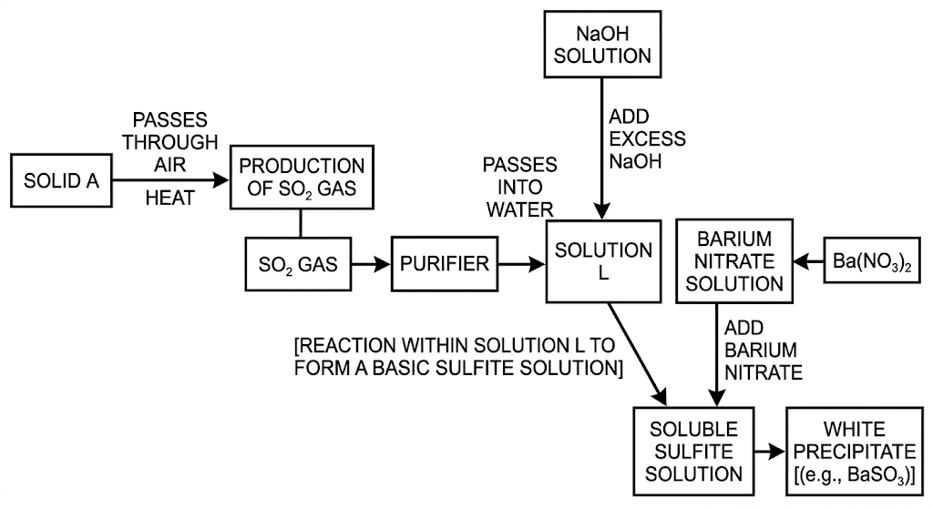
i) Other than sulphur, name two possible identities of solid A. (1 mark)
________________________________________________________________________________
ii) Write an ionic equation for formation of the white precipitate. (1 mark)
________________________________________________________________________________
iii) State and explain the observation when dilute hydrochloric acid is added to the white precipitate. (1 mark)
________________________________________________________________________________
iv) State and explain the observation when blue litmus paper is dipped into solution L. (1 mark)
________________________________________________________________________________
v) Hydrogen sulphide is passed through iron(III) chloride solution. The reddish-brown solution turns green and a yellow solid is deposited. Explain these observations. (2 marks)
________________________________________________________________________________
3. Carbon chemistry and industrial nitrogen compounds.
a) The diagrams below show two allotropes of carbon. Study them and answer the questions. (1 mark)
________________________________________________________________________________
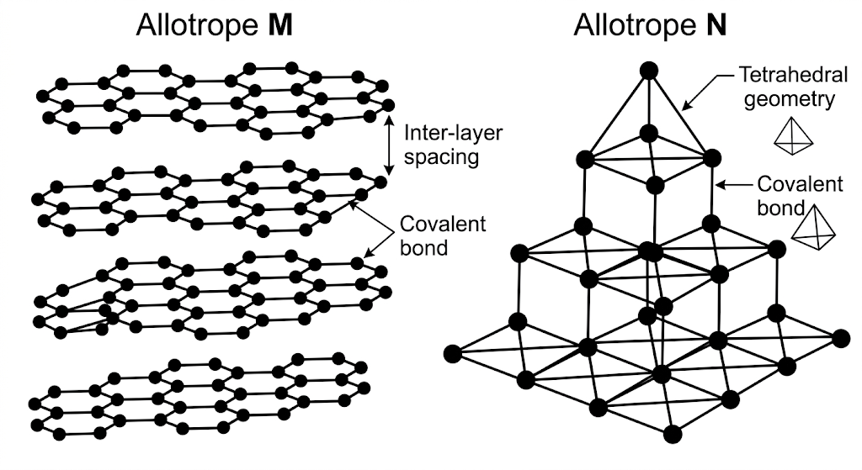
i) What is meant by allotropy? (1 mark)
________________________________________________________________________________
ii) Name allotropes M and N. (2 marks)
________________________________________________________________________________
iii) Give one use of N. (1 mark)
________________________________________________________________________________
iv) Which allotrope conducts electricity? Explain. (2 marks)
________________________________________________________________________________
b) Carbon(IV) oxide is passed over heated charcoal. Write the equation for the reaction that takes place. (1 mark)
________________________________________________________________________________
c) State one substance that can be used to absorb the gaseous product in a gas mixture. (1 mark)
________________________________________________________________________________
d) Describe a simple chemical test to distinguish between carbon(IV) oxide and carbon(II) oxide. (2 marks)
________________________________________________________________________________
4. The flow chart below represents industrial processes leading to nitrogenous and sulphate fertilizers.
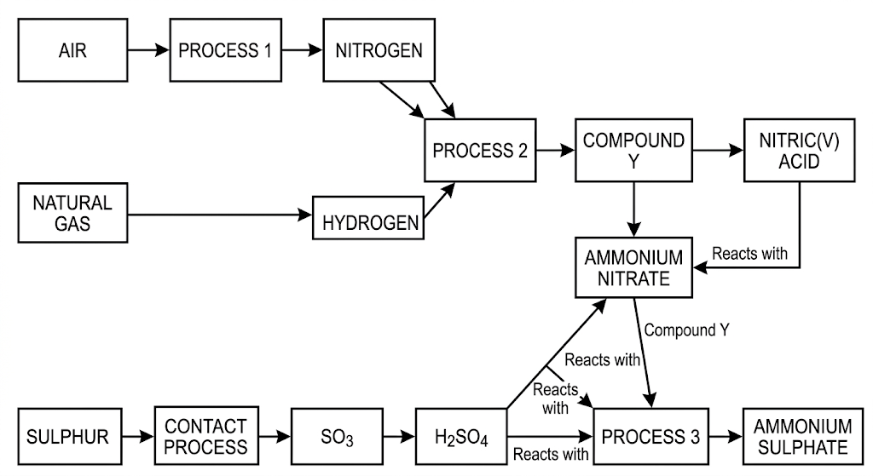
a) (i) Name Process 1. (1 mark)
________________________________________________________________________________
(ii) Name Process 2. (1 mark)
________________________________________________________________________________
b) (i) Name the catalyst used in Process 2. (1 mark)
________________________________________________________________________________
(ii) Name the catalyst used in the Ostwald process. (1 mark)
________________________________________________________________________________
(iii) Name the catalyst used in the Contact process. (1 mark)
________________________________________________________________________________
c) Name compound Y. (1 mark)
________________________________________________________________________________
d) Write the equation for the reaction leading to formation of ammonium sulphate. (1 mark)
________________________________________________________________________________
5. Answer the following questions on gas volumes and formulae.
a) (i) State Gay-Lussac's law of combining gas volumes. (1 mark)
________________________________________________________________________________
(ii) 80 cm³ of propane is ignited in oxygen and the gaseous products are cooled. Using C₃H₈ + 5O₂ → 3CO₂ + 4H₂O, determine the volume of residual gas and the volume of oxygen used. (3 marks)
________________________________________________________________________________
________________________________________________________________________________
________________________________________________________________________________
b) (i) What is an empirical formula? (1 mark)
________________________________________________________________________________
(ii) A compound contains 40.00% C, 6.67% H and 53.33% O by mass. [C=12, H=1, O=16] Determine its empirical formula. (3 marks)
________________________________________________________________________________
________________________________________________________________________________
________________________________________________________________________________
________________________________________________________________________________
(iii) If the molecular mass of the compound is 180, determine its molecular formula. (2 marks)
________________________________________________________________________________
________________________________________________________________________________
________________________________________________________________________________
c) A solution of calcium nitrate is made by dissolving 16.4 g in 2 litres of solution. Calculate the concentration of nitrate ions in moles per litre. [Ca=40, N=14, O=16]. (3 marks)
________________________________________________________________________________
________________________________________________________________________________
________________________________________________________________________________
________________________________________________________________________________
6. Answer the following questions on chlorine, laboratory technique and separation.
a) (i) Chlorine is prepared by reacting concentrated hydrochloric acid with an oxidising agent. Name two oxidising agents that can replace potassium manganate(VII). (1 mark)
________________________________________________________________________________
(ii) Freshly cut blue flower petals are placed separately in oxygen and chlorine. Explain the difference in observations. (2 marks)
________________________________________________________________________________
(iii) State two uses of hydrochloric acid. (2 marks)
________________________________________________________________________________
b) Hydrogen chloride gas is passed over heated iron powder and the gas produced is collected over water. (1 mark)
________________________________________________________________________________
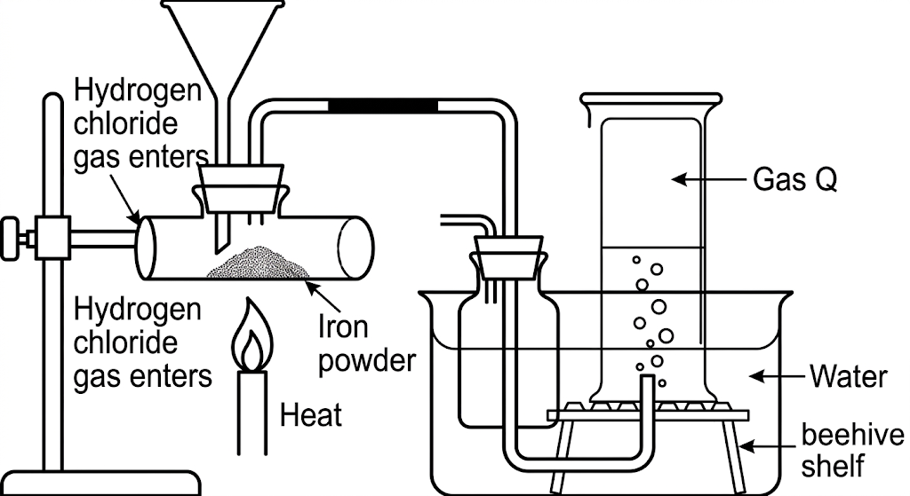
i) State and explain the observations in the combustion tube. (2 marks)
________________________________________________________________________________
ii) Blue litmus paper placed in the water turns red. Explain this observation. (1 mark)
________________________________________________________________________________
iii) Describe a chemical test for Gas Q. (1 mark)
________________________________________________________________________________
c) State two adaptations of a burette that enable it to perform its function. (2 marks)
________________________________________________________________________________
d) The Bunsen burner produces luminous and non-luminous flames. State the condition under which the luminous flame is produced and give two reasons why it is unsuitable for heating. (3 marks)
________________________________________________________________________________
e) Describe the procedure for determining the pH of a soil sample before selecting a fertilizer. (2 marks)
________________________________________________________________________________
f) A liquid Q is immiscible with water, while liquid J is miscible with water. Ethanol is miscible with both. State the physical property used to choose a separation method for ethanol and J, and name two methods that could separate water and Q. (3 marks)
________________________________________________________________________________
g) Describe how a mixture of potassium chloride, anhydrous iron(III) chloride and lead sulphate can be separated. (3 marks)
________________________________________________________________________________

