KENYA CERTIFICATE OF BASIC EDUCATION

SENIOR SCHOOL ASSESSMENT

DECEMBER ASSIGNMENT 2026
GRADE 10 – COMPUTER STUDIES
Time: 2 Hours
LEARNER’S DETAILS
Name: _____________________________________________________________. School: ____________________________________________.
Assessment Number: _______________________________________________. Date: ____________________________________________.
School Code: ______________________________________________________. Signature: _______________________________________.

INSTRUCTIONS TO CANDIDATES
- Write your name in the spaces provided above.
- Write the name of your school and your stream in the spaces provided.
- Write your admission number and the date of the assessment in the spaces provided.
- This paper consists of two sections: A and B.
- Answer all questions in section A and section B.
- Answer the questions in English.
- All answers MUST be written in the spaces provided in the paper.
- Do NOT remove any page from this question paper.

FOR OFFICIAL USE ONLY (EXAMINER’S USE)
SECTION | SECTION A | SECTION B | % SCORE | EE1 | EE2 | ME1 | ME2 | AE1 | AE2 | BE1 | BE2
SCORE RANGE | 30 MARKS | 50 MARKS |  | 90-100 | 75-89 | 58-74 | 41-57 | 31-40 | 21-30 | 11-20 | 1-10
POINTS |  |  |  | 8 POINTS | 7 POINTS | 6 POINTS | 5 POINTS | 4 POINTS | 3 POINTS | 2 POINTS | 1 POINT
LEARNER’S TOTAL SCORE

SECTION A (30 MARKS)
Answer ALL questions in this section.
  - a) Define the term hardware. (1 mark)
______________________________________________________________________________________________________________________________________________________________________________________________
b) State two examples of input devices. (2 marks)
- _________________________________________________________________________________________
- _________________________________________________________________________________________
c) Give one example of an output device. (1 mark)
________________________________________________________
d) State one function of a storage device. (1 mark)
____________________________________________________________________________________________
  - Study the diagram below and answer the questions that follow.

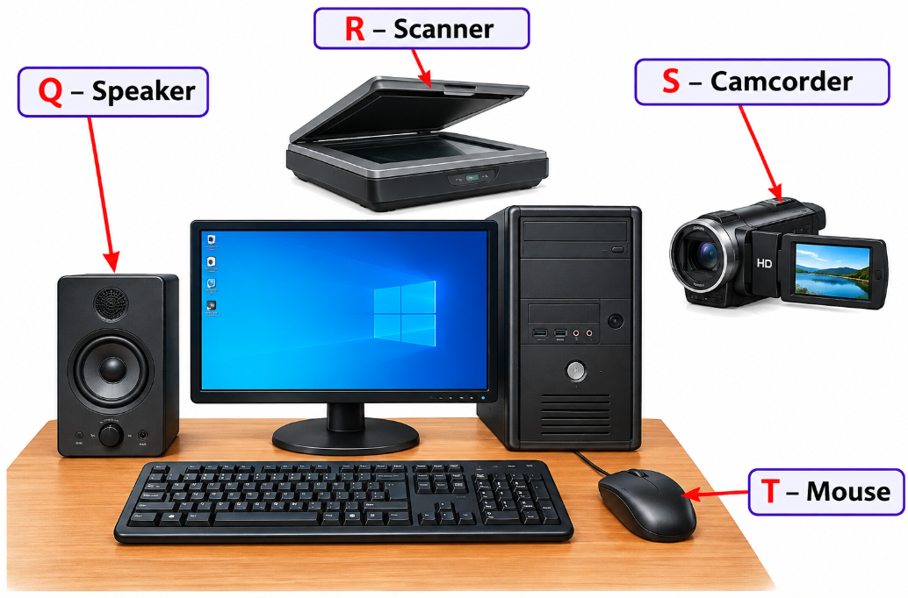

a) Identify device Q. ______________________________________ (1 mark)
b) Identify device R. ______________________________________ (1 mark)
c) Identify device S. ______________________________________ (1 mark)
d) Identify device T ______________________________________ (1 mark)
e) State one use of device T. (1 mark) ______________________________________________________________________________________________________________________________________________________________________________________________
  - a) What is computer memory? (1 mark)
______________________________________________________________________________________________________________________________________________________________________________________________

b) Distinguish between RAM and ROM. (2 marks)
______________________________________________________________________________________________________________________________________________________________________________________________
c) State two examples of secondary storage devices. (2 marks)
- _________________________________________________________________________________________
- _________________________________________________________________________________________
  - A teacher records the following marks:
65, 72, 48, 80, 75
a) What is meant by data? (1 mark)
______________________________________________________________________________________________________________________________________________________________________________________________
b) What is meant by information? (1 mark) ______________________________________________________________________________________________________________________________________________________________________________________________
c) Calculate the total marks obtained. (1 mark)

d) Calculate the average mark. Show your working. (2 marks)

  - a) State the base of the binary number system. (1 mark)
___________________________________________________________
b) Write the two digits used in binary notation. (1 mark)
- _________________________________________________________________________________________
- _________________________________________________________________________________________
c) Convert 11001₂ to decimal. Show your working. (2 marks)

d) State one use of binary numbers in computing. (1 mark)
______________________________________________________________________________________________________________________________________________________________________________________________
  - a) Define computer ethics. (1 mark)
________________________________________________________________________________________________________________________________________________________________________________________
b) State two examples of unethical use of computers. (2 marks)
- _________________________________________________________________________________________
- _________________________________________________________________________________________
c) State two measures that can be taken to protect personal data on a computer. (2 marks)
- _________________________________________________________________________________________
- _________________________________________________________________________________________

SECTION B: 50 MARKS
Answer ALL questions in this section.
  - Study the diagram below.
┌──────────────┐
│ INPUT │
└──────┬───────┘
│
▼
┌──────────────┐
│ A │
│ │
│ PROCESSING │
└──────┬───────┘
│
▼
┌──────────────┐
│ OUTPUT │
└──────────────┘

↕
┌──────────────┐
│ STORAGE │
└──────────────┘
a) Identify component A represented by the stage A. ____________________________ (1 mark)
b) State the three major stages of the information processing cycle. (3 marks)
- _________________________________________________________________________________________
- _________________________________________________________________________________________
- _________________________________________________________________________________________
c) Give two examples of devices used for entering data into a computer. (2 marks)
- _________________________________________________________________________________________
- _________________________________________________________________________________________
d) Give two examples of devices used for presenting processed information. (2 marks)
- _________________________________________________________________________________________
- _________________________________________________________________________________________
e) State two reasons why information needs to be stored. (2 marks)
- _________________________________________________________________________________________
- _________________________________________________________________________________________
  - A learner switches on a computer and is presented with a desktop containing icons, menus and a taskbar.
a) Identify the type of user interface described above. (1 mark)
_________________________________________________
b) State three features of a Graphical User Interface (GUI). (3 marks)
- _________________________________________________________________________________________
- _________________________________________________________________________________________
- _________________________________________________________________________________________
c) Explain three functions of an operating system. (3 marks)
- _________________________________________________________________________________________
- _________________________________________________________________________________________
- _________________________________________________________________________________________
d) Distinguish between system software and application software. (2 marks)
_____________________________________________________________________________________________________________________________________________________________________________________________________________________________________________________________________________________________
e) Give one example of application software used for word processing. (1 mark)
_________________________________________________________
  - A school wants a program that determines whether a learner has passed or failed an examination. A learner passes if the mark is 50 or above.

Study the flowchart below.

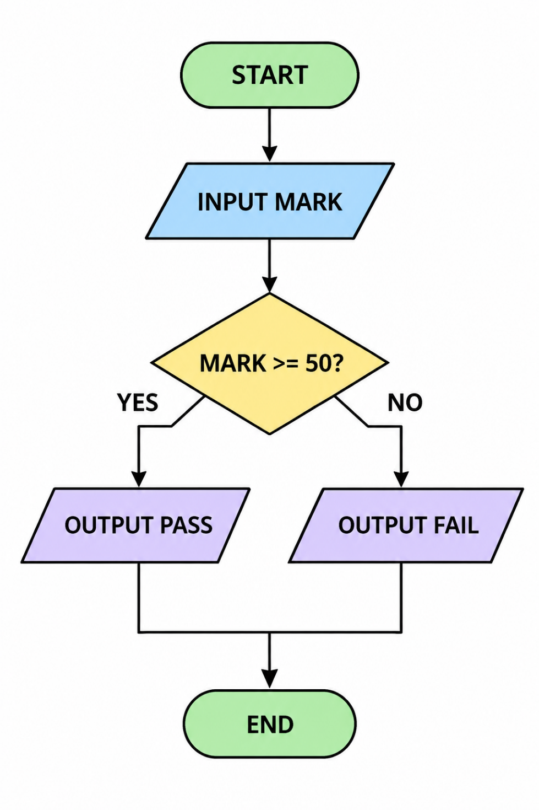
a) Identify the flowchart symbol used to represent a decision. _____________________________(1 mark)
b) State the condition tested by the decision symbol. (1 mark)
______________________________________________________________________________________________________________________________________________________________________________________________
c) Write an algorithm in numbered steps for the process shown. (4 marks)
___________________________________________________________________________________________________________________________________________________________________________________________________________________________________________________________________________________________________________________________________________________________________________________________________________________________________________________________________________________________
d) State the output if the learner scores 67 marks. (1 mark)
______________________________________________________________________________________________________________________________________________________________________________________________
e) State the output if the learner scores 42 marks. (1 mark)
______________________________________________________________________________________________________________________________________________________________________________________________
f) Explain why algorithms are important when developing computer programs. (2 marks)
______________________________________________________________________________________________________________________________________________________________________________________________
  - Consider the following pseudocode:
BEGIN
INPUT number
IF number > 0 THEN
OUTPUT "Positive"
ELSE IF number < 0 THEN
OUTPUT "Negative"
ELSE
OUTPUT "Zero"
ENDIF
END
a) Identify the input variable in the pseudocode. (1 mark)
_______________________________________________________________________________________________
b) Identify the control structure used in the pseudocode. (1 mark)
______________________________________________________________________________________________________________________________________________________________________________________________
c) State the output when the value entered is 25. (1 mark)
_______________________________________________________________________________________________
d) State the output when the value entered is -8. (1 mark)
______________________________________________________________________________________________________________________________________________________________________________________________
e) State the output when the value entered is 0. (1 mark)
_______________________________________________________________________________________________

f) Explain the purpose of an IF...ELSE statement in programming. (2 marks)
_____________________________________________________________________________________________________________________________________________________________________________________________________________________________________________________________________________________________
g) State three common errors that may occur when writing a computer program. (3 marks)
- _________________________________________________________________________________________
- _________________________________________________________________________________________
- _________________________________________________________________________________________
  - A school has twenty computers in one laboratory. The computers are connected so that learners can share files and a printer. The network is also connected to the Internet.
a) Identify the type of network most suitable for the computer laboratory. (1 mark)
_______________________________________________
b) Give two advantages of networking the computers. (2 marks)
- ____________________________________________________________________________________________
- ____________________________________________________________________________________________
c) Explain the function of a network switch in the laboratory. (2 marks)
_____________________________________________________________________________________________________________________________________________________________________________________________________________________________________________________________________________________________
d) Explain the function of a router when connecting the school network to the Internet. (2 marks)
_____________________________________________________________________________________________________________________________________________________________________________________________________________________________________________________________________________________________
e) State three practices that can help protect the school's network from unauthorised access. (3 marks)
- _________________________________________________________________________________________
- _________________________________________________________________________________________
- _________________________________________________________________________________________

THIS IS THE LAST PRINTED PAGE

GRADE 10 COMPUTER SCIENCE

MARKING SCHEME

SECTION A: 30 MARKS

1:
(5 marks)
a) Hardware is the physical/tangible parts of a computer system that can be seen and touched.
(1 mark)
b) Examples of input devices:
- Keyboard
- Mouse
- Scanner
- Microphone
- Webcam
Any two – 2 marks
c) Example of an output device:
- Monitor
- Printer
- Speakers
- Projector
Any one – 1 mark
d) A storage device is used to store data, programs and information for future use.
(1 mark)

2:
Q – speaker. (1 mark)
b) R – scanner (1 mark)
c) S – camcorder (1 mark)
d) T – Mouse. (1 mark)
e) Use of a mouse:
- Used to point to, select and open items on the computer screen.
- Used to control the pointer/cursor.
Any one – 1 mark

3:
(5 marks)
a) Computer memory is the part of a computer system used to hold data and instructions needed for processing.
(1 mark)
b)
RAM | ROM
RAM is temporary/volatile memory. | ROM is generally permanent/non-volatile memory.
Its contents are lost when power is switched off. | Its contents are retained when power is switched off.
(2 marks)
c) Examples of secondary storage:
- Hard disk drive (HDD)
- Solid-state drive (SSD)
- Flash disk
- Memory card
- Optical disc
Any two – 2 marks

4:
(5 marks)
a) Data refers to raw facts and figures that have not been processed.
(1 mark)
b) Information is processed data that has meaning and can be used to make decisions.
(1 mark)
c) Total:
65+72+48+80+75=340
Total = 340 marks
(1 mark)
d) Average:
$340\backslash 5$=68
Average = 68 marks
(2 marks)

5:
(5 marks)
a) The base of the binary number system is 2.
(1 mark)
b) The two binary digits are 0 and 1.
(1 mark)
c) Convert 11001₂ to decimal:
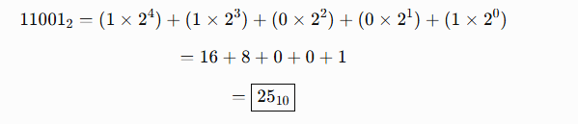
(2 marks)
d) Binary numbers are used to represent and process data in digital computer systems.
(1 mark)

6:
(5 marks)
a) Computer ethics refers to moral principles and rules that guide responsible and acceptable use of computers and information technology.
(1 mark)
b) Examples of unethical computer use:
- Hacking into another person's account.
- Accessing information without permission.
- Software piracy.
- Cyberbullying.
- Spreading malware.
- Stealing or altering data.
Any two – 2 marks
c) Measures for protecting personal data:
- Use strong passwords.
- Enable two-factor authentication.
- Keep antivirus/security software updated.
- Avoid sharing passwords.
- Back up important data.
- Encrypt sensitive information.
- Lock the computer when not in use.
Any two – 2 marks

SECTION B: 50 MARKS

7:
(10 marks)
a) Component A – Central Processing Unit (CPU).
(1 mark)
b) Three major stages of the information processing cycle:
- Input
- Processing
- Output
(3 marks)
c) Examples of input devices:
- Keyboard
- Mouse
- Scanner
- Microphone
- Webcam
Any two – 2 marks
d) Examples of output devices:
- Monitor
- Printer
- Speakers
- Projector
Any two – 2 marks
e) Reasons for storing information:
- For future reference and retrieval.
- To maintain records.
- To allow information to be reused.
- To provide backup copies.
- For future processing and analysis.
Any two – 2 marks

8:
(10 marks)
a) The interface described is a Graphical User Interface (GUI).
(1 mark)
b) Features of a GUI:
- Icons
- Windows
- Menus
- Pointers
- Buttons
- Taskbars
- Dialog boxes
Any three – 3 marks
c) Functions of an operating system:
1. File management:
Organises, stores, retrieves and manages files and folders.
2. Memory management:
Allocates and manages computer memory among running programs.
3. Device management:
Controls and coordinates hardware devices such as printers, keyboards and storage devices.
Other acceptable functions: process management, security management, user-interface provision and input/output management.
Any three well-explained – 3 marks
d)
System software: Software that manages and controls computer hardware and provides a platform for application software to operate.
Application software: Software designed to enable users to perform specific tasks.
(2 marks)
e) Example: Microsoft Word.
(1 mark)

9:
(10 marks)
a) The symbol used to represent a decision is the diamond symbol.
(1 mark)
b) The condition tested is:
MARK ≥ 50
or
Whether the mark is greater than or equal to 50.
(1 mark)
c) Algorithm:
- Start.
- Input the learner's mark.
- Check whether the mark is greater than or equal to 50.
- If the mark is 50 or above, display "PASS"; otherwise display "FAIL".
- End.
(4 marks)
d) If the learner scores 67:
PASS
(1 mark)
e) If the learner scores 42:
FAIL
(1 mark)
f) Algorithms are important because they:
- Provide a logical step-by-step solution to a problem.
- Guide programmers when writing programs.
- Make problems easier to understand and solve.
- Help identify errors before coding.
Any two – 2 marks

10:
(10 marks)
a) Input variable: number.
(1 mark)
b) Control structure: Selection/decision control structure (IF...ELSE IF...ELSE).
(1 mark)
c) For 25:
Since 25 > 0,
Output: Positive
(1 mark)
d) For -8:
Since -8 < 0,
Output: Negative
(1 mark)
e) For 0:
The number is neither greater nor less than zero.
Output: Zero
(1 mark)
f) An IF...ELSE statement allows a program to make a decision by testing a condition and executing different instructions depending on whether the condition is true or false.
(2 marks)
g) Common programming errors:
- Syntax errors – errors caused by violating the rules of a programming language.
- Logic errors – errors that cause a program to produce incorrect results.
- Runtime errors – errors that occur while a program is executing.
3 marks

11:
(10 marks)
a) The most suitable network is a Local Area Network (LAN).
(1 mark)
b) Advantages of networking the computers:
- Enables sharing of files and information.
- Allows sharing of printers and other hardware.
- Enables sharing of an Internet connection.
- Facilitates communication and collaboration.
- Makes centralised management possible.
Any two – 2 marks
c) A network switch connects computers and other devices within the local network and forwards data to the appropriate device.
(2 marks)
d) A router connects the school's LAN to other networks, such as the Internet, and directs data packets between the networks.
(2 marks)
e) Practices for protecting the school's network:
- Use strong passwords.
- Change default passwords on network devices.
- Install and update firewall/security software.
- Keep operating systems and applications updated.
- Restrict access to authorised users.
- Use secure Wi-Fi encryption.
- Avoid sharing network passwords unnecessarily.
- Regularly monitor network activity.
Any three – 3 marks

KENYA CERTIFICATE OF BASIC EDUCATION

SENIOR SCHOOL ASSESSMENT

TERM 3: PROJECT BASED ASSESSMENT 2026
GRADE 10 – COMPUTER STUDIES
Time: 2 Hours
LEARNER’S DETAILS
Name: _____________________________________________________________. School: ____________________________________________.
Assessment Number: _______________________________________________. Date: ____________________________________________.
School Code: ______________________________________________________. Signature: _______________________________________.

GENERAL INSTRUCTIONS
- This project shall be completed individually or in an approved small group, as directed by the teacher.
- The learner shall identify a real-life problem in the school, home or community that can be addressed using computer science.
- The learner shall design and develop a simple digital solution, computational model, program, website, database, information system or other suitable computer-based product.
- The project should demonstrate the learner's ability to apply concepts and skills acquired in Grade 10 Computer Science.
- The learner must show evidence of the problem identification, planning, design, development, testing and evaluation of the solution.
- The learner must maintain a digital portfolio/evidence folder containing evidence of work done.
- The digital portfolio may contain:
  - Typed project report;
  - Program/source code;
  - Screenshots of the work at different stages;
  - Photographs of the learner undertaking the project;
  - Flowcharts, algorithms, pseudocode or system designs;
  - Testing records;
  - Corrections/improvements made;
  - Emails or other digital communication related to the project, where applicable;
  - Final product screenshots or demonstration videos.
- Where the project involves a sizeable physical model or hardware prototype, the learner should bring the model to school on the opening date for assessment, where practical and safe to do so.
- If the model is too large, fragile or otherwise impractical to transport, the learner should submit clear photographs and/or a video demonstrating the model and its operation.
- The learner should be prepared to demonstrate and explain the project to the teacher/assessor.
- All digital files should be clearly named and organised in a suitable folder.
- The work submitted must be the learner's own work. Any external resources, code, images or information used should be appropriately acknowledged.
- The teacher may ask questions to establish the learner's understanding and contribution to the project.
- No multiple-choice questions are used in this assessment.
- Total: 20 marks.

PROJECT TASK

TASK: Solving a Real-Life Problem Using Computer Science
Identify a problem affecting your school, home or community that can reasonably be addressed using computer science.
Examples of suitable areas include:
- School records management;
- Learner’s attendance;
- Library management;
- School timetable management;
- Simple school fee or expenditure tracking;
- Small business record keeping;
- Agriculture information management;
- Environmental conservation;
- Cyber safety awareness;
- Personal budgeting;
- Inventory management;
- Health and safety information;
- Transport or booking management;
- School club management;
- Educational information systems;
- Community information management.
You are not required to copy these examples. You should identify a problem that is relevant to your own environment.

QUESTION 1: PROBLEM IDENTIFICATION AND INVESTIGATION — 4 MARKS

(a) State the problem you have identified and explain the environment or situation in which the problem occurs.
(2 marks)

(b) Explain two ways in which the identified problem affects the intended users. (2 marks)

QUESTION 2: PROPOSED DIGITAL SOLUTION — 4 MARKS

(a) State the proposed computer-based solution to the identified problem. (1 mark)

(b) State three main functions/features that your proposed solution should perform. (3 marks)

QUESTION 3: ALGORITHM AND SYSTEM DESIGN — 4 MARKS
Design the logical solution before developing the final product.

(a) Write an appropriate algorithm or pseudocode showing the main steps that the proposed solution will follow.
(2 marks)

(b) Draw a suitable flowchart, system diagram, interface design or other relevant design representation for your proposed solution. (2 marks)
The design should clearly show the movement of information or the major stages of the solution.

QUESTION 4: DEVELOPMENT AND IMPLEMENTATION — 4 MARKS
Develop the proposed solution using an appropriate computer science tool, programming environment or digital technology.
Your product may, where appropriate, include:
- A computer program;
- A simple website;
- A database/application;
- A digital information system;
- A computational model;
- An interactive educational application;
- An appropriate hardware/software prototype.

(a) Demonstrate the completed digital solution/model to the teacher. (2 marks)

(b) Demonstrate that the solution performs the intended functions identified in Question 2. (2 marks)

QUESTION 5: TESTING, EVALUATION AND DIGITAL PORTFOLIO — 4 MARKS

(a) Carry out at least two tests on your solution and record:
Test | Expected Result | Actual Result | Action Taken
Test 1 | __________________ | __________________ | __________________
Test 2 | __________________ | __________________ | __________________
(2 marks)

(b) State one strength and one limitation of your solution and suggest one improvement that could be made in the future. (1 mark)

(c) Submit your digital portfolio/evidence of work showing the development process from the initial idea to the completed project. (1 mark)

DIGITAL PORTFOLIO REQUIREMENTS
The learner should create a clearly organised folder, for example:
GRADE 10 COMPUTER SCIENCE PROJECT – [LEARNER NAME]
The folder may contain:
01 – Problem Identification
- Problem description
- Investigation notes
02 – Planning and Design
- Objectives
- Algorithm/pseudocode
- Flowchart/system design
- Interface sketches
03 – Development
- Source code
- Working files
- Database/files used
- Development screenshots
04 – Testing
- Test data
- Expected results
- Actual results
- Corrections made
05 – Final Product
- Final screenshots
- Final program/application/website
- Demonstration video, where applicable
06 – Evidence
- Photographs of work in progress
- Photographs of the learner working on the project
- Relevant emails/digital communication, where applicable
- Evidence of presentation/demonstration
07 – Project Report
- Final written report
- Conclusion
- Recommendations
- References/acknowledgements

PROJECT SUBMISSION AND EVIDENCE

IMPORTANT
The digital portfolio is compulsory evidence of the project process.
The learner should:
- Save the work regularly during the development process.
- Keep evidence of important stages rather than submitting only the final product.
- Take clear photographs/screenshots showing the development and final outcome.
- Save relevant emails or digital communication used in the project, where applicable.
- Submit the project electronically using the method specified by the school.
- If the project includes a sizeable physical model, bring the model to school on the opening date for physical inspection and demonstration.
- If bringing the model is not practical, submit clear photographs and/or video evidence showing:
  - The complete model;
  - Important components;
  - The learner's work on the model;
  - The model in operation, where applicable.
- The learner may be required to explain the project and answer questions about its development.

MARK DISTRIBUTION
Assessment Area | Marks
1. Problem Identification and Investigation | 4
2. Proposed Digital Solution | 4
3. Algorithm and System Design | 4
4. Development and Implementation | 4
5. Testing, Evaluation and Digital Portfolio | 4
TOTAL | 20

GRADE 10 COMPUTER SCIENCE PROJECT WORK

MARKING SCHEME
Note to the assessor: Since this is a project-based assessment, answers will vary according to the learner's selected problem and digital solution. Award marks for technically correct, relevant and well-supported responses. The examples below are model answers, not the only acceptable answers.

QUESTION 1: PROBLEM IDENTIFICATION AND INVESTIGATION — 4 MARKS

(a) State the problem identified and explain the environment/situation.
(2 marks)

Model Answer
The school currently records student attendance manually in exercise books. This makes it difficult to retrieve attendance information quickly and may lead to inaccurate or missing records.

Marking Scheme
- Clearly identifies a relevant real-life problem – 1 mark
- Clearly explains the environment/situation in which the problem occurs – 1 mark
Accept: Any relevant school, home or community problem that can appropriately be addressed through computer science.

(b) Explain two ways the problem affects the intended users.
(2 marks)

Model Answer
- Teachers spend a lot of time recording and searching for attendance records.
- Manual records can easily be misplaced or contain errors, making it difficult to determine attendance accurately.

Marking Scheme
- Correct effect 1, with explanation – 1 mark
- Correct effect 2, with explanation – 1 mark
Other acceptable effects: delays, increased workload, loss of information, duplication of records, difficulty generating reports, poor decision-making, etc.

QUESTION 2: PROPOSED DIGITAL SOLUTION — 4 MARKS

(a) State the proposed computer-based solution.
(1 mark)

Model Answer
I will develop a simple computerized student attendance management system for recording, storing and retrieving student attendance information.

Marking Scheme
- Appropriate computer-based solution clearly related to the identified problem – 1 mark

(b) State three main functions/features.
(3 marks)

Model Answer
The system will:
- Allow the teacher to enter student attendance.
- Store attendance records for future retrieval.
- Generate attendance reports for individual students or classes.

Marking Scheme
Award 1 mark each for any three relevant functions/features.
Examples include:
- Data entry – 1
- Data storage – 1
- Data retrieval – 1
- Searching records – 1
- Editing/updating records – 1
- Generating reports – 1
- Calculating attendance percentage – 1
- User authentication/security – 1
Maximum: 3 marks

QUESTION 3: ALGORITHM AND SYSTEM DESIGN — 4 MARKS

(a) Algorithm/pseudocode
(2 marks)

Model Answer
Algorithm: Student Attendance System
- Start.
- Enter student's name/admission number.
- Display attendance options.
- Enter whether the student is present or absent.
- Store the attendance record.
- Calculate/update the attendance record.
- Display confirmation.
- Stop.

Marking Scheme
- Logical and sequential algorithm/pseudocode – 1 mark
- Appropriate processing, storage/output and termination steps – 1 mark
Alternative correct algorithms should be accepted.

(b) Flowchart/system design
(2 marks)

Model Answer
A suitable flow sequence is:
START
↓
Enter Student Details
↓
Select Date
↓
Enter Present/Absent
↓
Store Record
↓
Update Attendance
↓
Display Confirmation/Report
↓
END

Marking Scheme
- Correct logical sequence of the process – 1 mark
- Appropriate flowchart symbols/system representation and clear presentation – 1 mark

QUESTION 4: DEVELOPMENT AND IMPLEMENTATION — 4 MARKS

(a) Demonstrate the completed digital solution/model.
(2 marks)

Expected Evidence
The learner should present a working product such as:
- A simple computer program;
- Website;
- Database;
- Information management system;
- Interactive application;
- Computational model;
- Appropriate hardware/software prototype.

Marking Scheme
Evidence | Marks
Completed product/model is presented | 1
Product/model is functional and demonstrates substantial learner work | 1
Total | 2
If the project is a physical/hardware model: inspect the model and require the learner to explain its operation.
If the model is sizeable: assess the physical model at school where practical.
If it cannot reasonably be transported: assess clear photographs/video evidence and demonstration.

(b) Demonstrate that the solution performs the intended functions.
(2 marks)

Marking Scheme
- Demonstrates at least two intended functions correctly – 2 marks
- Demonstrates only one intended function correctly – 1 mark
- No functional demonstration – 0 marks

Example
For an attendance system:
- Enters and saves student attendance – 1 mark
- Retrieves/generates attendance information – 1 mark

QUESTION 5: TESTING, EVALUATION AND DIGITAL PORTFOLIO — 4 MARKS

(a) Carry out at least two tests.
(2 marks)

Model Answer
Test | Expected Result | Actual Result | Action Taken
Enter a present student | Record should be saved as present | Record saved correctly | No correction required
Enter an absent student | Record should be saved as absent | Record saved correctly | No correction required

Marking Scheme
For each correctly documented test:
- Appropriate test/inputs identified – 0.5 mark
- Expected result stated – 0.5 mark
- Actual result recorded – 0.5 mark
- Appropriate action/correction stated – 0.5 mark
Maximum: 2 marks
Accept any two meaningful tests relevant to the learner's project.

QUESTION 5(b): STRENGTH, LIMITATION AND IMPROVEMENT — 1 MARK

Model Answer
Strength: The system makes it easier and faster to retrieve student attendance records.
Limitation: The system requires a computer and may not work when there is no electricity or power backup.
Improvement: A future version could include automatic cloud backup and a mobile version.

Marking Scheme
Award 1 mark for a relevant response covering the required evaluation.
The learner should identify:
- A realistic strength;
- A realistic limitation;
- A sensible improvement.
Accept equivalent technically correct responses.

QUESTION 5(c): DIGITAL PORTFOLIO / EVIDENCE — 1 MARK

Expected Evidence
The learner should submit a digital portfolio containing appropriate evidence such as:
- Problem identification;
- Planning notes;
- Algorithm/pseudocode;
- Flowchart/system design;
- Development screenshots;
- Source code or working files;
- Photographs of the learner undertaking the project;
- Testing evidence;
- Corrections made;
- Final product screenshots;
- Demonstration video where appropriate;
- Relevant emails/digital communication;
- Final project report.

Marking Scheme
Evidence | Marks
Well-organised digital portfolio containing sufficient evidence of the project process | 1
Incomplete/minimal or no evidence | 0

CONSOLIDATED MARKING SCHEME
Question | Assessment Area | Marks
1(a) | Problem identified and situation explained | 2
1(b) | Two effects of the problem | 2
2(a) | Proposed digital solution | 1
2(b) | Three functions/features | 3
3(a) | Algorithm/pseudocode | 2
3(b) | Flowchart/system design | 2
4(a) | Completed product/model | 2
4(b) | Demonstration of intended functions | 2
5(a) | Testing | 2
5(b) | Evaluation and improvement | 1
5(c) | Digital portfolio/evidence | 1
TOTAL |  | 20 MARKS

PROJECT ASSESSMENT RUBRIC
Level | Performance Description | Suggested Score
Excellent | Clearly identifies a relevant problem, produces a well-planned and functional digital solution, applies algorithms/design appropriately, tests the product effectively and maintains comprehensive evidence. | 17–20
Good | Identifies a suitable problem, develops a mostly functional solution, demonstrates appropriate design and testing, with adequate evidence. | 13–16
Fair | Identifies a problem and develops a partially functional solution, but planning, testing or documentation is incomplete. | 9–12
Below Expected Level | Limited understanding of the problem and computer science process; product is incomplete/non-functional and evidence is insufficient. | 0–8

TEACHER/ASSESSOR OBSERVATION RECORD
Learner: __________________________________________
Project Title: ______________________________________
Competency Observed | Yes | Partly | No
Identified a genuine problem | ☐ | ☐ | ☐
Investigated the problem | ☐ | ☐ | ☐
Proposed an appropriate digital solution | ☐ | ☐ | ☐
Developed an algorithm/pseudocode | ☐ | ☐ | ☐
Produced a suitable design/flowchart | ☐ | ☐ | ☐
Developed the product/model | ☐ | ☐ | ☐
Tested the solution | ☐ | ☐ | ☐
Made corrections/improvements | ☐ | ☐ | ☐
Maintained digital evidence/portfolio | ☐ | ☐ | ☐
Demonstrated understanding of the project | ☐ | ☐ | ☐

FINAL SCORE
Marks Obtained: ______ / 20
Assessor's Name: ___________________________________
Signature: ______________________
Date: ___________________________
Teacher's Comment:
_____________________________________________________________________________________________
_____________________________________________________________________________________________

Important Assessment Note
Do not penalise a learner merely because their project differs from the model answer. Computer Science project work is expected to produce different solutions. Award marks based on relevance, logical thinking, application of computer science concepts, functionality, testing, documentation and evidence of the learner's own work.

