COMPETENCY BASED EDUCATION

JUNIOR SCHOOL EDUCATION ASSESSMENT

NOVEMBER-DECEMBER ASSIGNMENT 2026
GRADE 8 – PRETECHNICAL STUDIES
Time: 2 Hours
LEARNER’S DETAILS
Name: ________________________________________________. School: ________________________________________.
Assessment Number: _________________________________. Date: __________________________________________.
School Code: _______________________________________. Signature: ______________________________________.

INSTRUCTIONS TO CANDIDATES
- Write your name in the spaces provided above.
- Write the name of your school and your stream in the spaces provided.
- Write your admission number and the date of the assessment in the spaces provided.
- This paper consists of two sections: A and B.
- Answer all questions in section A and section B.
- Answer the questions in English.
- All answers MUST be written in the spaces provided in the paper.
- Do NOT remove any page from this question paper.

FOR OFFICIAL USE ONLY (EXAMINER’S USE)
SECTION | SECTION A | SECTION B | % SCORE | EE1 | EE2 | ME1 | ME2 | AE1 | AE2 | BE1 | BE2
SCORE RANGE | 30 MARKS | 50 MARKS |  | 90-100 | 75-89 | 58-74 | 41-57 | 31-40 | 21-30 | 11-20 | 1-10
POINTS |  |  |  | 8 POINTS | 7 POINTS | 6 POINTS | 5 POINTS | 4 POINTS | 3 POINTS | 2 POINTS | 1 POINT
LEARNER’S TOTAL SCORE

SECTION A (30 MARKS)
Answer ALL questions in this section.
- a. During a field exhibition, Mr. Muhati tasked his students to name the tools and the corresponding career to which they fit. Fill the table below to correctly complete the task given to the students. (3 mks)
- ___________________________________________________________________________________
- ___________________________________________________________________________________
- ___________________________________________________________________________________

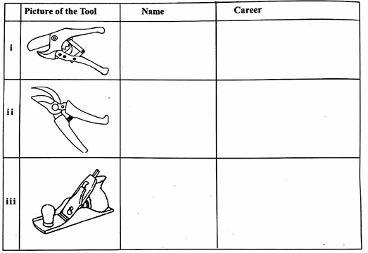

b. To instill safety of tools in a Pre-Technical laboratory, the learners were asked to list all the care and maintenance to guide them in the laboratory. Give three care and maintenance practices listed for tool in question 1(iii) above. (3 mks)
- ___________________________________________________________________________________
- ___________________________________________________________________________________
- ___________________________________________________________________________________
c. Describe how a worker in your school would use the tool in question 1(i) to cut the plastic pipes. (3 mks)

- ___________________________________________________________________________________
- ___________________________________________________________________________________
- ___________________________________________________________________________________

- Ms. Main clarified that ceramic materials are categorized into three broad classes based on the material from which they are made. Give three common classifications of ceramic materials in your environment based on this criterion of classification. (3 marks)
- ___________________________________________________________________________________
- ___________________________________________________________________________________
- ___________________________________________________________________________________

- List three main chronological procedures a potter would employ in order to make a complete ceramic material ready for sale. (3 mks)
- ___________________________________________________________________________________
- ___________________________________________________________________________________
- ___________________________________________________________________________________
- As an aspiring engineer, identify two items made from composite materials that are used in medical engineering. (1 mk)
___________________________________________________________________________________
___________________________________________________________________________________
- Classify the following materials as either composite or non-composite. (3 mks)
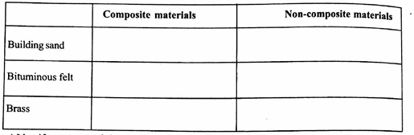

- a. Identify two types of visual programming applications used in day-to-day computer operations. (2 mks)
- ___________________________________________________________________________________
- ___________________________________________________________________________________
b. In order to introduce programming, the teacher stated features of visual programming. Give two features of one of the types of visual programming identified in question 6(a) above. (2 mks)
- ___________________________________________________________________________________
- ___________________________________________________________________________________
- During Art and design lesson, learners were tasked to define plane scale drawing. Fill the space below to show how they correctly defined the term. (1 mk)

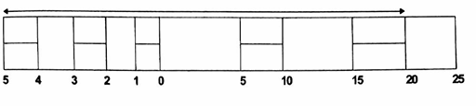
- Taking the scale in the measurement below to be in metres, determine the actual length of the arrowed line. (1 mk)

- Describe two features of plane scale as used in drawing. (2 mks)

- ___________________________________________________________________________________
- ___________________________________________________________________________________
- Identify two ethical practices in business organization a businessman would consider adopting to realize maximum profits in a market. (2 mks)
- ___________________________________________________________________________________
- ___________________________________________________________________________________
- The picture below illustrates the photograph of an organizational Chief Executive officer.


- Identify the form of communication being used by the officer. (1 mk)

_________________________________________________________________

- State three reasons that promoted the Chief Executive Officer of the organization to use the mode of communication identified in 11(a) above to pass information to his employees. (3 mks)
- ___________________________________________________________________________________
- ___________________________________________________________________________________
- ___________________________________________________________________________________

- Explain two ways in which investors and consumers are protected in kenya. (4 mks)

- ___________________________________________________________________________________
- ___________________________________________________________________________________
- ___________________________________________________________________________________
- Give the names of the following storage devices. (4 mks)

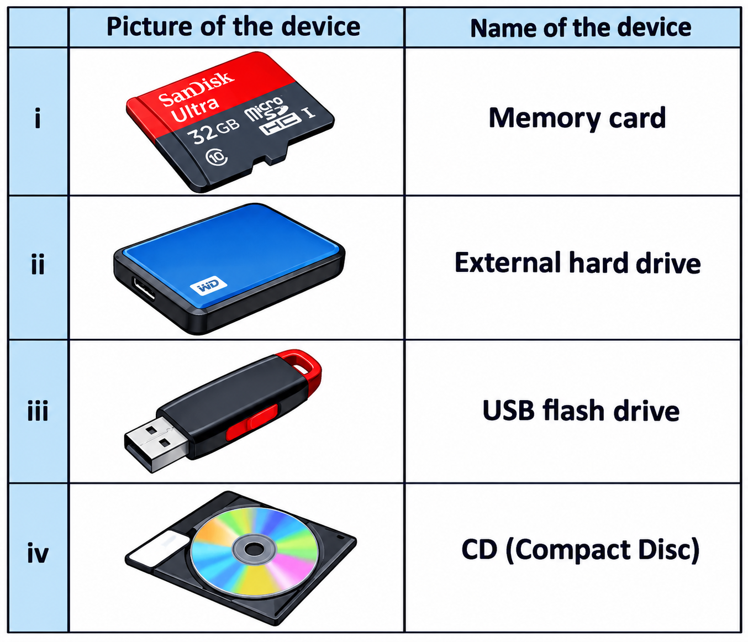
- There was a fire outbreak in Ukulima market in the recent past. Highlight three possible cause of the fire outbreak. (3 mks)
- ___________________________________________________________________________________
- ___________________________________________________________________________________
- ___________________________________________________________________________________

- To curb the fire outbreak incident, learners were advised to use the smothering technique. Explain how smothering technique is carried out to put fire during a fire outbreak. (3 mks)
- ___________________________________________________________________________________
- ___________________________________________________________________________________
- ___________________________________________________________________________________
- As the chief Executive officer of a local organization, explain three importance of book keeping to an entrepreneur. (3 mks)

- ___________________________________________________________________________________
- ___________________________________________________________________________________
- ___________________________________________________________________________________

Answers

- a.

  - - Pipe cutter - plumbing

  - - Secateurs/pruning shears - farming

  - - Plane - carpentry b.
    - Regular sharpening of blunt edges.
    - Oiling movable parts
    - Cleaning after use.
    - Proper storage
c.
 | 1. | Press the handle away from each other to open the blade
 | 2. | Put the plastic pipe in between the blades.
 | 3. | Press the handles towards each other strongly to cut.
2. | 1. | Earthware
 | 2. | Stone ware
 | 3. | Pokelain
3. | 1. | Dig and grind the required clay.
 | 2. | Knead the clay to remove all the air bubbles.
 | 3. | Shape the kneaded clay to and heat in a kiln at a temperature between 1000°C to 1150°C
4. | 1. | Artificial body parts
 | 2. | Implants
5. | 1. | Building sand - non-composite material
 | 2. | Bituminous felt - composite material
 | 3. | Brass - Composite material
6. a.
 | 1. | Microsoft make code
 | 2. | Sprite box
 | 3. | Scratch
 | 4. | Microsoft Visual Studio
 | 5. | Roblox
 | 6. | Mine craft
b.
 | 1. | They are easy to use
 | 2. | Source of entertainment
 | 3. | They are interesting to use.
 | 4. | Help in creating stones, animations and riders

- Plain scale drawing involves drawing a line that has been divided into a specific number of equal parts.

- Main scale = 25.00 Small scale = 5.00
= 25.00 + 5.00

= 30.00cm

- 1. Lines are divided into specific number of equal parts.
- Uses a representative factor for interpretation.
- 1. Timely communication with partners and shareholders.
2. Relevant and timely advertising.

- a. Oral or verbal communication b.
  - Information is urgent and first hand.
  - Feedback is immediate.
  - Cheaper
  - Information can be reinforced through persuasion.
- 1. Regulated pricing by government.
- Quality goods by KEBS
- Regulated imports to reduce dumping.

- i. Memory card

- External hard drive

- Universal Serial Bus

- Floppy disc

- 1. Faulty electric equipment
- Fire outbreak
- Improper storage of flammable materials.
- Human errors when using equipment i.e. electrical sock
- 1. Spread a blanket across the fire
- Cover the flame uniformly at once.
- If the flame doesn't go off, put more blankets until the flame goes off
- 1. Helps entrepreneur to prepare for taxes.
- Reveals the financial structure of a business.
- Maintains organized records in business.
- making accurate budgeting possible.

