
KENYA CERTIFICATE OF BASIC EDUCATION

SENIOR SCHOOL ASSESSMENT

AUGUST ASSIGNMENT 2026
GRADE 10 – PHYSICAL EDUCATION
Time: 2 Hours
LEARNER’S DETAILS
Name: _____________________________________________________________. School: ____________________________________________.
Assessment Number: _______________________________________________. Date: ____________________________________________.

School Code: ______________________________________________________. Signature: _______________________________________.

INSTRUCTIONS TO CANDIDATES
- Write your name in the spaces provided above.
- Write the name of your school and your stream in the spaces provided.
- Write your admission number and the date of the assessment in the spaces provided.
- This paper consists of two sections: A and B.
- Answer all questions in section A and section B.
- Answer the questions in English.
- All answers MUST be written in the spaces provided in the paper.
- Do NOT remove any page from this question paper.

FOR OFFICIAL USE ONLY
SECTION | SECTION A | SECTION B | % SCORE | EE1 | EE2 | ME1 | ME2 | AE1 | AE2 | BE1 | BE2
SCORE RANGE | 30 MARKS | 50 MARKS |  | 90-100 | 75-89 | 58-74 | 41-57 | 31-40 | 21-30 | 11-20 | 1-10
POINTS |  |  |  | 8 POINTS | 7 POINTS | 6 POINTS | 5 POINTS | 4 POINTS | 3 POINTS | 2 POINTS | 1 POINT
LEARNER’S TOTAL SCORE

SECTION A (30 MARKS)
Answer ALL questions in this section.
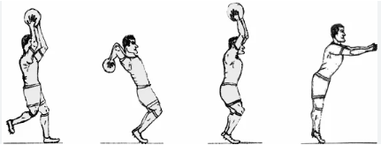
- During a match at Kagundo Senior School, the ball goes out of play over the touchline. A learner, Otieno, prepares to bring the ball back into play.

(a) Identify the restart method shown in the diagram. (1 mark) ____________________
(b) State two technical requirements for this restart to be legal. (2 marks)
(i) _________________________________________________________________________ (ii) _________________________________________________________________________ (c) True/False: A goal can be scored directly from a throw-in. [__________] (1 mark)
(d) Mention the restart used after a goal is scored. (1 mark) ____________________
- Four learners at Lugulu Girls are discussing passes.
Mutua: "I use one hand to flick the ball quickly to a teammate."
Sarah: "I pass the ball while I am moving at high speed."
Nekesa: "I release the ball from the side of my body to avoid a defender."
(a) Name the pass described by Mutua. (1 mark) ____________________
(b) Identify the pass described by Sarah. (1 mark) ____________________
(c) Select the "Side Pass" from the images below. (1 mark)
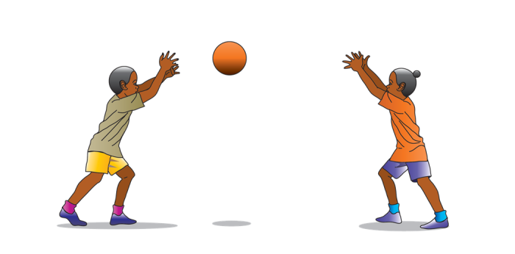
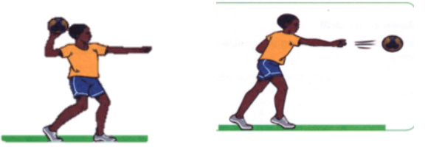
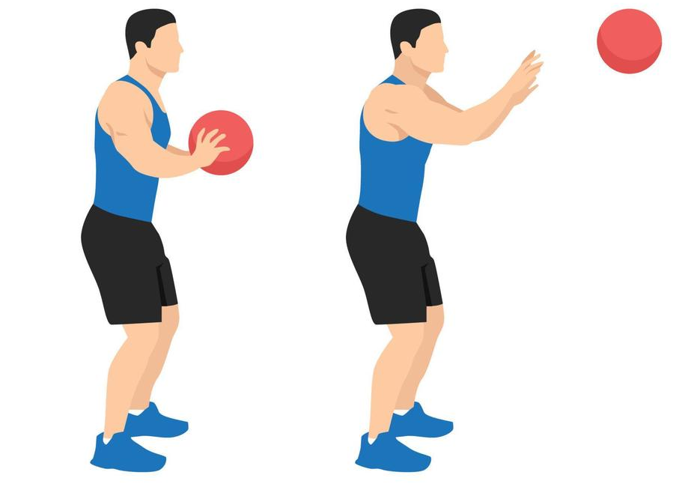
A: B: C:
(d) Outline two steps in executing a "Running Shot" in Netball. (2 marks)
(i) _________________________________________________________________________ (ii) _________________________________________________________________________
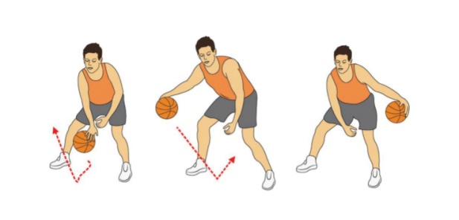
- A coach at certain school is teaching the "Crossover Dribble."

(a) Identify the dribbling technique shown. (1 mark) ____________________
(b) Explain the purpose of "Faking" and "Feinting" in Basketball. (2 marks)
______________________________________________________________________________________________________________________________________________________
(c) Distinguish between a "Set Shot" and a "Jump Shot." (2 marks)
Set Shot | Jump Shot
- Learners at Kaplong Girls are practicing the 100m Hurdles.
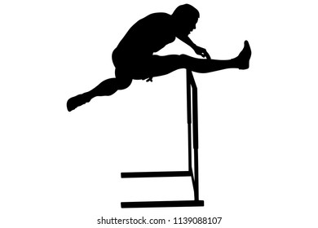

X
Y

(a) Label the parts of the technique indicated: (2 marks)
X: ____________________
Y: ____________________
(b) Identify the phase of hurdling that happens immediately after clearing the hurdle. (1 mark) ______________________________________________________
(c) List two safety measures to observe during hurdle practice. (2 marks)
(i) ________________________________________________________________________
(ii) ________________________________________________________________________
- Learners from Nyeri High School are sorting items for a camping trip to Mt. Kenya.

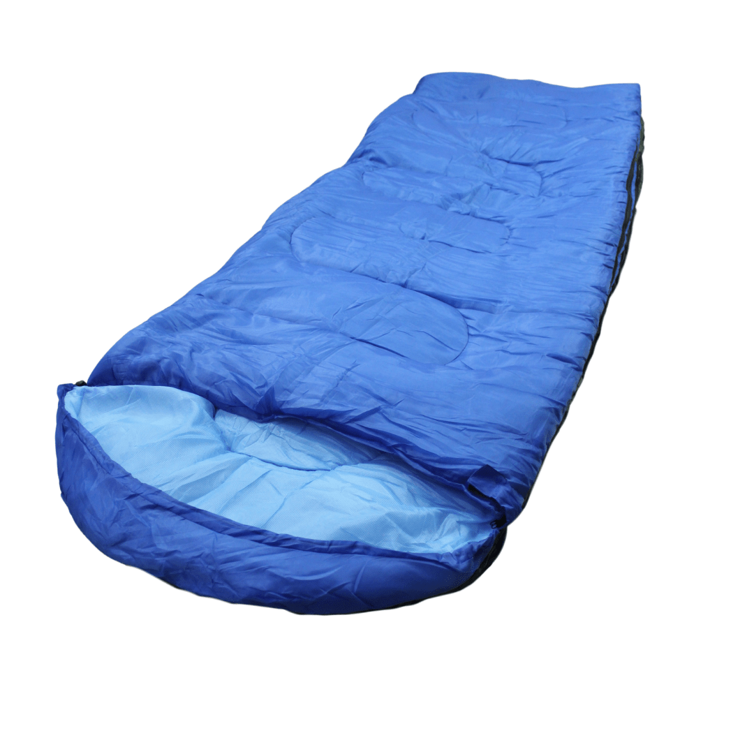

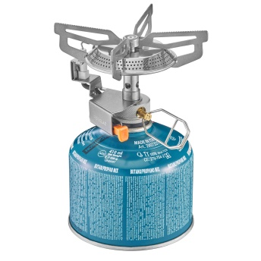
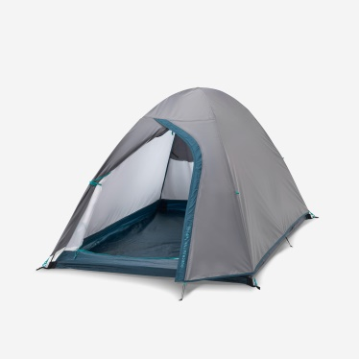

H J K L
(a) Match the item to its function. (4 marks)
Item | Name | Function
H
J
K
L
(b) Define the term "Campsite." (1 mark) __________________________________________________________________________________________________________________________________________________
- (a) Write True/False in the following statement:
The 800m and 1500m races are examples of middle-distance races. [__________] (1 mark)
(b) State why "Pacing" is important in middle-distance running. (2 marks)
______________________________________________________________________________________________________________________________________________________
(c) Identify the correct "Breathing Technique" for long-distance efficiency. (2 marks) ______________________________________________________________________________________________________________________________________________________

SECTION B (50 MARKS)
- A goalkeeper at Kakamega High is performing a "Lofted Pass."

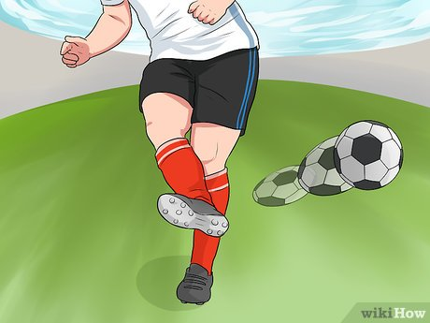
(a) Describe the point of contact on the ball to achieve a lofted pass. (2 marks)
______________________________________________________________________________________________________________________________________________________
(b) List three roles of a goalkeeper in a football match. (3 marks)
(i) _______________________________________________________________________
(ii) _______________________________________________________________________
(iii) _______________________________________________________________________
(c) Explain the difference between "Marking" and "Dodging." (3 marks)
Marking | Dodging
(d) Mention two restart skills that a goalkeeper is directly involved in. (2 marks)
(i) _______________________________________________________________________
(ii) _______________________________________________________________________
- Players at Pangani Girls are practicing the "Forehand Clear" and "Drop Shot."
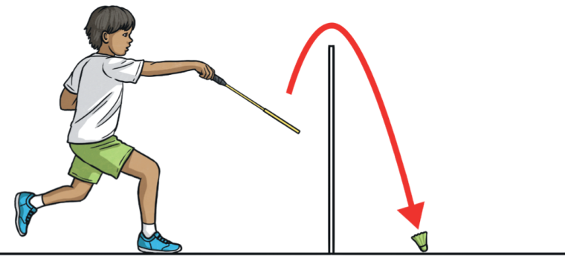
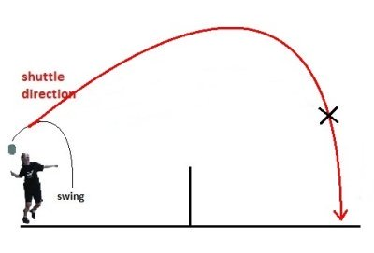
A B
(a) Identify the strokes: (2 marks)
Diagram A: ____________________
Diagram B: ____________________
(b) Compare a "Long Service" and a "Short Service" in Badminton. (4 marks)
Long Service | Short Service
(c) Explain how the "Grip" affects the execution of a smash. (2 marks)
______________________________________________________________________________________________________________________________________________________
(d) Name the equipment used to hit the shuttlecock. (2 marks) ____________________
- Learners are running a Cross Country race in the hilly terrain of Iten, Elgeyo Marakwet.
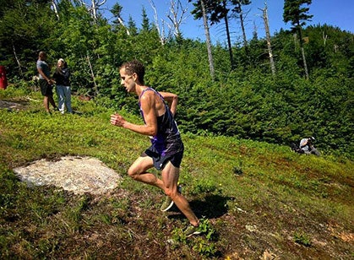
(a) Describe the correct body posture for running uphill. (3 marks)
_________________________________________________________________________________________________________________________________________________________________________________________________________________________________
(b) Outline how "Terrain Adaptation" influences an athlete's speed. (3 marks)
_________________________________________________________________________________________________________________________________________________________________________________________________________________________________
(c) Mention two health benefits of participating in Cross Country. (2 marks)
(i) _______________________________________________________________________
(ii) _______________________________________________________________________
(d) Identify the type of start used in Cross Country. (2 marks) _________________________
- A Grade 10 group at Limuru Girls has reached their destination and needs to set up camp.
(a) Identify three essential features of a well-organized campsite shown in the diagram. (3 marks)
(i) ___________________________________________________________________
(ii) ___________________________________________________________________
(iii) ___________________________________________________________________
(b) Explain why the "Fire Pit" should be located away from the "Tent Area." (2 marks)
_________________________________________________________________________________________________________________________________________________________________________________________________________________________________
(c) List three factors to consider when selecting a campsite. (3 marks)
(i) ________________________________________________________________________
(ii) ________________________________________________________________________
(iii) ________________________________________________________________________
(d) State the importance of "Teamwork" in pitching a tent. (2 marks)
_________________________________________________________________________________________________________________________________________________________________________________________________________________________________
- A learner, Kamau, is demonstrating a certain type of a shot at Maseno School.
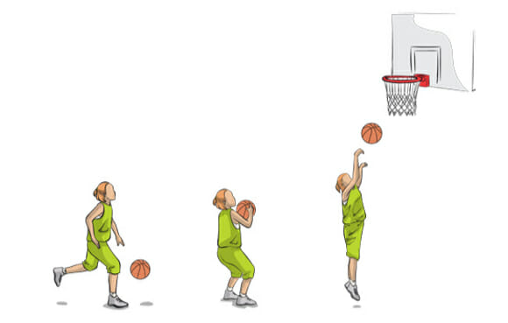
(a) Identify the shot being performed. (1 mark) ____________________
(b) Describe the "Footwork" involved in the final stages of this shot. (3 marks)
_________________________________________________________________________________________________________________________________________________________________________________________________________________________________
(c) Explain why the "Backboard" is used during a lay-up. (2 marks)
______________________________________________________________________________________________________________________________________________________
(d) State two interpersonal skills developed through playing Basketball. (2 marks)
(i) ________________________________________________________________________
(ii) ________________________________________________________________________
(e) Name the part of the hand that should control the ball during a dribble. (2 marks)
_____________________________________________

MARKING SCHEME (SUMMARY)

SECTION A (30 MARKS)
1. Football: Starts and Restarts (5 Marks)
(a) Throw-in (1mk)
(b) (i) Both feet must be on the ground (on or behind the touchline). (ii) The ball must be thrown with both hands from behind and over the head. (2mks)
(c) FALSE (A goal cannot be scored directly from a throw-in). (1mk)
(d) Kick-off (1mk)
2. Netball: Passing Techniques (5 Marks)
(a) Flip pass (1mk)
(b) Running pass (1mk)
(c) Image B (1mk)
(d) (i) Receive the ball while on the move towards the goal. (ii) Take the allowed steps (one-two rhythm) and shoot while maintaining balance/momentum. (2mks)
3. Basketball: Dribbling and Faking (5 Marks)
(a) Crossover Dribble (1mk)
(b) To deceive the defender, create space, or change direction to move past an opponent. (2mks)
(c) A Set Shot is taken with both feet firmly on the ground (usually for free throws), whereas a Jump Shot is taken by releasing the ball at the highest point of a vertical jump. (2mks)
4. Athletics: Hurdling (5 Marks)
(a) X: Lead Leg | Y: Trail Leg (2mks)
(b) Landing (1mk)
(c) (i) Ensure hurdles are facing the right direction (so they fall if hit). (ii) Clear the track of any obstacles or loose stones. (2mks)
5. Outdoor Education: Camping (5 Marks)
(a)
Tent: Shelter/Protection from weather.
First Aid Kit: Treating injuries/emergencies.
Sleeping Bag: Warmth and comfort during sleep.
Gas Stove: Cooking meals. (4mks)
(b) A designated area where a tent is pitched or an outdoor base is established for a temporary stay. (1mk)
6. Athletics: Middle Distance (5 Marks)
(a) TRUE (1mk)
(b) To conserve energy throughout the race and ensure a strong finish without early exhaustion. (2mks)
(c) Rhythmic breathing (inhaling and exhaling through both nose and mouth to maximize oxygen intake). (2mks)

SECTION B (50 MARKS)
7. Football (10 Marks)
(a) Striking the bottom half/underneath of the ball with the laces or instep. (2mks)
(b) (i) Stopping shots. (ii) Organizing the defense. (iii) Restarting play (goal kicks/punts). (3mks)
(c) Marking is staying close to an opponent to prevent them from receiving the ball. Dodging is a sudden body movement used by a player to get away from a marker. (3mks)
(d) Goal kick and Corner kick (defending) or Kick-off. (2mks)
8. Badminton (10 Marks)
(a) A: Forehand Clear | B: Drop Shot (2mks)
(b) A Long Service is hit high and deep to the back of the court. A Short Service is hit low and just clears the net to land in the front service box. (4mks)
(c) A firm grip allows for maximum wrist snap, which increases the power and downward angle of the smash. (2mks)
(d) Racket (2mks)
Q9. Athletics: Cross Country (10 Marks)
(a) Lean slightly forward, shorten the stride length, and pump the arms more vigorously for drive. (3mks)
(b) Athletes must adjust their stride and center of gravity to maintain balance and speed on uneven, muddy, or hilly surfaces. (3mks)
(c) (i) Improved cardiovascular endurance. (ii) Mental toughness/discipline. (2mks)
(d) Curved Start (2mks)
10. Outdoor Education: Campsite (10 Marks)
(a) Tent area, Cooking/Fire area, Waste disposal area. (3mks)
(b) To prevent smoke from entering tents and to reduce the risk of fire spreading to flammable tent materials. (2mks)
(c) (i) Safety/Security. (ii) Availability of water. (iii) Flatness/Drainage of the ground. (3mks)
(d) It speeds up the process and ensures the tent is tensioned correctly and securely fastened against wind. (2mks)
11. Basketball: Lay-up (10 Marks)
(a) Lay-up shot (1mk)
(b) The player takes two legal steps (right-left or left-right) after picking up the dribble before jumping. (3mks)
(c) It acts as a target to absorb the ball's momentum and guide it into the basket. (2mks)
(d) (i) Communication. (ii) Cooperation/Teamwork. (2mks)
(e) Finger pads (not the palm). (2mks)

