TERM 3 HOLIDAY ASSIGNMENT 2026
FORM THREE
GEOGRAPHY PAPER 1
Section | Questions | Maximum Score | Candidate's Score
A | 1 – 5 | 25
B | 6 | 25
B | 7 | 25
B | 8 | 25
B | 9 | 25
B | 10 | 25
TOTAL |  | 100

SECTION A
1. (a) State three sources of heat that contribute to the high temperature of the earth's interior. (3 marks)
________________________________________________________________________________
________________________________________________________________________________
(b) Name two layers of the atmosphere in which temperature remains nearly constant over a vertical distance. (2 marks)
________________________________________________________________________________
2. (a) Define the term weather. (2 marks)
________________________________________________________________________________
(b) State two ways in which prevailing winds influence the climate of a place. (2 marks)
________________________________________________________________________________
3. (a) Give two causes of earth movements. (2 marks)
________________________________________________________________________________
(b) Name three types of plate boundaries. (3 marks)
________________________________________________________________________________
4. (a) Distinguish between a sea and an ocean. (2 marks)
________________________________________________________________________________
(b) State three sources of salts dissolved in ocean water. (3 marks)
________________________________________________________________________________
5. The diagram below represents an artesian basin.
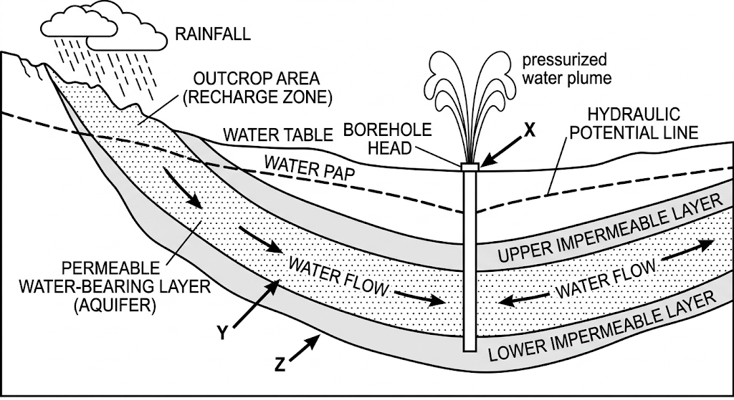
(a) Name the parts marked X, Y and Z. (3 marks)
________________________________________________________________________________
________________________________________________________________________________
(b) State three characteristics of karst landscapes. (3 marks)
________________________________________________________________________________
________________________________________________________________________________
SECTION B
(ANSWER QUESTION 6 AND ANY OTHER TWO QUESTIONS FROM THIS SECTION)
6. (a) Use the topographical map provided to answer the questions that follow.
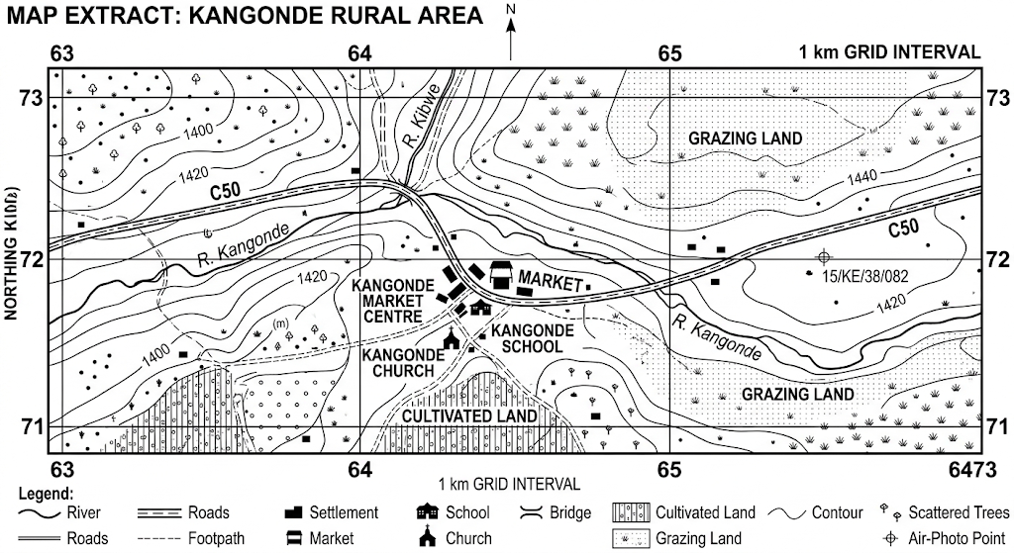
(i) What is the title of the map provided? (1 mark)
________________________________________________________________________________
(ii) Give the six-figure grid reference of the air-photo principal point 15/KE/38/082. (2 marks)
________________________________________________________________________________
(iii) Identify three human features found in grid square 6472. (3 marks)
________________________________________________________________________________
________________________________________________________________________________
(b) Describe the drainage of the area covered by the map. (7 marks)
________________________________________________________________________________
________________________________________________________________________________
________________________________________________________________________________
________________________________________________________________________________
(c) Citing evidence from the map, give three economic activities carried out in the area covered by the map. (6 marks)
________________________________________________________________________________
________________________________________________________________________________
________________________________________________________________________________
(d) Citing evidence from the map, explain three factors favouring livestock production in the area. (6 marks)
________________________________________________________________________________
________________________________________________________________________________
________________________________________________________________________________
7. (a) (i) Differentiate between faulting and folding. (2 marks)
________________________________________________________________________________
(ii) Name five features formed as a result of faulting. (5 marks)
________________________________________________________________________________
________________________________________________________________________________
(b) The world map below shows the location of some fold mountain systems. Use it to answer question (i).
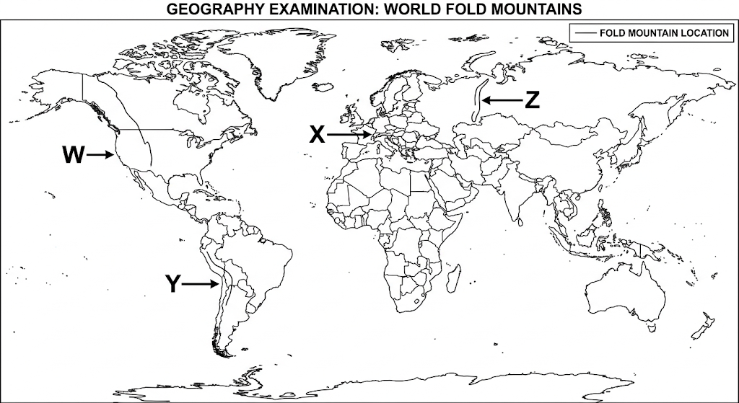
(i) Identify the fold mountains marked W, X, Y and Z. (4 marks)
________________________________________________________________________________
________________________________________________________________________________
(ii) With the aid of well-labelled diagrams, describe how anticlinorium–synclinorium folds are formed. (6 marks)
________________________________________________________________________________
________________________________________________________________________________
________________________________________________________________________________
(c) Explain four economic importance of fold mountains to people. (8 marks)
________________________________________________________________________________
________________________________________________________________________________
________________________________________________________________________________
________________________________________________________________________________
8. (a) Give three examples of deserts found on the western margins of continents. (3 marks)
________________________________________________________________________________
________________________________________________________________________________
(b) (i) Apart from rock pedestals, name four other features formed due to wind erosion in arid regions. (4 marks)
________________________________________________________________________________
________________________________________________________________________________
(ii) With the aid of well-labelled diagrams, describe how a rock pedestal is formed. (7 marks)
________________________________________________________________________________
________________________________________________________________________________
________________________________________________________________________________
________________________________________________________________________________
(c) Explain four factors that influence the rate of wind transport. (8 marks)
________________________________________________________________________________
________________________________________________________________________________
________________________________________________________________________________
________________________________________________________________________________
(d) State three negative influences of desert features on human activities. (3 marks)
________________________________________________________________________________
________________________________________________________________________________
9. (a) Explain how the following factors influence the distribution of natural vegetation.
(i) Climate (2 marks)
________________________________________________________________________________
(ii) Soils (2 marks)
________________________________________________________________________________
(b) The map below shows selected vegetation zones of Kenya. Use it to answer question (i).
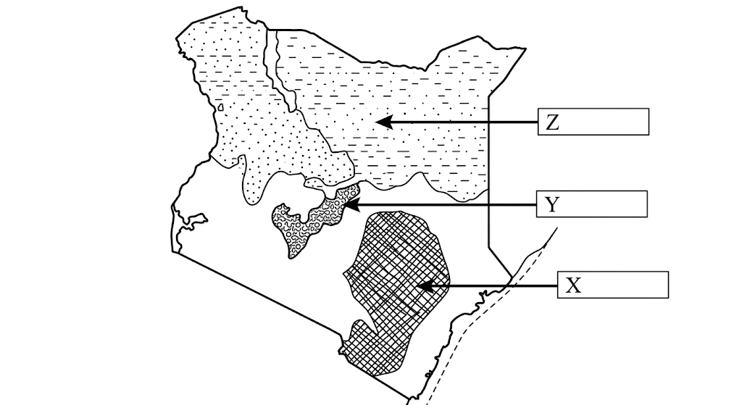
(i) Name the vegetation zones marked X, Y and Z. (3 marks)
________________________________________________________________________________
________________________________________________________________________________
(ii) Give two uses of Savannah vegetation. (2 marks)
________________________________________________________________________________
(iii) Describe four characteristics of mangrove vegetation. (4 marks)
________________________________________________________________________________
________________________________________________________________________________
(c) Explain three ways in which coniferous trees adapt to climatic conditions. (6 marks)
________________________________________________________________________________
________________________________________________________________________________
________________________________________________________________________________
(d) You are planning to carry out a field study of vegetation within the local environment.
(i) State three objectives that you would set for the field study. (3 marks)
________________________________________________________________________________
________________________________________________________________________________
(ii) How would you identify the different types of vegetation during the field study? (3 marks)
________________________________________________________________________________
________________________________________________________________________________
10. (a) (i) What is a lake? (2 marks)
________________________________________________________________________________
(ii) Give three processes that can lead to the formation of lakes. (3 marks)
________________________________________________________________________________
________________________________________________________________________________
(b) Describe how Lake Victoria was formed. (6 marks)
________________________________________________________________________________
________________________________________________________________________________
________________________________________________________________________________
(c) Explain three factors that make some lakes in the Kenyan Rift Valley saline. (6 marks)
________________________________________________________________________________
________________________________________________________________________________
________________________________________________________________________________
(d) Explain four ways in which lakes influence the climate of the surrounding areas. (8 marks)
________________________________________________________________________________
________________________________________________________________________________
________________________________________________________________________________
________________________________________________________________________________

END OF QUESTION PAPER

