KENYA JUNIOR SCHOOL EDUCATION ASSESSMENT
GRADE 7 SOCIAL STUDIES
DECEMBER ASSIGNMENT

LEARNER’S DETAILS
Name: _____________________________________________________________________.
School: ____________________________________________________________________.
Assessment Number: __________________________. Date: ____________________.
School Code: _____________________. Signature: ______________________.

INSTRUCTIONS TO LEARNERS
- Write your name and class on the answer sheet provided.
- Answer ALL questions in Section A and Section B.
- Ensure your work is neat and clear, Answer in English.
Answer all questions. Choose the correct answer from the given options
- Below is a list of actions taken during colonization.
  - Using Christian missionaries
  - Signing treaties with African leaders
  - Establishing military garrisons
  - Trading fairly with Africans
Which one was a method of colonizing Africa?
A) All except iv
B) i, ii and iii only
C) ii and iv only
D) i and iv only

- Learners from St. Joseph School visited Fort Jesus Museum and saw chains used to tie enslaved Africans. The chains were used during which historical trade?
A. Trans-Atlantic trade
B. Indian Ocean Slave Trade
C. Barter Trade
D. Local exchange trade
- In a community meeting, elders described a person who was owned by another and forced to work without pay. This person was called a:
A. Merchant B. Master
C. Slave D. Servant

- During a history lesson, Grade 7 learners at Kabarnet Junior School discussed the movement of African people across continents. The teacher asked them to give one factor that led to the presence of Africans in other parts of the world.
A. Early agricultural practices
B. African diaspora through slave trade
C. Development of irrigation farming
D. Formation of African kingdoms

- Which of the following is the correct order of field work stages?
A. Data presentation → Data collection → Report writing
B. Planning → Data collection → Data analysis → Report writing
C. Data collection → Planning → Data presentation
D. Data analysis → Planning → Report writing

The graph given below shows the mean average monthly temperatures (in ºC) and mean monthly rainfall of a place:

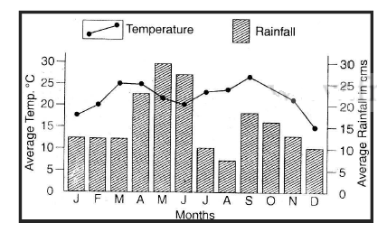
- The highest rainfall occurs in the month of?
- March
- August
- December
- January
- Which one is the hottest month on the year?
- May
- September
- December
- January

- When carrying out fieldwork, learners from Nyamira Junior School experienced heavy rainfall that delayed their data collection. Which challenge did they face?
A. Lack of cooperation
B. Harsh weather conditions
C. Inadequate resources
D. Poor communication
- During an inter-class peace campaign, students discussed ways of promoting peace in school. Which of the following promotes peace?
A. Fighting for one’s right violently
B. Listening to others and forgiving
C. Discriminating against others
D. Ignoring other people’s opinions
- A student from Murang’a Junior School stated that all people should be treated fairly regardless of gender or tribe. Which human right was the learner referring to?
A. Right to education
B. Right to equality and non-discrimination
C. Right to property ownership
D. Right to privacy
- The Asante kingdom became powerful before 1900 due to:
A. Weak leadership
B. Rich agricultural lands and trade
C. Isolation from neighbours
D. Lack of unity among clans
- When carrying out community service learning, learners must first identify:
A. The problem in the community
B. The cost of materials
C. The rewards to be gained
D. The people to blame
- The Great Zimbabwe kingdom grew mainly because of:
A. Its mining and trade activities
B. Heavy rainfall
C. Large forests
D. Lack of foreign traders
- A learner who remains calm and respectful even in disagreement demonstrates:
A. Assertiveness
B. Aggression
C. Negligence
D. Rudeness
- One of the countries in Africa that was not colonized was:
A. Kenya
B. Congo
C. Ethiopia
D. Sudan
- During a study of maps, Grade 7 learners noted that longitudes are used to:
A. Measure height above sea level
B. Show temperature of an area
C. Calculate time differences
D. Measure rainfall
- The process of turning raw data collected from the field into information is called:
A. Data analysis
B. Data collection
C. Data presentation
D. Data storage
- The type of satellite made by humans to study space is known as:
A. Natural satellite
B. Artificial satellite
C. Planetary body
D. Meteor
- Suzzy visited a local weather station and observed the following instrument
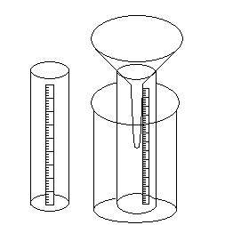
This instrument is a:
A) Rain gauge.
B) Thermometer.
C) Windmill.
D) Windsock.
- The Berlin Conference of 1884–1885 was hosted by:
A) Otto von Bismarck of Germany
B) Nelson Mandela of South Africa
C) King Leopold II of Belgium
D) William Samoei Ruto of Kenya

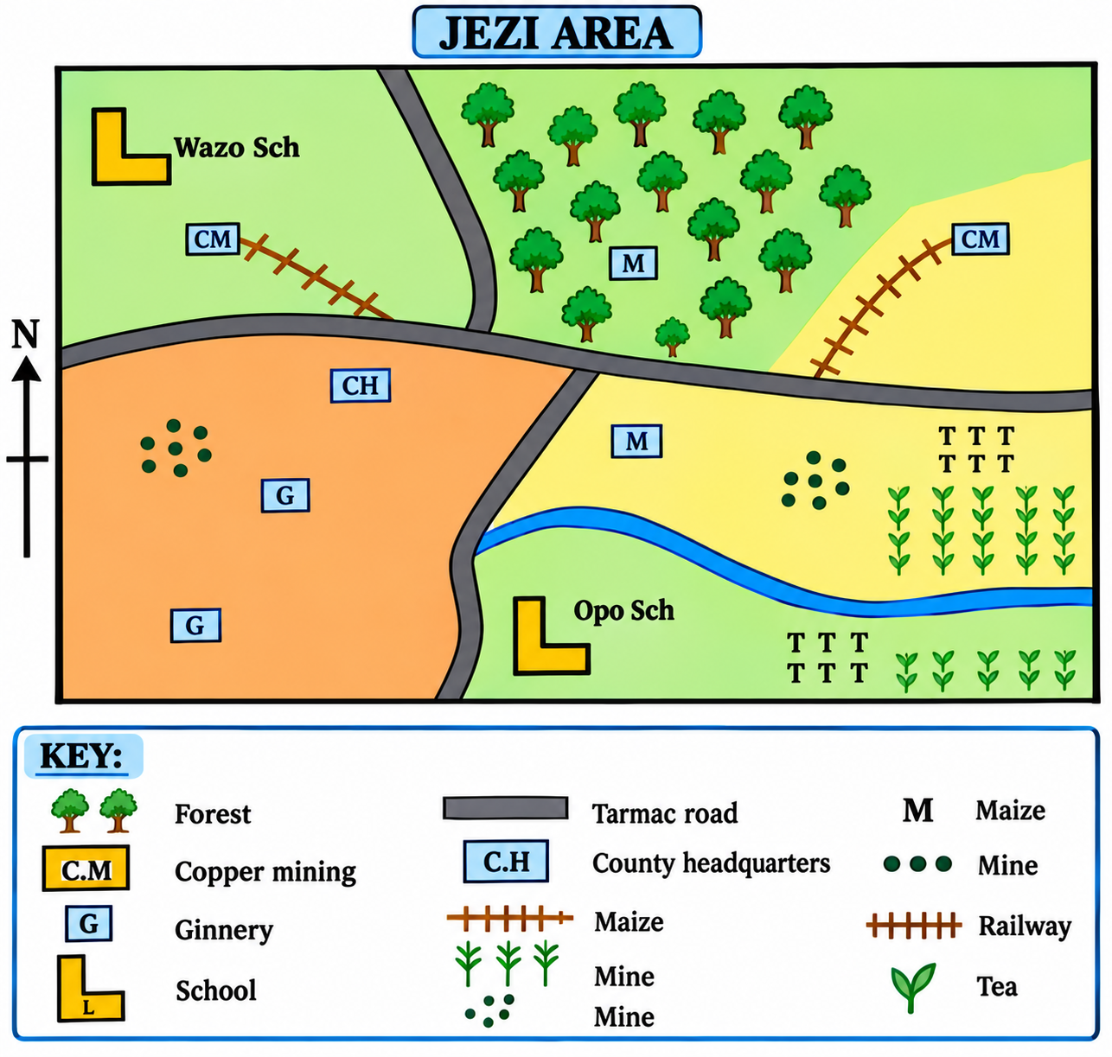
21. Study the map of Jezi Area below and use it to answer questions 1(a) to (d).

(a) Apart from tea, which other cash crop is likely to be grown in the Jezi Area? (1 mark)
_____________________________________________________________________________________________
(b) Describe the type of population in the Jezi Area. (1 mark)
_____________________________________________________________________________________________
(c) Describe the type of climate experienced in the south-eastern part of the Jezi Area. (1 mark)
_____________________________________________________________________________________________
(d) The railway line in the Jezi Area is likely to be used to transport _____________________________. (2 marks)

22. What is meant by gender stereotypes? (2 marks)
_________________________________________________________________________________________________
_________________________________________________________________________________________________
_________________________________________________________________________________________________
23. State the branch of Social Studies that is most relevant to each of the following careers. (4 marks)
(a) Geologist – ___________________________________________
(b) Pilot – _______________________________________________
(c) Archaeologist – _______________________________________
(d) Public Administrator – _________________________________
24. State four qualities of a good citizen. (4 marks)
i. ________________________________________________________________________________________
ii. ________________________________________________________________________________________
iii. _______________________________________________________________________________________
iv. _______________________________________________________________________________________
25. Complete the table below by correctly stating the name of the following planets. (4 marks)
Description | Name of planet
(a) red planet | ______________________________
(b) Gas giant | ______________________________
(c) coldest planet | ______________________________
(d) hottest planet | ______________________________

26. Identify the language group to which each of the following belongs. (4 marks)
(a) Dahalo – ______________________________________________
(b) Japanese – ____________________________________________
(c) Mijikenda – ___________________________________________
(d) Iteso – _______________________________________________
27. Define the following terms. (4 marks)
(a) Revolution _____________________________________________________________________________________________
(b) Rotation _____________________________________________________________________________________________
28. Explain the following terms. (4 marks)
(a) Slavery
_________________________________________________________________________________________________
_________________________________________________________________________________________________
(b) Servitude
_________________________________________________________________________________________________
_________________________________________________________________________________________________

29. Study the map of Africa below and use it to answer questions 9(a) to (d). (4 marks)
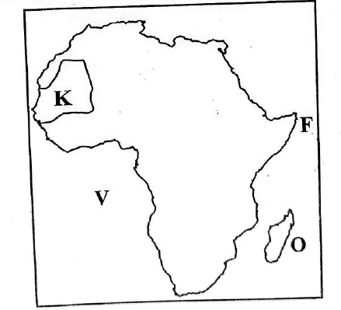

(a) The capital city of the island marked O is ____________________________.
(b) The ocean marked V is ____________________________________________.
(c) The part marked F is called _______________________________________.
(d) The country marked K is known as __________________________________.
30. In the Buganda Kingdom, state the title given to the following officials. (2 marks)
(a) Sub-county Chief – _________________________________________________
(b) Chief Justice – ____________________________________________________
31. Relationships are part and parcel of our lives because they help us to live harmoniously with others. State three types of relationships. (3 marks)
i. _________________________________________________________
ii. _________________________________________________________
iii. ________________________________________________________

32. In our daily lives, there are situations that require creative thinking. State three such situations. (3 marks)
i. ________________________________________________________________________________________
ii. _______________________________________________________________________________________
iii. _______________________________________________________________________________________
33. Communication is the process of passing a message from one person to another. State three important elements of communication. (3 marks)
i. _________________________________________________________________________________________
ii. ________________________________________________________________________________________
iii. _______________________________________________________________________________________
34. Some harmful traditional practices are outdated and may endanger a person's health and well-being. State three harmful traditional practices. (3 marks)
i. __________________________________________________________________________________________
ii. _________________________________________________________________________________________
iii. ________________________________________________________________________________________
35. During a seminar on peace-building initiatives, the facilitator discussed the importance of peaceful coexistence among Grade 7 learners. State three important aspects of a culture of peace. (3 marks)
i. _________________________________________________________________________________________
ii. ________________________________________________________________________________________
iii. _______________________________________________________________________________________
36. State and explain four factors that led to the growth of Great Zimbabwe. (8 marks)
(a) _______________________________________________________________________________________
(b) _______________________________________________________________________________________
(c) _______________________________________________________________________________________
(d) _______________________________________________________________________________________
37. Outline the procedure for carrying out fieldwork research. (10 marks)
i. _______________________________________________________________________________________
ii. _______________________________________________________________________________________
iii. ______________________________________________________________________________________
iv. ______________________________________________________________________________________
v. ______________________________________________________________________________________
vi. ______________________________________________________________________________________
vii. ______________________________________________________________________________________
viii. _____________________________________________________________________________________
ix. ______________________________________________________________________________________
x. _______________________________________________________________________________________
38. State five methods of irrigation that were used in Ancient Egypt. (5 marks)
i. _________________________________________________________
ii. _________________________________________________________
iii. ________________________________________________________
iv. _________________________________________________________
v. __________________________________________________________
39. Explain three ways in which agriculture in the Nile Valley contributed to the development of world civilisation. (3 marks)
i. _______________________________________________________________________________________
ii. _______________________________________________________________________________________
iii. ______________________________________________________________________________________
40. State four ways in which you can demonstrate assertiveness. (4 marks)
i. _______________________________________________________________________________________
ii. _______________________________________________________________________________________
iii. ______________________________________________________________________________________
iv. ______________________________________________________________________________________
41. Kimende is crying in a corner at school. After talking to him, you realise that he needs empathy. State five ways in which you can show empathy to Kimende. (5 marks)
i. _______________________________________________________________________________________
ii. _______________________________________________________________________________________
iii. ______________________________________________________________________________________
iv. ______________________________________________________________________________________

- During a Science–Social Studies integration activity, learners drew a cross-section of the Earth showing the internal layers.
Q
R
S

(a) Name the three layers of the Earth. (3 marks)
- Q: ____________________________
- R: ____________________________
- S: _____________________________
(b) State two characteristics of the Earth’s core. (2 marks)
- ______________________________________________________________________________________
- ______________________________________________________________________________________
(c) Name one career related to the study of the Earth’s structure. (1 mark)
______________________________________________________________________________________
- Learners were studying the map of Africa to identify countries crossed by the Equator.
(a) Define a map. (1 mark)
______________________________________________________________________________________
______________________________________________________________________________________
(b) Identify two countries in Africa crossed by the Equator. (2 marks)
- ______________________________________________________________________________________
- ______________________________________________________________________________________
(c) Calculate the approximate time at Marsabit town at longitude 38⁰E when it is 8.00 a.m. at Cape Verde which is 18⁰W. (2 marks)

(d) State two main types of maps used in Social Studies. (2 marks)
- ______________________________________________________________________________________
- ______________________________________________________________________________________
- Grade 7 learners discussed barter and currency trade during a project on early African economy.
(a) Define money. (1 mark)
______________________________________________________________________________________
______________________________________________________________________________________
(b) Name two types of trade. (2 marks)
- ______________________________________________________________________________________
- ______________________________________________________________________________________
(c) Mention two sources of money. (2 marks)
- ______________________________________________________________________________________
- ______________________________________________________________________________________
(d) Explain two ways adolescents in your school misuse their pocket money. (2 marks)
- ______________________________________________________________________________________
- ______________________________________________________________________________________
(e) State one effect of introducing money on African trade. (1 mark)
- ______________________________________________________________________________________

- State two factors that influence career choice. (2 marks)
- ______________________________________________________________________________________
- ______________________________________________________________________________________
- Give two careers related to Geography. (2 marks)
- ______________________________________________________________________________________
- ______________________________________________________________________________________
- a) Describe two factors that contribute to individual differences among people. (2 Marks)

- ______________________________________________________________________________________
- ______________________________________________________________________________________
b) Identify two major physical features found in Kenya. (2 Marks)
- ______________________________________________________________________________________
- ______________________________________________________________________________________
c) Name the capital cities of the following African country. (1 mark)

Kenya- _________________________________________

- A teacher told learners stories of how communities believe God created the first man and woman.
(a) Describe traditional stories about human origin from one community in Kenya. (2 marks)
______________________________________________________________________________________
______________________________________________________________________________________
______________________________________________________________________________________
(b) State one similarity between traditional and religious theories of human origin. (1 mark)
- ______________________________________________________________________________________
(c) Explain two differences between traditional and religious theories. (2 marks)
 | Traditional stories | Religious stories
i.
ii.
(d) Mention the God of the following African community. (2 marks)
- Maasai: ____________________________________________________________
- Luhya:_____________________________________________________________
- Learners conducted research on ancient African kingdoms.
(a) Identify three factors that led to the rise of ancient African kingdoms. (3 marks)
- ______________________________________________________________________________________
- ______________________________________________________________________________________
- ______________________________________________________________________________________
(b) Explain two contributions of the Great Zimbabwe Kingdom to modern Africa. (2 marks)
- ______________________________________________________________________________________
- ______________________________________________________________________________________
(c) Describe two economic activities of the Kingdom of Kongo. (2 marks)
- ______________________________________________________________________________________
- ______________________________________________________________________________________
(d) Mention one reason for the decline of the Egyptian Kingdom. (1 mark)
- ______________________________________________________________________________________
- During a study tour, learners compared Ogiek, Zulu, and Asante communities.
(a) State one social activity practiced by the Asante. (1 mark)
- ______________________________________________________________________________________
(b) Give two similarities in economic organization between the Zulu and Ogiek. (2 marks)
- ______________________________________________________________________________________
- ______________________________________________________________________________________
(c) Mention two differences between the Ogiek and Zulu communities. (2 marks)
______________________________________________________________________________________
______________________________________________________________________________________
______________________________________________________________________________________
- Learners watched a documentary about Indian Ocean Slave Trade.
(a) State two factors that led to the growth of Indian Ocean slave trade. (2 marks)
- ______________________________________________________________________________________
- ______________________________________________________________________________________
(b) Mention two forms of slavery. (2 marks)
- ______________________________________________________________________________________
- ______________________________________________________________________________________
- Learners discussed the importance of peace and dignity in society.
(a) Define peace. (1 mark)
______________________________________________________________________________________
______________________________________________________________________________________
(b) State two characteristics of a peaceful person. (2 marks)
- ______________________________________________________________________________________
- ______________________________________________________________________________________
(c) Explain two steps used in peaceful conflict resolution. (2 marks)
- ______________________________________________________________________________________
- ______________________________________________________________________________________
- During a class project on self-improvement, Grade 7 learners discussed career choices.During guidance and counseling lesson, learners discussed human identity and diversity.
(a) Define racism. (1 mark)
______________________________________________________________________________________
______________________________________________________________________________________
(b) Mention two factors that cause individual differences. (2 marks)
- ______________________________________________________________________________________
- ______________________________________________________________________________________
(c) List two desirable attributes that promote healthy relationships. (2 marks)
- ______________________________________________________________________________________
- ______________________________________________________________________________________
(d) Give two benefits of healthy multicultural relationships. (2 marks)
- ______________________________________________________________________________________
- ______________________________________________________________________________________

MARKING SCHEME

SECTION A: MULTIPLE CHOICE
- B – i, ii and iii only
- B – Indian Ocean Slave Trade
- C – Slave
- B – African diaspora through slave trade
- B – Planning → Data collection → Data analysis → Report writing
- A – March
- D – September
- B – Harsh weather conditions
- B – Listening to others and forgiving
- B – Right to equality and non-discrimination
- B – Rich agricultural lands and trade
- A – The problem in the community
- A – Its mining and trade activities
- A – Assertiveness
- C – Ethiopia
- C – Calculate time differences
- A – Data analysis
- B – Artificial satellite
- A – Rain gauge
- A – Otto von Bismarck of Germany

21. Jezi Area Map
(a) Coffee. (1 mark)
(b) Clustered population. (1 mark)
(c) Cool and wet climate. (1 mark)
(d) Copper and other minerals/mineral ores. (2 marks)
These four answers depend on the actual Jezi Area map. The railway-transport answer should particularly be verified against the map legend.

22. Gender Stereotypes
Gender stereotypes are fixed or commonly held beliefs that certain behaviours, roles or characteristics are suitable for people simply because they are male or female. (2 marks)

23. Branches of Social Studies
(a) Geologist – Geography
(b) Pilot – Geography
(c) Archaeologist – History
(d) Public Administrator – Citizenship/Civics

24. Qualities of a Good Citizen
Any four:
- Honesty
- Respect for others
- Responsibility
- Obedience to the law
- Patriotism
- Cooperation
- Tolerance
- Integrity

25. Planets
(a) Red planet – Mars
(b) Gas giant – Jupiter (Saturn may also be accepted
(c) Coldest planet – Uranus
(d) Hottest planet – Venus

26. Language Groups
(a) Dahalo – Cushitic
(b) Japanese – Asian
(c) Mijikenda – Bantu
(d) Iteso – Nilotic

27. Definitions
(a) Revolution:
The movement of the Earth around the Sun along its orbit.
(b) Rotation:
The spinning movement of the Earth on its axis.

28. Slavery and Servitude
(a) Slavery:
A condition in which one person is owned or controlled by another person and is forced to work without freedom.
(b) Servitude:
A condition in which a person is forced to serve or work for another person and has limited freedom.

29. Map of Africa
(a) Antananarivo
(b) Atlantic Ocean
(c) Horn of Africa/ Ras Hafun (Cape Hafun)
(d) Mauritania

30. Buganda Kingdom
(a) Sub-county Chief – Saza Chief
(b) Chief Justice – Omulamuzi

31. Types of Relationships
Any three:
- Marriage relationship
- Blood relationship
- Friendship relationship
- Parent-child relationship
- Professional relationship

32. Situations Requiring Creative Thinking
Any three:
- Solving a new or difficult problem
- Finding solutions to environmental problems
- Making decisions when resources are limited
- Developing a new product or idea
- Finding alternative ways of doing a task

33. Elements of Communication
Any three:
- Sender/source
- Message
- Channel
- Receiver
- Feedback

34. Harmful Traditional Practices
Any three:
- Female genital mutilation (FGM)
- Early/forced marriage
- Child marriage
- Forced widow inheritance
- Harmful initiation practices

35. Culture of Peace
Any three:
- Avoiding violence and violent conflicts
- Promoting understanding and tolerance
- Respecting human rights
- Promoting equality and fairness
- Respecting diversity
- Using dialogue to solve conflicts

36. Factors That Led to the Growth of Great Zimbabwe
Any four well-explained points:
(a) Fertile soils – supported crop cultivation and increased food production.
(b) Availability of pasture – encouraged livestock keeping and provided food and other resources.
(c) Mining activities – provided valuable minerals such as gold, which promoted economic growth.
(d) Trade – Great Zimbabwe participated in long-distance trade, especially in gold and other goods, which generated wealth.
(e) Availability of granite stones – provided building materials for constructing the famous stone structures.
(f) Good leadership – strong leadership helped organise and control the kingdom.

37. Procedure for Carrying Out Fieldwork Research
Award 1 mark for each correctly stated stage, up to 10 marks.
- Identify the topic/title of the study.
- Select the area of study.
- Set the objectives of the study.
- Carry out a reconnaissance/pre-visit.
- Seek permission from the relevant authorities.
- Select appropriate methods of data collection.
- Prepare a work schedule.
- Assemble the required tools and materials.
- Carry out the fieldwork and collect data.
- Analyse, present and report the findings.

38. Methods of Irrigation Used in Ancient Egypt
Any five:
- Shadoof
- Basin irrigation
- Canal irrigation
- Water wheel
- Archimedes' screw

39. Contribution of Nile Valley Agriculture to World Civilisation
Any three:
- Increased food production, which supported population growth.
- Promoted trade and led to the development of trade centres.
- Encouraged job specialisation, with people becoming farmers, craftsmen, traders and other specialists.
- Led to the development of irrigation technology.
- Supported the growth of permanent settlements and urban centres.

40. Ways of Demonstrating Assertiveness
Any four:
- Being confident when expressing one's views.
- Communicating clearly and respectfully.
- Standing up for one's rights without violating the rights of others.
- Saying "no" politely when necessary.
- Being a good listener.
- Maintaining appropriate eye contact.
- Remaining calm during disagreements.

41. Ways of Showing Empathy to Kimende
Any five:
- Listen to him carefully without interrupting.
- Show concern and understanding about his feelings.
- Encourage him to talk about what is troubling him.
- Offer support and comfort in a compassionate way.
- Respond kindly and respectfully to his feelings.
- Stay with him and reassure him that he is not alone.
- Offer appropriate help or seek assistance from a trusted adult when necessary.

42.
(a) Three layers of the Earth
i. Q: Crust
ii. R: mantle
iii. S: core
(b) Two characteristics of the Earth’s core
i. It is made mainly of iron and nickel.
ii. It has very high temperatures and pressure.
(c) One related career
Geologist

43.
(a) Define a map.
A map is a representation of the whole or part of the Earth's surface drawn on a flat surface using a scale and symbols.
(b) Two African countries crossed by the Equator
i. Kenya
ii. Uganda
Other acceptable answers include Somalia, Ethiopia, Democratic Republic of Congo, Republic of Congo, Gabon and São Tomé and Príncipe.
(c) Time calculation
Cape Verde = 18°W
Marsabit = 38°E
Difference in longitude:
38° + 18° = 56°
Every 1° = 4 minutes.
56 × 4 = 224 minutes = 3 hours 44 minutes
Marsabit is east of Cape Verde, so its time is ahead.
8:00 a.m. + 3 hours 44 minutes = 11:44 a.m.
Answer: 11:44 a.m.
(d) Two main types of maps
i. sketch maps
ii. Topographical maps and atlas maps

44.
(a) Define money.
Money is anything that is generally accepted as a medium of exchange for goods and services.
(b) Two types of trade
i. Internal trade
ii. International trade
(c) Two sources of money
i. Employment/wages or salary
ii. Business activities
(d) Two ways adolescents misuse pocket money
i. Spending it on unnecessary snacks and sweets.
ii. Spending it on gambling or other harmful activities.
(e) One effect of introducing money on African trade
It made trade easier by providing a common medium of exchange.

45.
Two factors that influence career choice
i. Individual interests and talents
ii. Educational qualifications and abilities

46.
Two careers related to Geography
i. Geographer
ii. Cartographer
Other acceptable answers: surveyor, meteorologist, urban planner, GIS specialist, environmentalist.

47.
(a) Two factors that contribute to individual differences
i. Heredity – People inherit different physical and mental characteristics from their parents.
ii. Environment – Differences in upbringing, education, culture and experiences influence people differently.
(b) Two major physical features found in Kenya
i. Mount Kenya
ii. The Great Rift Valley
(c) Capital city
Kenya – Nairobi

48.
(a) Traditional story about human origin from one Kenyan community
Maasai: The Maasai traditionally believe that Enkai (God) created and gave them cattle, which became central to their way of life. Human origin is linked to the creator and the beginning of the community.
(b) One similarity between traditional and religious theories
Both believe that human beings were created by a supernatural being/God.
(c) Two differences
i. Traditional stories: They are passed down mainly through oral traditions and community elders.
Religious stories: They are recorded in sacred scriptures, such as the Bible or Quran.
ii. Traditional stories: They differ from one community to another.
Religious stories: They are based on the teachings of particular religions.
(d) Names of God
i. Maasai: Enkai
ii. Luhya: Nyasaye

49.
(a) Three factors that led to the rise of ancient African kingdoms
i. Availability of fertile land and water for agriculture.
ii. Growth of trade and availability of valuable trade goods.
iii. Strong leadership and effective administration.
(b) Two contributions of the Great Zimbabwe Kingdom to modern Africa
i. It left a valuable heritage and archaeological site that promotes tourism.
ii. Its stone structures demonstrate the advanced building and engineering skills of ancient African societies.
(c) Two economic activities of the Kingdom of Kongo
i. Agriculture, including the growing of crops such as millet and bananas.
ii. Trade, both within the kingdom and with foreign traders.
(d) One reason for the decline of the Egyptian Kingdom
Invasions by foreign powers, which weakened Egyptian political control.

50.
(a) One social activity practised by the Asante
Traditional dancing and music.
(b) Two similarities in economic organization between the Zulu and Ogiek
i. Both practised hunting and gathering.
ii. Both engaged in livestock keeping.
(c) Two differences between the Ogiek and Zulu communities
i. Ogiek: Traditionally depended greatly on hunting, gathering and beekeeping.
Zulu: Traditionally depended more on crop cultivation and livestock keeping.
ii. Ogiek: Traditionally lived mainly in forest environments.
Zulu: Traditionally lived mainly in the grassland areas of southern Africa.

51.
(a) Two factors that led to the growth of the Indian Ocean slave trade
i. High demand for slaves as labourers in plantations, homes and other economic activities.
ii. Growth of trade and plantation agriculture along the Indian Ocean coast and in other regions.
(b) Two forms of slavery
i. Domestic slavery
ii. Agricultural/plantation slavery

52.
(a) Define peace.
Peace is a state of harmony and absence of violence or conflict.
(b) Two characteristics of a peaceful person
i. Tolerant and respectful of others.
ii. Patient and willing to listen to others.
(c) Two steps used in peaceful conflict resolution
i. Discuss the problem calmly and listen to each person's point of view.
ii. Agree on a fair solution through negotiation or compromise.

53.
(a) Define racism.
Racism is unfair discrimination or prejudice against people because of their race or perceived racial background.
(b) Two factors that cause individual differences
i. Heredity
ii. Environment
(c) Two desirable attributes that promote healthy relationships
i. Respect
ii. Tolerance
(d) Two benefits of healthy multicultural relationships
i. They promote peaceful coexistence and reduce discrimination.
ii. They encourage sharing of ideas, cultures and experiences.

