TERM 3 HOLIDAY ASSIGNMENT 2026
FORM THREE
PHYSICS PAPER 3 (232/3)
Question | Maximum Score | Candidate's Score
1 | 20
2 | 20
TOTAL | 40

QUESTION ONE — 20 MARKS
You are provided with the following:
• A voltmeter
• A dry cell
• A cell holder
• A switch
• Four connecting wires, two fitted with crocodile clips
• A resistance wire labelled S
• A micrometer screw gauge
• An ammeter
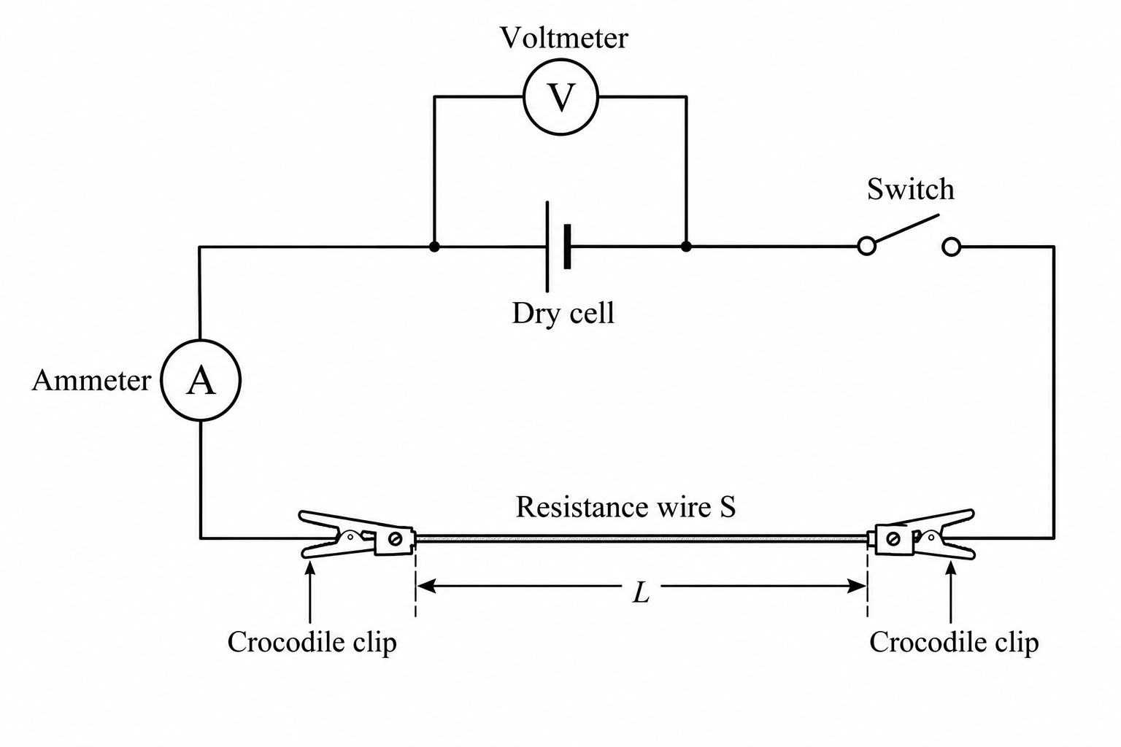
1(a). Connect the apparatus provided as shown in the circuit diagram above.
________________________________________________________________________________
________________________________________________________________________________
________________________________________________________________________________
________________________________________________________________________________
1(b). Measure the voltage, E, of the dry cell before carrying out the experiment. (1 marks)
E = __________________________ V
________________________________________________________________________________
1(c). Adjust the length, L, of the resistance wire to 0.10 m and measure the corresponding current, I. Record the value in Table 1.
1(d). Repeat the procedure in (c) for all the lengths given and record the corresponding values of current, I, in Table 1. (6 marks)
Length, L (m) | 0.10 | 0.15 | 0.20 | 0.25 | 0.30
Current, I (A)
1/I (A⁻¹)
Use appropriate units and record readings to a consistent number of decimal places.
1(e). Calculate 1/I for each current reading and plot a graph of 1/I against length, L. (5 marks)
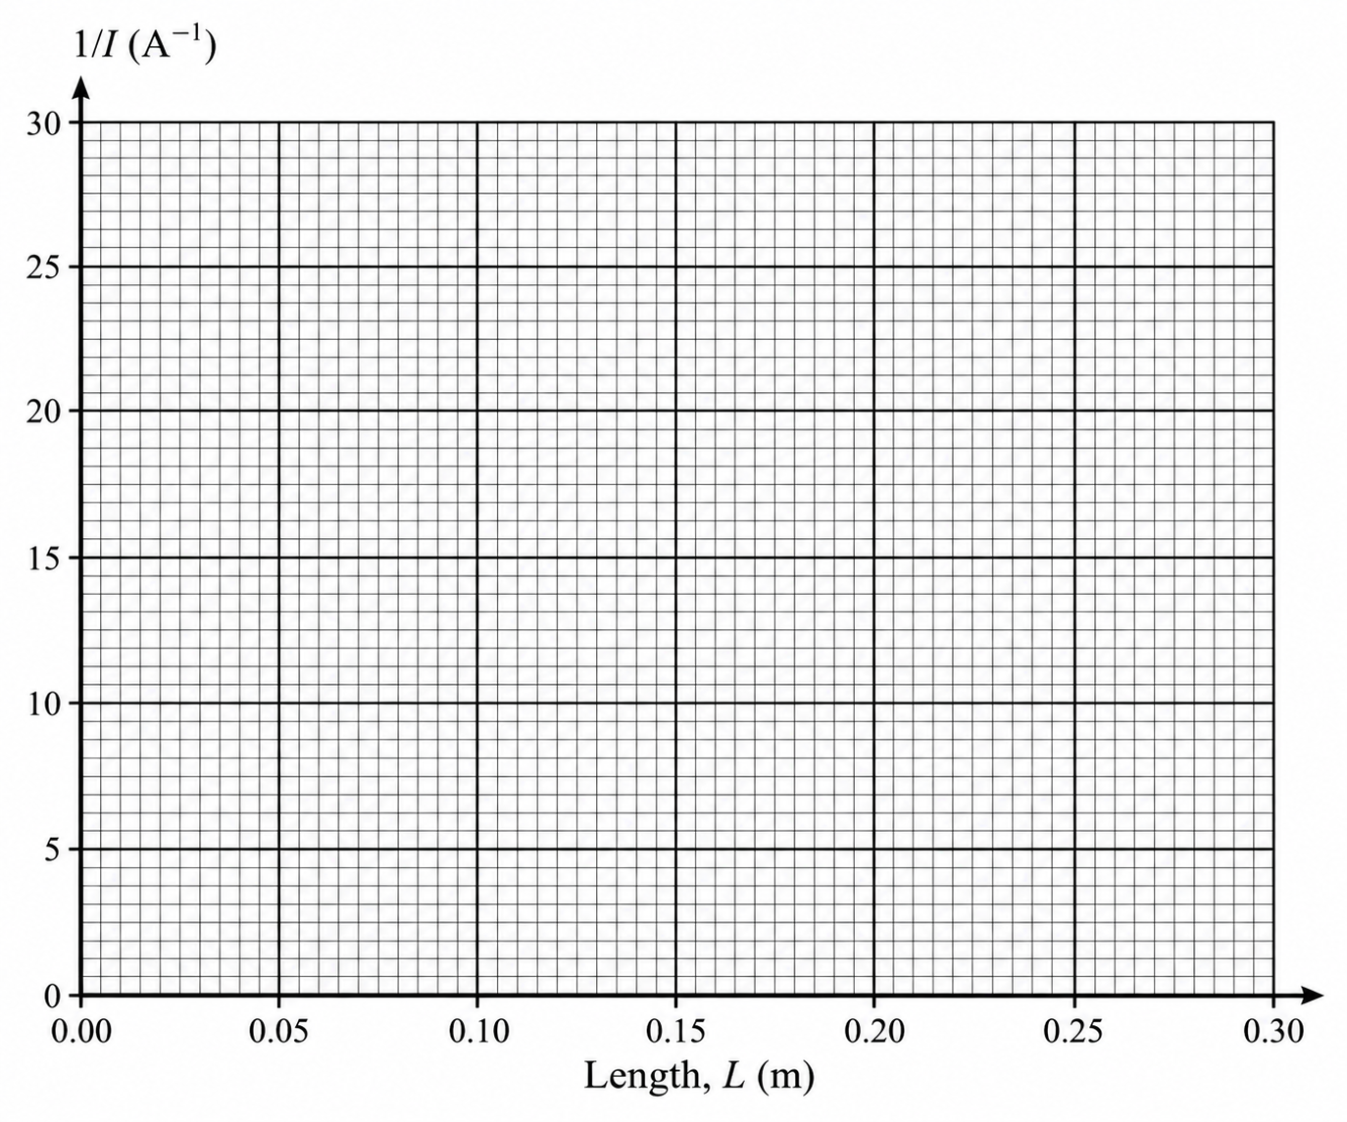
1(f). Determine the slope, K, of the graph. (3 marks)
________________________________________________________________________________
________________________________________________________________________________
________________________________________________________________________________
________________________________________________________________________________
1(g). Measure the diameter, d, of the resistance wire using the micrometer screw gauge. Give your answer in metres. (1 marks)
d = __________________________ m
________________________________________________________________________________
1(h). Determine the cross-sectional area, A, of the resistance wire in square metres. (1 marks)
________________________________________________________________________________
________________________________________________________________________________
1(i). The relation between 1/I and L is given by: 1/I = KL + Q, where K and Q are constants. Use your graph to determine:
(i) the value of K. (2 marks)
________________________________________________________________________________
________________________________________________________________________________
(ii) the value of Q. (1 marks)
________________________________________________________________________________
________________________________________________________________________________

QUESTION TWO — 20 MARKS
You are provided with the following:
• A helical spring with pointer
• One clamp, one stand and one boss
• A stopwatch
• A metre rule or half-metre rule
• One 50 g mass, four 20 g masses and one 300 g mass, or suitable slotted masses
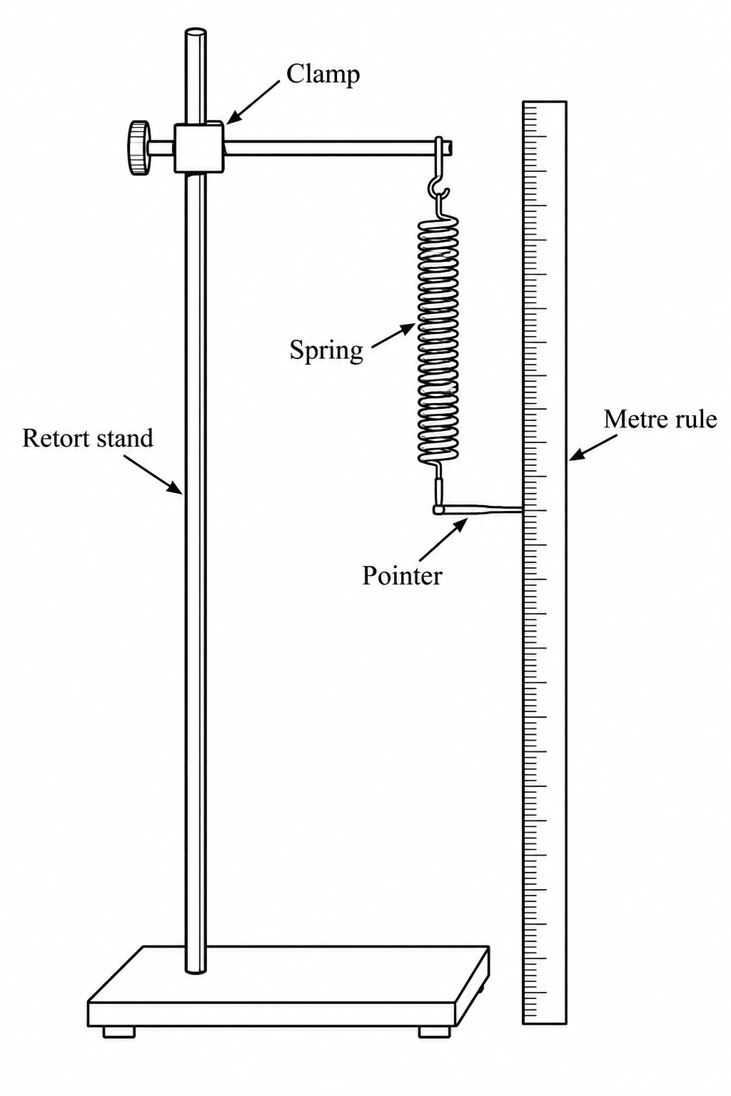
2(a). Suspend the spring vertically alongside the clamped metre rule as shown above. Measure the original length, L₀, of the spring before loading it. (1 marks)
L₀ = __________________________ cm
________________________________________________________________________________
2(b). Attach a mass of 20 g to the spring, measure the new length L, calculate the extension e = L − L₀ and record the result. Repeat using additional masses. (4 marks)
Mass, M (g) | 20 | 40 | 60 | 80 | 100 | 120
Length, L (cm)
Extension, e = L − L₀ (cm)
2(c). Plot a graph of extension, e, on the y-axis against mass, M, on the x-axis. (5 marks)
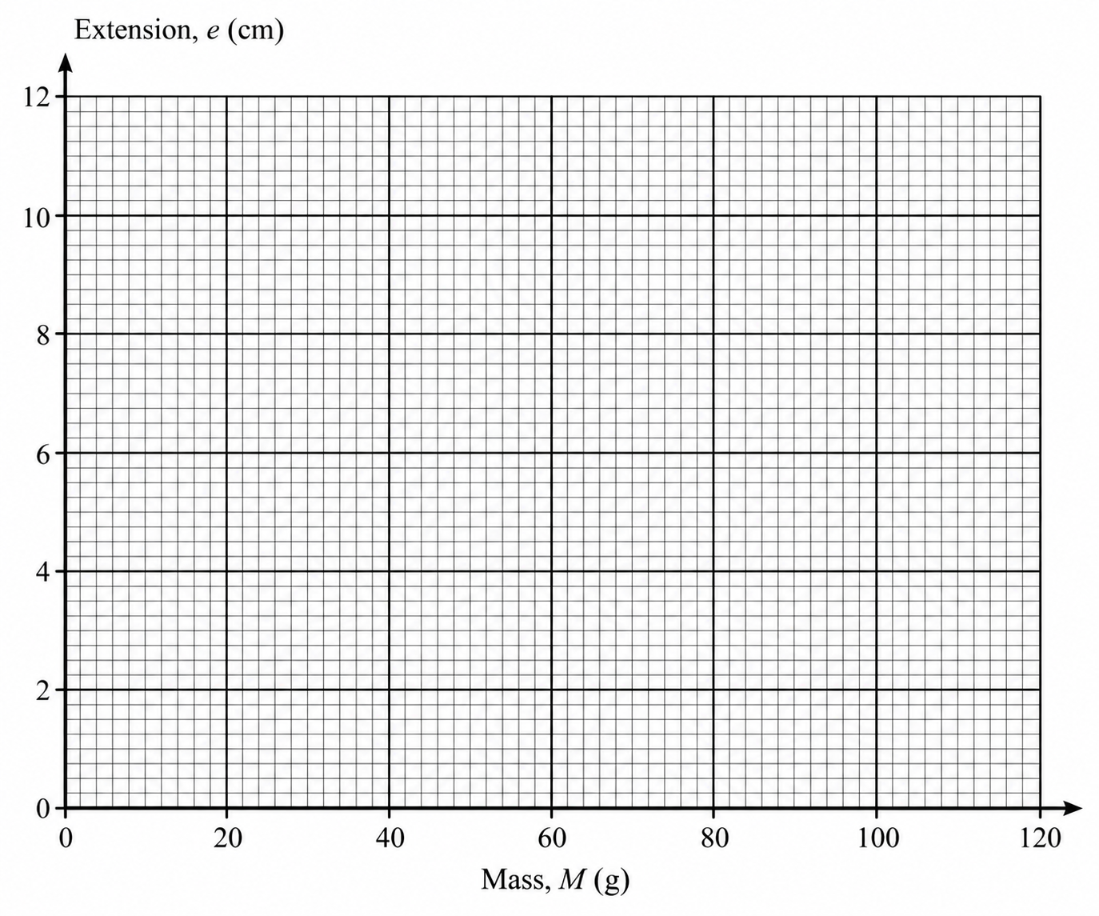
2(d). Determine the gradient, S, of the graph. (2 marks)
________________________________________________________________________________
________________________________________________________________________________
________________________________________________________________________________
2(e). Using the same setup, attach a 120 g mass and support it from below with your palm so that it does not oscillate. Pull the mass a small distance vertically downwards and release it to execute vertical oscillations. Record the time, t, for 20 complete oscillations. Repeat to obtain three readings. Repeat the procedure using a mass of 150 g.
Mass, M (g) | t₁ (s) | t₂ (s) | t₃ (s) | Average time for 20 oscillations (s) | T²/M (s² kg⁻¹)
120
150
2(f). Find the average value of T²/M and let this value be Q. (1 marks)
________________________________________________________________________________
________________________________________________________________________________
2(g). Given that the gradient S is related to Q and the constant K by S = QK/(4π²), determine K. (2 marks)
________________________________________________________________________________
________________________________________________________________________________
________________________________________________________________________________
2(h). What does K represent? (1 marks)
________________________________________________________________________________
________________________________________________________________________________

