TERM 3 HOLIDAY ASSIGNMENT 2026
FORM THREE
MATHEMATICS PAPER 2 (121/2)
Section / Question Numbers | Maximum Score | Candidate’s Score
SECTION I: 1 – 16 | 50
SECTION II: 17 – 24 (Any five) | 50
TOTAL | 100

SECTION I: 50 MARKS
1. Evaluate using logarithms: √0.005625 ÷ (18.75 × 0.2). (4 marks)
________________________________________________________________________________
________________________________________________________________________________
________________________________________________________________________________
2. The ratio of the corresponding sides of two similar tanks is 2 : 3. The volume of the smaller tank is 12.8 m³. Calculate the volume of the larger tank. (3 marks)
________________________________________________________________________________
________________________________________________________________________________
________________________________________________________________________________
3. Find the value of k if 4x² − 12x + k + 5 is a perfect square. (2 marks)
________________________________________________________________________________
________________________________________________________________________________
4. Solve the simultaneous equations: 2x − y = 3; x² − xy = −4. (4 marks)
________________________________________________________________________________
________________________________________________________________________________
________________________________________________________________________________
________________________________________________________________________________
5. A rectangular block has a square base whose sides are 10 cm. Its height, measured to the nearest millimetre, is 4.6 cm. Calculate the greatest possible error in calculating its volume. (3 marks)
________________________________________________________________________________
________________________________________________________________________________
________________________________________________________________________________
6. Simplify by rationalizing the denominator: 7/(√5 + √2). (3 marks)
________________________________________________________________________________
________________________________________________________________________________
________________________________________________________________________________
7. Find x if cos x = ½ for 0° ≤ x ≤ 180°. (3 marks)
________________________________________________________________________________
________________________________________________________________________________
________________________________________________________________________________
8. A tablet computer is marked at Ksh 1,850. Under hire purchase it is available for a down-payment of Ksh 350 and five monthly instalments of Ksh 320 each. Calculate:
a) the hire purchase price. (2 marks)
________________________________________________________________________________
________________________________________________________________________________
b) the extra amount paid above the cash price. (1 marks)
________________________________________________________________________________
9. Solve the equation: log x + 2 log 4 − 2 log 3 = log(8 − x). (3 marks)
________________________________________________________________________________
________________________________________________________________________________
________________________________________________________________________________
10. Make x the subject of the formula: p = 2√(x² + b²)/(3y). (3 marks)
________________________________________________________________________________
________________________________________________________________________________
________________________________________________________________________________
11. In the figure below, BT is a tangent to the circle at B. AXCT and BXD are straight lines. AX = 5 cm, CT = 7 cm, BX = 6 cm and XD = 7 cm.
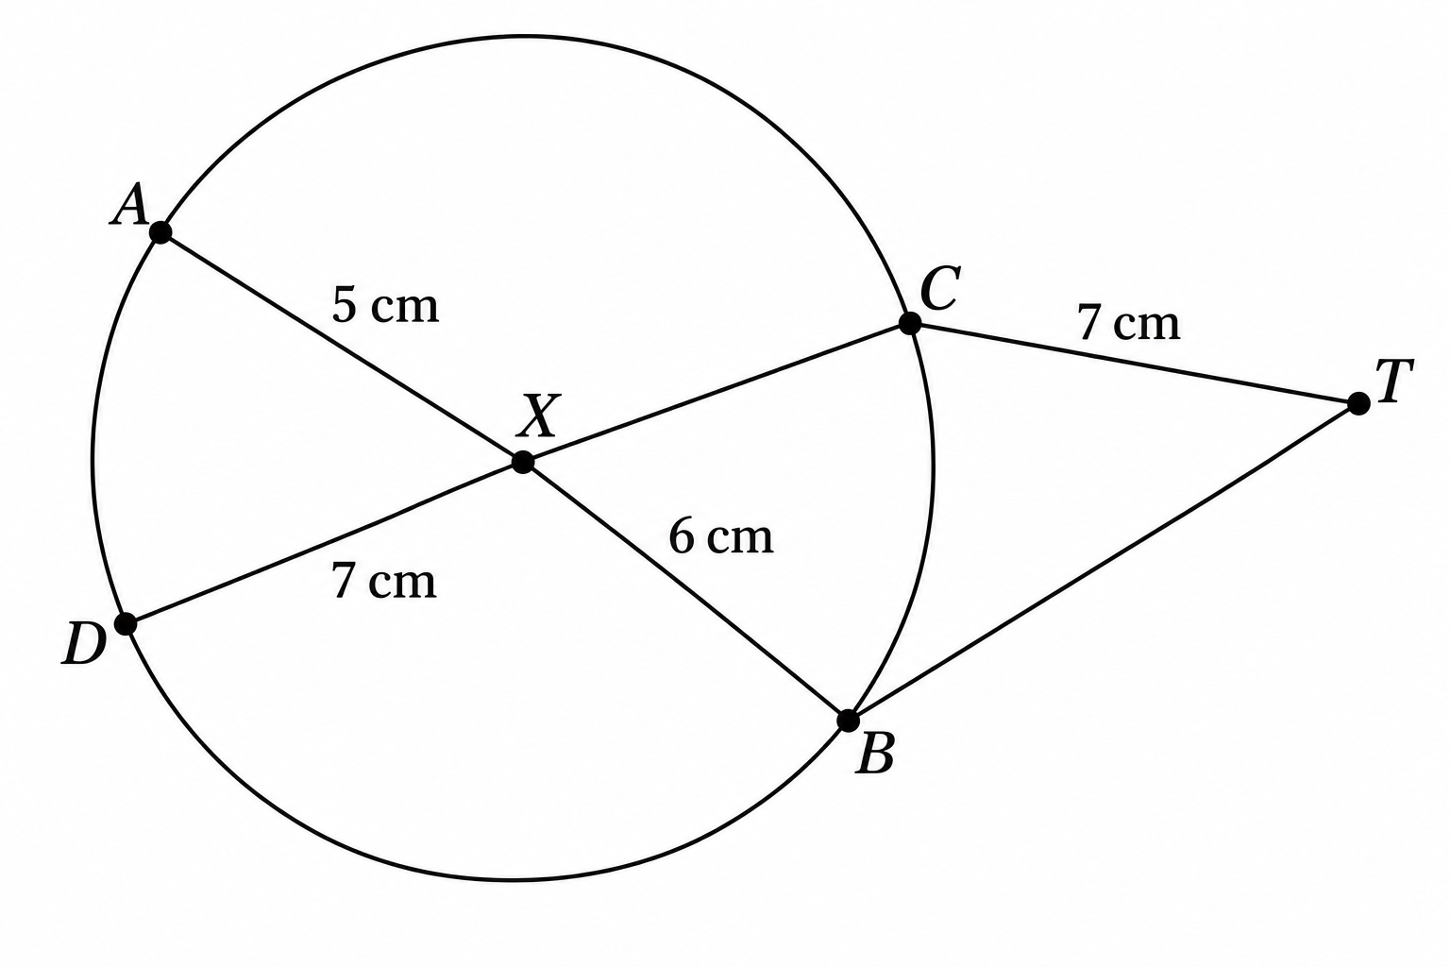
Find the length of:
a) XC. (2 marks)
________________________________________________________________________________
________________________________________________________________________________
b) BT. (2 marks)
________________________________________________________________________________
________________________________________________________________________________
12. Find the values of x if the matrix [[x, 2], [3, x − 2]] is a singular matrix. (3 marks)
________________________________________________________________________________
________________________________________________________________________________
________________________________________________________________________________
13. A manufacturer sells a bottle of fruit juice to a trader at a profit of 35%. The trader sells it for Ksh 92 at a profit of 15%. Find the trader’s buying price. (2 marks)
________________________________________________________________________________
________________________________________________________________________________
14. Four years ago, Juma was three times as old as Ali. In three years’ time, the sum of their ages will be 70. Determine their present ages. (3 marks)
________________________________________________________________________________
________________________________________________________________________________
________________________________________________________________________________
15. Evaluate: ⅖ of (3½ − 6¼) × 4⅔ ÷ 7/3. (3 marks)
________________________________________________________________________________
________________________________________________________________________________
________________________________________________________________________________
16. In the figure below, O is the centre of a circle of radius 6 cm. TA and TB are tangents to the circle at A and B respectively. OT = 10 cm. Using π = 3.142, calculate the shaded area, correct to 3 decimal places. (4 marks)
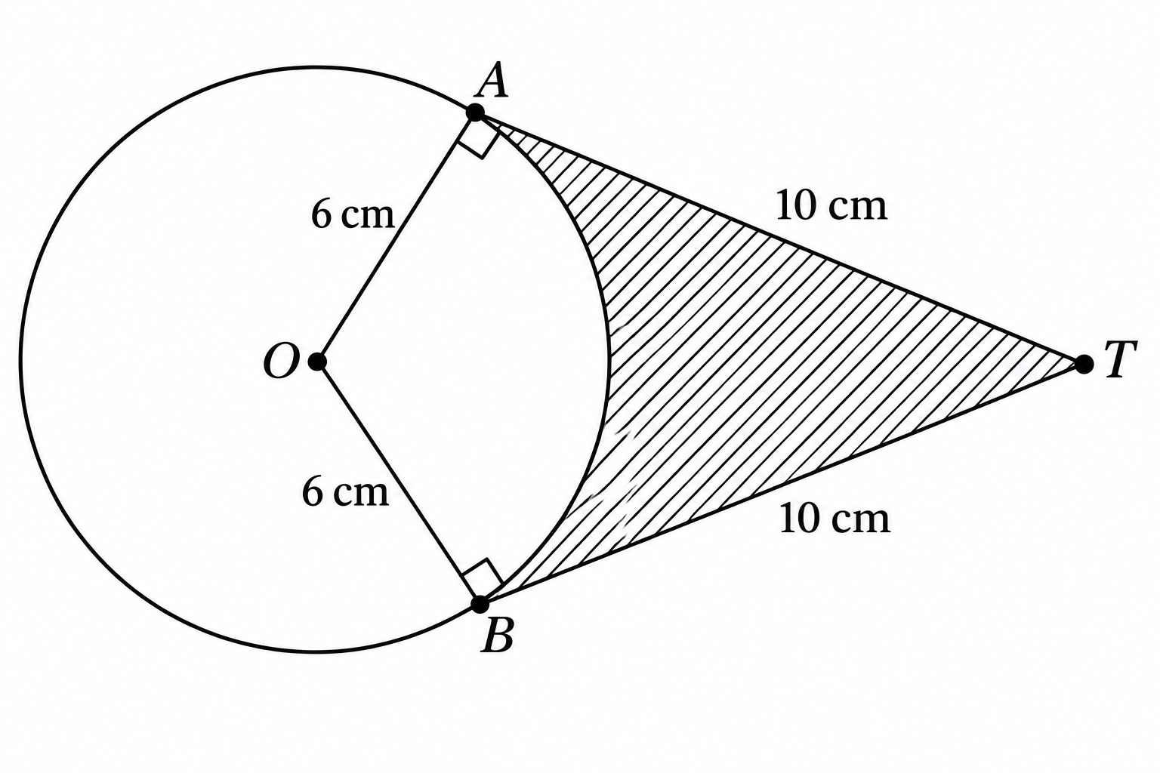
________________________________________________________________________________
________________________________________________________________________________
________________________________________________________________________________
________________________________________________________________________________

SECTION II: 50 MARKS
Answer ONLY FIVE questions in this section.
17. Complete the table below for the function y = 2x² + 2x − 3. (2 marks)
x | −3 | −2 | −1 | 0 | 1 | 2
y
________________________________________________________________________________
b) On the grid provided, draw the graph of y = 2x² + 2x − 3 for −3 ≤ x ≤ 2 and use your graph to determine the roots of 2x² + 2x − 3 = 0, correct to 1 decimal place. (4 marks)
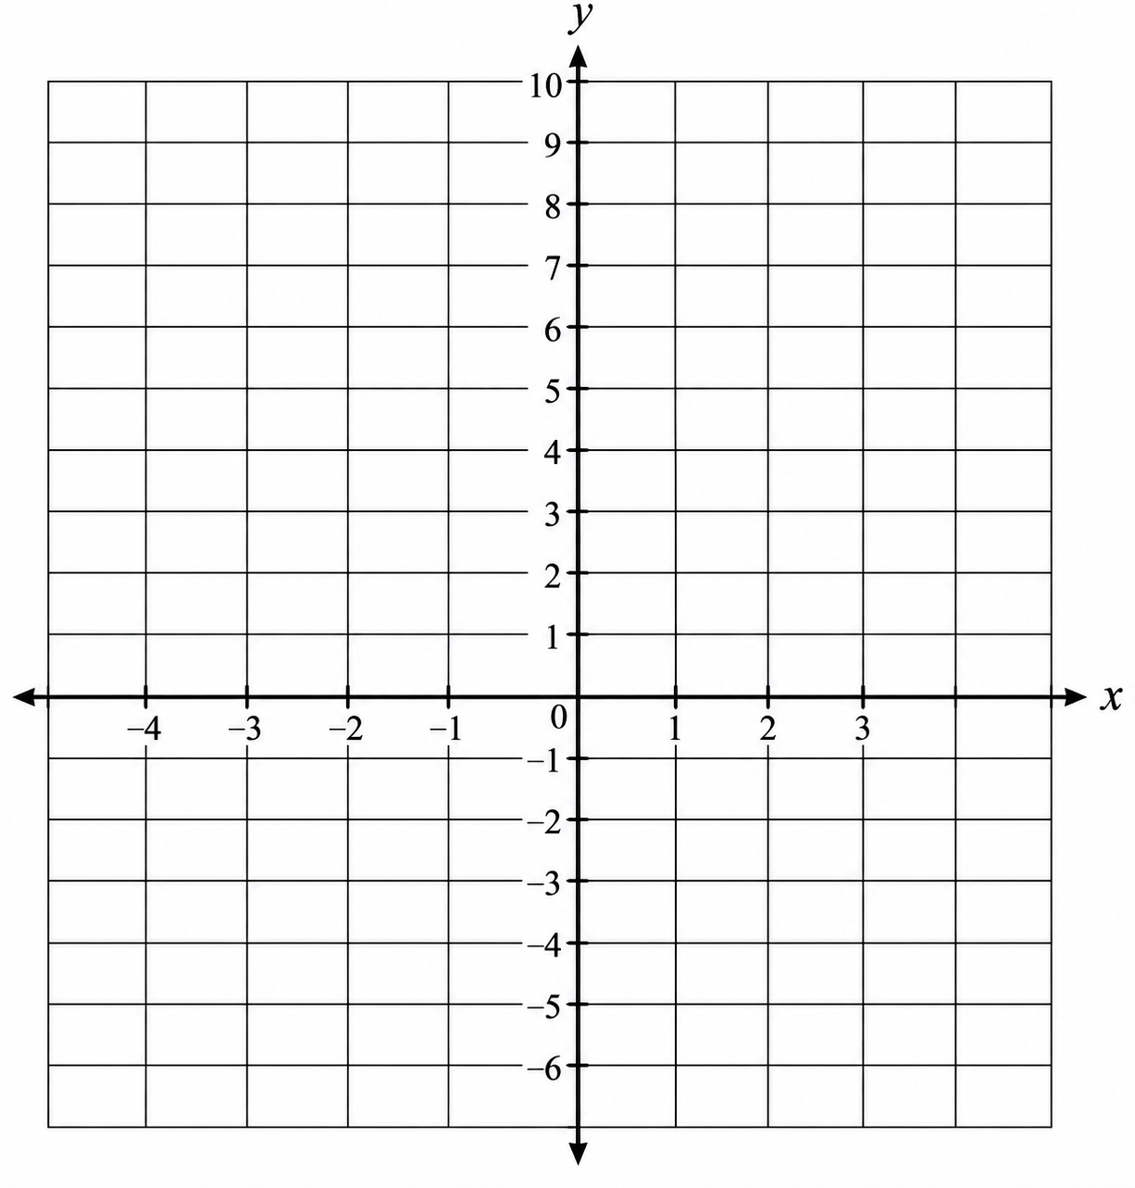
c) Use your graph to solve the following quadratic equations:
i) 2x² + 2x − 7 = 0. (2 marks)
________________________________________________________________________________
________________________________________________________________________________
ii) 2x² + 2x + 1 = 0. (2 marks)
________________________________________________________________________________
________________________________________________________________________________
18. A matrix T is given by T = [[3, 2], [5, 4]].
a) Find T⁻¹. (2 marks)
________________________________________________________________________________
________________________________________________________________________________
b) A trader bought 20 bags of maize and 25 bags of beans at a total cost of Ksh 76,000. If she had bought 30 bags of maize and 20 bags of beans, she would have spent Ksh 86,000.
i) Form a matrix equation from this information. (1 marks)
________________________________________________________________________________
ii) Determine the cost of one bag of maize and one bag of beans. (3 marks)
________________________________________________________________________________
________________________________________________________________________________
________________________________________________________________________________
c) She sold all the maize and beans at a profit of 10% on each bag of maize and 12½% on each bag of beans. Calculate the total percentage profit. (4 marks)
________________________________________________________________________________
________________________________________________________________________________
________________________________________________________________________________
________________________________________________________________________________
19. At the beginning of 2018, Amina bought two houses, one in Eldoret and the other in Kisumu, each at Ksh 1,500,000. The value of the house in Eldoret appreciated at a rate of 10% p.a.
a) Calculate the value of the house in Eldoret after 8 years, to the nearest shilling. (2 marks)
________________________________________________________________________________
________________________________________________________________________________
b) After n years, the value of the house in Eldoret was Ksh 3,215,383 while the value of the house in Kisumu was Ksh 2,742,059.
i) Find n. (4 marks)
________________________________________________________________________________
________________________________________________________________________________
________________________________________________________________________________
ii) Find the annual rate of appreciation of the house in Kisumu. (4 marks)
________________________________________________________________________________
________________________________________________________________________________
________________________________________________________________________________
20. The table below shows income tax rates.
Taxable income in k£ per month | Rate in shillings per k£
1 – 325 | 2
326 – 650 | 3
651 – 975 | 4
976 – 1300 | 5
1301 – 1625 | 6
Over 1626 | 7
For this assessment, K£1 = Ksh 20. Wanjiku earns a basic salary of Ksh 24,000. She has a house allowance of Ksh 5,000 per month, medical allowance of Ksh 3,000 per month and transport allowance of Ksh 2,000 per month. She claims a tax relief of Ksh 1,100 per month.
a) Calculate:
i) Wanjiku’s taxable income in k£ per month. (2 marks)
________________________________________________________________________________
________________________________________________________________________________
ii) Gross tax. (3 marks)
________________________________________________________________________________
________________________________________________________________________________
________________________________________________________________________________
iii) Net tax. (2 marks)
________________________________________________________________________________
________________________________________________________________________________
b) Her net income per month has the following deductions: health insurance fund Ksh 175; loan interest Ksh 250; service charge Ksh 225; Sacco loan Ksh 2,200. Calculate her net income per month. (3 marks)
________________________________________________________________________________
________________________________________________________________________________
________________________________________________________________________________
21. The figure below is a cyclic quadrilateral PQRS. Given that TRX is a tangent at R, O is the centre of the circle, PR is a diameter and PSX is a straight line. ∠PRS = 45° and ∠QPR = 35°.
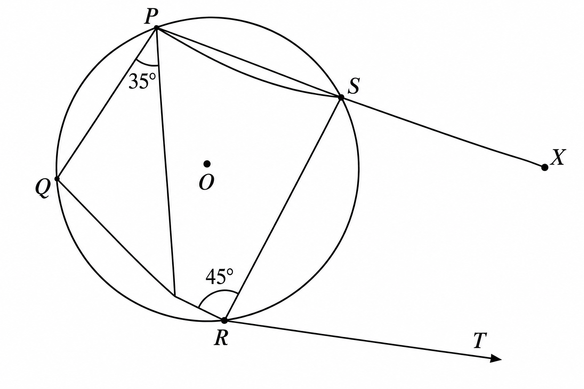
Giving a reason in each case, find the sizes of:
a) ∠XRS. (2 marks)
________________________________________________________________________________
________________________________________________________________________________
b) ∠SXR. (3 marks)
________________________________________________________________________________
________________________________________________________________________________
c) ∠PQR. (2 marks)
________________________________________________________________________________
________________________________________________________________________________
d) Reflex ∠QOR. (3 marks)
________________________________________________________________________________
________________________________________________________________________________
________________________________________________________________________________
22. Construct triangle ABC with AB = 9 cm, BC = 7 cm and ∠ABC = 90°. (3 marks)
________________________________________________________________________________
________________________________________________________________________________
________________________________________________________________________________
________________________________________________________________________________
________________________________________________________________________________
________________________________________________________________________________
a) Inscribe a circle in the triangle and measure its radius. (4 marks)
________________________________________________________________________________
________________________________________________________________________________
________________________________________________________________________________
________________________________________________________________________________
b) Calculate the area inside the triangle but not part of the circle. (3 marks)
________________________________________________________________________________
________________________________________________________________________________
________________________________________________________________________________
23. Three quantities X, Y and Z are such that X varies directly as the cube root of Y and inversely as the square root of Z. When X = 72, Y = 27 and Z = 16:
a) Determine the equation connecting X, Y and Z. (4 marks)
________________________________________________________________________________
________________________________________________________________________________
________________________________________________________________________________
________________________________________________________________________________
b) Find the value of Z when Y = 64 and X = 96. (2 marks)
________________________________________________________________________________
________________________________________________________________________________
c) Find the percentage change in X when Y is increased by 72.8%, with Z remaining constant. (4 marks)
________________________________________________________________________________
________________________________________________________________________________
________________________________________________________________________________
________________________________________________________________________________
24. Complete the table below for y = sin x and y = 3 cos x in the range 0° ≤ x ≤ 360°. (2 marks)
x° | 0 | 30 | 60 | 90 | 120 | 150 | 180 | 210 | 240 | 270 | 300 | 330 | 360
sin x | 0.00 | 0.50 | 0.87 | 1.00 | 0.87 | 0.50 | 0.00 | −0.50 | −0.87 | −1.00 | −0.87 | −0.50 | 0.00
3 cos x | 3.00 | 2.60 | 1.50 | 0.00 | −1.50 | −2.60 | −3.00 | −2.60 | −1.50 | 0.00 | 1.50 | 2.60 | 3.00
a) On the grid provided, plot on the same axes the graphs of y = sin x and y = 3 cos x. (4 marks)
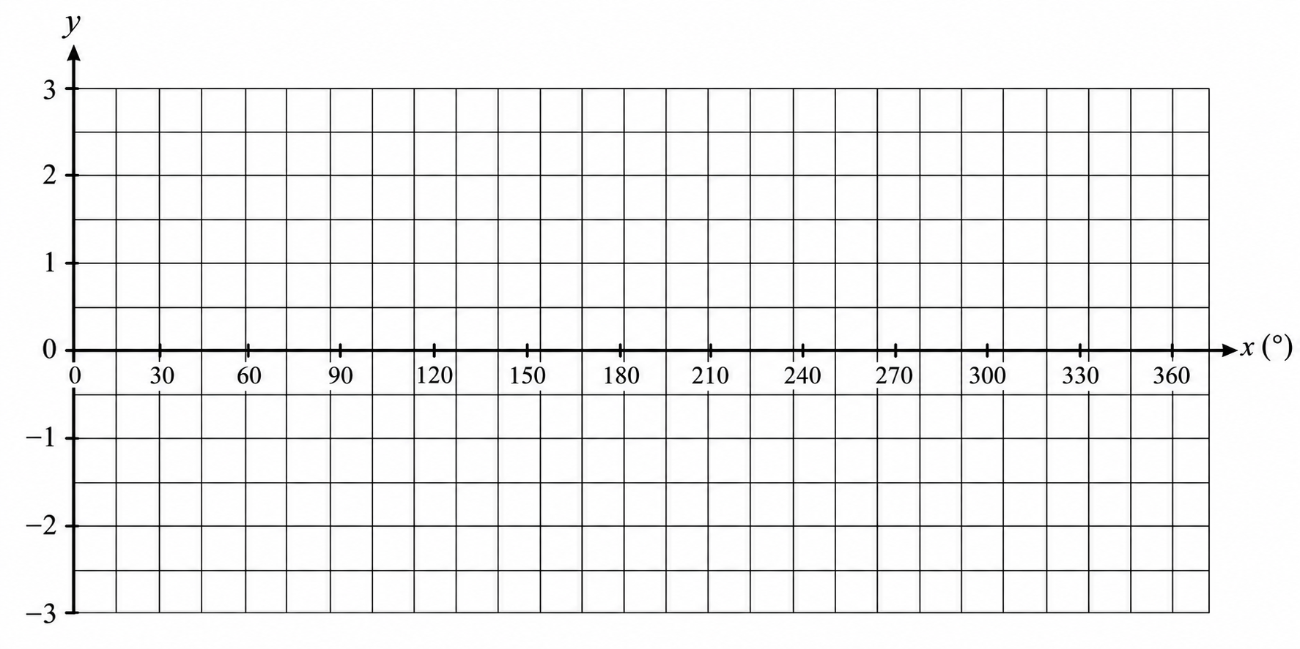
b) Use your graph above to:
i) determine the value of cos 60°. (1 marks)
________________________________________________________________________________
ii) determine the value of cos 42°. (1 marks)
________________________________________________________________________________
iii) determine the angle whose sine is 0.34. (1 marks)
________________________________________________________________________________
iv) determine the values of x for which sin x = 3 cos x. (1 marks)
________________________________________________________________________________
________________________________________________________________________________

