KENYA JUNIOR SCHOOL EDUCATION ASSESSMENT
GRADE 7 DECEMBER ASSIGNMENT
INTEGRATED SCIENCE PRACTICAL

LEARNER’S DETAILS
Name: _________________________________________________________________________________.
School: _________________________________________________________________________________.
Assessment Number: _____________________________. Date: _______________________________.
School Code: ___________________________. Signature: ______________________________.

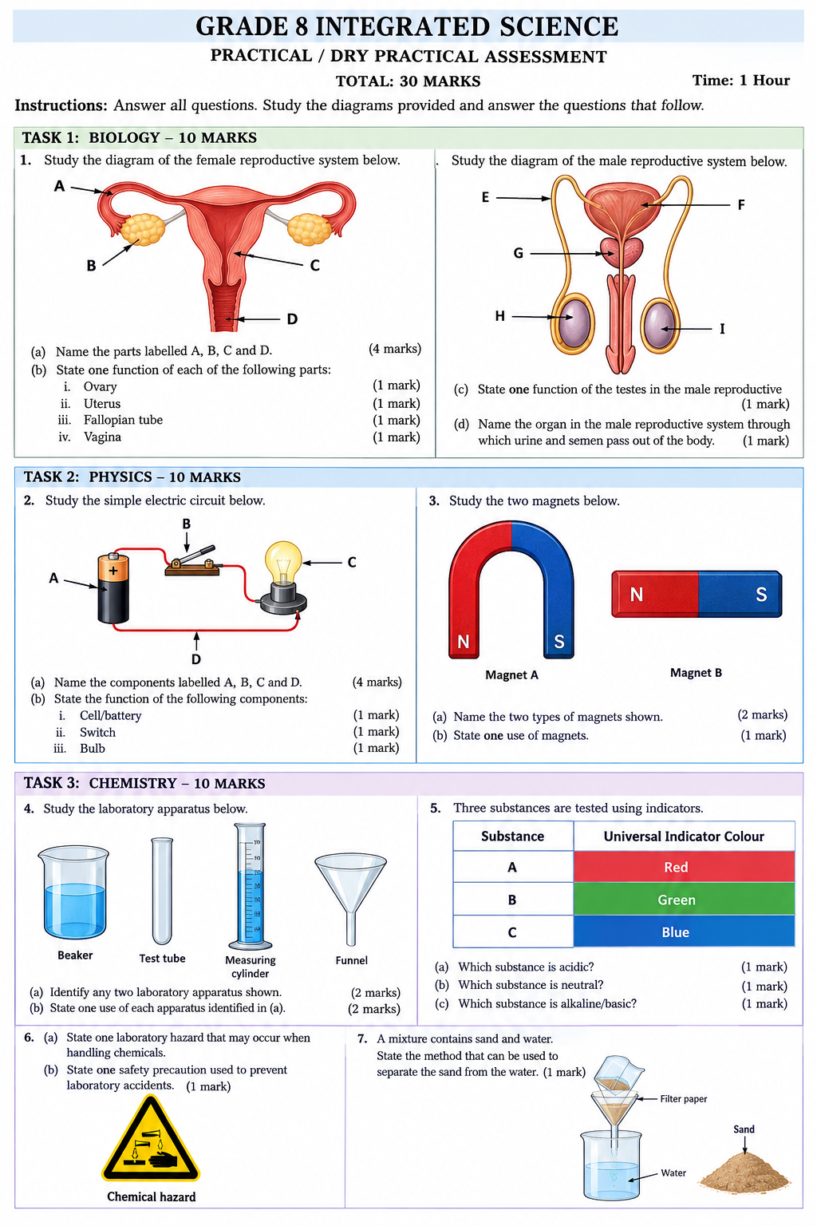

Marking scheme
Grade 7 Integrated Science Practical / Dry Practical Assessment:

TASK 1: BIOLOGY (10 MARKS)

1. Female and Male Reproductive Systems
(a) Name the parts labelled A, B, C and D: (4 marks)
- A: Fallopian tube (Oviduct)
- B: Ovary
- C: Uterus (Womb)
- D: Vagina
(b) State one function of each of the following parts: (4 marks)
- i. Ovary: Produces and releases ova (egg cells) and female hormones (estrogen and progesterone).
- ii. Uterus: Holds, nourishes, and protects the developing fetus during pregnancy.
- iii. Fallopian tube: Site of fertilization (where the egg meets the sperm) and conducts the egg towards the uterus.
- iv. Vagina: Acts as the birth canal during childbirth and receives sperm during sexual intercourse.
(c) State one function of the testes in the male reproductive system: (1 mark)
- Produces sperm cells and the male sex hormone (testosterone).
(d) Name the organ in the male reproductive system through which urine and semen pass out of the body: (1 mark)
- Penis (or Urethra)

TASK 2: PHYSICS (10 MARKS)

2. Simple Electric Circuit
(a) Name the components labelled A, B, C and D: (4 marks)
- A: Dry cell / Battery / Source of electrical energy
- B: Switch
- C: Electric bulb / Lamp
- D: Connecting wire / Conductor
(b) State the function of the following components: (3 marks)
- i. Cell/battery: Provides electrical energy / voltage to drive current through the circuit.
- ii. Switch: Opens or closes the electric circuit to control the flow of electric current.
- iii. Bulb: Converts electrical energy into light energy (and heat energy).

3. Magnets
(a) Name the two types of magnets shown: (2 marks)
- Magnet A: Horse-shoe magnet (or U-shaped magnet)
- Magnet B: Bar magnet
(b) State one use of magnets: (1 mark)
- Used in magnetic compasses for navigation. (Other acceptable answers: used in loudspeakers, magnetic door latches, electric motors, magnetic locks, recycling separators).

TASK 3: CHEMISTRY (10 MARKS)

4. Laboratory Apparatus
(a) Identify any two laboratory apparatus shown: (2 marks) (Choose any two from below)
- Beaker
- Test tube
- Measuring cylinder
- Funnel (Filter funnel)
(b) State one use of each apparatus identified in (a): (2 marks)
- Beaker: Used for holding, heating, or mixing liquids.
- Test tube: Used to hold, mix, or heat small amounts of liquid or solid chemicals.
- Measuring cylinder: Used to accurately measure the volume of liquids.
- Funnel: Used to channel liquids or fine-grained substances into containers with narrow openings, and to hold filter paper during filtration.

5. Indicators and pH Test
(a) Which substance is acidic? (1 mark)
- Substance A (Red colour indicates an acid)
(b) Which substance is neutral? (1 mark)
- Substance B (Green colour indicates neutral, pH 7)
(c) Which substance is alkaline/basic? (1 mark)
- Substance C (Blue colour indicates a base/alkali)

6. Laboratory Safety
(a) State one laboratory hazard that may occur when handling chemicals: (1 mark)
- Chemical burns on skin/eyes, toxic gas inhalation, or chemical spill/corrosion.
(b) State one safety precaution used to prevent laboratory accidents: (1 mark)
- Wearing protective gear (goggles, lab coat, gloves) OR avoiding tasting/smelling unknown chemicals.

7. Separation of Mixtures
- State the method that can be used to separate the sand from the water: (1 mark)
- Filtration

