GRADE 10 SENIOR SCHOOL
OPENER EXAMINATION
TERM 3 2026 HISTORY AND CITIZENSHIP
TIME: 2 HOURS 30 MINUTES

CANDIDATE NAME: __________________________________________________ | ADM NO: _______________
 | DATE: _________________

INSTRUCTIONS TO CANDIDATES:
1. Write your name, admission number, class, and date in the spaces provided above.
2. This paper consists of THREE sections: Section A (20 Marks), Section B (45 Marks), and Section C (35 Marks).
3. Answer ALL questions in Section A, Section B, and Section C in the spaces provided after each question.
4. All answers must be written in clear, concise English.
5. Candidates should check to ensure all questions and pages are printed fully before commencing.

SECTION A: (20 MARKS)
Answer ALL questions in this section in the spaces provided.
1. Define the term 'Citizenship' within the context of Kenya's modern constitutional framework. [2 marks]
...........................................................................................................................................................
...........................................................................................................................................................
2. State TWO unwritten sources of History and Citizenship. [2 marks]
...........................................................................................................................................................
...........................................................................................................................................................
3. Identify TWO biological theories that attempt to explain the origin of early human beings. [2 marks]
...........................................................................................................................................................
...........................................................................................................................................................
4. Give TWO reasons why the discovery of fire was a significant turning point in the culture of early humans. [2 marks]
...........................................................................................................................................................
...........................................................................................................................................................
5. State TWO characteristics of Agriculture in ancient Egypt that made it highly successful along the River Nile. [2 marks]
...........................................................................................................................................................
...........................................................................................................................................................
6. Name TWO main items of trade exported from Western Africa during the Trans-Saharan Trade. [2 marks]
...........................................................................................................................................................
...........................................................................................................................................................
7. Identify TWO modern forms of transport that replaced human porterage in Africa during the 19th and 20th centuries. [2 marks]
...........................................................................................................................................................
...........................................................................................................................................................
8. Define the concept 'National Integration' as applied in Kenya. [2 marks]
...........................................................................................................................................................
...........................................................................................................................................................
9. State TWO ways in which a person can lose Kenyan citizenship by registration under the 2010 Constitution. [2 marks]
...........................................................................................................................................................
...........................................................................................................................................................
10. Identify TWO peaceful methods of resolving conflicts in a school or local community setting. [2 marks]
...........................................................................................................................................................
...........................................................................................................................................................
SECTION B: (45 MARKS)
Answer ALL questions in this section in the spaces provided.

11 (a) Outline THREE reasons why studying History and Citizenship is essential for Grade 10 learners under the Competency-Based Education (CBE) curriculum. [3 marks]
...........................................................................................................................................................
...........................................................................................................................................................
...........................................................................................................................................................
11 (b) Explain SIX limitations of using Oral Traditions as a primary source of historical information. [6 marks]
...........................................................................................................................................................
...........................................................................................................................................................
...........................................................................................................................................................
...........................................................................................................................................................
...........................................................................................................................................................
...........................................................................................................................................................
12 (a) Identify THREE physical cultural developments associated with Homo erectus during the Middle Stone Age. [3 marks]
...........................................................................................................................................................
...........................................................................................................................................................
...........................................................................................................................................................
12 (b) Analyze SIX factors that facilitated the development of early agriculture in Mesopotamia (the Fertile Crescent). [6 marks]
...........................................................................................................................................................
...........................................................................................................................................................
...........................................................................................................................................................
...........................................................................................................................................................
...........................................................................................................................................................
...........................................................................................................................................................
13. Study the trade route illustration below representing the Trans-Saharan Trade network and answer the questions that follow:
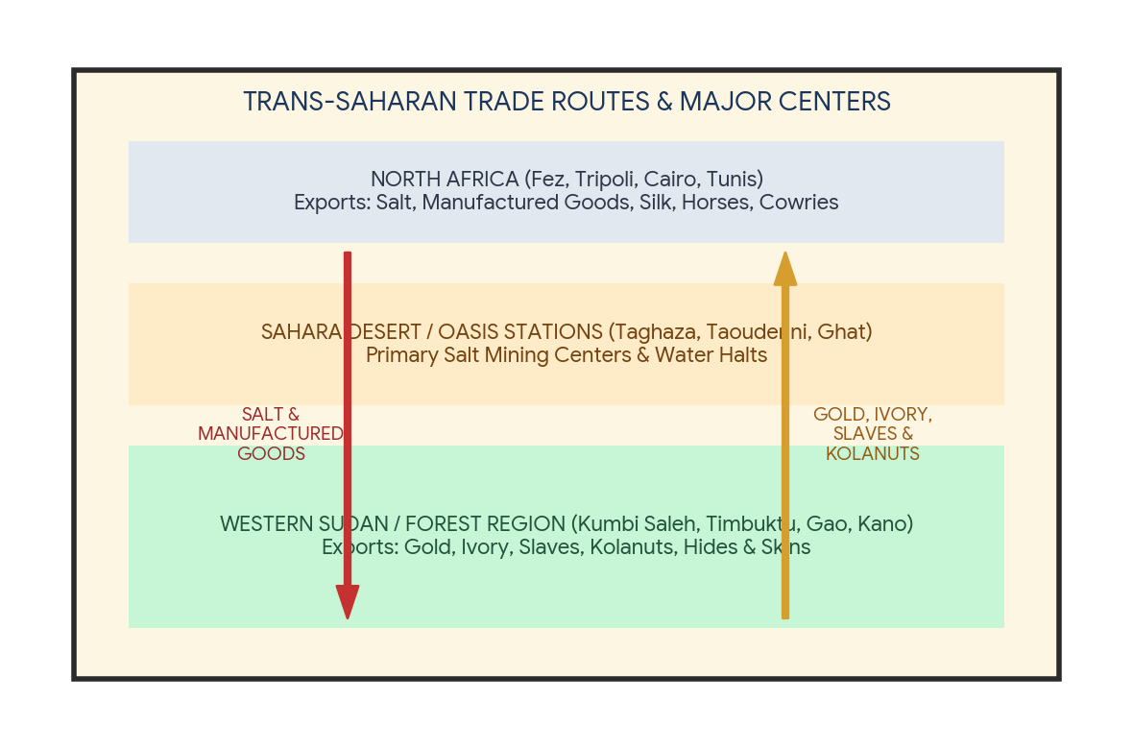
13 (a) Name TWO major desert trading centers/oases where Trans-Saharan traders stopped to replenish water and salt supplies. [2 marks]
...........................................................................................................................................................
...........................................................................................................................................................
13 (b) Identify TWO primary commodities exported from North Africa to Western Sudan, as illustrated in the diagram. [2 marks]
...........................................................................................................................................................
...........................................................................................................................................................
13 (c) Explain FIVE roles played by Tuaregs / Berber desert guides during the Trans-Saharan trade operations. [5 marks]
...........................................................................................................................................................
...........................................................................................................................................................
...........................................................................................................................................................
...........................................................................................................................................................
...........................................................................................................................................................
13 (d) Examine SIX social and economic effects of the Trans-Saharan Trade on the communities of West Africa. [6 marks]
...........................................................................................................................................................
...........................................................................................................................................................
...........................................................................................................................................................
...........................................................................................................................................................
...........................................................................................................................................................
...........................................................................................................................................................

14 (a) Highlight THREE disadvantages of using animal transport (such as pack animals) prior to the Industrial Revolution. [3 marks]
...........................................................................................................................................................
...........................................................................................................................................................
...........................................................................................................................................................
14 (b) Discuss NINE positive impacts of the development of railway transport on European industrialization and economic growth. [9 marks]
...........................................................................................................................................................
...........................................................................................................................................................
...........................................................................................................................................................
...........................................................................................................................................................
...........................................................................................................................................................
...........................................................................................................................................................
...........................................................................................................................................................
...........................................................................................................................................................
...........................................................................................................................................................
SECTION C: (35 MARKS)
Answer ALL questions in this section in the spaces provided.
15 (a) Identify THREE responsibilities of a good Kenyan citizen as enshrined in the Constitution. [3 marks]
...........................................................................................................................................................
...........................................................................................................................................................
...........................................................................................................................................................
15 (b) Explain SIX values of good citizenship that promote national cohesion and democratic governance in Kenya. [6 marks]
...........................................................................................................................................................
...........................................................................................................................................................
...........................................................................................................................................................
...........................................................................................................................................................
...........................................................................................................................................................
...........................................................................................................................................................
16 (a) State THREE national symbols of Kenya established under the Constitution to foster national unity. [3 marks]
...........................................................................................................................................................
...........................................................................................................................................................
...........................................................................................................................................................
16 (b) Analyze NINE factors that promote national integration and harmonious co-existence among diverse communities in Kenya. [9 marks]
...........................................................................................................................................................
...........................................................................................................................................................
...........................................................................................................................................................
...........................................................................................................................................................
...........................................................................................................................................................
...........................................................................................................................................................
...........................................................................................................................................................
...........................................................................................................................................................
...........................................................................................................................................................
17 (a) Read the scenario below carefully and answer the questions that follow:
'In Amani County, a dispute arose between pastoralists and crop farmers over access to the Mara River water point during a severe drought. The farmers accused pastoralists of allowing livestock to destroy crops, while pastoralists claimed farmers fenced off communal water points. The County Commissioner convened a peace committee involving elders, youth, and local leaders using Negotiation and Mediation processes.'
17 (b) Identify TWO conflict resolution methods explicitly highlighted in the scenario above. [2 marks]
...........................................................................................................................................................
...........................................................................................................................................................
17 (c) Distinguish between 'Arbitration' and 'Mediation' as alternative dispute resolution mechanisms. [4 marks]
...........................................................................................................................................................
...........................................................................................................................................................
...........................................................................................................................................................
...........................................................................................................................................................
17 (d) A local peace project in Amani County received a community development fund of KSh 1,200,000 to distribute among conflict resolution activities. The budget was allocated as follows:
- Dialogue and Mediation Workshops: 40%
- Youth Peace Sports Tournaments: 35%
- Water Trough Construction (Shared Infrastructure): 25%
Calculate the exact amount in KSh spent on EACH of the three peace activities, and determine how much more was spent on Dialogue/Mediation than on Water Trough Construction. [8 marks]
...........................................................................................................................................................
...........................................................................................................................................................
...........................................................................................................................................................
...........................................................................................................................................................
...........................................................................................................................................................
...........................................................................................................................................................
...........................................................................................................................................................
...........................................................................................................................................................

