COMPUTER STUDIES
GRADE 10 TERM 3 OPENER EXAMINATION 2026
TIME: 2 HOURS

Candidate's Name: …………………………………………………… | Admission No.: ……………………………………
 | Date: ……………………………………………
Candidate's Signature: ……………………………………

INSTRUCTIONS TO CANDIDATES
- Write your name, admission number, class and date in the spaces provided above.
- This paper consists of eight (8) questions.
- Answer ALL questions in the spaces provided in this booklet.
- All working for calculations MUST be shown clearly in the spaces provided.

1.(a) Define the term "computer". (2 marks)

(b) State two characteristics of electronic computers that distinguish them from earlier mechanical computing devices. (4 marks)

(c) Name one early computing device and state one function it performed. (2 marks)

2.
(a) Classify computers according to size, naming three categories. (3 marks)

(b) Distinguish between an input device and an output device, giving one example of each. (4 marks)

(c) The diagram below shows the basic block diagram of a computer system. (5 marks)
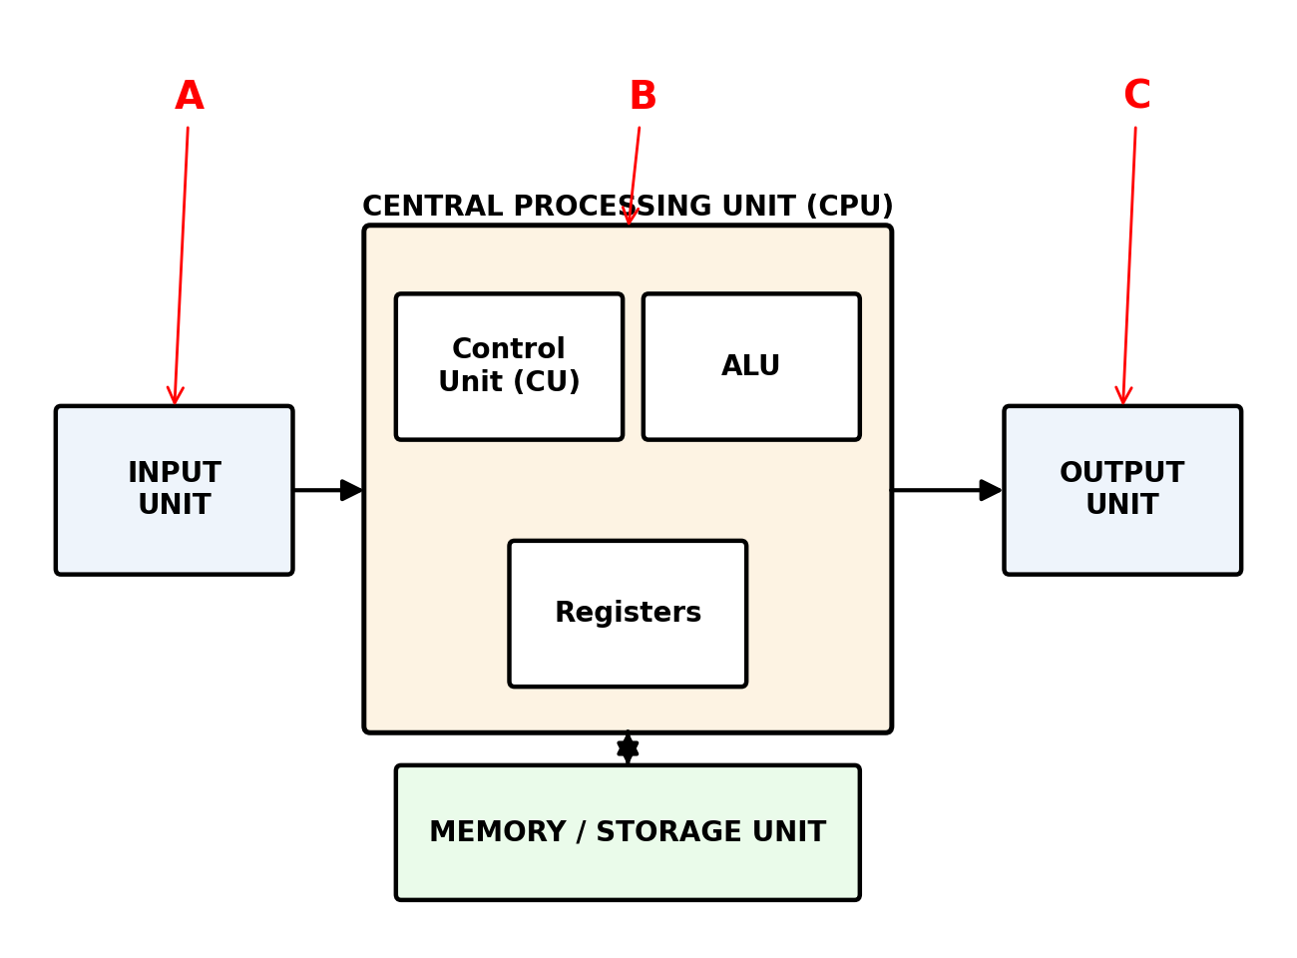
(i) Identify the parts labelled A, B and C.

(ii) State the function of the Control Unit.

3.
(a) Define the terms "bit" and "byte" as used in data representation. (2 marks)

(b) Convert the following numbers as instructed. Show your working clearly. (9 marks)
(i) 42₁₀ to binary

(ii) 101101₂ to decimal

(iii) 2A₁₆ (hexadecimal) to decimal

(c) Add the following binary numbers, giving your answer in binary: 1011₂ + 0110₂ (3 marks)

(d) State one reason why the binary number system is used in computers. (2 marks)

4.
(a) State the three main components of the CPU and briefly state the function of each. (6 marks)

(b) Distinguish between RISC and CISC processor architectures. (2 marks)

(c) The diagram below shows three logic gate symbols. (6 marks)
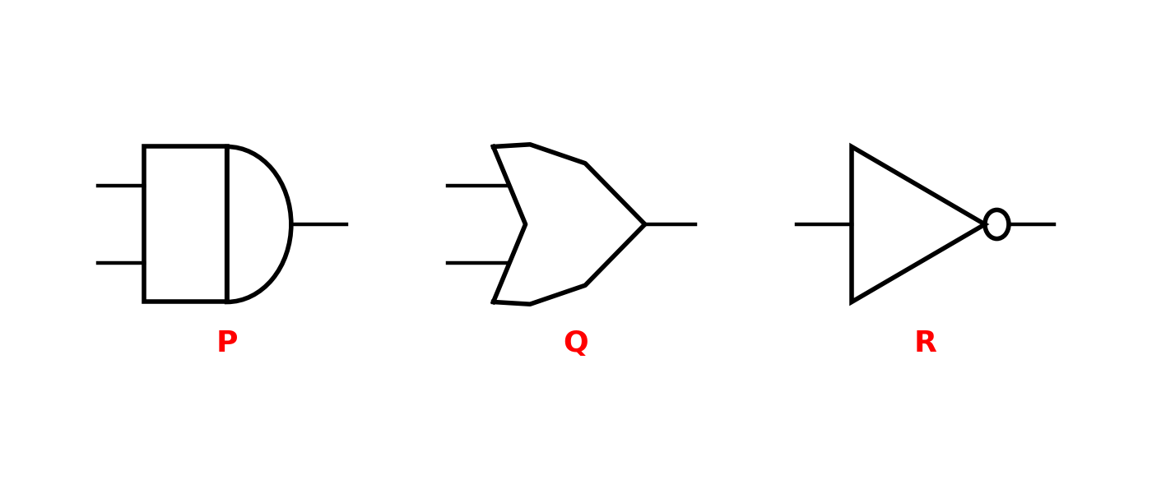
(i) Identify the logic gates labelled P, Q and R.

(ii) Complete the truth table below for the AND gate labelled P.

A | B | Output
0 | 0 | 0
0 | 1
1 | 0
1 | 1

5.
(a) Distinguish between primary storage and secondary storage, giving one example of each. (4 marks)

(b) State two characteristics of RAM that distinguish it from ROM. (2 marks)

(c) A student has a flash disk with a capacity of 8 GB. If each photo file takes up an average of 4 MB of storage space, calculate the maximum number of photo files that can be stored on the flash disk. (Take 1 GB = 1024 MB) (4 marks)

6.
(a) Define the term "operating system". (2 marks)

(b) State three functions of an operating system. (3 marks)

(c) Name two types of operating systems based on the number of users they can support, giving one example of each. (4 marks)

(d) State two importances of proper file management in a computer system. (3 marks)

7.
(a) Define the term "computer network". (2 marks)

(b) State three advantages of networking computers. (3 marks)

(c) The diagrams below show three common network topologies. (5 marks)
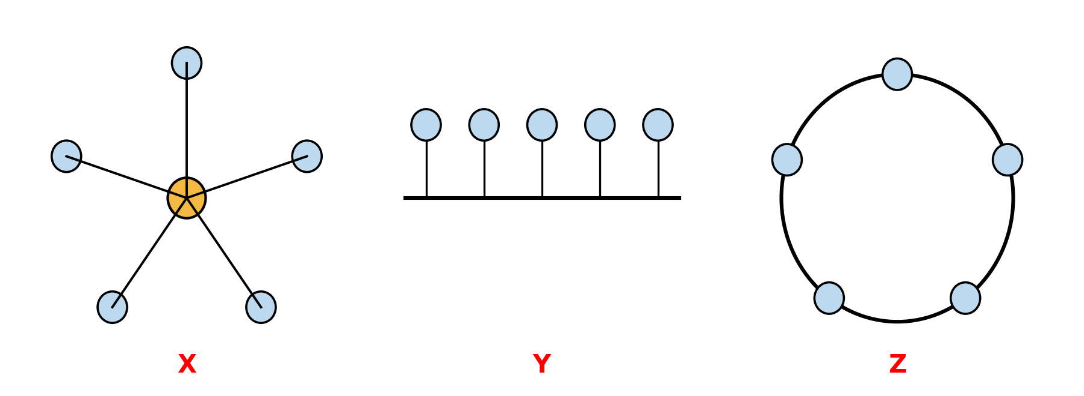
(i) Identify the topologies labelled X, Y and Z.

(ii) State one advantage of the topology labelled X.

(d) Distinguish between a LAN and a WAN. (4 marks)

(e) State two examples of transmission media used in data communication. (2 marks)

8.
(a) Define the following terms as used in programming: (4 marks)
(i) Variable

(ii) Constant

(b) State the data type that would be most appropriate for storing each of the following: (3 marks)
(i) a person's age

(ii) a person's name

(iii) whether a statement is true or false

(c) Study the flowchart below, used to determine the larger of two numbers A and B, then answer the questions that follow. (4 marks)
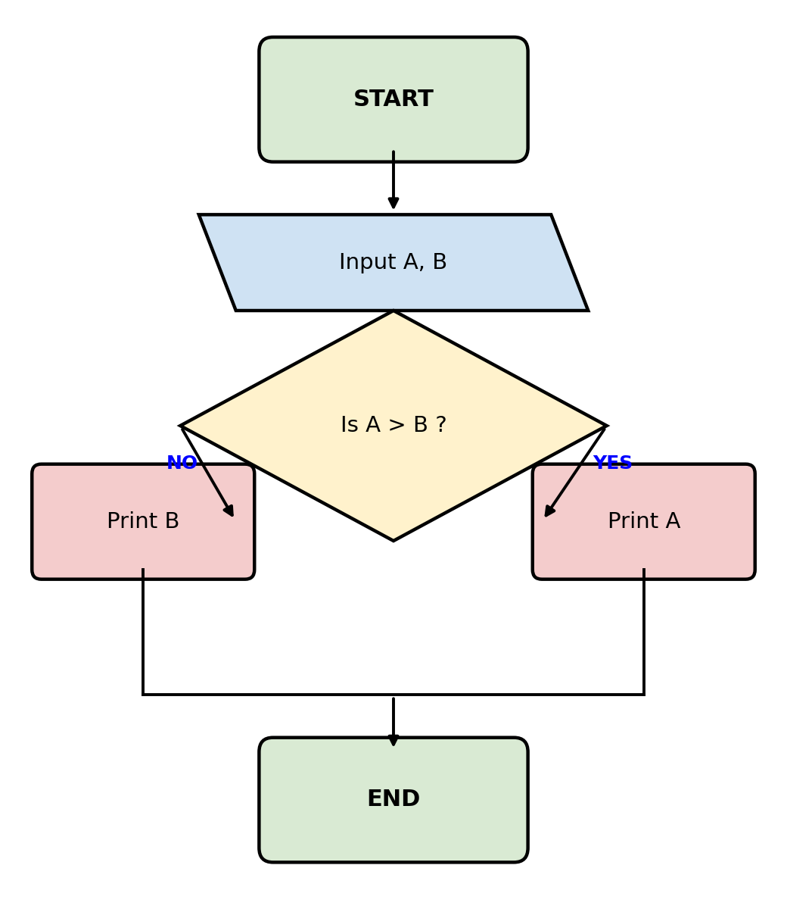
(i) State the output of the flowchart if A = 15 and B = 9.

(ii) State the output of the flowchart if A = 6 and B = 20.

(d) State one advantage of using a flowchart when designing a program. (1 mark)

