KENYA CERTIFICATE OF BASIC EDUCATION

SENIOR SCHOOL ASSESSMENT

DECEMBER ASSIGNMENT 2026
GRADE 10 – FINE ARTS
Time: 2 Hours
LEARNER’S DETAILS
Name: _____________________________________________________________. School: ____________________________________________.
Assessment Number: _______________________________________________. Date: ____________________________________________.
School Code: ______________________________________________________. Signature: _______________________________________.

INSTRUCTIONS TO CANDIDATES
- Fill in your name, school name, your assessment number, date, the school code and signature in the spaces provided above.
- This paper consists of two sections: A and B.
- Answer all questions in section A and section B.
- Answer the questions in English.
- All answers MUST be written in the spaces provided in PAPER.
- Do NOT remove any page from this question paper.

FOR OFFICIAL USE ONLY (EXAMINER’S USE)
SECTION | SECTION A | SECTION B | % SCORE | EE1 | EE2 | ME1 | ME2 | AE1 | AE2 | BE1 | BE2
SCORE RANGE | 30 MARKS | 50 MARKS |  | 90-100 | 75-89 | 58-74 | 41-57 | 31-40 | 21-30 | 11-20 | 1-10
POINTS |  |  |  | 8 POINTS | 7 POINTS | 6 POINTS | 5 POINTS | 4 POINTS | 3 POINTS | 2 POINTS | 1 POINT
LEARNER’S TOTAL SCORE

SECTION A: (30 marks) Answer ALL questions in this section.

1. a) Define shape in art. (1 mark)
______________________________________________________________________________________________________________________________________________________________________________________________
b) State two types of shapes used by artists. (2 marks)
- _________________________________________________________________________________________
- _________________________________________________________________________________________
c) Explain the difference between shape and form. (2 marks)

________________________________________________________________________________________________________________________________________________________________________

2. a) What is meant by texture in art? (1 mark)
______________________________________________________________________________________________________________________________________________________________________________________________
b) Give two examples of natural textures that an artist may observe. (2 marks)
- _________________________________________________________________________________________
- _________________________________________________________________________________________
c) Name two techniques an artist can use to represent texture in a drawing or painting. (2 marks)
- _________________________________________________________________________________________
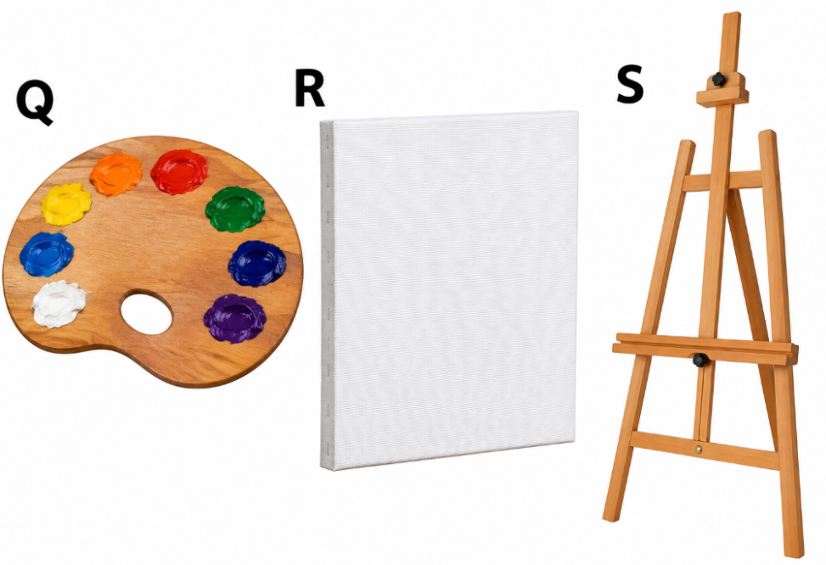
- _________________________________________________________________________________________

3. Study the fine arts tools below.

a) Identify three art materials or tools that could be represented by Q, R and S. (3 marks)
Q: _____________________________________
R: ______________________________________
S: _______________________________________
b) State one artistic use of any two of the materials/tools identified. (2 marks)

________________________________________________________________________________________________________________________________________________________________________

4. a) What are complementary colours? (1 mark)
______________________________________________________________________________________________________________________________________________________________________________________________
b) Give two pairs of complementary colours. (2 marks)
- _________________________________________________________________________________________
- _________________________________________________________________________________________
c) State two effects that complementary colours can create when placed next to each other. (2 marks)
- _________________________________________________________________________________________
- _________________________________________________________________________________________

5. a) Define printmaking. (1 mark)
______________________________________________________________________________________________________________________________________________________________________________________________
b) Name two printmaking techniques. (2 marks)
- _________________________________________________________________________________________
- _________________________________________________________________________________________
c) State two materials that can be used to create a simple printmaking surface or block. (2 marks)
- _________________________________________________________________________________________
- _________________________________________________________________________________________

6. a) State one way in which the natural environment can inspire an artist. (1 mark)
______________________________________________________________________________________________________________________________________________________________________________________________
b) Give two natural materials that may be used in artwork. (2 marks)
- _________________________________________________________________________________________
- _________________________________________________________________________________________
c) Explain two ways in which artists can promote environmental conservation through art. (2 marks)
- _________________________________________________________________________________________
- _________________________________________________________________________________________

SECTION B: 50 MARKS
Answer ALL questions.

7. Your teacher places a metallic cup, a bottle and a round fruit on a table for an observational drawing exercise.
a) State three stages you would follow when beginning the drawing. (3 marks)
- _________________________________________________________________________________________
- _________________________________________________________________________________________
- _________________________________________________________________________________________
b) Explain two ways of representing the metallic surface of the cup. (2 marks)
- _________________________________________________________________________________________
- _________________________________________________________________________________________
c) Name three tonal areas that may be observed when an object is illuminated by a light source. (3 marks)
- _________________________________________________________________________________________
- _________________________________________________________________________________________
- _________________________________________________________________________________________
d) State two reasons why an artist should identify the direction of the light source before shading. (2 marks)
- _________________________________________________________________________________________
- _________________________________________________________________________________________

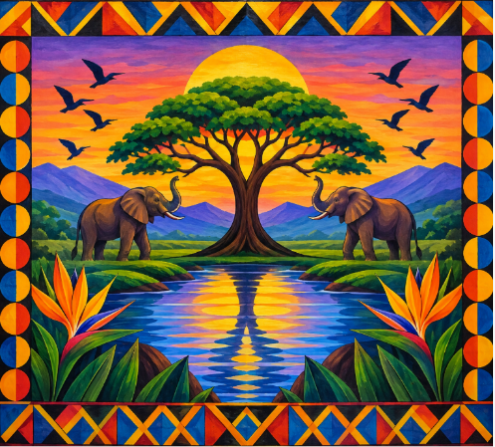
8. Sir Mwangi bought the following piece of art

a) Identify two principles of design demonstrated by the art (2 marks)
- _________________________________________________________________________________________
- _________________________________________________________________________________________
b) Explain how radial balance can be created in an artwork. (2 marks)
- _________________________________________________________________________________________
- _________________________________________________________________________________________
c) Explain three ways of creating emphasis in a composition. (3 marks)
- _________________________________________________________________________________________
- _________________________________________________________________________________________
- _________________________________________________________________________________________
d) State three qualities of a well-organised composition. (3 marks)
- _________________________________________________________________________________________
- _________________________________________________________________________________________
- _________________________________________________________________________________________

9. A learner is required to produce a landscape showing a road, trees, mountains, houses and a river extending into the distance.
a) What is perspective in drawing? (2 marks)
______________________________________________________________________________________________________________________________________________________________________________________________
b) Explain how size can be used to show distance in the landscape. (2 marks)
- _________________________________________________________________________________________
- _________________________________________________________________________________________
c) State two ways of showing overlapping forms in a landscape. (2 marks)
- _________________________________________________________________________________________
- _________________________________________________________________________________________
d) Explain two ways of using colour to create atmospheric or aerial perspective. (2 marks)
- _________________________________________________________________________________________
- _________________________________________________________________________________________
e) State two features that may be included in the foreground of the landscape. (2 marks)
- _________________________________________________________________________________________
- _________________________________________________________________________________________

10. A school art club plans to create a sculpture from clay and recycled materials.
a) Define sculpture. (2 marks) ______________________________________________________________________________________________________________________________________________________________________________________________
b) Name three methods of creating or shaping sculpture. (3 marks)
- _________________________________________________________________________________________
- _________________________________________________________________________________________
- _________________________________________________________________________________________

c) Describe two ways of creating surface texture on a clay sculpture. (2 marks)
- _________________________________________________________________________________________
- _________________________________________________________________________________________
d) State three precautions that should be observed when working with clay and sculptural tools. (3 marks)
- _________________________________________________________________________________________
- _________________________________________________________________________________________
- _________________________________________________________________________________________

11. A Kenyan artist produces a series of paintings showing traditional ceremonies, local architecture, clothing, landscapes and everyday community activities.
a) Identify two cultural aspects that may be communicated through such artwork. (2 marks)
- _________________________________________________________________________________________
- _________________________________________________________________________________________
b) Explain two reasons why artists should document and preserve cultural heritage. (2 marks)
- _________________________________________________________________________________________
- _________________________________________________________________________________________
c) Describe three stages involved in appreciating or analysing an artwork. (3 marks)
- _________________________________________________________________________________________
- _________________________________________________________________________________________
- _________________________________________________________________________________________
d) State three ways in which an artist can earn income from visual art. (3 marks)
- _________________________________________________________________________________________
- _________________________________________________________________________________________
- _________________________________________________________________________________________

THIS IS THE LAST PRINTED PAGE

GRADE 10 KENYA – FINE ARTS

MARKING SCHEME

SECTION A: 30 MARKS

1.
a) Shape is a two-dimensional enclosed area defined by lines, colours, tones or boundaries.
(1 mark)
b) Any two:
- Geometric shapes
- Organic shapes
- Regular shapes
- Irregular shapes
(2 marks)
c)
- Shape is two-dimensional and has length and width.
- Form is three-dimensional and has length, width and depth.
(2 marks)

2.
a) Texture is the surface quality or appearance of an object that can be seen or felt.
(1 mark)
b) Any two:
- Roughness of tree bark
- Smoothness of leaves
- Texture of rocks
- Sand
- Animal fur
- Grass
- Tree wood
(2 marks)
c) Any two:
- Hatching
- Cross-hatching
- Stippling
- Dry-brush technique
- Frottage/rubbing
- Scumbling
(2 marks)

3.
a) Any three appropriate materials/tools represented by the diagrams, for example:
- Palette
- Canvas
- Easel
(3 marks)
b) Any two correctly matched uses:
- Drawing board – provides a firm, flat surface for drawing.
- Ruler – used for measuring and drawing straight lines.
- Paintbrush – used for applying paint.
- Pencil – used for sketching, outlining and shading.
- Palette – used for holding and mixing colours.
- Eraser – used to remove unwanted pencil marks.
- Easel – supports an artwork while the artist is working.
(2 marks)

4.
a) Complementary colours are pairs of colours that are opposite each other on the colour wheel.
(1 mark)
b) Any two pairs:
- Red and green
- Blue and orange
- Yellow and violet/purple
(2 marks)
c) Any two:
- Creates strong contrast.
- Makes colours appear more vivid.
- Creates emphasis.
- Attracts the viewer's attention.
- Produces visual excitement.
(2 marks)

5.
a) Printmaking is the process of producing images by transferring an image or design from a prepared surface onto another surface, usually paper or fabric.
(1 mark)
b) Any two:
- Relief printing
- Linocut
- Woodcut
- Monoprinting
- Stencil printing
- Screen printing
- Intaglio
(2 marks)
c) Any two:
- Cardboard
- Foam
- Wood
- Linoleum
- Potatoes/vegetables
- Polystyrene
- Rubber
(2 marks)

6.
a) The environment can provide subjects, colours, forms, patterns and textures for artworks.
(1 mark)
b) Any two:
- Leaves
- Seeds
- Twigs
- Stones
- Sand
- Clay
- Dried grass
- Bark
(2 marks)
c) Any two well-explained points:
- Artists can create posters and paintings that educate people about environmental conservation.
- Artists can use recycled materials to demonstrate the importance of waste reduction.
- Art can communicate the effects of pollution, deforestation and climate change.
- Public artworks can encourage communities to protect natural resources.
- Exhibitions can raise awareness about environmental issues.
(2 marks)

SECTION B: 50 MARKS

7.
a) Any three stages:
- Observe and analyse the arrangement.
- Identify the overall proportions and relationships between objects.
- Lightly sketch the basic shapes.
- Establish the position of objects on the page.
- Refine the outlines.
- Add details, texture and tonal values.
- Apply shadows and highlights.
Any three correctly described stages.
(3 marks)
b) Any two:
- Use strong highlights and dark reflected shadows to show the reflective surface.
- Use sharp tonal contrasts to represent reflected light.
- Include distorted reflections of surrounding objects.
- Use smooth blending rather than uniform shading.
- Leave selected areas lighter to represent reflected light.
(2 marks)
c) Any three:
- Highlight
- Mid-tone
- Core shadow
- Reflected light
- Cast shadow
Any three.
(3 marks)
d) Any two:
- Determines where highlights and shadows should be placed.
- Helps maintain consistency in shading.
- Makes the objects appear three-dimensional.
- Helps create realistic cast shadows.
- Establishes the direction from which illumination reaches the objects.
(2 marks)

8.
a) Any two:
- Balance
- Symmetry
- Repetition
- Rhythm
- Emphasis
- Unity
- Pattern
(2 marks)
b) Radial balance is created when visual elements are arranged around a central point, with lines, shapes or forms radiating outward from the centre.
(2 marks)
c) Any three:
- Use a contrasting colour for the focal point.
- Make the focal object larger or more detailed.
- Place the main subject in a prominent position.
- Use strong tonal contrast.
- Surround the focal point with less dominant elements.
- Use directional lines to lead the eye towards the focal point.
(3 marks)
d) Any three:
- Balance
- Unity
- Clear focal point
- Appropriate proportion
- Good use of space
- Rhythm
- Harmony
- Effective contrast
(3 marks)

9.
a) Perspective is a method of representing three-dimensional objects and space on a two-dimensional surface so that objects appear to have depth and distance.
(2 marks)
b) Objects that are closer to the viewer are generally drawn larger, while objects farther away are drawn smaller.
(2 marks)
c) Any two:
- Place one object partly in front of another.
- Allow foreground objects to obscure parts of background objects.
- Vary the position of objects at different depths.
- Use intersecting forms to establish spatial relationships.
(2 marks)
d) Any two:
- Use brighter, stronger colours in the foreground and lighter, less intense colours in the distance.
- Use warmer/more intense colours for nearer objects and cooler, less intense colours for distant objects.
- Reduce colour contrast as objects move into the distance.
- Use bluish or greyish tones for distant mountains and objects.
(2 marks)
e) Any two:
- Rocks
- Trees
- Grass
- Flowers
- Fence
- Road
- Buildings
- People
- Bushes
(2 marks)

10.
a) Sculpture is a three-dimensional form of art in which materials are shaped, modelled, carved, constructed or assembled to create an artwork.
(2 marks)
b) Any three:
- Modelling
- Carving
- Casting
- Construction/assembling
- Papier-mâché
- Welding
- Joining
(3 marks)
c) Any two:
- Pressing objects or tools into the wet clay to create impressions.
- Scratching lines or patterns into the clay.
- Adding clay to form raised textures.
- Using combs, sticks or other tools to create surface patterns.
- Stamping natural materials into the clay.
(2 marks)
d) Any three:
- Handle sculpting tools carefully.
- Keep the work area clean.
- Store tools safely after use.
- Avoid throwing or misusing tools.
- Wash hands after working with clay.
- Avoid inhaling dry clay dust.
- Use protective equipment where necessary.
- Report damaged tools to the teacher.
(3 marks)

11.
a) Any two:
- Traditional ceremonies
- Traditional clothing
- Architecture
- Cultural symbols
- Community occupations
- Traditional lifestyles
- Landscapes
- Religious or social practices
- Indigenous patterns and motifs
(2 marks)
b) Any two well-explained points:
- Preserves cultural identity for future generations.
- Records traditions that may otherwise disappear.
- Educates young people about their heritage.
- Promotes appreciation of cultural diversity.
- Provides historical documentation.
- Strengthens community identity.
(2 marks)
c) Any three stages:
- Description – identify and describe what is visible in the artwork.
- Analysis – examine the elements and principles used by the artist.
- Interpretation – explain the possible meaning, message or feelings communicated.
- Evaluation – make a supported judgement about the effectiveness or quality of the artwork.
Award 1 mark each for any three appropriately described stages.
(3 marks)
d) Any three:
- Selling original paintings and drawings.
- Selling sculptures and crafts.
- Taking commissions for artwork.
- Producing illustrations for publications.
- Teaching art skills.
- Participating in exhibitions.
- Selling prints, cards or reproductions.
- Creating murals for clients.
- Providing graphic/visual design services.
- Selling artwork through online platforms.
(3 marks)

KENYA CERTIFICATE OF BASIC EDUCATION

SENIOR SCHOOL ASSESSMENT

TERM 3: PROJECT BASED ASSESSMENT 2026
GRADE 10 – FINE ARTS
LEARNER’S DETAILS
Name: _____________________________________________________________. School: ____________________________________________.
Assessment Number: _______________________________________________. Date: ____________________________________________.
School Code: ______________________________________________________. Signature: _______________________________________.

PROJECT TASK: CREATIVE 2D ARTWORK
Create an original two-dimensional artwork based on a theme of your choice from the immediate environment, such as environmental conservation, Kenyan culture, community life, wildlife, or everyday life.
Your artwork should demonstrate effective use of elements and principles of art, including line, shape, colour, texture, value, balance, rhythm, movement, dominance and unity. These elements and principles are explicitly covered in the Grade 10 Drawing and Painting content.

Instructions
- Select an appropriate theme and develop at least two preliminary sketches.
- Select one sketch and develop it into a final composition.
- Use one appropriate Fine Arts technique:
  - Drawing
  - Painting
  - Collage
  - Graphic design
- Apply suitable elements and principles of art to create an effective composition.
- Use locally available or recyclable materials where appropriate.
- Complete and neatly present the final artwork.
- Mount or display the finished artwork appropriately.
- Briefly explain the artistic decisions made in your work during the critique session.
The choice of drawing, painting, collage or graphic design is consistent with the KICD Grade 10 curriculum, which covers drawing, painting, collage and graphic design as major practical areas.

THIS IS THE LAST PRINTED PAGE

MARKING SCHEME – 20 MARKS
Assessment Area | Marks
1. Preliminary sketches and development of idea | 3
2. Application of elements of art | 4
3. Application of principles of art | 4
4. Technical skill and appropriate use of materials | 3
5. Creativity and originality | 3
6. Finishing, presentation and mounting | 2
7. Ability to explain/critique the artwork | 1
TOTAL | 20

Detailed Marking Guide
1. Preliminary sketches and development of idea – 3 marks
- Two or more relevant preliminary sketches – 1
- Clear development from sketch to final idea – 1
- Appropriate composition – 1
2. Elements of art – 4 marks
Award one mark for effective application of any four:
- Line
- Shape/form
- Colour
- Texture
- Value
3. Principles of art – 4 marks
Award one mark for effective application of any four:
- Balance
- Rhythm
- Movement
- Dominance/emphasis
- Unity/harmony
- Proportion
4. Technical skill and materials – 3 marks
- Correct handling of selected materials/tools – 1
- Control and accuracy of technique – 1
- Appropriate combination/use of materials – 1
5. Creativity and originality – 3 marks
- Original idea – 1
- Creative interpretation of the theme – 1
- Evidence of personal artistic expression – 1
6. Finishing, presentation and mounting – 2 marks
- Neat finishing – 1
- Appropriate presentation/mounting – 1
7. Critique/explanation – 1 mark
- Clearly explains the theme, technique and artistic decisions – 1

