GRADE 10 END - TERM TWO 2026 ASSESSMENT
SUBJECT: BIOLOGY
NAME_______________________. ADM NO______________.
CLASS_______________________. DATE_________________.

Answer all questions in the spaces provided
- Biology is important in many fields of life.
- Give three applications of Biology in agriculture. (3 marks)

- Explain how Biology contributes to environmental conservation. (2 marks)

- A student observed that a bean seedling increased from 5 cm to 15 cm in height after two weeks.
- Which characteristic of living things is demonstrated? (1 mark)

- Draw a plant cell and label three parts. (4 marks)

- Distinguish between a plant cell and an animal cell. (2 marks)

- . Explain the functions of the following cell structures: (4 marks)
- Nucleus

- Cell membrane

- Vacuole

,,,
- Mitochondrion

- Explain how the structure of a root hair cell enables it to perform its function efficiently. (3 marks)

- A learner ate a meal containing maize, beans and avocado.
Identify the main nutrient provided by each food item and state one function of that nutrient in the body. (3 marks)
Food item | Main nutrient | Function

- A student carried out tests on four food samples labelled A, B, C and D. The observations are shown below.
Sample | Test Used | Observation | Food substance present
A | Iodine solution | Blue-black colour formed
B | Benedict’s solution + heating | Brick-red precipitate formed
C | Biuret solution | Purple colour formed
D | Ethanol emulsion test | Turbid white solution formed

- Name the food substance present in each sample. (4 marks)

b) Explain why heating was necessary in sample B. (1marks)

- State the importance of the food substance found in sample C in the human body. (3 marks)

- A learner mistakenly added iodine solution to sample D. Predict the observation and explain your answer. (2 marks)

- A patient was advised to reduce intake of foods that test positive with Benedict’s solution.
- Which type of nutrient was the patient advised to reduce? (1 mark)

- Suggest two foods the patient should avoid. (2 marks

- The diagram below shows a simplified cross-section of a plant leaf.

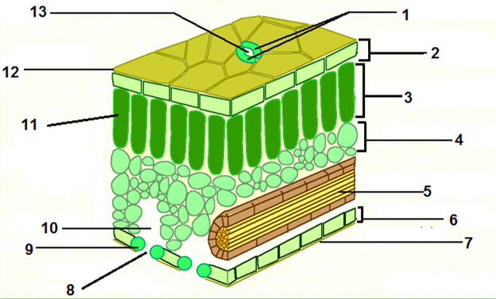
- Identify the parts labelled 2, 3, 4, and 9 in the diagram. (4 marks

- State the primary function of part 3 in relation to photosynthesis. (2 marks

- What is the role of veins in the leaf in supporting photosynthesis? (3 marks)

- During a biology lesson, a student is observing a fresh green leaf.

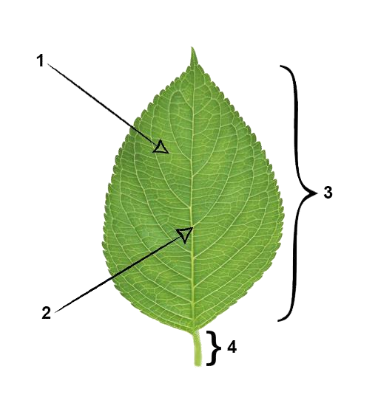

- What is the name of the part labelled1,2,3$ 4? (4mrks)
1. 3.
2. 4.

- Give the importance of part labelled 3 and 4 (2 marks)
Part 3

Part 4

