TERM 3 HOLIDAY ASSIGNMENT 2026
FORM THREE
PHYSICS PAPER 2 (232/2)
Section / Question | Maximum Score | Candidate's Score
A: 1–9 | 25
B: 10 | 6
B: 11 | 10
B: 12 | 12
B: 13 | 11
B: 14 | 16
TOTAL | 80

SECTION A (25 MARKS)
1. State two characteristics of an image formed by a plane mirror. (2 marks)
________________________________________________________________________________
________________________________________________________________________________
2. An object 30 m tall is placed 10 m from a pinhole camera. If the image is formed 7.5 cm from the pinhole, calculate the height of the image. (3 marks)
________________________________________________________________________________
________________________________________________________________________________
________________________________________________________________________________
3. State three factors that affect the speed of sound in air. (3 marks)
________________________________________________________________________________
________________________________________________________________________________
________________________________________________________________________________
4. A mark at the bottom of a jar containing glycerine appears to be 15.0 cm below the surface. Calculate the real depth of the mark if the refractive index of glycerine is 1.50. (3 marks)
________________________________________________________________________________
________________________________________________________________________________
________________________________________________________________________________
5. State the law of electrostatics. (1 marks)
________________________________________________________________________________
6. A sound is produced at a point and an echo is heard at the same point 0.72 s later. Determine the distance between the reflecting barrier and the source if the speed of sound in air is 340 m/s. (3 marks)
________________________________________________________________________________
________________________________________________________________________________
________________________________________________________________________________
7. (i) Sketch rays to show the image formed by the object in the figure above. (2 marks)
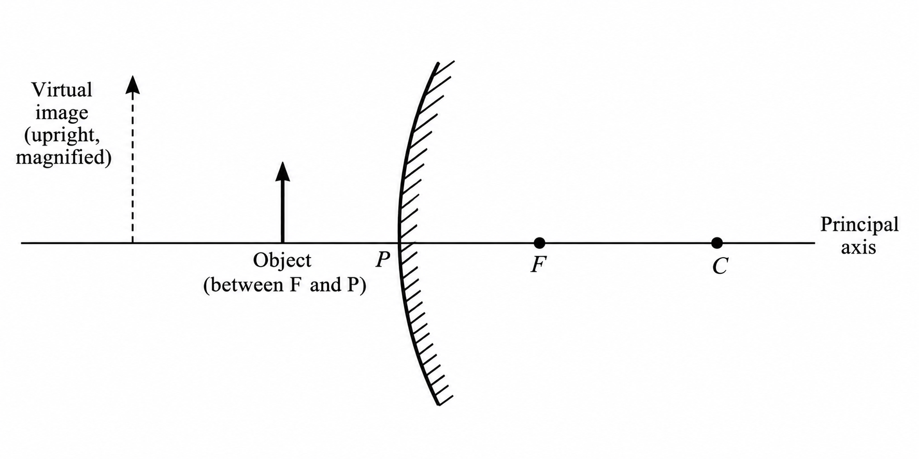
(ii) State two characteristics of the image formed in (i) above. (2 marks)
________________________________________________________________________________
________________________________________________________________________________
8. State two defects of a simple cell and state one way of minimizing each defect. (3 marks)
________________________________________________________________________________
________________________________________________________________________________
________________________________________________________________________________
9. A radio station broadcasts on a wavelength of 1.2 km. Determine its frequency if the velocity of radio waves is 3.0 × 10⁸ m/s. (3 marks)
________________________________________________________________________________
________________________________________________________________________________
________________________________________________________________________________

SECTION B (55 MARKS)
Answer ALL the questions in this section.
10. (a) State two ways of charging a gold-leaf electroscope. (2 marks)
________________________________________________________________________________
________________________________________________________________________________
(b) The figure shows two identical electroscopes. The electroscope on the right is positively charged while the one on the left is uncharged. Show, using a sketch, the charge distribution after the two caps are connected by a thin conducting wire. (2 marks)
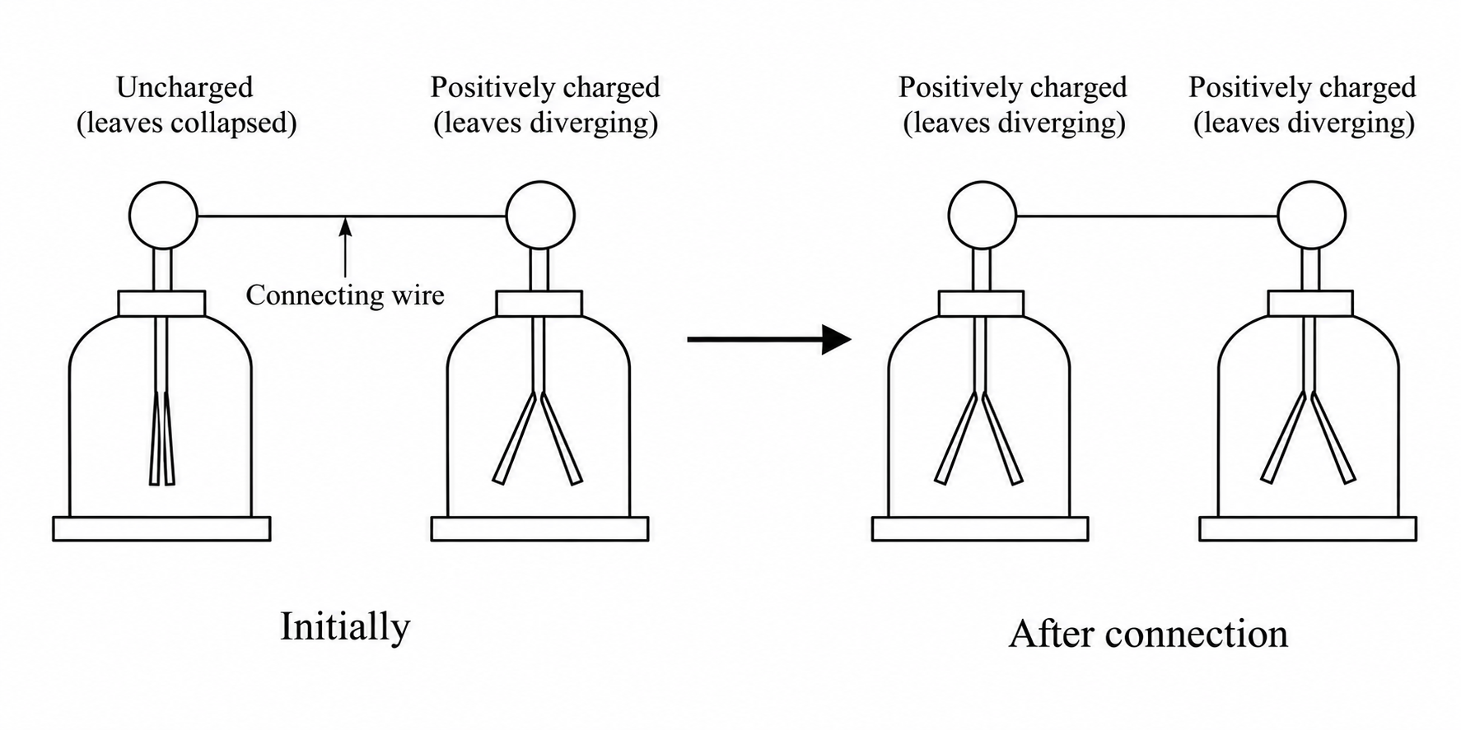
________________________________________________________________________________
________________________________________________________________________________
________________________________________________________________________________
________________________________________________________________________________
________________________________________________________________________________
________________________________________________________________________________
________________________________________________________________________________
________________________________________________________________________________
(c) Give two uses of a gold-leaf electroscope. (2 marks)
________________________________________________________________________________
________________________________________________________________________________
11. (a) State Snell's law of refraction. (1 marks)
________________________________________________________________________________
(b) State two necessary and sufficient conditions for total internal reflection to occur. (2 marks)
________________________________________________________________________________
________________________________________________________________________________
(c) The figure below shows white light incident on a raindrop.
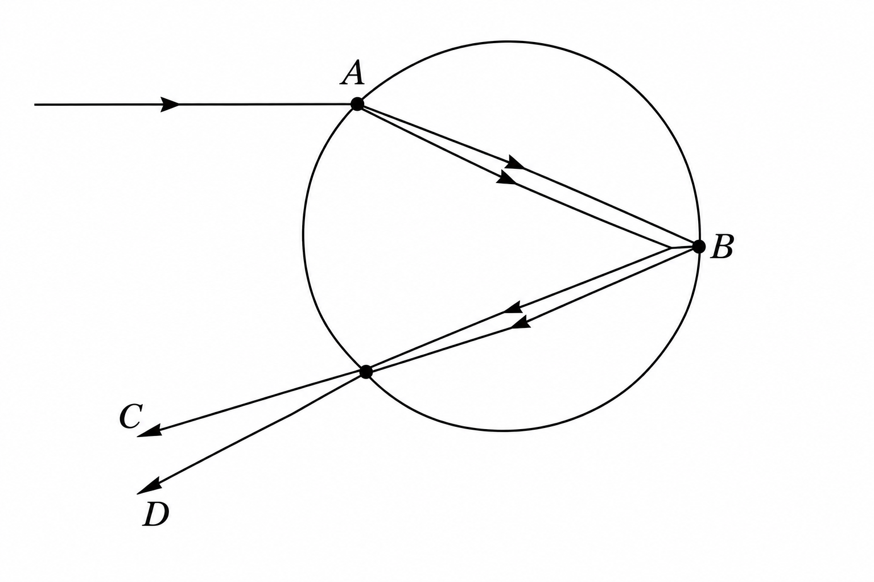
(i) State what happens at A and B. (2 marks)
________________________________________________________________________________
________________________________________________________________________________
(ii) State the colours represented by rays C and D. (2 marks)
________________________________________________________________________________
________________________________________________________________________________
(d) A ray of light travels inside a rectangular Perspex block and strikes the upper surface at an angle of 42° to the normal. The refracted ray travels along the surface. Calculate the refractive index of the Perspex. (3 marks)
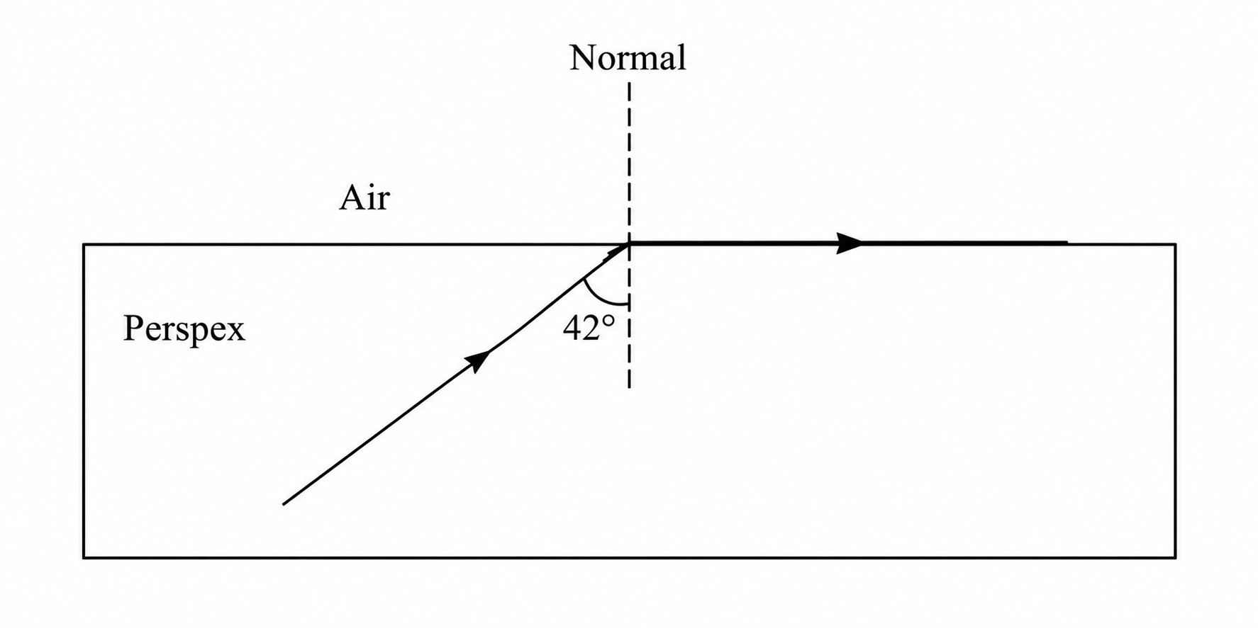
________________________________________________________________________________
________________________________________________________________________________
________________________________________________________________________________
12. (a) Draw the magnetic field pattern between two north poles. (2 marks)
________________________________________________________________________________
________________________________________________________________________________
________________________________________________________________________________
________________________________________________________________________________
________________________________________________________________________________
________________________________________________________________________________
________________________________________________________________________________
(b) Using domain theory, explain why it is not possible to magnetize a magnetic material beyond a certain limit. (2 marks)
________________________________________________________________________________
________________________________________________________________________________
________________________________________________________________________________
(c) The figure shows an electromagnet connected to a battery.
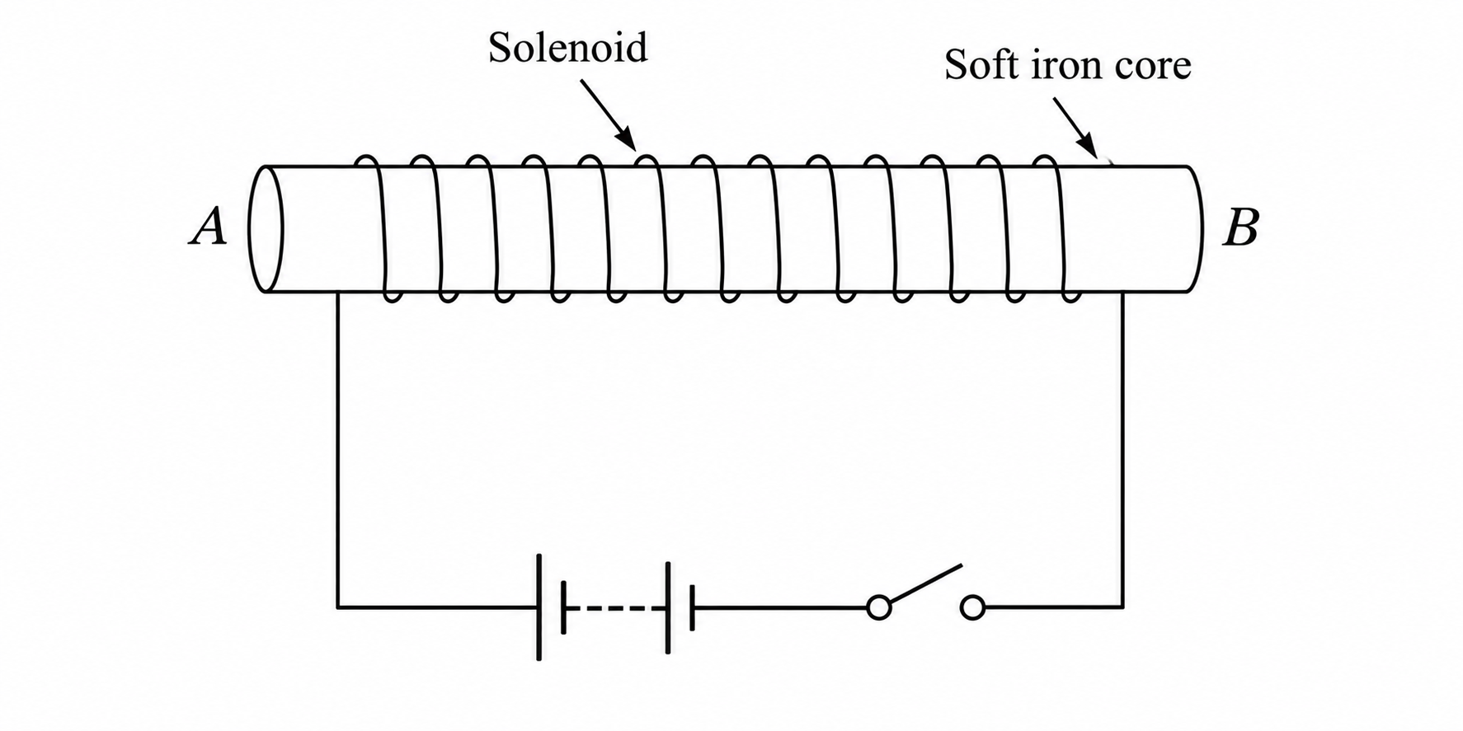
(i) On the same diagram, indicate the direction of conventional current flow when the switch is closed. (1 marks)
________________________________________________________________________________
________________________________________________________________________________
(ii) State the polarities of A and B. (2 marks)
________________________________________________________________________________
________________________________________________________________________________
(iii) State three ways of increasing the strength of the electromagnet. (3 marks)
________________________________________________________________________________
________________________________________________________________________________
________________________________________________________________________________
(iv) State two uses of electromagnets. (2 marks)
________________________________________________________________________________
________________________________________________________________________________
13. (a) Define the following terms:
(i) Amplitude. (1 marks)
________________________________________________________________________________
(ii) Frequency. (1 marks)
________________________________________________________________________________
(b) Distinguish between electromagnetic and mechanical waves and give one example of each. (3 marks)
________________________________________________________________________________
________________________________________________________________________________
________________________________________________________________________________
(c) The wave shown has a velocity of 240 m/s.
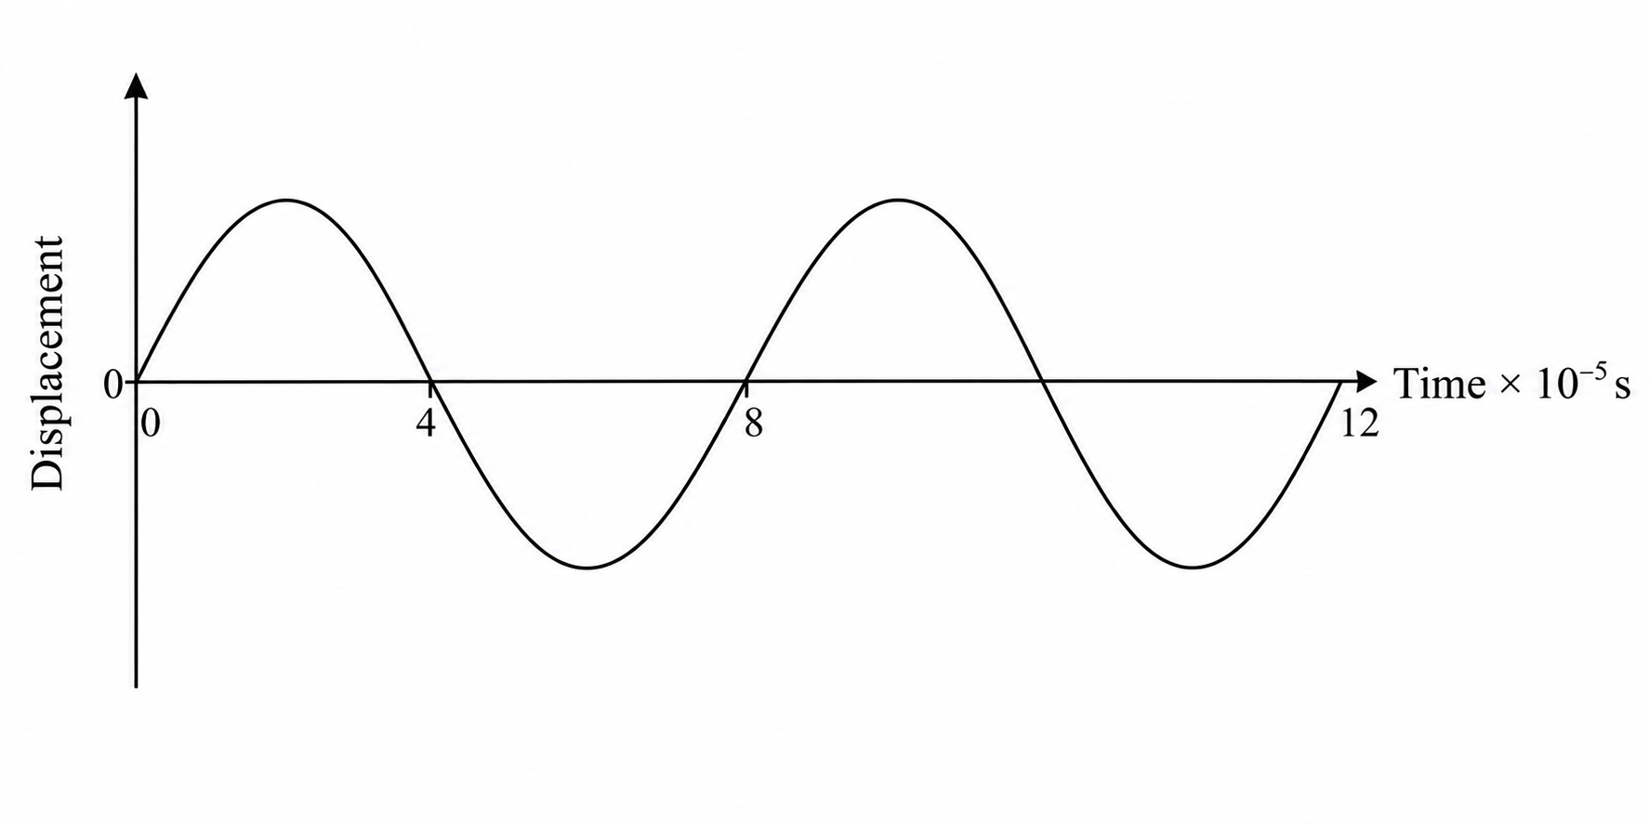
Determine:
(i) the period of the wave. (1 marks)
________________________________________________________________________________
(ii) the frequency of the wave. (2 marks)
________________________________________________________________________________
________________________________________________________________________________
(iii) the wavelength of the wave. (3 marks)
________________________________________________________________________________
________________________________________________________________________________
________________________________________________________________________________
14. (a) State Ohm's law. (1 marks)
________________________________________________________________________________
(b) Differentiate between potential difference (p.d.) and electromotive force (e.m.f.). (2 marks)
________________________________________________________________________________
________________________________________________________________________________
(c) A cell drives a current of 2.0 A through a 0.8 Ω resistor. When the same cell is connected to a 1.2 Ω resistor, the current is 1.5 A. Find:
(i) the internal resistance of the cell. (3 marks)
________________________________________________________________________________
________________________________________________________________________________
________________________________________________________________________________
(ii) the electromotive force of the cell. (1 marks)
________________________________________________________________________________
________________________________________________________________________________
(d) State two factors that affect the resistance of a metallic conductor. (2 marks)
________________________________________________________________________________
________________________________________________________________________________
(e) From the figure determine:
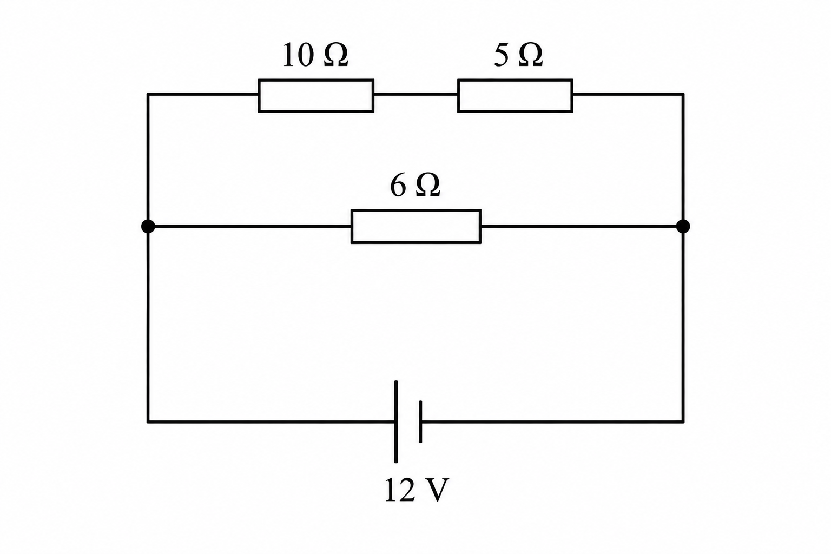
(i) the total resistance. (3 marks)
________________________________________________________________________________
________________________________________________________________________________
________________________________________________________________________________
(ii) the total current. (2 marks)
________________________________________________________________________________
________________________________________________________________________________
(iii) the voltage across the 6 Ω resistor. (2 marks)
________________________________________________________________________________
________________________________________________________________________________

