TERM 3 HOLIDAY ASSIGNMENT 2026
FORM THREE
BIOLOGY PAPER 1
Section | Question Numbers | Maximum Score | Candidate's Score
Paper 1 | 1 – 25 | 50 Marks*
TOTAL |  | 50 Marks*

1. Give the structure of the cell that performs each of the following functions:
a) Synthesis of ribosomes. (1 mark)
________________________________________________________________________________
b) Regulates exchange of substances in and out of the nucleus. (1 mark)
________________________________________________________________________________
c) Breaks down large molecules and destroys worn-out organelles. (1 mark)
________________________________________________________________________________
2. Give the meaning of the following terms as used in ecology:
i) Synecology. (1 mark)
________________________________________________________________________________
ii) Carrying capacity. (1 mark)
________________________________________________________________________________
iii) Population. (1 mark)
________________________________________________________________________________
3. The apparatus below was set up by students to investigate a reaction involving hydrogen peroxide and catalase. Study it and answer the questions.
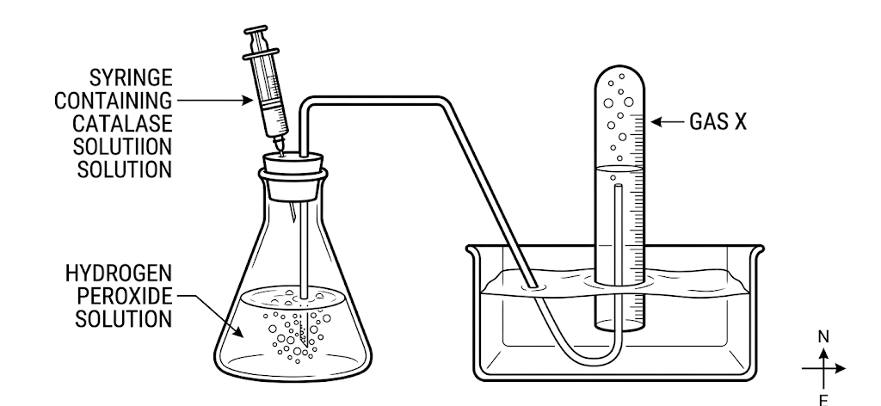
a) Name gas X. (1 mark)
________________________________________________________________________________
b) Write a word equation for the reaction which produces the gas. (1 mark)
________________________________________________________________________________
c) Where in the human body does this type of reaction occur? (1 mark)
________________________________________________________________________________
4. Study the cell-division diagrams below and answer the questions that follow.
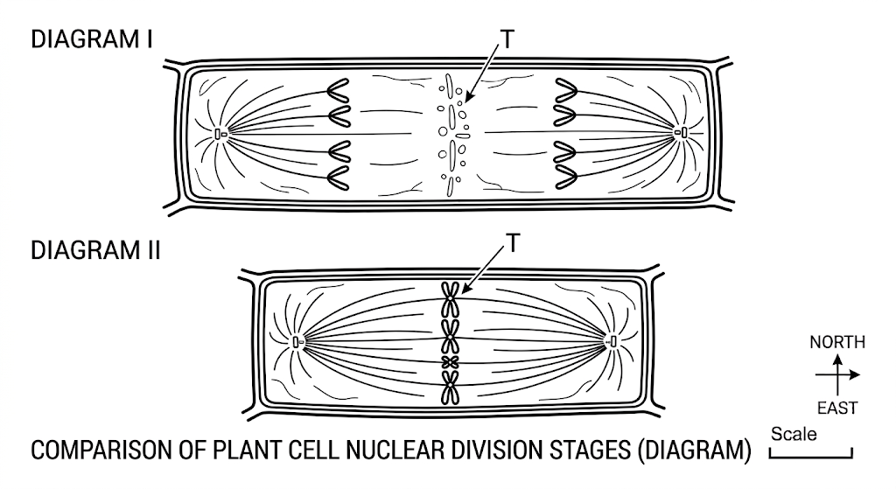
i) Identify the phase of cell division represented by Diagram II. (1 mark)
________________________________________________________________________________
ii) Name the structure labelled T. (1 mark)
________________________________________________________________________________
iii) Identify, with a reason, why the cell shown is not an animal cell. (2 marks)
________________________________________________________________________________
________________________________________________________________________________
5. Explain the significance of each of the following:
i) Cardiac muscle is myogenic. (1 mark)
________________________________________________________________________________
ii) The left ventricle of a mammalian heart is more muscular than the right ventricle. (1 mark)
________________________________________________________________________________
iii) Most carbon(IV) oxide is not transported simply dissolved in blood plasma. (1 mark)
________________________________________________________________________________
6. Give ONE function of centrioles. (1 mark)
b) Name a kingdom in which all members lack centrioles in their cells. (1 mark)
________________________________________________________________________________
7. Study the flow chart below which represents a physiological process in mammals and answer the questions.
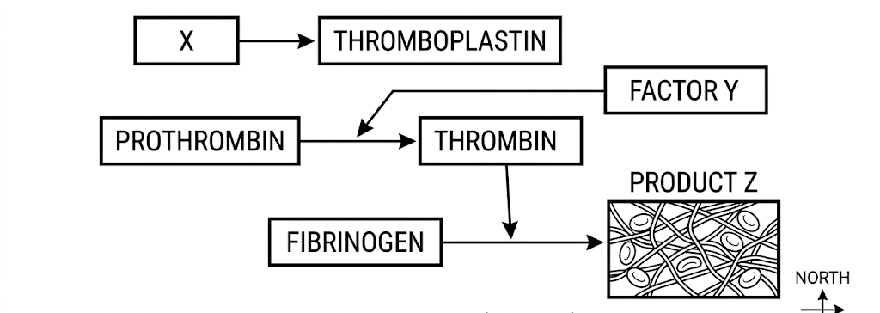
i) Name the blood component represented by X. (1 mark)
________________________________________________________________________________
ii) What is the significance of the product represented by Z? (2 marks)
________________________________________________________________________________
________________________________________________________________________________
iii) Under what condition is thrombokinase released by platelets? (1 mark)
________________________________________________________________________________
8. The figure below represents a plant. Study it and answer the questions.
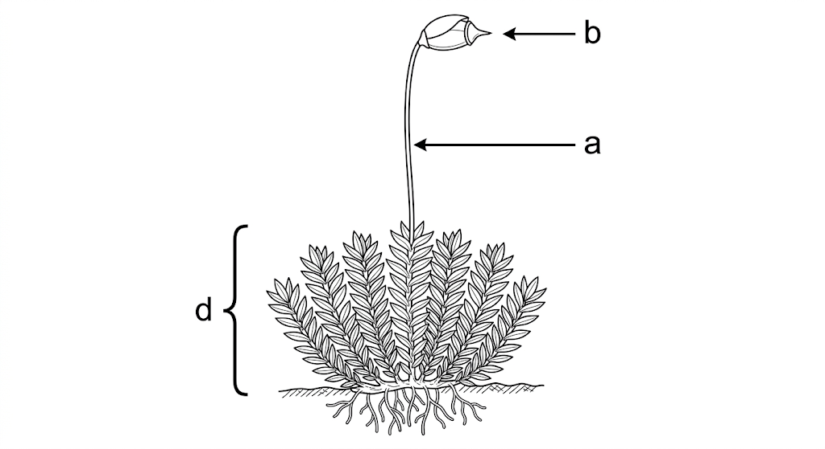
a) State the division to which the plant belongs. (1 mark)
________________________________________________________________________________
b) Label the parts marked a and b. (2 marks)
________________________________________________________________________________
________________________________________________________________________________
c) State the role of part d in the life cycle of the organism. (1 mark)
________________________________________________________________________________
9. The diagram below represents a specialized cell found in the human body. Study it and answer the questions.
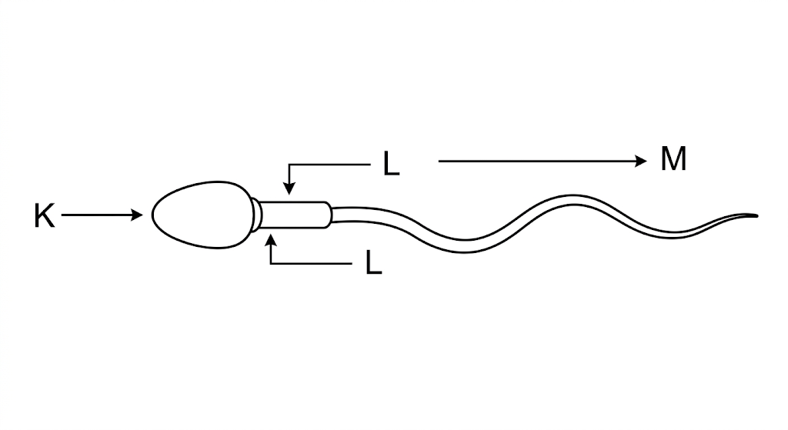
a) Identify the cell. (1 mark)
________________________________________________________________________________
b) Name the parts labelled K and L. (2 marks)
________________________________________________________________________________
________________________________________________________________________________
c) What is the function of part M? (1 mark)
________________________________________________________________________________
10. The diagram below represents the dental formula of an organism. Study it and answer the questions.
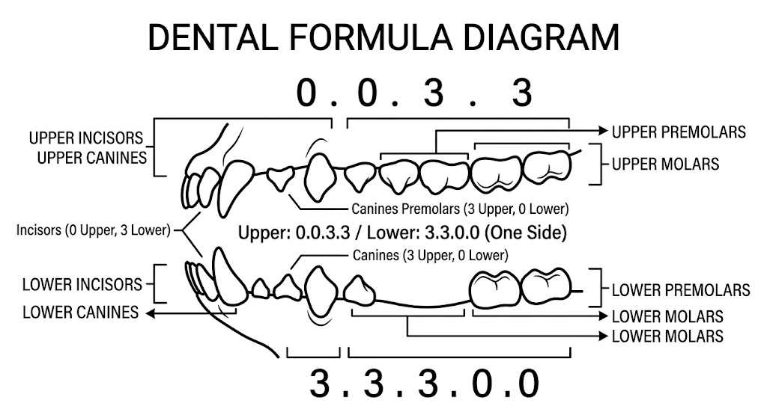
i) Calculate the total number of teeth in the jaw of the animal. (1 mark)
________________________________________________________________________________
ii) With a reason, identify the type of dentition represented. (2 marks)
________________________________________________________________________________
________________________________________________________________________________
11. a) Name the organism that:
i) Causes malaria. (1 mark)
________________________________________________________________________________
ii) Transmits malaria. (1 mark)
________________________________________________________________________________
b) State two control measures for malaria. (2 marks)
________________________________________________________________________________
________________________________________________________________________________
12. The table below shows three enzymes A, B and C and their respective optimum pH.
Enzyme | Optimum pH
A | 6.8
B | 2.0
C | 8.0

a) i) Name the most likely region of the alimentary canal of a mammal where enzyme B would be found. (1 mark)
________________________________________________________________________________
ii) Give a reason for your answer. (2 marks)
________________________________________________________________________________
________________________________________________________________________________
13. a)
i) Name the respiratory surface in insects. (1 mark)
________________________________________________________________________________
ii) Name any one feature that adapts the structure named in (i) to its function. (1 mark)
________________________________________________________________________________
iii) Why does the blood of insects lack haemoglobin? (1 mark)
________________________________________________________________________________
b) Why do fish have gills that are highly vascularized? (1 mark)
________________________________________________________________________________
14. The diagram below represents a fern. Study it and answer the questions.
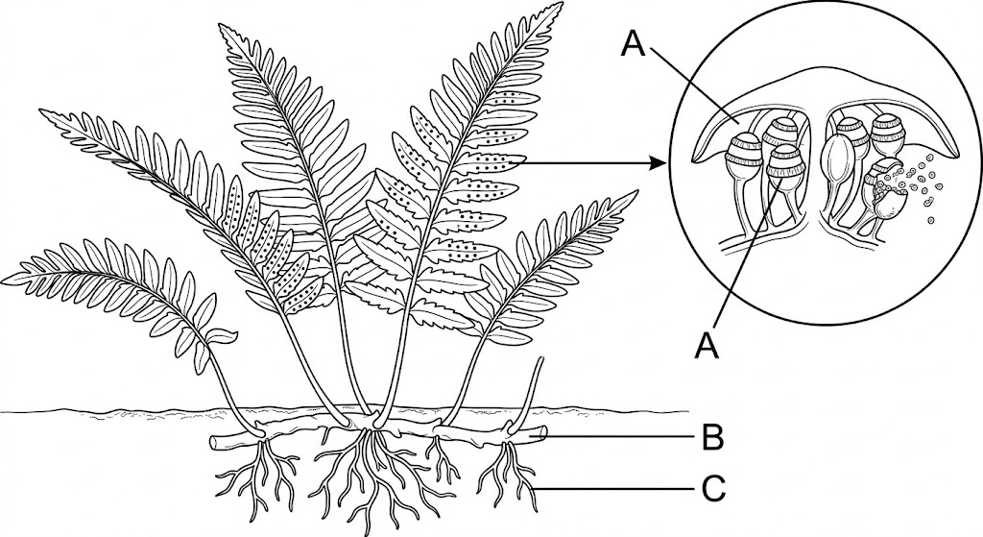
a) Name parts labelled A, B and C. (3 marks)
________________________________________________________________________________
________________________________________________________________________________
________________________________________________________________________________
b) To which division does the plant belong? (1 mark)
________________________________________________________________________________
15. State two ways in which Schistosoma species are adapted to a parasitic mode of life. (2 marks)
________________________________________________________________________________
________________________________________________________________________________
16. The diagram below represents a transverse section of a plant organ. Study it and answer the questions.
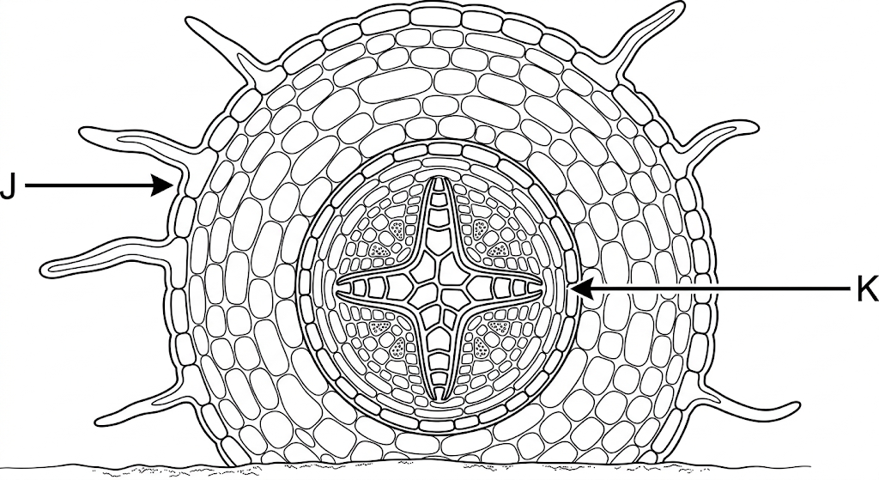
a) From which plant organ was the section obtained? (1 mark)
________________________________________________________________________________
b) Give two reasons for your answer. (2 marks)
________________________________________________________________________________
________________________________________________________________________________
17. To estimate the population size of mosquitoes in a village, researchers caught 500 mosquitoes, marked and released them. After 24 hours, 250 mosquitoes were caught, of which 50 had the mark.
a) Estimate the population size of the mosquitoes in the village. Show your working. (3 marks)
________________________________________________________________________________
________________________________________________________________________________
________________________________________________________________________________
________________________________________________________________________________
b) State three assumptions made by the researchers when using this method. (3 marks)
________________________________________________________________________________
________________________________________________________________________________
________________________________________________________________________________
18. a) Name the bacterium found in the root nodules of leguminous plants. (1 mark)
b) What relationship is shown by the bacterium and the leguminous plant? (1 mark)
________________________________________________________________________________
19. Explain how each of the following mechanisms hinders self-pollination:
a) Protandry. (1 mark)
________________________________________________________________________________
b) Heterostyly. (1 mark)
________________________________________________________________________________
20. State three roles of osmosis in plant nutrition. (3 marks)
________________________________________________________________________________
________________________________________________________________________________
________________________________________________________________________________
21. Name the carbohydrate that is:
a) Found in abundance in mammalian blood. (1 mark)
________________________________________________________________________________
b) Stored in a mammalian liver. (1 mark)
________________________________________________________________________________
22. Liver damage can lead to impaired digestion of fats. Explain. (2 marks)
________________________________________________________________________________
________________________________________________________________________________
23. An individual belongs to blood group B+.
a) Name the antigens present in the individual's blood group. (2 marks)
________________________________________________________________________________
________________________________________________________________________________
b) Give the reason why this individual cannot receive blood from a blood group A donor. (2 marks)
________________________________________________________________________________
________________________________________________________________________________
24. a) Define the term eutrophication. (1 mark)
b) List two effects of eutrophication in an aquatic ecosystem. (2 marks)
________________________________________________________________________________
________________________________________________________________________________
25. What is the significance of each of the following in gaseous exchange in mammals?
a) Cartilage in the trachea. (1 mark)
________________________________________________________________________________
b) Moisture on the surface of alveoli. (1 mark)
________________________________________________________________________________
c) Mucus on the inner surface of the trachea. (1 mark)
________________________________________________________________________________

