COMPETENCY BASED EDUCATION

JUNIOR SCHOOL EDUCATION ASSESSMENT

NOVEMBER-DECEMBER ASSIGNMENT 2026
GRADE 8 – AGRICULTURE
Time: 2 Hours
LEARNER’S DETAILS
Name: ________________________________________________. School: ________________________________________.
Assessment Number: _________________________________. Date: __________________________________________.
School Code: _______________________________________. Signature: ______________________________________.

INSTRUCTIONS TO CANDIDATES
- Write your name in the spaces provided above.
- Write the name of your school and your stream in the spaces provided.
- Write your admission number and the date of the assessment in the spaces provided.
- This paper consists of two sections: A and B.
- Answer all questions in section A and section B.
- Answer the questions in English.
- All answers MUST be written in the spaces provided in the paper.
- Do NOT remove any page from this question paper.

FOR OFFICIAL USE ONLY (EXAMINER’S USE)
SECTION | SECTION A | SECTION B | % SCORE | EE1 | EE2 | ME1 | ME2 | AE1 | AE2 | BE1 | BE2
SCORE RANGE | 30 MARKS | 50 MARKS |  | 90-100 | 75-89 | 58-74 | 41-57 | 31-40 | 21-30 | 11-20 | 1-10
POINTS |  |  |  | 8 POINTS | 7 POINTS | 6 POINTS | 5 POINTS | 4 POINTS | 3 POINTS | 2 POINTS | 1 POINT
LEARNER’S TOTAL SCORE

SECTION A (30 MARKS)
Answer ALL questions in this section.
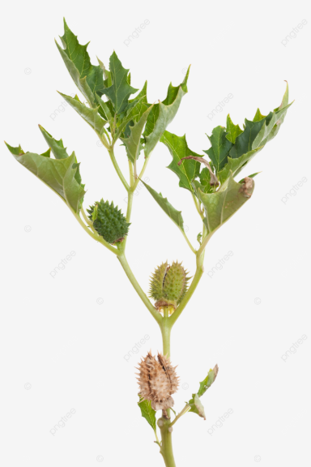
- During a field excursion, a grade 8 learner came across a weed shown below growing in vegetable field.

  - Identify the weed. _______________________________________ (1 mk)

  - Give four methods of controlling the weed above. (2 mks)

- ___________________________________________________________________________________
- ___________________________________________________________________________________
- ___________________________________________________________________________________
- ___________________________________________________________________________________
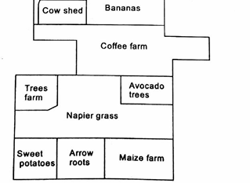
- Grade 8 learners were guided by their Agriculture and Nutrition teacher to model a plan shown below.

  - What name is given to this type of plan? (1 mk)
______________________________

  - State two benefits of this plan to a farmer. (2 mks)

- ___________________________________________________________________________________
- ___________________________________________________________________________________
- ___________________________________________________________________________________
- ___________________________________________________________________________________
  - Give three materials the learners used to model the plan above. (3 mks)
- ___________________________________________________________________________________
- ___________________________________________________________________________________
- ___________________________________________________________________________________
- ___________________________________________________________________________________

- Wafula is a farmer who comes from a county with little rain. He decides to construct the structure below to enable him collect the surface runoff from the little rains in the county.

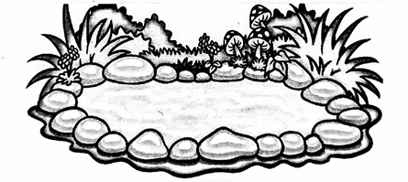

  - Identify the structure shown above. _________________________________(1 mk)

  - Explain why polythene lining was used in the construction. (2 mks)

________________________________________________________________________________________________________________________________________________________________________________________

- During a class discussion, a teacher guided learners on the role of kitchen garden in food and nutrition security. Highlight four roles kitchen gardens play in Kenya. (4 mks)
- ___________________________________________________________________________________
- ___________________________________________________________________________________
- ___________________________________________________________________________________
- ___________________________________________________________________________________

- During a practical lesson, learners were guided on preparation and cooking of a poultry carcass.

The following practices were carried out during the preparations;

- Singeing
- Defeathering
- Beheading
- Washing

Give the correct order of these activities. (4 mks)

- ___________________________________________________________________________________
- ___________________________________________________________________________________
- ___________________________________________________________________________________
- ___________________________________________________________________________________

- During a field trip, learners saw a farmer heaping soil at the base of his crops.

  - What name is given to this crop management practice? (1 mark)
________________________________________

  - Name three crops learners are likely to have seen on this farm. (3 mks)

- ___________________________________________________________________________________
- ___________________________________________________________________________________
- ___________________________________________________________________________________
  - Give two benefit of this practice to the crops. (2 mks)

- ___________________________________________________________________________________
- ___________________________________________________________________________________
- Mr. Mweusi asked his learners to use their digital devices to search for information on advantages of grilling food and share their findings with their peers during presentation. Give four advantages of grilling food the learners shared with their peers. (4 marks)
- ___________________________________________________________________________________
- ___________________________________________________________________________________
- ___________________________________________________________________________________
- ___________________________________________________________________________________
- Grade 8 learners want to choose an appropriate seam to help them in a certain clothing construction. Highlight four factors they should consider when choosing the appropriate seam. (4 marks)
- ___________________________________________________________________________________
- ___________________________________________________________________________________
- ___________________________________________________________________________________
- ___________________________________________________________________________________
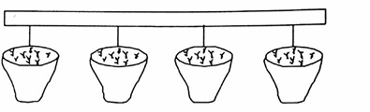
- A group of learners constructed a framed suspended structure and used it to establish some crops as shown in the picture below.

  - Mention four factors the learners considered before constructing the above structure. (4 mks)
- ___________________________________________________________________________________
- ___________________________________________________________________________________
- ___________________________________________________________________________________
- ___________________________________________________________________________________
  - Name three crops the learners planted in the structure. (3 mks)
- ___________________________________________________________________________________
- ___________________________________________________________________________________
- ___________________________________________________________________________________
- During a class practical, learners cooked food using the method shown below.



  - Give three examples of vegetables which can be prepared using the above method. (3 mks)
- ___________________________________________________________________________________
- ___________________________________________________________________________________
- ___________________________________________________________________________________
- ___________________________________________________________________________________
  - State four reasons for cooking food in question 10(a) above using this method. (4 mks)

- ___________________________________________________________________________________
- ___________________________________________________________________________________
- ___________________________________________________________________________________
- ___________________________________________________________________________________

  - Give two equipment's the learners used. (2 mks)

- ___________________________________________________________________________________
- ___________________________________________________________________________________

Answers

- a. Thorn apple
b
  - Tilling (digging)
  - Slashing
  - Uprooting
  - Mulching

- a. Farm layout b.
  - Land is maximumly used.
  - It is easy to locate various farm activities.
  - Farm enterprises are organized.

c,

- Cartons
- Cardboards
- Soil
- papier mache

  - The type of materials required for construction
  - Availability of water

b. Vegetables, fruits such as strawberry, herbs

- a. Cabbages, broccoli, green beans, kales, cauliflower b.

  - No oil is required
  - Preserves the nutrients
  - Quick and inexpensive
  - Reduces smells of some food
  - Produces light dishes

c.

- Microwave steamers
- Electric combinations ovens
- Convection steamers-answer
- Sandwich and tortilla steamers
- Steam generators

- a. Water pond

b. To minimize underground seepage

- 1. Produce safe, fresh and excessive, food to the family
- Increases food production
- Ensures a steady supply of nutritious food
- It is a reliable source of green leafy vegetables, herbs and fruits
- It generates income from sale of surplus feed
- It saves family income
- 1. Beheading
- Defeathering
- Singeing
- Washing

- a. Earthing up b.
  - Cassava
  - Irish potatoes
  - Onions
  - Sweet potatoes

c.

- Provides enough space for the crops to increase in size
- Conserves moisture for the crops.
- Provides enough support needed by crops.
- 1. Less fat
- Preserves nutrients
- It is quick
- Outdoor life
- No indoor smells or heat
- Versatile
- No special skills required
- Flavorsome food
- 1. Type of garment
- Type of fabric
- Position of seam on the garment
- The effect desired

- a.

  - The shape the garden will take
  - The space available for the garden
  - The site where the garden is to be constructed
  - The type of plants to be grown in the framed structure

