

KENYA CERTIFICATE OF BASIC EDUCATION

SENIOR SCHOOL ASSESSMENT

DECEMBER ACTIVITIES 2026
GRADE 10 – AGRICULTURE
Time: 2 Hours
LEARNER’S DETAILS
Name: ________________________________________________. School: ________________________________________.
Assessment Number: _________________________________. Date: __________________________________________.
School Code: _______________________________________. Signature: ______________________________________.

INSTRUCTIONS TO CANDIDATES
- Write your name in the spaces provided above.
- Write the name of your school and your stream in the spaces provided.
- Write your admission number and the date of the assessment in the spaces provided.
- This paper consists of two sections: A and B.
- Answer all questions in section A and section B.
- Answer the questions in English.
- All answers MUST be written in the spaces provided in the paper.
- Do NOT remove any page from this question paper.

FOR OFFICIAL USE ONLY (EXAMINER’S USE)
SECTION | SECTION A | SECTION B | % SCORE | EE1 | EE2 | ME1 | ME2 | AE1 | AE2 | BE1 | BE2
SCORE RANGE | 30 MARKS | 50 MARKS |  | 90-100 | 75-89 | 58-74 | 41-57 | 31-40 | 21-30 | 11-20 | 1-10
POINTS |  |  |  | 8 POINTS | 7 POINTS | 6 POINTS | 5 POINTS | 4 POINTS | 3 POINTS | 2 POINTS | 1 POINT
LEARNER’S TOTAL SCORE

SECTION A (30 MARKS)
Answer ALL questions in this section.
1. A farmer wants to establish a crop farm on newly acquired land. State two factors that should be considered when selecting the land. (2 marks)
- ____________________________________________________________________________________
- ____________________________________________________________________________________
2. Differentiate between soil fertility and soil productivity. (2 marks)
________________________________________________________________________________________________________________________________________________________________________________________________________________________________________________________________________________________________

3. State two characteristics of a fertile agricultural soil. (2 marks)
- ____________________________________________________________________________________
- ____________________________________________________________________________________
4. During land preparation, a farmer uses a mouldboard plough followed by a harrow.
a) State the main purpose of ploughing. (1 mark) ________________________________________________________________________________________________ b) State the purpose of harrowing. (1 mark) ________________________________________________________________________________________________
5. Give three reasons why planting materials should be of good quality. (3 marks)
- ____________________________________________________________________________________
- ____________________________________________________________________________________
- ____________________________________________________________________________________
6. A farmer planted maize seeds at a very shallow depth.
State two problems that may result from shallow planting. (2 marks)
- ____________________________________________________________________________________
- ____________________________________________________________________________________
7. State three factors that influence the choice of a method of weed control. (3 marks)
- ____________________________________________________________________________________
- ____________________________________________________________________________________
- ____________________________________________________________________________________
8. Give two reasons why farmers practise crop rotation. (2 marks)
- ____________________________________________________________________________________
- ____________________________________________________________________________________
9. A farmer notices that some maize leaves are being eaten by caterpillars.
a) Identify the likely category of organism causing the damage. (1 mark)
_____________________________________________________________________________________________
b) State one method of controlling such pests. (1 mark)
________________________________________________________________________________________________

10. State two benefits of mulching in crop production. (2 marks)
- ____________________________________________________________________________________
- ____________________________________________________________________________________
11. Give two signs that can be used to determine whether a crop is ready for harvesting. (2 marks)
- ____________________________________________________________________________________
- ____________________________________________________________________________________
12. State two characteristics of a good beef animal. (2 marks)
- ____________________________________________________________________________________
- ____________________________________________________________________________________
13. Give two reasons why livestock require a balanced diet. (2 marks)
- ____________________________________________________________________________________
- ____________________________________________________________________________________
14. State two factors that should be considered when selecting livestock housing. (2 marks)
- ____________________________________________________________________________________
- ____________________________________________________________________________________
15. A farmer keeps poultry for commercial purposes. State one record that should be maintained in the poultry enterprise and give one reason for keeping it. (2 marks)
________________________________________________________________________________________________________________________________________________________________________________________________

SECTION B: 50 MARKS

Answer ALL questions.

16.A farmer in a semi-arid area of Kenya intends to establish a horticultural farm. The farmer observes that the soil dries quickly and that rainfall is unreliable. During heavy rainfall, water also runs rapidly down the slope.

a) Explain four ways in which soil water is important to crop production. (4 marks)
- _______________________________________________________________________________________
- _______________________________________________________________________________________
- _______________________________________________________________________________________
- _______________________________________________________________________________________

b) Describe three methods that the farmer can use to conserve soil moisture. (3 marks)
- ____________________________________________________________________________________
- ____________________________________________________________________________________
- ____________________________________________________________________________________

c) Explain three measures that can be used to reduce soil erosion on the farm. (3 marks)
- ____________________________________________________________________________________
- ____________________________________________________________________________________
- ____________________________________________________________________________________

17. A farmer plans to grow Irish potatoes for the local market. Before planting, the farmer selects healthy planting materials, prepares the land and plans to carry out appropriate crop management practices.

a) Explain four factors that should be considered when selecting planting materials. (4 marks)
- ____________________________________________________________________________________
- ____________________________________________________________________________________
- ____________________________________________________________________________________
- ____________________________________________________________________________________

b) Describe three crop management practices that should be carried out after crop emergence. (3 marks)
- ____________________________________________________________________________________
- ____________________________________________________________________________________
- ____________________________________________________________________________________

c) State three factors that may influence the choice of an appropriate harvesting method. (3 marks)
- ____________________________________________________________________________________
- ____________________________________________________________________________________
- ____________________________________________________________________________________

18. A farmer keeps dairy goats. Recently, some goats have shown reduced appetite, weight loss and abnormal discharge. The farmer seeks advice from an agricultural extension officer.

a) State four signs that may indicate poor health in livestock. (4 marks)
- ____________________________________________________________________________________
- ____________________________________________________________________________________
- ____________________________________________________________________________________
- ____________________________________________________________________________________

b) Explain two practices that the farmer can use to prevent livestock diseases. (2 marks)
- ____________________________________________________________________________________
- ____________________________________________________________________________________

c) State two factors that should be considered when constructing livestock housing. (2 marks)
- ____________________________________________________________________________________
- ____________________________________________________________________________________

d) State two factors that should be considered when constructing livestock housing. (2 marks)
- ____________________________________________________________________________________
- ____________________________________________________________________________________
e) Study the pictures of the farm animals shown below and identify the breed of each animal. (3 marks)
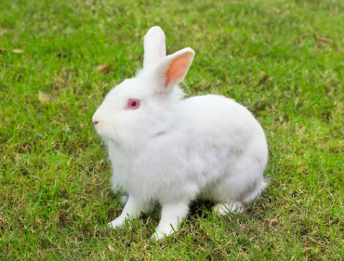
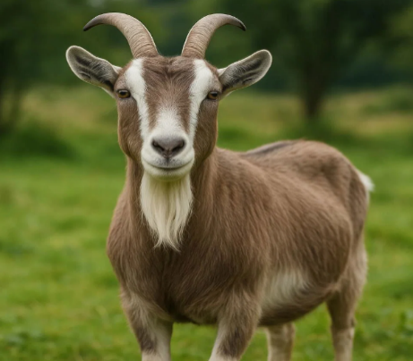
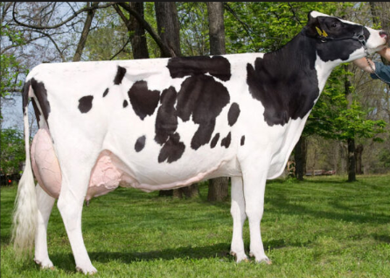

X Y Z
Animal |  | Breed type
Rabbit | X
Goat | Y
Cow | Z

19. During an Agriculture practical lesson, learners are given a wheelbarrow, watering can, rake, pruning saw and jembe. They are instructed to demonstrate their correct use and maintenance.

a) State the use of four of the tools listed above. (4 marks)
- ____________________________________________________________________________________
- ____________________________________________________________________________________
- ____________________________________________________________________________________
- ____________________________________________________________________________________

b) Explain three practices that can prolong the useful life of farm tools and equipment. (3 marks)
- ____________________________________________________________________________________
- ____________________________________________________________________________________
- ____________________________________________________________________________________

c) State three advantages of using appropriate agricultural technology in farming. (3 marks)
- ____________________________________________________________________________________
- ____________________________________________________________________________________
- ____________________________________________________________________________________

20. A Grade 10 Agriculture club establishes a tomato enterprise. The learners invest KSh 12,000 in seeds, fertilisers, pesticides, labour and transport. At the end of the season, they sell their tomatoes for KSh 20,000.

a) Calculate the profit made by the enterprise. (2 marks)

b) Explain three factors that could affect the profitability of the tomato enterprise. (3 marks)
- ____________________________________________________________________________________
- ____________________________________________________________________________________
- ____________________________________________________________________________________

c) Describe three ways through which the learners can add value to tomatoes before selling them. (3 marks)
- ____________________________________________________________________________________
- ____________________________________________________________________________________
- ____________________________________________________________________________________

d) State two qualities that the learners need to become successful agricultural entrepreneurs. (2 marks)
- ____________________________________________________________________________________
- ____________________________________________________________________________________

KENYA CERTIFICATE OF BASIC EDUCATION

SENIOR SCHOOL ASSESSMENT

DECEMBER ACTIVITIES 2026
GRADE 10 – AVIATION TECHNOLOGY
Time: 2 Hours
LEARNER’S DETAILS
Name: ________________________________________________. School: ________________________________________.
Assessment Number: _________________________________. Date: __________________________________________.
School Code: _______________________________________. Signature: ______________________________________.

INSTRUCTIONS TO CANDIDATES
- Write your name in the spaces provided above.
- Write the name of your school and your stream in the spaces provided.
- Write your admission number and the date of the assessment in the spaces provided.
- This paper consists of two sections: A and B.
- Answer all questions in section A and section B.
- Answer the questions in English.
- All answers MUST be written in the spaces provided in the paper.
- Do NOT remove any page from this question paper.

FOR OFFICIAL USE ONLY (EXAMINER’S USE)
SECTION | SECTION A | SECTION B | % SCORE | EE1 | EE2 | ME1 | ME2 | AE1 | AE2 | BE1 | BE2
SCORE RANGE | 30 MARKS | 50 MARKS |  | 90-100 | 75-89 | 58-74 | 41-57 | 31-40 | 21-30 | 11-20 | 1-10
POINTS |  |  |  | 8 POINTS | 7 POINTS | 6 POINTS | 5 POINTS | 4 POINTS | 3 POINTS | 2 POINTS | 1 POINT
LEARNER’S TOTAL SCORE

SECTION A (30 MARKS)
Answer ALL questions in this section.
1. Define the term aviation technology. (2 marks)
______________________________________________________________________________________________________________________________________________________________________________________
2. State two advantages of air transport over other forms of transport. (2 marks)
- ________________________________________________________________________________
- ________________________________________________________________________________
3. Give two examples of heavier-than-air aircraft. (2 marks)
- ________________________________________________________________________________
- ________________________________________________________________________________
4. State two characteristics of a good aviation professional. (2 marks)
- ________________________________________________________________________________
- ________________________________________________________________________________
5. Give two causes of accidents in an aviation workshop. (2 marks)
- ________________________________________________________________________________
- ________________________________________________________________________________
6. State two purposes of safety signs in an aviation workplace. (2 marks)
- ________________________________________________________________________________
- ________________________________________________________________________________
7. Name two types of personal protective equipment (PPE) used in an aviation workshop. (2 marks)
- ________________________________________________________________________________
- ________________________________________________________________________________
8. State two functions of the aircraft cockpit. (2 marks)
- ________________________________________________________________________________
- ________________________________________________________________________________
9. Name two primary flight control surfaces. (2 marks)
- ________________________________________________________________________________
- ________________________________________________________________________________
10. State two functions of the aircraft tail assembly. (2 marks)
- ________________________________________________________________________________
- ________________________________________________________________________________
11. Give two examples of materials used in aircraft construction. (2 marks)
- ________________________________________________________________________________
- ________________________________________________________________________________
12. State two factors considered when selecting materials for aircraft construction. (2 marks)
- ________________________________________________________________________________
- ________________________________________________________________________________
13. Name two tools used for cutting materials in an aviation workshop. (2 marks)
- ________________________________________________________________________________
- ________________________________________________________________________________
14. State two functions of an airport runway. (2 marks)
- ________________________________________________________________________________
- ________________________________________________________________________________
15. Give two services provided by an airport to passengers. (2 marks)
- ________________________________________________________________________________
- ________________________________________________________________________________

SECTION B: 50 MARKS

Answer ALL questions.

16. During a school Aviation Technology exhibition, learners displayed models representing different stages in the development of flight. The teacher asked them to explain how aviation progressed from simple flying machines to modern aircraft.
(a) State two early attempts at human flight before the development of modern aeroplanes. (2 marks)
- ________________________________________________________________________________
- ________________________________________________________________________________
(b) Name two pioneers associated with the development of powered flight. (2 marks)
- ________________________________________________________________________________
- ________________________________________________________________________________
(c) Explain three factors that contributed to the development of modern aviation technology. (3 marks)
- ________________________________________________________________________________
- ________________________________________________________________________________
(d) State three benefits of aviation to the Kenyan economy and society. (3 marks)
- ________________________________________________________________________________
- ________________________________________________________________________________
- ________________________________________________________________________________

17. During a practical lesson, Brian enters an aircraft workshop and observes a learner grinding metal without safety goggles. There are loose tools scattered around the workbench, and an electrical appliance has a damaged power cable.
(a) Identify three safety hazards in the workshop. (3 marks)
- ________________________________________________________________________________
- ________________________________________________________________________________
- ________________________________________________________________________________

(b) State one appropriate corrective measure for each hazard identified in (a). (3 marks)
__________________________________________________________________________________________________________________________________________________________________________________
(c) Explain two reasons why housekeeping is important in an aviation workshop. (2 marks)
- ________________________________________________________________________________
- ________________________________________________________________________________
(d) State two procedures to follow when using electrical equipment in an aviation workshop. (2 marks)
- ________________________________________________________________________________
- ________________________________________________________________________________

18. Aviation Technology learners are studying a conventional fixed-wing aircraft. Their teacher asks them to identify the major structural components and explain how the aircraft is controlled during flight.
(a) Name the aircraft component that:
(i) Contains the cockpit, passengers and cargo. ____________________________________ (1 mark)
(ii) Produces aerodynamic lift. ____________________________________ (1 mark)
(iii) Houses the rudder and elevators. ____________________________________ (1 mark)
(iv) Supports the aircraft when it is on the ground. ____________________________________ (1 mark)
(b) State the function of each of the following control surfaces:
(i) Aileron (2 marks)
______________________________________________________________________________________________________________________________________________________________________________________________
(ii) Elevator (2 marks)
______________________________________________________________________________________________________________________________________________________________________________________________
(iii) Rudder (2 marks)
______________________________________________________________________________________________________________________________________________________________________________________________

19. A school aviation club is making a model aircraft using aluminium sheets and other materials. The learners are instructed to measure, mark, cut and finish the materials accurately.
(a) State two properties that make aluminium suitable for aircraft construction. (2 marks)
- ________________________________________________________________________________
- ________________________________________________________________________________
(b) Differentiate between a measuring tool and a marking-out tool. (2 marks)
___________________________________________________________________________________________________________________________________________________________________________________________________________________________________________________________________________
(c) Give two examples of measuring tools used in aircraft construction. (2 marks)
- ________________________________________________________________________________
- ________________________________________________________________________________
(d) Give two examples of marking-out tools used in aircraft construction. (2 marks)
- ________________________________________________________________________________
- ________________________________________________________________________________
(e) State two reasons for using accurate dimensions in technical drawings. (2 marks)
- ________________________________________________________________________________
- ________________________________________________________________________________

20. A passenger aircraft is scheduled to depart from a Kenyan airport at 10:00 a.m. Before departure, the crew receives information concerning weather, runway conditions, air traffic and the aircraft's flight plan.
(a) State two pieces of information that a pilot may obtain before departure. (2 marks)
- ________________________________________________________________________________
- ________________________________________________________________________________
(b) Explain two ways in which wind affects aircraft operations. (4 marks)
- ________________________________________________________________________________
- ________________________________________________________________________________
(c) State two reasons why air traffic control is important at an airport. (2 marks)
- ________________________________________________________________________________
- ________________________________________________________________________________
(d) State two activities carried out during passenger handling at an airport. (2 marks)
- ________________________________________________________________________________
- ________________________________________________________________________________

KENYA CERTIFICATE OF BASIC EDUCATION

SENIOR SCHOOL ASSESSMENT

DECEMBER ACTIVITIES 2026
GRADE 10 – BIOLOGY
Time: 2 Hours
LEARNER’S DETAILS
Name: ________________________________________________. School: ________________________________________.
Assessment Number: _________________________________. Date: __________________________________________.
School Code: _______________________________________. Signature: ______________________________________.

INSTRUCTIONS TO CANDIDATES
- Write your name in the spaces provided above.
- Write the name of your school and your school code in the spaces provided.
- Write your assessment number and the date of the assessment and sign in the spaces provided.
- This paper consists of two sections: A and B.
- Answer all questions in section A and section B.
- Answer the questions in English.
- All answers MUST be written in the spaces provided in the paper.
- Do NOT remove any page from this question paper.

FOR OFFICIAL USE ONLY (EXAMINER’S USE)
SECTION | SECTION A | SECTION B | % SCORE | EE1 | EE2 | ME1 | ME2 | AE1 | AE2 | BE1 | BE2
SCORE RANGE | 30 MARKS | 50 MARKS |  | 90-100 | 75-89 | 58-74 | 41-57 | 31-40 | 21-30 | 11-20 | 1-10
POINTS |  |  |  | 8 POINTS | 7 POINTS | 6 POINTS | 5 POINTS | 4 POINTS | 3 POINTS | 2 POINTS | 1 POINT
LEARNER’S TOTAL SCORE

SECTION A (30 MARKS)
Answer ALL questions in this section.

1. A group of Grade 10 learners visited a forest to observe different organisms.
a) State one characteristic that all living organisms possess. (1 mark)
______________________________________________________________________________________________________________________________________________________________________________________________
b) Give two reasons why Biology learners study organisms in their natural habitats. (2 marks)
- ___________________________________________________________________________________
- ___________________________________________________________________________________

2. A learner accidentally left a prepared biological specimen exposed to high temperatures for several hours.
a) What is meant by preservation of a specimen? (1 mark)
______________________________________________________________________________________________________________________________________________________________________________________________
b) State one method of preserving a biological specimen. (1 mark)

____________________________________________________________________________________________

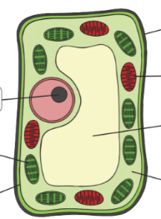
3. The diagram below represents a typical plant cell.
Q
R
S
T
W
X Y

a) Name the structure that controls the activities of the cell. (1 mark)
________________________________________________________
b) State one function of the cell wall. (1 mark)
______________________________________________________________________________________________________________________________________________________________________________________________
c) Name the organelle responsible for photosynthesis. (1 mark)
_____________________________________________________________________________________________

4. A student observed onion cells under a microscope.
a) Why was iodine solution added to the specimen? (1 mark)
______________________________________________________________________________________________________________________________________________________________________________________________
b) State one advantage of using a stain when observing cells. (1 mark)
______________________________________________________________________________________________________________________________________________________________________________________________

5. A learner tested a food sample using Benedict's solution and heated the mixture.
a) What food substance was being tested? (1 mark)
______________________________________________________________________________________________________________________________________________________________________________________________
b) State the colour change that indicates a positive result. (1 mark)
______________________________________________________________________________________________________________________________________________________________________________________________

6. A farmer watered a young maize plant adequately but kept it in complete darkness.
a) Explain why the plant could not manufacture enough food. (1 mark)
______________________________________________________________________________________________________________________________________________________________________________________________
b) Name the green pigment required for photosynthesis. (1 mark)
______________________________________________________________________________________________________________________________________________________________________________________________

7. Plants require mineral salts for healthy growth.
a) Name one mineral element required by plants. (1 mark)
______________________________________________________________________________________________________________________________________________________________________________________________
b) State one function of the mineral element named in (a). (1 mark)
______________________________________________________________________________________________________________________________________________________________________________________________

8. A learner noticed that water droplets disappeared from the surface of a leaf after several hours.
a) Name the process responsible for the loss of water vapour from leaves. (1 mark)
______________________________________________________________________________________________________________________________________________________________________________________________
b) Through which structures does most water vapour leave the leaf? (1 mark)
______________________________________________________________________________________________________________________________________________________________________________________________

9. During a football match, players breathe faster and their hearts beat more rapidly.
a) Why does the heartbeat increase during vigorous exercise? (1 mark)
______________________________________________________________________________________________________________________________________________________________________________________________
b) State one substance transported in the blood from the lungs to actively respiring muscles. (1 mark)
______________________________________________________________________________________________________________________________________________________________________________________________

10. A learner compared aerobic and anaerobic respiration.
a) Which type of respiration requires oxygen? (1 mark)
______________________________________________________________________________________________________________________________________________________________________________________________
b) State one product of anaerobic respiration in human muscles. (1 mark)
______________________________________________________________________________________

11. A balanced diet contains different nutrients in appropriate proportions.
a) Name two vitamins required by humans. (2 marks)
- ___________________________________________________________________________________
- ___________________________________________________________________________________
b) State one function of vitamins in the body. (1 mark)
______________________________________________________________________________________________________________________________________________________________________________________________

12. State three differences between diffusion and osmosis. (3 marks)
Diffusion | Osmosis

SECTION B: 50 MARKS
Answer all questions.

13. A Biology teacher gave learners a compound light microscope and a prepared slide containing plant cells.
a) Name the following microscope parts and state one function of each:
i. Eyepiece lens. (2 marks)
______________________________________________________________________________________________________________________________________________________________________________________________
ii. Objective lens. (2 marks)
______________________________________________________________________________________________________________________________________________________________________________________________b) Describe how a learner should obtain a clear image of a specimen using a light microscope. (3 marks)
____________________________________________________________________________________________________________________________________________________________________________________________________________________________________________________________________________________________________________________________________________________________________________________________c) State three precautions that should be observed when using a microscope. (3 marks)
- ___________________________________________________________________________________
- ___________________________________________________________________________________
- ___________________________________________________________________________________

14. Different cells in organisms have structures suited to their functions.
a) Explain the meaning of cell differentiation. (2 marks)
______________________________________________________________________________________________________________________________________________________________________________________________
b) State two adaptations of a red blood cell for transporting oxygen. (2 marks)
- ___________________________________________________________________________________
- ___________________________________________________________________________________
c) Explain how each of the following processes occurs:
i. Crenation. (2 marks)
____________________________________________________________________________________________________________________________________________________________________________________________________________________________________________________________________________________________________________________________________________________________________________________________
ii. Haemolysis. (2 marks)
____________________________________________________________________________________________________________________________________________________________________________________________________________________________________________________________________________________________________________________________________________________________________________________________
d) State two factors that affect the rate of diffusion. (2 marks)
- ___________________________________________________________________________________
- ___________________________________________________________________________________

15. A school canteen introduced a menu consisting of ugali, beans, vegetables, fruit and milk. The Biology teacher asked learners to identify the nutrients provided by the meal.
a) State the main function of each of the following nutrients:
i. Carbohydrates. (1 mark)
______________________________________________________________________________________________________________________________________________________________________________________________
ii. Proteins. (1 mark)
______________________________________________________________________________________________________________________________________________________________________________________________iii. Fats and oils. (1 mark)
______________________________________________________________________________________________________________________________________________________________________________________________
b) Explain why water is important in the human body. (2 marks)
________________________________________________________________________________________________________________________________________________________________________________________________________________________________________________________________________________________________________________________________________________________________________________________________________c) Describe how you would test a food sample for starch in a laboratory. (3 marks) ____________________________________________________________________________________________________________________________________________________________________________________________________________________________________________________________________________________________________________________________________________________________________________________________
d) State two consequences of consuming an unbalanced diet for a long period. (2 marks)
- ___________________________________________________________________________________
- ___________________________________________________________________________________

16. A farmer noticed that some maize plants had yellow leaves and poor growth despite receiving enough water.
a) Explain how a deficiency of mineral salts can affect plant growth. (2 marks)
____________________________________________________________________________________________________________________________________________________________________________________________________
b) Describe the role of xylem tissue in a plant. (3 marks)
____________________________________________________________________________________________________________________________________________________________________________________________________c) Explain how water moves from the soil into a root hair cell. (2 marks)
____________________________________________________________________________________________________________________________________________________________________________________________________d) State three factors that can affect the rate of transpiration. (3 marks)
- ___________________________________________________________________________________
- ___________________________________________________________________________________
- ___________________________________________________________________________________

17. A group of learners investigated breathing before and after running. They recorded the following observations:
Condition | Breaths per minute
Before running | 18
Immediately after running | 32
Five minutes after running | 24
a) Calculate the increase in breathing rate immediately after running. (1 mark)

b) Explain why breathing rate increased after running. (3 marks)
- ___________________________________________________________________________________
- ___________________________________________________________________________________
- ___________________________________________________________________________________
c) Distinguish between gaseous exchange and respiration. (2 marks)
________________________________________________________________________________________________________________________________________________________________________________________________________________________________________________________________________________________________________________________________________________________________________________________________________
d) State two adaptations of the alveoli that make them efficient for gaseous exchange. (2 marks)
- ___________________________________________________________________________________
- ___________________________________________________________________________________
e) Give two reasons why breathing rate gradually returns towards normal after exercise. (2 marks)
- ___________________________________________________________________________________
- ___________________________________________________________________________________

KENYA CERTIFICATE OF BASIC EDUCATION

SENIOR SCHOOL ASSESSMENT

DECEMBER ASSIGNMENTS 2026
GRADE 10 – BUILDING CONTRUCTION
Time: 2 Hours
LEARNER’S DETAILS
Name: _____________________________________________________________. School: ____________________________________________.
Assessment Number: _______________________________________________. Date: ____________________________________________.
School Code: ______________________________________________________. Signature: _______________________________________.

INSTRUCTIONS TO CANDIDATES
- Write your name in the spaces provided above.
- Write the name of your school and your stream in the spaces provided.
- Write your admission number and the date of the assessment in the spaces provided.
- This paper consists of two sections: A and B.
- Answer all questions in section A and section B.
- Answer the questions in English.
- All answers MUST be written in the spaces provided in the paper.
- Do NOT remove any page from this question paper.

FOR OFFICIAL USE ONLY (EXAMINER’S USE)
SECTION | SECTION A | SECTION B | % SCORE | EE1 | EE2 | ME1 | ME2 | AE1 | AE2 | BE1 | BE2
SCORE RANGE | 30 MARKS | 50 MARKS |  | 90-100 | 75-89 | 58-74 | 41-57 | 31-40 | 21-30 | 11-20 | 1-10
POINTS |  |  |  | 8 POINTS | 7 POINTS | 6 POINTS | 5 POINTS | 4 POINTS | 3 POINTS | 2 POINTS | 1 POINT
LEARNER’S TOTAL SCORE

SECTION A (30 MARKS)
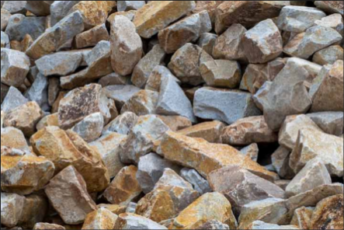
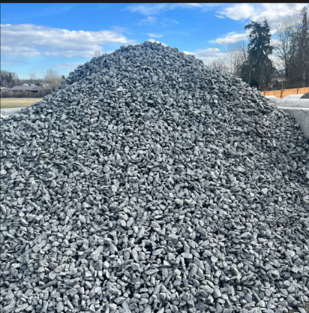
Answer ALL questions in this section. 1. Study the samples represented below and answer the questions.
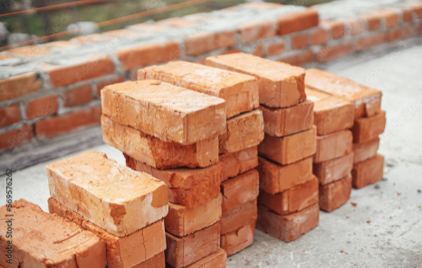

A B C

a) Identify the building materials represented by A, B and C. (3 marks)
A. .......................................... B. ............................................ C. .............................................

b) State one use of material A in building construction. (1 mark)
...................................................................................................................................................................................
c) State one property of a good building stone. (1 mark)
......................................................................................................................................................................................

2. Study the simplified cross-section below.

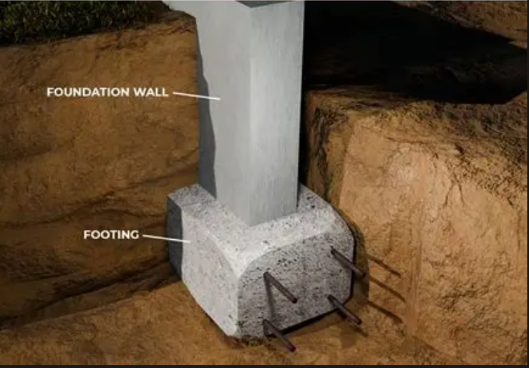
X
a) Identify the component labelled X. (1 mark)
..............................................................................................
b) State two functions of X. (2 marks)
i. .................................................................................................................................................................................
ii. ................................................................................................................................................................................
c) State two factors that influence foundation depth. (2 marks)
i. ..........................................................................................................................................................................................
ii. ........................................................................................................................................................................................

3. Study the tools shown below.
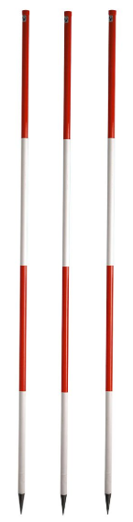
A B

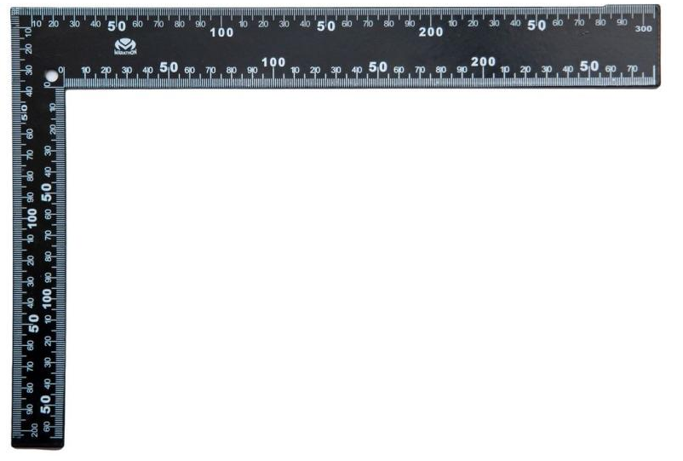

a) Identify any two setting-out tools represented above. (2 marks)
A. ......................................................................................
B. ...................................................................................
b) State one use of a builder's square. (1 mark)
...................................................................................................................................................................................

4. Study the line below.
A ●────────────────────────────● B
600 mm
The line represents a wall on a building drawing. The actual wall is 6 metres long.
a) Calculate the scale of the drawing. (2 marks)

b) State one importance of scale in building drawing. (1 mark)
...........................................................................................................................................................................................................................................................................................................................................................................................

5. Study the simplified building representation.
FRONT ELEVATION

┌─────────────┐
│ ┌───────┐ │
│ │ │ │
│ │ │ │
│ └───────┘ │
│ ┌──┐ │
│ │ │ │
└─────┴──┴────┘
a) Identify the type of building drawing shown. (1 mark)
..............................................................................................
b) State two pieces of information that may be obtained from this type of drawing. (2 marks)
i. ............................................................................................
ii. ...........................................................................................

6. Susan was asked to list the materials used in making concrete.

a) Identify the four basic materials. (4 marks)
A. ......................................................................................
B. ......................................................................................
C. ......................................................................................
D. ......................................................................................
b) State one purpose of water in concrete. (1 mark)
...........................................................................................................................................................................................................................................................................................................................................................................................

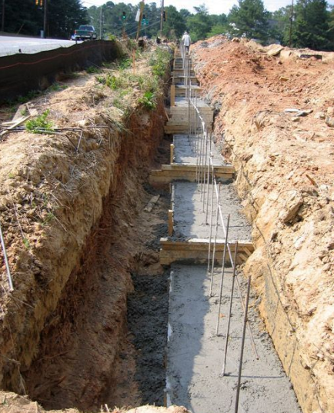
7. Study the excavation shown below.

a) Identify the construction activity represented by the diagram. (1 mark)
...............................................................................................................................................................
b) Name one danger associated with unsupported deep excavations.(1 mark)
.......................................................................................................................................................................................
c) State one method of preventing collapse of the excavation sides.(1 mark)
...................................................................................................................................................................................

8. Study the diagram below.
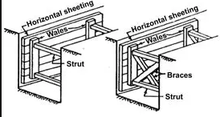
  - Identify the construction support represented by the shaded members. .

...........................................................................................................................................
b) State two reasons for providing this support. (2 marks)
i. ..................................................................................................................................................................................
ii. ...................................................................................................................................................................................

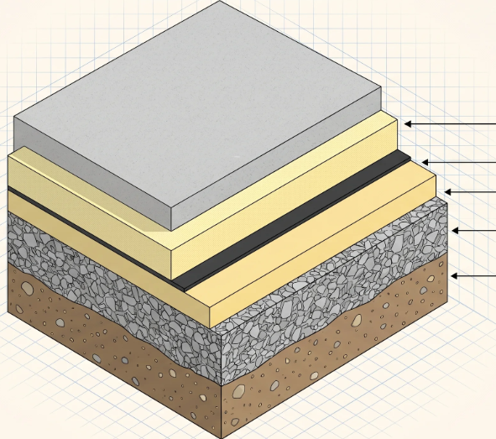
9. Study the simplified floor construction.

T

a) Identify the layer represented by the T. (1 mark)
..............................................................................................
b) State one purpose of hardcore in floor construction. (1 mark)
..............................................................................................
c) State one reason for compacting the ground before laying a floor. (1 mark)
...................................................................................................................................................................................

10. Study the pipe fittings below.
A B C
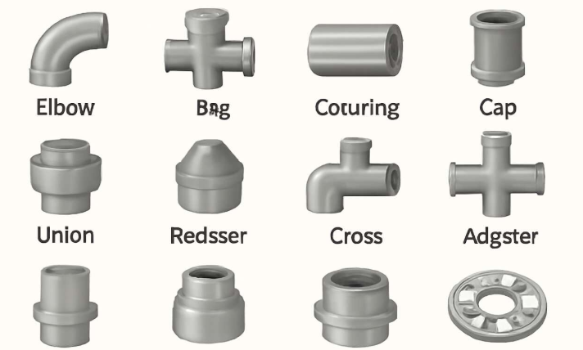

a) Identify fittings A, B and C. (3 marks)
A. ......................................................................................
B. ......................................................................................
C. ......................................................................................
b) State one function of a tee fitting. (1 mark)
.........................................................................................................................................................................................
c) Name one material used for manufacturing water pipes. (1 mark)
.................................................................................................................................................................................

SECTION B: 50 MARKS
Answer ALL questions.

11. A contractor has been given a piece of land on which a residential building is to be constructed. The site contains bushes, tree stumps, loose soil and some stones.

a)Identify four activities that should be undertaken during site preparation.(4 marks)
- .........................................................................................................................................................................
- .........................................................................................................................................................................
- .........................................................................................................................................................................
- ..........................................................................................................................................................................

b)Explain three factors that should be investigated before construction begins.(3 marks)
- .........................................................................................................................................................................
- .........................................................................................................................................................................
- .........................................................................................................................................................................

c) State three reasons why setting out must be accurate. (3 marks)
- .........................................................................................................................................................................
- .........................................................................................................................................................................
- .........................................................................................................................................................................

12. Study the setting-out illustration below.
A────────────────────────B
│ │
│ │
│ │
│ │
D────────────────────────C

AB = DC
AD = BC

a)
Identify the shape of the building being set out. (1 mark)
..............................................................................................

b) Explain four steps involved in setting out the building shown above. (4 marks)
- .........................................................................................................................................................................
- .........................................................................................................................................................................
- .........................................................................................................................................................................
- ..........................................................................................................................................................................

c) State three methods/tools that can be used to ensure that corners A, B, C and D are accurately positioned.
(3 marks)
- .........................................................................................................................................................................
- .........................................................................................................................................................................
- .........................................................................................................................................................................

d) State two checks that should be made before excavation begins. (2 marks)
i. ............................................................................................................................................................................
ii. ..........................................................................................................................................................................

13. Study the simplified plan below.

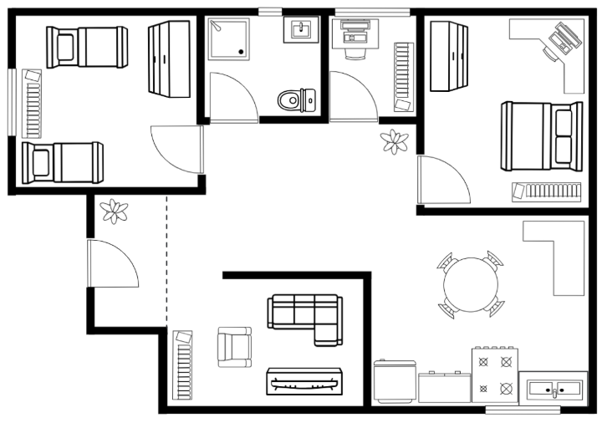

a) Identify the type of drawing shown. (1 mark)
..............................................................................................

b) Name four features visible on the drawing. (4 marks)
- .........................................................................................................................................................................
- .........................................................................................................................................................................
- .........................................................................................................................................................................
- ..........................................................................................................................................................................

c) The actual length of the building is 8 metres. On a drawing it measures 16 cm.
Calculate the scale. (3 marks)

d) State two reasons why dimensions are included on building drawings. (2 marks)
i. ..............................................................................................................................................................................
ii. ..............................................................................................................................................................................

14.

a) Identify four components shown in the cross-section. (4 marks)
i. ............................................................................................
ii. ...........................................................................................
iii. ..........................................................................................
iv. ..........................................................................................

b) Explain three functions of the foundation. (3 marks)
i. ..........................................................................................................................................................................................
ii. .........................................................................................................................................................................................
iii. ........................................................................................................................................................................................

c)State three requirements of a good ground floor.(3 marks)
i. .........................................................................................................................................................................................
ii. ......................................................................................................................................................................................
iii. ......................................................................................................................................................................................

15.Study the two illustrations below.

A. CONCRETE MIXING
WATER
↓
┌───────────────┐
│ CEMENT │
│ + SAND │
│ + AGGREGATE │
└───────────────┘
↓
MIXING
↓
CONCRETE

B. PLUMBING SYSTEM
WATER TANK
│
│
▼
┌─────────┐
│ VALVE │
└────┬────┘
│
├───────────┐
│ │
▼ ▼
TAP TAP

a)
From illustration A, state four operations involved in producing good concrete. (4 marks)
i. ............................................................................................
ii. ...........................................................................................
iii. ..........................................................................................
iv. ..........................................................................................

b)
State three functions of a valve in a water-supply system. (3 marks)
i. ............................................................................................
ii. ...........................................................................................
iii. ..........................................................................................

c)
State three safety precautions when carrying out plumbing work. (3 marks)
i. ............................................................................................
ii. ...........................................................................................
iii. ..........................................................................................

KENYA CERTIFICATE OF BASIC EDUCATION

SENIOR SCHOOL ASSESSMENT

DECEMBER ASSIGNMENT 2026
GRADE 10 – BUSINESS STUDIES
Time: 2 Hours
LEARNER’S DETAILS
Name: _____________________________________________________________. School: ____________________________________________.
Assessment Number: _______________________________________________. Date: ____________________________________________.
School Code: ______________________________________________________. Signature: _______________________________________.

INSTRUCTIONS TO CANDIDATES
- Write your name in the spaces provided above.
- Write the name of your school and your stream in the spaces provided.
- Write your admission number and the date of the assessment in the spaces provided.
- This paper consists of two sections: A and B.
- Answer all questions in section A and section B.
- Answer the questions in English.
- All answers MUST be written in the spaces provided in the paper.
- Do NOT remove any page from this question paper.

FOR OFFICIAL USE ONLY (EXAMINER’S USE)
SECTION | SECTION A | SECTION B | % SCORE | EE1 | EE2 | ME1 | ME2 | AE1 | AE2 | BE1 | BE2
SCORE RANGE | 30 MARKS | 50 MARKS |  | 90-100 | 75-89 | 58-74 | 41-57 | 31-40 | 21-30 | 11-20 | 1-10
POINTS |  |  |  | 8 POINTS | 7 POINTS | 6 POINTS | 5 POINTS | 4 POINTS | 3 POINTS | 2 POINTS | 1 POINT
LEARNER’S TOTAL SCORE

SECTION A (30 MARKS)
Answer ALL questions in this section.

1. a) Define the term business environment. (1 mark)
______________________________________________________________________________________________________________________________________________________________________________________________
b) State two internal factors that may influence the operations of a business. (2 marks)
- ____________________________________________________________________________________
- ____________________________________________________________________________________
c) State two external factors that may influence a business. (2 marks)
- ___________________________________________________________________________________
- ___________________________________________________________________________________

2. Study the illustration below and answer the questions that follow.
BUSINESS
│
┌───────────┴───────────┐
│ │
OWNER OWNER
│ │
└───────────┬───────────┘
│
AGREEMENT
│
SHARING OF
PROFITS/LOSSES
a) Identify the form of business ownership represented by the diagram. (1 mark)
______________________________________________________________________________________
b) State two features of this form of business ownership. (2 marks)
- ___________________________________________________________________________________
- ___________________________________________________________________________________
c) State two sources from which the owners may obtain capital for the business. (2 marks)
- ___________________________________________________________________________________
- ___________________________________________________________________________________

3. a) What is meant by trade? (1 mark)
______________________________________________________________________________________________________________________________________________________________________________________________
b) Distinguish between home trade and foreign trade. (2 marks)
______________________________________________________________________________________________________________________________________________________________________________________________
c) State two benefits of trade to consumers. (2 marks)
- ___________________________________________________________________________________
- ___________________________________________________________________________________

4. Study the communication process below.
┌───────────┐
│ SENDER │
└─────┬─────┘
│
▼
┌───────────┐
│ MESSAGE │
└─────┬─────┘
│
▼
┌───────────┐
│ [X] │
└─────┬─────┘
│
▼
┌───────────┐
│ RECEIVER │
└───────────┘
a) Identify the communication element represented by X. (1 mark)
____________________________________________________________________________________________
b) State two methods of communication that a business may use. (2 marks)
- ___________________________________________________________________________________
- ___________________________________________________________________________________
c) State two qualities of effective business communication. (2 marks)
- ___________________________________________________________________________________
- ___________________________________________________________________________________

5. a) Define insurance. (1 mark)
______________________________________________________________________________________________________________________________________________________________________________________________
b) State two principles of insurance. (2 marks)
- ___________________________________________________________________________________
- ___________________________________________________________________________________
c) Give two reasons why businesses take insurance policies. (2 marks)
- ___________________________________________________________________________________
- ___________________________________________________________________________________

6. A learner wants to establish a small poultry enterprise but does not have enough money to purchase the required equipment and chicks.
a) State two internal sources of business finance. (2 marks)
- ___________________________________________________________________________________
- ___________________________________________________________________________________
b) State two external sources of business finance. (2 marks)
- ___________________________________________________________________________________
- ___________________________________________________________________________________
c) State one factor the learner should consider before obtaining a loan. (1 mark)
______________________________________________________________________________________________________________________________________________________________________________________________

SECTION B: 50 MARKS
Answer ALL questions in this section.

7. Read the case study below and answer the questions that follow.
Tumaini General Store operates in a growing town. Recently, the number of customers has increased because a new residential estate has been established nearby. However, the business has also experienced increased competition. The cost of transporting goods has risen, and customers increasingly prefer businesses that accept digital payments. The owner is considering introducing electronic payment facilities and expanding the range of goods sold.
a) Identify two opportunities available to Tumaini General Store from the case study. (2 marks)
- ___________________________________________________________________________________
- ___________________________________________________________________________________
b) Identify two challenges facing the business. (2 marks)
- ___________________________________________________________________________________
- ___________________________________________________________________________________
c) Explain three ways in which technology can improve the operations of the business. (3 marks)
- ___________________________________________________________________________________
- ___________________________________________________________________________________
- ___________________________________________________________________________________
d) Explain three ways in which competition may affect the business. (3 marks)
- ___________________________________________________________________________________
- ___________________________________________________________________________________
- ___________________________________________________________________________________

8. A group of learners observes that many people in their community travel a long distance to obtain freshly baked bread and other bakery products. They decide to establish a small bakery.
Before starting the business, they investigate customer needs, competitors, availability of raw materials, required capital and the possible selling price.
a) Identify two sources of business ideas demonstrated in the case. (2 marks)
- ___________________________________________________________________________________
- ___________________________________________________________________________________
b) Explain three factors the learners should consider when assessing the viability of the bakery business.
(3 marks)
- ___________________________________________________________________________________
- ___________________________________________________________________________________
- ___________________________________________________________________________________
c) State two risks that the learners may face when starting the business. (2 marks)
- ___________________________________________________________________________________
- ___________________________________________________________________________________
d) Explain three ways of reducing business risks. (3 marks)
- ___________________________________________________________________________________
- ___________________________________________________________________________________
- ___________________________________________________________________________________

9. Study the distribution chain below.
PRODUCER
│
▼
WHOLESALER
│
▼
RETAILER
│
▼
CONSUMER
a) Identify the type of distribution channel represented by the diagram. (1 mark)
____________________________________________________________________________________
b) State two functions of a wholesaler in this channel. (2 marks)
- ___________________________________________________________________________________
- ___________________________________________________________________________________
c) State two functions of a retailer. (2 marks)
- ___________________________________________________________________________________
- ___________________________________________________________________________________
d) Explain three advantages of using intermediaries in the distribution of goods. (3 marks)
- ___________________________________________________________________________________
- ___________________________________________________________________________________
- ___________________________________________________________________________________
e) State two factors that may determine the choice of a distribution channel. (2 marks)
- ___________________________________________________________________________________
- ___________________________________________________________________________________

10. A hardware business owns a building, delivery vehicle, stock and business equipment. The owner is concerned about possible losses arising from fire, theft and road accidents involving the delivery vehicle.
a) Identify three risks faced by the business from the case study. (3 marks)
- ___________________________________________________________________________________
- ___________________________________________________________________________________
- ___________________________________________________________________________________
b) Explain two ways through which insurance can help the business. (2 marks)
- ___________________________________________________________________________________
- ___________________________________________________________________________________
c) Distinguish between life insurance and general insurance. (2 marks)
_____________________________________________________________________________________________________________________________________________________________________________________________________________________________________________________________________________________________
d) Explain three factors that may influence the amount of insurance premium paid by a business. (3 marks)
- ___________________________________________________________________________________
- ___________________________________________________________________________________
- ___________________________________________________________________________________

11. Mwangaza Traders provided the following information for the month of August:
Item | Amount (KSh)
Capital introduced by owner | 100,000
Sales revenue | 180,000
Purchases | 90,000
Rent | 15,000
Wages | 20,000
Transport expenses | 8,000
Electricity | 7,000
a) Calculate the total operating expenses, excluding purchases. (2 marks)

b) Calculate the total expenditure including purchases. (2 marks)

c) Assuming that the cost of goods sold is KSh 90,000, calculate the gross profit. (2 marks)

d) Calculate the net profit. (2 marks)

e) State two ways in which the business can improve its profitability. (2 marks)
- ___________________________________________________________________________________
- ___________________________________________________________________________________

KENYA CERTIFICATE OF BASIC EDUCATION

SENIOR SCHOOL ASSESSMENT

DECEMBER ASSIGNMENT 2026
GRADE 10 – CHEMISTRY
Time: 2 Hours
LEARNER’S DETAILS
Name: _____________________________________________________________. School: ____________________________________________.
Assessment Number: _______________________________________________. Date: ____________________________________________.
School Code: ______________________________________________________. Signature: _______________________________________.

INSTRUCTIONS TO CANDIDATES
- Write your name in the spaces provided above.
- Write the name of your school and your stream in the spaces provided.
- Write your admission number and the date of the assessment in the spaces provided.
- This paper consists of two sections: A and B.
- Answer all questions in section A and section B.
- Answer the questions in English.
- All answers MUST be written in the spaces provided in the paper.
- Do NOT remove any page from this question paper.

FOR OFFICIAL USE ONLY (EXAMINER’S USE)
SECTION | SECTION A | SECTION B | % SCORE | EE1 | EE2 | ME1 | ME2 | AE1 | AE2 | BE1 | BE2
SCORE RANGE | 30 MARKS | 50 MARKS |  | 90-100 | 75-89 | 58-74 | 41-57 | 31-40 | 21-30 | 11-20 | 1-10
POINTS |  |  |  | 8 POINTS | 7 POINTS | 6 POINTS | 5 POINTS | 4 POINTS | 3 POINTS | 2 POINTS | 1 POINT
LEARNER’S TOTAL SCORE

SECTION A (30 MARKS)
Answer ALL questions in this section.
  - A mixture contains iron filings, sand and common salt.
a) Name the method that can be used to separate the iron filings from the mixture. (1 mark)
____________________________________________________
b) State the method used to separate sand from the salt solution after adding water to the remaining mixture. (1 mark)
_____________________________________________________
c) Name the method that can be used to obtain solid sodium chloride from the salt solution. (1 mark)
__________________________________________________________________

  - A learner measured the volume of a liquid using a measuring cylinder as shown below.
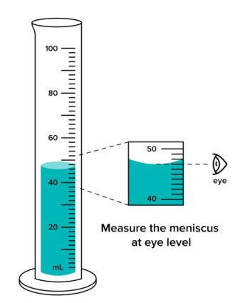
a) What should the learner do to obtain an accurate reading of the volume? (1 mark)
___________________________________________________________________________________________
b) At which part of the meniscus should the reading be taken for water? (1 mark)
______________________________________________________________
c) State the appropriate position of the learner's eye when taking the reading. (1 mark)
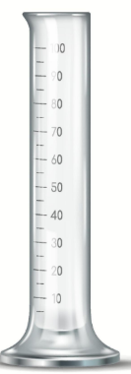
________________________________________________________________________________________
  - Study the apparatus represented below.

a) Identify the apparatus represented above. _________________________________ (1 mark)
b) State one use of the apparatus in the chemistry laboratory. (1 mark)
_______________________________________________________________________________________
c) Name one other apparatus that can be used to measure a fixed volume of a liquid accurately. (1 mark)
_____________________________________________________________________________________
  - An atom of element A has 13 protons, 13 electrons and 14 neutrons.
a) State the atomic number of element A. (1 mark)
___________________________________________________________________________
b) Calculate the mass number of element A. (1 mark)

c) Write the electronic arrangement of element A. (1 mark)
___________________________________________________________________________
  - Consider the following elements:
Element | Electronic arrangement
P | 2.1
Q | 2.8.2
R | 2.8.6
a) Which element belongs to Group 1? (1 mark)
___________________________________________________________________________
b) Which element belongs to Group 16? (1 mark)
___________________________________________________________________________
c) State the period occupied by element Q. (1 mark)
___________________________________________________________________________
  - Calcium has the electronic arrangement 2.8.8.2, while oxygen has the electronic arrangement 2.6.
a) State the number of electrons calcium loses when forming an ion. (1 mark)
___________________________________________________________________________
b) State the number of electrons oxygen gains when forming an ion. (1 mark)
___________________________________________________________________________
c) Write the formula of the compound formed between calcium and oxygen. (1 mark)
___________________________________________________________________________
  - A learner tested three solutions using litmus paper.
Solution | Effect on blue litmus | Effect on red litmus
A | Turns red | No change
B | No change | Turns blue
C | No change | No change
a) Identify solution A as acidic, alkaline or neutral. (1 mark)
___________________________________________________________________________
b) Identify solution B as acidic, alkaline or neutral. (1 mark)
___________________________________________________________________________
c) Identify solution C as acidic, alkaline or neutral. (1 mark)
___________________________________________________________________________
  - Study the observations obtained when two indicators were added to an unknown solution.
UNKNOWN SOLUTION

┌─────────────┐
│ │
│ SAMPLE │
│ │
└─────────────┘
↓
Indicator X
↓
RED

┌─────────────┐
│ │
│ SAMPLE │
│ │
└─────────────┘
↓
Indicator Y
↓
COLOURLESS
a) If indicator X is phenolphthalein, state whether the observation is possible. Give a reason. (1 mark)
___________________________________________________________________________
b) State the colour of phenolphthalein in an alkaline solution. (1 mark)
___________________________________________________________________________
c) Name one indicator that may give a red colour in a strongly acidic solution. (1 mark)
___________________________________________________________________________
  - Study the compounds below:
A
H H H
| | |
H – C – C – C – H
| | |
H H H

B

H H H H
| | | |
H – C – C – C – C – H
| | | |
H H H H

a) Name compound A. (1 mark)
___________________________________________________________________________
b) Name compound B. (1 mark)
___________________________________________________________________________
c) State the homologous series to which the two compounds belong. (1 mark)
___________________________________________________________________________
  - A learner burns a hydrocarbon in a plentiful supply of air.
a) Name the type of combustion expected when sufficient oxygen is available. (1 mark)
____________________________________________________________________________________
b) Name the two main products formed during complete combustion of a hydrocarbon. (1 mark)
____________________________________________________________________________________
c) State one environmental effect of carbon dioxide released during combustion. (1 mark)
___________________________________________________________________________________

SECTION B:50 MARKS
Answer ALL questions in this section.
  - A learner carried out an experiment in which magnesium ribbon was placed in dilute hydrochloric acid. Bubbles of gas were produced and the magnesium gradually disappeared.
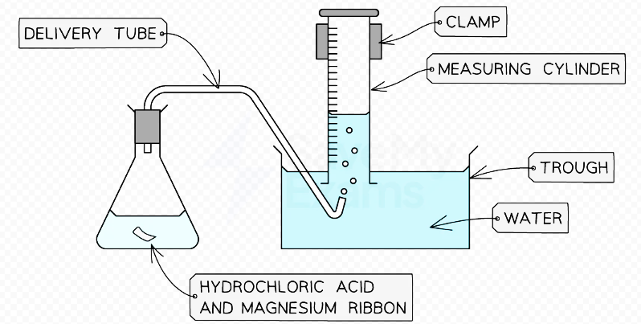

a) Name the gas produced. ____________________________________________ (1 mark)
b) Describe a chemical test for the gas identified in (a). (2 marks)
____________________________________________________________________________________________________________________________________________________________________________________________________

c) State two observations made during the reaction apart from the production of gas. (2 marks)
____________________________________________________________________________________________________________________________________________________________________________________________________
d) Write a balanced chemical equation for the reaction. (2 marks)
____________________________________________________________________________________________________________________________________________________________________________________________________
e) Name the salt formed in the reaction. (1 mark)
__________________________________________________________________
f) Explain why magnesium ribbon is cleaned before it is placed in the acid. (2 marks)
____________________________________________________________________________________________________________________________________________________________________________________________________
  - A farmer obtained a soil sample that was found to be excessively acidic. The farmer was advised to apply an appropriate substance to reduce the acidity.
a) What is meant by an acid? (1 mark)
____________________________________________________________________________________________________________________________________________________________________________________________________
b) Name one substance that can be used to reduce excessive acidity in agricultural soil. (1 mark)
_____________________________________________________________________________
c) Explain how the substance named in (b) helps to reduce soil acidity. (2 marks)
____________________________________________________________________________________________________________________________________________________________________________________________________
d) Hydrochloric acid reacts with calcium hydroxide. Write a balanced chemical equation for the reaction.
(2 marks)
____________________________________________________________________________________________________________________________________________________________________________________________________
e) Name the type of reaction represented by the equation in (d). (1 mark)
______________________________________________________________
f) Name the salt formed in the reaction. (1 mark)
____________________________________________________________
g) State two practical applications of neutralisation reactions. (2 marks)
____________________________________________________________________________________________________________________________________________________________________________________________________
  - A learner was instructed to prepare lead(II) iodide by mixing suitable solutions of lead(II) nitrate and potassium iodide.
The process is represented below.
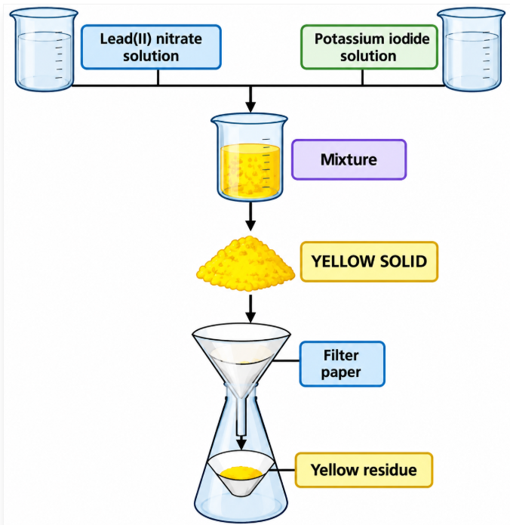

a) Name the yellow solid formed. ______________________________ (1 mark)
b) Name the method used to separate the solid from the mixture. _____________________________ (1 mark)
c) State the purpose of the filter paper. (1 mark)
____________________________________________________________________________________
d) Write a balanced chemical equation for the reaction using chemical formulae. (3 marks)
____________________________________________________________________________________________________________________________________________________________________________________________________e) Explain why the reaction is classified as a precipitation reaction. (2 marks)
____________________________________________________________________________________________________________________________________________________________________________________________________f) State one way of obtaining a cleaner sample of the solid product. (1 mark)
__________________________________________________________________________________________________
  - The following compounds are represented by their molecular formulae:
- A – C₂H₆
- B – C₃H₆
- C – C₄H₁₀
- D – C₅H₁₀
a) Identify the compounds that are alkanes. (2 marks) _______________________________________________________
b) Identify the compounds that could represent alkenes. (2 marks) _______________________________________________
c) State the general formula of alkanes. (1 mark) ____________________________________________________________________________________________________________________________________________________________________________________________________d) State the general formula of alkenes. (1 mark) ____________________________________________________________________________________________________________________________________________________________________________________________________e) Give the names of compounds A and C. (2 marks)
A: ________________________________________
C: ________________________________________
f) State one chemical test that can be used to distinguish an alkene from an alkane. (1 mark) ____________________________________________________________________________________________________________________________________________________________________________________________________g) State the expected observation when the test in (f) is carried out on an alkene. (1 mark) ____________________________________________________________________________________________________________________________________________________________________________________________________

  - A Grade 10 learner was investigating the reaction between an acid and a carbonate. The learner placed a small amount of calcium carbonate in a flask and added dilute hydrochloric acid.
The experimental arrangement is represented below.
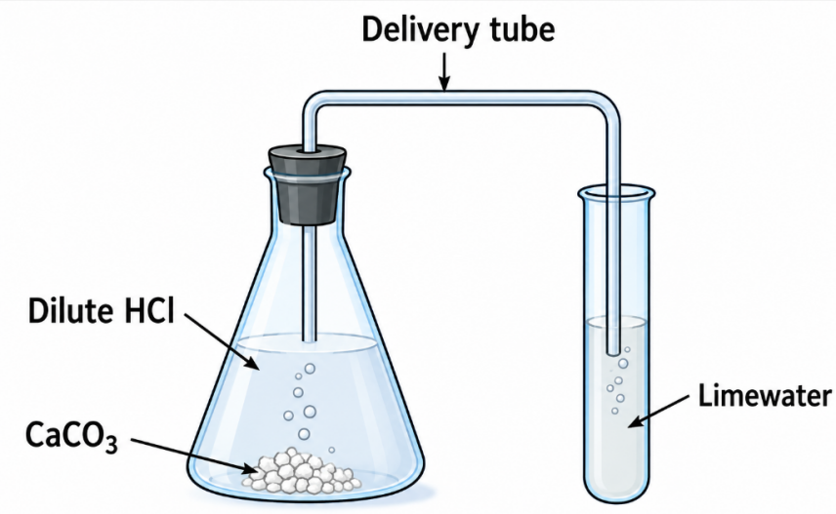
a) Name the gas produced in the flask. ___________________________________________(1 mark)

b) State the chemical test for the gas using limewater. (2 marks) ____________________________________________________________________________________________________________________________________________________________________________________________________c) State the observation expected in the limewater test. (1 mark) ____________________________________________________________________________________________________________________________________________________________________________________________________d) Write a balanced chemical equation for the reaction between calcium carbonate and hydrochloric acid. (3 marks) ____________________________________________________________________________________________________________________________________________________________________________________________________e) Name the salt formed in the reaction. (1 mark) ____________________________________________________
f) State two safety precautions the learner should observe during the experiment. (2 marks) ____________________________________________________________________________________________________________________________________________________________________________________________________

KENYA CERTIFICATE OF BASIC EDUCATION

SENIOR SCHOOL ASSESSMENT

DECEMBER ASSIGNMENT 2026
GRADE 10 – COMPUTER STUDIES
Time: 2 Hours
LEARNER’S DETAILS
Name: _____________________________________________________________. School: ____________________________________________.
Assessment Number: _______________________________________________. Date: ____________________________________________.
School Code: ______________________________________________________. Signature: _______________________________________.

INSTRUCTIONS TO CANDIDATES
- Write your name in the spaces provided above.
- Write the name of your school and your stream in the spaces provided.
- Write your admission number and the date of the assessment in the spaces provided.
- This paper consists of two sections: A and B.
- Answer all questions in section A and section B.
- Answer the questions in English.
- All answers MUST be written in the spaces provided in the paper.
- Do NOT remove any page from this question paper.

FOR OFFICIAL USE ONLY (EXAMINER’S USE)
SECTION | SECTION A | SECTION B | % SCORE | EE1 | EE2 | ME1 | ME2 | AE1 | AE2 | BE1 | BE2
SCORE RANGE | 30 MARKS | 50 MARKS |  | 90-100 | 75-89 | 58-74 | 41-57 | 31-40 | 21-30 | 11-20 | 1-10
POINTS |  |  |  | 8 POINTS | 7 POINTS | 6 POINTS | 5 POINTS | 4 POINTS | 3 POINTS | 2 POINTS | 1 POINT
LEARNER’S TOTAL SCORE

SECTION A (30 MARKS)
Answer ALL questions in this section.
  - a) Define the term hardware. (1 mark)
______________________________________________________________________________________________________________________________________________________________________________________________
b) State two examples of input devices. (2 marks)
- _________________________________________________________________________________________
- _________________________________________________________________________________________

c) Give one example of an output device. (1 mark)
________________________________________________________
d) State one function of a storage device. (1 mark)
____________________________________________________________________________________________
  - Study the diagram below and answer the questions that follow.

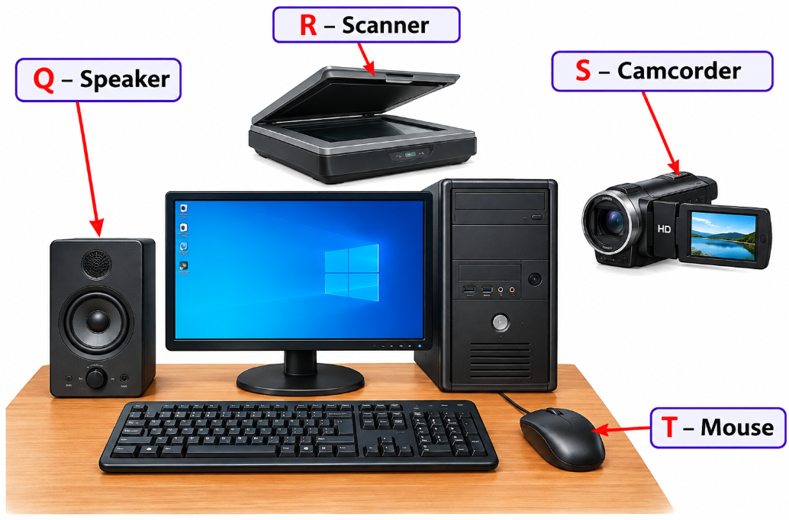

a) Identify device Q. ______________________________________ (1 mark)
b) Identify device R. ______________________________________ (1 mark)
c) Identify device S. ______________________________________ (1 mark)
d) Identify device T ______________________________________ (1 mark)
e) State one use of device T. (1 mark) ______________________________________________________________________________________________________________________________________________________________________________________________

  - a) What is computer memory? (1 mark)
______________________________________________________________________________________________________________________________________________________________________________________________

b) Distinguish between RAM and ROM. (2 marks)
______________________________________________________________________________________________________________________________________________________________________________________________
c) State two examples of secondary storage devices. (2 marks)
- _________________________________________________________________________________________
- _________________________________________________________________________________________
  - A teacher records the following marks:
65, 72, 48, 80, 75
a) What is meant by data? (1 mark)
______________________________________________________________________________________________________________________________________________________________________________________________
b) What is meant by information? (1 mark) ______________________________________________________________________________________________________________________________________________________________________________________________
c) Calculate the total marks obtained. (1 mark)

d) Calculate the average mark. Show your working. (2 marks)

  - a) State the base of the binary number system. (1 mark)
___________________________________________________________
b) Write the two digits used in binary notation. (1 mark)
- _________________________________________________________________________________________
- _________________________________________________________________________________________
c) Convert 11001₂ to decimal. Show your working. (2 marks)

d) State one use of binary numbers in computing. (1 mark)
____________________________________________________________________________________________________________________________________________________________________________________________________
  - a) Define computer ethics. (1 mark)
_________________________________________________________________________________________________________________________________________________________________________________________________
b) State two examples of unethical use of computers. (2 marks)
- ____________________________________________________________________________________________
- ____________________________________________________________________________________________
c) State two measures that can be taken to protect personal data on a computer. (2 marks)
- ____________________________________________________________________________________________
- ___________________________________________________________________________________________

SECTION B: 50 MARKS
Answer ALL questions in this section.
  - Study the diagram below.
┌──────────────┐
│ INPUT │
└──────┬───────┘
│
▼
┌──────────────┐
│ A │
│ │
│ PROCESSING │
└──────┬───────┘
│
▼
┌──────────────┐
│ OUTPUT │
└──────────────┘

↕
┌──────────────┐
│ STORAGE │
└──────────────┘
a) Identify component A represented by the stage A. ____________________________ (1 mark)
b) State the three major stages of the information processing cycle. (3 marks)
- _________________________________________________________________________________________
- _________________________________________________________________________________________
- _________________________________________________________________________________________
c) Give two examples of devices used for entering data into a computer. (2 marks)
- _________________________________________________________________________________________
- _________________________________________________________________________________________
d) Give two examples of devices used for presenting processed information. (2 marks)
- _________________________________________________________________________________________
- _________________________________________________________________________________________
e) State two reasons why information needs to be stored. (2 marks)
- _________________________________________________________________________________________
- _________________________________________________________________________________________
  - A learner switches on a computer and is presented with a desktop containing icons, menus and a taskbar.
a) Identify the type of user interface described above. (1 mark)
_________________________________________________
b) State three features of a Graphical User Interface (GUI). (3 marks)
- _________________________________________________________________________________________
- _________________________________________________________________________________________
- _________________________________________________________________________________________
c) Explain three functions of an operating system. (3 marks)
- _________________________________________________________________________________________
- _________________________________________________________________________________________
- _________________________________________________________________________________________
d) Distinguish between system software and application software. (2 marks)
_____________________________________________________________________________________________________________________________________________________________________________________________________________________________________________________________________________________________
e) Give one example of application software used for word processing. (1 mark)
_________________________________________________________
  - A school wants a program that determines whether a learner has passed or failed an examination. A learner passes if the mark is 50 or above.
Study the flowchart below.

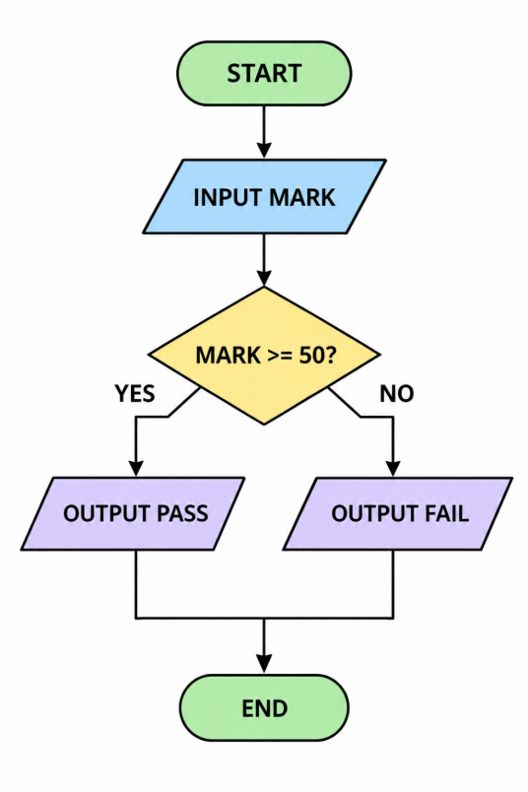
a) Identify the flowchart symbol used to represent a decision. _____________________________(1 mark)
b) State the condition tested by the decision symbol. (1 mark)
______________________________________________________________________________________________________________________________________________________________________________________________
c) Write an algorithm in numbered steps for the process shown. (4 marks)
________________________________________________________________________________________________________________________________________________________________________________________________________________________________________________________________________________________________________________________________________________________________________________________________________
d) State the output if the learner scores 67 marks. (1 mark)
___________________________________________________________________________________________________________________________________________________________________________________________________
e) State the output if the learner scores 42 marks. (1 mark)
____________________________________________________________________________________________________________________________________________________________________________________________________
f) Explain why algorithms are important when developing computer programs. (2 marks)
____________________________________________________________________________________________________________________________________________________________________________________________________
  - Consider the following pseudocode:
BEGIN
INPUT number
IF number > 0 THEN
OUTPUT "Positive"
ELSE IF number < 0 THEN
OUTPUT "Negative"
ELSE
OUTPUT "Zero"
ENDIF
END
a) Identify the input variable in the pseudocode. (1 mark)
_______________________________________________________________________________________________
b) Identify the control structure used in the pseudocode. (1 mark)
______________________________________________________________________________________________________________________________________________________________________________________________
c) State the output when the value entered is 25. (1 mark)
_______________________________________________________________________________________________
d) State the output when the value entered is -8. (1 mark)
______________________________________________________________________________________________________________________________________________________________________________________________
e) State the output when the value entered is 0. (1 mark)
_______________________________________________________________________________________________

f) Explain the purpose of an IF...ELSE statement in programming. (2 marks)
_____________________________________________________________________________________________________________________________________________________________________________________________________________________________________________________________________________________________
g) State three common errors that may occur when writing a computer program. (3 marks)
- _________________________________________________________________________________________
- _________________________________________________________________________________________
- _________________________________________________________________________________________
  - A school has twenty computers in one laboratory. The computers are connected so that learners can share files and a printer. The network is also connected to the Internet.
a) Identify the type of network most suitable for the computer laboratory. (1 mark)
_______________________________________________
b) Give two advantages of networking the computers. (2 marks)
- ____________________________________________________________________________________________
- ____________________________________________________________________________________________
c) Explain the function of a network switch in the laboratory. (2 marks)
_____________________________________________________________________________________________________________________________________________________________________________________________________________________________________________________________________________________________
d) Explain the function of a router when connecting the school network to the Internet. (2 marks)
_____________________________________________________________________________________________________________________________________________________________________________________________________________________________________________________________________________________________

e) State three practices that can help protect the school's network from unauthorised access. (3 marks)
- _________________________________________________________________________________________
- _________________________________________________________________________________________
- _________________________________________________________________________________________

KENYA CERTIFICATE OF BASIC EDUCATION

SENIOR SCHOOL ASSESSMENT

DECEMBER ASSESSMENT 2026
GRADE 10 – CORE MATHEMATICS
Time: 2 Hours
LEARNER’S DETAILS
Name: _____________________________________________________________. School: ____________________________________________.
Assessment Number: _______________________________________________. Date: ____________________________________________.
School Code: ______________________________________________________. Signature: _______________________________________.

INSTRUCTIONS TO CANDIDATES
- Write your full name in the space provided above.
- Indicate your school, stream, admission number, and date clearly.
- This paper has TWO sections: A and B.
- Attempt ALL questions in both sections.
- Show all working clearly where necessary.
- Write all answers in the spaces provided.
- Do NOT remove any page from this paper.

FOR OFFICIAL USE ONLY (EXAMINER’S USE)
SECTION | SECTION A | SECTION B | % SCORE | EE1 | EE2 | ME1 | ME2 | AE1 | AE2 | BE1 | BE2
SCORE RANGE | 30 MARKS | 50 MARKS |  | 90-100 | 75-89 | 58-74 | 41-57 | 31-40 | 21-30 | 11-20 | 1-10
POINTS |  |  |  | 8 POINTS | 7 POINTS | 6 POINTS | 5 POINTS | 4 POINTS | 3 POINTS | 2 POINTS | 1 POINT
LEARNER’S TOTAL SCORE

SECTION A (30 MARKS)

Answer ALL questions in this section.

Without using a calculator, simplify the following expression, leaving your answer in exact index form:
$${81}^{−1}×2^{−3}÷\left({27}^{−\frac{3}{2}}×{16}^{\frac{4}{3}}\right)$$
(5 marks)

Using four-figure logarithm tables, evaluate the following calculation correct to 4 significant figures:
$$\frac{3672.3}{0.0456×(18.42)^{2}}$$
(5 marks)

Two position vectors are given on a Cartesian plane as
$$\vec{OA}=\left(\begin{matrix}−3 \\ 4\end{matrix}\right) \text{and} \vec{OB}=\left(\begin{matrix}9 \\ −12\end{matrix}\right).$$
(a) Find the magnitude of vector $\vec{AB}$.

(b) Determine the position vector of point $M$, which is the midpoint of segment $AB$. (5 marks)

- A triangular plot of land $PQR$ has side lengths(5 marks)

$$PQ=13\text{ m}, QR=14\text{ m}, PR=15\text{ m}.$$
(a) Calculate the exact area of the triangular plot $PQR$ using Heron's Formula.

(b) Hence, find the acute included angle $∠PQR$, giving your answer correct to 2 decimal places.

A triangle $T$ has vertices
$$A(1,2), B(4,2), C(1,6).$$
The triangle is rotated through ${90}^{∘}$ counterclockwise about the centre of rotation
$$P(2,−1)$$
to form triangle $T^{'}$.
Determine the exact coordinates of the image vertices
$$A^{'}, B^{'}, C^{'}.$$
(5 marks)



Bag A contains 4 red marbles and 6 blue marbles. Bag B contains 5 red marbles and 3 blue marbles.
A fair six-sided die is rolled. If a prime number appears, a marble is drawn at random from Bag A. Otherwise, a marble is drawn from Bag B. (5 marks)

(a) Draw a fully labelled tree diagram to represent this probability space.

(b) Calculate the probability of selecting a red marble.

SECTION B — 50 MARKS
Answer ALL questions in this section. Show all working clearly.

Triangle $XYZ$ has coordinates
$$X(2,3), Y(5,4), Z(3,7).$$

Triangle $X^{'}Y^{'}Z^{'}$ is the image of triangle $XYZ$ under reflection in the mirror line
$$L:y=2x−1.$$
Determine the coordinates of $X^{'}$. (4 marks)

(b) A second transformation enlarges triangle $X^{'}Y^{'}Z^{'}$ with centre of enlargement at
$$(0,0)$$
and linear scale factor
$$k=−2$$
to form triangle $X^{″}Y^{″}Z^{″}$.
State the coordinates of $Y^{″}$ and $Z^{″}$. (3 marks)

(c) Determine whether triangle $XYZ$ is congruent to triangle $X^{″}Y^{″}Z^{″}$.
Give a mathematical explanation using congruence properties and scale factors. (3 marks)

An annular sector was formed by two concentric circles with radii $R=14\text{ cm }$and $r=7\text{ cm}.$ The sector subtends a central angle of $θ={120}^{∘}$ at the centre $O$. Inside the inner circle, a circular segment is formed by a chord joining the endpoints of the inner arc.

(a)
Calculate the area of the annular sector, that is, the region between the circles of radii $7$ cm and $14$ cm bounded by the angle ${120}^{∘}$.
Take
$$π=\frac{22}{7}.$$
(3 marks)

(b)
Calculate the area of the circular segment formed by the inner circle of radius $7$ cm and its chord.
Give your answer correct to 2 decimal places. (4 marks)

(c)
Find the perimeter of the entire shaded annular-sector region. (3 marks)

The table below records the speeds, in km/h, of 50 vehicles passing a checkpoint.
Speed $v$ (km/h) | Frequency $f$
$$40≤v<50$$ | 4
$$50≤v<60$$ | 9
$$60≤v<70$$ | 16
$$70≤v<80$$ | 12
$$80≤v<90$$ | 6
$$90≤v<100$$ | 3
Total | 50

Construct a table showing the cumulative frequency and mid-interval value for each class. (2 marks)

Calculate the estimated mean speed of the vehicles using the assumed mean
$$A=65.$$
(4 marks)

Determine the modal class and calculate the median speed using the interpolation formula. (4 marks)

A vessel moves from port $O$ such that its position vector relative to $O$, at time $t$ hours, is given by $r\left(t\right)=\left(\begin{matrix}3t−2 \\ 4t+1\end{matrix}\right)$nautical miles.

Find the displacement vector of the vessel between $t=1\text{ hour }$and $t=4\text{ hours}.$(2 marks)

(b)
Calculate the speed of the vessel during this interval. (3 marks)

(c)
A second vessel starts at position $P_{0}=\left(\begin{matrix}10 \\ 25\end{matrix}\right)$ and moves with a constant velocity vector $v_{2}=\left(\begin{matrix}−1 \\ 2\end{matrix}\right)$ knots.
Determine whether, and at what time $t$, the paths of the two vessels intersect. (5 marks)

11. A closed right triangular prism has a length of
$$(x+5)\text{ cm}.$$
The cross-section of the prism is a right-angled triangle with perpendicular legs measuring $x\text{ cm}$ and $(x−1)\text{ cm}.$

(a)
Show that the hypotenuse of the right-angled triangular cross-section is
$$\sqrt{2x^{2}−2x+1}\text{ cm}.$$
(2 marks)

(b)
Form a simplified expression, in terms of $x$, for the total surface area $S$ of the prism. (4 marks)

(c) The total surface area of the prism is $132{\text{ cm}}^{2}$. For the purposes of this question, use the given effective linear-perimeter approximation, which produces the quadratic equation
$$2x^{2}+7x−99=0.$$
Solve the quadratic equation to find the valid value of $x$.
Hence, determine the exact volume of the prism. (4 marks)

KENYA CERTIFICATE OF BASIC EDUCATION

SENIOR SCHOOL ASSESSMENT

DECEMBER ASSIGNMENT 2026
GRADE 10 – CHRISTIAN RELIGIOUS EDUCATION
Time: 2 Hours
LEARNER’S DETAILS
Name: _____________________________________________________________. School: ____________________________________________.
Assessment Number: _______________________________________________. Date: ____________________________________________.
School Code: ______________________________________________________. Signature: _______________________________________.

INSTRUCTIONS TO CANDIDATES
- Write your name in the spaces provided above.
- Write the name of your school and your stream.
- Write your admission number and the date.
- This paper consists of TWO sections: A and B.
- Answer ALL questions in both sections.
- Answer all questions in English.
- All answers MUST be written in the spaces provided.
- Do NOT remove any page from this paper.

FOR OFFICIAL USE ONLY (EXAMINER’S USE)
SECTION | SECTION A | SECTION B | % SCORE | EE1 | EE2 | ME1 | ME2 | AE1 | AE2 | BE1 | BE2
SCORE RANGE | 30 MARKS | 50 MARKS |  | 90-100 | 75-89 | 58-74 | 41-57 | 31-40 | 21-30 | 11-20 | 1-10
POINTS |  |  |  | 8 POINTS | 7 POINTS | 6 POINTS | 5 POINTS | 4 POINTS | 3 POINTS | 2 POINTS | 1 POINT
LEARNER’S TOTAL SCORE

SECTION A (30 MARKS)
Answer ALL questions in this section.

1.
a) State two ways in which Christians understand the Bible as the Word of God. (2 marks)
- _________________________________________________________________________________________
- _________________________________________________________________________________________
b) Explain two ways in which biblical teachings can influence the conduct of a learner. (2 marks)
- _________________________________________________________________________________________
- _________________________________________________________________________________________

c) Give one reason why Christians should relate biblical teachings to situations in contemporary society. (1 mark)

_____________________________________________________________________________________________________________________________________________________________________________________________________________________________________________________________________

2.
a) State two ways in which human beings demonstrate stewardship of God's creation. (2 marks)
- _________________________________________________________________________________________
- _________________________________________________________________________________________
b) Explain two effects of environmental destruction on human life. (2 marks)
- _________________________________________________________________________________________
- _________________________________________________________________________________________
c) Give one Christian teaching that encourages people to care for creation. (1 mark)

_____________________________________________________________________________________________________________________________________________________________________________________________________________________________________________________________________

3.
a) Identify two factors that may lead young people into temptation. (2 marks)
- _________________________________________________________________________________________
- _________________________________________________________________________________________
b) Explain two consequences of persistent sinful behaviour. (2 marks)
- _________________________________________________________________________________________
- _________________________________________________________________________________________

c) State one way through which a Christian can demonstrate genuine repentance. (1 mark)

_____________________________________________________________________________________________________________________________________________________________________________________________________________________________________________________________________

4.
a) State two purposes of prayer in Christian life. (2 marks)
- _________________________________________________________________________________________
- _________________________________________________________________________________________
b) Explain two ways prayer can help Christians when facing challenges. (2 marks)
- ____________________________________________________________________________________________
- ___________________________________________________________________________________________
c) Give one reason why Christians should combine prayer with responsible action. (1 mark)

_____________________________________________________________________________________________________________________________________________________________________________________________________________________________________________________________________

5.
a) Name two values demonstrated by Jesus Christ in his interaction with other people. (2 marks)
- ___________________________________________________________________________________________
- ___________________________________________________________________________________________
b) Explain two ways Christians can practise the values identified in part (a) in their school community. (2 marks)
- ____________________________________________________________________________________________
- ___________________________________________________________________________________________
c) State one benefit of following the example of Jesus Christ. (1 mark)
___________________________________________________________________________________________________________________________________________________________________________________________________

6.
Two learners disagree over the leadership of a school project. The disagreement becomes hostile and begins to affect other members of the group.
a) Identify two Christian values that could help resolve the conflict. (2 marks)
- ___________________________________________________________________________________________
- ____________________________________________________________________________________________
b) Explain two peaceful methods the learners could use to resolve their disagreement. (2 marks)
- ___________________________________________________________________________________________
- ____________________________________________________________________________________________
c) State one danger of allowing unresolved conflict to continue. (1 mark)
____________________________________________________________________________________________________________________________________________________________________________________________________

SECTION B: 50 MARKS

Answer ALL questions.

7.
Read the situation below and answer the questions that follow.
A learner receives a message on social media containing embarrassing information about another learner. Several friends encourage the learner to forward the message to other students. The learner knows that forwarding it could cause serious embarrassment but is afraid of being left out by friends.
a) Identify two moral issues involved in the situation. (2 marks)
- _________________________________________________________________________________________
- _________________________________________________________________________________________
b) Explain three Christian values that should guide the learner's decision. (3 marks)
- _________________________________________________________________________________________
- _________________________________________________________________________________________
- _________________________________________________________________________________________
c) Describe three actions the learner should take in dealing with the message. (3 marks)
- _________________________________________________________________________________________
- _________________________________________________________________________________________
- _________________________________________________________________________________________
d) State two consequences of spreading harmful information about another person. (2 marks)
- _________________________________________________________________________________________
- _________________________________________________________________________________________

8.
Jesus taught his followers to demonstrate love through practical service to others.
a) State four ways Christians can demonstrate love for their neighbours. (4 marks)
- _________________________________________________________________________________________
- _________________________________________________________________________________________
- _________________________________________________________________________________________
- _________________________________________________________________________________________
b) Explain three ways Christian service can improve the lives of vulnerable members of society. (3 marks)
- _________________________________________________________________________________________
- _________________________________________________________________________________________
- _________________________________________________________________________________________
c) State three benefits of serving others without discrimination. (3 marks)
- _________________________________________________________________________________________
- _________________________________________________________________________________________
- _________________________________________________________________________________________

9.
A family notices that communication between parents and children has become difficult. The children spend most of their free time on digital devices, while the parents feel that their concerns are being ignored.

a) State three causes of poor communication within families. (3 marks)
- _________________________________________________________________________________________
- _________________________________________________________________________________________
- _________________________________________________________________________________________
b) Explain three ways Christian values can strengthen relationships between parents and children. (3 marks)
- _________________________________________________________________________________________
- _________________________________________________________________________________________
- _________________________________________________________________________________________
c) Suggest two practical measures the family can take to improve communication. (2 marks)
- _________________________________________________________________________________________
- _________________________________________________________________________________________

d) State two benefits of effective communication in a family. (2 marks)
- _________________________________________________________________________________________
- _________________________________________________________________________________________

10.
A student leader has been given money to purchase materials for a school activity. The leader discovers that the supplier has offered a personal financial reward if the leader chooses the supplier, even though another supplier offers better value.
a) Identify two forms of unethical behaviour presented in the situation. (2 marks)
- _________________________________________________________________________________________
- _________________________________________________________________________________________
b) Explain three Christian principles that should guide the student leader. (3 marks)
- _________________________________________________________________________________________
- _________________________________________________________________________________________
- _________________________________________________________________________________________
c) Describe three actions the leader should take to demonstrate integrity. (3 marks)
- _________________________________________________________________________________________
- _________________________________________________________________________________________
- _________________________________________________________________________________________
d) State two benefits of honest leadership in a school or community. (2 marks)
- _________________________________________________________________________________________
- _________________________________________________________________________________________

11.
Young people today face challenges such as peer pressure, substance abuse, cyberbullying, corruption, unemployment, violence and environmental degradation.
a) Identify four challenges facing young people that require a Christian response. (4 marks)
- _________________________________________________________________________________________
- _________________________________________________________________________________________
- _________________________________________________________________________________________
- _________________________________________________________________________________________
b) Explain three ways Christian teachings can help young people resist negative peer pressure. (3 marks)
- _________________________________________________________________________________________
- _________________________________________________________________________________________
- _________________________________________________________________________________________

c) Suggest three practical ways young Christians can contribute to solving problems in their communities. (3 marks)
- _________________________________________________________________________________________
- _________________________________________________________________________________________
- _________________________________________________________________________________________

KENYA CERTIFICATE OF BASIC EDUCATION

SENIOR SCHOOL ASSESSMENT

DECEMBER ASSIGNMENT 2026
GRADE 10 – COMMUNITY SERVICE LEARNING
Time: 2 Hours
LEARNER’S DETAILS
Name: _____________________________________________________________. School: ____________________________________________.
Assessment Number: _______________________________________________. Date: ____________________________________________.
School Code: ______________________________________________________. Signature: _______________________________________.

INSTRUCTIONS TO CANDIDATES
- Write your name in the spaces provided above.
- Write the name of your school and your stream.
- Write your admission number and the date.
- This paper consists of TWO sections: A and B.
- Answer ALL questions in both sections.
- Answer all questions in English.
- All answers MUST be written in the spaces provided.
- Do NOT remove any page from this paper.

FOR OFFICIAL USE ONLY (EXAMINER’S USE)
SECTION | SECTION A | SECTION B | % SCORE | EE1 | EE2 | ME1 | ME2 | AE1 | AE2 | BE1 | BE2
SCORE RANGE | 30 MARKS | 50 MARKS |  | 90-100 | 75-89 | 58-74 | 41-57 | 31-40 | 21-30 | 11-20 | 1-10
POINTS |  |  |  | 8 POINTS | 7 POINTS | 6 POINTS | 5 POINTS | 4 POINTS | 3 POINTS | 2 POINTS | 1 POINT
LEARNER’S TOTAL SCORE

SECTION A (30 MARKS)
Answer ALL questions in this section.

1.
a) What is meant by community development? (2 marks)
_______________________________________________________________________________________________
_______________________________________________________________________________________________
b) State two ways Community Service Learning can contribute to community development. (2 marks)
i. _____________________________________________________________________________________________
ii. ____________________________________________________________________________________________

2.
A group of learners observes that many young people in their community spend most of their free time without engaging in productive activities.
a) Identify one community problem illustrated by the situation. (1 mark)
_______________________________________________________________________________________________
_______________________________________________________________________________________________
b) State two possible causes of the problem. (2 marks)
i. ______________________________________________________________________________________________
ii. _____________________________________________________________________________________________
c) Suggest one CSL activity that could help address the problem. (1 mark)
_______________________________________________________________________________________________
_______________________________________________________________________________________________

3.
a) What is a community resource? (1 mark)
_______________________________________________________________________________________________
_______________________________________________________________________________________________
b) Give three examples of resources that may be available in a community. (3 marks)
i. ______________________________________________________________________________________________
ii. _____________________________________________________________________________________________
iii. ____________________________________________________________________________________________

4.
a) Define empathy. (2 marks)
_______________________________________________________________________________________________
_______________________________________________________________________________________________
b) State two ways a learner can demonstrate respect when working with community members. (2 marks)
i. ______________________________________________________________________________________________
ii. _____________________________________________________________________________________________

5.
a) State two methods of communication that can be used when organising a community service project. (2 marks)
i. ______________________________________________________________________________________________
ii. _____________________________________________________________________________________________
b) Give one reason why effective communication is important in CSL. (1 mark)
_______________________________________________________________________________________________
_______________________________________________________________________________________________

6.
Before starting a community clean-up project, learners inspect the area and notice broken glass, exposed wires and stagnant water.
a) Identify two risks in the situation. (2 marks)
i. ______________________________________________________________________________________________
ii. _____________________________________________________________________________________________
b) State two safety measures learners should take. (2 marks)
i. ______________________________________________________________________________________________
ii. _____________________________________________________________________________________________

7.
a) State two questions a learner may ask themselves when reflecting on a completed CSL activity. (2 marks)
i. ______________________________________________________________________________________________
ii. _____________________________________________________________________________________________
b) State one importance of reflection in Community Service Learning. (1 mark)
_______________________________________________________________________________________________
_______________________________________________________________________________________________

SECTION B: 50 MARKS
Answer ALL questions in this section.

8.
Your school wants Grade 10 learners to develop a project that will address poor waste management in the community surrounding the school.
a) Identify two methods learners could use to collect information about waste-management problems. (2 marks)
i. ______________________________________________________________________________________________
ii. _____________________________________________________________________________________________

b) State three questions learners could ask community members during the needs assessment. (3 marks)
i. ______________________________________________________________________________________________
ii. _____________________________________________________________________________________________
iii. ____________________________________________________________________________________________
c) State three objectives that could guide the proposed project. (3 marks)
i. ______________________________________________________________________________________________
ii. _____________________________________________________________________________________________
iii. ____________________________________________________________________________________________
d) Identify two stakeholders who should be consulted before implementing the project. (2 marks)
i. ______________________________________________________________________________________________
ii. _____________________________________________________________________________________________

9.
A group of Grade 10 learners identifies elderly people living alone in their community. Some of the elderly people have difficulty obtaining basic necessities and maintaining their surroundings. The learners decide to develop a service project to support them.
a) Identify two needs of the elderly people from the case study. (2 marks)
i. ______________________________________________________________________________________________
ii. _____________________________________________________________________________________________
b) Suggest three appropriate service activities learners could undertake. (3 marks)
i. ______________________________________________________________________________________________
ii. _____________________________________________________________________________________________
iii. ____________________________________________________________________________________________
c) State two values learners should demonstrate while working with the elderly. (2 marks) i. ______________________________________________________________________________________________
ii. _____________________________________________________________________________________________
d) Explain two precautions learners should observe when providing assistance to vulnerable people. (2 marks)
i. ______________________________________________________________________________________________
ii. _____________________________________________________________________________________________

e) State one possible benefit of the project to the learners. (1 mark)
_______________________________________________________________________________________________
_______________________________________________________________________________________________

10.
During a tree-planting project, the learners realise that they have fewer seedlings than expected. Some members suggest cancelling the activity, while others suggest changing the project plan.
a) Identify two possible causes of the shortage of seedlings. (2 marks)
i. ______________________________________________________________________________________________
ii. _____________________________________________________________________________________________
b) State three possible solutions to the problem. (3 marks)
i. ______________________________________________________________________________________________
ii. _____________________________________________________________________________________________
iii. ____________________________________________________________________________________________
c) Identify two qualities that would help the project leader make an appropriate decision. (2 marks)
i. ______________________________________________________________________________________________
ii. _____________________________________________________________________________________________
d) Explain two reasons why learners should consider alternative solutions before making a final decision. (2 marks)
i. ______________________________________________________________________________________________
ii. _____________________________________________________________________________________________
e) State one lesson learners can gain from experiencing such a challenge. (1 mark)
_______________________________________________________________________________________________
_______________________________________________________________________________________________

11.
A CSL group receives money and materials from community members to support a school sanitation project. After purchasing some materials, the group leader does not record all the expenditure and cannot clearly explain how some of the money was used.
a) Identify one ethical problem in the situation. (1 mark)
_______________________________________________________________________________________________
_______________________________________________________________________________________________

b) State three principles of accountability that should guide the management of project resources. (3 marks)
i. ______________________________________________________________________________________________
ii. _____________________________________________________________________________________________
iii. ____________________________________________________________________________________________
c) Suggest two measures that could prevent misuse of resources in future projects. (2 marks)
i. ______________________________________________________________________________________________
ii. _____________________________________________________________________________________________
d) Explain two reasons why proper record keeping is important in CSL projects. (2 marks)
i. ______________________________________________________________________________________________
ii. _____________________________________________________________________________________________
e) State two people or groups to whom the project team should be accountable. (2 marks)
i. ______________________________________________________________________________________________
ii. _____________________________________________________________________________________________

12.
Your class has completed a community project aimed at improving access to clean water. The project involved creating awareness about water conservation, cleaning the surroundings of a community water point and encouraging proper use of the facility.
a) State three indicators that could be used to evaluate the success of the project. (3 marks)
i. ______________________________________________________________________________________________
ii. _____________________________________________________________________________________________
iii. ____________________________________________________________________________________________
b) Give two methods that could be used to obtain feedback from community members. (2 marks)
i. ______________________________________________________________________________________________
ii. _____________________________________________________________________________________________
c) Suggest two measures that could make the project sustainable after the learners complete their activities. (2 marks)
i. ______________________________________________________________________________________________
ii. _____________________________________________________________________________________________

d) State one challenge that could affect the sustainability of the project. (1 mark)
_______________________________________________________________________________________________
_______________________________________________________________________________________________
e) Explain one way learners can use what they learned from the project in their future lives. (1 mark)
_______________________________________________________________________________________________
_______________________________________________________________________________________________
f) Why is reflection important after completing a Community Service Learning project? (1 mark)
_______________________________________________________________________________________________
_______________________________________________________________________________________________

KENYA CERTIFICATE OF BASIC EDUCATION

SENIOR SCHOOL ASSESSMENT

DECEMBER ASSIGNMENT 2026
GRADE 10 – ELECTRICITY TECHNOLOGY
Time: 2 Hours
LEARNER’S DETAILS
Name: _____________________________________________________________. School: ____________________________________________.
Assessment Number: _______________________________________________. Date: ____________________________________________.
School Code: ______________________________________________________. Signature: _______________________________________.

INSTRUCTIONS TO CANDIDATES
- Write your full name in the space provided above.
- Indicate your school and stream clearly.
- Fill in your admission number and the date.
- The paper is divided into Section A and Section B.
- Attempt all questions in both sections.
- Respond to all questions in English.
- Write all answers in the spaces provided in the question paper.
- Do not tear or remove any page from this paper.

FOR OFFICIAL USE ONLY (EXAMINER’S USE)
SECTION | SECTION A | SECTION B | % SCORE | EE1 | EE2 | ME1 | ME2 | AE1 | AE2 | BE1 | BE2
SCORE RANGE | 30 MARKS | 50 MARKS |  | 90-100 | 75-89 | 58-74 | 41-57 | 31-40 | 21-30 | 11-20 | 1-10
POINTS |  |  |  | 8 POINTS | 7 POINTS | 6 POINTS | 5 POINTS | 4 POINTS | 3 POINTS | 2 POINTS | 1 POINT
LEARNER’S TOTAL SCORE

SECTION A (30 MARKS)
Answer ALL questions in this section.

1. a) Define electric charge. (1 mark)
______________________________________________________________________________________________________________________________________________________________________________________________
b) State the SI unit of electric charge. _____________________________(1 mark)
c) Name the two types of electric charge. (1 mark)
- _________________________________________________________________________________________
- _________________________________________________________________________________________

2. a) What is an electrical source? (1 mark)
___________________________________________________________________________________________________________________________________________________________________________________________________
b) Name two sources of electrical energy commonly used in Kenya. (2 marks)
- ___________________________________________________________________________________________
- ___________________________________________________________________________________________

3. a) State the purpose of insulation around an electrical conductor. (1 mark)
____________________________________________________________________________________________________________________________________________________________________________________________________
b) Give two materials commonly used for insulating electrical conductors. (2 marks)
- ___________________________________________________________________________________________
- ___________________________________________________________________________________________

4. a) Define potential difference. (1 mark)
____________________________________________________________________________________________________________________________________________________________________________________________________
b) State its SI unit. (1 mark)
___________________________________________________________________________________________________________________________________________________________________________________________________
c) Name the instrument used to measure potential difference. (1 mark)
____________________________________________

5. A resistor has a resistance of 6 Ω and carries a current of 2 A.
a) Write the formula relating voltage, current and resistance. (1 mark)

b) Calculate the potential difference across the resistor. (2 marks)

6. State the function of each of the following:
a) Resistor. (1 mark) ___________________________________________________________________________________________________________________________________________________________________________________________________
b) Capacitor. (1 mark) ____________________________________________________________________________________________________________________________________________________________________________________________________c) Switch. (1 mark) ____________________________________________________________________________________________________________________________________________________________________________________________________7. a) What is a short circuit? (1 mark) ______________________________________________________________________________________________________________________________________________________________________________________________
b) State two possible causes of short circuits in electrical installations. (2 marks) ____________________________________________________________________________________________________________________________________________________________________________________________________8. a) State one effect produced when electric current flows through a conductor. (1 mark)
______________________________________________________________________________________________________________________________________________________________________________________________
b) Name the device that uses the magnetic effect of electric current to produce mechanical motion. (1 mark)
____________________________________________________________________________________________________________________________________________________________________________________________________

c) Give one application of such a device. (1 mark)

____________________________________________________________________________________________________________________________________________________________________________________________________9. An electrical appliance operates at 240 V and draws a current of 5 A.
a) Write the formula for electrical power. (1 mark)
____________________________________________________________________________________________________________________________________________________________________________________________________b) Calculate the power rating of the appliance. (2 marks)

10. State three reasons why electrical installations should be properly earthed. (3 marks)
- _________________________________________________________________________________________
- _________________________________________________________________________________________
- _________________________________________________________________________________________

SECTION B: 50 MARKS
Answer ALL questions.

11. Study the simplified diagrams below.
A B C


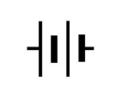

a) Identify component A.____________________________ (1 mark)
b) Identify component B._________________________ (1 mark)
c) Identify component C.____________________________ (1 mark)
d) State one function of component A. (1 mark)
____________________________________________________________________________________________________________________________________________________________________________________________________
e) State one function of component B. (1 mark)
____________________________________________________________________________________________________________________________________________________________________________________________________f) State one function of component C. (1 mark)
____________________________________________________________________________________________________________________________________________________________________________________________________g) Explain why a resistor is used in an electrical circuit. (2 marks)
____________________________________________________________________________________________________________________________________________________________________________________________________h) State one safety precaution when replacing a faulty electrical component. (1 mark)

i) State the unit used to measure resistance. (1 mark)
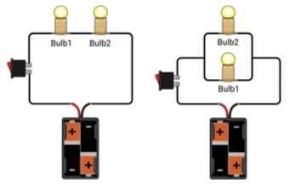
______________________________________________________________________________________________________________________________________________________________________________________________

12. Consider the two arrangements below.

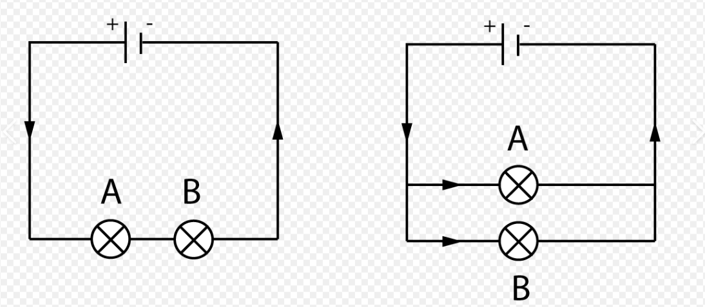

Arrangement A Arrangement B
a) Identify arrangement A.___________________________________ (1 mark)
b) Identify arrangement B. ____________________________________(1 mark)
c) State two characteristics of a arrangement A. (2 marks)
- _________________________________________________________________________________________
- _________________________________________________________________________________________
d) State two characteristics of arrangement B. (2 marks)
- _________________________________________________________________________________________
- _________________________________________________________________________________________
e) Explain why domestic lighting circuits are normally connected in parallel. (2 marks)
____________________________________________________________________________________________________________________________________________________________________________________________________

f) What happens to L2 in arrangement A if L1 develops an open circuit? (1 mark)
____________________________________________________________________________________________________________________________________________________________________________________________________
g) What happens to L2 in arrangement B if L1 develops an open circuit? (1 mark)

___________________________________________________________________________________________________________________________________________________________________________________________________13. The cell in the figure below has an emf of 2.1V and negligible internal resistance.
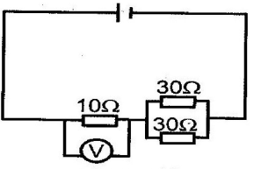
a) Determine the
    - Total resistance in the circuit (2 marks)

    - Current in the circuit (1 mark)

    - Reading on the voltmeter (2 marks)

b) Explain why an ammeter is connected in series. (2 marks)
____________________________________________________________________________________________________________________________________________________________________________________________________
c) Explain why a voltmeter is connected in parallel. (2 marks)
____________________________________________________________________________________________________________________________________________________________________________________________________
d) State one precaution when taking electrical measurements. (1 mark)
____________________________________________________________________________________________________________________________________________________________________________________________________

14. Study the simplified domestic installation arrangement below.
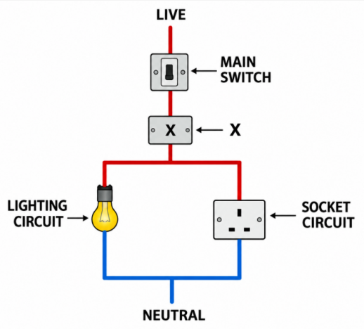
a) Identify the device labelled X. (1 mark)
_______________________________________________________________________________________________

b) State the main function of the parts you have identified in 14(a) above. (2 marks)
______________________________________________________________________________________________________________________________________________________________________________________________
c) Explain what happens when the current flowing through a protected circuit becomes excessively high. (2 marks)
______________________________________________________________________________________________________________________________________________________________________________________________
d) State two advantages of using an MCB instead of a conventional fuse. (2 marks)
- _________________________________________________________________________________________
- _________________________________________________________________________________________
e) State three precautions that should be observed when carrying out domestic electrical installation work. (3 marks)
- _________________________________________________________________________________________
- _________________________________________________________________________________________
- _________________________________________________________________________________________

15.A school workshop operates the following appliances:
Appliance | Power Rating | Daily Operating Time
Electric kettle | 2,000 W | 1 hour
Drill | 750 W | 2 hours
Lighting | 500 W | 6 hours
Assume the workshop operates for 5 days.
a) Calculate the energy consumed by the electric kettle in one day in kWh. (2 marks)

b) Calculate the energy consumed by the drill in one day in kWh. (2 marks)

c) Calculate the energy consumed by the lighting system in one day in kWh. (2 marks)

d) Calculate the total electrical energy consumed by all three appliances in five days. (3 marks)

e) State one practical measure the school could take to reduce electricity consumption. (1 mark)
_________________________________________________________________________________________
_________________________________________________________________________________________

KENYA CERTIFICATE OF BASIC EDUCATION

SENIOR SCHOOL ASSESSMENT

DECEMBER ASSIGNMENT 2026
GRADE 10 – ENGLISH
Time: 2 Hours
LEARNER’S DETAILS
Name: _____________________________________________________________. School: ____________________________________________.
Assessment Number: _______________________________________________. Date: ____________________________________________.
School Code: ______________________________________________________. Signature: _______________________________________.

INSTRUCTIONS TO CANDIDATES
- Answer ALL questions.
- Write your answers clearly in the spaces provided.
- Read each question carefully before answering.
- Give complete and grammatically correct answers where required.
- This examination consists of TWO sections:
  - Section A: Reading and Comprehension – 30 marks
  - Section B: Grammar and Functional Writing – 50 marks

FOR OFFICIAL USE ONLY (EXAMINER’S USE)
SECTION | A | B | C | D | E | % SCORE | EE1 | EE2 | ME1 | ME2 | AE1 | AE2 | BE1 | BE2
SCORE RANGE | 10 MARKS | 20 MARKS | 25 MARKS | 5 MARKS | 20 MARKS |  | 90–100 | 75–89 | 58–74 | 41–57 | 31–40 | 21–30 | 11–20 | 1–10
POINTS |  |  |  |  |  |  | 8 POINTS | 7 POINTS | 6 POINTS | 5 POINTS | 4 POINTS | 3 POINTS | 2 POINTS | 1 POINT
LEARNER’S TOTAL SCORE

SECTION A: 30 MARKS

1: Identify the underlined word in each sentence and state the part of speech it represents. (5 marks)
a) The students worked diligently throughout the examination. ______________________________________.
b) Although it was raining, the team continued with the match. ______________________________________.
c) The teacher gave them an additional exercise. ______________________________________.
d) The carpenter made a beautiful table. ______________________________________.
e) The children walked through the narrow corridor. ______________________________________.

2: Rewrite each sentence correctly by choosing the appropriate form of the verb in brackets. (5 marks)
a) Neither the teacher nor the students (was/were) ready for the inspection.
_____________________________________________________________________________________________
b) The basket of oranges (is/are) on the table.
_____________________________________________________________________________________________
c) Each of the candidates (has/have) submitted the assignment.
_____________________________________________________________________________________________
d) The news from the school (was/were) encouraging.
_____________________________________________________________________________________________
e) My brother and his friend (plays/play) football every Saturday.
_____________________________________________________________________________________________

3: Complete each sentence using the correct form of the verb in brackets. (5 marks)
a) By the time the bus arrived, we __________________________ the station. (leave)
b) She __________________________ her homework when the lights went off. (do)
c) The students __________________________ the project next week. (complete)
d) I __________________________ this book twice since January. (read)
e) When I reached home yesterday, my mother __________________________ dinner. (prepare)

4: Rewrite each sentence by supplying an appropriate pronoun or determiner in the blank. (5 marks)
a) Jane and I completed the work by __________________________.
b) The teacher asked John whether the bag belonged to __________________________.
c) There isn't __________________________ water left in the tank.
d) __________________________ of the two boys received a certificate.
e) The children forgot __________________________ books at home.

5: Fill in each blank with an appropriate preposition or conjunction. (5 marks)
a) The meeting begins __________________________ 8.00 a.m.
b) We stayed indoors __________________________ it was raining heavily.
c) The prefect walked __________________________ the classroom and addressed the students.
d) You will succeed __________________________ you work hard.
e) The teacher was pleased __________________________ the students' performance.

6: Rewrite each sentence according to the instructions given without changing its meaning. (5 marks)
a) The boy is too young to drive a car.
Begin: The boy is so...
_____________________________________________________________________________________________
b) “I have completed my assignment,” Mary said.
Rewrite in reported speech.
_____________________________________________________________________________________________
c) Despite being tired, the athlete continued running.
Begin: Although...
_____________________________________________________________________________________________
d) The teacher praised the student because he had worked hard.
Begin: Having...
_____________________________________________________________________________________________
e) It is possible that John will win the competition.
Rewrite using may.
_____________________________________________________________________________________________

SECTION B:– 50 MARKS

7: The paragraph below contains ten grammatical errors. Rewrite it correctly.
Last Monday, our class were preparing for an educational trip. The teacher tell us that each student must brings enough food and water. Neither the students nor the teacher were willing to arrive late. When the bus arrived, everyone have boarded quickly. Our guide, who were a very experienced man, welcomed us warmly. He advised us to listened carefully and obey all the instructions.
(10 marks)
______________________________________________________________________________________________________________________________________________________________________________________________________________________________________________________________________________________________________________________________________________________________________________________________________________________________________________________________________________________________________________________________________________________________________________________________________________________________________________________________________________________________________________________________________________________________________________________________________________________________________________________________________________________________________________________________________________________________________________________________________________________________________________________________________________________________________________________

8: Rewrite the following sentences in the passive voice. (5 marks)
a) The students cleaned the laboratory after the experiment.
_____________________________________________________________________________________________
b) The school will organize a cultural day next month.
_____________________________________________________________________________________________
c) The prefect has announced the examination timetable.
_____________________________________________________________________________________________
d) The carpenter was repairing the broken desk.
_____________________________________________________________________________________________
e) The committee had approved the proposal before the meeting ended.
_____________________________________________________________________________________________
_____________________________________________________________________________________________

9: Rewrite the following sentences in reported speech. (5 marks)
a) “I am studying for my examination,” Peter said.
_____________________________________________________________________________________________
b) “We shall visit the museum tomorrow,” the students said.
_____________________________________________________________________________________________
c) “Do you understand the instructions?” the teacher asked me.
_____________________________________________________________________________________________
d) “Please close the window,” the teacher told Brian.
_____________________________________________________________________________________________
e) “Why did you arrive late?” the principal asked the student.
__________________________________________________________________________________________________________________________________________________________________________________________

10: Complete or transform the following sentences as instructed. (5 marks)
a) If you work hard, you __________________________ the examination. (pass)
b) If I had enough money, I __________________________ a new computer. (buy)
c) If they had left early, they __________________________ the train. (catch)
d) Rewrite using unless:
You will fail if you do not revise adequately.
_____________________________________________________________________________________________
e) Rewrite as a third conditional sentence:
She did not carry an umbrella, so she got wet.
_____________________________________________________________________________________________

11: Join each pair of sentences using an appropriate relative pronoun. (5 marks)
a) The woman is our new principal. She addressed the students yesterday.
_____________________________________________________________________________________________
b) I borrowed a book from the library. The book is very interesting.
_____________________________________________________________________________________________
c) The boy won the scholarship. His father is a farmer.
_____________________________________________________________________________________________
d) We visited a school. The school has modern laboratories.
_____________________________________________________________________________________________
e) I met a teacher. You recommended the teacher to me.
_____________________________________________________________________________________________

12: Rewrite the following passage correctly, using appropriate capital letters and punctuation marks.
last friday our english teacher said students you should prepare yourselves for the end of year examination she then asked who among you has revised all the topics peter replied i have revised most of them but i need more practice
(5 marks)
___________________________________________________________________________________________________________________________________________________________________________________________________________________________________________________________________________________________________________________________________________________________________________________________________________________________________________________________________________________________

13: Follow the instructions given in each item. (5 marks)
a) Combine the sentences using not only...but also:
The candidate was intelligent. The candidate was hardworking.
_____________________________________________________________________________________________
b) Begin with Hardly:
The bell had rung when the students entered the classroom.
_____________________________________________________________________________________________
c) Rewrite using too...to:
The box is so heavy that the child cannot lift it.
_____________________________________________________________________________________________
d) Begin with No sooner:
The teacher entered the room than the students became quiet.
_____________________________________________________________________________________________
e) Rewrite using unless:
You cannot enter the laboratory if you do not have permission.
_____________________________________________________________________________________________
Cloze Test (5 marks)
14: Read the passage below and fill in each blank with an appropriate word.
Education plays an important role __________ (a) the development of an individual. A learner who is committed __________ (b) his or her studies is likely to perform well. Success does not come __________ (c) hard work and discipline. Students should therefore make good use __________ (d) their time and avoid activities that interfere __________ (e) their studies.

KENYA CERTIFICATE OF BASIC EDUCATION

SENIOR SCHOOL ASSESSMENT

DECEMBER ASSIGNMENT 2026
GRADE 10 – ESSENTIAL MATHEMATICS
Time: 2 Hours
LEARNER’S DETAILS
Name: _____________________________________________________________. School: ____________________________________________.
Assessment Number: _______________________________________________. Date: ____________________________________________.
School Code: ______________________________________________________. Signature: _______________________________________.

INSTRUCTIONS TO CANDIDATES
- Write your full name in the space provided above.
- Indicate your school, stream, admission number, and date clearly.
- This paper has TWO sections: A and B.
- Attempt ALL questions in both sections.
- Show all working clearly where necessary.
- Write all answers in the spaces provided.
- Do NOT remove any page from this paper.

FOR OFFICIAL USE ONLY (EXAMINER’S USE)
SECTION | SECTION A | SECTION B | % SCORE | EE1 | EE2 | ME1 | ME2 | AE1 | AE2 | BE1 | BE2
SCORE RANGE | 30 MARKS | 50 MARKS |  | 90-100 | 75-89 | 58-74 | 41-57 | 31-40 | 21-30 | 11-20 | 1-10
POINTS |  |  |  | 8 POINTS | 7 POINTS | 6 POINTS | 5 POINTS | 4 POINTS | 3 POINTS | 2 POINTS | 1 POINT
TOTAL SCORE

SECTION A (30 MARKS)

Answer ALL questions in this section.

(a) Without using a calculator, simplify the following expression into a single fraction in its lowest terms:
$\frac{−2.4×(−1.5)+\frac{3}{5}}{{\left(\frac{1}{2}\right)}^{−3}÷4}$ [3 marks]

(b) Use a calculator to determine the reciprocal of $0.0325$, giving your answer correct to 4 significant figures. [2 marks]

(a) Solve for $x$ in the exponential equation:
$9^{x+1}×3^{x−2}={27}^{2x−1}$ [3 marks]

(b) Determine whether $\sqrt{18}×\sqrt{2}$is a rational or irrational number.
Show complete working to justify your answer. [2 marks]

- A solid conical decorative piece has a base radius of $6\text{ cm}$ and a slant height of $10\text{ cm}$.

(a) Calculate the total surface area of the cone in terms of $π$. [2 marks]

(b) Calculate the exact volume of the cone in terms of $π$. [3 marks]

- Point $A(3,−2)$ is reflected across the mirror line $y=x$ to obtain point $A^{'}$. Point $A^{'}$ is then reflected across the line $x=−1$ to obtain point $A^{″}$. Determine the final coordinates of point $A^{″}$. [5 marks]

- In $△PQR$, $PQ=14\text{ cm}, PR=9\text{ cm}$ and the included angle $∠QPR={42}^{∘}.$
Calculate the area of $△PQR$, giving your final answer correct to 2 decimal places. [5 marks]

- A bag contains:
- $4$ red marbles,
- $5$ blue marbles, and
- $3$ Green marbles.
Two marbles are drawn sequentially from the bag without replacement. Calculate the probability of drawing one red marble and one blue marble in any order. [5 marks]

SECTION B: 50 MARKS
Answer ALL questions in this section.

(a) A trader bought a laptop in the United States for USD 650.
On the day of purchase, the exchange rate was
$$1\text{ USD}=135.50\text{ KES}.$$
The trader paid an import tax of $15\%$ of the cost price in Kenya Shillings.
Calculate the total cost of importing the laptop into Kenya, in KES. [4 marks]

(b) The trader plans to sell the laptop in Kenya at a net profit margin of 20% on the total cost, including import tax.
Calculate the selling price of the laptop in KES. [3 marks]
If a customer pays for the laptop in Euros, given that $1\text{ EUR}=145.20\text{ KES},$calculate the amount the customer pays in Euros.
Give your answer correct to 2 decimal places. [3 marks]

(a) Solve the following quadratic equation by factorisation:
$$6x^{2}−11x−35=0$$
[4 marks]

(b) A rectangular garden plot has a length that is $7\text{ m}$ longer than its width.
Let the original width be $w$ metres.
The original length is therefore
$$(w+7)\text{ m}.$$
If the length is reduced by $2\text{ m}$ and the width is doubled, the area of the new rectangular plot increases by $88{\text{ m}}^{2}$.

(i) Formulate a quadratic equation in terms of the original width $w$. [3 marks]

(ii) Solve the quadratic equation to determine the original dimensions of the garden. [3 marks]

- Two geometrically similar solid pyramids, Pyramid S and Pyramid L, have base areas of $45{\text{ cm}}^{2}$
and $180{\text{ cm}}^{2}$respectively.

(a) Find the area scale factor from Pyramid S to Pyramid L, giving your answer in its simplest form. [2 marks]

(b) Deduce the corresponding linear scale factor from Pyramid S to Pyramid L. [2 marks]

(c) If the height of Pyramid L is $24\text{ cm}$, calculate the height of Pyramid S. [3 marks]

(d) Pyramid S has a volume of $120{\text{ cm}}^{3}$.
Calculate: [3 marks]

(i) the volume of Pyramid L; and

(ii) the capacity of Pyramid L in litres.

- A surveyor standing at ground level at point $X$ observes the top of a vertical tower $T$ at an angle of elevation of ${32}^{∘}$.
The surveyor then walks $40\text{ m}$ directly towards the base of the tower to point $Y$. From $Y$, the angle of elevation to the top of the tower increases to ${54}^{∘}$.

(a) Draw a clearly labelled diagram showing:
- point $X$;
- point $Y$;
- the base of the tower $B$;
- the top of the tower $T$;
- the $40\text{ m}$ distance between $X$ and $Y$;
- the height $h$ of the tower; and
- the angles of elevation ${32}^{∘}$ and ${54}^{∘}$.
[3 marks]

(b) Let
$$YB=d\text{ m}.$$
Formulate two trigonometric equations involving $h$ and $d$.
Hence, calculate the height $h$ of the tower, correct to 2 decimal places. [5 marks]

(c) Calculate the direct distance from point $X$ to the top of the tower $T$, correct to 2 decimal places.
[2 marks]

- The table below shows the marks obtained by 40 Grade 10 students in a Mathematics assessment test.
Mark Range | Frequency $f$
$10−19$​ | 4
$20−29$​ | 7
$30−39$​ | 12
$40−49$​ | 11
$50−59$​ | 6
Total | 40

(a) Construct a complete frequency distribution table showing:
- Mark range;
- Midpoint $x$;
- Frequency $f$;
- Product $fx$;
- Cumulative frequency $cf$.
[3 marks]

(b) Calculate the estimated mean mark of the distribution.
[3 marks]

(c) Two students are chosen at random from the class, one after another, without replacement.
Calculate the probability that:
(i) both students scored 30 marks or more; [2 marks]

(ii) one student scored in the $10−19$ range and the other student scored in the $50−59$ range. [2 marks]

ELIMU MSINGI INAYOENDANA NA UMAHIRI (CBE)

TATHMINI YA SHULE ZA SEKONDARI (DARAJA LA JUU)

TATHMINI YA DISEMBA – 2026

GREDI YA 10 – FASIHI YA KISWAHILI
Muda: Saa 2

TAARIFA ZA MTAHINIWA
JINA: _____________________________________________________ SHULE: ____________________________________________________
DARASA: ___________________________________________ NAMBARI YA MTIHANI: ____________________________________________
TAREHE: ________________________________________________ SAINI: ______________________________________________________

MAELEKEZO KWA WATAHINIWA
- Andika jina lako na taarifa zote muhimu katika nafasi ulizopewa.
- Karatasi hii ina sehemu mbili: A na B.
- Jibu maswali yote katika sehemu zote mbili.
- Tumia lugha ya Kiswahili sanifu katika majibu yako.
- Andika majibu yako katika nafasi ulizoachiwa.
- Usiondoe ukurasa wowote wa karatasi hii.

KWA MATUMIZI RASMI PEKEE (MATUMIZI YA MTAHINI)
SEHEMU | SEHEMU A | SEHEMU B | ASILIMIA (%) | KUZ 1 | KUZ 2 | KUF1 | KUF2 | KUK1 | KUK2 | CHI1 | CHI2
WIGO LA ALAMA | ALAMA 50 | ALAMA 20 |  | 90–100 | 75–89 | 58–74 | 41–57 | 31–40 | 21–30 | 11–20 | 1–10
POINTI |  |  |  | POINTI 8 | POINTI 7 | POINTI 6 | POINTI 5 | POINTI 4 | POINTI 3 | POINTI 2 | POINTI 1
JUMLA YA ALAMA ZA MWANAFUNZI

SEHEMU A: FASIHI SIMULIZI (Alama 20)
Soma kifungu kifuatacho cha Fasihi Simulizi kwa makini kisha ujibu maswali yanayofuata.
Hapo zamani za kale, katika msitu mkubwa uliokuwa umezungukwa na milima na mabonde, waliishi wanyama wengi. Miongoni mwa wanyama hao walikuwa Kinyonga na Sungura, ambao walikuwa marafiki wa karibu. Wanyama wengine walimjua Sungura kwa ujanja wake na kwa kujivunia kuwa yeye ndiye mnyama mwenye kasi zaidi msituni. Kinyonga, kwa upande mwingine, alikuwa mtulivu, mwenye subira na mwenye kutumia akili kabla ya kufanya jambo.
Siku moja, wanyama walikusanyika chini ya mti mkubwa baada ya shughuli zao za kila siku. Sungura alianza kujigamba mbele ya wanyama wenzake.
“Hakuna mnyama yeyote katika msitu huu anayeweza kunishinda kwa mbio. Mimi nikianza kukimbia, hata upepo hushindwa kunifikia!” Sungura alisema huku akicheka kwa majivuno.
Wanyama wengine walicheka, huku Kinyonga akimtazama kwa utulivu. Kisha Kinyonga akasema:
“Kasi si kila kitu maishani. Wakati mwingine akili na subira humsaidia mtu kufikia lengo kuliko nguvu.”
Sungura alikasirika kusikia maneno hayo.
“Wewe Kinyonga? Unataka kushindana nami kwa mbio? Hata kabla hujaanza, nitakuwa nimefika mwisho wa mashindano!” alisema kwa dharau.
Wanyama walipoona mvutano huo, walipendekeza wafanye mashindano ili kubaini ukweli. Waliweka mstari wa kuanzia na mwingine wa kumalizia karibu na mto uliokuwa upande wa pili wa msitu. Mzee Kobe aliteuliwa kuwa mwamuzi wa mashindano hayo.
Siku ya mashindano ilipofika, wanyama wengi walikusanyika kushuhudia. Sungura alifika mapema akiwa na furaha na kuanza kujinyoosha tayari kwa mbio. Kinyonga naye alifika kwa utulivu bila kuonyesha hofu yoyote.
Mzee Kobe alipotoa ishara ya kuanza, Sungura alikimbia kwa kasi sana. Kinyonga alianza kutembea polepole kama kawaida yake. Sungura alipokuwa mbali mbele, aligeuka na kucheka.
“Nilikwambia! Huwezi kunifikia hata kesho!” alisema.
Kinyonga hakujibu. Alijua kuwa ushindi haupatikani kwa haraka pekee bali pia kwa kutumia akili.
Kabla ya mashindano kuanza, Kinyonga alikuwa amepanga mbinu yake. Alikuwa amejishikiza kwa siri kwenye mkia wa Sungura bila Sungura kutambua. Sungura aliendelea kukimbia kwa kasi, huku Kinyonga akiwa ameshikilia mkia wake.
Walipokaribia mstari wa mwisho, Sungura aliona wanyama wakipiga kelele na kushangilia. Akafikiri kuwa alikuwa ameshinda. Alipofika kwenye mstari wa mwisho, alisimama na kugeuka nyuma ili kuwadhihirishia wanyama jinsi alivyokuwa mwepesi.
Ghafla, Kinyonga alidondoka kutoka kwenye mkia wake na kutua upande wa mbele wa mstari wa mwisho.
Wanyama wote walipiga makofi na kushangilia.
“Kinyonga ameshinda!” walipaza sauti.
Sungura alibaki ameduwaa. Hakuamini macho yake. Alikuwa ameshindwa na mnyama ambaye alikuwa amemdharau kwa sababu ya mwendo wake wa polepole.
Mzee Kobe alimwita Sungura na kumwambia:
“Mwanangu, leo umejifunza somo muhimu. Usimdharau mtu kwa sababu ya mwonekano wake au uwezo unaouona kwa macho. Kila mmoja ana kipawa chake.”
Sungura aliinama kwa aibu na kumwomba Kinyonga msamaha.
“Nimejifunza kwamba kujivuna hakunifanyi kuwa bora kuliko wengine. Kuanzia leo nitawaheshimu wanyama wenzangu,” alisema.
Kinyonga akamjibu kwa upole:
“Ushindi wa kweli si kumshinda mwingine tu, bali ni kujifunza kutokana na makosa yako.”
Tangu siku hiyo, Sungura aliacha kujivuna na kuanza kuwaheshimu wanyama wengine. Wanyama wa msituni nao walitambua kuwa akili, unyenyekevu, subira na busara ni muhimu kuliko kujivuna kwa uwezo wa mtu.

MASWALI
(a) Bainisha kipera cha Fasihi Simulizi kilichotumika katika kifungu hiki na utoe sababu moja ya jibu lako. (Alama 2)
.............................................................................................................................................................................................
............................................................................................................................................................................................
(b) Eleza sifa nne za kipera ulichokitaja katika (a). (Alama 4)
(i) ........................................................................................................................................................................................
(ii) .......................................................................................................................................................................................
(iii) ......................................................................................................................................................................................
(iv) ......................................................................................................................................................................................
(c) Fafanua madhumuni matatu ya utambaji wa ngano za aina hii katika jamii. (Alama 6)
(i) .......................................................................................................................................................................................
(ii) .......................................................................................................................................................................................
(iii) ......................................................................................................................................................................................
(d) Onyesha njia nne ambazo msimulizi anaweza kutumia ili kuifanya hadithi hii ivutie zaidi wakati wa uwasilishaji. (Alama 8)
(i) ......................................................................................................................................................................................
(ii) ........................................................................................................................................................................................
(iii) ......................................................................................................................................................................................
(iv) ......................................................................................................................................................................................

SEHEMU B: USHAIRI (Alama 20)

SWALI LA 2 –
Soma shairi lifuatalo kwa makini kisha ujibu maswali yanayofuata.

MWANGA WA KESHO
Mti uliopandwa vema, matunda mema hutoa,
Kijana aliye na wema, jamii humsifia,
Elimu ni taa njema, gizani inayoangaza,
Soma kwa bidii mwana, kesho yako kuijenga.
Siku zinasonga mbele, maisha hayatulii,
Uvivu uweke mbali, bidii ikuongoze,
Nchi inakutazama, uwe nguzo ya kesho,
Jasho la mtu hodari, mafanikio huleta.
Usikate tamaa kamwe, shida zikikufikia,
Vikwazo vitakapotokea, usirudi nyuma mwana,
Subira ikiongoza, malengo utayafikia,
Kwa moyo wa matumaini, maisha yatang'ara.
Wazazi waheshimu sana, walimu nao wasikilize,
Maarifa uyatafute, kila siku uyapate,
Vipawa vyako vitumie, kwa manufaa ya jamii,
Kesho ikiwa njema, ni matokeo ya leo.
Kijana wewe ni nguvu, taifa linakutegemea,
Kwa maarifa na juhudi, maendeleo yatazuka,
Uadilifu uwe ngao, bidii iwe mwongozo,
Jenga taifa kwa upendo, kesho itakuwa njema.

MASWALI
(a) Onyesha na ueleze muundo wa shairi hili kwa kuzingatia yafuatayo: (Alama 4)
(i) Taja idadi ya beti katika shairi hili na idadi ya mishororo katika kila ubeti. (Alama 2)
.........................................................................................................................................................................................
.........................................................................................................................................................................................
(ii) Eleza urari wa vina katika ubeti wa kwanza. (Alama 2)
..........................................................................................................................................................................................
..........................................................................................................................................................................................
(b) Fafanua uhuru/ustaarabu wa mshairi uliotumiwa katika shairi hili na utoe mifano miwili kutoka kwenye shairi. (Alama 4)
..........................................................................................................................................................................................
..........................................................................................................................................................................................
..........................................................................................................................................................................................
..........................................................................................................................................................................................
(c) Eleza dhamira kuu ya mshairi katika shairi hili. (Alama 3)
..........................................................................................................................................................................................
..........................................................................................................................................................................................
..........................................................................................................................................................................................

(d) Andika ubeti wa kwanza wa shairi hili kwa lugha ya nathari (lugha ya kawaida). (Alama 4)
..........................................................................................................................................................................................
..........................................................................................................................................................................................
..........................................................................................................................................................................................
..........................................................................................................................................................................................
(e) Eleza maana ya msamiati ufuatao kama ulivyotumiwa katika shairi. (Alama 5)
(i) Inaangaza (Alama 1)
..........................................................................................................................................................................................
..........................................................................................................................................................................................
(ii) Nguzo (Alama 1)
..........................................................................................................................................................................................
..........................................................................................................................................................................................
(iii) Uvivu (Alama 1)
..........................................................................................................................................................................................
..........................................................................................................................................................................................
(iv) Vikwazo (Alama 1)
..........................................................................................................................................................................................
..........................................................................................................................................................................................
(v) Uadilifu (Alama 1)
..........................................................................................................................................................................................
..........................................................................................................................................................................................

SEHEMU C: TAMTHILIA (Alama 30)

SWALI LA 3:
Soma dondoo lifuatalo kisha ujibu maswali yanayofuata.
KIZITO: Siasa yenyewe huielewi, pengine ya kina mkataba...
DINCO: Kalale wewe! Mimi siwezi siasa za pesa nyeupe...
(Anaweka kibonzo kinachocha...)
KIZITO: Tumechoka na ahadi za uongo. Tuliahidiwa kazi kwa vijana wote. Leo hata waliohitimu hawana kazi. Seuze wasiohitimu!
MODE: Unasoma miaka kumi na sita na kutafuta kazi miaka kumi na sita. Ukienda kutafuta kazi unaambiwa kuwa you are overqualified. Wanawataka waliofika hadi chumba cha nane shuleni ndio wawalipe mshahara mdogo.
KIZITO: Huku kwetu kozi ya kutafuta kazi ndiyo kozi ngumu zaidi kuliko kazi yenyewe. Pengine mfumo mpya wa elimu unaoegemea ujuzi utatufaa zaidi.
MODE: Utazunguka na kuzunguka ukitafuta kazi kama humjui mtu.
MBUYU: Waache uvivu wafanye kazi za mikono kama uvuvi. Isitoshe, mfumo mpya wa elimu unaolenga ujuzi unanuia kutufaa kwa kusisitiza utendaji wala si ukariri wa nadharia.
MODE: (Huku akienda miayo.) Hatukatai, lakini nafasi za kazi zinafaa zitolewe bila mapendeleo, na kwa haki.
KIZITO: Watavua wapi kama visiwa ndiyo vyetu na maji yanayovizingira visiwa si yetu?

(a) Weka dondoo hili katika muktadha wake.
(i) Msemaji mkuu wa dondoo hili ni nani? (Alama 2)
..........................................................................................................................................................................................
..........................................................................................................................................................................................
(ii) Msemewa wa maneno haya ni nani? (Alama 2)
..........................................................................................................................................................................................
..........................................................................................................................................................................................
(iii) Eleza mazingira ambayo mazungumzo haya yalitokea. (Alama 2)
..........................................................................................................................................................................................
..........................................................................................................................................................................................

(b)
Fafanua maudhui manne yanayojitokeza katika dondoo hili na ueleze jinsi kila mojawapo linavyoendelezwa katika kazi nzima. (Alama 8)
..........................................................................................................................................................................................
..........................................................................................................................................................................................

(c)
Tathmini sifa nne za Kizito kwa kuzingatia kauli na matendo yake katika dondoo hili na mchango wake katika kazi nzima. (Alama 8)
..........................................................................................................................................................................................
..........................................................................................................................................................................................
..........................................................................................................................................................................................
..........................................................................................................................................................................................

(d)
Jadili jinsi maudhui ya umaskini na bidii yanavyosawiriwa katika jamii ya leo. Toa mifano inayodhihirisha uhalisia wa maudhui haya. (Alama 8)
..........................................................................................................................................................................................
..........................................................................................................................................................................................
..........................................................................................................................................................................................
..........................................................................................................................................................................................

SEHEMU D: (Alama 30)

SWALI LA 4:
Soma hadithi ifuatayo kasha ujibu maswali yafuatayo
Hapo zamani za hivi karibuni, katika kijiji cha Mwangaza, aliishi kijana mmoja aliyeitwa Musa. Musa alikuwa mtoto wa familia maskini iliyotegemea kilimo kidogo na ufugaji wa mifugo michache. Baba yake alikuwa mkulima wa kawaida huku mama yake akiuza mboga katika soko la kijiji ili kusaidia familia kupata mahitaji ya kila siku.
Musa alikuwa mwanafunzi mwenye bidii. Kila asubuhi aliamka mapema, akawasaidia wazazi wake kufanya kazi za nyumbani kabla ya kuelekea shuleni. Alitembea karibu kilomita tano kwenda shule. Licha ya uchovu, hakuruhusu hali hiyo imzuie kusoma. Mara nyingi aliwasili shuleni kabla ya wanafunzi wenzake.
Mwalimu wake, Bi. Amina, aligundua kuwa Musa alikuwa na kipawa kikubwa cha kujifunza. Alikuwa akimsisitiza asikate tamaa kwa sababu mazingira aliyokuwa akiishi hayakuwa kigezo cha kuamua mustakabali wake.
Siku moja, Bi. Amina aliwaambia wanafunzi kuwa shule ilikuwa imeanzisha mashindano ya kitaifa ya ubunifu. Mshindi angepata ufadhili wa masomo na vifaa vya kujifunzia. Wanafunzi wengi walifurahia habari hiyo, lakini Musa alikaa kimya.
“Kwa nini hujafurahia kama wenzako?” mwalimu aliuliza.
Musa akajibu, “Ningependa kushiriki, lakini sina vifaa vya kutengeneza mradi. Wazazi wangu hawawezi kununua vifaa hivyo.”
Bi. Amina akatabasamu na kusema, “Musa, ubunifu hauanzi na pesa. Huanzia kwenye wazo. Tumia vitu vinavyopatikana katika mazingira yako.”
Kauli hiyo ilimpa Musa moyo. Alianza kutafuta vifaa vilivyotupwa katika kijiji. Alikusanya maboksi, chupa za plastiki, vipande vya waya, makopo na mabaki ya mbao. Kwa siku kadhaa alifanya kazi bila kuchoka.
Baada ya wiki mbili, Musa alitengeneza kifaa rahisi cha kukusanya na kuhifadhi maji ya mvua. Alikiita “Mkombozi wa Maji.” Kifaa hicho kingesaidia familia kuhifadhi maji wakati wa mvua na kuyatumia wakati wa kiangazi.
Baadhi ya vijana wa kijiji walimcheka.
“Unadhani utabadilisha dunia kwa maboksi na chupa?” mmoja wao alimdhihaki.
Musa hakukasirika. Alijibu kwa utulivu, “Mabadiliko makubwa huanza kwa hatua ndogo.”
Siku ya mashindano ilipofika, Musa aliwasilisha mradi wake mbele ya majaji. Aliueleza kwa ujasiri na kuonyesha jinsi kifaa hicho kilivyofanya kazi. Majaji walivutiwa na ubunifu wake, hasa kwa sababu alitumia vifaa vilivyopatikana kwa urahisi.
Baada ya mashindano, jina la Musa lilitangazwa kuwa mshindi wa kwanza. Alipata ufadhili wa masomo pamoja na vifaa vya shule.
Habari hizo zilipoenea kijijini, watu waliokuwa wakimcheka hapo awali walimpongeza. Baba yake alimtazama kwa fahari na kusema, “Mwanangu, leo umetufundisha kuwa umaskini si mwisho wa ndoto.”
Mama yake naye alimkumbatia na kumwambia, “Kile ulichokosa kwa pesa umekipata kwa bidii, ubunifu na uvumilivu.”
Musa hakusahau maneno ya mwalimu wake. Aliendelea kusoma kwa bidii na kuwahamasisha vijana wengine kutumia vipawa vyao kutatua matatizo yanayowakabili katika jamii.
Miaka kadhaa baadaye, Musa akawa mhandisi aliyebuni mifumo ya gharama nafuu ya kuhifadhi maji. Alirudi katika kijiji chake na kuanzisha kituo cha kuwafundisha vijana ubunifu na ujasiriamali.
Aliposimama mbele ya vijana hao, alisema:
“Usingoje mazingira mazuri ndipo uanze kutimiza ndoto zako. Anza na ulicho nacho, tumia akili yako, fanya kazi kwa bidii na usikate tamaa.”
Maneno hayo yakawa chanzo cha matumaini kwa vijana wengi wa Mwangaza.

MASWALI

(a)
Fafanua mbinu tano za kisanaa na kiandishi zilizotumiwa na mwandishi katika hadithi hii. Toa mfano kutoka katika hadithi kwa kila mbinu.(Alama 10)
..........................................................................................................................................................................................
..........................................................................................................................................................................................
..........................................................................................................................................................................................
..........................................................................................................................................................................................
..........................................................................................................................................................................................
..........................................................................................................................................................................................
..........................................................................................................................................................................................
..........................................................................................................................................................................................
..........................................................................................................................................................................................
..........................................................................................................................................................................................
..........................................................................................................................................................................................

(b)
Eleza mgogoro mkuu unaojitokeza katika hadithi hii. Onyesha:
- Chanzo cha mgogoro huo.
- Wahusika wanaohusika.
- Jinsi Musa alivyokabiliana nao.
- Jinsi mgogoro huo ulivyotatuliwa.
(Alama 10)

..........................................................................................................................................................................................
..........................................................................................................................................................................................
..........................................................................................................................................................................................
..........................................................................................................................................................................................
..........................................................................................................................................................................................
..........................................................................................................................................................................................
..........................................................................................................................................................................................
..........................................................................................................................................................................................
..........................................................................................................................................................................................
..........................................................................................................................................................................................
..........................................................................................................................................................................................
..........................................................................................................................................................................................
..........................................................................................................................................................................................
..........................................................................................................................................................................................
..........................................................................................................................................................................................
..........................................................................................................................................................................................
..........................................................................................................................................................................................
..........................................................................................................................................................................................
..........................................................................................................................................................................................
..........................................................................................................................................................................................

(c)
Jadili ujumbe mitano ambao msomaji anaweza kujifunza kutokana na tabia na matendo ya wahusika katika hadithi hii. Toa mifano kutoka katika hadithi kuunga mkono kila ujumbe. (Alama 10)

..........................................................................................................................................................................................
..........................................................................................................................................................................................
..........................................................................................................................................................................................
..........................................................................................................................................................................................
..........................................................................................................................................................................................
..........................................................................................................................................................................................
..........................................................................................................................................................................................
..........................................................................................................................................................................................
..........................................................................................................................................................................................
..........................................................................................................................................................................................
..........................................................................................................................................................................................
..........................................................................................................................................................................................
..........................................................................................................................................................................................
..........................................................................................................................................................................................
..........................................................................................................................................................................................
..........................................................................................................................................................................................

KENYA CERTIFICATE OF BASIC EDUCATION

SENIOR SCHOOL ASSESSMENT

ENDTERM ASSESSMENT 2026
GRADE 10 – FINE ARTS
Time: 2 Hours
LEARNER’S DETAILS
Name: _____________________________________________________________. School: ____________________________________________.
Assessment Number: _______________________________________________. Date: ____________________________________________.
School Code: ______________________________________________________. Signature: _______________________________________.

INSTRUCTIONS TO CANDIDATES
- Fill in your name, school name, your assessment number, date, the school code and signature in the spaces provided above.
- This paper consists of two sections: A and B.
- Answer all questions in section A and section B.
- Answer the questions in English.
- All answers MUST be written in the spaces provided in PAPER.
- Do NOT remove any page from this question paper.

FOR OFFICIAL USE ONLY (EXAMINER’S USE)
SECTION | SECTION A | SECTION B | % SCORE | EE1 | EE2 | ME1 | ME2 | AE1 | AE2 | BE1 | BE2
SCORE RANGE | 30 MARKS | 50 MARKS |  | 90-100 | 75-89 | 58-74 | 41-57 | 31-40 | 21-30 | 11-20 | 1-10
POINTS |  |  |  | 8 POINTS | 7 POINTS | 6 POINTS | 5 POINTS | 4 POINTS | 3 POINTS | 2 POINTS | 1 POINT
LEARNER’S TOTAL SCORE

SECTION A: (30 marks) Answer ALL questions in this section.

1. a) Define shape in art. (1 mark)
___________________________________________________________________________________________________________________________________________________________________________________________________
b) State two types of shapes used by artists. (2 marks)
- ____________________________________________________________________________________________
- ___________________________________________________________________________________________
c) Explain the difference between shape and form. (2 marks)

______________________________________________________________________________________________________________________________________________________________________________

2. a) What is meant by texture in art? (1 mark)
___________________________________________________________________________________________________________________________________________________________________________________________________
b) Give two examples of natural textures that an artist may observe. (2 marks)
- _________________________________________________________________________________________
- _________________________________________________________________________________________
c) Name two techniques an artist can use to represent texture in a drawing or painting. (2 marks)
- _________________________________________________________________________________________

- _________________________________________________________________________________________

3. Study the fine arts tools below.

a) Identify three art materials or tools that could be represented by Q, R and S. (3 marks)
Q: _____________________________________
R: ______________________________________
S: _______________________________________
b) State one artistic use of any two of the materials/tools identified. (2 marks)

______________________________________________________________________________________________________________________________________________________________________________

4. a) What are complementary colours? (1 mark)
___________________________________________________________________________________________________________________________________________________________________________________________________
b) Give two pairs of complementary colours. (2 marks)
- _________________________________________________________________________________________
- _________________________________________________________________________________________
c) State two effects that complementary colours can create when placed next to each other. (2 marks)
- _________________________________________________________________________________________
- _________________________________________________________________________________________

5. a) Define printmaking. (1 mark)
_________________________________________________________________________________________________________________________________________________________________________________________________
b) Name two printmaking techniques. (2 marks)
- _________________________________________________________________________________________
- _________________________________________________________________________________________
c) State two materials that can be used to create a simple printmaking surface or block. (2 marks)
- _________________________________________________________________________________________
- _________________________________________________________________________________________

6. a) State one way in which the natural environment can inspire an artist. (1 mark)
____________________________________________________________________________________________________________________________________________________________________________________________________
b) Give two natural materials that may be used in artwork. (2 marks)
- _________________________________________________________________________________________
- _________________________________________________________________________________________
c) Explain two ways in which artists can promote environmental conservation through art. (2 marks)
- _________________________________________________________________________________________
- _________________________________________________________________________________________

SECTION B: 50 MARKS
Answer ALL questions.

7. Your teacher places a metallic cup, a bottle and a round fruit on a table for an observational drawing exercise.
a) State three stages you would follow when beginning the drawing. (3 marks)
- _________________________________________________________________________________________
- _________________________________________________________________________________________
- _________________________________________________________________________________________

b) Explain two ways of representing the metallic surface of the cup. (2 marks)
- _________________________________________________________________________________________
- _________________________________________________________________________________________
c) Name three tonal areas that may be observed when an object is illuminated by a light source. (3 marks)
- _________________________________________________________________________________________
- _________________________________________________________________________________________
- _________________________________________________________________________________________
d) State two reasons why an artist should identify the direction of the light source before shading. (2 marks)
- _________________________________________________________________________________________
- _________________________________________________________________________________________


8. Sir Mwangi bought the following piece of art

a) Identify two principles of design demonstrated by the art (2 marks)
- _________________________________________________________________________________________
- _________________________________________________________________________________________
b) Explain how radial balance can be created in an artwork. (2 marks)
- _________________________________________________________________________________________
- _________________________________________________________________________________________
c) Explain three ways of creating emphasis in a composition. (3 marks)
- _________________________________________________________________________________________
- _________________________________________________________________________________________
- _________________________________________________________________________________________
d) State three qualities of a well-organised composition. (3 marks)
- _________________________________________________________________________________________
- _________________________________________________________________________________________
- _________________________________________________________________________________________

9. A learner is required to produce a landscape showing a road, trees, mountains, houses and a river extending into the distance.
a) What is perspective in drawing? (2 marks)
____________________________________________________________________________________________________________________________________________________________________________________________________
b) Explain how size can be used to show distance in the landscape. (2 marks)
- _________________________________________________________________________________________
- _________________________________________________________________________________________
c) State two ways of showing overlapping forms in a landscape. (2 marks)
- _________________________________________________________________________________________
- _________________________________________________________________________________________
d) Explain two ways of using colour to create atmospheric or aerial perspective. (2 marks)
- _________________________________________________________________________________________
- _________________________________________________________________________________________
e) State two features that may be included in the foreground of the landscape. (2 marks)
- _________________________________________________________________________________________
- _________________________________________________________________________________________

10. A school art club plans to create a sculpture from clay and recycled materials.
a) Define sculpture. (2 marks) ______________________________________________________________________________________________________________________________________________________________________________________________
b) Name three methods of creating or shaping sculpture. (3 marks)
- _________________________________________________________________________________________
- _________________________________________________________________________________________
- _________________________________________________________________________________________

c) Describe two ways of creating surface texture on a clay sculpture. (2 marks)
- _________________________________________________________________________________________
- _________________________________________________________________________________________
d) State three precautions that should be observed when working with clay and sculptural tools. (3 marks)
- _________________________________________________________________________________________
- _________________________________________________________________________________________
- _________________________________________________________________________________________

11. A Kenyan artist produces a series of paintings showing traditional ceremonies, local architecture, clothing, landscapes and everyday community activities.
a) Identify two cultural aspects that may be communicated through such artwork. (2 marks)
- _________________________________________________________________________________________
- _________________________________________________________________________________________
b) Explain two reasons why artists should document and preserve cultural heritage. (2 marks)
- _________________________________________________________________________________________
- _________________________________________________________________________________________
c) Describe three stages involved in appreciating or analysing an artwork. (3 marks)
- _________________________________________________________________________________________
- _________________________________________________________________________________________
- _________________________________________________________________________________________
d) State three ways in which an artist can earn income from visual art. (3 marks)
- _________________________________________________________________________________________
- _________________________________________________________________________________________
- _________________________________________________________________________________________

ÉVALUATION DU NIVEAU SUPÉRIEUR

TRIMESTRE 3: DECEMBER ASSIGNMENT 2026

CLASSE DE 10e – FRANÇAIS
Durée : 2 heures

INFORMATIONS DU CANDIDAT
Nom : _________________________________________.École : ____________________________________.
Numéro d’évaluation : _______________________________. Date : _____________________________.
Code de l’école : ___________________________________.Signature : ____________________________.

INSTRUCTIONS AUX CANDIDATS
- Écrivez votre nom dans les espaces prévus ci-dessus.
- Écrivez le nom de votre école et votre classe dans les espaces prévus.
- Écrivez votre numéro d’admission et la date de l’évaluation dans les espaces prévus.
- Cette épreuve comprend deux sections : A et B.
- Répondez à toutes les questions des sections A et B.
- Répondez aux questions en Francais lorsque cela est demandé.
- Toutes les réponses DOIVENT être écrites dans les espaces prévus dans ce document.
- Ne retirez aucune page de ce sujet d’examen.

FOR OFFICIAL USE ONLY (EXAMINER’S USE)
SECTION | SECTION A | SECTION B | % SCORE | EE1 | EE2 | ME1 | ME2 | AE1 | AE2 | BE1 | BE2
SCORE RANGE | 40 MARKS | 40 MARKS |  | 90-100 | 75-89 | 58-74 | 41-57 | 31-40 | 21-30 | 11-20 | 1-10
POINTS |  |  |  | 8 POINTS | 7 POINTS | 6 POINTS | 5 POINTS | 4 POINTS | 3 POINTS | 2 POINTS | 1 POINT
TOTAL SCORE

SECTION A: 30 MARKS
1: Complete the dialogue below with suitable French expressions. (5 marks)
Pierre: Bonjour, comment t'appelles-tu ?
David: ___________________________________________________________________________________.
Pierre: Quel âge as-tu ?
David: ____________________________________________________________________________________.
Pierre: Tu habites où ?
David: _____________________________________________________________________________________.
Pierre: Quelle est ta nationalité ?
David: _____________________________________________________________________________________.
Pierre: Enchanté de faire ta connaissance.
David: ______________________________________________________________________________________.

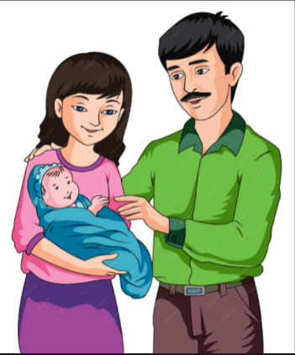
2: Give the French equivalent of each of the following. (5 marks)

A B

A) __________________________________ B) __________________________________
c) Brother – _________________________________
d) Sister – __________________________________
e) Grandmother – ____________________________

3: Rewrite each sentence correctly by changing the adjective to agree with the noun.
a) Marie est intelligent.
_____________________________________________________________________________________________
b) Paul est grande.
_____________________________________________________________________________________________
c) Les filles sont heureux.
_____________________________________________________________________________________________
d) Les garçons sont actif.
_____________________________________________________________________________________________
e) Ma sœur est sportif.
______________________________________________________________________________________________

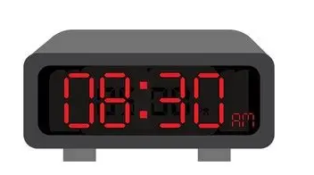

4: Write the following times in French words.

a) ______________________________________ b) ______________________________________

c) 10:15 – _____________________________________
d) 12:00 – _____________________________________
e) 18:45 – _____________________________________

5: Read the passage below and answer the questions that follow.

Le week-end de Kevin
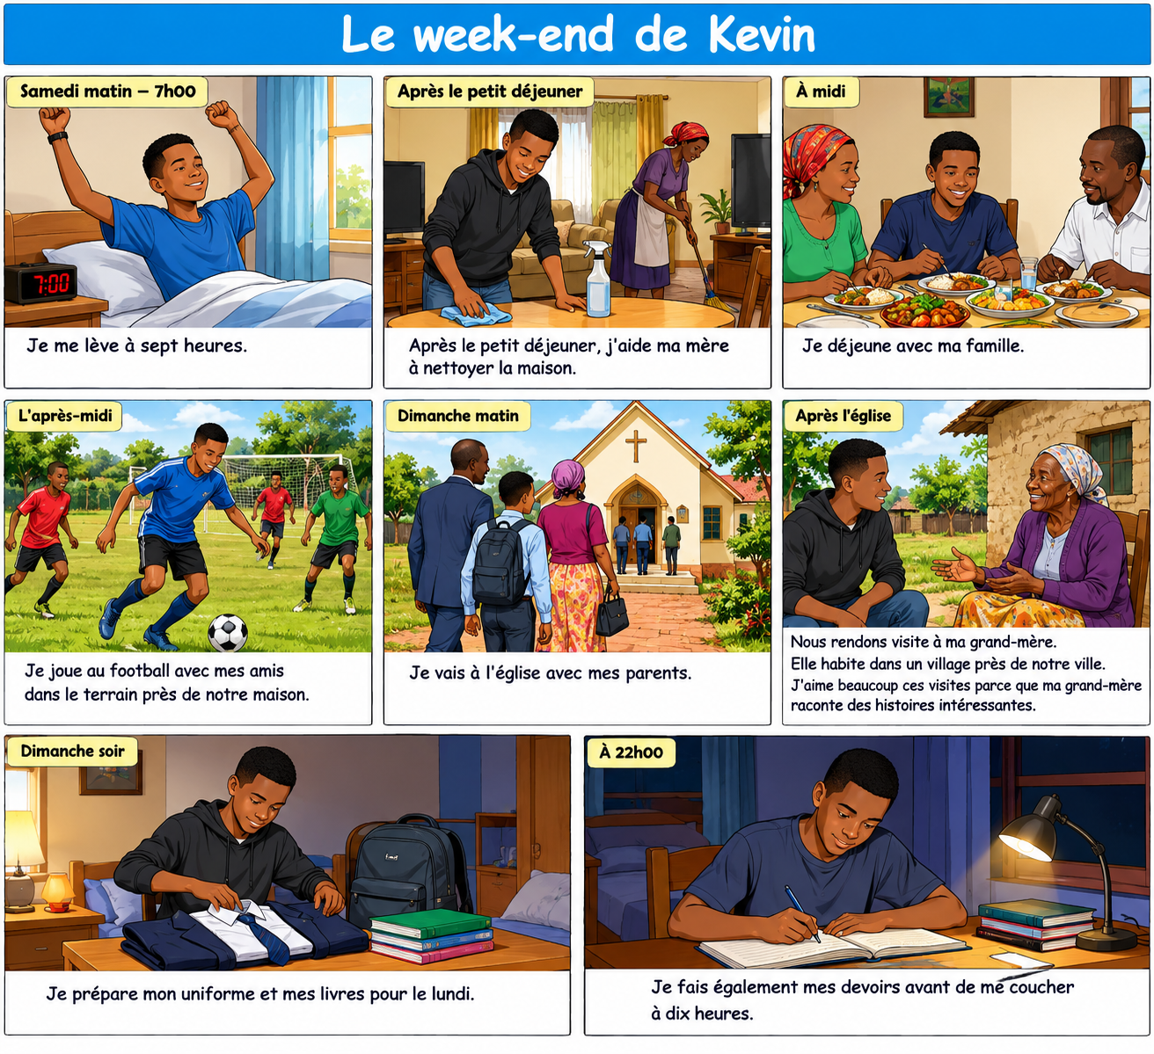
a) Quel âge a Kevin ? (1 mark)
_______________________________________________________________________________________________
b) Où est-ce qu'il étudie ? (1 mark)
_______________________________________________________________________________________________
c) Pourquoi est-il très occupé pendant la semaine ? (2 marks)
______________________________________________________________________________________________
d) À quelle heure se lève-t-il le samedi ? (1 mark)
_______________________________________________________________________________________________
e) Comment aide-t-il sa mère ? (1 mark)
_______________________________________________________________________________________________
f) Que fait-il le samedi après-midi ? (1 mark)
_______________________________________________________________________________________________
g) Avec qui va-t-il à l'église le dimanche ? (1 mark)
_______________________________________________________________________________________________
h) Pourquoi aime-t-il rendre visite à sa grand-mère ? (2 marks)
______________________________________________________________________________________________

SECTION B: 50 MARKS

6: Complete the following conversation appropriately.
Élève: Bonjour, madame.
Professeur: _______________________________________________________________________________.
Élève: Excusez-moi, puis-je entrer ?
Professeur: _______________________________________________________________________________.
Élève: Je suis désolé(e) d'être en retard.
Professeur: _______________________________________________________________________________.
Élève: Où est-ce que je peux m'asseoir ?
Professeur: _______________________________________________________________________________.
Élève: Merci, madame.
Professeur: ________________________________________________________________________________.

B. School Activities – 5 marks
Write five complete French sentences about activities you normally do at school. (5 marks)
Example:
Je lis des livres à la bibliothèque.
- _________________________________________________________________________________________
- _________________________________________________________________________________________
- _________________________________________________________________________________________
- _________________________________________________________________________________________
- _________________________________________________________________________________________

7: Complete the sentences with the correct form of the verb in brackets. (10 marks)
a) Tu __________ le français tous les jours. (étudier)
b) Nous __________ nos devoirs après le dîner. (faire)
c) Elle __________ au marché avec sa mère. (aller)
d) Vous __________ une lettre à votre professeur. (écrire)
e) Ils __________ du football le samedi. (jouer)
f) Je __________ un livre intéressant. (lire)
g) Mes amis __________ très heureux. (être)
h) Nous __________ une nouvelle voiture. (avoir)
i) Paul __________ de l'eau après le sport. (boire)
j) Vous __________ à huit heures. (arriver)

8:

A. Change into the negative. (5 marks)
a) J'aime le français.
_____________________________________________________________________________________________
b) Nous avons une voiture.
____________________________________________________________________________________________
c) Elle mange du riz.
____________________________________________________________________________________________
d) Ils vont à Nairobi.
____________________________________________________________________________________________
e) Tu regardes la télévision.
____________________________________________________________________________________________

B.
Rewrite each statement as a question. (5 marks)
a) Tu habites à Kisumu.
____________________________________________________________________________________________
b) Elle parle français.
___________________________________________________________________________________________
c) Vous aimez le sport.
___________________________________________________________________________________________
d) Ils jouent au football.
___________________________________________________________________________________________
e) Il travaille à l'hôpital.
____________________________________________________________________________________________

9: Write 80–100 words in French on:
Ma journée scolaire(10 marks) ____________________________________________________________________________________________________________________________________________________________________________________________________________________________________________________________________________________________________________________________________________________________________________________________________________________________________________________________________________________________________________________________________________________________________________________________________________________________________________________________________________________________________________________________________________________________________________________________________________________________________________________________________________________________________________________________________________________________________________________________________________________________________________________________________________________________________________________________________________________________________________________________________________________________________________________________________________________________________________________________________________________________________________________________________________________________

10: You have a French-speaking pen pal called Sophie who lives in France. Write a letter of 80–100 words telling her about your school.
Include: (10 marks)
- your school's name;
- where it is located;
- the number of learners;
- subjects you study;
- school facilities;
- your favourite subject;
- your favourite school activity;
- what you like about your school.
_________________________________________________________________________________________________________________________________________________________________________________________________________________________________________________________________________________________________________________________________________________________________________________________________________________________________________________________________________________________________________________________________________________________________________________________________________________________________________________________________________________________________________________________________________________________________________________________________________________________________________________________________________________________________________________________________________________________________________________________________________________________________________________________________________________________________________________________________________________________________________________________________________________________________________________________________________________________________________________________________________________________________________________________________________________________________________________________________________________________________________________________________________________________________________________________________________________________________________________________________________________________________________________________________

F

KENYA CERTIFICATE OF BASIC EDUCATION

SENIOR SCHOOL ASSESSMENT

TERM 3: ENDTERM ASSESSMENT 2026
GRADE 10 – GENERAL SCIENCE
Time: 2 Hours
LEARNER’S DETAILS
Name: _____________________________________________________________. School: ____________________________________________.
Assessment Number: _______________________________________________. Date: ____________________________________________.
School Code: ______________________________________________________. Signature: _______________________________________.

INSTRUCTIONS TO CANDIDATES
- Write your name in the spaces provided above.
- Write the name of your school and your stream in the spaces provided.
- Write your admission number and the date of the assessment in the spaces provided.
- This paper consists of two sections: A and B.
- Answer all questions in section A and section B.
- Answer the questions in English.
- All answers MUST be written in the spaces provided in PAPER.
- Do NOT remove any page from this question paper.

FOR OFFICIAL USE ONLY (EXAMINER’S USE)
SECTION | SECTION A | SECTION B | % SCORE | EE1 | EE2 | ME1 | ME2 | AE1 | AE2 | BE1 | BE2
SCORE RANGE | 35 MARKS | 45 MARKS |  | 90-100 | 75-89 | 58-74 | 41-57 | 31-40 | 21-30 | 11-20 | 1-10
POINTS |  |  |  | 8 POINTS | 7 POINTS | 6 POINTS | 5 POINTS | 4 POINTS | 3 POINTS | 2 POINTS | 1 POINT
LEARNER’S TOTAL SCORE

SECTION A (35 MARKS)
Answer ALL questions in this section.

1. a) Explain what is meant by scientific knowledge. (1 mark)
______________________________________________________________________________________________________________________________________________________________________________________________
b) State three ways in which science and technology have improved life in Kenya. (3 marks)
- _________________________________________________________________________________________
- _________________________________________________________________________________________
- _________________________________________________________________________________________

c) State one reason why scientific investigations should be based on evidence. (1 mark)
_______________________________________________________________________________________________


2. Study the apparatus represented below.

a) Identify the apparatus shown. (1 mark)
_________________________________________________
b) State two uses of this apparatus in a science laboratory. (2 marks)
- _________________________________________________________________________________________
- _________________________________________________________________________________________
c) State two precautions that should be observed when heating substances in a laboratory. (2 marks)
- _________________________________________________________________________________________
- _________________________________________________________________________________________

3. A learner observed cells from a leaf under a light microscope.

a) Identify the type of cell most likely represented by the diagram. (1 mark)
__________________________________________________
b) Name the structures represented by the small oval bodies marked in the diagram. (1 mark)
__________________________________________________

c) State the function of these structures. (1 mark)
_____________________________________________________________________________________________
d) Give two differences between a plant cell and an animal cell. (2 marks)
 | Plant cell | Animal cell

i

ii

4.
Grass → Grasshopper → Frog → Snake → Hawk
a) Identify the producer in the food chain. _____________________________________(1 mark)
b) Identify the primary consumer. _____________________________________(1 mark)
c) State the role of decomposers in an ecosystem. (1 mark)
__________________________________________________________________________________________
d) Explain what would happen to the frog population if the number of grasshoppers decreased greatly. (2 marks)

____________________________________________________________________________________________________________________________________________________________________________________________________

5. A mixture contains sand, salt and water.
a) Name the first method that can be used to remove the sand from the mixture. (1 mark)
_________________________________________________________
b) Describe how salt can be recovered from the remaining solution. (2 marks)

______________________________________________________________________________________________________________________________________________________________________________________________________________________________________________________________________________________________________
c) State one difference between a physical change and a chemical change. (1 mark)

____________________________________________________________________________________________________________________________________________________________________________________________________
d) Give one example of a chemical change in everyday life. (1 mark)

____________________________________________________________________________________________________________________________________________________________________________________________________

6. The figure below shows a hydraulic press P which is used to raise a load of 10KN. A force F of 25N is applied at the end of a lever pivoted at O to raise the load
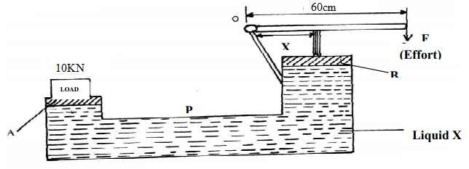
a) State one property of liquid X
____________________________________________________________________________________________________________________________________________________________________________________________________
b) Determine the distance x indicated on the press if force on piston B is 100N
____________________________________________________________________________________________________________________________________________________________________________________________________
c) State one way of increasing pressure when the applied force remains constant. (1 mark)

____________________________________________________________________________________________________________________________________________________________________________________________________

SECTION B: 50 MARKS
Answer ALL questions in this section.

7. A learner carried out an experiment to investigate the importance of light in photosynthesis. Part of a healthy plant was covered with opaque paper and the plant was exposed to sunlight for several hours. The leaf was later tested for starch.
a) State the purpose of covering part of the leaf with opaque paper. (1 mark)
____________________________________________________________________________________________________________________________________________________________________________________________________
b) Name the food substance tested for in the leaf. (1 mark) ____________________________________________________________________________________________________________________________________________________________________________________________________
c) Name the reagent used to test for the substance in (b). (1 mark) ____________________________________________________________________________________________________________________________________________________________________________________________________
d) State the colour change expected when the test is positive. (1 mark) ____________________________________________________________________________________________________________________________________________________________________________________________________
e) Write the word equation for photosynthesis. (2 marks) ____________________________________________________________________________________________________________________________________________________________________________________________________
f) State two conditions necessary for photosynthesis apart from light. (2 marks)
- _________________________________________________________________________________________
- _________________________________________________________________________________________

8. Study the diagram of the female reproductive system.

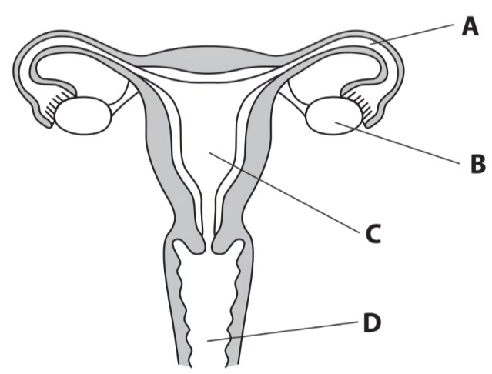
a) Name the part marked C. (1 mark)
____________________________________________________
b) State the function of the marked A. (2 marks)
_____________________________________________________________________________________________
c) Define fertilisation. (2 marks)
____________________________________________________________________________________________________________________________________________________________________________________________________
d) Distinguish between puberty and adolescence. (2 marks)
____________________________________________________________________________________________________________________________________________________________________________________________________
e) State one importance of reproductive health education among adolescents. (1 mark)
____________________________________________________________________________________________________________________________________________________________________________________________________

9. A community experiences an outbreak of a water-borne disease after heavy rainfall. Several residents develop diarrhoea and vomiting.
a) Explain how contaminated water can cause disease. (2 marks)
____________________________________________________________________________________________________________________________________________________________________________________________________
b) State three measures that can be used to prevent water-borne diseases. (3 marks)
- _________________________________________________________________________________________
- _________________________________________________________________________________________
- _________________________________________________________________________________________
c) Distinguish between a pathogen and a vector. (2 marks)
____________________________________________________________________________________________________________________________________________________________________________________________________
d) Give one example of a disease transmitted by a vector. (1 mark)
____________________________________________________________________________________________________________________________________________________________________________________________________

10. A learner placed dilute hydrochloric acid in a flask and added calcium carbonate chips. The flask was connected to a gas collection system.
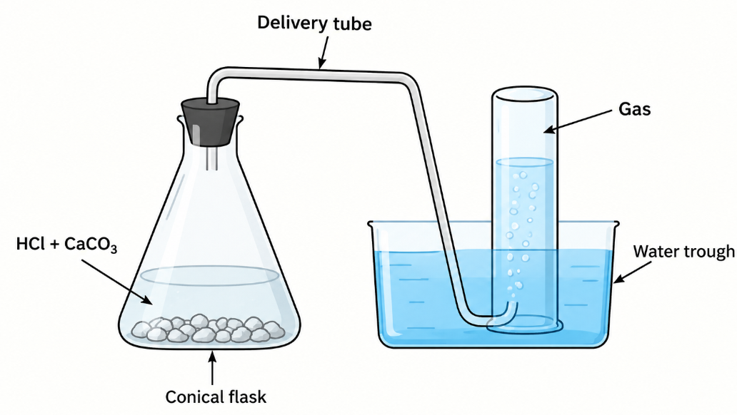
a) Name the gas produced in the reaction. (1 mark)
_____________________________________________
b) Describe a simple test for the gas. (2 marks)
____________________________________________________________________________________________________________________________________________________________________________________________________
c) Write the word equation for the reaction. (2 marks)
____________________________________________________________________________________________________________________________________________________________________________________________________
d) State two observations that would be made during the reaction. (2 marks)
- _________________________________________________________________________________________
- _________________________________________________________________________________________
e) Explain the meaning of the law of conservation of mass. (2 marks)
____________________________________________________________________________________________________________________________________________________________________________________________________

11. A learner uses a simple machine to raise a load of 400 N by applying an effort of 100 N.
a) Define a machine. (1 mark)
____________________________________________________________________________________________________________________________________________________________________________________________________
b) Calculate the mechanical advantage of the machine. (2 marks)

c) State two advantages of using machines. (2 marks)
- _________________________________________________________________________________________
- _________________________________________________________________________________________
d) If the machine has a velocity ratio of 5, calculate its efficiency. (2 marks)

e) Give one example of a simple machine used in the home. (1 mark)
__________________________________________________________________

12. Study the circuit below.
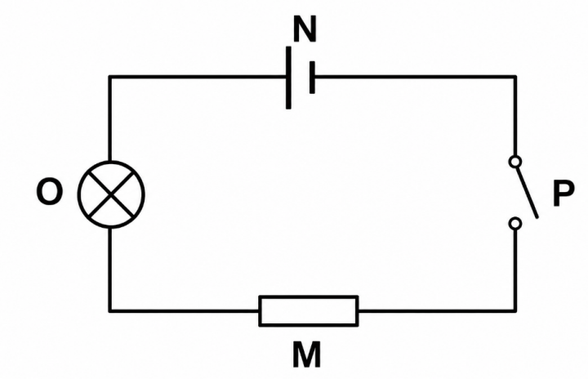
a) Identify component O. _______________________________ (1 mark)
b) Identify component N. ________________________________ (1 mark)
c) State the function of part labeled P. (1 mark)
d) Distinguish between conductors and insulators. (2 marks)
e) State two causes of electrical accidents in the home. (2 marks)
- _________________________________________________________________________________________
- _________________________________________________________________________________________
f) State two measures for preventing electrical accidents. (2 marks)
- _________________________________________________________________________________________
- _________________________________________________________________________________________

13. A metal block has a mass of 540 g and a volume of 200 cm³.
a) Define density. (1 mark)
___________________________________________________________________________________________________________________________________________________________________________________________________

b) State the formula for density. (1 mark)

c) Calculate the density of the metal block. (2 marks)

d) State whether the block would float or sink in water if the density of water is 1 g/cm³. Give a reason for your answer. (2 marks)

e) State two factors that determine whether an object floats or sinks in a fluid. (2 marks)
- _________________________________________________________________________________________
- _________________________________________________________________________________________

KENYA CERTIFICATE OF BASIC EDUCATION

SENIOR SCHOOL ASSESSMENT

ECEMBER ASSIGNMENTS 2026
GRADE 10 – GEOGRAPHY
Time: 2 Hours
LEARNER’S DETAILS
Name: _____________________________________________________________. School: ____________________________________________.
Assessment Number: _______________________________________________. Date: ____________________________________________.
School Code: ______________________________________________________. Signature: _______________________________________.

INSTRUCTIONS TO CANDIDATES
- Write your name in the spaces provided above.
- Write the name of your school and your stream in the spaces provided.
- Write your admission number and the date of the assessment in the spaces provided.
- This paper consists of two sections: A and B.
- Answer all questions in section A and section B.
- Answer the questions in English.
- All answers MUST be written in the spaces provided in PAPER.
- Do NOT remove any page from this question paper.

FOR OFFICIAL USE ONLY (EXAMINER’S USE)
SECTION | SECTION A | SECTION B | % SCORE | EE1 | EE2 | ME1 | ME2 | AE1 | AE2 | BE1 | BE2
SCORE RANGE | 45 MARKS | 35 MARKS |  | 90-100 | 75-89 | 58-74 | 41-57 | 31-40 | 21-30 | 11-20 | 1-10
POINTS |  |  |  | 8 POINTS | 7 POINTS | 6 POINTS | 5 POINTS | 4 POINTS | 3 POINTS | 2 POINTS | 1 POINT
LEARNER’S TOTAL SCORE

SECTION A 30 MARKS Answer ALL questions in this section.
- (a) The table below shows agricultural crop production data (in metric tonnes) for a region in Kenya over a 4-year period: Study the data and answer the following sub-questions:
Year | Maize (Tonnes) | Tea (Tonnes) | Coffee (Tonnes) | Total
2021 | 120 | 80 | 40 | 240
2022 | 150 | 90 | 60 | 300
2023 | 180 | 110 | 70 | 360
2024 | 200 | 120 | 80 | 400
(i) Calculate the percentage contribution of Tea to the total agricultural output in the year 2023. Show your working. (2 marks)

(ii) Calculate the percentage increase in Maize production from 2021 to 2024. (2 marks)

(iii) State two advantages of using a comparative (grouped) bar graph to represent this data compared to a simple pie chart. (2 marks)
(i) _____________________________________________________________________________________
(ii) ____________________________________________________________________________________
- State three causes of movements of the Earth. (3 marks)
- _________________________________________________________________________________________
- _________________________________________________________________________________________
- _________________________________________________________________________________________
- State two characteristics of a destructive plate boundary. (2 marks)
- _________________________________________________________________________________________
- _________________________________________________________________________________________
- Outline three natural causes of earthquakes. (3 marks)
- _________________________________________________________________________________________
- _________________________________________________________________________________________
- _________________________________________________________________________________________
- State two effects of earthquakes on crustal rocks. (2 marks)
- _________________________________________________________________________________________
- _________________________________________________________________________________________
- a) State two factors that determine the degree of folding in rocks. (2 marks)
- _________________________________________________________________________________________
- _________________________________________________________________________________________

b) State three effects of faulting on drainage systems. (3 marks)
- _________________________________________________________________________________________
- _________________________________________________________________________________________
- _________________________________________________________________________________________
- The feature shown below is an extrusive volcanic landform. Study it and answer the questions that follow.
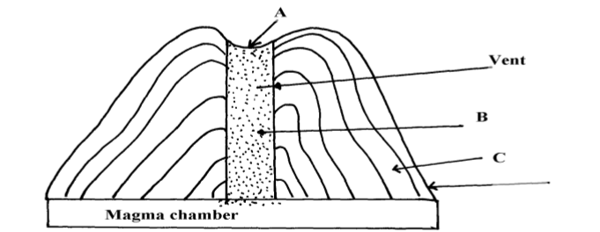
b) Name the parts labelled A, B and C (3 marks)
A: _______________________________
B: _______________________________
C: _______________________________
c) Using well-labelled diagrams, describe how each of the following features is formed:
i. An anticline (3 marks)

ii. An overthrust fold (3 marks)

SECTION A 50 MARKS Answer ALL questions in this section.
- a) What is meant by the Plate Tectonic Theory? (2 marks)
_____________________________________________________________________________________________________________________________________________________________________________________________________________________________________________________________________________________________
b) Name three types of plate boundaries. (3 marks)
- _________________________________________________________________________________________
- _________________________________________________________________________________________
- _________________________________________________________________________________________
c) Explain two pieces of evidence that support the Continental Drift Theory. (2 marks)
- _________________________________________________________________________________________
- _________________________________________________________________________________________
d) Explain three ways in which folding features can pose problems to people. (3 marks)
(i) _____________________________________________________________________________________
(ii) ____________________________________________________________________________________
(iii) ___________________________________________________________________________________

- (a) Define the term Geographic Information System (GIS). (2 marks)
______________________________________________________________________________________________________________________________________________________________________________________________
(b) Differentiate between Vector data and Raster data structures as used in GIS spatial analysis. (2 marks)
______________________________________________________________________________________________________________________________________________________________________________________________
(c) State three application areas of GIS in modern agricultural resource management in Kenya. (3 marks)
(i) _____________________________________________________________________________________
(ii) ____________________________________________________________________________________
(iii) ___________________________________________________________________________________
- (a) What is the fundamental difference between plutonic igneous rocks and volcanic igneous rocks based on cooling rate and texture? (2 marks)
_____________________________________________________________________________________________________________________________________________________________________________________________________________________________________________________________________________________________
(b) Complete the table below by providing the corresponding metamorphic equivalent for each original rock type: (3 marks)
Original Parent Rock | Metamorphic Equivalent
Limestone | (i)
Clay / Shale | (ii)
Granite | (iii)
- (a) Name two features formed by major crustal folding on a global scale. (2 marks)
(i) _____________________________________________________________________________________
(ii) ____________________________________________________________________________________

(b) Describe how an Overthrust Fold (Nappe) is formed under intense compression. (4 marks)
____________________________________________________________________________________________________________________________________________________________________________________________________________________________________________________________________________________________________________________________________________________________________________________________
- Study the topographic contour map representation provided below to answer sub-questions (a) through (e).
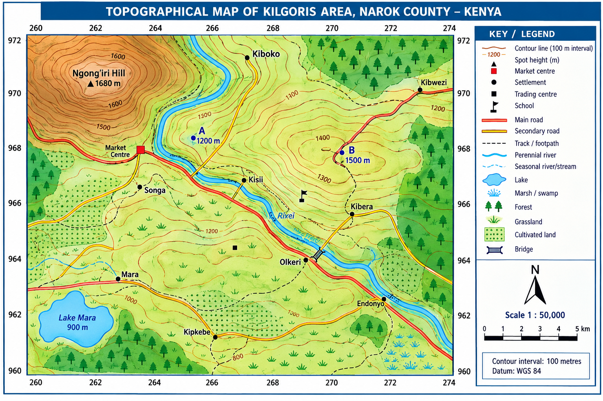
(a) (i) Convert a map scale of 1:50,000 into a statement scale in kilometers. (1 mark)

(ii) If the distance between two market centers measured along a straight line on a 1:50,000 map is 14.6 cm, calculate the actual ground distance in kilometers. (2 marks)

(b) (i) Calculate the gradient between point A (elevation 1200 m) and point B (elevation 1500 m) separated by a map distance corresponding to 6 km on the ground. Give your answer as a ratio. (3 marks)

(ii) Identify the terrain relief feature characterized by closely spaced contour lines along a river valley. (1 mark)
_________________________________________________________________________
(c) Below is statistical data representing energy generation by source in Kenya for a specific operational year:
- Geothermal: 45%
- Hydroelectric: 35%
- Wind & Solar: 15%
- Thermal (Fossil Fuels): 5%
(i) Calculate the proportional central angle in degrees (∘) for each energy sector required to construct a standard Pie Chart (Divided Circle). (4 marks)
- Geothermal: _________________________________________________________________________
- Hydroelectric: ______________________________________________________________________
- Wind & Solar: ______________________________________________________________________
- Thermal: ___________________________________________________________________________
(ii) State two mathematical rules that must be adhered to when drawing a divided rectangle (component bar chart). (2 marks)
(i) _____________________________________________________________________________________
(ii) ____________________________________________________________________________________
(d) Explain three factors influencing the distribution of human settlements as interpreted from topographic maps. (3 marks)
(i) _____________________________________________________________________________________
(ii) ____________________________________________________________________________________
(iii) ___________________________________________________________________________________
(e) State four primary steps followed when constructing a topographic cross-section (relief profile) between two grid references. (4 marks)
(i) _____________________________________________________________________________________
(ii) ____________________________________________________________________________________
(iii) ___________________________________________________________________________________
(iv) ___________________________________________________________________________________
- (a) (i) Distinguish between intrusive and extrusive volcanic landforms. (2 marks)

(ii) State three characteristics of a basic (basaltic) lava flow. (3 marks)
(i) _____________________________________________________________________________________
(ii) ____________________________________________________________________________________
(iii) ___________________________________________________________________________________
(b) Describe the operational process of extracting soda ash (trona) from Lake Magadi using the dredging method. (4 marks)
____________________________________________________________________________________________________________________________________________________________________________________________________________________________________________________________________________________________________________________________________________________________________________________________
(c) Explain three environmental degradation problems associated with open-cast mining in Kenya. (3 marks)
(i) _____________________________________________________________________________________
(ii) ____________________________________________________________________________________
(iii) ___________________________________________________________________________________
- (a) (i) Define large-scale commercial plantation farming. (1 mark)
______________________________________________________________________________________________________________________________________________________________________________________________
(ii) State three physical conditions required for successful commercial tea cultivation in the Kenyan highlands. (3 marks)
(i) _____________________________________________________________________________________
(ii) ____________________________________________________________________________________
(iii) ___________________________________________________________________________________
(b) Explain two ways in which the Kenyan government supports small-scale sugarcane farmers to boost national agricultural yield. (2 marks)
(i) _____________________________________________________________________________________
(ii) ____________________________________________________________________________________
(iii) ___________________________________________________________________________________
(c) (i) Differentiate between raw-material-oriented industries and market-oriented industries. (2 marks)
_____________________________________________________________________________________________________________________________________________________________________________________________________________________________________________________________________________________________
(ii) Name two cottage industries practiced in Kenya. (2 marks)
(i) _____________________________________________________________________________________
(ii) ____________________________________________________________________________________
- (a) (i) Define Geothermal Energy. (1 mark)
______________________________________________________________________________________________________________________________________________________________________________________________
(ii) State three advantages of geothermal power over hydroelectric power in Kenya. (3 marks)
(i) _____________________________________________________________________________________
(ii) ____________________________________________________________________________________
(iii) ___________________________________________________________________________________
(b) Describe how electrical energy is produced from geothermal steam at the Olkaria Geothermal Station. (3 marks)
____________________________________________________________________________________________________________________________________________________________________________________________________________________________________________________________________________________________________________________________________________________________________________________________
(c) Explain three factors that have favored Japan as a global industrial giant despite lacking major natural mineral resources. (3 marks)
(i) _____________________________________________________________________________________
(ii) ____________________________________________________________________________________
(iii) ___________________________________________________________________________________

- Study the data in the table below and use it to answer the questions that follow.
Mineral | Production (000 tonnes)
Gold | 26
Fluorspar | 14
Soda ash | 32
Zinc | 28

a) Using a radius of 5 cm, draw a pie chart to represent the mineral production in Kenya shown in the table above. (7 marks)

b) State three advantages of using a pie chart to represent statistical data. (3 marks)
- _________________________________________________________________________________________
- _________________________________________________________________________________________
- _________________________________________________________________________________________
- A county has fertile volcanic soils, adequate rainfall, deposits of minerals, a river, geothermal resources and a growing population. The county government plans to develop agriculture, mining, energy generation and manufacturing industries.

a) Explain two ways in which physical factors favour agriculture in the county. (2 marks)
- _________________________________________________________________________________________
- _________________________________________________________________________________________

b) State two economic benefits of mining to the county. (2 marks)
- _________________________________________________________________________________________
- _________________________________________________________________________________________

c) State one environmental problem associated with mining. (1 mark)

________________________________________________________________________________________________________________________________________________________________________

d) Name two renewable sources of energy that could be developed in the county. (2 marks)
- _________________________________________________________________________________________
- _________________________________________________________________________________________

e) State one advantage of using renewable energy. (1 mark)
______________________________________________________________________________________________________________________________________________________________________________________________

f) Explain two factors that could influence the location of industries in the county. (2 marks)
- _________________________________________________________________________________________
- _________________________________________________________________________________________

KENYA CERTIFICATE OF BASIC EDUCATION

SENIOR SCHOOL ASSESSMENT

DECEMBER ASSIGNMENT 2026
GRADE 10 – GERMAN
Time: 2 Hours
LEARNER’S DETAILS
Name: _____________________________________________________________. School: ____________________________________________.
Assessment Number: _______________________________________________. Date: ____________________________________________.
School Code: ______________________________________________________. Signature: _______________________________________.

INSTRUCTIONS TO CANDIDATES
- Write your name in the spaces provided above.
- Write the name of your school and your stream in the spaces provided.
- Write your admission number and the date of the assessment in the spaces provided.
- This paper consists of two sections: A and B.
- Answer all questions in Section A and Section B.
- Answer the questions in English where required.
- All answers MUST be written in the spaces provided in this paper.
- Do NOT remove any page from this question paper.

FOR OFFICIAL USE ONLY (EXAMINER’S USE)
SECTION | SECTION A | SECTION B | % SCORE | EE1 | EE2 | ME1 | ME2 | AE1 | AE2 | BE1 | BE2
SCORE RANGE | 30 MARKS | 50 MARKS |  | 90-100 | 75-89 | 58-74 | 41-57 | 31-40 | 21-30 | 11-20 | 1-10
POINTS |  |  |  | 8 POINTS | 7 POINTS | 6 POINTS | 5 POINTS | 4 POINTS | 3 POINTS | 2 POINTS | 1 POINT
LEARNER’S TOTAL SCORE

SECTION A: COMPREHENSION AND READING SKILLS (15 MARKS)
1. Lies den Text und beantworte die Fragen. (Read the text and answer the questions.) [10 Marks]
Hallo! Ich heiße Amani und ich bin sechzehn Jahre alt. Ich wohne in Nakuru, Kenya, aber ich lerne Deutsch in der Schule. Mein Tag beginnt um sechs Uhr morgens. Ich esse Brot mit Marmelade und trinke Milch zum Frühstück. Um sieben Uhr fahre ich mit dem Bus zur Schule.
Meine Lieblingsfächer sind Deutsch, Biologie und Mathematik. Ich mag Deutsch, weil ich in den Ferien nach Berlin reisen möchte. In meiner Freizeit spiele ich gerne Fußball und höre Musik. Am Wochenende helfe ich meinen Eltern im Garten.

a) Wie alt ist Amani? (1 mark) _____________________________________________________________________________________________
b) Wo wohnt Amani? (1 mark) _____________________________________________________________________________________________
c) Was isst und trinkt Amani zum Frühstück? (2 marks) _____________________________________________________________________________________________
d) Wie kommt Amani zur Schule? (1 mark) _____________________________________________________________________________________________
e) Welche drei Schulfächer mag Amani? (3 marks) _____________________________________________________________________________________________
f) Warum lernt Amani Deutsch? (1 mark) _____________________________________________________________________________________________
g) Was macht Amani am Wochenende? (1 mark) _____________________________________________________________________________________________
2. Richtig oder Falsch?
(True or False? Write 'R' for Richtig or 'F' for Falsch based on the text above.) [5 Marks]
a) Amani steht um sieben Uhr auf. _____________________________________________________________________________________________
b) Amani fährt mit dem Fahrrad zur Schule. _____________________________________________________________________________________________
c) Amanis Lieblingsfach ist Geschichte. _____________________________________________________________________________________________
d) Amani hört in der Freizeit Musik. _____________________________________________________________________________________________
e) Amani hilft den Eltern im Garten. _____________________________________________________________________________________________

SECTION B: GRAMMAR AND VOCABULARY (25 MARKS)
- Ergänze das richtige Verb im Präsens.
(Complete with the correct present tense form of the verb in brackets.) [5 Marks]
a) Maria ______________ gerne Bücher. (lesen)
b) Wir ______________ am Samstag nach Nairobi. (fahren)
c) ______________ du Morgen Zeit? (haben)
d) Die Schüler ______________ Deutsch. (lernen)
e) Er ______________ den Bleistift auf den Tisch. (legen)
4. Welches Wort passt nicht?
(Which word does not belong in the group?) [5 Marks]
a) Mutter / Vater / Lehrer / Schwester
b) Bleistift / Buch / Hund / Lineal
c) Montagmorgen / Mittwoch / September / Freitag
d) Trinken / Essen / Kochen / Stuhl
e) Rot / Grün / Milch / Blau
5. Ergänze die richtigen Artikel (bestimmt oder unbestimmt).
(Fill in the blanks with correct articles: der, die, das or ein, eine). [5 Marks]
a) Das ist ______________ (a) Schultasche.
b) ______________ (the) Lehrer heißt Herr Kamau.
c) Ich kaufe ______________ (a) Buch.
d) Wo ist ______________ (the) Klassenzimmer?
e) Sie hat ______________ (a) Bruder.

6. Satzbau: Bilde korrekte Sätze.
(Form correct sentences from the given words.) [5 Marks]
a) spielt / nachmittags / Fußball / Peter .
b) woher / du / kommst / ?
c) um / stehe / 6 Uhr / auf / ich .
d) Deutsch / wir / lernen / gerne .
e) keinen / habe / Bleistift / ich .
7. Personalpronomen und Possessivpronomen.
(Complete with the correct pronouns.) [5 Marks]
a) Das ist Juma. Das ist ______________ (his) Buch.
b) Sarah lernt viel. ______________ (she) ist fleißig.
c) Wir haben ein Haus. Das ist ______________ (our) Haus.
d) Wie heißt ______________ (your - informal) Deutschlehrer?
e) Hast du den Schlüssel? Nein, ich habe ______________ (it - masculine) nicht.

SECTION C: WRITTEN EXPRESSION & CREATIVE WRITING (20 MARKS)
8. Guided Composition. [10 Marks]
Write a profile about yourself in German (60–80 words).
________________________________________________________________________________________________________________________________________________________________________________________________________________________________________________________________________________________________________________________________________________________________________________________________________________________________________________________________________________________________________________________________________________________________________________________________________________________________________________________________________________________________________________________________________________________________________________________
9. Functional Writing: E-Mail / Brief. [10 Marks]
Your German friend, Lukas, sent you an email asking about your school life in Kenya. Write a reply (60–80 words) answering his questions:
- What time does your school day start and end?
- What are your favorite subjects?
- What do you do during break time?

________________________________________________________________________________________________________________________________________________________________________________________________________________________________________________________________________________________________________________________________________________________________________________________________________________________________________________________________________________________________________________________________________________________________________________________________________________________________________________________________________________________________________________________________________________________________________________________________________________

KENYA CERTIFICATE OF BASIC EDUCATION

SENIOR SCHOOL ASSESSMENT

DECEMBER ASSIGNMENT 2026
GRADE 10 – HISTORY AND CITIZAENSHIP
Time: 2 Hours
LEARNER’S DETAILS
Name: _____________________________________________________________. School: ____________________________________________.
Assessment Number: _______________________________________________. Date: ____________________________________________.
School Code: ______________________________________________________. Signature: _______________________________________.

INSTRUCTIONS TO CANDIDATES
- Write the detail required above
- This paper consists of two sections: A and B. Answer all questions in section A and section B.
- Answer the questions in English.
- All answers MUST be written in the spaces provided in PAPER.
- Do NOT remove any page from this question paper.

FOR OFFICIAL USE ONLY (EXAMINER’S USE)
SECTION | SECTION A | SECTION B | % SCORE | EE1 | EE2 | ME1 | ME2 | AE1 | AE2 | BE1 | BE2
SCORE RANGE | 30 MARKS | 50 MARKS |  | 90-100 | 75-89 | 58-74 | 41-57 | 31-40 | 21-30 | 11-20 | 1-10
POINTS |  |  |  | 8 POINTS | 7 POINTS | 6 POINTS | 5 POINTS | 4 POINTS | 3 POINTS | 2 POINTS | 1 POINT
LEARNER’S TOTAL SCORE

SECTION A: (30 marks)
Answer ALL questions in this section.

1.
a) Define the term History. (1 mark) ______________________________________________________________________________________________________________________________________________________________________________________________
b) State one source of historical information. (1 mark) ______________________________________________________________________________________________________________________________________________________________________________________________
c) Give one importance of studying History and Citizenship. (1 mark) ______________________________________________________________________________________________________________________________________________________________________________________________

2.
a) Name one major linguistic group found in Kenya. (1 mark)
_________________________________________
b) State one reason for the migration of the Cushites into Kenya. (1 mark)
______________________________________________________________________________________________________________________________________________________________________________________________
c) State one effect of migration on the communities that settled in Kenya. (1 mark)
______________________________________________________________________________________________________________________________________________________________________________________________

3.
a) State one reason why European powers established colonial rule in Africa. (1 mark)
______________________________________________________________________________________________________________________________________________________________________________________________
b) Name one method used by Europeans to establish colonial rule in Kenya. (1 mark)
______________________________________________________________________________________________________________________________________________________________________________________________
c) State one feature of the colonial system of administration in Kenya. (1 mark)
______________________________________________________________________________________________________________________________________________________________________________________________

4.
a) What is meant by public participation? (1 mark)
______________________________________________________________________________________________________________________________________________________________________________________________

b) State one way in which public participation promotes democracy. (1 mark)
______________________________________________________________________________________________________________________________________________________________________________________________
c) Identify one challenge facing effective public participation in Kenya. (1 mark)
______________________________________________________________________________________________________________________________________________________________________________________________

5.
a) What is meant by republican status? (1 mark)
______________________________________________________________________________________________________________________________________________________________________________________________
b) State one significance of the repeal of Section 2A of the Constitution. (1 mark)
______________________________________________________________________________________________________________________________________________________________________________________________
c) Give one importance of the Constitution of Kenya, 2010. (1 mark)
______________________________________________________________________________________________________________________________________________________________________________________________

6.
a) Name the body responsible for conducting and supervising elections in Kenya. (1 mark)
______________________________________________________________________________________________________________________________________________________________________________________________
b) State one electoral malpractice that can undermine free and fair elections. (1 mark)
______________________________________________________________________________________________________________________________________________________________________________________________

c) State one factor that promotes national integration in Kenya. (1 mark)
______________________________________________________________________________________________________________________________________________________________________________________________

7.
a) State one factor that led to the transition from a migratory to a sedentary lifestyle. (1 mark)
______________________________________________________________________________________________________________________________________________________________________________________________
b) Give one advancement associated with the Neolithic Revolution. (1 mark)
______________________________________________________________________________________________________________________________________________________________________________________________
c) Name one ancient African civilisation that developed before the nineteenth century. (1 mark)
______________________________________________________________________________________________________________________________________________________________________________________________

8.
a) State one major decision made at the Berlin Conference of 1884–1885. (1 mark)
______________________________________________________________________________________________________________________________________________________________________________________________

b) Name one African leader associated with modern African nationalism. (1 mark)
______________________________________________________________________________________________________________________________________________________________________________________________
c) State one lesson African countries can learn from African nationalist leaders. (1 mark)
______________________________________________________________________________________________________________________________________________________________________________________________

9.
a) State one cause of the First World War. (1 mark)
______________________________________________________________________________________________________________________________________________________________________________________________
b) Give one effect of the World Wars on Africa. (1 mark)
______________________________________________________________________________________________________________________________________________________________________________________________
c) State one strategy used by international organisations to promote peace. (1 mark)
______________________________________________________________________________________________________________________________________________________________________________________________

10.
a) State one factor that contributed to the American Revolution. (1 mark)
______________________________________________________________________________________________________________________________________________________________________________________________
b) Name one form of modern slavery or servitude. (1 mark)
______________________________________________________________________________________________________________________________________________________________________________________________
c) State one factor that promotes equity and non-discrimination in society. (1 mark)
______________________________________________________________________________________________________________________________________________________________________________________________

SECTION B: 50 MARKS
Answer all questions in this section.

11. a) Explain two ways in which different branches of History influence contemporary Kenyan society. (4 marks)
- _________________________________________________________________________________________
- _________________________________________________________________________________________
b) Explain three causes of migration of linguistic groups into Kenya. (6 marks)
- _________________________________________________________________________________________
- _________________________________________________________________________________________
- _________________________________________________________________________________________

12.
a) Explain three reasons for the establishment of colonial rule in Kenya. (6 marks)
- _________________________________________________________________________________________
- _________________________________________________________________________________________
- _________________________________________________________________________________________
b) Explain two ways in which the colonial system of administration influenced the development of the modern Kenyan government. (4 marks)
- _________________________________________________________________________________________
- _________________________________________________________________________________________

13.
a) Explain three roles of the Independent Electoral and Boundaries Commission (IEBC) in Kenya's electoral process. (6 marks)
- _________________________________________________________________________________________
- _________________________________________________________________________________________
- _________________________________________________________________________________________
b) Explain two ways of promoting effective public participation in Kenya. (4 marks)
- _________________________________________________________________________________________
- _________________________________________________________________________________________

14.
a) Explain three factors that contributed to the development of early African civilisations. (6 marks)
- _________________________________________________________________________________________
- _________________________________________________________________________________________
- _________________________________________________________________________________________

b) Explain two contributions of ancient African civilisations to modern society. (4 marks)
- _________________________________________________________________________________________
- _________________________________________________________________________________________

15.
a) Explain three factors that contributed to the First Industrial Revolution in Britain. (6 marks)
- _________________________________________________________________________________________
- _________________________________________________________________________________________
- _________________________________________________________________________________________
b) Explain two ways in which the United Nations and African Union promote peace and global stability. (4 marks)
- _________________________________________________________________________________________
- _________________________________________________________________________________________

KENYA CERTIFICATE OF BASIC EDUCATION

SENIOR SCHOOL ASSESSMENT

SECOND ASSESSMENT 2026
GRADE 10 – HOMESCIENCE
Time: 2 Hours
LEARNER’S DETAILS
Name: _____________________________________________________________. School: ____________________________________________.
Assessment Number: _______________________________________________. Date: ____________________________________________.
School Code: ______________________________________________________. Signature: _______________________________________.

INSTRUCTIONS TO CANDIDATES
- Write your name in the spaces provided above.
- Write the name of your school and your stream in the spaces provided.
- Write your admission number and the date of the assessment in the spaces provided.
- This paper consists of two sections: A and B.
- Answer all questions in section A and section B.
- Answer the questions in English.
- All answers MUST be written in the spaces provided in PAPER.
- Do NOT remove any page from this question paper.

FOR OFFICIAL USE ONLY (EXAMINER’S USE)
SECTION | SECTION A | SECTION B | % SCORE | EE1 | EE2 | ME1 | ME2 | AE1 | AE2 | BE1 | BE2
SCORE RANGE | 45 MARKS | 35 MARKS |  | 90-100 | 75-89 | 58-74 | 41-57 | 31-40 | 21-30 | 11-20 | 1-10
POINTS |  |  |  | 8 POINTS | 7 POINTS | 6 POINTS | 5 POINTS | 4 POINTS | 3 POINTS | 2 POINTS | 1 POINT
LEARNER’S TOTAL SCORE

SECTION A (30 MARKS)
Answer ALL questions in this section.

1.
a) State two areas of study covered under Home Science at Grade 10 level. (2 marks)
- ____________________________________________________________________________________________
- ____________________________________________________________________________________________
b) Give two ways in which Home Science knowledge can improve the quality of family life. (2 marks)
- ____________________________________________________________________________________________
- ____________________________________________________________________________________________

c) State one entrepreneurial opportunity that can be created from Home Science skills. (1 mark)
___________________________________________________________________________________________________________________________________________________________________________________________________

2.
Study the diagram below.
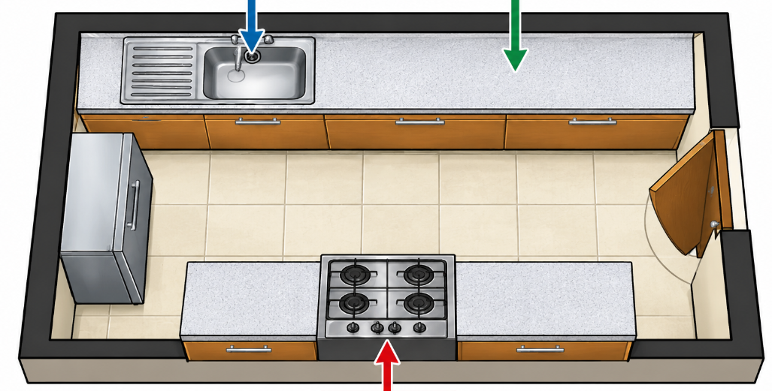
Q R

S
a) Identify the three major work centres represented by Q, R and S. (3 marks)
Q: ____________________________________
R: ____________________________________
S: _____________________________________
b) State two reasons why work centres should be arranged conveniently in a kitchen. (2 marks)
- ____________________________________________________________________________________________
- ____________________________________________________________________________________________

3.
A learner buys fresh vegetables from a market and carries them together with raw meat in one uncovered container. At home, the learner places the food on the kitchen floor before preparation.
a) Identify two unhygienic practices in the situation. (2 marks)
- ____________________________________________________________________________________________
- ____________________________________________________________________________________________
b) Explain one health risk associated with poor food hygiene. (1 mark)
____________________________________________________________________________________________________________________________________________________________________________________________________
c) State two appropriate ways of storing food safely before preparation. (2 marks)
- ____________________________________________________________________________________________
- ____________________________________________________________________________________________

4.
a) State the main function of each of the following nutrients:
i. Fats and oils. (1 mark)
____________________________________________________________________________________________________________________________________________________________________________________________________
ii. Vitamins. (1 mark)
____________________________________________________________________________________________________________________________________________________________________________________________________ iii. Minerals. (1 mark)
____________________________________________________________________________________________________________________________________________________________________________________________________b) Give two examples of foods rich in vitamins and minerals. (2 marks)
- ____________________________________________________________________________________________
- ____________________________________________________________________________________________

5.
a) What is meant by personal hygiene? (1 mark)
b) State three changes that may occur during puberty. (3 marks)
- ____________________________________________________________________________________________
- ____________________________________________________________________________________________
- ____________________________________________________________________________________________
c) Give one reason why maintaining personal hygiene is particularly important during puberty. (1 mark)

______________________________________________________________________________________________________________________________________________________________________________

6.
Study the fabric illustration below.
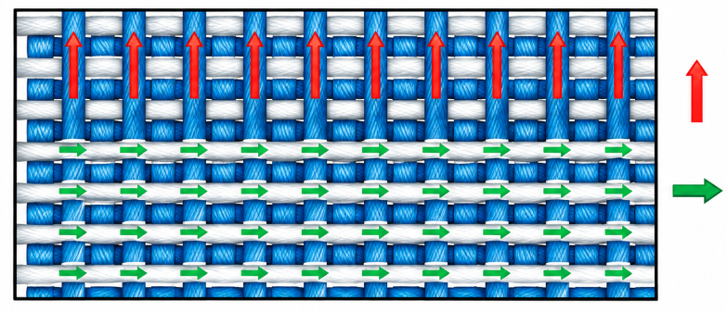
a) Identify the two directions of threads represented by the arrows. (2 marks)
_________________________________

_________________________________
b) State two characteristics of a well-constructed seam. (2 marks)
- ____________________________________________________________________________________________
- ____________________________________________________________________________________________
c) Name one tool used for measuring fabric during garment construction. (1 mark)

________________________________________________________________________________

SECTION B: 50 MARKS
Answer ALL questions in this section.

7. A school Home Science class is preparing a vegetable dish, rice and grilled meat for a practical lesson.
a) Explain the meaning of food preparation. (2 marks)
- ____________________________________________________________________________________________
- ____________________________________________________________________________________________
b) State four principles that should be followed when preparing vegetables for cooking. (4 marks)
- ____________________________________________________________________________________________
- ____________________________________________________________________________________________
- ____________________________________________________________________________________________
- ____________________________________________________________________________________________
c) Explain two advantages of steaming vegetables. (2 marks)
- ____________________________________________________________________________________________
- ____________________________________________________________________________________________
d) Give two precautions to observe when grilling meat. (2 marks)
- ____________________________________________________________________________________________
- ____________________________________________________________________________________________

8. The following foods are available in a household:
maize meal, beans, sukuma wiki, milk, bananas, cooking oil and oranges.
a) Classify the foods according to the major nutrients they mainly provide. (4 marks)
- ____________________________________________________________________________________________
- ____________________________________________________________________________________________
- ____________________________________________________________________________________________
- ____________________________________________________________________________________________
b) Using the foods listed above, suggest a balanced main meal for the family. (2 marks)
- ____________________________________________________________________________________________
- ____________________________________________________________________________________________
c) State two factors that may influence the nutritional needs of a family member. (2 marks)
- ____________________________________________________________________________________________
- ____________________________________________________________________________________________
d) Explain two advantages of variety in meals. (2 marks)
- ____________________________________________________________________________________________
- ____________________________________________________________________________________________

9.
A family receives a monthly income of KSh 45,000. The family needs to allocate money for food, housing, education, clothing, transport, healthcare and savings.
a) Define the term family budget. (2 marks)
____________________________________________________________________________________________________________________________________________________________________________________________________

b) State four advantages of preparing a family budget. (4 marks)
- ____________________________________________________________________________________________
- ____________________________________________________________________________________________
- ____________________________________________________________________________________________
- ____________________________________________________________________________________________
c) Explain two factors that should be considered when making purchasing decisions. (2 marks)
- ____________________________________________________________________________________________
- ____________________________________________________________________________________________
d) State two qualities of a wise consumer. (2 marks)
- ____________________________________________________________________________________________
- ____________________________________________________________________________________________

10. Study the cleaning sequence below.
DUSTING
↓
SWEEPING
↓
MOPPING
↓
DRYING
a) Explain why cleaning should generally proceed from high surfaces to low surfaces. (2 marks)
- ____________________________________________________________________________________________
- ____________________________________________________________________________________________
b) State three precautions when using household cleaning agents. (3 marks)
- ____________________________________________________________________________________________
- ____________________________________________________________________________________________
- ____________________________________________________________________________________________
c) A learner is preparing to wash a woollen sweater.
State three precautions that should be taken when laundering woollen garments. (3 marks)
- ____________________________________________________________________________________________
- ____________________________________________________________________________________________
- ____________________________________________________________________________________________

d) State two ways of preventing accidents caused by electrical appliances in the home. (2 marks)
- ____________________________________________________________________________________________
- ____________________________________________________________________________________________

11.
a) Identify the following parts of the garment:
i. The opening around the neck. __________________________________ (1 mark)
ii. The curved opening where the arm passes through. __________________________ (1 mark)
iii. The finished lower edge of the garment. __________________________ (1 mark)
b) State two purposes of pressing during garment construction. (2 marks)
- ____________________________________________________________________________________________
- ____________________________________________________________________________________________
c) Distinguish between natural fibres and manufactured fibres. (2 marks)
Natural fibres | Manufactured fibres
d) Give three examples of natural textile fibres. (3 marks)
- ____________________________________________________________________________________________
- ____________________________________________________________________________________________
- ____________________________________________________________________________________________

KENYA CERTIFICATE OF BASIC EDUCATION

SENIOR SCHOOL ASSESSMENT

DECEMBER ASSIGNMENT 2026
GRADE 10 – HINDU RELIGIOUS EDUCATION
Time: 2 Hours
LEARNER’S DETAILS
Name: _____________________________________________________________. School: ____________________________________________.
Assessment Number: _______________________________________________. Date: ____________________________________________.
School Code: ______________________________________________________. Signature: _______________________________________.

INSTRUCTIONS TO CANDIDATES
- Write your name in the spaces provided above.
- Write the name of your school and your stream in the spaces provided.
- Write your admission number and the date of the assessment in the spaces provided.
- This paper consists of two sections: A and B.
- Answer all questions in section A and section B.
- All answers MUST be written in the spaces provided in the paper.
- Do NOT remove any page from this question paper.

FOR OFFICIAL USE ONLY (EXAMINER’S USE)
SECTION | SECTION A | SECTION B | % SCORE | EE1 | EE2 | ME1 | ME2 | AE1 | AE2 | BE1 | BE2
SCORE RANGE | 30 MARKS | 50 MARKS |  | 90-100 | 75-89 | 58-74 | 41-57 | 31-40 | 21-30 | 11-20 | 1-10
POINTS |  |  |  | 8 POINTS | 7 POINTS | 6 POINTS | 5 POINTS | 4 POINTS | 3 POINTS | 2 POINTS | 1 POINT
LEARNER’S TOTAL SCORE

SECTION A (30 MARKS)
Answer ALL questions in this section.
  - Study the representation below.
PARAMATMA
│
┌───────────────┼───────────────┐
│ │ │
BRAHMA VISHNU SHIVA
│ │ │
CREATION PRESERVATION TRANSFORMATION
a) What is meant by Paramatma? (1 mark)
..........................................................................................................................................................................................

b) Name the three manifestations shown in the diagram. (3 marks)
i. ...........................................................................................................................................................................................
ii. ..........................................................................................................................................................................................
iii. ........................................................................................................................................................................................
c) State two reasons why Vishnu is regarded as the preserver of creation. (2 marks)
i. ...........................................................................................................................................................................................
ii. .........................................................................................................................................................................................
  - The diagram below shows some avatars associated with Vishnu.
AVATARS OF VISHNU

┌─────────┬──────────┬───────────┐
│ │ │ │
MATSYA KURMA VARAHA NARASIMHA
│ │ │ │
Fish Tortoise Boar Man-Lion

│
┌───────┴────────┐
│ │
RAMA KRISHNA
│ │
________ ________
a) Identify the two avatars represented by the blank spaces. (2 marks)
i. ...........................................................................................................................................................................................
ii. .........................................................................................................................................................................................
b) State two reasons why avatars are important in Hindu religious understanding. (2 marks)
i. ............................................................................................................................................................................................
ii. ........................................................................................................................................................................................
c) State two values demonstrated by Lord Rama. (2 marks)
i. ...........................................................................................................................................................................................
ii. ..........................................................................................................................................................................................

  - Complete the following table by stating one distinctive teaching or emphasis associated with each tradition.
Tradition | Teaching/Emphasis
Sanatan/Vedic
Jain
Buddhist
Sikh
(4 marks)
b) State two ways in which studying the four Panths can promote religious tolerance in Kenya. (2 marks)
i. ..........................................................................................................................................................................................
ii. ........................................................................................................................................................................................
  - Study the classification below.
HINDU SACRED LITERATURE
│
┌─────────────┴─────────────┐
│ │
SHRUTI SMRITI
│ │
┌─────┴─────┐ ┌──────┴──────┐
│ │ │ │
VEDAS UPANISHADS EPICS PURANAS
a) Explain the meaning of Shruti. (1 mark)
........................................................................................................................................................................................................................................................................................................................................................................................................
b) Explain the meaning of Smriti. (1 mark)
.......................................................................................................................................................................................................................................................................................................................................................................................................
c) Name two Vedas. (2 marks)
i. ................................................................................................................
ii. ................................................................................................................
d) Name two Hindu epics associated with Smriti literature. (2 marks)
i. .......................................................................................................................................................................................
ii. .......................................................................................................................................................................................
  - A learner discovers that a classmate has been falsely accused of stealing school property. Although the learner knows the truth, other learners pressure them to remain silent. The learner decides to tell the teacher what actually happened.
a) Identify one principle of Dharma demonstrated by the learner. (1 mark)
.............................................................................................................................................................................................
b) Explain how the learner's decision demonstrates righteous conduct. (2 marks)
..............................................................................................................................................................................................
.............................................................................................................................................................................................
c) State three ways a Grade 10 learner can practise Dharma at school. (3 marks)
i. ..........................................................................................................................................................................................
ii. ........................................................................................................................................................................................
iii. ........................................................................................................................................................................................

SECTION B: 50 MARKS
  - a) Explain the Hindu understanding of Paramatma. (2 marks)
..............................................................................................................................................................................................
..............................................................................................................................................................................................
b) Explain the relationship between Brahma, Vishnu and Shiva in the Trimurti. (3 marks)
..............................................................................................................................................................................................
..............................................................................................................................................................................................
............................................................................................................................................................................................
c) Explain two ways in which the concept of the Trimurti can help a learner understand the processes of creation and transformation. (2 marks)
i. ..........................................................................................................................................................................................
ii. ..........................................................................................................................................................................................
d) State three lessons that learners can derive from studying manifestations of Paramatma. (3 marks)
i. ...........................................................................................................................................................................................
ii. ..........................................................................................................................................................................................
iii. ........................................................................................................................................................................................

  - a) What is an avatar in Hindu religious thought? (2 marks)
..............................................................................................................................................................................................
..............................................................................................................................................................................................
b) Explain three reasons for the appearance of avatars according to Hindu understanding. (3 marks)
i. ...........................................................................................................................................................................................
ii. .........................................................................................................................................................................................
iii. .......................................................................................................................................................................................
c) Explain two moral lessons from the life of Lord Rama that can guide young people today. (2 marks)
i. ...........................................................................................................................................................................................
ii. ..........................................................................................................................................................................................
d) Explain three lessons that can be drawn from the teachings associated with Lord Krishna. (3 marks)
i. ...........................................................................................................................................................................................
ii. .........................................................................................................................................................................................
iii. ........................................................................................................................................................................................
  - a) Define the term Tirthankara. (2 marks)
.............................................................................................................................................................................................
..............................................................................................................................................................................................
b) Name two Jain Tirthankaras. (2 marks)
i. ................................................................................................................
ii. ................................................................................................................
c) Explain two principles of Jainism that encourage peaceful coexistence. (2 marks)
i. ...........................................................................................................................................................................................
ii. ..........................................................................................................................................................................................
d) State two teachings of Buddhism that can help a learner deal with conflict. (2 marks)
i. ...........................................................................................................................................................................................
ii. ..........................................................................................................................................................................................

e) Explain two Sikh values that can promote responsible citizenship. (2 marks)
i. ..........................................................................................................................................................................................
ii. .........................................................................................................................................................................................
  - Study the diagram below.
SACRED TEXTS
│
┌────────────────┼─────────────────┐
│ │ │
HINDUISM JAINISM BUDDHISM
│ │ │
VEDAS AGAMAS TRIPITAKA
│
DHARMA
│
RIGHT CONDUCT
a) Identify the Hindu sacred texts represented in the diagram. (1 mark)
.............................................................................................................................
b) What is meant by Dharma? (2 marks)
.............................................................................................................................................................................................
............................................................................................................................................................................................
c) Explain three ways scriptures provide guidance to believers. (3 marks)
i. ..........................................................................................................................................................................................
ii. ..........................................................................................................................................................................................
iii. ........................................................................................................................................................................................
d) Explain two ways Hindu scriptures can influence the conduct of young people. (2 marks)
i. ...........................................................................................................................................................................................
ii. ..........................................................................................................................................................................................
e) State two dangers of deliberately misrepresenting religious teachings. (2 marks)
i. ..........................................................................................................................................................................................
ii. .........................................................................................................................................................................................

  - Study the illustration below.
THOUGHT / INTENTION
│
▼
ACTION
│
▼
CONSEQUENCE
│
▼
FUTURE ACTION
│
└─────────────►
a) Identify the principle illustrated above. (1 mark)
....................................................................................................................
b) Define the Law of Karma. (2 marks)
..........................................................................................................................................................................................
..........................................................................................................................................................................................
c) Explain three ways the Law of Karma can influence decision-making among young people. (3 marks)
i. ...........................................................................................................................................................................................
ii. ..........................................................................................................................................................................................
iii. ........................................................................................................................................................................................
d) Explain two functions of music in Hindu religious and cultural life. (2 marks)
i. ...........................................................................................................................................................................................
ii. ..........................................................................................................................................................................................
e) State two ways dance contributes to the preservation of Hindu cultural heritage. (2 marks)
i. ...........................................................................................................................................................................................
ii. .........................................................................................................................................................................................

KENYA CERTIFICATE OF BASIC EDUCATION

SENIOR SCHOOL ASSESSMENT

DECEMBER ASSIGNMENT 2026
GRADE 10 – INFORMATION COMMUNICATION TECHNOLOGY
Time: 2 Hours
LEARNER’S DETAILS
Name: _____________________________________________________________. School: ____________________________________________.
Assessment Number: _______________________________________________. Date: ____________________________________________.
School Code: ______________________________________________________. Signature: _______________________________________.

INSTRUCTIONS TO CANDIDATES
- Write your details as required in the spaces provided above.
- This paper consists of two sections: A and B.
- Answer all questions in section A and section B.
- Answer the questions in English.
- All answers MUST be written in the spaces provided in the paper.
- Do NOT remove any page from this question paper.

FOR OFFICIAL USE ONLY (EXAMINER’S USE)
SECTION | SECTION A | SECTION B | % SCORE | EE1 | EE2 | ME1 | ME2 | AE1 | AE2 | BE1 | BE2
SCORE RANGE | 30 MARKS | 50 MARKS |  | 90-100 | 75-89 | 58-74 | 41-57 | 31-40 | 21-30 | 11-20 | 1-10
POINTS |  |  |  | 8 POINTS | 7 POINTS | 6 POINTS | 5 POINTS | 4 POINTS | 3 POINTS | 2 POINTS | 1 POINT
LEARNER’S TOTAL SCORE

SECTION A (35 MARKS)
Answer ALL questions in this section.
- a) Define the term digital technology. (1 mark)
__________________________________________________________________________________________________________________________________________________________________________________________________
b) State two ways in which ICT contributes to economic development in Kenya. (2 marks)
- ________________________________________________________________________________________
- ________________________________________________________________________________________
c) Give two challenges that may arise from increased use of ICT in society. (2 marks)
- ________________________________________________________________________________________
- ________________________________________________________________________________________

- Study the diagram below and answer the questions that follow.
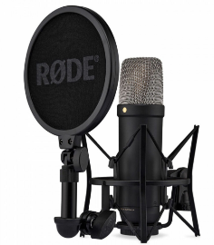

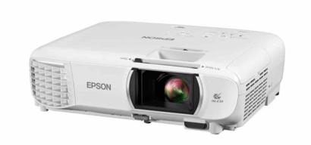

Q R S T
a) Identify any two devices that could be represented by A, B, C or D. (2 marks)
Q: _____________________________________________
R: _____________________________________________
S: ______________________________________________
T: _____________________________________________
b) State one function of an input device. (1 mark)
_________________________________________________________________________________________________________________________________________________________________________________________________
c) State one function of an output device. (1 mark)
__________________________________________________________________________________________________________________________________________________________________________________________________
d) Give one example of a storage device. (1 mark)
_____________________________
- a) Distinguish between system software and application software. (2 marks)
__________________________________________________________________________________________________________________________________________________________________________________________________
b) Give one example of system software. (1 mark)
_________________________________________________

c) Give two examples of application software commonly used by learners. (2 marks)
- ___________________________________________________________
- ___________________________________________________________
- A learner has organised schoolwork on a computer as shown below:
GRADE 10
│
├── Mathematics
├── English
├── ICT
│ ├── Notes
│ ├── Assignments
│ └── Projects
└── Biology
a) What is the name given to Grade 10 in this arrangement? (1 mark)
______________________________________
b) Name two subfolders found inside the ICT folder. (2 marks)
- _______________________________
- _______________________________
c) State two benefits of organising files into folders. (2 marks)
- __________________________________________________________________________________________
- __________________________________________________________________________________________
- A learner uses a public computer to access an online learning account. After completing the work, the learner leaves the account open and walks away.
a) Identify one security risk in this situation. (1 mark)
__________________________________________________________
b) State two actions the learner should have taken before leaving the computer. (2 marks)
- __________________________________________________________________________________________
- __________________________________________________________________________________________

c) Explain two characteristics of a strong password. (2 marks)
- __________________________________________________________________________________________
- __________________________________________________________________________________________
- a) What is meant by digital ethics? (1 mark)
____________________________________________________________________________________________________________________________________________________________________________________________
b) State two ways of respecting intellectual property when using digital materials. (2 marks)
- __________________________________________________________________________________________
- __________________________________________________________________________________________
c) Give two examples of unacceptable online behaviour. (2 marks)
- __________________________________________________________________________________________
- __________________________________________________________________________________________

SECTION B: 50 MARKS
Answer ALL questions in this section.
- A school ICT teacher asks learners to prepare a report titled:

THE IMPORTANCE OF DIGITAL LITERACY
The report should contain a title, headings, paragraphs, a table and page numbers.
a) State two word-processing features that can be used to prepare the report professionally. (2 marks)
- __________________________________________________________________________________________
- __________________________________________________________________________________________
b) Identify the role of part labelled S and T (2 marks)
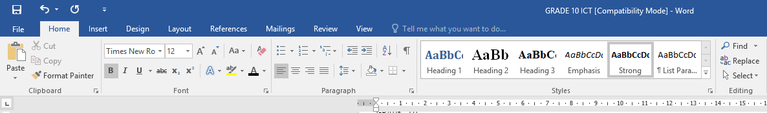

S T

S: ________________________________________
T: ________________________________________

c) Explain the difference between Save and Save As. (2 marks)
Save | Save As
d) Describe two ways of inserting a table into a word-processing document. (2 marks)
- __________________________________________________________________________________________
- __________________________________________________________________________________________
e) State two reasons for using headings in a long document. (2 marks)
- __________________________________________________________________________________________
- __________________________________________________________________________________________

- A learner is preparing a presentation on:

a) Identify two elements of the slide shown in the diagram. (2 marks)
- __________________________________________________________________________________________
- __________________________________________________________________________________________

b) State three guidelines for selecting images for a presentation. (3 marks)
- __________________________________________________________________________________________
- __________________________________________________________________________________________
- __________________________________________________________________________________________
c) Explain two advantages of using presentation software in teaching and learning. (2 marks)
- __________________________________________________________________________________________
- __________________________________________________________________________________________
d) State three features that can be used to make a presentation interactive or engaging. (3 marks)
- __________________________________________________________________________________________
- __________________________________________________________________________________________
- __________________________________________________________________________________________
- The ICT Club wants to design a flyer advertising an ICT INNOVATION DAY.

a) Identify two publication elements shown in the flyer. (2 marks)
- __________________________________________________________________________________________
- __________________________________________________________________________________________

b) State three factors that should be considered when selecting images and graphics for a publication. (3 marks)
- __________________________________________________________________________________________
- __________________________________________________________________________________________
- __________________________________________________________________________________________
c) Explain two ways in which alignment improves the appearance of a publication. (2 marks)
- __________________________________________________________________________________________
- __________________________________________________________________________________________
d) State three types of publications that can be created using desktop publishing software. (3 marks)
- __________________________________________________________________________________________
- __________________________________________________________________________________________
- __________________________________________________________________________________________
- A learner wants to research information about climate change in Kenya using the Internet.
The learner follows this process:
Learner
↓
Open Web Browser
↓
Enter Search Terms
↓
Search Engine
↓
Search Results
↓
Select Relevant Sources
↓
Read and Evaluate Information
↓
Record Sources
a) What is a web browser? (1 mark)
__________________________________________________________________________________________________________________________________________________________________________________________________
b) What is a search engine? (1 mark)
__________________________________________________________________________________________________________________________________________________________________________________________________
c) Give two examples of web browsers. (2 marks)
- __________________________________________________________________________________________
- __________________________________________________________________________________________
d) State three criteria the learner should use to determine whether an online source is reliable. (3 marks)
- __________________________________________________________________________________________
- __________________________________________________________________________________________
- __________________________________________________________________________________________
e) Explain three reasons why a learner should acknowledge online sources when using information in an assignment. (3 marks)
- __________________________________________________________________________________________
- __________________________________________________________________________________________
- __________________________________________________________________________________________
- A Grade 10 class is working on a group ICT project. The members are in different locations and need to communicate, share documents and work together online.
a) Name three digital communication methods that the learners could use. (3 marks)
- __________________________________________________________________________________________
- __________________________________________________________________________________________
- __________________________________________________________________________________________
b) State two digital tools that can support collaborative work. (2 marks)
- __________________________________________________________________________________________
- __________________________________________________________________________________________
c) Explain two advantages of using cloud-based collaboration tools in education. (2 marks)
- __________________________________________________________________________________________
- __________________________________________________________________________________________
d) State three rules that learners should follow when communicating in an online group. (3 marks)
- __________________________________________________________________________________________
- __________________________________________________________________________________________
- __________________________________________________________________________________________

KENYA CERTIFICATE OF BASIC EDUCATION

SENIOR SCHOOL ASSESSMENT

DECEMBER ASSIGNMENT
GRADE 10 – ISLAMIC RELIGIOUS EDUCATION
Time: 2 Hours
LEARNER’S DETAILS
Name: _________________________________. School: ________________________________.
Assessment Number:____________________. Date: _________________________________.
School Code: ________________________. Signature: _____________________________.

INSTRUCTIONS TO CANDIDATES
- Write your details as required above
- This paper consists of two sections: A and B.
- Answer all questions in section A and section B.
- Answer the questions in English.
- All answers MUST be written in the spaces provided in the paper.
- Do NOT remove any page from this question paper.

FOR OFFICIAL USE ONLY (EXAMINER’S USE)
SECTION | SECTION A | SECTION B | % SCORE | EE1 | EE2 | ME1 | ME2 | AE1 | AE2 | BE1 | BE2
SCORE RANGE | 30 MARKS | 50 MARKS |  | 90-100 | 75-89 | 58-74 | 41-57 | 31-40 | 21-30 | 11-20 | 1-10
POINTS |  |  |  | 8 POINTS | 7 POINTS | 6 POINTS | 5 POINTS | 4 POINTS | 3 POINTS | 2 POINTS | 1 POINT
LEARNER’S TOTAL SCORE

SECTION A (30 MARKS)
Answer ALL questions in this section.
  - a) State one method through which the Qur'an was preserved during the lifetime of Prophet Muhammad (PBUH).
(1 mark)
_______________________________________________________________________________
b) Why was Zayd ibn Thabit (R.A.) suitable for the task of compiling the Qur'an? (1 mark)
_____________________________________________________________________________________________

c) State one role played by Hafsah bint Umar (R.A.) in the preservation of the Qur'anic manuscript. (1 mark)
______________________________________________________________________________________________________________________________________________________________________________________________
  - a) Why was there a need to introduce diacritical marks into Arabic writing? (1 mark)
_______________________________________________________________________________________________
b) State two benefits of diacriticalisation of the Qur'an. (2 marks) _______________________________________________________________________________________________
_______________________________________________________________________________________________
  - a) Define Asbabu al-Nuzul. (1 mark)
_______________________________________________________________________________________________
_______________________________________________________________________________________________
b) State two ways in which knowledge of Asbabu al-Nuzul assists a Muslim in understanding the Qur'an. (2 marks)
_______________________________________________________________________________________________
_______________________________________________________________________________________________
  - With reference to Surah Al-Furqan 25:63–77:
a) State one characteristic of the servants of the Most Merciful ('Ibad al-Rahman). (1 mark)
_______________________________________________________________________________________________
b) Give two behaviours that Muslims are encouraged to avoid according to the passage. (2 marks) _______________________________________________________________________________________________
_______________________________________________________________________________________________
  - a) What is meant by Hadith? (1 mark)
_______________________________________________________________________________________________
_______________________________________________________________________________________________
b) Distinguish between Sahih Hadith and Da'if Hadith. (2 marks) _______________________________________________________________________________________________
_______________________________________________________________________________________________
_______________________________________________________________________________________________
_______________________________________________________________________________________________

  - a) Name one prayer performed during an eclipse. (1 mark)
_______________________________________________________________________________________________
_______________________________________________________________________________________________
b) State two circumstances under which Muslims may perform special prayers. (2 marks) _______________________________________________________________________________________________
_______________________________________________________________________________________________
  - a) State one Islamic duty towards a deceased Muslim. (1 mark)
_______________________________________________________________________________________________
b) Give two purposes of performing Salat al-Janazah. (2 marks) _______________________________________________________________________________________________
_______________________________________________________________________________________________
  - a) Distinguish between Zakat and Sadaqah. (2 marks)
_______________________________________________________________________________________________
b) State one condition that makes Zakat obligatory on eligible wealth. (1 mark) _______________________________________________________________________________________________
_______________________________________________________________________________________________
  - a) What is meant by Talaq? (1 mark)
_______________________________________________________________________________________________
_______________________________________________________________________________________________
b) State two Islamic guidelines that should be observed when divorce takes place. (2 marks) _______________________________________________________________________________________________
_______________________________________________________________________________________________
  - a) State one Islamic teaching on humility. (1 mark)
_______________________________________________________________________________________________
b) Give two ways in which honesty strengthens society. (2 marks) _______________________________________________________________________________________________
_______________________________________________________________________________________________

SECTION B: 50 MARKS
Answer ALL questions.

  - During an IRE lesson, a learner argued that there was no need for Muslims to study the history of Qur'anic compilation because the Qur'an is already available in printed copies. The teacher explained that understanding its preservation helps Muslims appreciate the efforts made by the early Muslim community.
a) Explain four reasons why the Qur'an was compiled into a written collection during the caliphate of Abu Bakr (R.A.). (4 marks)
_______________________________________________________________________________________________
_______________________________________________________________________________________________
_______________________________________________________________________________________________
_______________________________________________________________________________________________
b) Explain three reasons why Caliph Uthman (R.A.) standardised the Qur'anic manuscripts. (3 marks)
_______________________________________________________________________________________________
_______________________________________________________________________________________________
_______________________________________________________________________________________________
c) Explain three lessons Muslims can learn from the efforts made by the companions to preserve the Qur'an. (3 marks) _______________________________________________________________________________________________
_______________________________________________________________________________________________
_______________________________________________________________________________________________
  - a) Explain three differences between Muhkamat and Mutashabihat verses. (3 marks)
_______________________________________________________________________________________________
_______________________________________________________________________________________________
_______________________________________________________________________________________________
b) Discuss three benefits of studying Asbabu al-Nuzul in Qur'anic interpretation. (3 marks)
_______________________________________________________________________________________________
_______________________________________________________________________________________________
_______________________________________________________________________________________________

c) Explain four characteristics of 'Ibad al-Rahman described in Surah Al-Furqan 25:63–77. (4 marks) _______________________________________________________________________________________________
_______________________________________________________________________________________________
_______________________________________________________________________________________________
_______________________________________________________________________________________________
  - A Muslim community has organised a programme to educate young people about their religious responsibilities. The programme covers special prayers, funeral rites and Zakat.
a) Explain three special prayers and state the circumstances under which each is performed. (6 marks)
_______________________________________________________________________________________________
_______________________________________________________________________________________________
_______________________________________________________________________________________________
b) Describe four major stages in the Islamic funeral process, from preparation of the deceased to burial. (4 marks) _______________________________________________________________________________________________
_______________________________________________________________________________________________
_______________________________________________________________________________________________
_______________________________________________________________________________________________
  - A Muslim family is experiencing serious disagreements. At the same time, one member of the family has lost employment and another has become a widow. The family seeks guidance from Islamic teachings.
a) Explain three Islamic principles that should guide the process of divorce. (3 marks) _______________________________________________________________________________________________
_______________________________________________________________________________________________
_______________________________________________________________________________________________
b) Explain three ways in which the rights and welfare of widows can be protected in Muslim society. (3 marks)
_______________________________________________________________________________________________
_______________________________________________________________________________________________
_______________________________________________________________________________________________
c) Discuss two principles governing fair labour relations in Islam. (2 marks)
_______________________________________________________________________________________________
_______________________________________________________________________________________________

d) State two ways in which Zakat can support vulnerable members of society. (2 marks) _______________________________________________________________________________________________
_______________________________________________________________________________________________
  - a) Explain three qualities that a Muslim should demonstrate when carrying out Da'wah. (3 marks)
_______________________________________________________________________________________________
_______________________________________________________________________________________________
_______________________________________________________________________________________________
b) Explain two reasons why Islam prohibits intoxicants and other harmful substances. (2 marks)
_______________________________________________________________________________________________
_______________________________________________________________________________________________
c) Explain two major achievements of the Umayyad period. (2 marks)
_______________________________________________________________________________________________
_______________________________________________________________________________________________
d) Explain one contribution of Umar ibn Abdulaziz (R.A.) to Islamic governance. (1 mark)
_______________________________________________________________________________________________
_______________________________________________________________________________________________
e) State two contributions made by Muslim scholars to human civilisation. (2 marks)
_______________________________________________________________________________________________
_______________________________________________________________________________________________

CHETI CHA ELIMU YA MSINGI KENYA (KCBE)
TATHMINI YA SHULE YA UPILI YA JUU
TATHMINI YA LIKIZO YA DISEMBA, 2026
GREDI YA 10 – KISWAHILI
Muda: Saa 2

TAARIFA ZA MWANAFUNZI
Jina: ________________________________________ Shule: _________________________________
Nambari ya Tathmini: _________________________ Tarehe: ________________________________
Nambari ya Shule: ____________________________ Sahihi: ________________________________

MAAGIZO
- Mtihani huu una Sehemu A na Sehemu B.
- Una Kazi Tano.
- Jibu maswali yote isipokuwa pale ambapo umeagizwa kuchagua.
- Andika majibu yote kwa Kiswahili sanifu.
- Zingatia maagizo ya kila kazi.
- Kazi ya 5 ina chaguo mbili; jibu swali moja pekee.

ALAMA ZA MWANAFUNZI
SEHEMU | SEHEMU A | SEHEMU B | ASILIMIA (%) | KUZ 1 | KUZ 2 | KUF 1 | KUF 2 | KUK 1 | KUK 2 | CHI 1 | CHI12
KIWANGO CHA ALAMA | ALAMA 30 | ALAMA 50 |  | 90–100 | 75–89 | 58–74 | 41–57 | 31–40 | 21–30 | 11–20 | 1–10
POINTI |  |  | 8 POINTI | 7 POINTI | 6 POINTI | 5 POINTI | 4 POINTI | 3 POINTI | 2 POINTI | 1 POINTI

JUMLA YA ALAMA ZA MWANAFUNZI

SEHEMU A: ALAMA 50

KAZI YA 1: UFAHAMU Alama 10
  - Soma kifungu hiki kisha ujibu maswali yanayofuata.

TEKNOLOJIA NA MAISHA YA VIJANA
Katika ulimwengu wa sasa, teknolojia imekuwa sehemu muhimu ya maisha ya vijana. Simu za mkononi, tarakilishi na vifaa vingine vya kidijitali huwasaidia vijana katika mawasiliano, elimu na burudani. Kupitia intaneti, mwanafunzi anaweza kupata vitabu, majarida, makala na video za kielimu bila kulazimika kutembelea maktaba ya kawaida.
Teknolojia pia imebadilisha namna vijana wanavyowasiliana. Zamani, watu walitegemea barua na simu za kawaida kwa mawasiliano ya mbali. Siku hizi, ujumbe unaweza kutumwa kwa mtu aliye katika nchi nyingine kwa muda mfupi sana. Watu wanaweza pia kufanya mikutano ya video bila kusafiri kutoka sehemu moja hadi nyingine.
Pamoja na manufaa hayo, matumizi ya teknolojia yana changamoto zake. Baadhi ya vijana hutumia muda mwingi kwenye mitandao ya kijamii na hivyo kupuuza masomo yao. Wengine hukutana na taarifa za uongo, lugha chafu au watu wenye nia mbaya. Aidha, matumizi yasiyofaa ya mitandao yanaweza kuhatarisha usalama na faragha ya mtu.
Kwa hiyo, vijana wanapaswa kujifunza kutumia teknolojia kwa busara. Wanapaswa kupanga muda wa kutumia vifaa vya kidijitali, kuchunguza uhalali wa taarifa wanazopata na kuepuka kushiriki taarifa zao binafsi na watu wasiowajua. Teknolojia inapotumiwa kwa uwajibikaji inaweza kuwa nyenzo muhimu ya elimu, ubunifu na maendeleo.

Maswali
a) Taja vifaa viwili vya kidijitali vilivyotajwa katika kifungu. (2 alama) __________________________________________________________________________________________________________________________________________________________________________________________________
b) Eleza manufaa mawili ya intaneti kwa mwanafunzi. (2 alama) __________________________________________________________________________________________________________________________________________________________________________________________________
c) Ni kwa nini baadhi ya vijana hupuuza masomo yao kwa sababu ya teknolojia? (2 alama) __________________________________________________________________________________________________________________________________________________________________________________________________
d) Taja changamoto mbili zinazoweza kutokana na matumizi mabaya ya mitandao. (2 alama) __________________________________________________________________________________________________________________________________________________________________________________________________
e) Eleza hatua mbili ambazo kijana anaweza kuchukua ili kutumia teknolojia kwa uwajibikaji. (2 alama) __________________________________________________________________________________________________________________________________________________________________________________________________

KAZI YA 2: Alama 10
Jaza nafasi zilizoachwa wazi kwa maneno yanayofaa.

UHIFADHI WA MAJI
Maji ni rasilimali muhimu sana katika maisha ya binadamu. Bila maji, binadamu, wanyama na mimea hawawezi __________ (a). Kwa sababu hiyo, kila mwananchi anapaswa kutumia maji kwa __________ (b).
Katika maeneo mengi, watu hukumbwa na uhaba wa maji hasa wakati wa __________ (c). Hali hii inaweza kupunguzwa kwa kuvuna __________ (d) wakati wa mvua. Maji hayo yanaweza kutumika nyumbani, shuleni na katika shughuli za __________ (e).
Ni muhimu pia kutunza vyanzo vya maji kama mito, maziwa na __________ (f). Uchafu haupaswi kutupwa karibu na vyanzo hivyo kwa sababu unaweza __________ (g) maji. Jamii inapaswa kushirikiana katika kulinda mazingira na kupanda __________ (h) karibu na vyanzo vya maji.
Shule zinaweza kuwafundisha wanafunzi umuhimu wa __________ (i) maji. Wanafunzi wakipewa maarifa na kushirikishwa katika miradi ya uhifadhi, wanaweza kuwa mabalozi wazuri wa matumizi __________ (j) ya maji.

KAZI YA 3: SARUFI NA MSAMIATI Alama 30

A. Aina za Maneno Alama 6
Taja aina ya maneno yaliyopigiwa mstari.
a) Vijana wengi wanatumia teknolojia. (1 alama) __________________________________________________________________________________________________________________________________________________________________________________________________
b) Mwalimu huyo aliandaa somo vizuri. (1 alama) __________________________________________________________________________________________________________________________________________________________________________________________________
c) Wanafunzi walifanya kazi kwa haraka. (1 alama) __________________________________________________________________________________________________________________________________________________________________________________________________
d) Watoto walicheza uwanjani. (1 alama) __________________________________________________________________________________________________________________________________________________________________________________________________
e) Walinunua vitabu vitatu. (1 alama) __________________________________________________________________________________________________________________________________________________________________________________________________
f) Mwanafunzi mwenye bidii hufaulu. (1 alama) __________________________________________________________________________________________________________________________________________________________________________________________________

B. Ngeli za Nomino Alama 6
Andika sentensi zifuatazo katika umoja.
a) Vitabu hivi vimepangwa vizuri. (2 alama) __________________________________________________________________________________________________________________________________________________________________________________________________
b) Miti ile imekatwa. (2 alama) __________________________________________________________________________________________________________________________________________________________________________________________________
c) Majembe haya yamepotea. (2 alama) __________________________________________________________________________________________________________________________________________________________________________________________________

C. Nyakati za Vitenzi Alama 6
Badilisha sentensi kulingana na maagizo.
a) Wanafunzi walisoma kuhusu mazingira.
Badilisha kuwa wakati uliopo. (2 alama) __________________________________________________________________________________________________________________________________________________________________________________________________
b) Mama anapika chakula cha familia.
Badilisha kuwa wakati uliopita. (2 alama) __________________________________________________________________________________________________________________________________________________________________________________________________
c) Wakulima wanapanda miti.
Badilisha kuwa wakati ujao. (2 alama) __________________________________________________________________________________________________________________________________________________________________________________________________

D. Ukanushaji Alama 4
Andika sentensi hizi katika hali ya ukanushaji.
a) Amina amemaliza kazi yake. (2 alama) __________________________________________________________________________________________________________________________________________________________________________________________________
b) Wanafunzi watafanya mtihani kesho. (2 alama) __________________________________________________________________________________________________________________________________________________________________________________________________

E. Mnyambuliko wa Vitenzi Alama 4
Andika vitenzi katika kauli uliyopewa.
a) Mwalimu ali________ wanafunzi somo jipya.
(–fundish–)
Tumia kauli ya kutendea. (2 alama)
b) Juma ali________ na mwalimu.
(–zungumz–)
Tumia kauli ya kutendana. (2 alama)

F. Msamiati Alama 4
Toa neno lenye maana sawa na neno lililopigiwa mstari.
a) Wanafunzi walifanya kazi kwa bidii. (1 alama) __________________________________________________________________________________________________________________________________________________________________________________________________
b) Mwalimu aliwaomba wanafunzi wawe makini. (1 alama) __________________________________________________________________________________________________________________________________________________________________________________________________
c) Serikali inapaswa kulinda misitu. (1 alama) __________________________________________________________________________________________________________________________________________________________________________________________________
d) Habari hiyo ilikuwa ya uwongo. (1 alama) __________________________________________________________________________________________________________________________________________________________________________________________________

SEHEMU B: ALAMA 30

KAZI YA 4: UFAHAMU Alama 10
Soma kifungu hiki kisha ujibu maswali.

UHIFADHI WA WANYAMAPORI
Kenya inajulikana kwa kuwa na aina mbalimbali za wanyamapori. Wanyama kama vile simba, tembo, twiga, vifaru na nyati hupatikana katika maeneo mbalimbali ya nchi. Wanyamapori hawa ni sehemu muhimu ya urithi wa taifa na huvutia wageni kutoka sehemu mbalimbali za dunia.
Utalii unaotokana na wanyamapori huleta mapato yanayosaidia maendeleo ya nchi. Sekta hii pia hutoa ajira kwa waongozaji watalii, wahudumu wa hoteli, madereva na watu wengine wanaohusika na shughuli za utalii. Kwa njia hii, jamii zinazoishi karibu na hifadhi zinaweza kunufaika kutokana na uwepo wa wanyamapori.
Hata hivyo, wanyamapori wanakabiliwa na changamoto nyingi. Uwindaji haramu, uharibifu wa makazi, ukame na migogoro kati ya binadamu na wanyama ni baadhi ya changamoto hizo. Baadhi ya wanyama wamepungua kwa idadi kutokana na shughuli hizi.
Ili kuwalinda wanyamapori, serikali na jamii zinapaswa kushirikiana. Wananchi wanapaswa kulinda makazi ya wanyama na kutoa taarifa kuhusu vitendo vya ujangili. Elimu kuhusu umuhimu wa wanyamapori inapaswa kutolewa ili kizazi cha sasa na kijacho kiweze kufaidika na rasilimali hii.

Maswali
a) Taja wanyama wawili waliotajwa katika kifungu. (2 alama) __________________________________________________________________________________________________________________________________________________________________________________________________
b) Eleza njia mbili ambazo utalii wa wanyamapori huchangia katika maendeleo ya nchi. (2 alama) __________________________________________________________________________________________________________________________________________________________________________________________________
c) Taja changamoto mbili zinazowakabili wanyamapori. (2 alama) __________________________________________________________________________________________________________________________________________________________________________________________________
d) Eleza maana ya neno ujangili kama lilivyotumika katika kifungu. (2 alama) __________________________________________________________________________________________________________________________________________________________________________________________________
e) Taja hatua mbili ambazo jamii inaweza kuchukua ili kuwalinda wanyamapori. (2 alama) __________________________________________________________________________________________________________________________________________________________________________________________________

KAZI YA 5: INSHA Alama 20
Jibu swali MOJA pekee.

A.
Anza insha yako kwa maneno yafuatayo:
“Siku hiyo nilikuwa nimejiandaa kwenda shuleni kama kawaida, lakini nilipofungua mlango nilishangazwa na nilichokiona...”
Endeleza kisa hicho kwa mtiririko mzuri wa mawazo.
Andika maneno 250–300.
(20 alama)

AU

B.
Endeleza insha kwa kutumia sentensi hii:
“Uhifadhi wa mazingira ni jukumu la kila mwananchi. Ikiwa kila mmoja wetu angechukua hatua...”
Andika insha kuhusu Umuhimu wa kuhifadhi mazingira katika jamii.
Andika maneno 250–300.
(20 alama)
______________________________________________________________________________________________________________________________________________________________________________________________________________________________________________________________________________________________________________________________________________________________________________________________________________________________________________________________________________________________________________________________________________________________________________________________________________________________________________________________________________________________________________________________________________________________________________________________________________________________________________________________________________________________________________________________________________________________________________________________________________________________________________________________________________________________________________________________________________________________________________________________________________________________________________________________________________________________________________________________________________________________________________________________________________________________________________________________________________________________________________________________________________________________________________________________________________________________________________________________________________________________________________________________________________________________________________________________________________________________________________________________________________________________________________________________________________________________________________________________________________________________________________________________________________________________________________________________________________________________________________________________________________________________________________________________________________________________________________________________________________________________________________________________________________________________________________________________________________________________________________________________________________________________________________________________________________________________________________________________________________________________________________________________________________________________________________________________________________________________________________________________________________________________________________________________________________________________________________________________________________________________________________________________________________________________________________________________________________________________________________________________________________________________________________________________________________________________________________________________________________________________________________________________________________________________________________________________________________________________________________________________________________________________________________________________________________________________________________________________________________________________________________________________________________________________________________________________________________________________________________________________________________________________________________________________________________________________________________________________________________________________________________________________________________________________________________________________________________________________________________________________________________________________________________________________________________________________________________________________________________________________________________________________________________________________________________________________________________________________________________________________________________________________________________________________________________________________________________________________________________________________________________________________________________________________________________________________________________________________________________________________________________________________________________________________________________________________________________________________________________________________________________________________________________________________________________________________________________________________________________________________________________________________________________________________________________________________________________________________________________________________________________________________________________________________________________________________________________________________________________________________________________________________________________________________________________________________________________________________________________________________________________________________________________________________________________________________________________________________________________________________________________________________________________________________________________________________________________________________________________________________________________________________________________________________________________________________________________________________________________________________________________________________________________________________________________________________________________________________________________________________________________________________________________________________________________________________________________________________________________________________________________________________________________________________________________________________________________________________________________________________________________________________________________________________________________________________________________________________________________________________________________________________________________________________________________________________________________________________________________________________________________________________________________________________________________________________________________________________________________________________________________________________________________________________________________________________________________________________________________________________________________________________________________________________________________________________________________________________________________________________________________________________________________________________________________________________________________________________________________________________________________________________________________________________________________________________________________________________________________________________________________________________________________________________________________________________________________________________________________________________________________________________________________________________________________________________________________________________________________________________________________________________________________________________________________________________________________________________________________________________________________________________________________________________________________________________________________________________________________________________________________________________________________________________________________________________________________________________________________________________________________________________________________________________________________________________________________________________________________________________________________________________________________________________________________________________________________________________________________________________

KENYA CERTIFICATE OF BASIC EDUCATION

SENIOR SCHOOL ASSESSMENT

DECEMBER ASSIGNMENT 2026
GRADE 10 – LITERATURE IN ENGLISH
Time: 2 Hours
LEARNER’S DETAILS
Name: _____________________________________________________________. School: ____________________________________________.
Assessment Number: _______________________________________________. Date: ____________________________________________.
School Code: ______________________________________________________. Signature: _______________________________________.

INSTRUCTIONS TO CANDIDATES
- Write your name, school, stream, admission number, and date in the spaces provided above.
- This paper consists of three sections: A, B and C.
- Answer all questions.
- Use complete sentences and well-reasoned literary arguments where required.
- Answer all questions in English.
- All answers MUST be written in the spaces provided on this question paper.
- Read each question carefully before answering.

FOR OFFICIAL USE ONLY (EXAMINER’S USE)
SECTION | SECTION A | SECTION B | % SCORE | EE1 | EE2 | ME1 | ME2 | AE1 | AE2 | BE1 | BE2
SCORE RANGE | 30 MARKS | 50 MARKS |  | 90-100 | 75-89 | 58-74 | 41-57 | 31-40 | 21-30 | 11-20 | 1-10
POINTS |  |  |  | 8 POINTS | 7 POINTS | 6 POINTS | 5 POINTS | 4 POINTS | 3 POINTS | 2 POINTS | 1 POINT
LEARNER’S TOTAL SCORE

SECTION A: (20 MARKS)
Answer ALL questions in this section.

1. Read the narrative below and answer the questions that follow.

THE DRUM THAT SPOKE
Long ago, in a village called Lengo, there lived a young girl named Amina. The people of Lengo were farmers, and whenever they celebrated an important occasion, they gathered around the great village drum known as Mwangaza.
Mwangaza was not an ordinary drum. The elders said that it had been made from an ancient tree and that its voice could be heard across the whole village. Whenever it was beaten, people stopped what they were doing and listened.
One evening, Chief Baraka announced, “Tomorrow we shall hold a great harvest celebration. Everyone must bring something to share.”
Amina's grandmother warned her, “Remember, child, generosity makes a village strong.”
The next morning, Amina carried a basket of grain to the chief's compound. On her way, she met an old traveller sitting beneath a tree.
“Please, child,” said the traveller, “I have travelled for many days and have not eaten.”
Amina looked at her basket. She remembered her grandmother's words and gave the traveller some of her grain.
“Thank you,” said the traveller. “You have a generous heart.”
Amina continued to the chief's compound.
When the celebration began, the villagers danced and sang. Suddenly, the great drum was struck.
BOOM! BOOM! BOOM!
Everyone cheered.
But then something strange happened. The drum began producing words.
“Those who give shall receive.”
The villagers became silent.
Chief Baraka stepped forward. “Who has spoken?”
Again the drum sounded:
“Those who share their food shall never lack friends.”
The villagers looked at one another in amazement.
One wealthy farmer named Kenga became suspicious.
“This must be a trick!” he shouted.
He moved closer to the drum and struck it violently.
BOOM!
The drum answered:
“Greed makes the heart poor.”
Kenga became angry. He demanded to know who was hiding inside the drum.
At that moment, the old traveller appeared.
The villagers recognized him as a wise elder who had been travelling from village to village to discover whether people still practised generosity.
He smiled and said, “The drum did not create these words. It merely revealed what was already inside your hearts.”
Amina smiled.
Chief Baraka praised her and said, “Today we have learned that the strength of a community is not measured by how much its richest people possess, but by how willingly its members share.”
From that day onwards, the people of Lengo became known throughout the region for their generosity.
a) Identify the genre of oral narrative represented above. (1 mark)
_______________________________________________________________________________________________
_______________________________________________________________________________________________
b) Give two characteristics of the genre identified in (a). (2 marks)
_______________________________________________________________________________________________
_______________________________________________________________________________________________
c) Identify the opening formula used in the narrative. (1 mark)
_______________________________________________________________________________________________
_______________________________________________________________________________________________
d) Name two characters in the narrative. (2 marks)
_______________________________________________________________________________________________
_______________________________________________________________________________________________
e) Why was Mwangaza considered an unusual drum? (1 mark)
_______________________________________________________________________________________________
_______________________________________________________________________________________________
f) Describe Amina's character using evidence from the narrative. (3 marks)
_______________________________________________________________________________________________
_______________________________________________________________________________________________
_______________________________________________________________________________________________
_______________________________________________________________________________________________
g) Identify two elements of fantasy or supernaturalism in the narrative. (3 marks)
_______________________________________________________________________________________________
_______________________________________________________________________________________________
h) Explain the significance of the repetition of the words “BOOM! BOOM! BOOM!” in the narrative. (3 marks)
_______________________________________________________________________________________________
_______________________________________________________________________________________________
_______________________________________________________________________________________________
_______________________________________________________________________________________________
i) What moral lesson can the community learn from the narrative? (2 marks)
_______________________________________________________________________________________________
_______________________________________________________________________________________________
j) If you were Amina, would you have shared your grain with the traveller? Give a reason for your answer. (2 marks)
_______________________________________________________________________________________________
_______________________________________________________________________________________________

SECTION B: ORAL LITERATURE (50 MARKS)
Answer ALL questions.

2. Name any three genres of oral literature. (3 marks)
i. _________________________________________________________________
ii. ________________________________________________________________
iii. _______________________________________________________________

3. List five types of songs found in oral literature. (5 marks)
i. ___________________________________________________________________________________________
ii. ___________________________________________________________________________________________
iii. __________________________________________________________________________________________
iv. __________________________________________________________________________________________
v. ___________________________________________________________________________________________

4. Explain four characteristics of oral literature. (8 marks)
i. _____________________________________________________________________________________________
ii. ____________________________________________________________________________________________
iii. ___________________________________________________________________________________________
iv. ___________________________________________________________________________________________

5. State and explain five functions of oral literature in society. (10 marks)
i. _____________________________________________________________________________________________
ii. _____________________________________________________________________________________________
iii. ____________________________________________________________________________________________
iv. ____________________________________________________________________________________________
v. _____________________________________________________________________________________________

6. The digital space has changed the way oral literature is created, performed and preserved.
Discuss four ways in which digital platforms have contributed to the development and preservation of oral literature. (8 marks)
i. _____________________________________________________________________________________________
ii. ____________________________________________________________________________________________
iii. ___________________________________________________________________________________________
iv. ___________________________________________________________________________________________

7. Give one challenge that digital technology may pose to traditional oral literature and explain it. (1 mark)
_______________________________________________________________________________________________
_______________________________________________________________________________________________

8. Read the poem below and answer the questions that follow.
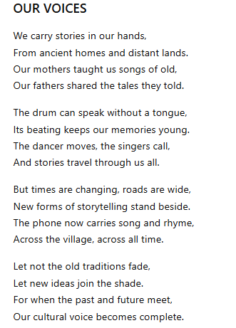
a) Who is the persona in the poem? (2 marks)
_______________________________________________________________________________________________
_______________________________________________________________________________________________

b) Identify two pairs of rhyming words from the poem. (2 marks)
_______________________________________________________________________________________________
_______________________________________________________________________________________________
c) What is the main message of the poem? (2 marks)
_______________________________________________________________________________________________
_______________________________________________________________________________________________
d) Identify one example of personification in the poem. (1 mark)
_______________________________________________________________________________________________
_______________________________________________________________________________________________

e) What does the drum symbolize in the poem? (2 marks)
_______________________________________________________________________________________________
_______________________________________________________________________________________________
f) Explain how modern technology has influenced storytelling according to the poem. (2 marks)
_______________________________________________________________________________________________
_______________________________________________________________________________________________
g) What attitude does the persona have towards traditional culture? Give a reason for your answer. (2 marks)
_______________________________________________________________________________________________
_______________________________________________________________________________________________
h) What lesson can young people learn from the poem? (2 marks)
_______________________________________________________________________________________________
_______________________________________________________________________________________________

THIS IS THE LAST PRINTED PAGE.

KENYA CERTIFICATE OF BASIC EDUCATION

SENIOR SCHOOL ASSESSMENT

DECEMBER ASSIGNMENT 2026
GRADE 10 – MANDARIN
Time: 2 Hours
LEARNER’S DETAILS
Name: _____________________________. School: ______________________________.
Assessment Number: __________________. Date: ___________________________.
School Code: ________________________. Signature: _____________________________.

INSTRUCTIONS TO CANDIDATES
- This paper consists of TWO SECTIONS: A and B.
- The paper has FOUR TASKS.
- Answer ALL questions.
- The examination carries 80 marks.
- Write Chinese characters carefully and observe correct stroke order, character formation and spacing.
- Where required, write answers in Chinese characters, Pinyin or English.
- Use correct Pinyin tone marks where required.
- Observe correct Chinese word order and punctuation.
- There are NO multiple-choice questions in this paper.
- Task 4 is an oral assessment and shall be administered individually by the teacher/examiner.

FOR OFFICIAL USE ONLY (EXAMINER’S USE)
SECTION | SECTION A | SECTION B | % SCORE | EE1 | EE2 | ME1 | ME2 | AE1 | AE2 | BE1 | BE2
SCORE RANGE | 30 MARKS | 50 MARKS |  | 90-100 | 75-89 | 58-74 | 41-57 | 31-40 | 21-30 | 11-20 | 1-10
POINTS |  |  |  | 8 POINTS | 7 POINTS | 6 POINTS | 5 POINTS | 4 POINTS | 3 POINTS | 2 POINTS | 1 POINT
SCORE

阅读理解
Read the following passage carefully and answer ALL the questions that follow.

我的朋友安娜
我有一个好朋友，她叫安娜。她今年十五岁，是肯尼亚人。她住在纳库鲁，和爸爸、妈妈还有弟弟一起生活。
安娜是一名十年级学生。她每天早上五点半起床。她先洗脸、刷牙，然后吃早餐。六点半，她坐公共汽车去学校。
安娜很喜欢学校。她最喜欢的科目是中文，因为她觉得中文很有趣。她每天练习说中文，也学习汉字和拼音。她的中文老师很友好，常常帮助她学习。
安娜放学以后先回家做作业。晚上七点，她和家人一起吃晚饭。晚饭以后，她有时候看电视，有时候读书。
星期六，安娜喜欢和朋友一起打排球。星期日，她通常帮助妈妈做家务。她希望将来能去中国学习中文和了解中国文化。

1.1 Answer the following questions in English. (5 marks)
a) How old is Anna?
_____________________________________________________________________________________________
b) Where does Anna live?
_____________________________________________________________________________________________
c) Name two people Anna lives with.
______________________________________________________________________________________________
d) Why does Anna like Chinese?
______________________________________________________________________________________________
e) What does Anna hope to do in the future?
_______________________________________________________________________________________________

1.2 Answer the following questions in Chinese characters. (5 marks)
a) 安娜几点起床？
_______________________________________________________________________________________________
b) 她怎么去学校？
_______________________________________________________________________________________________

c) 她最喜欢什么科目？
_______________________________________________________________________________________________

d) 晚饭以后，她喜欢做什么？
_______________________________________________________________________________________________

e) 星期六她喜欢做什么？
_______________________________________________________________________________________________

1.3 Write the correct Pinyin with tone marks for the following words from the passage. (5 marks)
a) 朋友
_______________________________________________________________________________________________
b) 肯尼亚
_______________________________________________________________________________________________
c) 家人
_______________________________________________________________________________________________
d) 中文
_______________________________________________________________________________________________
e) 文化
_______________________________________________________________________________________________

1.4
(a) Give the English meaning of the following. (3 marks)
i) 弟弟 – ____________________________________________
ii) 早餐 – ____________________________________________
iii) 家务 – ___________________________________________
(b) Write the Chinese characters for the following Pinyin. (2 marks)
i) xuéxiào – __________________________________________
ii) māma – ___________________________________________

SECTION B – 50 MARKS

TASK 2: 30 MARKS

2.1 Rearrange the words to form correct Chinese sentences. (5 marks)
a) 今天 / 是 / 星期一
_______________________________________________________________________________________________
b) 喜欢 / 我 / 看书
_______________________________________________________________________________________________
c) 学校 / 在 / 我 / 学习
_______________________________________________________________________________________________
d) 妈妈 / 和 / 我 / 住
_______________________________________________________________________________________________
e) 中文 / 学习 / 她 / 每天
_______________________________________________________________________________________________

2.2 Fill in each blank with an appropriate word from:
也 都 很 不 吗 (5 marks)
a) 我______喜欢中文。
b) 你是学生______？
c) 我的老师______友好。
d) 我不喜欢咖啡，我______不喜欢茶。
e) 我和朋友______学习中文。

2.3 Rewrite the words in brackets in the correct position in each sentence. (5 marks)
a) 我去学校。
（每天）
_______________________________________________________________________________________________
b) 她做作业。
（晚上）
_______________________________________________________________________________________________
c) 我们打篮球。
（星期六）
_______________________________________________________________________________________________
d) 他吃早餐。
（早上六点）
_______________________________________________________________________________________________
e) 我学习中文。
（下午）
_______________________________________________________________________________________________

2.4 Follow the instructions carefully. (5 marks)
a) Change into a question using 吗:
你喜欢中文。_______________________________________________________________________________________________
b Change into a negative sentence using 不:
我喜欢看电视。
_______________________________________________________________________________________________
c) Change into a negative sentence using 没有:
她有弟弟。
_______________________________________________________________________________________________
d) Change into a question using 什么:
他喜欢篮球。 _______________________________________________________________________________________________
e) Change into a question using 谁:
王老师是我的中文老师。 _______________________________________________________________________________________________

2.5

(a) Add the correct tone marks to the following. (3 marks)
i) ni hao _______________________________________________________________________________________________
ii) pengyou
_______________________________________________________________________________________________
iii) xuexiao
_______________________________________________________________________________________________

(b) Write the Pinyin for the following characters. (2 marks)
i) 家人
_______________________________________________________________________________________________
ii) 文化
_______________________________________________________________________________________________

2.6

(a) Write the following characters correctly. (2 marks)
i) 口 _______________________________________________
ii) 女 _______________________________________________

(b) State the number of strokes in the following characters. (2 marks)
i) 人 — __________ strokes
ii) 女 — __________ strokes

2.7 Rewrite the following sentence using appropriate Chinese punctuation. (1 mark)
你叫什么名字你是哪国人 _______________________________________________________________________________________________

2.8 Give the English meaning of each character. (2 marks)
a) 大 — _____________________________________________ b) 小 — _____________________________________________

TASK 3: WRITING – 20 MARKS
3.1 Carefully copy the following words.– 5 marks
朋友 学校 老师 中文 家庭
______________________________________________________________________________________________________________________________________________________________________________________________
3.2 Write the correct Chinese characters. – 5 marks
a) bàba
_______________________________________________________________________________________________
b) māma
_______________________________________________________________________________________________
c) xuéshēng
_______________________________________________________________________________________________
d) lǎoshī
_______________________________________________________________________________________________
e) péngyou
_______________________________________________________________________________________________

3.3 Guided composition – 10 marks

我的家庭
Write 80–100 Chinese characters about your family.
Your composition should include:
- How many people are in your family.
- Who they are.
- Where you live.
- What your parents/guardians do.
- Whether you have brothers or sisters.
- What you do together.
- One activity you enjoy with your family.
- Why you like your family.
Use Chinese characters as much as possible. Pay attention to:
- correct character formation;
- Pinyin;
- word order;
- punctuation;
- grammar;
- spacing.

Writing space
______________________________________________________________________________________________________________________________________________________________________________________________________________________________________________________________________________________________________________________________________________________________________________________________________________________________________________________________________________________________________________________________________________________________________________________________________________________________________________________________________________________________________________________________________________________________________________________________________________________________________________________________________________________________________________________________________________________________________________________

TASK 4: ORAL ASSESSMENT – 10 MARKS
To be administered individually by the teacher/examiner.

4.1 Personal information – 4 marks
The learner should introduce himself/herself in Mandarin.
The learner should mention:
- name;
- age;
- nationality;
- family/school.

Examiner prompt:
请介绍一下你自己和你的家庭。
Pinyin: Qǐng jièshào yíxià nǐ zìjǐ hé nǐ de jiātíng.

4.2 Oral questions – 3 marks
The examiner asks:

(a)
你今年几岁？

(b)
你家有几个人？

(c)
你最喜欢什么科目？为什么？
The learner should respond appropriately in Mandarin.

4.3– 3 marks Study the picture below

The learner should describe the picture using at least three meaningful Mandarin sentences.
The learner may mention:
- the people;
- the place;
- what the family is doing;
- food;
- family relationships.

KENYA CERTIFICATE OF BASIC EDUCATION

SENIOR SCHOOL ASSESSMENT

DECEMBER ASSIGNMENT 2026
GRADE 10 – MARINE TECHNOLOGY
Time: 2 Hours
LEARNER’S DETAILS
Name: _____________________________________________________________. School: ____________________________________________.
Assessment Number: _______________________________________________. Date: ____________________________________________.
School Code: ______________________________________________________. Signature: _______________________________________.

INSTRUCTIONS TO CANDIDATES
- Write your details as required above
- This paper consists of two sections: A and B.
- Answer all questions in section A and section B.
- Answer the questions in English.
- All answers MUST be written in the spaces provided in the paper.
- Do NOT remove any page from this question paper.

FOR OFFICIAL USE ONLY (EXAMINER’S USE)
SECTION | SECTION A | SECTION B | % SCORE | EE1 | EE2 | ME1 | ME2 | AE1 | AE2 | BE1 | BE2
SCORE RANGE | 30 MARKS | 50 MARKS |  | 90-100 | 75-89 | 58-74 | 41-57 | 31-40 | 21-30 | 11-20 | 1-10
POINTS |  |  |  | 8 POINTS | 7 POINTS | 6 POINTS | 5 POINTS | 4 POINTS | 3 POINTS | 2 POINTS | 1 POINT
LEARNER’S TOTAL SCORE

SECTION A (30 MARKS) Answer ALL questions in this section.
  - a) Define the following terms:
i. Fisheries resource (1 mark)
.............................................................................................................................................................................................
.................................................................................................................... ……………………………………………….
ii. Capture fisheries (1 mark)
.............................................................................................................................................................................................
.................................................................................................................... ……………………………………………….
iii. Fishery (1 mark)
.............................................................................................................................................................................................
.................................................................................................................... ……………………………………………….
b) State three importance of fisheries resources to Kenyan communities. (3 marks)
i. .................................................................................................................
ii. .................................................................................................................
iii. .................................................................................................................
  - Study the illustration below.
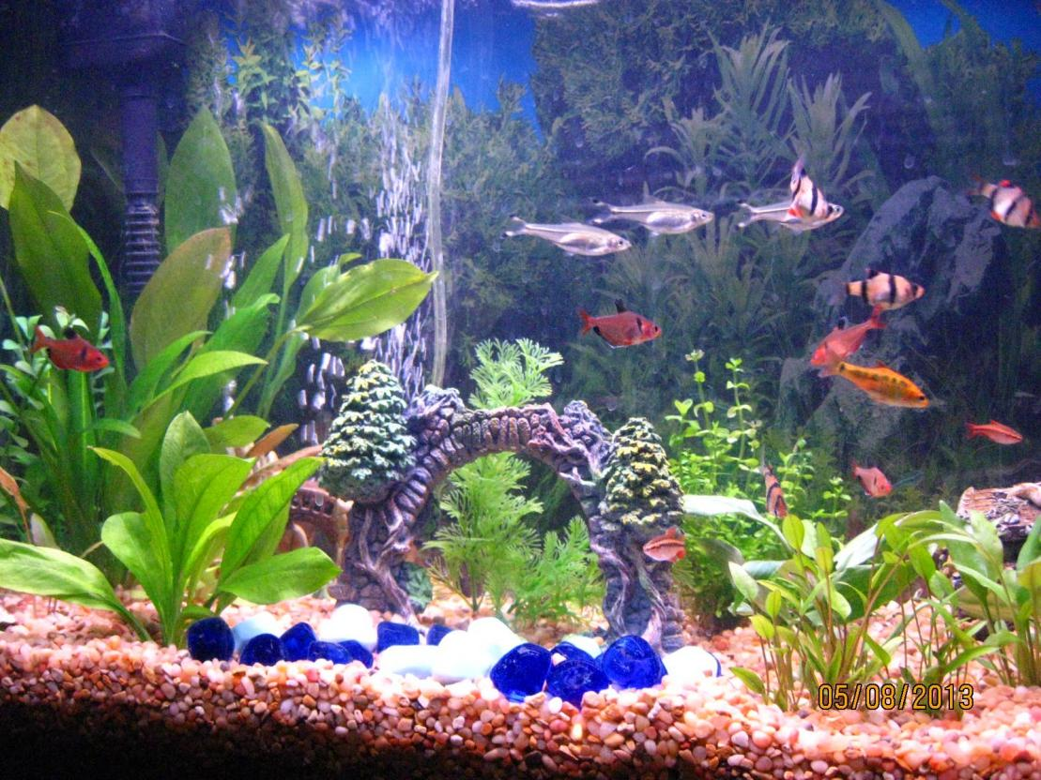
a) Identify the aquatic habitat represented by the illustration. (1 mark)
....................................................................................................................
b) State two biotic factors found in an aquatic ecosystem. (2 marks)
i. .................................................................................................................
ii. .................................................................................................................
c) State three abiotic factors that influence fish distribution in an aquatic ecosystem. (3 marks)
i. .................................................................................................................
ii. .................................................................................................................
iii. .................................................................................................................

  - Study the simplified fish diagram below.
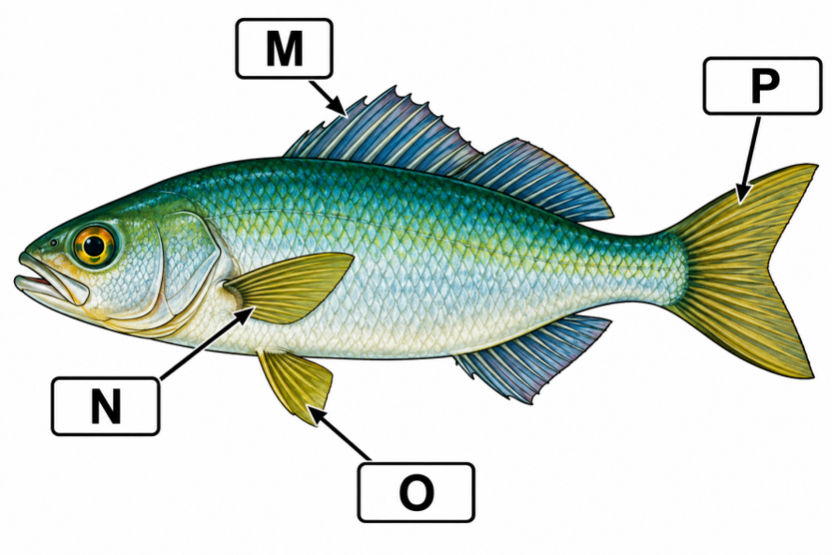
a) Identify the structures labelled M, N, O and P. (4 marks)
M. ...............................................................................................................
N. ...............................................................................................................
O. ...............................................................................................................
P. ...............................................................................................................
b) State two functions of fins in fish. (2 marks)
i. .........................................................................................................................................................................................
ii. ................................................................................................................. …………………………………..…………
  - A farmer wants to establish a fish pond on a piece of land near a river.
a) State four characteristics of a suitable site for fish pond construction. (4 marks)
i. ..........................................................................................................................................................................................
ii. ..........................................................................................................................................................................................
iii. ........................................................................................................................................................................................
iv. .........................................................................................................................................................................................

b) State two dangers of establishing a fish pond in a polluted area. (2 marks)
i. ...........................................................................................................................................................................................
ii. .....................................................................................................................................................................……………
  - a) Give three signs that may indicate poor health in cultured fish. (3 marks)
i. ..........................................................................................................................................................................................
ii. ..........................................................................................................................................................................................
iii. ........................................................................................................................................................................................
b) State three measures used to maintain good water quality in a fish pond. (3 marks)
i. ..........................................................................................................................................................................................
ii. ..........................................................................................................................................................................................
iii. ........................................................................................................................................................................................

SECTION B: 50 MARKS Answer ALL questions.
  - Fish possess various structural and physiological features that enable them to survive in aquatic environments.
a) Explain four ways in which the streamlined body of a fish contributes to survival in water. (4 marks)
i. ..........................................................................................................................................................................................
ii. ..........................................................................................................................................................................................
iii. ........................................................................................................................................................................................
iv. .........................................................................................................................................................................................

b) Explain the role of each of the following structures:
i. Gills (2 marks)
.............................................................................................................................................................................................
.................................................................................................................... ……………………………………………….
ii. Lateral line (2 marks)
.............................................................................................................................................................................................
.................................................................................................................... ……………………………………………….
c) State two adaptations that enable fish to maintain buoyancy. (2 marks)
i. ..........................................................................................................................................................................................
ii. ..........................................................................................................................................................................................
  - A school intends to establish a fish production project for learning and income generation.
a) Describe three types of aquaculture production systems. (6 marks)
i. ..........................................................................................................................................................................................
ii. ..........................................................................................................................................................................................
iii. ........................................................................................................................................................................................
b) A fish farmer stocks 2,000 fingerlings in a pond. During harvesting, 1,700 fish are recovered. Calculate the percentage survival rate. (3 marks)

c) State one reason why survival rate is important to an aquaculture farmer. (1 mark)
............................................................................................................................................................................................................................................................................................
  - A farmer observes that fish in a pond are growing slowly despite regular feeding.
a) State four factors that should be considered when selecting fish feed. (4 marks)
i. ..........................................................................................................................................................................................
ii. ..........................................................................................................................................................................................
iii. ........................................................................................................................................................................................
iv. .........................................................................................................................................................................................
b) Explain three consequences of using poor-quality or inappropriate feed. (3 marks)
i. ..........................................................................................................................................................................................
ii. ..........................................................................................................................................................................................
iii. ........................................................................................................................................................................................
c) Explain three good feeding practices that a fish farmer should observe. (3 marks)
i. ..........................................................................................................................................................................................
ii. ..........................................................................................................................................................................................
iii. ........................................................................................................................................................................................

  - Study the fishing gear illustrations below.
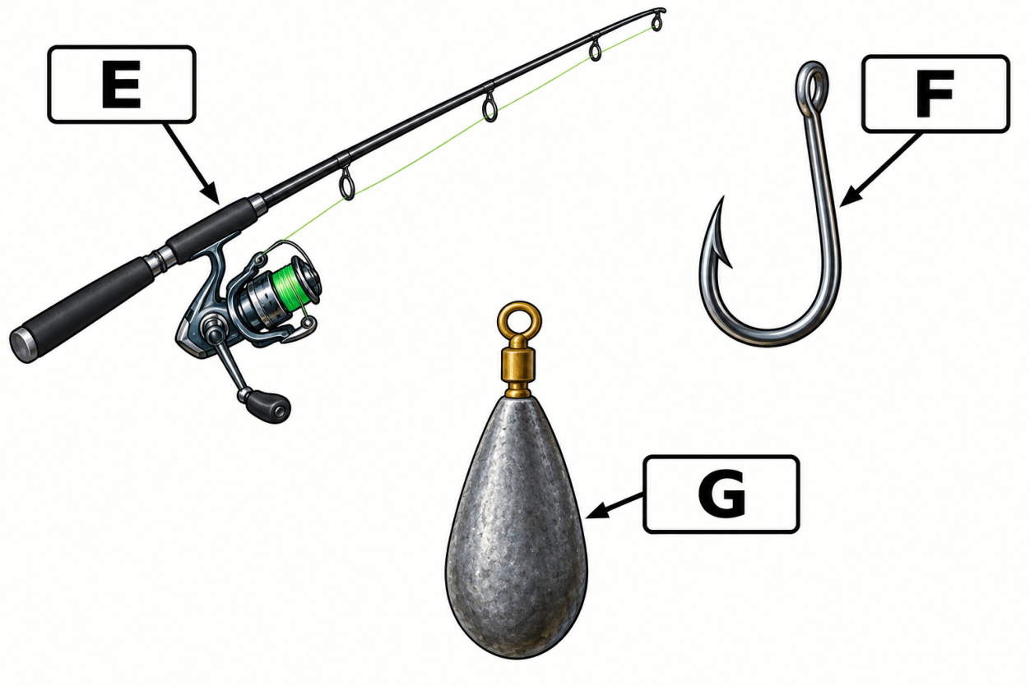

a) Identify the fishing gear represented by E, F and G. (3 marks)
E. ...............................................................................................................
F. ...............................................................................................................
G. ...............................................................................................................
b) State one advantage of each fishing tool. (3 marks)
E. ......................................................................................................................................................................................
F. .......................................................................................................................................................................................
G. .............................................................................................................................................................……………….

c) State two factors that should be considered when selecting fishing gear. (2 marks)
i. ..........................................................................................................................................................................................
ii. ..........................................................................................................................................................................................
d) Give two examples of responsible fishing practices. (2 marks)
i. ..........................................................................................................................................................................................
ii. ..........................................................................................................................................................................................
  - A group of learners visits a fishing community to study fishing operations. Before the fishing activity begins, the fisheries officer gives them safety instructions.
a) State four safety precautions that should be observed when working on or near water. (4 marks)
i. ..........................................................................................................................................................................................
ii. ..........................................................................................................................................................................................
iii. ........................................................................................................................................................................................
iv. .........................................................................................................................................................................................
b) Explain the importance of the following:
i. Life jacket/PFD (1 mark)
............................................................................................................................................................................................................................................................................................
ii. First-aid kit (1 mark)
..............................................................................................................................................
....................................................................................................................…………………………………

c) Explain two ways of conserving fisheries resources. (2 marks)
i. ..........................................................................................................................................................................................
ii. ..........................................................................................................................................................................................
d) State two entrepreneurial opportunities in marine and fisheries technology. (2 marks)
i. ..........................................................................................................................................................................................
ii. ..........................................................................................................................................................................................

KENYA CERTIFICATE OF BASIC EDUCATION

SENIOR SCHOOL ASSESSMENT

DECEMBER ASSIGNMENT 2026
GRADE 10 – MEDIA TECHNOLOGY
Time: 2 Hours
LEARNER’S DETAILS
Name: _____________________________________________________________. School: ____________________________________________.
Assessment Number: _______________________________________________. Date: ____________________________________________.
School Code: ______________________________________________________. Signature: _______________________________________.

INSTRUCTIONS TO CANDIDATES
- Write your details as required in the spaces above.
- This paper consists of two sections: A and B.
- Answer all questions in section A and section B.
- Answer the questions in English.
- All answers MUST be written in the spaces provided in the paper.
- Do NOT remove any page from this question paper.

FOR OFFICIAL USE ONLY (EXAMINER’S USE)
SECTION | SECTION A | SECTION B | % SCORE | EE1 | EE2 | ME1 | ME2 | AE1 | AE2 | BE1 | BE2
SCORE RANGE | 30 MARKS | 50 MARKS |  | 90-100 | 75-89 | 58-74 | 41-57 | 31-40 | 21-30 | 11-20 | 1-10
POINTS |  |  |  | 8 POINTS | 7 POINTS | 6 POINTS | 5 POINTS | 4 POINTS | 3 POINTS | 2 POINTS | 1 POINT
LEARNER’S TOTAL SCORE

SECTION A (30 MARKS)
Answer ALL questions in this section.
  - a) Explain the meaning of media content. (1 mark)
________________________________________________________________________________________________________
________________________________________________________________________________________________________
b) State three characteristics of effective media content. (3 marks)
i. _____________________________________________________________________________________________
ii. ____________________________________________________________________________________________
iii. ___________________________________________________________________________________________
c) Give two examples of media content that can be used to educate learners. (2 marks)
i. ____________________________________ ii. ___________________________________
  - a) Name the three major components of a media production. (3 marks)
i. _______________________________________________________________
ii. _______________________________________________________________
iii. _______________________________________________________________
b) State one importance of combining different media components when creating content. (1 mark)
___________________________________________________________________________________________________
___________________________________________________________________________________________________
c) Give one example of a multimedia production. (1 mark)
________________________________________________
  - A school environmental club wants to create a three-minute video encouraging learners to conserve water.
a) State two pieces of information that should be established before production begins. (2 marks)
i. ____________________________________________________________________________________________
ii. ____________________________________________________________________________________________
b) Explain three reasons why planning is important in media production. (3 marks)
i. ____________________________________________________________________________________________
ii. ____________________________________________________________________________________________
iii. ___________________________________________________________________________________________
  - a) State two safety precautions when handling media production equipment. (2 marks)
i. _____________________________________________________________________________________________
ii. _____________________________________________________________________________________________
b) State two ways of maintaining media equipment. (2 marks)
i. ____________________________________________________________________________________________
ii. ____________________________________________________________________________________________
  - a) What is meant by a target audience? (1 mark)
___________________________________________________________________________________________________
___________________________________________________________________________________________________

b) State two factors that can influence the choice of language in media content. (2 marks)
i. _____________________________________________________________________________________________
ii. ____________________________________________________________________________________________
c) Explain two reasons why media creators should understand their target audience. (2 marks)
i. _____________________________________________________________________________________________
ii. _____________________________________________________________________________________________

a) State two benefits of using social media to distribute media content. (2 marks)
i. _______________________________________________________________
ii. _______________________________________________________________
b) Identify one danger associated with sharing unverified media content online. (1 mark)
___________________________________________________________________________________________________
___________________________________________________________________________________________________
c) State two measures that can help a media creator verify information before publishing it. (2 marks)
i. _____________________________________________________________________________________________
ii. _____________________________________________________________________________________________

SECTION B: 50 MARKS
Answer ALL questions in this section.
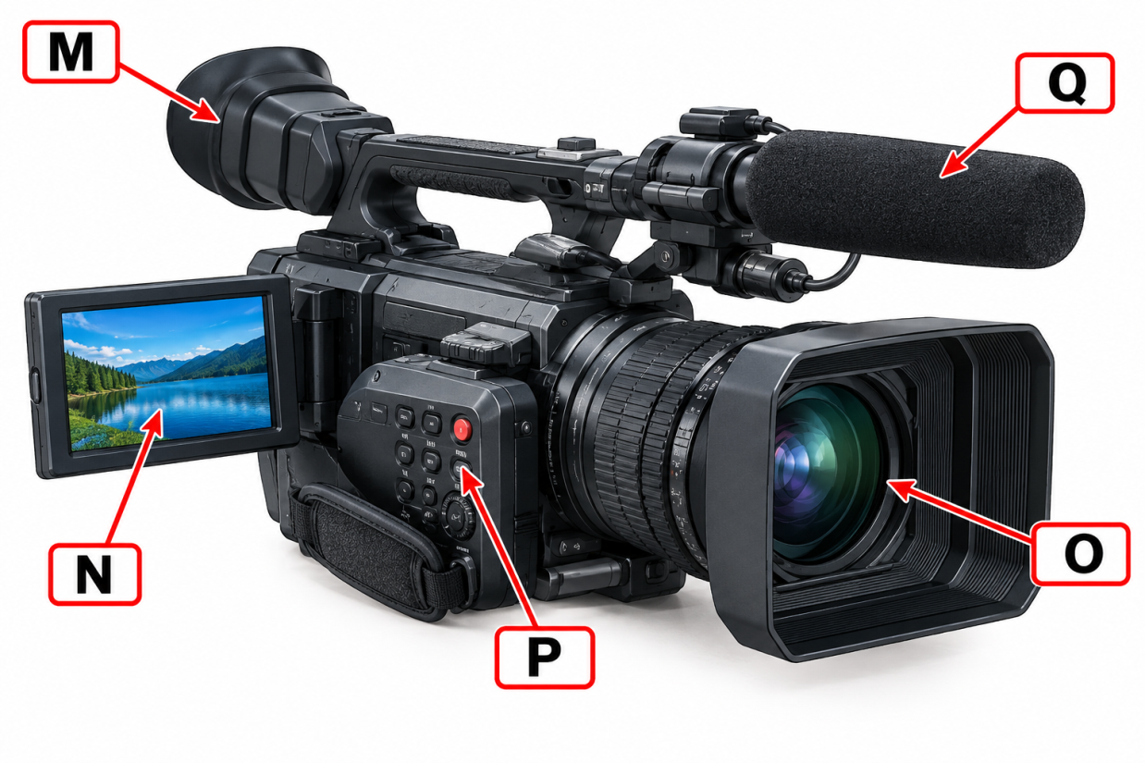
  - Study the simplified diagram of a video camera below.

a) Identify the components labelled A, B, C, D and E. (5 marks)
M. _________________________________________________________________
N. _________________________________________________________________
O. _________________________________________________________________
P. _________________________________________________________________
Q. _________________________________________________________________
b) State the function of the following:
i. Viewfinder _________________________________________________________________________ (1 mark)
ii. Lens _____________________________________________________________________________ (1 mark)
iii. Microphone _______________________________________________________________________(1 mark)
c) State two factors to consider when selecting a camera for a particular production. (2 marks)
i. _____________________________________________________________________________________________
ii. ____________________________________________________________________________________________
  - A learner is taking a photograph of a cultural performance at school.
a) State four principles or techniques of photographic composition that the learner could apply. (4 marks)
i. ____________________________________________________________________________________________
ii. ____________________________________________________________________________________________
iii. ____________________________________________________________________________________________
iv. ____________________________________________________________________________________________
b) Explain how each of the following can improve a photograph:
i. Rule of thirds (2 marks)
___________________________________________________________________________________________________
___________________________________________________________________________________________________
ii. Leading lines (2 marks)
___________________________________________________________________________________________________
___________________________________________________________________________________________________

c) State two factors that can make a photograph poorly composed. (2 marks)
i. ____________________________________________________________________________________________
ii. ____________________________________________________________________________________________
  - Study the audio recording arrangement below.
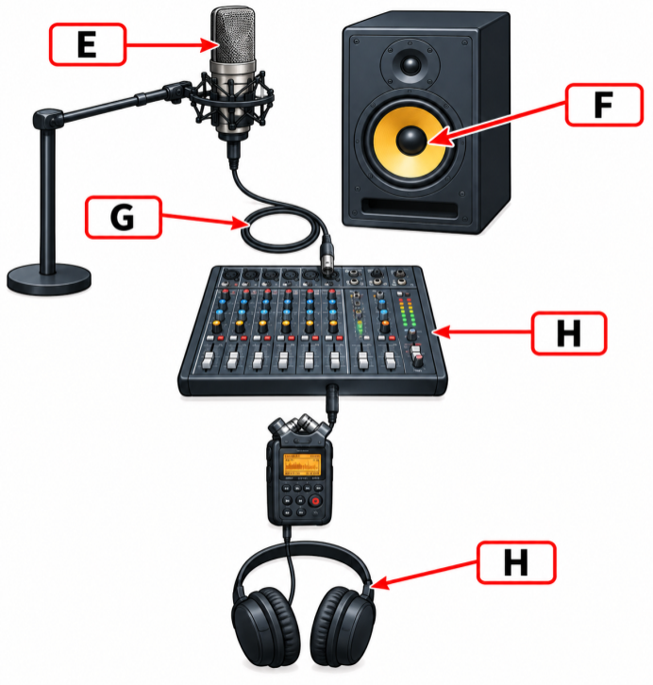
a) Identify the four pieces of equipment represented in the diagram. (4 marks)
i. _____________________________________________________________________________________________
ii. _____________________________________________________________________________________________
iii. ____________________________________________________________________________________________
iv. ____________________________________________________________________________________________
b) State the function of:
i. Audio mixer (1 mark)
___________________________________________________________________________________________________
___________________________________________________________________________________________________
ii. Audio recorder (1 mark)
___________________________________________________________________________________________________
___________________________________________________________________________________________________
iii. Headphones (1 mark)
___________________________________________________________________________________________________
___________________________________________________________________________________________________
c) Explain three causes of poor-quality sound during recording. (3 marks)
i. _____________________________________________________________________________________________
ii. _____________________________________________________________________________________________
iii. ____________________________________________________________________________________________
  - A media club produces a short news bulletin. During editing, the learners discover that some footage is unnecessary, the sound levels vary greatly and the opening lacks a title.
a) Identify three editing operations that should be performed. (3 marks)
i. _____________________________________________________________________________________________
ii. _____________________________________________________________________________________________
iii. ____________________________________________________________________________________________
b) Explain how each of the following can improve the final production:
i. Trimming (1 mark)
___________________________________________________________________________________________________
___________________________________________________________________________________________________
ii. Audio adjustment (1 mark)
______________________________________________________________________________________________________________________________________________________________________________________________________
iii. Adding titles (1 mark)
___________________________________________________________________________________________________
___________________________________________________________________________________________________

c) State two visual elements that may be added during video editing. (2 marks)
i. _____________________________________________________________________________________________
ii. _____________________________________________________________________________________________
d) State two considerations when choosing an output format for a video. (2 marks)
i. _____________________________________________________________________________________________
ii. _____________________________________________________________________________________________
  - A Grade 10 learner has developed skills in photography, video production and graphic design. The learner plans to start a small media enterprise serving schools and local businesses.
a) Identify three services that the learner could offer to clients. (3 marks)
i. _____________________________________________________________________________________________
ii. _____________________________________________________________________________________________
iii. ____________________________________________________________________________________________
b) Explain two ways the learner could market the media enterprise. (2 marks)
i. _____________________________________________________________________________________________
ii. _____________________________________________________________________________________________
c) State three factors that should be considered when setting prices for media services. (3 marks)
i. _____________________________________________________________________________________________
ii. _____________________________________________________________________________________________
iii. ____________________________________________________________________________________________
d) State two qualities of a successful media entrepreneur. (2 marks)
i. _____________________________________________________________________________________________
ii. _____________________________________________________________________________________________

KENYA CERTIFICATE OF BASIC EDUCATION

SENIOR SCHOOL ASSESSMENT

DECEMBER ASSIGNMENT 2026
GRADE 10 – METAL TECHNOLOGY
Time: 2 Hours
LEARNER’S DETAILS
Name: _____________________________________________________________. School: ____________________________________________.
Assessment Number: _______________________________________________. Date: ____________________________________________.
School Code: ______________________________________________________. Signature: _______________________________________.

INSTRUCTIONS TO CANDIDATES
- Write your name in the spaces provided above.
- Write the name of your school and your stream in the spaces provided.
- Write your admission number and the date of the assessment in the spaces provided.
- This paper consists of two sections: A and B.
- Answer all questions in section A and section B.
- Answer the questions in English.
- All answers MUST be written in the spaces provided in the paper.
- Do NOT remove any page from this question paper.

FOR OFFICIAL USE ONLY (EXAMINER’S USE)
SECTION | SECTION A | SECTION B | % SCORE | EE1 | EE2 | ME1 | ME2 | AE1 | AE2 | BE1 | BE2
SCORE RANGE | 30 MARKS | 50 MARKS |  | 90-100 | 75-89 | 58-74 | 41-57 | 31-40 | 21-30 | 11-20 | 1-10
POINTS |  |  |  | 8 POINTS | 7 POINTS | 6 POINTS | 5 POINTS | 4 POINTS | 3 POINTS | 2 POINTS | 1 POINT
LEARNER’S TOTAL SCORE

SECTION A (40 MARKS)
Answer ALL questions in this section.
  - A learner enters a metalwork workshop and notices that some tools are scattered on workbenches, metal off-cuts are lying on the floor, and a gas cylinder has been placed close to a source of heat.
a) Identify two unsafe conditions from the situation. (2 marks)
i. _________________________________________________________________
ii. ________________________________________________________________

b) State two measures that should be taken to make the workshop safer. (2 marks)
i. _________________________________________________________________
ii. ________________________________________________________________
  - Study the following simplified illustration.
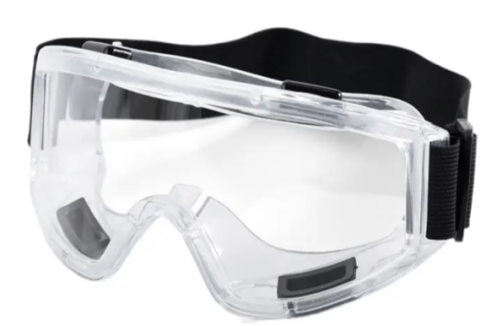
a) Identify the item of personal protective equipment represented by the illustration. (1 mark)
__________________________________________________________________
b) State TWO reasons for wearing appropriate personal protective equipment in a metalwork workshop. (2 marks)
i. _____________________________________________________________________________________________
ii. ____________________________________________________________________________________________
  - a) Name the appropriate tool used for each operation.
i. Measuring the length of a metal component accurately. ________________________ (1 mark)
ii. Making a fine line on a metal surface before cutting. __________________________ (1 mark)
iii. Checking whether two surfaces are at right angles. ____________________________ (1 mark)
b) State one reason for cleaning a metal surface before marking out. (1 mark) ______________________________________________________________________________________________________________________________________________________________________________________________
  - a) Define the following terms:
i. Hardness (1 mark) ______________________________________________________________________________________________________________________________________________________________________________________________
ii. Toughness (1 mark) ______________________________________________________________________________________________________________________________________________________________________________________________
b) Distinguish between malleability and ductility. (2 marks)
____________________________________________________________________________________________________________________________________________________________________________________________________________________________________________________________________________________________________________________________________________________________________________________________________________
  - a) Give two examples of ferrous metals. (2 marks)
i. _________________________________________________________________
ii. ________________________________________________________________
b) Give two examples of non-ferrous metals. (2 marks)
i. _________________________________________________________________
ii. ________________________________________________________________
  - Define the terms metals and metalwork. (2marks)
____________________________________________________________________________________________________________________________________________________________________________________________________________________________________________________________________________________________________________________________________________________________________________________________
  - Name any TWO careers in the field of metalwork. (2 marks)
i. ___________________________________________________________________
ii. __________________________________________________________________
  - Name the TWO aspects of safety. (2 marks)
i. ___________________________________________________________________________________________
ii. ___________________________________________________________________________________________
  - List any TWO safety rules in a metal workshop. (2 marks)
i. _____________________________________________________________________________________________
ii. ____________________________________________________________________________________________
  - Metal cutting tools should be made using hard materials.Explain why and name those two metals. (2marks)
____________________________________________________________________________________________________________________________________________________________________________________________________________________________________________________________________________________________________________________________________________________________________________________________
  - Give two differences between Steel and aluminium. (2marks)
i. _____________________________________________________________________________________________
ii. ____________________________________________________________________________________________
  - The figure shows a tool used in measuring and checking.
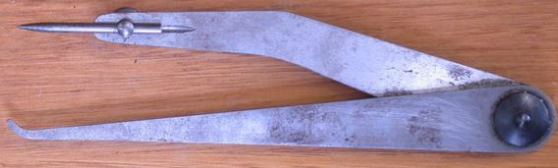
  - Give the name of the tool and name the material used for making it. (2marks)
Tool name | Material used
  - Give two uses of the tool. (2marks)
i. _____________________________________________________________________________________________
ii. ____________________________________________________________________________________________

  - Why is the cutting edge of a cold chisel hardened while the end struck by a hammer tempered. (2marks)
_____________________________________________________________________________________________________________________________________________________________________________________________________________________________________________________________________________________________
  - The figure below shows a tool used in cutting metals.
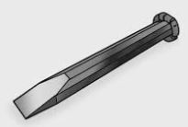
Name the problem that the tool has ,state the cause of it and explain how to correct it. (2marks)
Problem
Cause
Correction
  - The figure below shows a metal cutting tool.
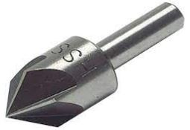
  - Give the name of the tool and its use. (2marks)
Tool: _________________________________.
Use: _____________________________________________________________________________________
  - State two reasons for notching edges of sheet metal. (2marks)
i. _____________________________________________________________________________________________
ii. ____________________________________________________________________________________________

SECTION B: 50 MARKS
Answer ALL questions.
  - Figure 2 shows orthographic views of a machined block drawn in third angle projection.
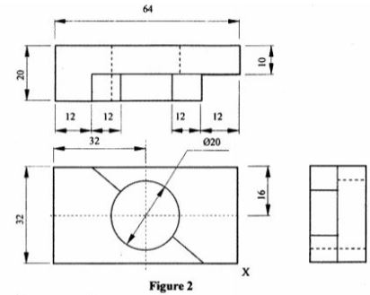
On the grid paper provided, draw the isometric view of the block taking X as the lowest point.
Show three main dimensions. (15 marks)
  - A learner is required to cut, hold, file and finish a mild-steel workpiece.
a) Name a suitable tool for each of the following operations. (4 marks)
i. Holding the workpiece firmly: _____________________________________
ii. Cutting the metal: ______________________________________________
iii. Removing small amounts of metal: ________________________________
iv. Checking a right angle: __________________________________________
b) Explain two factors that should be considered when selecting a file for a metalworking operation. (2 marks)
i. _________________________________________________________________
ii. ________________________________________________________________
c) State two safety precautions when using a hacksaw. (2 marks)
i. _________________________________________________________________
ii. ________________________________________________________________
d) State two ways of maintaining hand tools. (2 marks)
i. _________________________________________________________________
ii. ________________________________________________________________
  - A school workshop wants to manufacture the following items:
- A school gate;
- Electrical connecting wire;
- A lightweight sheet-metal container;
- A component that must resist corrosion.
a) Select a suitable metal for each item. (4 marks)
i. School gate: _____________________________________________________
ii. Electrical connecting wire: ______________________________________
iii. Lightweight sheet-metal container: _______________________________
iv. Corrosion-resistant component: __________________________________
b) Give two properties of mild steel that make it suitable for fabrication work. (2 marks)
i. _________________________________________________________________
ii. ________________________________________________________________
c) State two advantages of using aluminium in sheet-metal work. (2 marks)
i. _________________________________________________________________
ii. ________________________________________________________________
d) State two factors that influence the choice of a metal for a particular product. (2 marks)
i. _________________________________________________________________
ii. ________________________________________________________________
  - Study the object below.
80 mm
┌────────────────┐
/│ /│
/ │ / │
/ │ / │
└───┼────────────┘ │
│ │ │ │
│ │ │ │ 50 mm
│ └────────────┼───┘
│ / │ /
│ / │ /
│/_______________│/
40 mm
a) Identify the type of pictorial drawing represented above. __________________________________ (1 mark)
b) State two characteristics of this type of drawing. (2 marks)
i. _________________________________________________________________
ii. ________________________________________________________________
c) State the purpose of using a scale in technical drawing. (2 marks)
___________________________________________________________________________________________________
___________________________________________________________________________________________________
d) Name three instruments that can be used to produce accurate technical drawings. (3 marks)
i. _________________________________________________________________
ii. ________________________________________________________________
iii. _______________________________________________________________
e) State two qualities of a good technical drawing. (2 marks)
i. _________________________________________________________________
ii. ________________________________________________________________
  - Study the three simplified joints below.
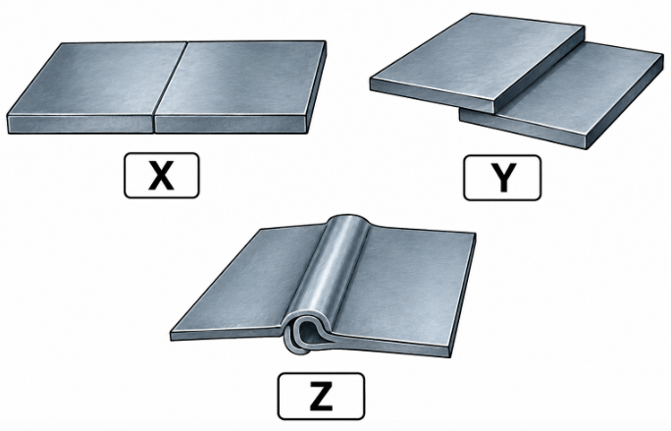
a) Identify joints X, Y and Z. (3 marks)
X: _________________________________________________________________
Y: _________________________________________________________________
Z: _________________________________________________________________
b) State three methods of joining sheet metal. (3 marks)
i. _________________________________________________________________
ii. ________________________________________________________________
iii. _______________________________________________________________
c) Describe how a riveted joint is produced from two pieces of sheet metal. (3 marks)
___________________________________________________________________________________________________
___________________________________________________________________________________________________
___________________________________________________________________________________________________
d) State one safety precaution when drilling holes in sheet metal. (1 mark)
___________________________________________________________________________________________________
___________________________________________________________________________________________________
  - A learner is required to make a small metal dustpan from a sheet of mild steel.
a) State four operations that may be carried out during the manufacture of the dustpan. (4 marks)
i. _____________________________________________________________________________________________
ii. _____________________________________________________________________________________________
iii. ____________________________________________________________________________________________
iv. ____________________________________________________________________________________________
b) Explain the importance of marking out before cutting the sheet metal. (2 marks)
___________________________________________________________________________________________________
___________________________________________________________________________________________________
c) State two methods that could be used to join parts of the dustpan. (2 marks)
i. _____________________________________________________________________________________________
ii. ____________________________________________________________________________________________
d) State two ways of evaluating the completed dustpan. (2 marks)
i. _____________________________________________________________________________________________
ii. ____________________________________________________________________________________________

KENYA CERTIFICATE OF BASIC EDUCATION

SENIOR SCHOOL ASSESSMENT

DECEMBER ASSIGNMENT 2026
GRADE 10 – MUSIC AND DANCE
Time: 2 Hours
LEARNER’S DETAILS
Name: _____________________________________________________________. School: ____________________________________________.
Assessment Number: _______________________________________________. Date: ____________________________________________.
School Code: ______________________________________________________. Signature: _______________________________________.

INSTRUCTIONS TO CANDIDATES
- Write your details as required above.
- This paper consists of two sections: A and B.
- Answer all questions in section A and section B.
- Answer the questions in English.
- All answers MUST be written in the spaces provided in the paper.
- Do NOT remove any page from this question paper.

FOR OFFICIAL USE ONLY (EXAMINER’S USE)
SECTION | SECTION A | SECTION B | % SCORE | EE1 | EE2 | ME1 | ME2 | AE1 | AE2 | BE1 | BE2
SCORE RANGE | 30 MARKS | 50 MARKS |  | 90-100 | 75-89 | 58-74 | 41-57 | 31-40 | 21-30 | 11-20 | 1-10
POINTS |  |  |  | 8 POINTS | 7 POINTS | 6 POINTS | 5 POINTS | 4 POINTS | 3 POINTS | 2 POINTS | 1 POINT
LEARNER’S TOTAL SCORE

SECTION A (30 MARKS)
Answer ALL questions in this section.
- a) Define the term rhythm as used in music. (2 marks)
___________________________________________________________________________________________________
___________________________________________________________________________________________________
b) Distinguish between a beat and a rhythm. (2 marks)
___________________________________________________________________________________________________
___________________________________________________________________________________________________

c) State two examples of compound time signatures. (2 marks)
i. ______________________________________ ii. _______________________________________
- a) What is a melody? (1 mark)
______________________________________________________________________________________________________________________________________________________________________________________________________
b) State the sequence of tones and semitones in a major scale, beginning from the first degree. (2 marks)
______________________________________________________________________________________________________________________________________________________________________________________________________
c) Write the G major scale in ascending order. (2 marks)
______________________________________________________________________________________________________________________________________________________________________________________________________
- The following notes form a short melody:
C – D – E – G – F – E – D – C
a) Write the melody one tone higher. (2 marks)
______________________________________________________________________________________________________________________________________________________________________________________________________
b) State the new key if the original melody is in C major. (1 mark)
______________________________________________________________________________________________________________________________________________________________________________________________________
c) Give one reason for transposing a song. (1 mark)
______________________________________________________________________________________________________________________________________________________________________________________________________
- Consider the following words:
KENYA, OUR BEAUTIFUL LAND,
WE SHALL CARE FOR YOU.
a) State two factors that a composer should consider when setting these words to music. (2 marks)
i. ____________________________________________________________________________________________
ii. ___________________________________________________________________________________________
b) Explain how the meaning of the text can influence the melody. (2 marks)
____________________________________________________________________________________________________________________________________________________________________________________________________________________________________________________________________________________________________________________________________________________________________________________________________________
- a) Explain the meaning of harmony in music. (2 marks)
_________________________________________________________________________________________________________________________________________________________________________________________________
b) What is meant by two-part harmony? (1 mark)
______________________________________________________________________________________________________________________________________________________________________________________________________
c) State two qualities of a good second vocal part. (2 marks)
i. ____________________________________________________________________________________________
ii. ___________________________________________________________________________________________
- a) Name one type of music notation software that may be used to create a musical score. (1 mark)
____________________________________________________________________
b) State two advantages of using music notation software. (2 marks)
i. ____________________________________________________________________________________________
ii. _____________________________________________________________________________________________
- a) What is a dance composition? (1 mark)
______________________________________________________________________________________________________________________________________________________________________________________________________
b) State two factors that should be considered when planning a dance performance. (2 marks)
i. _____________________________________________________________________________________________
ii. ____________________________________________________________________________________________

SECTION B: 50 MARKS
Answer ALL questions.
- Read the scenario below.
Learners from different Kenyan communities are preparing a cultural concert. Each group selects a folk song from its community. The performers research the purpose, language, instruments, movements and occasions associated with the song before presenting it to the audience.
a) What is a folk song? (2 marks)
______________________________________________________________________________________________________________________________________________________________________________________________________
b) State three functions of Kenyan folk songs. (3 marks)
i. ___________________________________________________________________________________________
ii. ____________________________________________________________________________________________
iii. ___________________________________________________________________________________________
c) Give two reasons why research is important before performing a folk song from another community. (2 marks)
i. ____________________________________________________________________________________________
ii. ____________________________________________________________________________________________
d) State three features that may be observed in a Kenyan folk-song performance.(3 marks)
i. ___________________________________________________________________________________________
ii. __________________________________________________________________________________________
iii. _________________________________________________________________________________________
- a) Explain the term vocal solo. (2 marks)
______________________________________________________________________________________________________________________________________________________________________________________________________
b) State three technical skills required by a solo singer. (3 marks)
i. _____________________________________________________________________________________________
ii. ____________________________________________________________________________________________
iii. ___________________________________________________________________________________________
c) Explain the importance of breath control in singing. (2 marks)
______________________________________________________________________________________________________________________________________________________________________________________________________
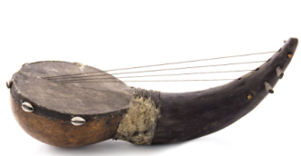
- Study the instruments below.

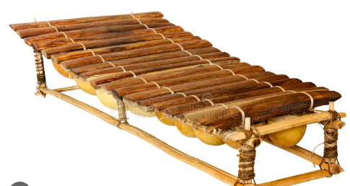
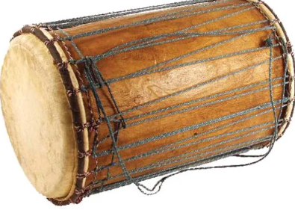

Instrument A Instrument B Instrument C
a) Identify the Hornbostel-Sachs family represented by Instrument A. (1 mark)
_________________________________________________________
b) Identify the likely family represented by Instrument B. (1 mark)
_____________________________________________________
c) Identify the likely family represented by Instrument C. (1 mark)
______________________________________________________

d) Explain the following classifications:
i. Idiophones (1 mark)
___________________________________________________________________________________________________
___________________________________________________________________________________________________
ii. Membranophones (1 mark)
___________________________________________________________________________________________________
___________________________________________________________________________________________________
iii. Chordophones (1 mark)
___________________________________________________________________________________________________
___________________________________________________________________________________________________
iv. Aerophones (1 mark)
___________________________________________________________________________________________________
___________________________________________________________________________________________________
e) Give one example of a Kenyan indigenous instrument for any one of the classifications above. (1 mark)
___________________________________________________________________________________________________
___________________________________________________________________________________________________
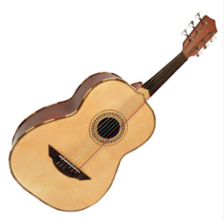
- Study the descriptions below.
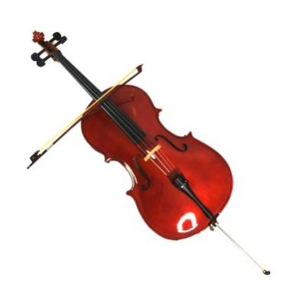
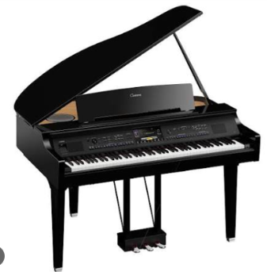
X Y Z

a) Name one Western instrument that could be represented by each description.
i. X: ______________________________________ (1 mark)
ii. Y: ______________________________________ (1 mark)
iii. Z: _____________________________________ (1 mark)
b) State two broad families of Western instruments. (2 marks)
i. ______________________________________________________________
ii. _____________________________________________________________
c) State two factors that determine the tone quality of an instrument. (2 marks)
i. ______________________________________________________________
ii. _____________________________________________________________
- a) Define contemporary dance. (2 marks)
___________________________________________________________________________________________________
___________________________________________________________________________________________________
b) State three movement elements used in dance. (3 marks)
i. ______________________________________________________________
ii. _____________________________________________________________
iii. ____________________________________________________________
c) Explain one way in which Kenyan culture can be incorporated into contemporary dance. (1 mark)
___________________________________________________________________________________________________
___________________________________________________________________________________________________
d) State two safety measures that dancers should observe during rehearsal or performance. (2 marks)
i. ______________________________________________________________
ii. _____________________________________________________________
- a) Name the period associated with Gregorian chant. (1 mark)
___________________________________________________________________________________________________
___________________________________________________________________________________________________

b) State two characteristics of Medieval music. (2 marks)
i. ______________________________________________________________
ii. _____________________________________________________________
c) State two characteristics of Renaissance music. (2 marks)
i. ______________________________________________________________
ii. _____________________________________________________________
- a) Explain two ways in which music and dance promote social cohesion. (2 marks)
i. ______________________________________________________________
ii. _____________________________________________________________
b) State two ways technology has changed the production and distribution of music. (2 marks)
i. ______________________________________________________________
ii. _____________________________________________________________
c) State one ethical consideration when recording and sharing a traditional cultural performance online.
(1 mark)
___________________________________________________________________________________________________
___________________________________________________________________________________________________

KENYA CERTIFICATE OF BASIC EDUCATION

SENIOR SCHOOL ASSESSMENT

DECEMBER ASSIGNMENT 2026
GRADE 10 – PHYSICAL EDUCATION
Time: 2 Hours
LEARNER’S DETAILS
Name: _____________________________________________________________. School: ____________________________________________.
Assessment Number: _______________________________________________. Date: ____________________________________________.
School Code: ______________________________________________________. Signature: _______________________________________.

INSTRUCTIONS TO CANDIDATES
- Write your full name in the space provided above.
- Indicate your school, stream, admission number, and date clearly.
- This paper has TWO sections: A and B.
- Attempt ALL questions in both sections.
- Show all working clearly where necessary.
- Write all answers in the spaces provided.
- Do NOT remove any page from this paper.

FOR OFFICIAL USE ONLY (EXAMINER’S USE)
SECTION | SECTION A | SECTION B | % SCORE | EE1 | EE2 | ME1 | ME2 | AE1 | AE2 | BE1 | BE2
SCORE RANGE | 30 MARKS | 50 MARKS |  | 90-100 | 75-89 | 58-74 | 41-57 | 31-40 | 21-30 | 11-20 | 1-10
POINTS |  |  |  | 8 POINTS | 7 POINTS | 6 POINTS | 5 POINTS | 4 POINTS | 3 POINTS | 2 POINTS | 1 POINT
LEARNER’S TOTAL SCORE

SECTION A (30 MARKS)
- a) Name two ways of controlling a football when it is received from a teammate. (2 marks)
- _______________________________________________________________________________________
- _______________________________________________________________________________________
b) State one reason why ball control is important in football. (1 mark)
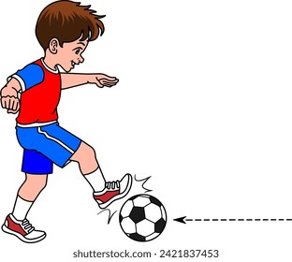
_______________________________________________________________________________________________
- Study the sequence below.

a) Identify the football skill represented. _____________________________(1 mark)
b) State two technical points that should be observed when performing the skill. (2 marks)
- _______________________________________________________________________________________
- _______________________________________________________________________________________
- a) What is meant by pivoting in netball? (1 mark)
________________________________________________________________________________________________________________________________________________________________________________________________
b) State two situations in which pivoting can be useful to a netball player. (2 marks)
- _______________________________________________________________________________________
- _______________________________________________________________________________________
- Study the diagram below.

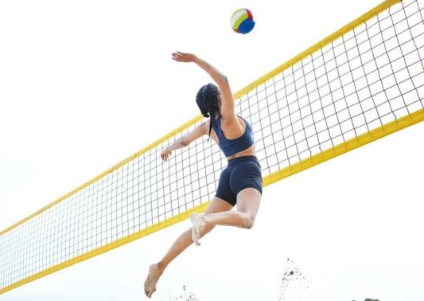
a) Identify the volleyball skill represented. _________________________________ (1 mark)
b) State two technical points to observe when performing the skill. (2 marks)
- _______________________________________________________________________________________
- _______________________________________________________________________________________
- a) Name one type of throw used to restart or continue play in handball. (1 mark)
__________________________________________________________
b) Explain two factors that determine the accuracy of a handball pass. (2 marks)
- _______________________________________________________________________________________
- _______________________________________________________________________________________
- a) What is meant by dribbling in basketball? (1 mark)
__________________________________________________________________________________________
b) State two purposes of dribbling during a basketball game. (2 marks)
- _______________________________________________________________________________________
- _______________________________________________________________________________________
- Study the illustration.
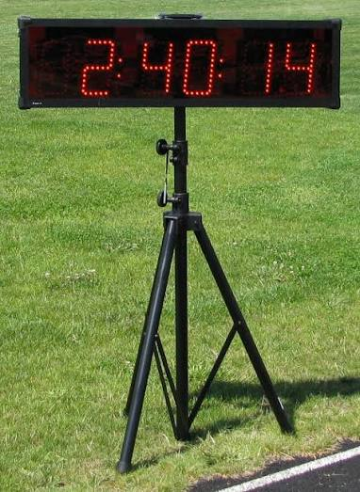
a) Identify the equipment illustrated. ____________________________________ (1 mark)
b) State two advantages of using a starting blocks in sprinting. (2 marks)
- _______________________________________________________________________________________
- _______________________________________________________________________________________
- State three technical considerations during the approach/run-up phase of a long jump. (3 marks)
- _______________________________________________________________________________________
- _______________________________________________________________________________________
- _______________________________________________________________________________________
- a) State one correct way of carrying a javelin before the throwing phase. (1 mark)
____________________________________________________________________________
b) Give two reasons why safety procedures are particularly important in javelin. (2 marks)
- _______________________________________________________________________________________
- _______________________________________________________________________________________
- a) Name one technique that may be used to put the shot. (1 mark)
___________________________________________________________________________
b) State two technical points that should be observed when putting the shot. (2 marks)
- _______________________________________________________________________________________
- _______________________________________________________________________________________

SECTION B: 50 MARKS
Answer ALL questions.
- A Grade 10 football team is preparing for an inter-school competition.

a) Describe four stages involved in performing a controlled inside-foot pass in football. (4 marks)
- _______________________________________________________________________________________
- _______________________________________________________________________________________
- _______________________________________________________________________________________
- _______________________________________________________________________________________

b) Explain three ways in which a football player can create space during an attacking situation. (3 marks)
- _______________________________________________________________________________________
- _______________________________________________________________________________________
- _______________________________________________________________________________________

c) State three responsibilities of an outfield player when the team is defending. (3 marks)
- _______________________________________________________________________________________
- _______________________________________________________________________________________
- _______________________________________________________________________________________

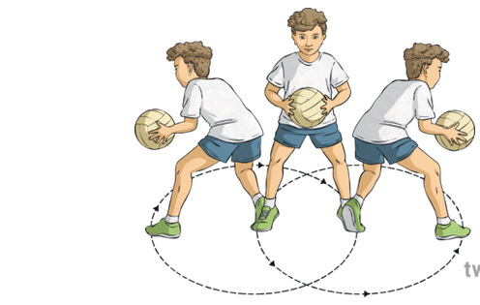
(a) NETBALL
Study the simplified movement below.

i. Identify the movement illustrated. _______________________________ (1 mark)
ii. Describe three important points to observe when performing the movement. (3 marks)
- _______________________________________________________________________________________
- _______________________________________________________________________________________
- _______________________________________________________________________________________
iii. State two advantages of effective footwork in netball. (2 marks)
- _______________________________________________________________________________________
- _______________________________________________________________________________________

(b) i. Name the skill used to send the ball forcefully over the net during an attacking volleyball play. (1 mark)
__________________________________________________
ii. Explain three technical points involved in executing this skill effectively. (3 marks)
- _______________________________________________________________________________________
- _______________________________________________________________________________________
- _______________________________________________________________________________________

(a) A player has possession of the ball and wants to move past a defender.
i. Explain three ways the player can use body movement to evade the defender in a handball game. (3 marks)
- _______________________________________________________________________________________
- _______________________________________________________________________________________
- _______________________________________________________________________________________
ii. State two qualities of an effective handball goalkeeper. (2 marks)
- _______________________________________________________________________________________
- _______________________________________________________________________________________

(b) A learner is practising dribbling around opponents.
i. Describe three important techniques for effective basketball dribbling. (3 marks)
- _______________________________________________________________________________________
- _______________________________________________________________________________________
- _______________________________________________________________________________________
ii. Explain two reasons why a player should avoid unnecessary dribbling during a game. (2 marks)
- _______________________________________________________________________________________
- _______________________________________________________________________________________

(a) Study the sprints sequence below.
A B C

i. Identify the three stages represented by A, B and C. (3 marks)
A: _____________________________
B: _____________________________
C: _____________________________

ii. Explain two ways in which arm action contributes to effective sprinting. (2 marks)
- _________________________________________________________________________________________
- _________________________________________________________________________________________

(b) i. Name the four main phases of the long jump. (2 marks)
ii. Explain one important technique during the flight phase. (1 mark)
________________________________________________________________________________________________
iii. State two safety measures to observe when performing long jump. (2 marks)
- _________________________________________________________________________________________
- _________________________________________________________________________________________

(a)
i. Distinguish between javelin and shot put according to the direction/manner in which the implement is propelled.
(2 marks)
________________________________________________________________________________________________________________________________________________________________________________________________________________________________________________________________________________________________________________________________________________________________________________________________
ii. Explain two factors that can affect the distance achieved in a throwing event. (2 marks)
- _________________________________________________________________________________________
- _________________________________________________________________________________________

(b) The school has introduced optional sports to broaden learners' participation in Physical Education.
i. Name three optional sports studied at Grade 10 level. (3 marks)
- _______________________________________________________________________________________
- _______________________________________________________________________________________
- _______________________________________________________________________________________
ii. Choose one sport named in (b)(i) and state one basic skill used in it. (1 mark)
_______________________________________________________________________________________________

(c) State two benefits of regular participation in physical activities. (2 marks)
- _________________________________________________________________________________________
- _________________________________________________________________________________________

KENYA CERTIFICATE OF BASIC EDUCATION

SENIOR SCHOOL ASSESSMENT

DECEMBER ASSIGNMENT 2026
GRADE 10 – PHYSICS
Time: 2 Hours
LEARNER’S DETAILS
Name: _____________________________________________________________. School: ____________________________________________.
Assessment Number: _______________________________________________. Date: ____________________________________________.
School Code: ______________________________________________________. Signature: _______________________________________.

INSTRUCTIONS TO LEARNERS
- This paper consists of TWO sections: A and B.
- Answer ALL questions in both sections.
- Show all working in numerical questions.
- Give answers to numerical questions to an appropriate number of significant figures where necessary.
- Use the following values unless otherwise stated:
  - $g=10 N/kg$​
  - Density of water $=1000 kg/m^{3}$
  - Speed of sound in air $=340 m/s$
  - Speed of light $=3.0×{10}^{8} m/s$
  - Take $π=3.14$.
- Non-programmable calculators may be used where necessary.

FOR OFFICIAL USE ONLY (EXAMINER’S USE)
SECTION | SECTION A | SECTION B | % SCORE | EE1 | EE2 | ME1 | ME2 | AE1 | AE2 | BE1 | BE2
SCORE RANGE | 30 MARKS | 60 MARKS |  | 90-100 | 75-89 | 58-74 | 41-57 | 31-40 | 21-30 | 11-20 | 1-10
POINTS |  |  |  | 8 POINTS | 7 POINTS | 6 POINTS | 5 POINTS | 4 POINTS | 3 POINTS | 2 POINTS | 1 POINT
LEARNER’S TOTAL SCORE

SECTION A (30 MARKS) Answer ALL questions in this section.

- Explain why Physics is considered a fundamental science. (1 mark)
______________________________________________________________________________________________________________________________________________________________________________________

- State two ways in which Physics is related to other fields of study. (2 marks)
- _____________________________________________________________________________________________
- _____________________________________________________________________________________________
  - A student descends in a swimming pool to a depth of 4.5 m.
- Calculate the pressure exerted by the water at this depth. (2 marks)

- State one factor, apart from depth, that affects pressure in a liquid. (1 mark)
______________________________________________________________________________________________________________________________________________________________________________________________________
- A hydraulic press has a small piston of area $0.015 m^{2}$ and a large piston of area $0.60 m^{2}$.
A force of 250 N is applied to the small piston.
- Calculate the pressure transmitted through the liquid. (1 mark)

- Calculate the force produced by the large piston. (2 marks)

- A spring is 25 cm long when unloaded. When a force of 40 N is applied, its length increases to 33 cm.
- Calculate its extension in metres. (1 mark)

- Determine the spring constant. (2 marks)

- Explain why a metal lid on a glass jar can sometimes be loosened by placing the lid in warm water. (2 marks)
______________________________________________________________________________________________________________________________________________________________________________________________________
- State the unusual property of water between $0^{∘}C$ and $4^{∘}C$. (1 mark)
______________________________________________________________________________________________________________________________________________________________________________________________________
- A 30 N force acts perpendicular to a spanner at a distance of 0.25 m from the pivot.
- Calculate the moment of the force. (1 mark)

- State two ways of increasing the turning effect of the force. (2 marks)
- _____________________________________________________________________________________________
- _____________________________________________________________________________________________
- A machine raises a 200 kg load through a vertical height of 12 m in 8 seconds.
- Calculate the useful work done. (1 mark)

- Calculate the useful power output of the machine. (2 marks)

- A wave has a frequency of 25 Hz and wavelength 1.2 m.
- Calculate its speed. (2 marks)

- Distinguish between a progressive wave and a stationary wave. (1 mark)
____________________________________________________________________________________________________________________________________________________________________________________________________________________________________________________________________________________________________________________________________________________________________________________________________________
- A radioactive substance has a half-life of 5 hours. Its initial activity is 9600 counts per minute.
Determine its activity after 15 hours. (3 marks)

- A $12 V$ battery is connected to a resistor of $4 Ω$.
- Calculate the current through the resistor. (1 mark)

- Determine the electrical energy converted to heat when the circuit operates for 5 minutes. (2 marks)

SECTION B: 50 MARKS
Answer ALL questions.
- A hydraulic lifting system is used in a garage to raise a vehicle. The small piston has a diameter of 4 cm, while the large piston has a diameter of 40 cm.
The vehicle has a mass of 1,600 kg.

a)
State the principle that explains the operation of the hydraulic system. (1 mark)
______________________________________________________________________________________________________________________________________________________________________________________________________

b)
Calculate the weight of the vehicle. (1 mark)

c)
Calculate the area of:
- the small piston;

- the large piston.

(3 marks)

d) Determine the minimum force that must be applied to the small piston to raise the vehicle.
(3 marks)

e) The small piston moves downwards through 0.80 m. Assuming no energy losses, calculate the distance through which the large piston rises. (2 marks)

- A metal wire has an original length of 2.5 m and a cross-sectional area of $2.0×{10}^{−6} m^{2}$.
The following measurements are obtained:
Force/N | Extension/mm
0 | 0
50 | 1.0
100 | 2.0
150 | 3.0
200 | 4.0
250 | 5.0

a) State Hooke’s law. (1 mark)
______________________________________________________________________________________________________________________________________________________________________________________________________

b) Using the data, determine the spring constant of the wire. (2 marks)

c) Calculate the stress in the wire when a force of 200 N is applied. (2 marks)

d) Calculate the strain produced when the force is 200 N. (2 marks)

e) Hence calculate the Young’s modulus of the material. (2 marks)

f) Explain what would happen to the wire if the force were increased beyond its elastic limit. (1 mark)
______________________________________________________________________________________________________________________________________________________________________________________________________
- A uniform beam of length 5.0 m and weight 300 N is supported at points A and B.
- A is 0.5 m from the left end.
- B is 1.0 m from the right end.
- A load of 800 N is placed 1.5 m from the left end.

a) State the two conditions required for the beam to remain in equilibrium. (2 marks)
____________________________________________________________________________________________________________________________________________________________________________________________________________________________________________________________________________________________________________________________________________________________________________________________________________

b) Calculate the distance of the 800 N load from support A. (1 mark)

c) Calculate the distance of support B from support A. (1 mark)

d) The beam is uniform. Determine the position of its centre of gravity measured from A. (1 mark)

e) Taking moments about A, calculate the reaction force at B. (3 marks)

f) Hence determine the reaction force at A. (2 marks)

- A construction company uses a machine to raise a load of 750 kg from the ground to a platform 8 m above the ground.
The machine requires an input force of 2,500 N. During the operation, the effort moves through a distance of 32 m.

a) Calculate the weight of the load. (1 mark)

b) Calculate the useful work done in raising the load. (2 marks)

c) Calculate the work input to the machine. (2 marks)

d) Determine the efficiency of the machine. (2 marks)

e) Calculate the mechanical advantage. (1 mark)

f) Calculate the velocity ratio. (1 mark)

g) Explain, using energy considerations, why the mechanical advantage is not necessarily equal to the velocity ratio in a real machine. (1 mark)
______________________________________________________________________________________________________________________________________________________________________________________________________
- A remote weather station is powered by a 24 V battery having an internal resistance of 2 Ω. The battery is connected to an external resistor of 10 Ω.
The station transmits a radio signal with a frequency of $1.5×{10}^{8}$ Hz.
A radioactive source used for calibration has an initial activity of 12,800 Bq and a half-life of 3 hours.

a)
- Calculate the total resistance of the circuit. (1 mark)

- Determine the current supplied by the battery. (2 marks)

- Calculate the terminal potential difference of the battery. (1 mark)

b)
Assuming the radio signal travels at $3.0×{10}^{8} m/s$, calculate its wavelength. (2 marks)

c)
Calculate the activity of the radioactive source after 12 hours. (2 marks)

d)
The weather station records a long-term increase in average temperature.
- Explain how increased concentration of greenhouse gases can contribute to this observation. (1 mark)
______________________________________________________________________________________________________________________________________________________________________________________________________
- State one practical technological measure that can help reduce greenhouse-gas emissions. (1 mark)
______________________________________________________________________________________________________________________________________________________________________________________________________

KENYA CERTIFICATE OF BASIC EDUCATION

SENIOR SCHOOL ASSESSMENT

ENDTERM ASSESSMENTS 2026
GRADE 10 – POWER MECHANICS
Time: 2 Hours 30 Minutes
LEARNER’S DETAILS
Name: _____________________________________________________________. School: ____________________________________________.
Assessment Number: _______________________________________________. Date: ____________________________________________.
School Code: ______________________________________________________. Signature: _______________________________________.

INSTRUCTIONS TO CANDIDATES
- Write your name in the spaces provided above.
- Write the name of your school and your stream in the spaces provided.
- Write your admission number and the date of the assessment in the spaces provided.
- This paper consists of two sections: A and B.
- Answer all questions in section A and section B.
- Answer the questions in English.
- All answers MUST be written in the spaces provided in the paper.
- Do NOT remove any page from this question paper.
- For technical drawing questions, ensure all construction steps are clearly shown

FOR OFFICIAL USE ONLY (EXAMINER’S USE)
SECTION | SECTION A | SECTION B | % SCORE | EE1 | EE2 | ME1 | ME2 | AE1 | AE2 | BE1 | BE2
SCORE RANGE | 30 MARKS | 50 MARKS |  | 90-100 | 75-89 | 58-74 | 41-57 | 31-40 | 21-30 | 11-20 | 1-10
POINTS |  |  |  | 8 POINTS | 7 POINTS | 6 POINTS | 5 POINTS | 4 POINTS | 3 POINTS | 2 POINTS | 1 POINT
LEARNER’S TOTAL SCORE

SECTION A (30 MARKS)
Answer ALL questions in this section.
- a) Define the term Power Mechanics as a learning area. (2 marks)
___________________________________________________________________________________________________
___________________________________________________________________________________________________
b) State two areas of application of Power Mechanics in everyday life. (2 marks)
i. _____________________________________________________________________________________________
ii. ____________________________________________________________________________________________

c) State two career opportunities available to a learner who studies Power Mechanics. (2 marks)
i. _________________________________________________________________________
ii. ________________________________________________________________________
- a) State two important developments that contributed to the evolution of the automobile from early vehicles to modern vehicles. (2 marks)
i. _________________________________________________________________
ii. ________________________________________________________________
b) Explain three benefits of technological development in modern automobiles. (3 marks)
i. _________________________________________________________________
ii. _______________________________________________________________
iii. ______________________________________________________________
- a) State three general safety rules that should be observed in a Power Mechanics workshop. (3 marks)
i. _________________________________________________________________
ii. ________________________________________________________________
iii. _______________________________________________________________
b) Give two examples of personal protective equipment (PPE) used in a Power Mechanics workshop. (2 marks)
i. _________________________________________________________________
ii. ________________________________________________________________

  - List four contents of a first aid box. (2 marks)
i. _________________________________________________________________
ii. _________________________________________________________________
iii. _________________________________________________________________
iv. _________________________________________________________________

  - Make a sketch of a double cut flat file. (2 marks)

  - State the meaning of each of the following engine terminologies: (3 marks)
    - bore;
______________________________________________________________________________________________________________________________________________________________________________________________
    - throw;
______________________________________________________________________________________________________________________________________________________________________________________________
    - volumetric efficiency.
______________________________________________________________________________________________________________________________________________________________________________________________
  - State two functions of the charging system in an engine.(2 marks)
i. _____________________________________________________________________________________________
ii. _____________________________________________________________________________________________

  - Name three checks that must be carried out when fitting new piston rings on a dismantled single cylinder engine piston.(3 marks)
i. _________________________________________________________________
ii. ________________________________________________________________
iii. _______________________________________________________________
  - Figure 1 shows two measurements A and B performed as an engine component.
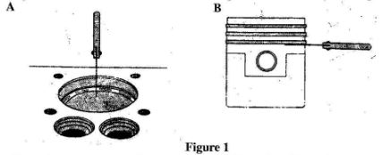
Name the measurement, the component and the tool used in each case.(2 marks)
Measurement | Component | Tool

SECTION B (50 marks)
Answer question 7 and any other FOUR questions from this section.
- Figure 3 shows an isometric drawing of an engine mounting, Draw, full size in first angle projection the following views:
  - Front elevation in the direction of arrow A;
  - End elevation;
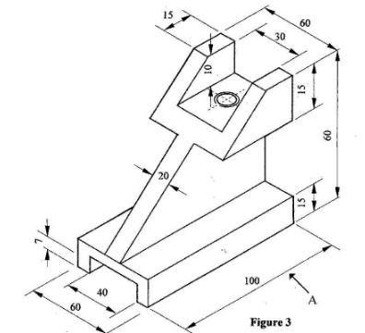
  - Plan.(10-marks)

  - State how the size of each of the following tools is determined: (4 marks)
    - open end spanner;
______________________________________________________________________________________________________________________________________________________________________________________________
    - ball pein hammer.
______________________________________________________________________________________________________________________________________________________________________________________________
  - Make a freehand drawing of straight snips and label two main parts.(6 marks)

- a) Name four important areas that may be found in a well-organised Power Mechanics workshop. (4 marks)
i. ___________________________________________________________________________________________
ii. __________________________________________________________________________________________
iii. __________________________________________________________________________________________
iv. __________________________________________________________________________________________
b) Explain three reasons why proper workshop layout is important. (3 marks)
i. __________________________________________________________________________________________
ii. __________________________________________________________________________________________
iii. _________________________________________________________________________________________
c) State three factors that should be considered when planning the layout of a Power Mechanics workshop.
(3 marks)
i. _________________________________________________________________
ii. ________________________________________________________________
iii. _______________________________________________________________
- During practical work, a learner notices that a mechanic is working beneath a vehicle supported only by a jack. Some tools are scattered on the workshop floor and used oil has been spilled near the working area.
a) Identify three unsafe practices in the situation described above. (3 marks)
i. ____________________________________________________________________________________________
ii. ___________________________________________________________________________________________
iii. ___________________________________________________________________________________________
b) Explain the possible danger associated with each unsafe practice identified in (a). (3 marks)
i. ____________________________________________________________________________________________
ii. ____________________________________________________________________________________________
iii. ___________________________________________________________________________________________
c) Describe four measures that should be taken to maintain safety and cleanliness in the workshop. (4 marks)
i. ____________________________________________________________________________________________
ii. ___________________________________________________________________________________________
iii. ___________________________________________________________________________________________
iv. __________________________________________________________________________________________
- a) Define the following terms as used in technical drawing:
i. Tangency (2 marks)
___________________________________________________________________________________________________
___________________________________________________________________________________________________
ii. Blending of curves (2 marks)
___________________________________________________________________________________________________
___________________________________________________________________________________________________
b) Explain two applications of loci in Power Mechanics. (2 marks)
i. _____________________________________________________________________________________________
ii. ____________________________________________________________________________________________
c) A technician is designing a curved component for a vehicle body. Explain why tangency and blending of curves are important when preparing the drawing of such a component. (2 marks)
___________________________________________________________________________________________________
___________________________________________________________________________________________________

d) State two qualities of a good technical drawing. (2 marks)
i. ____________________________________________________________________________________________
ii. ___________________________________________________________________________________________
- a) Identify the three major vehicle components. (3 marks)
i. _________________________________________________________________
ii. ________________________________________________________________
iii. ______________________________________________________________
b) State two functions of the vehicle chassis. (2 marks)
i. ___________________________________________________________________________________________
ii. __________________________________________________________________________________________
c) Explain two functions of road wheels. (2 marks)
i. ___________________________________________________________________________________________
ii. __________________________________________________________________________________________

d) State three factors that should be considered when selecting suitable road wheels for a vehicle. (3 marks)
i. ___________________________________________________________________________________________
ii. __________________________________________________________________________________________
iii. __________________________________________________________________________________________
- a) State four ways in which engines may be classified. (4 marks)
i. _________________________________________________________________
ii. ________________________________________________________________
iii. _______________________________________________________________
iv. _______________________________________________________________
b) Distinguish between the following:
i. Internal combustion engine and external combustion engine. (2 marks)
___________________________________________________________________________________________________
___________________________________________________________________________________________________
ii. Two-stroke engine and four-stroke engine. (2 marks)
___________________________________________________________________________________________________
___________________________________________________________________________________________________
c) State two advantages of an internal combustion engine in vehicle applications. (2 marks)
i. ____________________________________________________________________________________________
ii. ___________________________________________________________________________________________
- a) State four possible causes of engine backfiring.(4 marks)
i. ___________________________________________________________________________________________
ii. ___________________________________________________________________________________________
iii. ___________________________________________________________________________________________
iv. ___________________________________________________________________________________________

b) Sketch and name two types of tyre tread patterns.(4 marks)

c) List four different components that are involved in absorbing shock when a vehicle hits a bump.(2 marks)
i. __________________________________________________________________________________________
ii. __________________________________________________________________________________________
iii. __________________________________________________________________________________________
iv. __________________________________________________________________________________________

KENYA CERTIFICATE OF BASIC EDUCATION

SENIOR SCHOOL ASSESSMENT

DECEMBER ASSIGNMENT 2026
GRADE 10 – SPORTS AND RECREATION
Time: 2 Hours
LEARNER’S DETAILS
Name: _____________________________________________________________. School: ____________________________________________.
Assessment Number: _______________________________________________. Date: ____________________________________________.
School Code: ______________________________________________________. Signature: _______________________________________.

INSTRUCTIONS TO CANDIDATES
- Write your full name in the space provided above.
- Indicate your school, stream, admission number, and date clearly.
- This paper has TWO sections: A and B.
- Attempt ALL questions in both sections.
- Show all working clearly where necessary.
- Write all answers in the spaces provided.
- Do NOT remove any page from this paper.

FOR OFFICIAL USE ONLY (EXAMINER’S USE)
SECTION | SECTION A | SECTION B | % SCORE | EE1 | EE2 | ME1 | ME2 | AE1 | AE2 | BE1 | BE2
SCORE RANGE | 30 MARKS | 50 MARKS |  | 90-100 | 75-89 | 58-74 | 41-57 | 31-40 | 21-30 | 11-20 | 1-10
POINTS |  |  |  | 8 POINTS | 7 POINTS | 6 POINTS | 5 POINTS | 4 POINTS | 3 POINTS | 2 POINTS | 1 POINT
TOTAL SCORE

SECTION A (30 MARKS) Answer ALL questions in this section.
- (a) Define physical fitness. (1 mark)
______________________________________________________________________________________________________________________________________________________________________________________________________
(b) State two components of physical fitness that are important to a sports performer. (2 marks)
i. _________________________________________________________________
ii. ________________________________________________________________
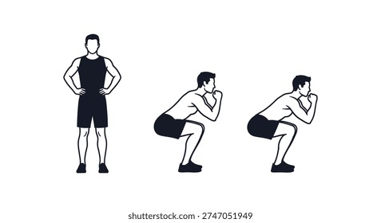
- Study the following sequence of movements.

The learner repeatedly bends the knees, lowers the body and returns to the standing position.
(a) Identify the exercise illustrated. (1 mark)
_______________________________________
(b) Name one major muscle group involved in the exercise. (1 mark)
_________________________________________
(c) State one fitness component developed by the exercise. (1 mark)
___________________________________________________________________________________________________
- (a) What is meant by muscular endurance? (1 mark)
______________________________________________________________________________________________________________________________________________________________________________________________________
(b) State two activities that can be used to develop muscular strength. (2 marks)
i. ______________________________________________________________________________
ii. _____________________________________________________________________________
- A learner runs continuously for 20 minutes without stopping.
(a) Identify the major fitness component being developed. (1 mark)
____________________________________________________________________

(b) Explain two benefits of cardiovascular endurance to the learner. (2 marks)
i. _____________________________________________________________________________________________
ii. _______________________________________________________________________________________________
- (a) Define flexibility. (1 mark)
___________________________________________________________________________________________________
___________________________________________________________________________________________________
(b) State two activities that can improve flexibility. (2 marks)
i. ________________________________________________________________________________________
ii. _______________________________________________________________________________________
- (a) What is meant by good posture? (1 mark)
______________________________________________________________________________________________________________________________________________________________________________________________________
(b) Give two effects of maintaining poor posture during physical activity. (2 marks)
i. ______________________________________________________________________________________________
ii. _____________________________________________________________________________________________
- A player sustains the injury shown above after landing awkwardly.

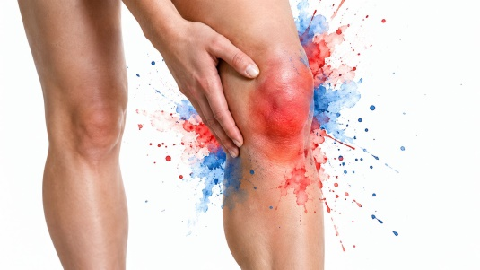

(a) Identify the likely type of injury. (1 mark)
_______________________________________________________________
(b) State two immediate management measures that may be appropriate. (2 marks)
i. ___________________________________________________________________________________________-
ii. ____________________________________________________________________________________________
- (a) Distinguish between recreation and competitive sport. (2 marks)
________________________________________________________________________________________________________________________________________________________________________________________________________________________________________________________________________________________________
(b) Give one example of a recreational activity. (1 mark)
_______________________________________________________________
- A coach notices that learners have different abilities and levels of fitness.
(a) State one reason why a coach should assess learners before designing a training programme. (1 mark)
______________________________________________________________________________________________________________________________________________________________________________________________________
(b) State two qualities of a good sports coach. (2 marks)
i. ______________________________________________________________________________________________
ii. ____________________________________________________________________________________________
- Kilgoris boys senior school bought the following athletics equipment
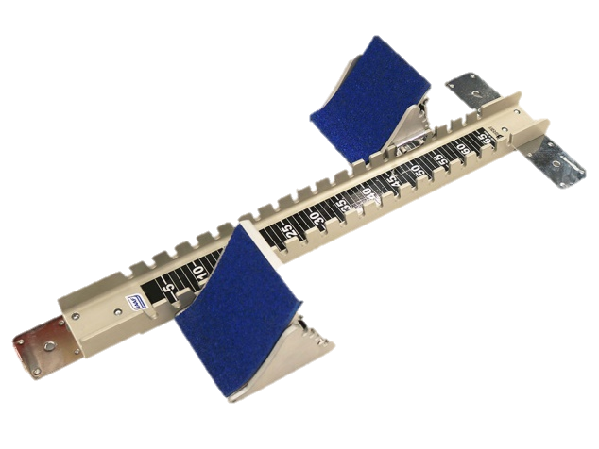
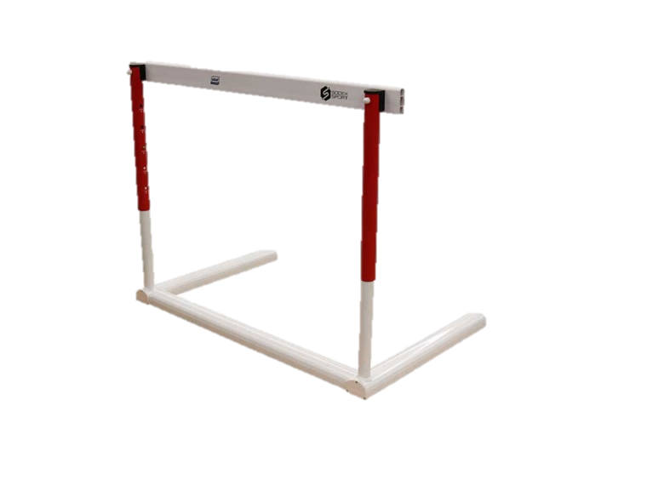

S T
(a) Identify the official's equipment labelled. (1 mark)
S: ________________________________________
T: ________________________________________
(b) State two duties of an athletics official. (2 marks)
i. ______________________________________________________________________________________________
ii. _____________________________________________________________________________________________

SECTION B: 50 MARKS
Answer ALL questions.
- A Grade 10 teacher wants to assess the fitness levels of learners before beginning a conditioning programme.
(a) Explain three reasons for conducting fitness assessments before training. (3 marks)
i. _________________________________________________________________
ii. ________________________________________________________________
iii. _______________________________________________________________
(b) Explain how each of the following may be developed through suitable training:
(i) Muscular strength (2 marks)
___________________________________________________________________________________________________
___________________________________________________________________________________________________
(ii) Muscular endurance (2 marks)
___________________________________________________________________________________________________
___________________________________________________________________________________________________
(iii) Cardiovascular endurance (2 marks)
___________________________________________________________________________________________________
___________________________________________________________________________________________________
(c) State one reason for allowing adequate recovery between demanding training sessions. (1 mark)
___________________________________________________________________________________________________
___________________________________________________________________________________________________

- A learner participates in gymnastics and athletics but has limited flexibility and poor body alignment.
(a) Explain three factors that may influence an individual's flexibility. (3 marks)
i. _____________________________________________________________________________________________
ii. _____________________________________________________________________________________________
iii. ____________________________________________________________________________________________
(b) Describe two appropriate methods of improving flexibility. (2 marks)
i. ______________________________________________________________________________________________
ii. ____________________________________________________________________________________________
(c) Explain three ways in which correct posture contributes to effective sports performance. (3 marks)
i. ______________________________________________________________________________________________
ii. _____________________________________________________________________________________________
iii. _____________________________________________________________________________________________
(d) State two precautions to observe when performing flexibility exercises. (2 marks)
i. ______________________________________________________________________________________________
ii. _____________________________________________________________________________________________
- A school establishes a recreation programme involving hiking, dance, cycling, swimming, traditional games and nature walks.
(a) Explain three physical benefits of participating regularly in recreational activities. (3 marks)
i. _____________________________________________________________________________________________
ii. ___________________________________________________________________________________________
iii. _____________________________________________________________________________________________

(b) Explain three psychological or emotional benefits of recreation. (3 marks)
i. _____________________________________________________________________________________________
ii. ____________________________________________________________________________________________
iii. _____________________________________________________________________________________________
(c) Explain two social benefits of recreational activities. (2 marks)
i. ______________________________________________________________________________________________
ii. _____________________________________________________________________________________________
(d) Give two factors that should be considered when selecting a recreational activity for learners. (2 marks)
i. ______________________________________________________________________________________________
ii. _____________________________________________________________________________________________
- During a school sports day, a learner falls while participating in an athletics event.
(a) Explain three common causes of sports injuries. (3 marks)
i. _____________________________________________________________________________________________
ii. ____________________________________________________________________________________________
iii. _____________________________________________________________________________________________
(b) Explain three measures that can be used to prevent sports injuries. (3 marks)
i. ______________________________________________________________________________________________
ii. _____________________________________________________________________________________________
iii. _____________________________________________________________________________________________

(c) Explain two principles that should guide the immediate management of a sports injury. (2 marks)
i. ______________________________________________________________________________________________
ii. _____________________________________________________________________________________________
(d) State two situations in which an injured participant should be referred for professional medical attention.
(2 marks)
i. _____________________________________________________________________________________________
ii. _____________________________________________________________________________________________
- You are assisting the sports teacher during an inter-school athletics competition.

(a) State and explain two responsibilities of a sports coach before a competition. (2 marks)
i. ______________________________________________________________________________________________
ii. _____________________________________________________________________________________________

(b) Explain three factors that a coach may consider when identifying sporting talent. (3 marks)
i. _____________________________________________________________________________________________
ii. _____________________________________________________________________________________________
iii. _____________________________________________________________________________________________

(c) Explain three qualities of an effective sports official. (3 marks)
i. _____________________________________________________________________________________________
ii. ____________________________________________________________________________________________
iii. ____________________________________________________________________________________________

(d) State two reasons why an official should remain impartial during competition. (2 marks)
i. _____________________________________________________________________________________________
ii. ____________________________________________________________________________________________

KENYA CERTIFICATE OF BASIC EDUCATION

SENIOR SCHOOL ASSESSMENT

DECEMBER ASSIGNMENTS 2026
GRADE 10 – THEATRE AND FILM
Time: 2 Hours
LEARNER’S DETAILS
Name: _____________________________________________________________. School: ____________________________________________.
Assessment Number: _______________________________________________. Date: ____________________________________________.
School Code: ______________________________________________________. Signature: _______________________________________.

INSTRUCTIONS TO CANDIDATES
- Write all the details as required above.
- This paper consists of two sections: A and B.
- Answer all questions in section A and section B.
- Answer the questions in English.
- All answers MUST be written in the spaces provided in the paper.
- Do NOT remove any page from this question paper.

FOR OFFICIAL USE ONLY (EXAMINER’S USE)
SECTION | SECTION A | SECTION B | % SCORE | EE1 | EE2 | ME1 | ME2 | AE1 | AE2 | BE1 | BE2
SCORE RANGE | 30 MARKS | 50 MARKS |  | 90-100 | 75-89 | 58-74 | 41-57 | 31-40 | 21-30 | 11-20 | 1-10
POINTS |  |  |  | 8 POINTS | 7 POINTS | 6 POINTS | 5 POINTS | 4 POINTS | 3 POINTS | 2 POINTS | 1 POINT
LEARNER’S TOTAL SCORE

SECTION A (30 MARKS)
Answer ALL questions in this section.
  - a) What is meant by the term theatre? (1 mark) ________________________________________________________________________________________________________________________________________________________________________________________
b) Define film as a form of artistic expression. (1 mark) ______________________________________________________________________________________________________________________________________________________________________________________________
c) State one similarity between theatre and film. (1 mark)
______________________________________________________________________________________________________________________________________________________________________________________________
d) State two differences between live theatre and film production. (2 marks)
Live Theatre | Film Production
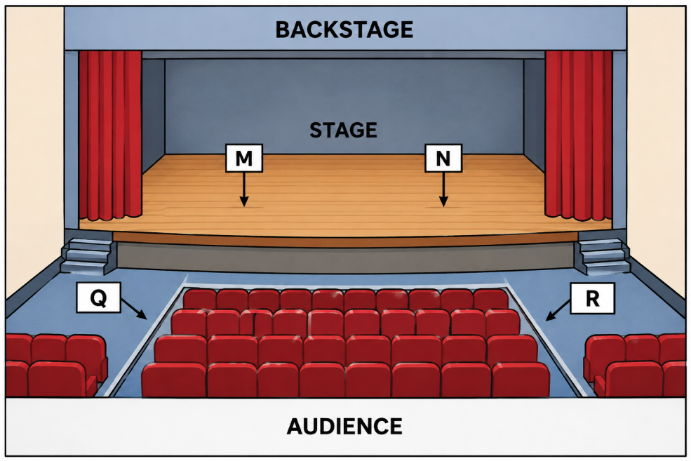
  - Study the stage diagram below.

a) Identify the stage position labelled M. ____________________________ (1 mark)
b) Identify the stage position labelled N. _____________________________ (1 mark)
c) Identify the two areas labelled Q and R. (2 marks)
Q: _________________________________________
R: _________________________________________
d) State one reason why actors need to understand stage directions. (1 mark)
________________________________________________________________________________________________________________________________________________________________________________________________

a) What is a costume in theatre? (1 mark)
________________________________________________________________________________________________________________________________________________________________________________________________

b) State two functions of costume in a theatrical production. (2 marks)
- _________________________________________________________________________________________
- _________________________________________________________________________________________
c) State two factors that a make-up artist should consider when preparing an actor for a performance. (2 marks)
- _________________________________________________________________________________________
- _________________________________________________________________________________________

Study the simplified camera illustrations below.
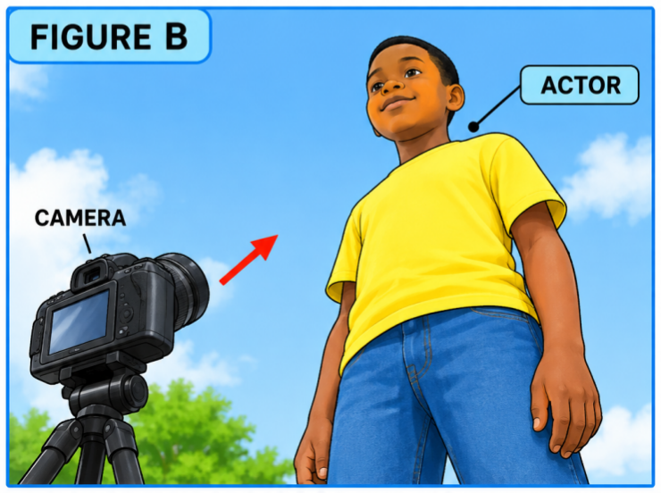
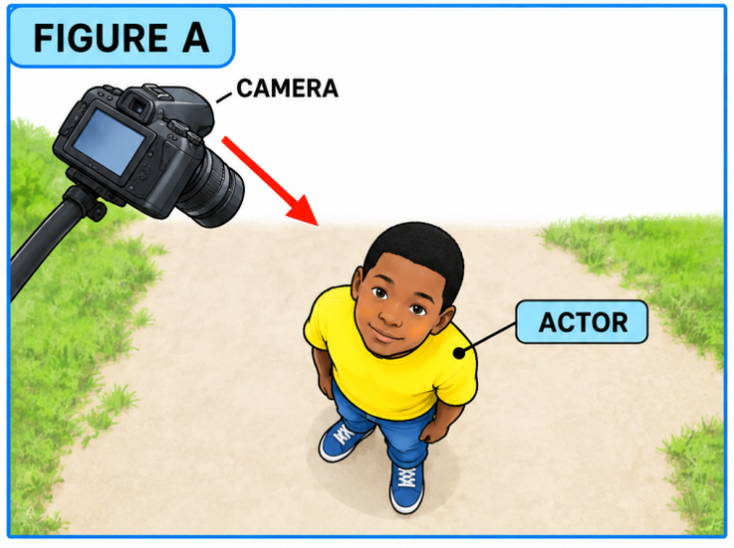
a) State the camera position represented in Figure A. _______________________________ (1 mark)
b) State the camera position represented in Figure B. _______________________________ (1 mark)
c) Name one type of camera shot that can be used to show the entire body of an actor. (1 mark)
______________________________________________________________________________________________________________________________________________________________________________________________
d) Give two reasons why camera angles are important in film production. (2 marks)
- _________________________________________________________________________________________
- _________________________________________________________________________________________
  - a) What is a rehearsal? (1 mark)
______________________________________________________________________________________________________________________________________________________________________________________________
b) State two activities that actors may undertake during rehearsals. (2 marks)
- _________________________________________________________________________________________
- _________________________________________________________________________________________
c) Give two reasons why rehearsals are important before a theatrical performance. (2 marks)
- _________________________________________________________________________________________
- _________________________________________________________________________________________
  - a) State one safety precaution when handling electrical theatre equipment. (1 mark)
__________________________________________________________________________________________________________________________________________________________________________________________
b) Give two safety precautions to observe when constructing or arranging a stage set. (2 marks)
- _________________________________________________________________________________________
- _________________________________________________________________________________________
c) State two ethical practices that should be observed when producing a theatre or film production involving members of the community. (2 marks)
- _________________________________________________________________________________________
- _________________________________________________________________________________________

SECTION B: 50 MARKS
Answer ALL questions.
- Read the following extract and answer the questions that follow.
MAYA: Why did you leave the meeting without telling anyone?
KELVIN: I was afraid they would laugh at my idea.
MAYA: An idea cannot help anyone if you keep it hidden.
KELVIN: Perhaps you are right. I will speak to them tomorrow.
(Maya walks towards Kelvin and places a hand on his shoulder.)
a) Identify the two characters in the extract. (2 marks)
- _________________________________________________________________________________________
- _________________________________________________________________________________________
b) State the setting that could appropriately be used for this scene. Give a reason for your choice. (2 marks)
________________________________________________________________________________________________________________________________________________________________________________________________
c) Identify one stage direction contained in the extract. (1 mark)
_________________________________________________________________________________________
d) State the main conflict presented in the extract. (2 marks)
________________________________________________________________________________________________________________________________________________________________________________________________
e) Describe three ways in which an actor playing Kelvin could portray his emotions effectively. (3 marks)
- _________________________________________________________________________________________
- _________________________________________________________________________________________
- _________________________________________________________________________________________
- You have been appointed the director of a school play with six actors.
a) Define blocking in theatre. (2 marks)
________________________________________________________________________________________________________________________________________________________________________________________________
b) State three factors you would consider when positioning actors on stage. (3 marks)
- _________________________________________________________________________________________
- _________________________________________________________________________________________
- _________________________________________________________________________________________
c) Explain two ways through which effective blocking improves a performance. (2 marks)
- _________________________________________________________________________________________
- _________________________________________________________________________________________
d) State three responsibilities of a theatre director during rehearsals. (3 marks)
- _________________________________________________________________________________________
- _________________________________________________________________________________________
- _________________________________________________________________________________________
- Your school is preparing a play set in a traditional Kenyan village.
a) Suggest two suitable stage-set features for the production. (2 marks)
- _________________________________________________________________________________________
- _________________________________________________________________________________________
b) Suggest two appropriate costume features for the characters. (2 marks)
- _________________________________________________________________________________________
- _________________________________________________________________________________________
c) Give two suitable props that could be used in the production. (2 marks)
- _________________________________________________________________________________________
- _________________________________________________________________________________________
d) State two ways of creating the appropriate atmosphere through lighting. (2 marks)
- _________________________________________________________________________________________
- _________________________________________________________________________________________
e) Explain two ways of using locally available materials in the production without compromising safety or artistic quality. (2 marks)
- _________________________________________________________________________________________
- _________________________________________________________________________________________
- A group of learners has decided to produce a five-minute short film about responsible use of social media.
a) State two activities involved in pre-production. (2 marks)
- _________________________________________________________________________________________
- _________________________________________________________________________________________

b) State two activities undertaken during production. (2 marks)
- _________________________________________________________________________________________
- _________________________________________________________________________________________
c) State two activities undertaken during post-production. (2 marks)
- _________________________________________________________________________________________
- _________________________________________________________________________________________
d) Explain two reasons why a storyboard is useful in film production. (2 marks)
- _________________________________________________________________________________________
- _________________________________________________________________________________________
e) State two ways of ensuring good-quality sound during filming. (2 marks)
- _________________________________________________________________________________________
- _________________________________________________________________________________________
- Your school has been invited to perform a short community theatre production on the importance of preserving Kenya's cultural heritage.
a) Identify two cultural aspects that could be incorporated into the performance. (2 marks)
- _________________________________________________________________________________________
- _________________________________________________________________________________________
b) State two methods of involving the community in developing the production. (2 marks)
- _________________________________________________________________________________________
- _________________________________________________________________________________________
c) Explain two ways theatre can help preserve cultural heritage. (2 marks)
- _________________________________________________________________________________________
- _________________________________________________________________________________________
d) Suggest two performance techniques that would make the production attractive to the audience. (2 marks)
- _________________________________________________________________________________________
- _________________________________________________________________________________________

e) State two ways of evaluating the success of the performance after presentation. (2 marks)
- _________________________________________________________________________________________
- _________________________________________________________________________________________

KENYA CERTIFICATE OF BASIC EDUCATION

SENIOR SCHOOL ASSESSMENT

DECEMBER ASSIGNMENT 2026
GRADE 10 – WOOD TECHNOLOGY
Time: 2 Hours
LEARNER’S DETAILS
Name: _____________________________________________________________. School: ____________________________________________.
Assessment Number: _______________________________________________. Date: ____________________________________________.
School Code: ______________________________________________________. Signature: _______________________________________.

INSTRUCTIONS TO CANDIDATES
- Write your name in the spaces provided above.
- Write the name of your school and your stream in the spaces provided.
- Write your admission number and the date of the assessment in the spaces provided.
- This paper consists of two sections: A and B.
- Answer all questions in section A and section B.
- Answer the questions in English.
- All answers MUST be written in the spaces provided in the paper.
- Do NOT remove any page from this question paper.

FOR OFFICIAL USE ONLY (EXAMINER’S USE)
SECTION | SECTION A | SECTION B | % SCORE | EE1 | EE2 | ME1 | ME2 | AE1 | AE2 | BE1 | BE2
SCORE RANGE | 30 MARKS | 50 MARKS |  | 90-100 | 75-89 | 58-74 | 41-57 | 31-40 | 21-30 | 11-20 | 1-10
POINTS |  |  |  | 8 POINTS | 7 POINTS | 6 POINTS | 5 POINTS | 4 POINTS | 3 POINTS | 2 POINTS | 1 POINT
LEARNER’S TOTAL SCORE

SECTION A (30MARKS)
Answer ALL questions in this section.

1.
a) State one reason why woodwork has developed over time. (1 mark)
______________________________________________________________________________________________________________________________________________________________________________________________
b) Name two careers related to woodwork. (2 marks)
- _________________________________________________________________________________________
- _________________________________________________________________________________________

2.
State three ways in which woodwork contributes to the economic development of a country. (3 marks)
- _________________________________________________________________________________________
- _________________________________________________________________________________________
- _________________________________________________________________________________________

3.
a) State two features of a well-designed wood workshop. (2 marks)
- _________________________________________________________________________________________
- _________________________________________________________________________________________
b) State one factor that should be considered when arranging the layout of a wood workshop. (1 mark)
______________________________________________________________________________________________________________________________________________________________________________________________

4.
State three safety precautions that should be observed when working in a wood workshop. (3 marks)
- _________________________________________________________________________________________
- _________________________________________________________________________________________
- _________________________________________________________________________________________

5.
Classify each of the following tools according to their main function:
a) Jack plane _____________________________________________________________________(1 mark)
b) Tenon saw_____________________________________________________________________(1 mark)
c) Try square ______________________________________________________________________ (1 mark)

6.
Give three reasons why hand tools should be properly maintained. (3 marks)
- _________________________________________________________________________________________
- _________________________________________________________________________________________
- _________________________________________________________________________________________

7.
a) State one condition necessary for healthy growth of timber trees. (1 mark)
______________________________________________________________________________________________
b) Name two classifications of timber trees based on the type of wood they produce. (2 marks)
- _________________________________________________________________________________________
- _________________________________________________________________________________________

8.
Name the following parts of a tree trunk:
a) The outer protective layer ___________________________________ (1 mark)
b) The layer through which water and minerals move upwards __________________________ (1 mark)
c) The central part of the trunk ________________________________(1 mark)

9.
a) Name one method of timber conversion. (1 mark)
__________________________________________________
b) Name one method of timber seasoning. (1 mark)
_________________________________________________
c) State one reason for seasoning timber. (1 mark)
________________________________________________________________________________________________________________________________________________________________________________________________

10.
a) What is an adhesive? (1 mark)
________________________________________________________________________________________________________________________________________________________________________________________________
b) State two characteristics of a good wood adhesive. (2 marks)
- _________________________________________________________________________________________
- _________________________________________________________________________________________

SECTION B: 50 MARKS
Answer ALL questions in this section.

11.
a) State two methods used to transport timber logs from the forest to a timber-processing area. (2 marks)
- _________________________________________________________________________________________
- _________________________________________________________________________________________
b) Explain two factors that influence the choice of a method of transporting timber logs. (2 marks)
- _________________________________________________________________________________________
- _________________________________________________________________________________________
c) Name three methods of timber conversion. (3 marks)
- _________________________________________________________________________________________
- _________________________________________________________________________________________
- _________________________________________________________________________________________
d) State one difference between natural seasoning and artificial seasoning. (1 mark)
- _________________________________________________________________________________________
- _________________________________________________________________________________________
- _________________________________________________________________________________________
e) State two reasons why converted timber should be properly stacked during seasoning. (2 marks)
- _________________________________________________________________________________________
- _________________________________________________________________________________________

12.
a) Distinguish between a hand tool and workshop equipment. (2 marks)
____________________________________________________________________________________________________________________________________________________________________________________________________________________________________________________________________________________________________________________________________________________________________________________________
b) Give four examples of hand tools used in woodwork. (4 marks)
- _________________________________________________________________________________________
- _________________________________________________________________________________________
- _________________________________________________________________________________________
- _________________________________________________________________________________________
c) State two safety precautions when using a woodworking machine or workshop equipment. (2 marks)
- _________________________________________________________________________________________
- _________________________________________________________________________________________
d) Explain one importance of using the correct tool for a particular operation. (1 mark)
______________________________________________________________________________________________________________________________________________________________________________________________
e) State one way of storing hand tools safely after use. (1 mark)
_______________________________________________________________________________________________________________________________________________________________________________________________

13.
a) List four processes involved in preparing timber for woodworking. (4 marks)
- _________________________________________________________________________________________
- _________________________________________________________________________________________
- _________________________________________________________________________________________
- _________________________________________________________________________________________
b) State two operations that can be carried out on prepared wood. (2 marks)
- _________________________________________________________________________________________
- _________________________________________________________________________________________
c) Name two woodworking joints used in the construction of wooden products. (2 marks)
- _________________________________________________________________________________________
- _________________________________________________________________________________________
d) State two roles of joints in wood products. (2 marks)
- _________________________________________________________________________________________
- _________________________________________________________________________________________

14.
a) Name the following woodworking joints:
i. A joint in which one member has a projection that fits into a corresponding hole in another member. (1 mark)
_______________________________________________________
ii. A joint formed by fitting two pieces together after removing equal portions from each. (1 mark)
_______________________________________________________
iii. A joint in which two pieces are joined end-to-end using a connecting member. (1 mark)
________________________________________________________
iv. A joint formed by joining two pieces along their edges. (1 mark)
________________________________________________________
b) Outline four main steps followed when preparing a mortise and tenon joint. (4 marks)
- _________________________________________________________________________________________
- _________________________________________________________________________________________
- _________________________________________________________________________________________
- _________________________________________________________________________________________
c) Name two fasteners commonly used in woodworking. (2 marks)
- _________________________________________________________________________________________
- _________________________________________________________________________________________

15.
a) State three reasons for finishing a wooden product. (3 marks)
- _________________________________________________________________________________________
- _________________________________________________________________________________________
- _________________________________________________________________________________________
b) Name three materials or tools used when preparing a wood surface for varnishing. (3 marks)
- _________________________________________________________________________________________
- _________________________________________________________________________________________
- _________________________________________________________________________________________

c) Outline two steps followed when preparing a wooden surface for applying clear varnish. (2 marks)
- _________________________________________________________________________________________
- _________________________________________________________________________________________
d) State one skill acquired when constructing a furniture item as a project. (1 mark)
__________________________________________________________________________________________
e) State one importance of applying clear varnish to a wooden product. (1 mark)

______________________________________________________________________________________________________________________________________________________________________________________________



