COMPETENCY BASED EDUCATION

JUNIOR SCHOOL EDUCATION ASSESSMENT

NOVEMBER-DECEMBER ASSIGNMENT 2026
GRADE 8 – INTEGRATED SCIENCE
Time: 2 Hours
LEARNER’S DETAILS
Name: ________________________________________________. School: ________________________________________.
Assessment Number: _________________________________. Date: __________________________________________.
School Code: _______________________________________. Signature: ______________________________________.

INSTRUCTIONS TO CANDIDATES
- Write your name in the spaces provided above.
- Write the name of your school and your stream in the spaces provided.
- Write your admission number and the date of the assessment in the spaces provided.
- This paper consists of two sections: A and B.
- Answer all questions in section A and section B.
- Answer the questions in English.
- All answers MUST be written in the spaces provided in the paper.
- Do NOT remove any page from this question paper.

FOR OFFICIAL USE ONLY (EXAMINER’S USE)
SECTION | SECTION A | SECTION B | % SCORE | EE1 | EE2 | ME1 | ME2 | AE1 | AE2 | BE1 | BE2
SCORE RANGE | 30 MARKS | 50 MARKS |  | 90-100 | 75-89 | 58-74 | 41-57 | 31-40 | 21-30 | 11-20 | 1-10
POINTS |  |  |  | 8 POINTS | 7 POINTS | 6 POINTS | 5 POINTS | 4 POINTS | 3 POINTS | 2 POINTS | 1 POINT
LEARNER’S TOTAL SCORE

SECTION A (30 MARKS)
Answer ALL questions in this section.
- During a practical in Integrated Science lesson, teacher Zachary provided his grade 8 learners with available digital devices such as mobile phones and laptops to search and record about cell components and their functions. Complete the table shown below on their research work. (4 mks)
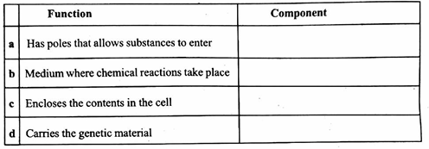

- Grade 8 learners invited Mr. Murimi from Kenyatta National Hospital as a guest speaker during their school career day. He told them the ability of a microscope to distinct and separate details of a specimen or sample is known as. (1 mk)

__________________________________________________________________________

- Damaris and Charity were discussing about plant and animal cells. They discovered that cells are too tiny to be observed with naked eyes. Their Science teacher Mr. Musa adviced them to use lens or microscope to magnify the cells. Calculate the total magnification of the cell if the eyepiece lens magnification was x5 while the objective lens magnification was x20. (4 mks)

- Last term grade 8 learners from Kianjeru Junior school visited fire station to leamn about causes and classes of fire. Mrs. Gakuuri incharge of Chuka Fire Station gave details of class B fire. She advised them that it is caused by some flammable liquids such as. (4 mks)
- ___________________________________________________________________________________
- ___________________________________________________________________________________
- ___________________________________________________________________________________
- ___________________________________________________________________________________
- Melody, a grade 8 learner heated a sample of hydrated copper(II) sulphate and recorded her observation. She noticed that it changed from colour blue to colour white. After searching from the books she concluded that it was a reversible chemical change. Give other changes she observed and list them down. (3 mks)
- ___________________________________________________________________________________
- ___________________________________________________________________________________
- ___________________________________________________________________________________
- Grade 8 learners from Taita Junior school were asked to name some common examples of compounds. Judy named water as an example of a compound. The teacher asked her to name the two elements that make up water. (2 mks)
- ___________________________________________________________________________________
- ___________________________________________________________________________________

- Different groups of grade 8 learners from Kisumu Junior school prepared charts on different states of matter. The diagram below shows one of the charts.
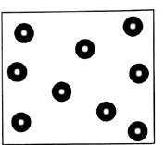

  - Identify the state of matter shown on the chart above. (1 mk)
_________________________________________________________

  - State any four characteristics of the state of matter discussed by the groups. (4 mks)
- ___________________________________________________________________________________
- ___________________________________________________________________________________
- ___________________________________________________________________________________
- ___________________________________________________________________________________
- Mr. Aketch of Fanya Kwa Bidii school used his mobile phone to search for the meaning of some words. He later asked his learners to complete the paragraph below. (3mks)
Impurities the boiling point of liquids. The boiling point of pure water is at
level.

- Murugi, a grade 8 learner at Kiereni Junior school watched a video clip on matter. She used a link provided by her teacher. The clip had information that matter is made up of particles which are in a continuous state of motion. This theory is known as (2 mks)
- ___________________________________________________________________________________
- ___________________________________________________________________________________
- Grade 8 learners collected the following materials during their Science walk.

- wood
- iron
- copper
- steel

Using the table drawn below, classify the collected materials as either magnetic or non-magnetic materials. (4 mks)
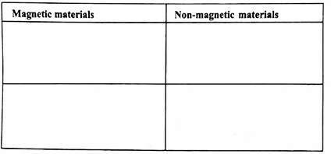

- Grade 8 learners used a light microscope to observe components of plant cell. Give a reason for the following action as they observed. (3 mks)
  - Adding some drops of water to the specimen.

__________________________________________________________________________________________________________________________________________________________________________________

  - Use of coverslip.
__________________________________________________________________________________________________________________________________________________________________________________
  - Use of stain (iodine solution)
__________________________________________________________________________________________________________________________________________________________________________________
- Learners visited a Science laboratory to learn more about elements. The table below was later made by the learners. They copied and completed the missing information on symbols and elements. Complete the table by filling in the missing information. (4 mks)
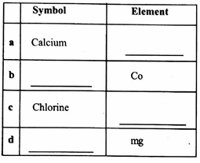
During 2024 trade fair organised by Nairobi International Show, grade 8 learners of Naivasha Junior school visited different strands to fill in the missing information about the importance of some common elements in our every day life. Identify the elements used in making of some common items such as; (4 mks)
- making medals _________________________________

- making toothpaste ________________________________

- making roofing sheets _____________________________

- making electric cables _______________________________________

- Weekend assignment of grade 8 learners of Coast Junior school was to draw, name and prepare charts on differences between the animal and plant cells. Yasir prepared and gave some of the differences between plant and animal cells. The table below shows what Yasir made. Complete it with right answers. (4 mks)
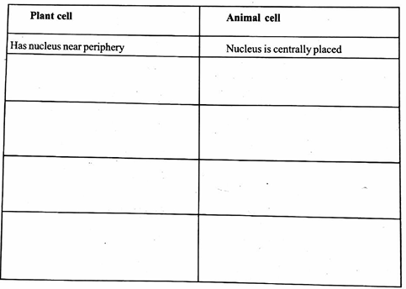

- During an educational trip to Kenya Defence Forces, Fire Fighting Barracks, major Abdi explained to grade 8 learners details about fire. He informed them that fire starts and continues to burn in presence of three components. List down the possible correct components named by major Abdi. (3 mks)

- __________________________________________________________________________________
- ___________________________________________________________________________________
- ___________________________________________________________________________________
- ___________________________________________________________________________________

- A car has a weight of 12,000 N. The total area of contact between the four tyres and the ground is 0.12 m². Calculate the pressure exerted by the car on the ground.

Answers

- a. Cell wall

  - Cytoplasm

  - Cell membrane

  - Nucleus

- Resolving power

- x5 x20 = x100

- Petrol, desiel, kerosene, paint

- Change os mass, new substance is formed, heat is evolved.

- Hydrogen, Oxygen

- a. Gas

b. No definite volume, shape definite mass, they flow, compressible

- raises, 100°C, sea

- Kinetic theory matter

Magnetic materials

- iron
- steel

Non-magnetic materials

- wood
- cooper

- a. Protect it from drying and losing the shape.

b. Keeping the specimen press and flat for easy observation.

c. Iodine makes the cell clearer and visible.

- a ca

  - CL

  - Cobalt

  - Magnesium
- i. Gold/silver

- Fluorine

- iron

- Copper

Plant cell

- Has cell wall
- Usually large
- Definite shape
- Some have chloroplast
- Have vacuole

Animal cell

- No cell wall
- Small
- No definite shape
- No chloroplast
- Vacuole absent in most animal cell
- 1. Fuel
- Heat
- Oxygen

