TERM 3 HOLIDAY ASSIGNMENT 2026
FORM THREE
CHEMISTRY PAPER 1
Question Numbers | Maximum Score | Candidate's Score
1 – 26 | 80
TOTAL | 80

1. Name another gas which is used together with oxygen in welding. (1 mark)
Answer: (1 mark)
________________________________________________________________________________
2. a) Write the electronic configuration of the following elements: (2 marks)
i) Calcium (atomic number 20) (1 mark)
________________________________________________________________________________
ii) Magnesium (atomic number 12) (1 mark)
________________________________________________________________________________
b) Explain why calcium is more reactive than magnesium. (2 marks)
________________________________________________________________________________
3. The table below shows the relative atomic masses and percentage abundances of isotopes U₁ and U₂ of element U. Calculate the relative atomic mass of element U. (3 marks)
Isotope | Relative atomic mass | Percentage abundance
U₁ | 78.92 | 51.84
U₂ | 80.92 | 48.16

________________________________________________________________________________
________________________________________________________________________________
________________________________________________________________________________
________________________________________________________________________________
4. The diagram below shows a laboratory set-up for the preparation and collection of oxygen gas.
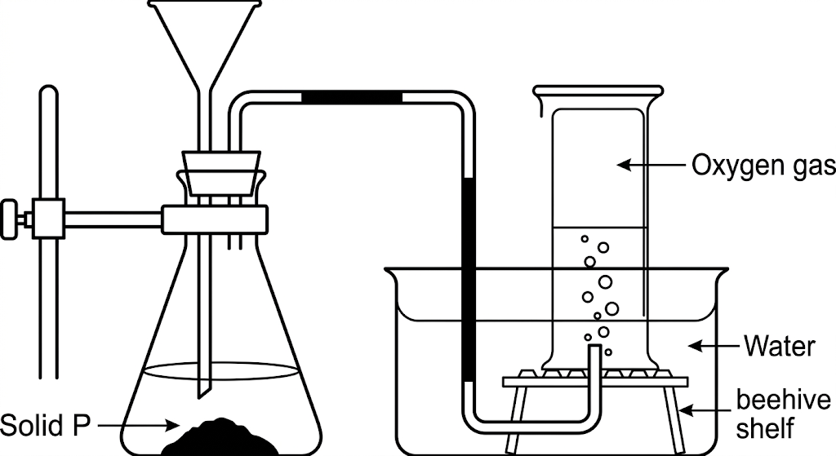
a) Name solid P. (1 mark)
________________________________________________________________________________
b) Write a balanced equation for the reaction taking place in the conical flask. (1 mark)
________________________________________________________________________________
c) State two commercial uses of oxygen. (2 marks)
________________________________________________________________________________
5. State the role of the following parts during fractional distillation of a mixture of water and ethanol.
i) Glass beads in the fractionating column. (1 mark)
________________________________________________________________________________
ii) Fractionating column. (1 mark)
________________________________________________________________________________
b) State one application of fractional distillation. (1 mark)
________________________________________________________________________________
6. The figure below shows a set-up used by a Form Three student to prepare a gas by reacting calcium metal with water.
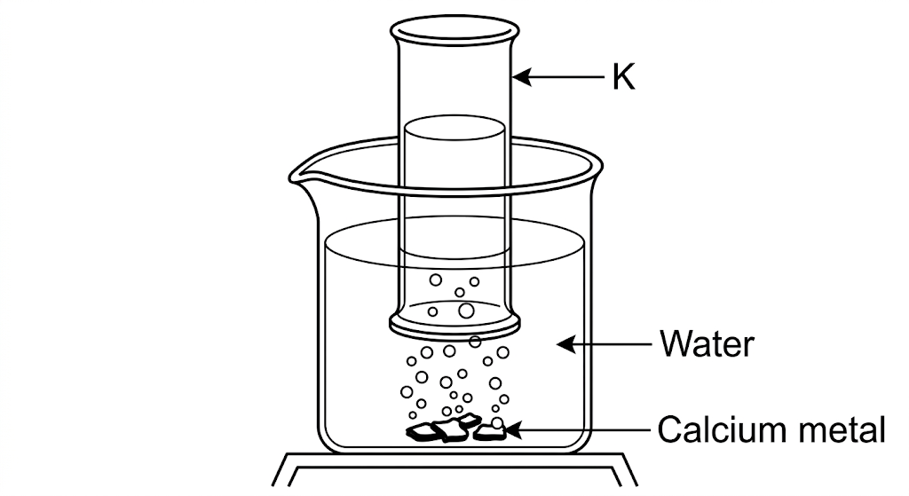
a) Write an equation for the formation of gas K. (1 mark)
________________________________________________________________________________
b) State one industrial use of gas K. (1 mark)
________________________________________________________________________________
c) State one use of the solution remaining after the metal has reacted. (1 mark)
________________________________________________________________________________
7. Draw a dot-and-cross diagram showing the bonding in a molecule of magnesium oxide. Name the type of bond. (3 marks)
________________________________________________________________________________
________________________________________________________________________________
________________________________________________________________________________
8. When 0.360 g of an oxide of metal M was reduced using a suitable reducing agent, 0.288 g of pure metal was formed. Determine the empirical formula of the oxide. [M = 64; O = 16] (4 marks)
________________________________________________________________________________
________________________________________________________________________________
________________________________________________________________________________
________________________________________________________________________________
________________________________________________________________________________
________________________________________________________________________________
9. X⁺ is an ion with electronic configuration 2,8,8. Identify the electronic configuration of element X. (1 mark)
Answer: (1 mark)
________________________________________________________________________________
10. 20.0 g of solid sodium hydroxide were dissolved in distilled water and made up to 500 cm³. 25.0 cm³ of this solution required 20.0 cm³ of dilute sulphuric(VI) acid for complete reaction. [Na = 23, O = 16, H = 1] Determine: (6 marks)
i) the moles of sodium hydroxide contained in 25.0 cm³ of the solution. (2 marks)
________________________________________________________________________________
________________________________________________________________________________
ii) the moles of sulphuric(VI) acid that reacted. (2 marks)
________________________________________________________________________________
________________________________________________________________________________
iii) the concentration of the sulphuric(VI) acid in moles per litre. (2 marks)
________________________________________________________________________________
________________________________________________________________________________
11. The diagram shows the structures of two allotropes of carbon. Study them and answer the questions that follow.
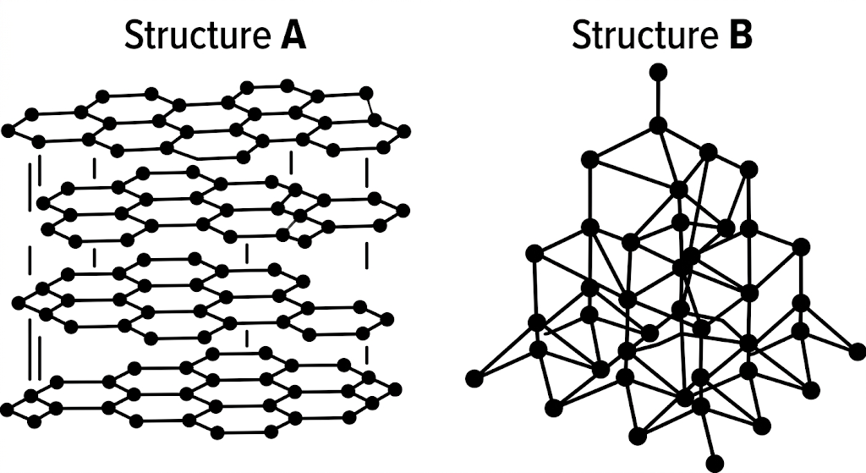
a) Name allotropes A and B. (2 marks)
________________________________________________________________________________
b) State two uses of allotrope B. (2 marks)
________________________________________________________________________________
c) Which allotrope conducts electricity? Explain. (2 marks)
________________________________________________________________________________
12. An oxide of element F has the formula F₂O₅.
a) Determine the oxidation state of F. (1 mark)
________________________________________________________________________________
b) State the group of the periodic table in which element F is found. (1 mark)
________________________________________________________________________________
13. Explain how you would obtain solid sodium carbonate from a mixture of lead(II) carbonate and sodium carbonate. (3 marks)
________________________________________________________________________________
________________________________________________________________________________
________________________________________________________________________________
________________________________________________________________________________
14. State two properties of aluminium that make it suitable for making cooking utensils. (2 marks)
i) (1 mark)
________________________________________________________________________________
ii) (1 mark)
________________________________________________________________________________
15. Write an ionic equation for the reaction between dilute hydrochloric acid and calcium carbonate. (2 marks)
________________________________________________________________________________
________________________________________________________________________________
16. a) Rhombic sulphur is one allotrope of sulphur. Name the other common allotrope. (1 mark)
b) i) Concentrated sulphuric(VI) acid reacts with ethanol. State the property of the acid shown. (1 mark)
________________________________________________________________________________
ii) Concentrated sulphuric(VI) acid reacts with copper. State the property of the acid shown. (1 mark)
________________________________________________________________________________
17. State and explain the change in mass that occurs when the following substances are separately heated in open crucibles. (2 marks)
a) Copper metal. (1 mark)
________________________________________________________________________________
b) Copper(II) nitrate. (1 mark)
________________________________________________________________________________
18. The diagram below represents paper chromatography for three brands of juice suspected to contain banned food colourings. The results show that banned food colourings are present in brands M and N only.
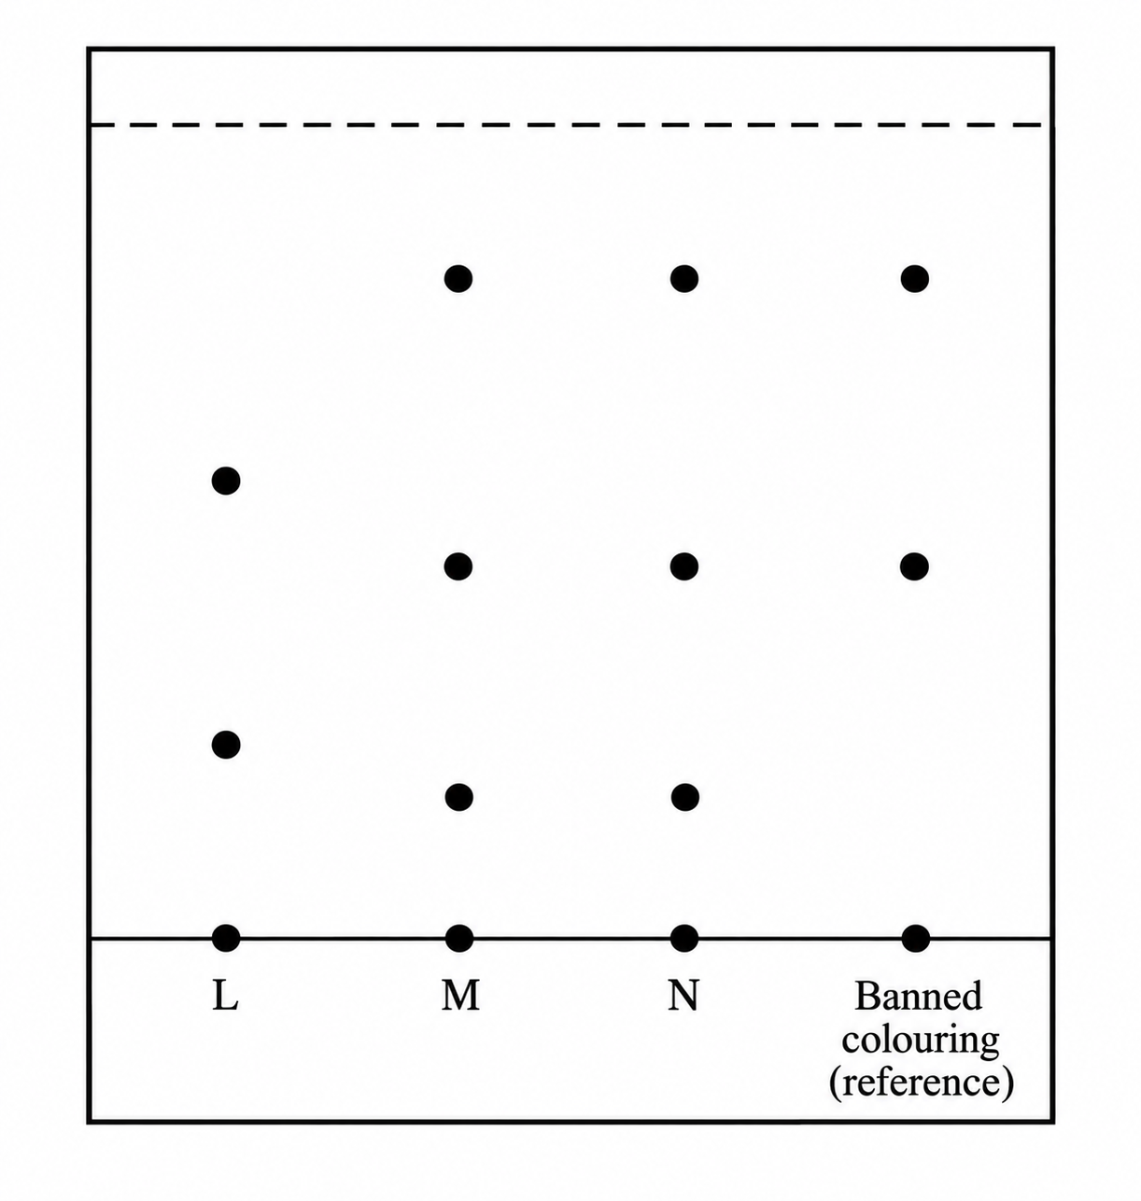
a) i) On the diagram, circle the spots that show the banned colouring. (2 marks)
________________________________________________________________________________
a) ii) Show and label the solvent front. (1 mark)
________________________________________________________________________________
b) On the same diagram, indicate and label the baseline. (1 mark)
________________________________________________________________________________
19. Determine the number of sodium ions contained in 25.0 cm³ of 0.40 M sodium carbonate solution. [L = 6.02 × 10²³ mol⁻¹] (3 marks)
________________________________________________________________________________
________________________________________________________________________________
________________________________________________________________________________
________________________________________________________________________________
________________________________________________________________________________
20. The graph below shows a curve obtained when water initially at 18 °C was heated for 15 minutes.
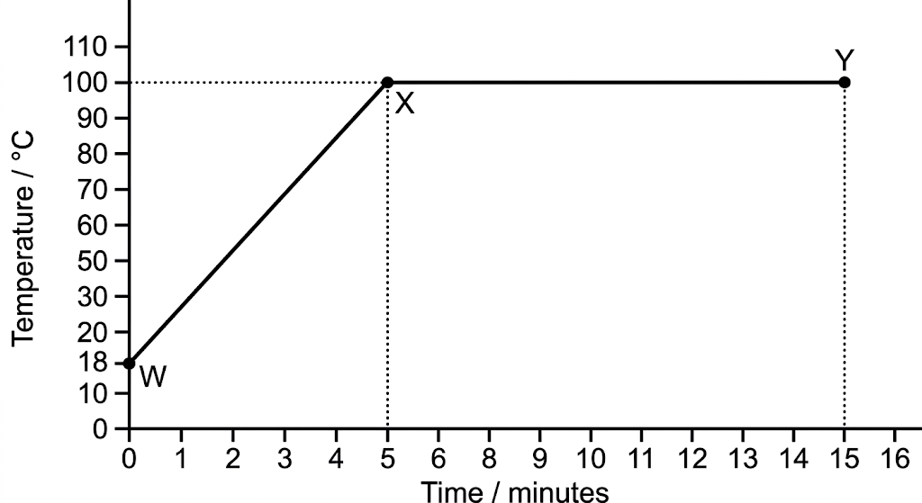
a) What happens to the water molecules between points W and X? (1 mark)
________________________________________________________________________________
b) In which part of the curve does a change of state occur? (1 mark)
________________________________________________________________________________
c) Explain why the temperature does not rise between points X and Y. (1 mark)
________________________________________________________________________________
21. In the industrial manufacture of sodium carbonate:
a) Give the name of the process used to manufacture sodium carbonate. (1 mark)
________________________________________________________________________________
b) Write the final equation for the formation of sodium carbonate in the process. (1 mark)
________________________________________________________________________________
c) State one use of sodium carbonate. (1 mark)
________________________________________________________________________________
22. Study the flow chart below and answer the questions that follow.
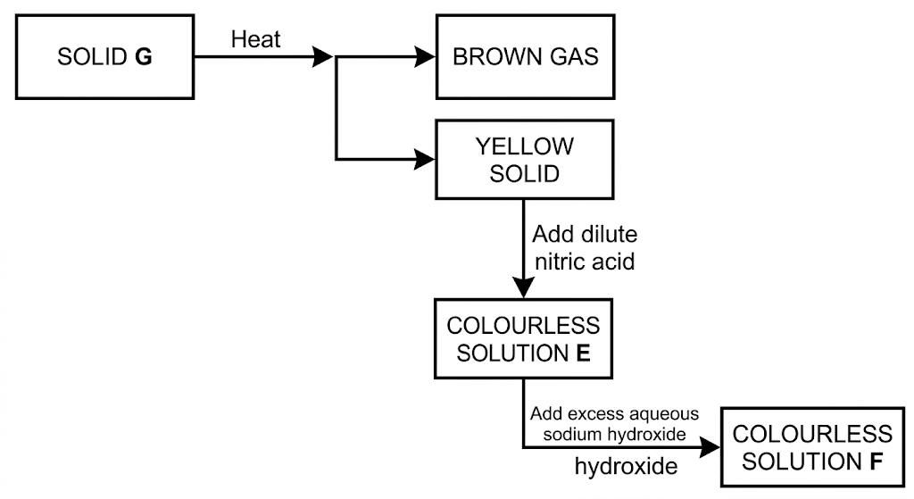
a) Identify solid G. (1 mark)
________________________________________________________________________________
b) Write a balanced chemical equation between the yellow solid and dilute nitric acid. (1 mark)
________________________________________________________________________________
23. The diagram shows possible pH values for several substances. Choose the likely pH value for each substance listed.
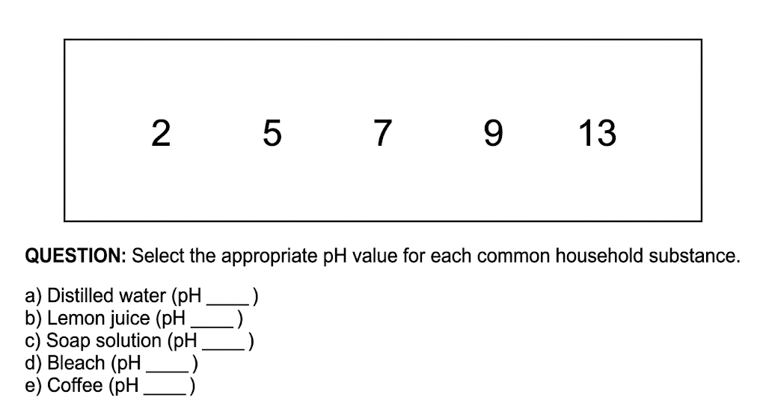
i) Dilute hydrochloric acid. (1 mark)
________________________________________________________________________________
ii) Calcium hydroxide solution. (1 mark)
________________________________________________________________________________
iii) Sodium hydroxide solution. (1 mark)
________________________________________________________________________________
iv) Lemon juice. (1 mark)
________________________________________________________________________________
24. The first step in the industrial manufacture of nitric acid is the catalytic oxidation of ammonia gas.
a) Name the catalyst used. (1 mark)
________________________________________________________________________________
b) Write the equation for the catalytic oxidation of ammonia. (1 mark)
________________________________________________________________________________
c) State two uses of ammonium nitrate. (1 mark)
________________________________________________________________________________
25. a) What is rust? (1 mark)
b) Give two advantages of rusting. (2 marks)
________________________________________________________________________________
26. The diagram below shows the Frasch process used for extraction of sulphur. Use it to answer the questions that follow.
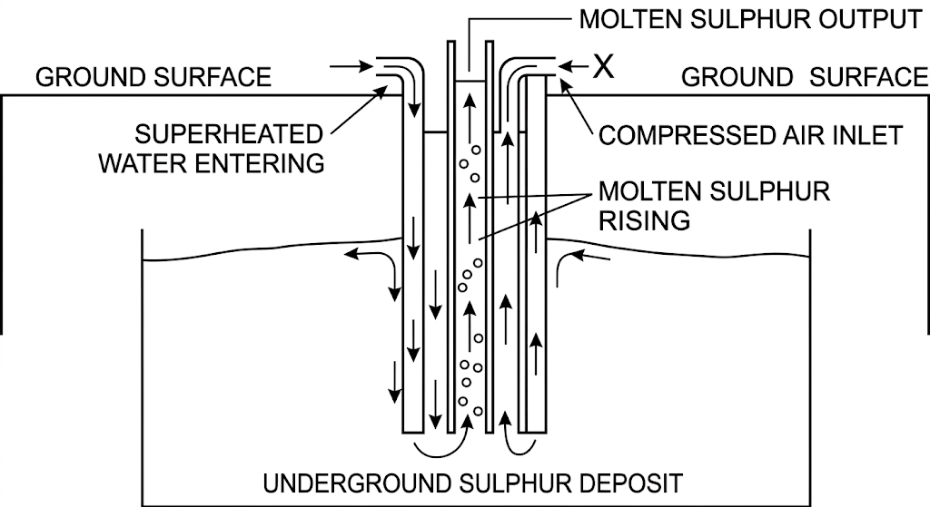
i) Identify X. (1 mark)
________________________________________________________________________________
ii) Explain why superheated water is necessary in this process. (1 mark)
________________________________________________________________________________
iii) State two physical properties of sulphur that make it possible to extract it by this method. (2 marks)
________________________________________________________________________________

