KENYA CERTIFICATE OF BASIC EDUCATION

SENIOR SCHOOL ASSESSMENT

DECEMBER ASSIGNMENT 2026
GRADE 10 – HOMESCIENCE
Time: 2 Hours
LEARNER’S DETAILS
Name: _____________________________________________________________. School: ____________________________________________.
Assessment Number: _______________________________________________. Date: ____________________________________________.
School Code: ______________________________________________________. Signature: _______________________________________.

INSTRUCTIONS TO CANDIDATES
- Write your name in the spaces provided above.
- Write the name of your school and your stream in the spaces provided.
- Write your admission number and the date of the assessment in the spaces provided.
- This paper consists of two sections: A and B.
- Answer all questions in section A and section B.
- Answer the questions in English.
- All answers MUST be written in the spaces provided in PAPER.
- Do NOT remove any page from this question paper.

FOR OFFICIAL USE ONLY (EXAMINER’S USE)
SECTION | SECTION A | SECTION B | % SCORE | EE1 | EE2 | ME1 | ME2 | AE1 | AE2 | BE1 | BE2
SCORE RANGE | 45 MARKS | 35 MARKS |  | 90-100 | 75-89 | 58-74 | 41-57 | 31-40 | 21-30 | 11-20 | 1-10
POINTS |  |  |  | 8 POINTS | 7 POINTS | 6 POINTS | 5 POINTS | 4 POINTS | 3 POINTS | 2 POINTS | 1 POINT
LEARNER’S TOTAL SCORE

SECTION A (30 MARKS)
Answer ALL questions in this section.

1.
a) State two areas of study covered under Home Science at Grade 10 level. (2 marks)
- ____________________________________________________________________________________________
- ____________________________________________________________________________________________
b) Give two ways in which Home Science knowledge can improve the quality of family life. (2 marks)
- ____________________________________________________________________________________________
- ____________________________________________________________________________________________

c) State one entrepreneurial opportunity that can be created from Home Science skills. (1 mark)
___________________________________________________________________________________________________________________________________________________________________________________________________

2.
Study the diagram below.
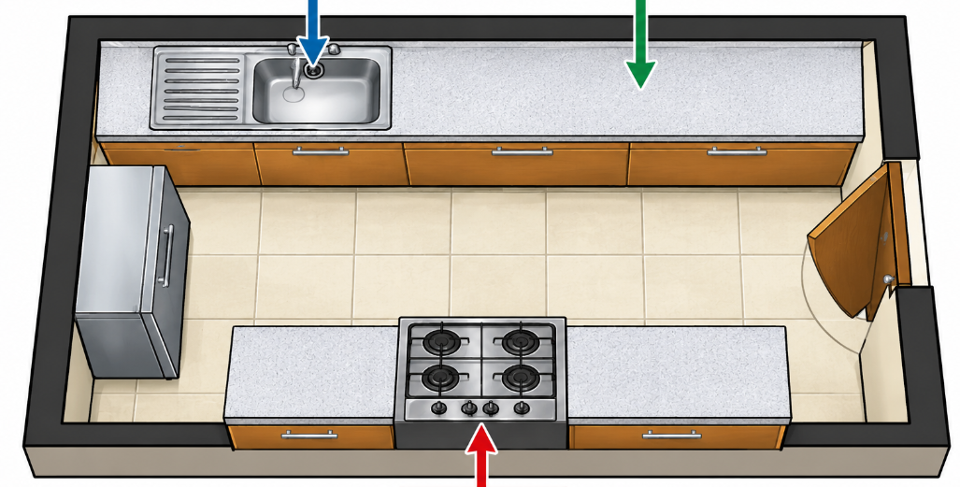
Q R

S
a) Identify the three major work centres represented by Q, R and S. (3 marks)
Q: ____________________________________
R: ____________________________________
S: _____________________________________
b) State two reasons why work centres should be arranged conveniently in a kitchen. (2 marks)
- ____________________________________________________________________________________________
- ____________________________________________________________________________________________

3.
A learner buys fresh vegetables from a market and carries them together with raw meat in one uncovered container. At home, the learner places the food on the kitchen floor before preparation.
a) Identify two unhygienic practices in the situation. (2 marks)
- ____________________________________________________________________________________________
- ____________________________________________________________________________________________
b) Explain one health risk associated with poor food hygiene. (1 mark)
____________________________________________________________________________________________________________________________________________________________________________________________________
c) State two appropriate ways of storing food safely before preparation. (2 marks)
- ____________________________________________________________________________________________
- ____________________________________________________________________________________________

4.
a) State the main function of each of the following nutrients:
i. Fats and oils. (1 mark)
____________________________________________________________________________________________________________________________________________________________________________________________________
ii. Vitamins. (1 mark)
____________________________________________________________________________________________________________________________________________________________________________________________________ iii. Minerals. (1 mark)
____________________________________________________________________________________________________________________________________________________________________________________________________b) Give two examples of foods rich in vitamins and minerals. (2 marks)
- ____________________________________________________________________________________________
- ____________________________________________________________________________________________

5.
a) What is meant by personal hygiene? (1 mark)
b) State three changes that may occur during puberty. (3 marks)
- ____________________________________________________________________________________________
- ____________________________________________________________________________________________
- ____________________________________________________________________________________________
c) Give one reason why maintaining personal hygiene is particularly important during puberty. (1 mark)

______________________________________________________________________________________________________________________________________________________________________________

6.
Study the fabric illustration below.
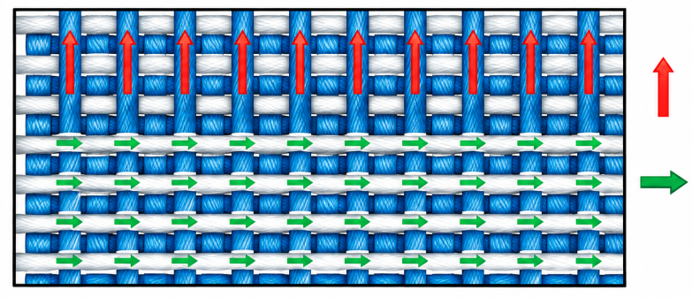
a) Identify the two directions of threads represented by the arrows. (2 marks)
_________________________________

_________________________________

b) State two characteristics of a well-constructed seam. (2 marks)
- ____________________________________________________________________________________________
- ____________________________________________________________________________________________
c) Name one tool used for measuring fabric during garment construction. (1 mark)

____________________________________________________________________

SECTION B: 50 MARKS
Answer ALL questions in this section.

7. A school Home Science class is preparing a vegetable dish, rice and grilled meat for a practical lesson.
a) Explain the meaning of food preparation. (2 marks)
- ____________________________________________________________________________________________
- ____________________________________________________________________________________________

b) State four principles that should be followed when preparing vegetables for cooking. (4 marks)
- ____________________________________________________________________________________________
- ____________________________________________________________________________________________
- ____________________________________________________________________________________________
- ____________________________________________________________________________________________
c) Explain two advantages of steaming vegetables. (2 marks)
- ____________________________________________________________________________________________
- ____________________________________________________________________________________________
d) Give two precautions to observe when grilling meat. (2 marks)
- ____________________________________________________________________________________________
- ____________________________________________________________________________________________

8. The following foods are available in a household:
maize meal, beans, sukuma wiki, milk, bananas, cooking oil and oranges.
a) Classify the foods according to the major nutrients they mainly provide. (4 marks)
- ____________________________________________________________________________________________
- ____________________________________________________________________________________________
- ____________________________________________________________________________________________
- ____________________________________________________________________________________________
b) Using the foods listed above, suggest a balanced main meal for the family. (2 marks)
- ____________________________________________________________________________________________
- ____________________________________________________________________________________________
c) State two factors that may influence the nutritional needs of a family member. (2 marks)
- ____________________________________________________________________________________________
- ____________________________________________________________________________________________
d) Explain two advantages of variety in meals. (2 marks)
- ____________________________________________________________________________________________
- ____________________________________________________________________________________________

9.
A family receives a monthly income of KSh 45,000. The family needs to allocate money for food, housing, education, clothing, transport, healthcare and savings.
a) Define the term family budget. (2 marks)
____________________________________________________________________________________________________________________________________________________________________________________________________
b) State four advantages of preparing a family budget. (4 marks)
- ____________________________________________________________________________________________
- ____________________________________________________________________________________________
- ____________________________________________________________________________________________
- ____________________________________________________________________________________________
c) Explain two factors that should be considered when making purchasing decisions. (2 marks)
- ____________________________________________________________________________________________
- ____________________________________________________________________________________________
d) State two qualities of a wise consumer. (2 marks)
- ____________________________________________________________________________________________
- ____________________________________________________________________________________________

10. Study the cleaning sequence below.
DUSTING
↓
SWEEPING
↓
MOPPING
↓
DRYING
a) Explain why cleaning should generally proceed from high surfaces to low surfaces. (2 marks)
- ____________________________________________________________________________________________
- ____________________________________________________________________________________________
b) State three precautions when using household cleaning agents. (3 marks)
- ____________________________________________________________________________________________
- ____________________________________________________________________________________________
- ____________________________________________________________________________________________
c) A learner is preparing to wash a woollen sweater.
State three precautions that should be taken when laundering woollen garments. (3 marks)
- ____________________________________________________________________________________________
- ____________________________________________________________________________________________
- ____________________________________________________________________________________________
d) State two ways of preventing accidents caused by electrical appliances in the home. (2 marks)
- ____________________________________________________________________________________________
- ____________________________________________________________________________________________

11.
a) Identify the following parts of the garment:
i. The opening around the neck. __________________________________ (1 mark)
ii. The curved opening where the arm passes through. __________________________ (1 mark)
iii. The finished lower edge of the garment. __________________________ (1 mark)
b) State two purposes of pressing during garment construction. (2 marks)
- ____________________________________________________________________________________________
- ____________________________________________________________________________________________
c) Distinguish between natural fibres and manufactured fibres. (2 marks)
Natural fibres | Manufactured fibres
d) Give three examples of natural textile fibres. (3 marks)
- ____________________________________________________________________________________________
- ____________________________________________________________________________________________
- ____________________________________________________________________________________________

THIS IS THE LAST PRINTED PAGE

GRADE 10

HOME SCIENCE

MARKING SCHEME

SECTION A:

1.
a) Two areas of study covered under Home Science:
Any two:
- Foods and Nutrition.
- Home Management.
- Clothing and Textiles.
2 × 1 = 2 marks
b) Two ways Home Science improves family life:
- Promotes proper nutrition and healthy living.
- Enables efficient management of family resources.
- Promotes proper hygiene and sanitation.
- Develops skills in clothing construction and care.
- Promotes safety in the home.
- Helps families make informed consumer decisions.
Any 2 × 1 = 2 marks
c) One entrepreneurial opportunity:
- Catering business.
- Tailoring/dressmaking.
- Baking business.
- Laundry service.
- Food processing.
- Interior decoration.
1 × 1 = 1 mark

2.

a) Identify the three work centres.
S – Cleaning/washing centre — 1 mark
W – Preparation/work centre — 1 mark
C – Cooking centre — 1 mark
Total: 3 marks

b) Two reasons for convenient arrangement of work centres:
- Reduces unnecessary movement.
- Saves time and energy.
- Promotes efficient workflow.
- Reduces accidents.
- Makes kitchen work easier and more enjoyable.
Any 2 × 1 = 2 marks

3.

a) Two unhygienic practices:
- Carrying raw meat and vegetables together in an uncovered container.
- Placing food on the kitchen floor.
2 × 1 = 2 marks

b) One health risk:
Poor food hygiene may lead to food contamination and food-borne diseases, such as diarrhoea, vomiting or food poisoning.
1 mark

c) Two appropriate ways of storing food safely:
- Keep perishable foods such as meat in a refrigerator/freezer.
- Keep food covered in clean containers.
- Store food away from chemicals and other contaminants.
- Keep dry foods in clean, dry and well-ventilated storage areas.
- Separate raw foods from ready-to-eat foods.
Any 2 × 1 = 2 marks

4.

a) Functions of nutrients
i. Fats and oils:
Provide a concentrated source of energy and help in the absorption of fat-soluble vitamins.
(1 mark)
ii. Vitamins:
Regulate body processes and help maintain good health.
(1 mark)
iii. Minerals:
Help in body processes and the formation and maintenance of body structures such as bones and teeth.
(1 mark)

b) Two foods rich in vitamins and minerals:
- Fruits such as oranges, mangoes and bananas.
- Green leafy vegetables such as sukuma wiki and spinach.
- Milk.
- Fish.
- Liver.
- Eggs.
Any 2 × 1 = 2 marks

5.

a) Meaning of personal hygiene:
Personal hygiene is the practice of keeping one's body clean and maintaining habits that promote health and prevent disease.
1 mark

b) Three changes during puberty:
Any three:
- Growth of pubic and underarm hair.
- Development of breasts in girls.
- Deepening of the voice in boys.
- Enlargement of the reproductive organs.
- Increased sweating/body odour.
- Appearance of acne.
- Rapid increase in height and body size.
- Onset of menstruation in girls.
- Production of sperm/ejaculation in boys.
- Development of broader hips in girls and broader shoulders in boys.
Any 3 × 1 = 3 marks

c) Importance of personal hygiene during puberty:
It helps control body odour, prevent infections and promote self-confidence and wellbeing.
1 mark

6.

a) Two directions of threads:
Warp threads — threads running lengthwise along the fabric.
Weft threads — threads running across the width of the fabric.
2 × 1 = 2 marks

b) Two characteristics of a well-constructed seam:
- Stitches should be even and regular.
- The seam should be strong and secure.
- Seam allowance should be even.
- There should be no puckering.
- Raw edges should be appropriately finished.
- The seam should lie flat.
Any 2 × 1 = 2 marks

c) One measuring tool:
- Tape measure.
- Ruler.
- Metre rule.
1 mark

SECTION B: 50 MARKS

7.

a) Meaning of food preparation — 2 marks
Food preparation is the process of selecting, cleaning, trimming, cutting, combining and otherwise preparing food ingredients before or during cooking.
2 marks

b) Four principles when preparing vegetables — 4 marks
Any four:
- Wash vegetables thoroughly before cutting where appropriate.
- Use clean utensils and equipment.
- Avoid unnecessary peeling to minimise nutrient loss.
- Cut vegetables into suitable and uniform sizes.
- Avoid prolonged soaking after cutting.
- Prepare vegetables shortly before cooking.
- Avoid excessive cutting or chopping.
- Use appropriate cooking methods to preserve nutrients.
- Avoid overcooking.
Any 4 × 1 = 4 marks

c) Two advantages of steaming vegetables — 2 marks
- Helps retain more water-soluble nutrients than some prolonged cooking methods.
- Helps retain the natural colour, flavour and texture of vegetables.
- Does not require vegetables to be immersed in water.
- Can reduce nutrient loss into cooking water.
Any 2 × 1 = 2 marks

d) Two precautions when grilling meat — 2 marks
- Ensure the meat is cooked thoroughly to a safe internal temperature.
- Keep raw and cooked meat separate to prevent cross-contamination.
- Use clean utensils.
- Avoid excessive charring/burning.
- Use appropriate heat and turn the meat as necessary.
- Handle hot grills carefully to prevent burns.
Any 2 × 1 = 2 marks

8.

a) Classification of foods according to major nutrients — 4 marks
Possible answers:
Food | Main nutrient provided
Maize meal | Carbohydrates
Beans | Protein
Sukuma wiki | Vitamins and minerals
Milk | Protein, minerals and fat
Bananas | Carbohydrates, vitamins and minerals
Cooking oil | Fats and oils
Oranges | Vitamins and minerals
Any 4 correct classifications × 1 = 4 marks

b) Balanced main meal — 2 marks
One acceptable meal:
Ugali/maize meal + beans + sukuma wiki + orange/banana + milk.
Award marks for a meal containing a suitable combination of:
- Energy-giving food.
- Body-building/protein food.
- Protective foods such as vegetables/fruits.
2 marks

c) Two factors influencing nutritional needs — 2 marks
Any two:
- Age.
- Sex.
- Level of physical activity.
- Physiological state such as pregnancy or lactation.
- Health status.
- Body size.
- Growth requirements.
Any 2 × 1 = 2 marks

d) Two advantages of variety in meals — 2 marks
- Provides a wider range of nutrients.
- Prevents monotony and makes meals more appealing.
- Provides different tastes, colours and textures.
- Helps meet different nutritional requirements.
Any 2 × 1 = 2 marks

9.

a) Define family budget — 2 marks
A family budget is a planned estimate of the family's expected income and expenditure over a specified period.
2 marks

b) Four advantages of preparing a family budget — 4 marks
Any four:
- Helps control expenditure.
- Ensures available income is allocated according to priorities.
- Helps prevent unnecessary spending.
- Enables the family to save.
- Helps meet future financial needs.
- Prevents or reduces unnecessary borrowing.
- Helps the family monitor its financial position.
- Facilitates planning for emergencies.
Any 4 × 1 = 4 marks

c) Two factors considered when making purchasing decisions — 2 marks
Any two, with appropriate explanation:
- Price: The consumer should compare the price with the available budget.
- Quality: The product should be durable and fit for its intended purpose.
- Needs: Priority should be given to essential goods.
- Safety: The product should be safe to use.
- Quantity: The amount purchased should correspond to the family's needs.
- Availability: The product should be readily obtainable.
- Consumer information: Labels, expiry dates and instructions should be checked.
Any 2 × 1 = 2 marks

d) Two qualities of a wise consumer — 2 marks
- Makes informed decisions.
- Compares prices and quality.
- Plans purchases.
- Avoids impulse buying.
- Checks labels and product information.
- Considers value for money.
- Keeps within a budget.
Any 2 × 1 = 2 marks

10.

a) Why cleaning proceeds from high surfaces to low surfaces — 2 marks
Dust and dirt falling from higher surfaces can land on lower surfaces. Cleaning from high to low prevents already-cleaned surfaces from becoming dirty again.
2 marks

b) Three precautions when using household cleaning agents — 3 marks
Any three:
- Read and follow instructions on the label.
- Keep cleaning agents away from children.
- Do not mix different cleaning chemicals unless specifically directed.
- Store chemicals in their original, labelled containers.
- Use protective equipment such as gloves where appropriate.
- Ensure adequate ventilation.
- Avoid contact with eyes and skin.
- Wash hands after handling cleaning agents.
Any 3 × 1 = 3 marks

c) Three precautions when laundering woollen garments — 3 marks
- Use mild detergent suitable for wool.
- Avoid excessive rubbing or scrubbing.
- Avoid very hot water.
- Avoid sudden temperature changes.
- Handle gently to prevent felting.
- Avoid wringing or twisting.
- Reshape the garment while damp.
- Dry flat where appropriate.
- Follow the garment care label.
Any 3 × 1 = 3 marks

d) Two ways of preventing electrical accidents — 2 marks
- Do not handle electrical appliances with wet hands.
- Keep electrical appliances away from water.
- Replace damaged electrical cords.
- Avoid overloading sockets.
- Switch off and unplug appliances when not in use.
- Keep electrical appliances away from young children.
- Ensure appliances are properly maintained.
Any 2 × 1 = 2 marks

11.

a) Identify the garment parts
i. Opening around the neck:
Neckline. (1 mark)
ii. Curved opening where the arm passes through:
Armhole. (1 mark)
iii. Finished lower edge:
Hem. (1 mark)

b) Two purposes of pressing during garment construction — 2 marks
- Removes wrinkles and creases.
- Helps seams lie flat.
- Gives the garment a neat and professional appearance.
- Helps shape garment sections.
- Makes construction easier and improves the final fit.
Any 2 × 1 = 2 marks

c) Distinguish between natural and manufactured fibres — 2 marks
Natural fibres:
Fibres obtained from natural sources such as plants or animals.
(1 mark)
Manufactured fibres:
Fibres produced through chemical or industrial processes, usually from polymers or regenerated natural materials.
(1 mark)

d) Three examples of natural textile fibres — 3 marks
Any three:
- Cotton.
- Linen.
- Wool.
- Silk.
- Jute.
- Flax.
- Sisal.
Any 3 × 1 = 3 marks

SENIOR SCHOOL ASSESSMENT

TERM 3: PROJECT BASED ASSESSMENT 2026
GRADE 10 – HOMESCIENCE
LEARNER’S DETAILS
Name: _____________________________________________________________. School: ____________________________________________.
Assessment Number: _______________________________________________. Date: ____________________________________________.
School Code: ______________________________________________________. Signature: _______________________________________.

GRADE 10 HOME SCIENCE – PRACTICAL PROJECT ASSESSMENT

Project: Constructing a Simple Garment
Total Marks: 20
Task:
Learners are required to plan, prepare, construct and finish a simple garment such as an apron, simple skirt, shorts, headscarf or simple top using suitable fabric and basic sewing techniques.

Assessment Tasks and Mark Allocation
No. | Assessment Area | Marks
1 | Project planning – identifies the garment, gives purpose, prepares a simple sketch/design and lists materials and equipment | 3
2 | Preparation of materials and equipment – selects suitable fabric, sewing tools and equipment; observes safety precautions | 3
3 | Taking measurements and pattern preparation – takes/uses appropriate measurements and prepares or adapts a suitable pattern | 3
4 | Fabric preparation and cutting – prepares fabric, places pattern correctly, observes grain and cuts accurately | 3
5 | Garment construction – joins garment sections correctly using appropriate stitches/seams and follows the construction sequence | 4
6 | Finishing and presentation – neat hems, secure seams, appropriate fastenings, pressing and overall appearance | 3
7 | Project reflection – explains challenges encountered, solutions used and skills gained | 1
 | TOTAL | 20

Learner's Project Evidence
The learner should submit:
- A simple garment design/sketch.
- List of materials and equipment used.
- Measurements/pattern used.
- The completed garment.
- A brief project reflection.

Suggested Garments
- Simple apron
- Simple skirt
- Simple shorts
- Headscarf
- Simple top
- Simple child's garment
Key competencies assessed: creativity, communication, problem-solving, self-efficacy, collaboration, planning and practical application of sewing skills.

