TERM 3 HOLIDAY ASSIGNMENT 2026
FORM THREE
AGRICULTURE PAPER 1 (THEORY)
Section | Question Numbers | Maximum Score | Candidate's Score
Section A | 1 – 17 | 30 Marks*
Section B | 18 – 21 | 20 Marks
Section C | 22 – 24 (Answer any 2) | 40 Marks
TOTAL |  | 90 Marks*

SECTION A (30 MARKS*)
1. List any three climatic factors that influence crop production. (1½ marks)
________________________________________________________________________________
2. State four ways by which nutrients may be lost from the soil. (2 marks)
________________________________________________________________________________
________________________________________________________________________________
3. List three aspects of light that influence crop growth. (1½ marks)
________________________________________________________________________________
4. Name two types of water pumps which can be used on a farm. (1 marks)
________________________________________________________________________________
5. Outline four characteristics of plants used in the preparation of green manure. (2 marks)
________________________________________________________________________________
________________________________________________________________________________
6. State four roles of organic matter in sandy soil. (2 marks)
________________________________________________________________________________
________________________________________________________________________________
7. What are the causes of blossom end rot disease in tomatoes? (1½ marks)
________________________________________________________________________________
8. Give two reasons why soil testing is carried out in crop production. (1 marks)
________________________________________________________________________________
9. State four characteristics of phosphatic fertilizers. (2 marks)
________________________________________________________________________________
________________________________________________________________________________
10. Calculate the plant population of a piece of land measuring 0.72 ha planted with maize at a spacing of 90 cm by 40 cm. Show your working. (3 marks)
________________________________________________________________________________
________________________________________________________________________________
________________________________________________________________________________
________________________________________________________________________________
________________________________________________________________________________
11. State three methods of breaking dormancy in some crops before planting. (1½ marks)
________________________________________________________________________________
12. Give one reason for carrying out each of the following practices in a tomato nursery. (2 marks)
i) Pricking out. (1 marks)
________________________________________________________________________________
ii) Hardening off. (1 marks)
________________________________________________________________________________
13. State four agents of soil erosion. (2 marks)
________________________________________________________________________________
________________________________________________________________________________
14. Define the following terms:
i) Afforestation. (1 marks)
________________________________________________________________________________
ii) Re-afforestation. (1 marks)
________________________________________________________________________________
15. List four types of terraces. (2 marks)
________________________________________________________________________________
________________________________________________________________________________
16. State four ways in which a land title deed is important to a farmer. (2 marks)
________________________________________________________________________________
________________________________________________________________________________
17. State two forms of collective land tenure in Kenya. (2 marks)
________________________________________________________________________________
________________________________________________________________________________

SECTION B (20 MARKS)
Answer ALL questions in the spaces provided.
18. a) Distinguish between straight fertilizers and compound fertilizers. (2 marks)
________________________________________________________________________________
________________________________________________________________________________
b) A farmer applied 150 kg of CAN (20% N) per hectare on a four-hectare maize crop. Calculate the amount of nitrogen the farmer applied on the crop. Show your working. (5 marks)
________________________________________________________________________________
________________________________________________________________________________
________________________________________________________________________________
________________________________________________________________________________
19. The diagram below shows a soil sampling method. Study it and answer the questions that follow.
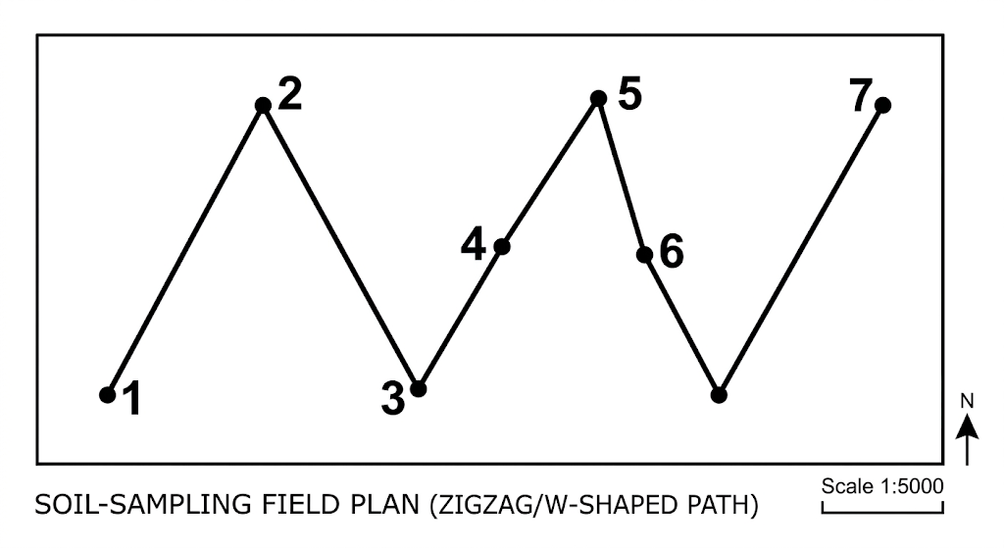
i) Identify the soil sampling method illustrated. (1 marks)
________________________________________________________________________________
ii) State four activities that are carried out during soil sampling in the field. (4 marks)
________________________________________________________________________________
________________________________________________________________________________
________________________________________________________________________________
iii) What information should the sample have before being taken to the laboratory? (2 marks)
________________________________________________________________________________
________________________________________________________________________________
20. The diagram below shows a crop pest and the damaged crop. Study it and answer the questions that follow.
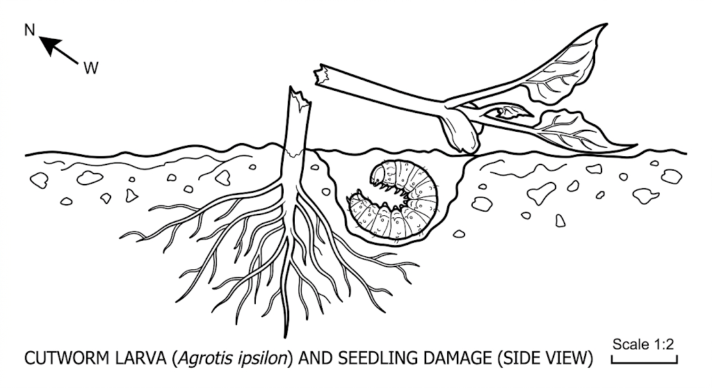
a) Identify the crop pest illustrated. (1 marks)
________________________________________________________________________________
b) State one way of controlling the pest. (1 marks)
________________________________________________________________________________
21. The diagram below illustrates a type of soil erosion.
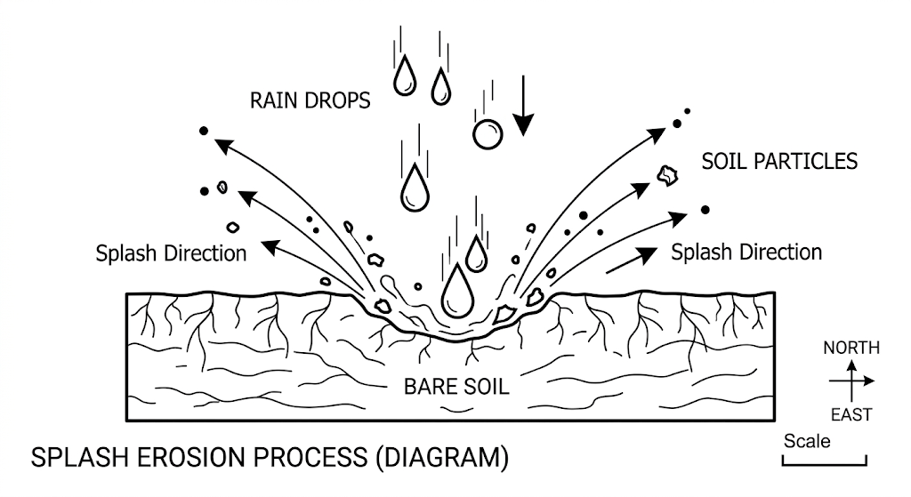
a) Identify the type of soil erosion shown. (2 marks)
________________________________________________________________________________
b) Explain how the type of erosion shown occurs. (2 marks)
________________________________________________________________________________
________________________________________________________________________________

SECTION C (40 MARKS)
Answer ANY TWO questions from this section in the spaces provided after question 24.
22. a) Explain eight cultural methods of soil and water conservation. (8 marks)
________________________________________________________________________________
________________________________________________________________________________
________________________________________________________________________________
________________________________________________________________________________
________________________________________________________________________________
________________________________________________________________________________
________________________________________________________________________________
________________________________________________________________________________
b) Describe eight methods used in water harvesting. (8 marks)
________________________________________________________________________________
________________________________________________________________________________
________________________________________________________________________________
________________________________________________________________________________
________________________________________________________________________________
________________________________________________________________________________
________________________________________________________________________________
________________________________________________________________________________
c) State four agents of soil erosion. (4 marks)
________________________________________________________________________________
________________________________________________________________________________
________________________________________________________________________________
________________________________________________________________________________
23. a) Describe the production of onions under the following subheadings.
i) Seedbed preparation. (3 marks)
________________________________________________________________________________
________________________________________________________________________________
________________________________________________________________________________
ii) Field management. (4 marks)
________________________________________________________________________________
________________________________________________________________________________
________________________________________________________________________________
________________________________________________________________________________
iii) Harvesting. (3 marks)
________________________________________________________________________________
________________________________________________________________________________
________________________________________________________________________________
b) Describe the field management practices for tomatoes. (10 marks)
________________________________________________________________________________
________________________________________________________________________________
________________________________________________________________________________
________________________________________________________________________________
________________________________________________________________________________
________________________________________________________________________________
________________________________________________________________________________
________________________________________________________________________________
________________________________________________________________________________
________________________________________________________________________________
24. a) State and explain five roles of agriculture in economic development of Kenya. (10 marks)
________________________________________________________________________________
________________________________________________________________________________
________________________________________________________________________________
________________________________________________________________________________
________________________________________________________________________________
________________________________________________________________________________
________________________________________________________________________________
________________________________________________________________________________
________________________________________________________________________________
________________________________________________________________________________
b) Give two effects of low temperatures on crop growth. (2 marks)
________________________________________________________________________________
________________________________________________________________________________
c) Explain four aspects of rainfall that a farmer should consider when choosing a crop to grow. (8 marks)
________________________________________________________________________________
________________________________________________________________________________
________________________________________________________________________________
________________________________________________________________________________
________________________________________________________________________________
________________________________________________________________________________
________________________________________________________________________________
________________________________________________________________________________

