TERM 3 HOLIDAY ASSIGNMENT 2026
FORM THREE
BIOLOGY PAPER 2
Section | Question Numbers | Maximum Score | Candidate's Score
Section A | 1 – 5 | 20 Marks
Section B | 1–8 (as instructed) | 60 Marks
TOTAL | Answered questions | 80 Marks*

SECTION A (40 MARKS)
1. The diagram below shows a phenomenon that occurs during cell division.
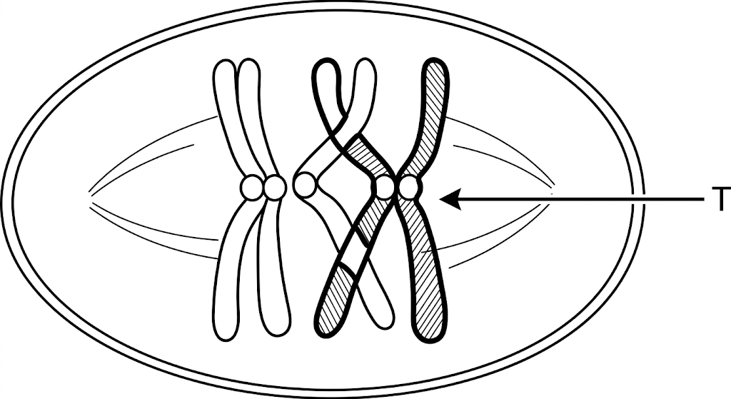
a) Identify the phenomenon exhibited in the diagram. (1 mark)
________________________________________________________________________________
b) Identify the type of cell division in which this phenomenon occurs. (1 mark)
________________________________________________________________________________
c) Name the part labelled T and state its biological importance. (2 marks)
________________________________________________________________________________
________________________________________________________________________________
d) Name two organs in a human being where this type of cell division occurs. (2 marks)
________________________________________________________________________________
________________________________________________________________________________
e) On the table below, state one significant event that occurs during each stage listed. (2 marks)
________________________________________________________________________________
________________________________________________________________________________
Stage in cell division | Meiosis I | Mitosis
Metaphase
Anaphase

2. A biological washing powder contains enzymes. The enzymes remove stains such as blood from clothes when the clothes are soaked in water with the powder.
a) What is an enzyme? (1 mark)
________________________________________________________________________________
b) Identify two possible enzymes that may be found in the washing powder. (2 marks)
________________________________________________________________________________
________________________________________________________________________________
c) Would the stains be removed faster with the powder in water at 35 °C or 15 °C? (1 mark)
________________________________________________________________________________
d) Explain your answer in (c). (2 marks)
________________________________________________________________________________
________________________________________________________________________________
e) Why does boiling clothes soaked with the washing powder not necessarily remove the stains? (2 marks)
________________________________________________________________________________
________________________________________________________________________________
3. The amount of blood flowing through selected parts of the mammalian body at different activity levels was measured as shown below.
Part of body | At rest (cm³/min) | Light exercise (cm³/min) | Strenuous exercise (cm³/min)
Alimentary canal | 1200 | 800 | 400
Cardiac muscle | 100 | 250 | 1400
Skeletal muscle | 900 | 5000 | 16000

a) i) Account for the high blood flow through cardiac and skeletal muscle during strenuous exercise. (4 marks)
________________________________________________________________________________
________________________________________________________________________________
________________________________________________________________________________
________________________________________________________________________________
ii) Account for the blood flow through the alimentary canal at rest. (2 marks)
________________________________________________________________________________
________________________________________________________________________________
b) Name two waste materials excreted by both the skin and the kidney. (2 marks)
________________________________________________________________________________
________________________________________________________________________________
4. a) Nitrogen in the atmosphere cannot be directly utilized by plants. State two ways by which this nitrogen is made available for plant use. (2 marks)
b) State the importance of saprophytic bacteria in the environment. (1 mark)
________________________________________________________________________________
c) Briefly explain how excessive use of fertilizers affects large water bodies. (3 marks)
________________________________________________________________________________
________________________________________________________________________________
________________________________________________________________________________
d) State two reasons why it has been difficult to eradicate malaria in the tropics. (2 marks)
________________________________________________________________________________
________________________________________________________________________________
5. The diagram below shows the exchange of gases in an alveolus. Study it and answer the questions that follow.
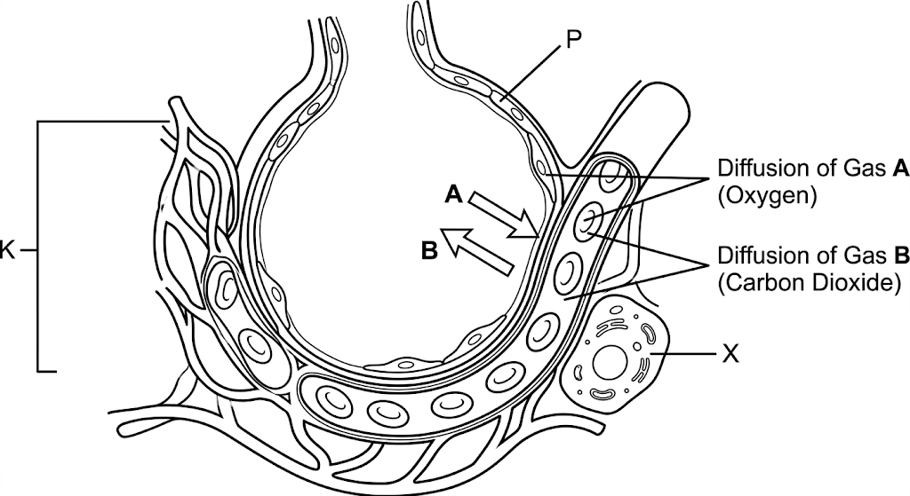
a) Name gases A and B. (2 marks)
________________________________________________________________________________
________________________________________________________________________________
b) State the importance of gas B in tissues. (1 mark)
________________________________________________________________________________
c) Name parts marked K and P. (2 marks)
________________________________________________________________________________
________________________________________________________________________________
d) State three adaptations of the alveolus to its function. (3 marks)
________________________________________________________________________________
________________________________________________________________________________
________________________________________________________________________________

SECTION B (ANSWER QUESTION 6 AND ANY ONE OF QUESTIONS 7 AND 8)
6. In an experiment to investigate a process in a plant species, the rates of carbon(IV) oxide consumption and carbon(IV) oxide release were measured at different times of the day. The results are shown below.
Time of day (hours) | 6 | 8 | 10 | 12 | 14 | 16 | 18 | 20 | 22 | 24
CO₂ consumption (mm³/min) | 0 | 50 | 72 | 96 | 96 | 55 | 20 | 0 | 0 | 0
CO₂ release (mm³/min) | 40 | 24 | 12 | 4 | 4 | 8 | 34 | 50 | 50 | 50

On the same axes, plot graphs of CO₂ consumed and CO₂ released against time.
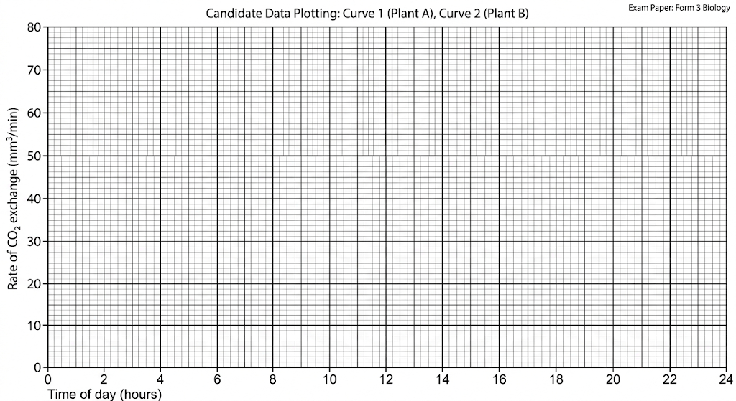
[a) Name the biological process represented by the CO₂ consumption curve. (2 marks)
________________________________________________________________________________
________________________________________________________________________________
b) Account for the shape of the curve for CO₂ consumption. (2 marks)
________________________________________________________________________________
________________________________________________________________________________
c) Account for the shape of the curve for CO₂ release. (2 marks)
________________________________________________________________________________
________________________________________________________________________________
d) i) From the graph, state the time of the day when the plant attains the compensation point. (1 mark)
________________________________________________________________________________
d) ii) What is meant by compensation point? (1 mark)
________________________________________________________________________________
e) Explain how temperature affects the rate of CO₂ consumption in a plant. (1 mark)
________________________________________________________________________________
f) Under certain conditions, CO₂ concentration in the blood of a mammal rises above normal. State two physiological changes that occur in the body to lower the CO₂ level back to normal. (2 marks)
________________________________________________________________________________
________________________________________________________________________________
g) Most CO₂ is transported from tissues to the lungs within red blood cells and not simply in plasma. State one advantage of this mode of transport. (1 mark)
________________________________________________________________________________
7. Describe how water molecules are absorbed from the soil and move to the leaves in a tree. (10 marks)
________________________________________________________________________________
________________________________________________________________________________
________________________________________________________________________________
________________________________________________________________________________
________________________________________________________________________________
________________________________________________________________________________
________________________________________________________________________________
________________________________________________________________________________
________________________________________________________________________________
________________________________________________________________________________
8. Explain any five adaptations of the ileum to the process of absorption. (10 marks)
________________________________________________________________________________
________________________________________________________________________________
________________________________________________________________________________
________________________________________________________________________________
________________________________________________________________________________
________________________________________________________________________________
________________________________________________________________________________
________________________________________________________________________________
________________________________________________________________________________
________________________________________________________________________________
b) Explain any five features or mechanisms that hinder self-pollination in plants. (10 marks)
________________________________________________________________________________
________________________________________________________________________________
________________________________________________________________________________
________________________________________________________________________________
________________________________________________________________________________
________________________________________________________________________________
________________________________________________________________________________
________________________________________________________________________________
________________________________________________________________________________
________________________________________________________________________________

