CHEMISTRY GRADE 10
TERM 3 OPENER EXAM 2026
TIME: 2 HOURS

NAME……………………………………ADM NO…………………………….

DATE………………………………………SIGN…………………………………

INSTRUCTIONS TO CANDIDATES
• Answer all questions.
• Show all working in calculations.
• The paper has 100 marks.

1a) State two safety precautions when heating chemicals in the laboratory. (2 marks)
________________________________________________________________________________
________________________________________________________________________________
b) Give the apparatus for measuring: i. 25.0 cm³ accurately; (1 mark) ii. 50 cm³ approximately. (1 mark)
________________________________________________________________________________
c) A learner heats 100 g of water from 25°C to 75°C. The specific heat capacity is 4.2 J g⁻¹ °C⁻¹. Calculate the heat absorbed. Show working. (3 marks)
________________________________________________________________________________
________________________________________________________________________________
________________________________________________________________________________

d) State three variables that should be controlled when investigating how temperature affects the rate of reaction between an acid and a metal. (3 marks)
________________________________________________________________________________
________________________________________________________________________________
2a) Explain, using particles, why gases are easily compressed but liquids are not. (2 marks)
________________________________________________________________________________
________________________________________________________________________________
b) Name the separation method for:
i. sand and water

ii. ethanol and water

iii. dyes in ink.

________________________________________________________________________________
c) Describe what happens to particles when a solid melts. (2 marks)
________________________________________________________________________________
________________________________________________________________________________
d) Describe how to separate a mixture of iron filings, sand and common salt and recover each substance. (3 marks)
________________________________________________________________________________
________________________________________________________________________________
________________________________________________________________________________
3a) The following is a simplified atom. Identify 1–4. (4 marks)
 | 4
3 | (12) Mg | 3
 | 2
Diagram 1: Simplified atomic structure.
b) The atom has proton number 12. State:
i. number of protons

ii. number of electrons in a neutral atom

iii. electronic arrangement.
________________________________________________________________________________
________________________________________________________________________________
c) Explain why elements in the same group have similar chemical properties. (2 marks)
________________________________________________________________________________
________________________________________________________________________________
d) X has electronic arrangement 2.8.1. i. State its group and period. (2) ii. Predict the ion it forms and explain. (1)
________________________________________________________________________________
________________________________________________________________________________
4a) Define an ionic bond. (2 marks)
________________________________________________________________________________
________________________________________________________________________________
b) Explain formation of sodium chloride from sodium and chlorine, including electron transfer and ions. (3 marks)
________________________________________________________________________________
________________________________________________________________________________
________________________________________________________________________________
c) State two properties of ionic compounds arising from their structure. (2 marks)
________________________________________________________________________________
________________________________________________________________________________
d) Explain why solid NaCl does not conduct electricity but molten NaCl does. (2 marks)
________________________________________________________________________________
________________________________________________________________________________
e) State one property of metals explained by metallic bonding. (1 mark)
________________________________________________________________________________
5a) Write formulae for:
i. calcium carbonate
ii. aluminium oxide
iii. ammonium sulfate.
________________________________________________________________________________
b) Balance: Mg + HCl → MgCl₂ + H₂. (2 marks)

________________________________________________________________________________
c) CaCO₃ + 2HCl → CaCl₂ + H₂O + CO₂. Calculate moles of CaCO₃ in 5.00 g. [Ca=40, C=12, O=16] (3 marks)
________________________________________________________________________________
________________________________________________________________________________
________________________________________________________________________________
d) Calculate moles of HCl required for the 5.00 g CaCO₃. (2 marks)

________________________________________________________________________________
________________________________________________________________________________
e) Calculate mass of CO₂ produced. [C=12, O=16] (4 marks)

________________________________________________________________________________
________________________________________________________________________________
6a) Define an acid in terms of aqueous hydrogen ions. (1 mark)

________________________________________________________________________________
b) State the universal-indicator colour in a strongly acidic solution and a strongly alkaline solution. (2 marks)

________________________________________________________________________________
c) 25.0 cm³ NaOH is titrated with 0.100 mol dm⁻³ HCl. Mean titre = 20.0 cm³. HCl + NaOH → NaCl + H₂O. i. Calculate moles HCl.

ii. Calculate concentration of NaOH.
________________________________________________________________________________
________________________________________________________________________________
________________________________________________________________________________
________________________________________________________________________________
d) State two uses of neutralisation. (2 marks)

________________________________________________________________________________
________________________________________________________________________________
e) Explain how an antacid relieves excess stomach acidity. (2 marks)

________________________________________________________________________________
________________________________________________________________________________
7a) State three factors that increase reaction rate between a solid metal and an acid. (3 marks)

________________________________________________________________________________
________________________________________________________________________________
b) 60 cm³ H₂ is collected in 30 s at 25°C and in 18 s at 40°C.
i. Calculate rate at 25°C.

ii. Calculate rate at 40°C.

iii. Explain the difference.
________________________________________________________________________________
________________________________________________________________________________
________________________________________________________________________________
________________________________________________________________________________
c) Distinguish between exothermic and endothermic reactions. (1 mark)

8a) Identify 1–4 in the electrolytic cell. (4 marks)
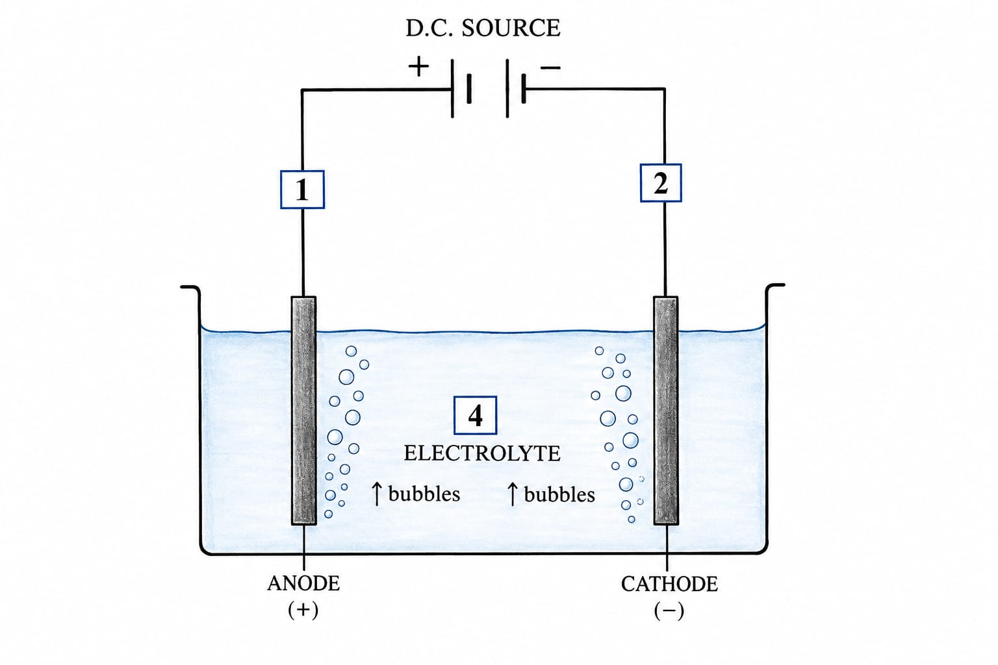

b) Define electrolysis. (2 marks)
________________________________________________________________________________
________________________________________________________________________________
c) State what happens at:
i. cathode

ii. anode.
________________________________________________________________________________
________________________________________________________________________________
d) During electrolysis of CuSO₄ using copper electrodes state:
i. ion discharged at cathode;

ii. cathode change

iii. anode change.
________________________________________________________________________________
________________________________________________________________________________
e) Give one industrial use of electrolysis. (1 mark)
________________________________________________________________________________
9a) Name two major components of clean, dry air. (2 marks)
________________________________________________________________________________
b) State one harmful effect of:
i. carbon monoxide.

ii. sulfur dioxide.
________________________________________________________________________________
________________________________________________________________________________
c) Explain formation of acid rain and state one environmental effect. (3 marks)
________________________________________________________________________________
________________________________________________________________________________
________________________________________________________________________________
d) A water sample leaves white deposit when heated. Give one likely cause and one way to reduce it. (2 marks)
________________________________________________________________________________
________________________________________________________________________________
e) State one reason for treating drinking water. (1 mark)
________________________________________________________________________________
10.A learner has dilute HCl, NaOH solution and NaCl solution, all unlabelled.
a) Describe a procedure using a suitable indicator to identify them. (4 marks)
________________________________________________________________________________
________________________________________________________________________________
________________________________________________________________________________
b) Equal volumes of equal concentrations of HCl and NaOH are mixed. Predict the resulting solution and write the balanced equation. (3 marks)
________________________________________________________________________________
________________________________________________________________________________
________________________________________________________________________________
c) Explain why temperature may rise during neutralisation. (1 mark)
________________________________________________________________________________
d) Suggest two improvements to make the identification experiment reliable. (2 marks)
________________________________________________________________________________
________________________________________________________________________________

