AGRICULTURE GRADE 10
TERM 3 OPENER EXAM 2026
TIME: 2 HOURS

NAME……………………….ADM NO……………………………….

DATE…………………………………...SIGN…………………………..

INSTRUCTIONS TO CANDIDATES
• Answer ALL questions.
• Write your answers clearly in the spaces provided.
• Where a calculation is required, show all working. Answers without supporting working may not earn full marks.

1. A farmer in Kitui has inherited a piece of land and wants to establish a commercial crop enterprise.
(a) State two factors the farmer should consider when selecting the land for crop production. [2 marks]
________________________________________________________________________________
________________________________________________________________________________
(b) Give three advantages of owning agricultural land rather than operating entirely under a short-term lease. [3 marks]
________________________________________________________________________________
________________________________________________________________________________
(c) Explain three ways in which poor land-use planning can reduce agricultural productivity. [3 marks]

________________________________________________________________________________
________________________________________________________________________________

2. Study Figure 1 below and answer the questions that follow.

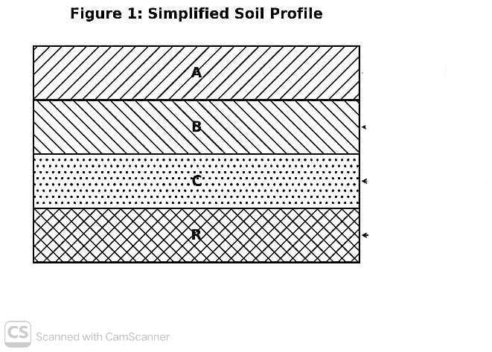
(a) Name the soil horizons labelled A, B, C and R. [4 marks]
A
B
C
R
________________________________________________________________________________
________________________________________________________________________________
(b) State two characteristics of a good agricultural soil. [2 marks]
________________________________________________________________________________
________________________________________________________________________________
(c) A learner collected 100 g of moist soil. After oven-drying, the sample weighed 84 g. Calculate the percentage moisture content of the soil sample. Show your working. [4 marks]
________________________________________________________________________________
________________________________________________________________________________
________________________________________________________________________________
________________________________________________________________________________
3. A farmer intends to grow maize on a field that was previously under natural grass.
(a) State four operations that may be carried out during land preparation, in a logical sequence. [4 marks]
________________________________________________________________________________
________________________________________________________________________________
________________________________________________________________________________
(b) Explain two reasons for carrying out primary cultivation before secondary cultivation. [2 marks]
________________________________________________________________________________
________________________________________________________________________________
(c) The farmer uses a mouldboard plough. State two conditions under which ploughing should be avoided. [2 marks]
________________________________________________________________________________
________________________________________________________________________________
4. A school farm establishes a maize plot measuring 30 m × 20 m. Maize is planted at a spacing of 75 cm between rows and 25 cm within rows.
(a) Calculate the approximate plant population expected in the plot. Show all working. [4 marks]
________________________________________________________________________________
________________________________________________________________________________
________________________________________________________________________________
________________________________________________________________________________
(b) State two reasons for thinning maize seedlings. [2 marks]
________________________________________________________________________________
________________________________________________________________________________
(c) Explain two benefits of timely weeding in a crop field. [2 marks]
________________________________________________________________________________
________________________________________________________________________________
5. A farmer wants to establish a healthy maize crop and has access to certified seed, manure and mineral fertilizer.
(a) State four qualities of good planting material. [4 marks]
________________________________________________________________________________
________________________________________________________________________________
________________________________________________________________________________
(b) Explain three factors that should be considered when determining the appropriate planting time for a crop. [3 marks]
________________________________________________________________________________
________________________________________________________________________________
________________________________________________________________________________
(c) Describe three management practices that should be carried out after crop emergence and explain how each promotes crop performance. [6 marks]
________________________________________________________________________________
________________________________________________________________________________
________________________________________________________________________________
________________________________________________________________________________
________________________________________________________________________________
6. During scouting, a farmer observes leaves with irregular holes, curling and yellowing. Some plants are also stunted.
(a) Distinguish between a pest and a crop disease. [2 marks]
________________________________________________________________________________
________________________________________________________________________________
(b) State three methods that can be used in an integrated crop protection programme. [3 marks]
________________________________________________________________________________
________________________________________________________________________________
(c) Explain three safety precautions a farmer should observe when handling or applying a crop protection product. [3 marks]
________________________________________________________________________________
________________________________________________________________________________
________________________________________________________________________________
7. A farmer harvests tomatoes for the fresh market and beans for dry storage.
(a) State two indicators that can be used to determine the correct harvesting stage of a crop. [2 marks]
________________________________________________________________________________
________________________________________________________________________________
(b) Explain two ways in which careless harvesting can reduce the quality and market value of produce. [2 marks]
________________________________________________________________________________
________________________________________________________________________________
(c) State two practices that help minimise post-harvest losses. [2 marks]
________________________________________________________________________________
________________________________________________________________________________
8. Study Figure 2 and answer the questions that follow.
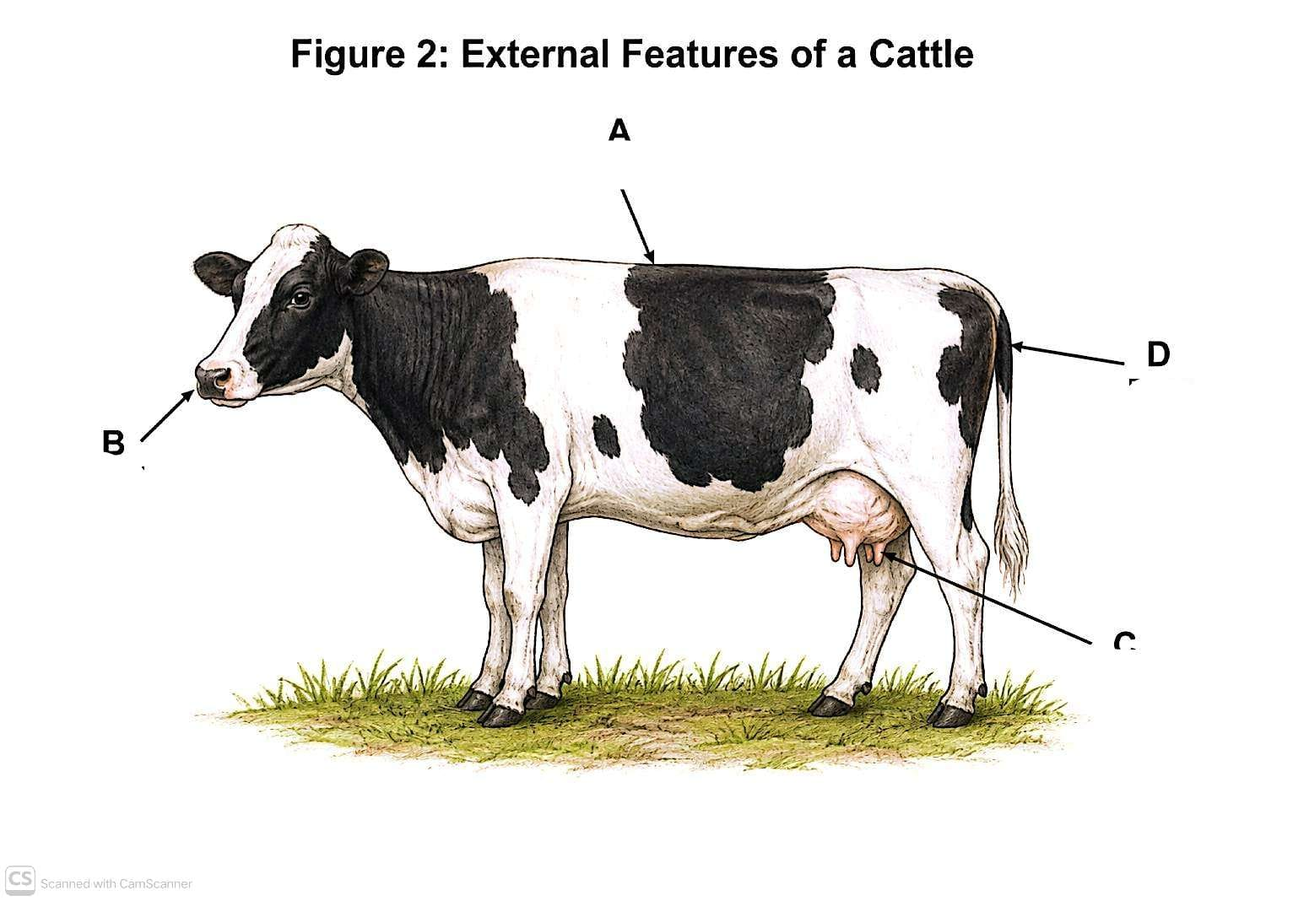
(a) Identify the external features labelled A, B, C and D. [4 marks]
________________________________________________________________________________
________________________________________________________________________________
(b) Name two dairy cattle breeds commonly kept in Kenya. [2 marks]
________________________________________________________________________________
________________________________________________________________________________
(c) A farmer has limited pasture but wants a high milk yield. Give two considerations that should guide the choice of dairy breed. [2 marks]
________________________________________________________________________________
________________________________________________________________________________
(d) State two ways in which livestock production contributes to the Kenyan economy. [2 marks]
________________________________________________________________________________
________________________________________________________________________________
9. A learner is asked to help restrain a docile cow for routine examination.
(a) State four safety precautions the learner should observe before and during handling. [4 marks]
________________________________________________________________________________
________________________________________________________________________________
________________________________________________________________________________
(b) Explain two reasons for using appropriate restraining methods instead of excessive force. [2 marks]
________________________________________________________________________________
________________________________________________________________________________
(c) State two items of protective clothing/equipment that may be used when handling livestock. [2 marks]
________________________________________________________________________________
________________________________________________________________________________
10. A farmer buys a new heifer. On arrival, the animal is dull, has poor appetite and an abnormal discharge from the nose.
(a) State four signs that can be used to assess the health of a livestock animal. [4 marks]
________________________________________________________________________________
________________________________________________________________________________
________________________________________________________________________________
(b) Explain three reasons why sick animals should be detected and managed early. [3 marks]
________________________________________________________________________________
________________________________________________________________________________
________________________________________________________________________________
(c) State three measures that can help prevent the spread of disease in a herd. [3 marks]
________________________________________________________________________________
________________________________________________________________________________
________________________________________________________________________________
11. A school agriculture club plans to establish a small beekeeping project as a learning and income-generating activity.
(a) State four basic requirements for establishing a safe beekeeping project. [4 marks]
________________________________________________________________________________
________________________________________________________________________________
________________________________________________________________________________
(b) The club has KSh 18,000 available. It budgets KSh 7,500 for a hive, KSh 4,200 for protective clothing, KSh 2,300 for a smoker and KSh 1,500 for miscellaneous materials.
(i) Calculate the total planned expenditure. [2 marks]
________________________________________________________________________________
________________________________________________________________________________
(ii) Calculate the balance remaining from the KSh 18,000 budget. [2 marks]
________________________________________________________________________________
________________________________________________________________________________
(c) Give four components that should appear in an animal-rearing project plan. [4 marks]
________________________________________________________________________________
________________________________________________________________________________
________________________________________________________________________________

