BIOLOGY GRADE 10
OPENER EXAM TERM 3 2026
TIME: 2 HOURS

NAME………………………………ADM NO…………………………
DATE…………………………………SIGN……………………………

INSTRUCTIONS TO CANDIDATES
• Answer ALL questions.
• Write your answers clearly in the spaces provided or on the answer sheets as instructed by your teacher.
• Show all working in calculation questions. Unsupported final answers may not earn full marks.

1a) State two ways in which the study of Biology contributes to improvement of human health. (2 marks)

b) A learner investigates the effect of temperature on the activity of an enzyme. State:
i. the independent variable; (1 mark)

ii. the dependent variable; (1 mark)

iii. one variable that should be controlled. (1 mark)

c) The learner records the following times taken for a reaction to reach the same end point: 20°C = 80 s; 30°C = 50 s; 40°C = 25 s; 50°C = 40 s.
i. Calculate the percentage decrease in reaction time from 20°C to 40°C. Show working. (2 marks)

ii. State the temperature at which the reaction was fastest and give a reason from the data. (1 mark)

d) Give two safety precautions that should be observed when carrying out biological investigations involving heating and chemical reagents. (2 marks)

2a) The diagram below represents a plant cell. Identify structures 1–4. (4 marks)
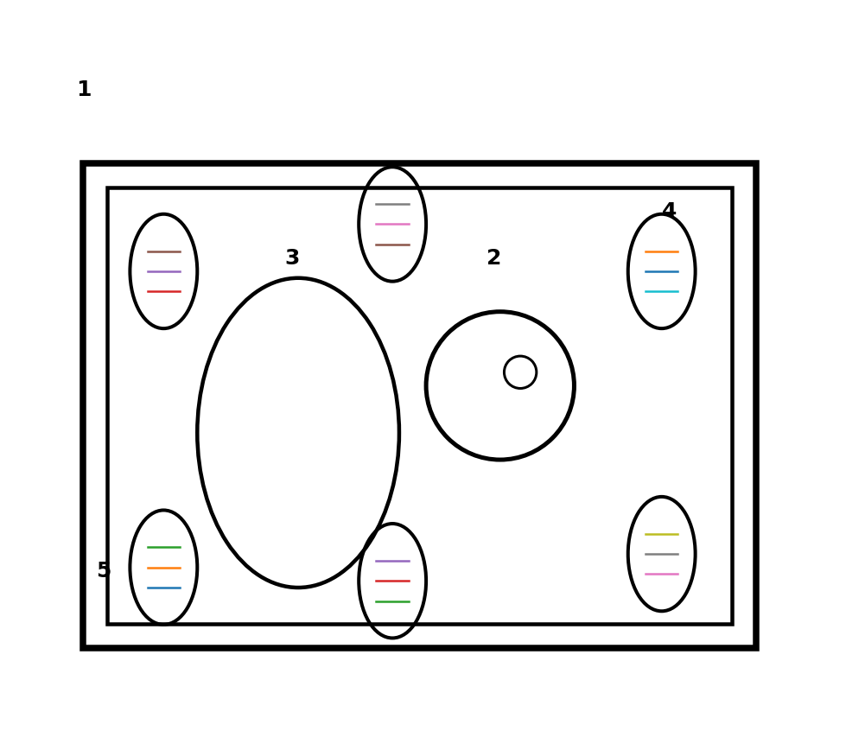
Diagram 1: Plant cell — not drawn to scale.
b) State one function of each of the following cell structures: nucleus, cell membrane and chloroplast. (3 marks)

c) Explain two ways in which a root hair cell is structurally adapted for absorption of water and mineral salts. (2 marks)

d) Distinguish between diffusion and active transport. (1 mark)

3a) Name the food substance tested for using each reagent:
i. iodine solution; (1 mark)

ii. Benedict's solution after heating; (1 mark)

iii. Biuret reagent. (1 mark)

b) Describe the positive result for each of the three tests in (a). (3 marks)

c) A learner obtains the following results from a food sample: iodine — blue-black; Benedict's — brick-red precipitate after heating; Biuret — lilac. What does this show about the sample? (3 marks)

d) State one biological importance of lipids. (1 mark)

4a) Define photosynthesis. (2 marks)

b) State two conditions necessary for photosynthesis to occur. (2 marks)

c) The diagram below shows a transverse section of a leaf. Identify structures 1–4. (4 marks)
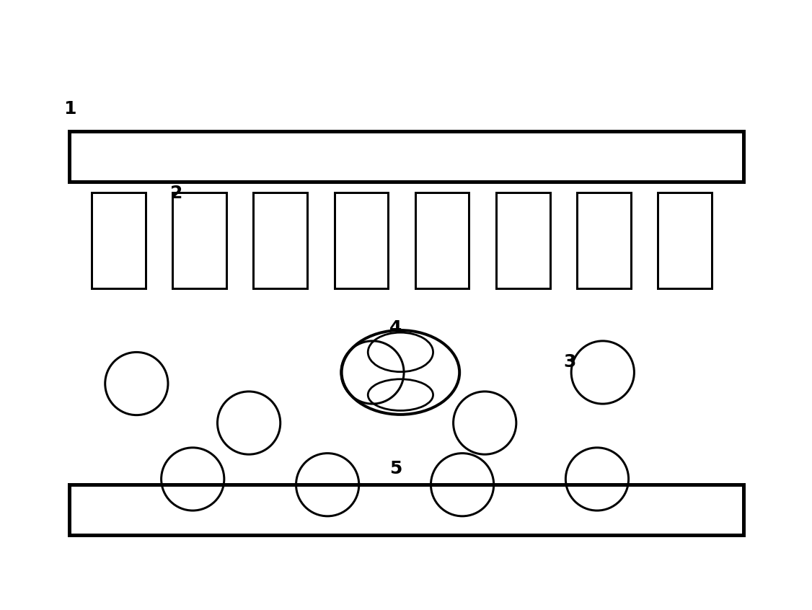
Diagram 2: Transverse section of a leaf — not drawn to scale.
d) Explain how the structure of palisade mesophyll cells makes them well adapted for photosynthesis. Give two points. (2 marks)

e) A farmer keeps a crop under a transparent sheet that allows light through but traps heat and reduces carbon dioxide concentration around the leaves. Predict the effect on the rate of photosynthesis and explain. (2 marks)

5a) Name the tissue responsible for transport of:
i. water and mineral salts from roots to leaves; (1 mark)

ii. manufactured food from leaves to other parts of the plant. (1 mark)

b) State three adaptations of xylem vessels for efficient water transport. (3 marks)

c) The apparatus below can be used to investigate water loss from a leafy shoot. State the purpose of:
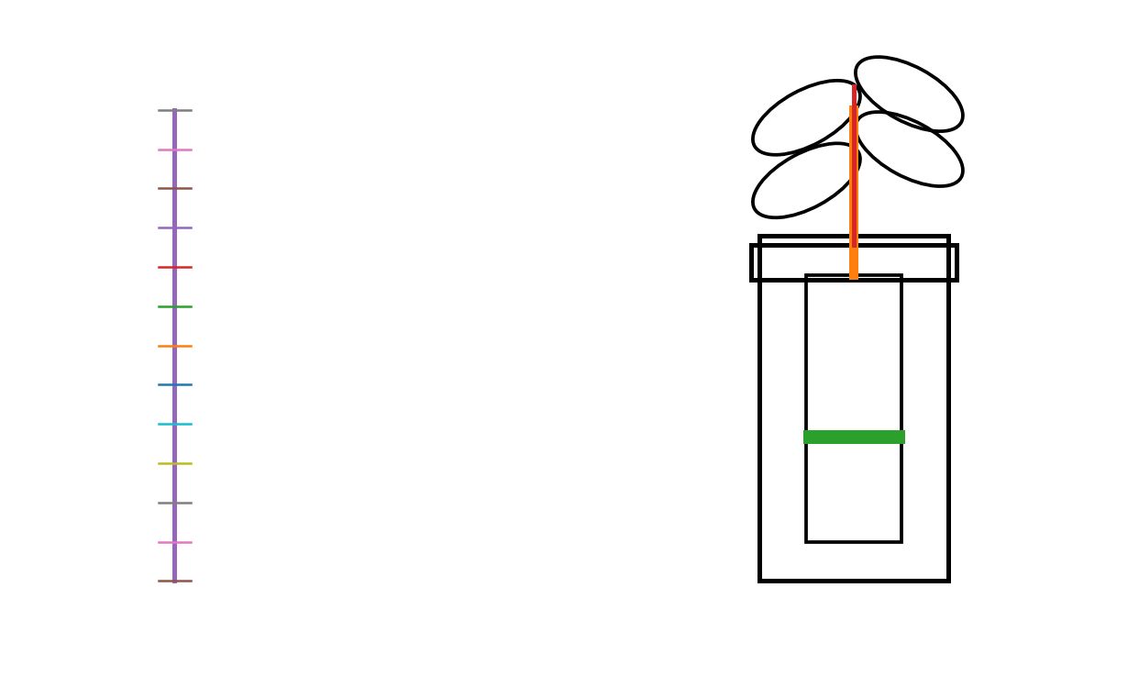
Diagram 3: Transpiration investigation apparatus — not drawn to scale.
i. the layer of oil on the water surface; (1 mark)

ii. the graduated scale/capillary arrangement; (1 mark)

iii. sealing the apparatus around the stem. (1 mark)

d) A leafy shoot causes the water level in a capillary tube to move 12 mm in 30 minutes. Calculate the mean rate of movement of the water column in mm per minute. (2 marks)

e) State one factor that would increase the rate of transpiration and explain why. (1 mark)

6a) State two functions of stomata in a green plant. (2 marks)

b) Explain how guard cells bring about opening of a stoma during favourable conditions. (3 marks)

c) Distinguish between aerobic and anaerobic respiration in plants. (2 marks)

d) A student places germinating seeds in a sealed flask fitted with a delivery tube leading into limewater. The limewater turns milky after some time.
i. State the gas responsible for the observation. (1 mark)

ii. Explain how the experiment demonstrates a product of respiration. (2 marks)

7a) State two functions of the digestive system in mammals. (2 marks)

b) Explain the importance of the following adaptations of the small intestine in absorption:
i. numerous villi; (2 marks)

ii. rich blood supply; (2 marks)

c) A learner eats a meal containing starch, protein and fats. State the end-products of digestion of each nutrient that can be absorbed into the blood or lymph. (3 marks)

d) Explain why bile is important in fat digestion even though it is not a digestive enzyme. (1 mark)

8a) The diagram below represents a simplified mammalian heart. Identify structures 1–6. (6 marks)
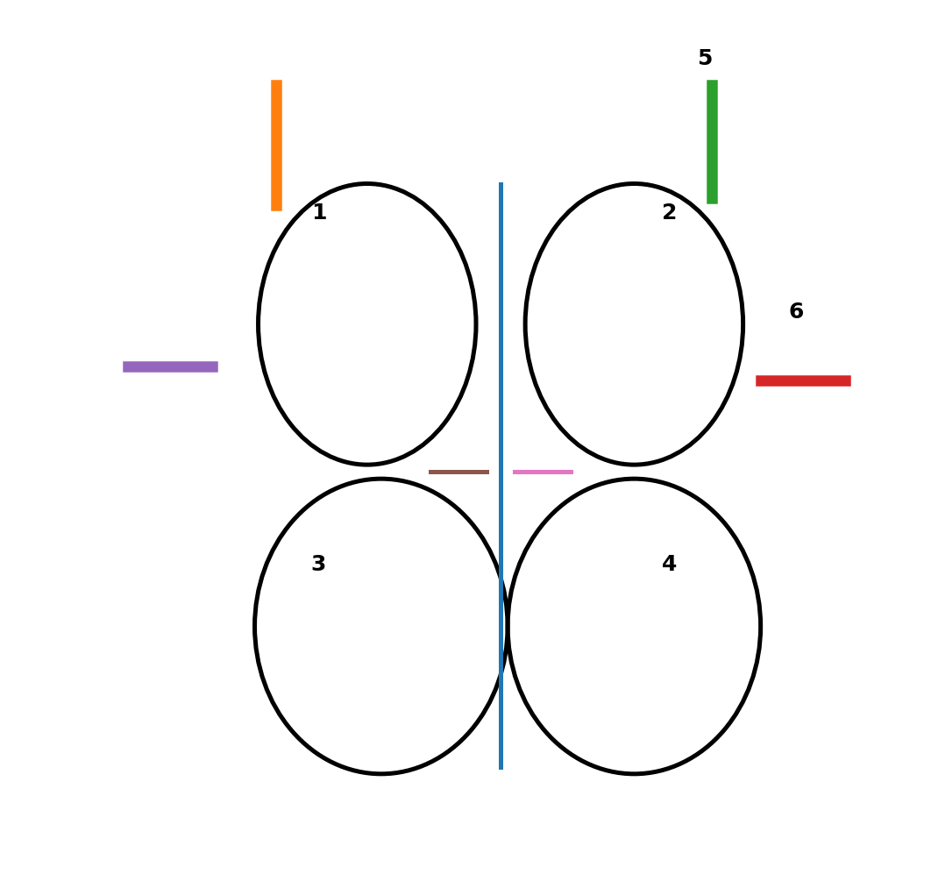
Diagram 4: Simplified mammalian heart — not drawn to scale.
b) Give two differences between arteries and veins. (2 marks)

c) Describe the pathway followed by a red blood cell from the right ventricle until it returns to the right atrium. (4 marks)

d) A learner has blood group A. State:
i. the antigen present on the red blood cells; (1 mark)

ii. the antibodies present in the plasma; (1 mark)

e) Explain why blood clotting is important after injury to a blood vessel. (2 marks)

9A school health club compares pulse rate before and after exercise. The results for one learner are:
Condition | Pulse rate (beats/min)
Before exercise | 72
Immediately after 5 min exercise | 128
After 5 min rest | 96
After 10 min rest | 78
a) Calculate the percentage increase in pulse rate immediately after exercise compared with the resting rate. Show working. (3 marks)

b) Explain why pulse rate increases during exercise. (3 marks)

c) Using the data, state whether the learner's pulse rate had returned to the original resting value after 10 minutes. Give evidence. (2 marks)

d) State two healthy practices that can help maintain an efficient circulatory system. (2 marks)

