KENYA JUNIOR SCHOOL EDUCATION ASSESSMENT
GRADE 7 AGRICULTURE
DECEMBER ASSIGNMENT

LEARNER’S DETAILS
Name: _______________________________________________________________________________________.
School: ______________________________________________________________________________________.
Assessment Number: ________________________________. Date: __________________________________.
School Code: _______________________________. Signature: ________________________________.

INSTRUCTIONS TO LEARNERS
- Write your name and class on the answer sheet provided.
- Answer ALL questions in Section A and Section B.
- Ensure your work is neat and clear, Answer in English.
Answer all questions. Choose the correct answer

- A Grade 7 learner, Peter, has collected 20 eggs from the poultry house. If 4 are cracked, what percentage is cracked?
A. 10% B. 20% C. 25% D. 15%
- The diagram below shows honeycomb cells.
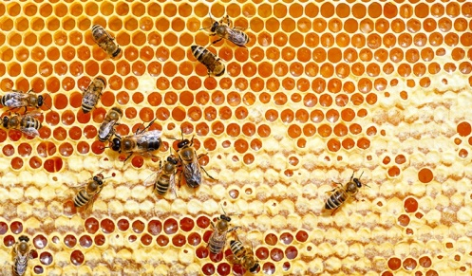
What is the main use of these cells?
A. Store pollen only
B. Store honey and raise brood
C. Keep bees warm
D. Filter nectar
- Which cooking method involves cooking food by direct exposure to radiant heat, often from below or above?
A) Steaming B) Roasting C) Grilling D) Boiling
- Which action falls under the finishing stage of laundering?
A) Applying detergent. B) Ironing or folding.
C) Rinsing. D) Hanging out to dry.
- The diagram below shows a light being used to check the inside of an egg.
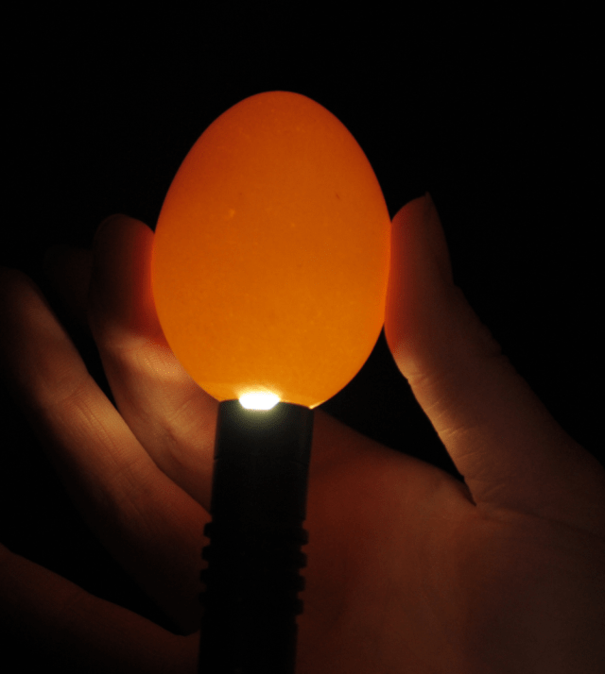
What is this process called?
A. Grading B. Sorting C. Candling D. Coating
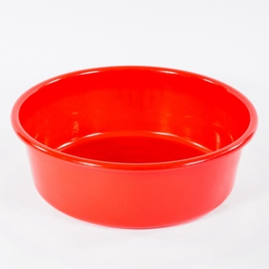
- The diagram below shows a plastic basin. What is its main use in soap making?

A. Measuring water B. Mixing soap ingredients C. Boiling oils D. Packaging soap

- Grade 7 learners from Todonyang Junior were asked to Identify the part marked X
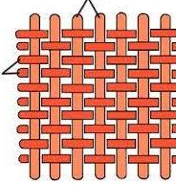
x

Y

  - Warp
  - Weft
  - Yarn
  - Horizontal
- A key advantage of a framed suspended garden for growing crops is its ability to:
A) Occupy a large ground area. B) Maximize space, especially in small areas. C) Require more water than traditional gardens. D) Attract more ground pests.
- Trees help in conserving the environment by absorbing which gas from the atmosphere? A) Oxygen B) Nitrogen C) Carbon dioxide D) Methane
- An old tyre was seen in a farm
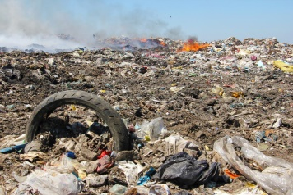
The waste shown in the diagram is dangerous because:
A. It adds nutrients to the soil
B. It decomposes quickly
C. It stays in the soil for many years
D. It reduces soil water retention

- During planting, learners observed that fine tilth allowed seeds to germinate well. What does fine tilth mean?
A. Soil with large lumps
B. Soil with medium particles
C. Soil that is loose and well broken
D. Soil mixed with stones
- When maize seedlings are too close together, a learner removes some to reduce overcrowding. This practice is called:
A. Weeding B. Thinning
C. Earthing up D. Gapping
- Mr. Mutai planted Grevillea trees between maize and beans on his farm.
This practice is called:
A. Afforestation
B. Agroforestry
C. Silviculture
D. Horticulture
- Tree seedlings can be obtained from:
A. Tree nurseries
B. Riverbanks
C. Roadside vendors
D. Forest rangers
- Which one of the following is not a management practice for young trees?
A. Watering B. Mulching
C. Uprooting D. Pruning
- When some plants fail to germinate, the practice of replacing them is called:
A. Thinning
B. Gapping
C. Weeding
D. Pruning
- When learners remove weeds using hoes and hands, the method used is:
A. Chemical
B. Biological
C. Physical
D. Mechanical spraying
- Which of the following practices causes soil pollution?
A. Using compost manure
B. Burning plastics on the farm
C. Mulching
D. Planting cover crops

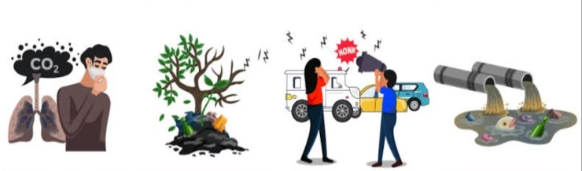
- Identify the common soil pollutant from the pictures below.

A B C D
- During a farm visit, Waithira saw the following water retention structure.
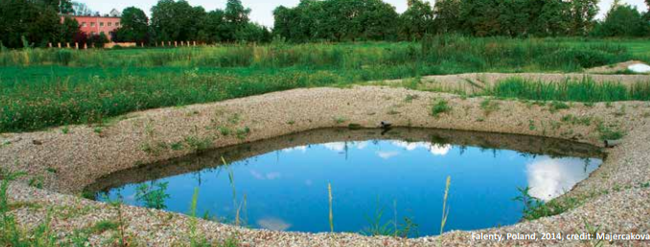
  - Retention pit
  - Retention ditch
  - Dam
  - Soil bunds
- Learners from Hope Junior School participated in a tree planting activity at the edge of River Nyangares. The activity helped protect the river from soil erosion.
Which environmental practice were they promoting?
A. Deforestation
B. Agroforestry
C. Environmental conservation
D. Tree felling
- Sorting and grading eggs helps to:
A. Make eggs look attractive
B. Group eggs by size and quality
C. Change egg colour
D. Reduce breakage
- Which of the following is not an animal product?
A. Honey B. Meat
C. Maize D. Eggs

- Vegetables such as cabbage and broccoli can be cooked by:
A. Steaming B. Frying
C. Roasting D. Grilling
- Mama Anita prepared the food below.
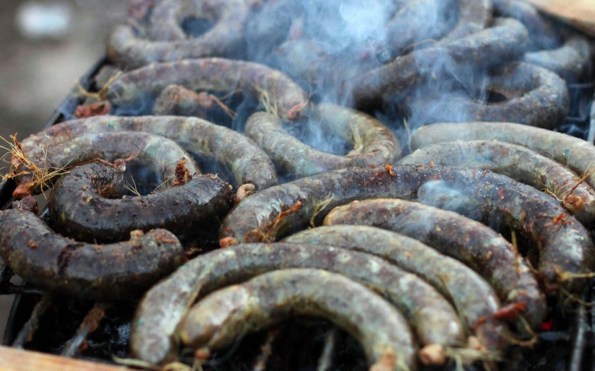
Which food is being cooked in the picture above?
A. Mutura B. Green maize
C. Cassava D. Beef
- When cooking using steam, which equipment can be used?
A. Steamer pot B. Oven
C. Grill D. Microwave
- Which of the following is a safety measure when handling domestic animals?
A. Washing hands after contact
B. Feeding them with dirty water
C. Touching sick animals bare-handed
D. Leaving animal waste uncollected
- Well-ventilated animal houses help animals to:
A. Stay healthy and clean
B. Grow slowly
C. Become sick often
D. Produce foul smell
- During a field study, Grade 7 learners found polythene bags, plastic bottles, and old rubber tires dumped on the farm. These items pollute the soil mainly because they:
A. Release heavy gases into the air B. Are non-biodegradable and persist in the soil for years C. Dissolve quickly into toxic liquids D. Absorb all rainwater from the soil
- during a heavy downpour. Which soil and water conservation structure is best suited to control this water movement?
A. Shade net B. Contour terraces
C. Sprinkler irrigation D. Windbreak

31. Learners from Grade 7 were tasked with planting Calliandra trees around their school.
a) Name two sources where they can obtain tree seedlings. (2 marks)
(i) ………………………………………………………………………………………………………………
(ii) ………………………..…………………………………………………….…………………………………
b) State three importance of planting trees. (3 marks)
(i) ………………………………………………………………………………………………………………
(ii) ………………………..…………………………………………………….…………………………………
(iii) …………………………………………………………………………………………………………………
c) Explain two management practices to promote healthy tree growth. (4 marks)
(i) …………………………………………………………………………………………………………………
(ii) ………………………..…………………………………………………….…………………………………
32. During a farm visit, the learners found that some maize plants did not germinate.
a) Which farm practice should they carry out to replace the missing plants? (1 mark)
(i) ………………………………………………………………………………………………………………
b) Give two reasons why this practice is important. (2 marks)
(i) ………………………………………………………………………………………………………………
(ii) ………………………..…………………………………………………….…………………………………
c) State two effects of failing to carry out this practice. (2 marks)
(i) …………………………………………………………………………………………………………………
(ii) ……………………..…………………………………………………….…………………………………
33.The school constructed a water pan to harvest rainwater.
a) Define a water retention structure. (2 marks)
….……………………………………………………………………………………………………………………………
…..…………………………………..…………………………………………………….…………………………………
b) Mention two examples of water retention structures. (2 marks)
(i) …………………………………………………………………………………………………………………
(ii) ………………………..…………………………………………………….…………………………………
c) State two importance of conserving surface runoff. (2 marks)
(i) ………………………………………………………………………………………………………………
(ii) ……………………..…………………………………………………….…………………………………

34.Some farmers in Kilgoris dump used oil and plastic bottles on their farms.
a) Define soil pollution. (2 marks)
……………………………………………………………………………………………………………………
………………………………..…………….………………………………………….…………………………
b) Identify three causes of soil pollution. (3 marks)
(i) …………………………………………………………………………………………………………………
(ii) ……………………………..…………………………………………………….……………………………
(iii) …………………………………………………………………………………………………………………
c) Explain two methods of controlling soil pollution. (2 marks)
(i) …………………………………………………………………………………………………………………
(ii) ……………………………..…………………………………………………….……………………………
35. Match the items in Column A with the correct answers in Column B. (4 marks)
Column A | Column B
Thinning | Adding soil around crop base
Earthing up | Removing excess seedlings
Gapping | Removing unwanted plants
Weeding | Replacing missing plants
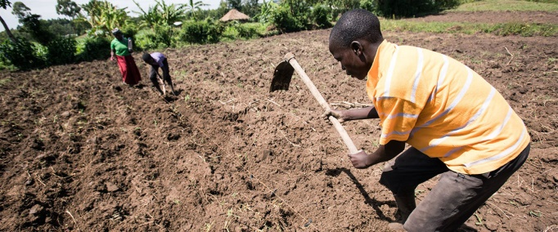
- (a) Ole Musere was seen in a planting site? Identify the activity

……………………………………………………………………
(b) Ole Musere was using the took above to break up hard soil for a planting site.
    - Name the tool: ……………………………………………………….
    - Identify two safety precautions they should observe while using the tool.
(i) ………………………………………………………………………………………………………………
(ii) ………………………..…………………………………………………….…………………………………
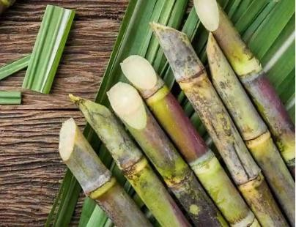
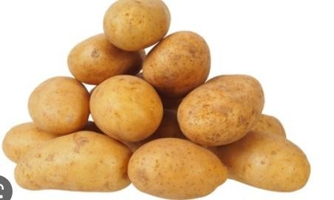
    - Study the pictures below and then answer the questions that follow. Identify the following planting materials
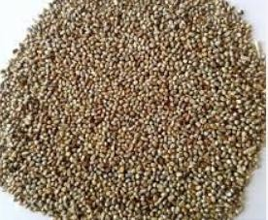

A B C

A:………………………………………………………………….

B:…………………………………………………………………..

C:……………………………………………………………………
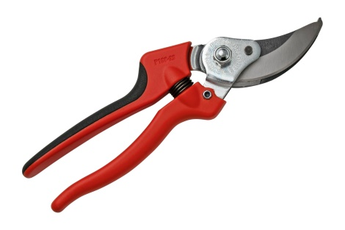
    - Identify the tool below used for pruning.

…………………………………………………………………………………………………………
    - Identify two reasons for pruning.
(i) ……………………………………………………………………………………………………………
(ii) ……………………..…………………………………………………….…………………………………
37.Learners from Enosaen Junior School visited a local poultry farm. They observed workers sorting, cleaning, and packing eggs.
a) State two purposes of preparing eggs. (2 marks)
(i) …………………………………………………………………………………………………………………
(ii) ………………………..…………………………………………………….…………………………………
b) Mention two reasons for sorting and grading eggs. (2 marks)
(i) ………………………………………………………………………………………………………………
(ii) ………………………..…………………………………………………….…………………………………
c) Give two materials used for packaging eggs. (2 marks)
(i) ………………………………………………………………………………………………………………
(ii) ………………………..…………………………………………………….…………………………………
38. During the same visit, learners observed how honey was strained and packed into jars.
a) Mention two methods of processing honey. (2 marks)
(i) ………………………………………………………………………………………………………………
(ii) ………………………..…………………………………………………….…………………………………
b) Give two by-products of honey. (2 marks)
(i) …………………………………………………………………………………………………………………
(ii) ………………………..…………………………………………………….…………………………………
c) Explain two reasons for labeling honey containers. (2 marks)
(i) …………………………………………………………………………………………………………………
(ii) ………………………..…………………………………………………….…………………………………
39. Learners cooked chicken using three methods: grilling, roasting, and steaming.
a) Mention the three methods of cooking. (3 marks)
(i) …………………………………………………………………………………………………………………
(ii) ………………………..…………………………………………………….…………………………………
(iii) ………………………………………..………………………………………………………………………
b) Give one advantage of each method. (3 marks)
Method of cooking
Advantage
c) Mention two safety practices to observe during grilling. (2 marks)
(i) ………………………………………………………………………………………………………………
(ii) ………………………..…………………………………………………….…………………………………
40. Mary steamed vegetables for lunch.
a) Name three pieces of equipment she could use for steaming. (3 marks)
(i) ………………………………………………………………………………………………………………
(ii) ………………………..…………………………………………………….…………………………………
(iii) ………………………………………………………………………………………………………………
b) Mention two guidelines to follow when steaming food. (2 marks)
(i) …………………………………………………………………………………………………………………
(ii) ………………………..…………………………………………………….…………………………………

41. Learners at Hope Junior School rear rabbits and chickens.
a) State two importance of maintaining hygiene when rearing animals. (2 marks)
(i) …………………………………………………………………………………………………………………
(ii) ………………………..…………………………………………………….…………………………………
b) Give two practices that promote hygiene in animal houses. (2 marks)
(i) ………………………………………………………………………………………………………………
(ii) ………………………..…………………………………………………….…………………………………
c) Mention two safety precautions when feeding animals. (2 marks)
(i) ………………………………………………………………………………………………………………
(ii) ……………………..…………………………………………………….…………………………………

d) Name two animal products obtained from domestic animals. (2 marks)
(i) ………………………………………………………………………………………………………………
(ii) ………………………..…………………………………………………….…………………………………
42. During an Agriculture lesson, learners discussed dibbling and drilling as methods of planting various crop materials. Explain the meaning of each method. (4 marks)
(a) Dibbling
...................................................................................................................................................................................
...................................................................................................................................................................................
(b) Drilling
..................................................................................................................................................................................
..................................................................................................................................................................................
43. Grade 7 learners formed groups to discuss the importance of water retention on the farm. Outline three importance of water retention. (3 marks)
i. ............................................................................................................................................
ii. ............................................................................................................................................
iii. ..........................................................................................................................................
44. Learners were discussing soil pollution. Identify three soil pollutants. (3 marks)
i. ............................................................................................................................................
ii. ............................................................................................................................................
iii. ..........................................................................................................................................

45. Grade 7 learners visited Mapoo Farm to learn about chicken rearing.
(a) Name two types of chickens reared for different purposes. (2 marks)
i. ............................................................................................................................................
ii. ..........................................................................................................................................
(b) When grading eggs, there are different categories based on their intended use. Name three categories of eggs. (3 marks)
i. ............................................................................................................................................
ii. ............................................................................................................................................
iii. ..........................................................................................................................................
46. List three factors to consider when selecting a pet. (3 marks)
i. ............................................................................................................................................
ii. ............................................................................................................................................
iii. ..........................................................................................................................................
47. While discussing methods of planting various crop materials, the Grade 7 Agriculture teacher asked learners to name different methods of planting. Name three methods of planting. (3 marks)
i. ............................................................................................................................................
ii. ............................................................................................................................................
iii. ..........................................................................................................................................
48. Contamination of soil with toxic chemicals or substances that can harm plants, animals and humans is known as __________________________________________. (1 mark)
49. Name three types of soil erosion. (3 marks)
i. ............................................................................................................................................
ii. ............................................................................................................................................
iii. ..........................................................................................................................................
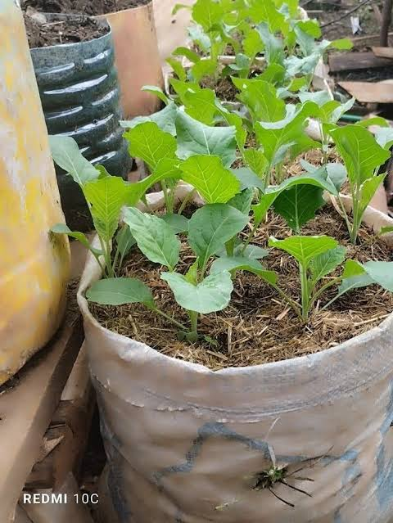
50. Grade 6 learners grew spinach in the setup shown below using a sack. Name the type of farming illustrated. (1 mark)
...............................................................................

51. During an agricultural extension activity, Grade 7 learners were asked to state five benefits of agroforestry to the environment. Write the five benefits they stated. (5 marks)
i. ............................................................................................................................................
ii. ............................................................................................................................................
iii. ..........................................................................................................................................
iv. ............................................................................................................................................
v. .............................................................................................................................................
52. Write two minimum tillage practices carried out on a farm to conserve water when growing crops. (2 marks)
i. ............................................................................................................................................
ii. ..........................................................................................................................................
53. Teacher Zomo was teaching about tools used for cutting during a Nutrition lesson. Identify three cutting tools that the learners discussed. (3 marks)
i. ............................................................................................................................................
ii. ............................................................................................................................................
iii. ..........................................................................................................................................
54. Grade 7 learners of Upeo Comprehensive School were learning about the importance of nutrition. List three importance of nutrition to the family. (3 marks)
i. ............................................................................................................................................
ii. ............................................................................................................................................
iii. ..........................................................................................................................................
55. Grade 7 learners of Mwangaza Comprehensive School were learning about various methods of buying household goods and services from different outlets. State four methods of buying household goods and services. (4 marks)
i. ............................................................................................................................................
ii. ............................................................................................................................................
iii. ..........................................................................................................................................
iv. ............................................................................................................................................
56. Explain the following terms. (4 marks)
(a) Parboiling
...............................................................................................................................................................................
..............................................................................................................................................................................
(b) Blanching
.................................................................................................................................................................................
.................................................................................................................................................................................
57. A teacher asked the learners to write down the uses of different baking tools. State the use of each of the following. (3 marks)
(a) Casserole
..............................................................................................................................................
(b) Loaf tin
..............................................................................................................................................
(c) Baking tray
..............................................................................................................................................
58. Learners from Macheo Comprehensive School went to Kioo Market to buy goods for cooking food. State four factors to consider when buying food and other household goods. (4 marks)
i. ............................................................................................................................................
ii. ............................................................................................................................................
iii. ..........................................................................................................................................
iv. ............................................................................................................................................
59. Mr. Job was teaching learners about grilling. State three guidelines for grilling food. (3 marks)
i. ............................................................................................................................................
ii. ............................................................................................................................................
iii. ............................................................................................................................................
60. Identify five off-season crops that can be grown in a suspended garden. (5 marks)
i. ............................................................................................................................................
ii. ............................................................................................................................................
iii. ..........................................................................................................................................
iv. ............................................................................................................................................
v. .............................................................................................................................................
61. Identify three factors to consider when selecting off-season crops for suspended gardening. (3 marks)
i. ............................................................................................................................................
ii. ............................................................................................................................................
iii. ..........................................................................................................................................

62. Identify three factors to consider when selecting a suitable site for suspended gardening. (3 marks)
i. ............................................................................................................................................
ii. ............................................................................................................................................
iii. ..........................................................................................................................................
63. State six ways of caring for crops in a suspended garden until they mature. (6 marks)
i. ............................................................................................................................................
ii. ............................................................................................................................................
iii. ..........................................................................................................................................
iv. ............................................................................................................................................
v. .............................................................................................................................................
vi. ............................................................................................................................................
64. State and explain five ways of adding value to crop produce. (10 marks)
No. | Method | Explanation
1.
2.
3.
4.
5.
65. Give three benefits of adding value to crop produce. (3 marks)
i. ............................................................................................................................................
ii. ............................................................................................................................................
iii. ..........................................................................................................................................
66. Explain three cooking methods that you know. (6 marks)
(a) .............................................................................................................................................................................
(b) .............................................................................................................................................................................
(c) .............................................................................................................................................................................
67. State three types of steaming equipment. (3 marks)
i. ............................................................................................................................................
ii. ............................................................................................................................................
iii. ..........................................................................................................................................

68. Give four guidelines for roasting food. (4 marks)
i. ............................................................................................................................................
ii. ............................................................................................................................................
iii. ..........................................................................................................................................
iv. ............................................................................................................................................
69. State three tools or pieces of equipment used for grilling. (3 marks)
i. ............................................................................................................................................
ii. ............................................................................................................................................
iii. ..........................................................................................................................................
70. Design four posters showing guidelines for grilling food. Each poster should contain one important guideline. (4 marks)

Poster 1
Guideline: ........................................................................................................................
[Drawing space]

Poster 2
Guideline: ........................................................................................................................
[Drawing space]

Poster 3
Guideline: ........................................................................................................................
[Drawing space]

Poster 4
Guideline: ........................................................................................................................
[Drawing space]

Section A: Multiple Choice Questions
- B. 20%
- B. Store honey and raise brood
- C) Grilling
- B) Ironing or folding.
- C. Candling
- B. Mixing soap ingredients
- A. Warp
- B) Maximize space, especially in small areas.
- C) Carbon dioxide
- C. It stays in the soil for many years
- C. Soil that is loose and well broken
- B. Thinning
- B. Agroforestry
- A. Tree nurseries
- C. Uprooting
- B. Gapping
- C. Physical
- B. Burning plastics on the farm
- B (Soil/garbage dumping pollutant)
- C. Dam (or retention pond/water pan)
- C. Environmental conservation
- B. Group eggs by size and quality
- C. Maize
- A. Steaming
- A. Mutura
- A. Steamer pot
- A. Washing hands after contact
- A. Stay healthy and clean
- B
- B

Section B: Structured & Short Answer Questions

Question 31
a) Sources of tree seedlings:
- (i) Local tree nurseries
- (ii) Forest department offices / Registered seed centers
b) Importance of planting trees:
- (i) Prevents soil erosion by binding the soil.
- (ii) Acts as windbreaks to protect crops.
- (iii) Absorbs carbon dioxide and purifies the air.
c) Management practices for healthy tree growth:
- (i) Watering: Ensures seedlings have sufficient moisture during dry periods.
- (ii) Mulching: Retains soil moisture and suppresses weed growth.

Question 32
a) Farm practice to replace missing plants:
- Gapping
b) Importance of gapping:
- (i) Maintains optimum plant population per unit area.
- (ii) Ensures maximum utilization of farm space and resources.
c) Effects of failing to carry out gapping:
- (i) Reduced total crop yield.
- (ii) Underutilization of available land and farm nutrients.

Question 33
a) Definition of a water retention structure:
- A structure constructed on a farm to capture, collect, and hold surface runoff or rainwater for agricultural and domestic use.
b) Examples of water retention structures:
- (i) Water pan / Retention ditch
- (ii) Earth dam / Retention pit
c) Importance of conserving surface runoff:
- (i) Provides water for irrigation and livestock during dry seasons.
- (ii) Reduces soil erosion by controlling high-velocity water movement.

Question 34
a) Definition of soil pollution:
- The presence of toxic chemicals, waste materials, or pollutants in soil that adversely alter its quality and harm plant/animal life.
b) Causes of soil pollution:
- (i) Dumping non-biodegradable waste (e.g., plastics, glass).
- (ii) Indiscriminate disposal of used engine oil/petroleum products.
- (iii) Excessive use of synthetic fertilizers and agrochemicals.
c) Methods of controlling soil pollution:
- (i) Proper waste disposal and recycling (e.g., plastic collection).
- (ii) Organic farming practices and controlled chemical usage.

Question 35: Matching Items
Column A | Column B
Thinning | Removing excess seedlings
Earthing up | Adding soil around crop base
Gapping | Replacing missing plants
Weeding | Removing unwanted plants

Question 36
(a) Activity identified: Planting / Digging holes using a hand hoe.
(b) Tool & Safety:
- i. Name: Hand hoe (Jembe)
- ii. Safety precautions:
  - (i) Wear protective boots/footwear.
  - (ii) Maintain a safe distance from other workers while swinging the tool.
(c) Planting materials:
- A: Seeds (Grain seeds / Maize/Sorghum)
- B: Tubers (Irish potatoes)
- C: Stem cuttings / Cane cuttings (Sugarcane)
(d) Pruning Tool: Pruning shears / Secateurs
(e) Reasons for pruning:
- (i) To control plant growth and shape.
- (ii) To remove diseased, dead, or damaged branches to boost ventilation and light exposure.

Question 37
a) Purposes of preparing eggs:
- (i) To remove dirt, feces, and stains before distribution.
- (ii) To improve presentation and shelf appeal for marketing.
b) Reasons for sorting and grading eggs:
- (i) Standardizes prices based on egg size, weight, and quality.
- (ii) Separates clean, intact eggs from damaged or defective ones.
c) Materials used for packaging eggs:
- (i) Egg trays (pulp/paper or plastic)
- (ii) Carton boxes

Question 38
a) Methods of processing honey:
- (i) Straining / Filtering through a fine cloth.
- (ii) Settling / Heating and skimming.
b) By-products of honey:
- (i) Beeswax
- (ii) Propolis / Royal jelly
c) Reasons for labeling honey containers:
- (i) To provide product details (weight, date, source/origin).
- (ii) To build trust and branding for consumers.

Question 39
a) Methods of cooking:
- (i) Grilling
- (ii) Roasting
- (iii) Steaming
b) Advantages:
Method of cooking | Advantage
Grilling | Quick process that allows excess fat to drain away.
Roasting | Enhances flavor and produces an attractive brown crust.
Steaming | Retains maximum nutrients, water-soluble vitamins, and flavor.
c) Safety practices during grilling:
- (i) Use long-handled tongs to avoid burns.
- (ii) Keep flammable items away from open heat sources.

Question 40
a) Equipment for steaming:
- (i) Food steamer pot / Double boiler
- (ii) Steaming basket / Colander over a pot
- (iii) Pressure cooker with steamer insert
b) Guidelines for steaming food:
- (i) Ensure water remains at a continuous boil to generate consistent steam.
- (ii) Keep the lid tightly sealed to prevent steam from escaping.

Question 41
a) Importance of animal hygiene:
- (i) Prevents disease outbreaks and parasite infestations.
- (ii) Promotes optimal growth and productivity.
b) Practices promoting animal house hygiene:
- (i) Regular cleaning, disinfection, and clearing of bedding/waste.
- (ii) Providing proper ventilation and dry flooring.
c) Safety precautions when feeding animals:
- (i) Avoid sudden aggressive movements that startle animals.
- (ii) Wear protective gear (gloves/boots) when handling feeding troughs.
d) Animal products:
- (i) Meat / Milk
- (ii) Eggs / Wool

Question 42
(a) Dibbling: A method of planting where individual holes are made in the soil at precise distances, seeds/seedlings are inserted, and covered with soil.
(b) Drilling: A method of planting seeds continuously along shallow furrows or trenches made in the soil, followed by light covering.

Question 43
i. Ensures adequate moisture availability for crops during dry spells.
ii. Reduces soil erosion by curbing excess surface runoff.
iii. Improves soil health and underground water recharge.

Question 44
i. Plastic containers/bags
ii. Agrochemical residues (pesticides, herbicides)
iii. Heavy metals / Used motor oils

Question 45
(a) Types of chickens:
- i. Broilers (for meat)
- ii. Layers (for egg production)
(b) Categories of eggs:
- i. Table eggs (for consumption)
- ii. Hatching / Fertile eggs (for incubation)
- iii. Industrial / Processing eggs

Question 46
i. Space availability and living environment.
ii. Cost of feeding, medical care, and maintenance.
iii. Temperament and health safety for family members.

Question 47
i. Dibbling
ii. Drilling
iii. Broadcasting

Question 48
Soil pollution

Question 49
i. Splash erosion
ii. Sheet erosion
iii. Rill erosion (or Gully erosion)

Question 50
Sack gardening / Vertical innovative farming

Question 51
i. Improves soil fertility through leaf litter decomposition.
ii. Reduces wind speed and prevents soil erosion.
iii. Enhances biodiversity and provides habitats for beneficial fauna.
iv. Helps absorb carbon dioxide, mitigating climate impacts.
v. Conserves soil moisture by shading the ground.

Question 52
i. Mulching
ii. Cover cropping / Shallow cultivation (ripping)

Question 53
i. Chef's knife / Kitchen knife
ii. Kitchen scissors / Shears
iii. Food slicer / Vegetable peeler

Question 54
i. Promotes optimal physical health and immune defense.
ii. Prevents nutritional deficiency diseases.
iii. Supports growth and brain development in children.

Question 55
i. Cash purchase
ii. Credit purchase
iii. Mobile money payment
iv. Electronic card payment (Debit/Credit card)

Question 56
(a) Parboiling: Partial boiling of food (such as rice or tubers) as a preliminary cooking or processing step.
(b) Blanching: Plunging vegetables or fruits into boiling water briefly, then submerging them in iced water to stop cooking and preserve color/nutrients.

Question 57
(a) Casserole: Used for baking and slow-cooking stews, meats, or multi-ingredient dishes in an oven.
(b) Loaf tin: Used for shaping and baking loaves of bread, cakes, or meatloaves.
(c) Baking tray: Used as a flat surface for baking cookies, pastries, or roasting small food items.

Question 58
i. Quality and freshness of the goods.
ii. Expiry dates and packaging integrity.
iii. Price and affordability within budget.
iv. Quantity and storage life available.

Question 59
i. Preheat the grill thoroughly before placing food items.
ii. Lightly oil the grill grates to prevent food sticking.
iii. Turn food items periodically using tongs to ensure even cooking without burning.

Question 60
i. Spinach
ii. Sukuma wiki (Kale)
iii. Tomatoes
iv. Capsicum (Sweet peppers)
v. Strawberries / Herbs (e.g., coriander, mint)

Question 61
i. Root depth and lightweight structure suitable for containers.
ii. Maturity period and water requirements.
iii. Resistance to local pests and environmental adaptability.

Question 62
i. Adequate exposure to sunlight.
ii. Protection from severe wind or damage.
iii. Accessibility for daily watering and monitoring.

Question 63
i. Watering regularly.
ii. Applying organic manure or liquid fertilizers.
iii. Weeding and removing dried leaves.
iv. Scouting and controlling pests/diseases.
v. Providing support/staking where required.
vi. Harvesting mature produce promptly to encourage further production.

Question 64: Value Addition Methods
No. | Method | Explanation
1. | Drying / Dehydration | Removing moisture from crops (e.g., grains, fruit slices) to increase shelf life and stop decay.
2. | Milling / Grinding | Processing grain crops (like maize or cassava) into flour for higher market value and culinary usability.
3. | Canning / Bottling | Sealing processed fruits/vegetables in airtight containers to preserve them for extended commercial sale.
4. | Fermentation | Processing crops (e.g., cocoa, dairy, fruits) using micro-organisms to convert them into wine, yogurt, or specialized foodstuffs.
5. | Packaging & Labeling | Sorting, branding, and sealing produce into attractive consumer packs to command higher retail pricing.

Question 65
i. Increases farmer earnings and market value.
ii. Extends shelf life and reduces post-harvest losses.
iii. Opens up new market opportunities and export potential.

Question 66
(a) Boiling: Cooking food fully submerged in boiling water at $100^\circ\text{C}$.
(b) Frying: Cooking food in heated oil or fat (shallow or deep frying).
(c) Roasting: Cooking food with dry heat in an oven or over an open flame/charcoal fire.

Question 67
i. Multi-tier food steamer
ii. Pressure cooker
iii. Steamer basket insert inside a covered pot

Question 68
i. Baste meat/food periodically to maintain moisture.
ii. Turn food occasionally for even browning and cooking.
iii. Control temperature carefully to avoid burning the exterior while leaving the inside raw.
iv. Pre-heat oven or charcoal hearth before starting.

Question 69
i. Charcoal/Gas grill frame
ii. Long-handled grilling tongs
iii. Wire rack / Grilling grate

Question 70: Posters Guidelines for Grilling Food
- Poster 1
  - Guideline: Always preheat the grill before placing food.
  - [Draw a glowing grill grid with heat waves rising]
- Poster 2
  - Guideline: Use long-handled tongs to flip food safely.
  - [Draw a hand using long tongs to hold a sausage over a grill]
- Poster 3
  - Guideline: Keep a safe distance from open flames.
  - [Draw a safety perimeter icon with heat warning signs]
- Poster 4
  - Guideline: Turn food regularly to ensure even cooking.
  - [Draw food items being turned 180 degrees over grill grates]

