MARKING SCHEME
GRADE 10 BIOLOGY
TERM 3 OPENER EXAM 2026

Question 1
a) Any two valid contributions, 1 mark each: diagnosis/prevention/treatment of diseases; development of medicines/vaccines; improved nutrition; public-health education; disease surveillance. (2)
b) i. Independent variable — temperature. (1)
ii. Dependent variable — enzyme reaction rate/activity, measured using reaction time/end point. (1)
iii. Controlled variable — any valid one, e.g. enzyme concentration, substrate concentration, pH, volume of reagents. (1)
c) i. Percentage decrease = ((80 − 25) / 80) × 100 = (55/80) × 100 = 68.75%. Award 1 mark for correct difference 55 s; 1 mark for correct percentage. (2)
ii. 40°C; it has the shortest reaction time (25 s), hence the highest rate. (1)
d) Any two: wear goggles/gloves; use a test-tube holder; handle hot apparatus carefully; keep chemicals away from skin/eyes; follow reagent instructions; use a heat source in a ventilated area. (2)

Question 2
a) Diagram labels: 1 Cell wall; 2 Nucleus; 3 Large central vacuole; 4 Chloroplast. Accept cell membrane where indicated at the inner boundary. 1 mark each. (4)
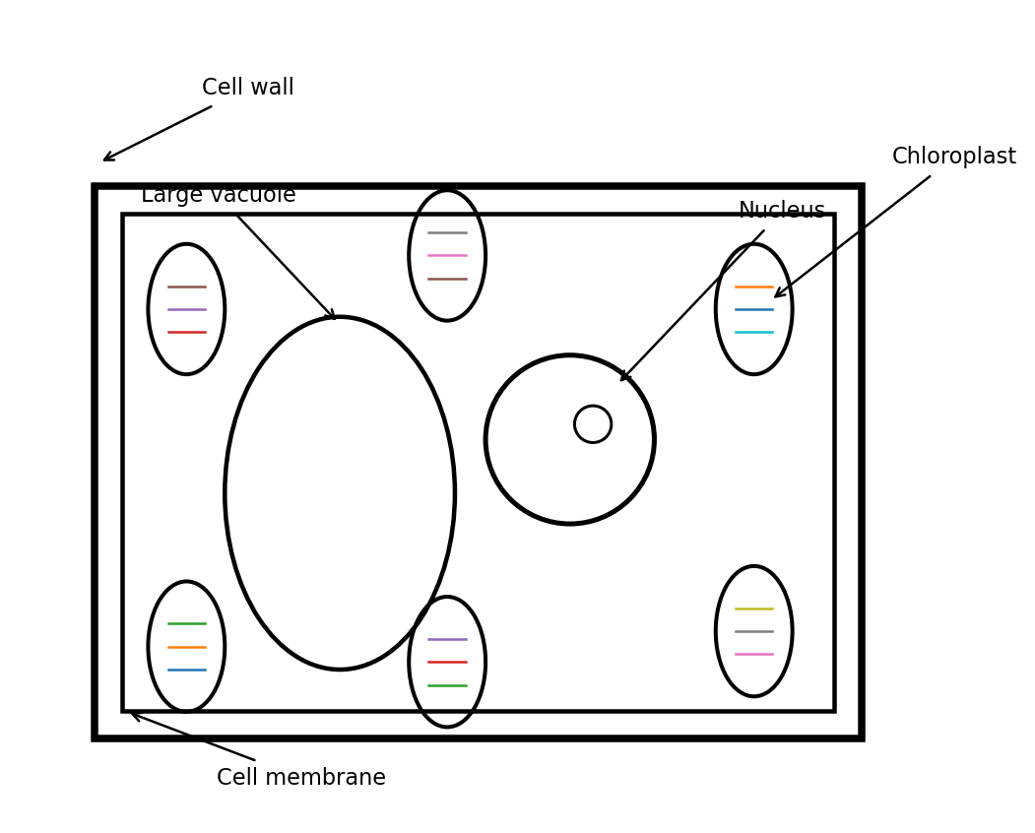
Expected labelled diagram.
b) Nucleus — controls cell activities/contains genetic material. Cell membrane — selectively controls movement of substances into and out of the cell. Chloroplast — site of photosynthesis/contains chlorophyll. 1 mark each. (3)
c) Any two: long extension gives large surface area; thin wall gives short diffusion distance; many mitochondria provide ATP for active uptake of mineral ions; large vacuole helps maintain water potential gradient. 1 mark each. (2)
d) Diffusion is net movement of particles down a concentration gradient without metabolic energy; active transport moves substances against a concentration gradient using energy. (1)

Question 3
a) i. Starch. (1) ii. Reducing sugar. (1) iii. Protein. (1)
b) Iodine: blue-black; Benedict's after heating: green/yellow/orange/brick-red depending on concentration; Biuret: lilac/purple. 1 mark each. (3)
c) The sample contains starch (1), reducing sugar (1), and protein (1). (3)
d) Any one: energy store; insulation; protection of organs; component of cell membranes. (1)

Question 4
a) Photosynthesis is the process by which green plants use light energy to manufacture organic food, mainly glucose, from carbon dioxide and water, releasing oxygen. Award 1 mark for raw materials and 1 for light/chlorophyll/food formation. (2)
b) Any two: light; chlorophyll; carbon dioxide; water; suitable temperature. (2)
c) 1 Upper epidermis; 2 Palisade mesophyll; 3 Spongy mesophyll; 4 Vascular bundle. 1 mark each. (4)
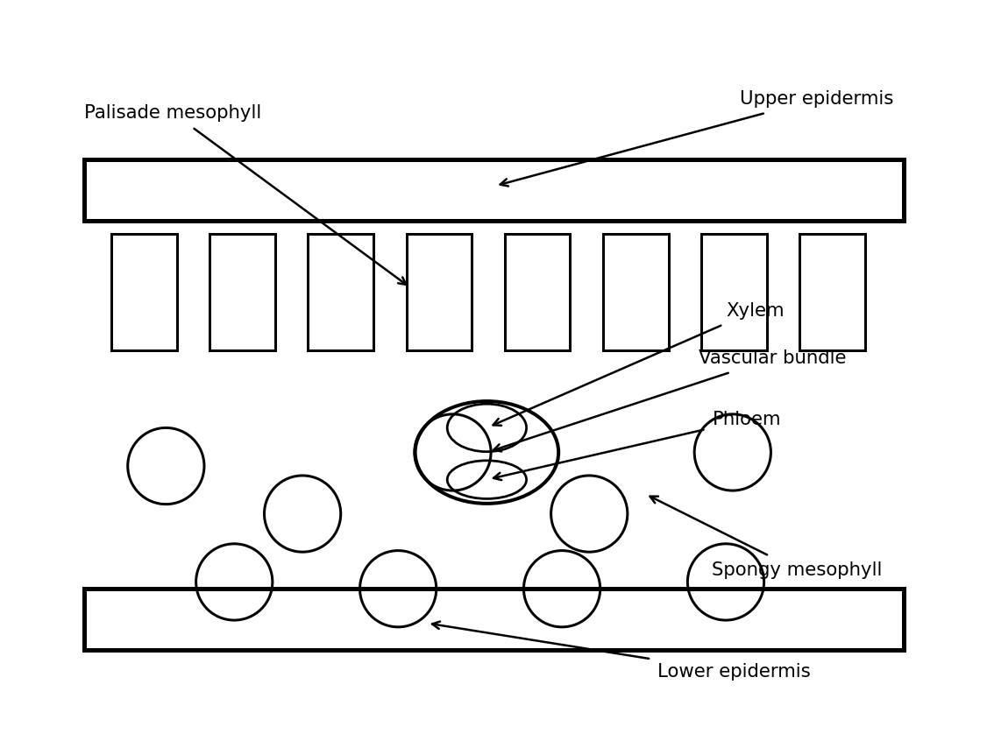
Expected labelled leaf section.
d) Any two: closely packed cells near upper surface receive strong light; many chloroplasts/chlorophyll; elongated cells provide large chloroplast-containing area; thin leaf allows light penetration. 1 mark each. (2)
e) Rate is likely to decrease because carbon dioxide becomes limiting; high temperature may also reduce enzyme-controlled photosynthetic processes if above optimum. Award 1 mark for prediction and 1 for valid explanation. (2)

Question 5
a) i. Xylem. (1) ii. Phloem. (1)
b) Any three: vessels are hollow with no cytoplasm; end walls are perforated/absent to form continuous tubes; lignified walls prevent collapse; thick walls provide strength; narrow lumen can maintain a continuous water column. 1 mark each. (3)
c) i. Oil prevents evaporation directly from the water surface. (1)
ii. It permits measurement of movement/volume of water taken up. (1)
iii. Prevents air leakage/ensures water loss is mainly through the shoot, improving validity. (1)
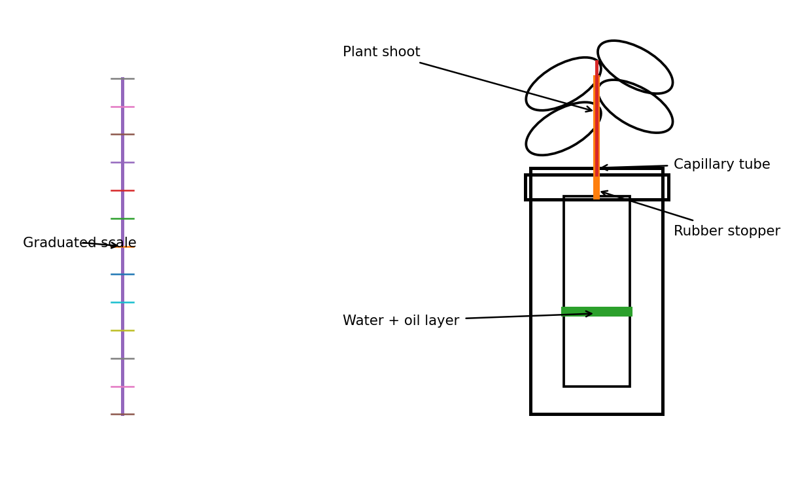
Expected apparatus features.
d) Rate = distance ÷ time = 12 mm ÷ 30 min = 0.4 mm min⁻¹. Award 1 mark for formula/substitution; 1 mark for answer and units. (2)
e) Any one factor such as increased wind speed, higher temperature, lower humidity or greater light intensity, with correct explanation linking it to a steeper water-vapour gradient/increased stomatal opening. (1)

Question 6
a) Any two: allow carbon dioxide in for photosynthesis; allow oxygen in/out; allow carbon dioxide out; allow water vapour loss/transpiration; regulate gaseous exchange. 1 mark each. (2)
b) In light/favourable conditions, guard cells accumulate solutes, water enters by osmosis, guard cells become turgid and their unequal wall thickness causes the stomatal pore to open. Award 1 mark each for solute/water change, turgidity, and opening mechanism. (3)
c) Aerobic respiration uses oxygen and releases more energy; anaerobic respiration occurs without oxygen and releases less energy, producing ethanol + carbon dioxide in plants. Any two clear contrasts. (2)
d) i. Carbon dioxide. (1)
ii. Germinating seeds respire and produce carbon dioxide; the gas enters limewater and reacts to form insoluble calcium carbonate, turning it milky. (2)

Question 7
a) Any two: ingestion; digestion; absorption; assimilation; egestion. 1 mark each. (2)
b) i. Numerous villi greatly increase surface area for absorption. (2)
ii. Rich capillary supply maintains concentration gradients and rapidly carries absorbed nutrients away. (2)
c) Starch → glucose/simple sugars; proteins → amino acids; fats → fatty acids and glycerol. 1 mark each. (3)
d) Bile emulsifies fats into small droplets, increasing surface area for lipase action; it also helps provide an alkaline medium. (1)

Question 8
a) 1 Right atrium; 2 Left atrium; 3 Right ventricle; 4 Left ventricle; 5 Aorta; 6 Pulmonary artery. 1 mark each. Accept pulmonary vein/vena cava only where the indicated structure is correctly identified from the diagram. (6)
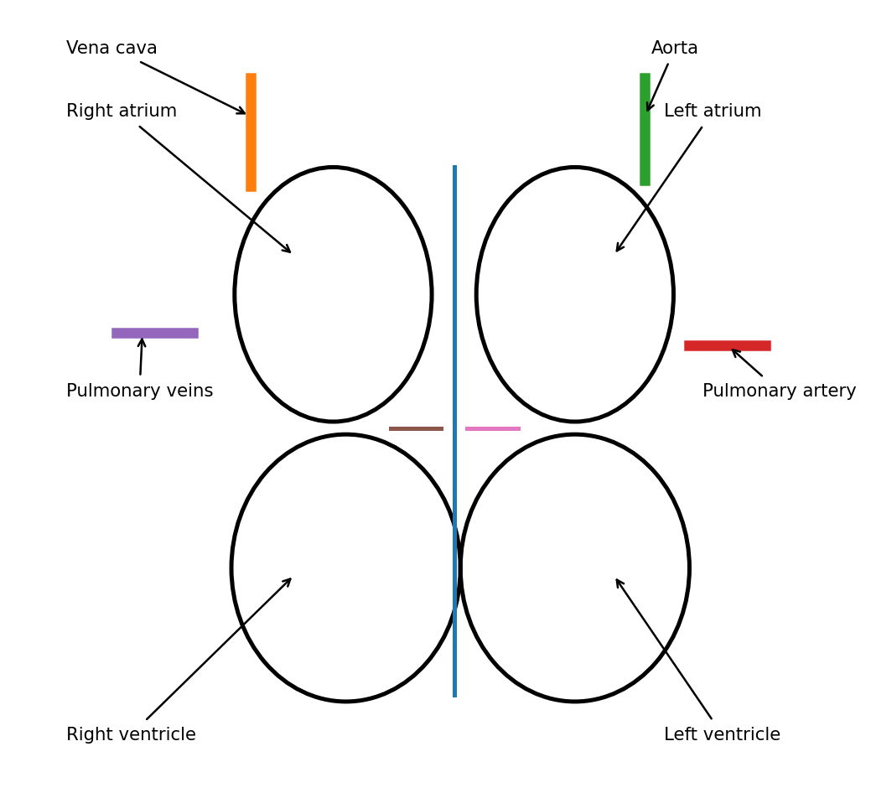
Expected labelled heart diagram.
b) Any two paired differences: arteries carry blood away from heart, veins toward heart; arteries have thicker muscular/elastic walls, veins thinner walls; arteries generally have narrower lumen, veins wider; veins have valves, most arteries do not. 1 mark per valid difference. (2)
c) Right ventricle → pulmonary artery → lungs/pulmonary capillaries → pulmonary veins → left atrium → left ventricle → aorta → body tissues → venae cavae → right atrium. Since the question asks until return to right atrium, award 1 mark for each of four major stages in correct sequence. (4)
d) i. Antigen A. (1) ii. Anti-B antibody. (1)
e) Clotting seals the damaged vessel, reduces blood loss, prevents entry of pathogens and starts repair. Any two valid points. (2)

Question 9
a) Percentage increase = ((128 − 72) / 72) × 100 = (56/72) × 100 = 77.78% ≈ 77.8%. Award 1 mark for difference 56, 1 for division by 72, 1 for correct percentage. (3)
b) Exercise increases energy demand by muscles; respiration rate increases, requiring more oxygen and glucose and producing more carbon dioxide; heart rate rises to deliver oxygen/nutrients and remove carbon dioxide. Award 1 mark for each valid linked point. (3)
c) No. Original = 72 beats/min; after 10 min rest = 78 beats/min, which is 6 beats/min higher. 1 mark for conclusion, 1 for evidence. (2)
d) Any two: regular physical activity; balanced diet; avoid smoking/tobacco; maintain healthy body mass; manage stress; adequate sleep; control alcohol intake. 1 mark each. (2)

